COUNTRY PROFILE AND MARKET INTELLIGENCE

Singapore
Executive summary

AI-generated depiction of Marina Bay Sands and the ArtScience Museum; not a photograph of the site.

Contents
At a glance 2
Health system 3
Market and competition 4
Institution directory 5
CSI position and risks 6
Prepared 7 October 2026. Analyst review draft. Numbered citations refer to Singapore_Profile_DRAFT_SOURCES.docx.

At a glance
6.21M  Total population, June 2026³ | 19.5%  Residents aged 65+, June 2026⁷
83.9 years  Resident life expectancy at birth, 2025⁷ | Int$163,354  GDP per capita, PPP, 2025⁵
5.0%  Real GDP growth, 2025¹² | US$3,922  Current health spending per person, 2023²⁶
2.9  Registered doctors per 1,000 total population, 2024³⁰ | 10,784  Public acute hospital beds, 2025¹⁹

Country background
Singapore is a city-state and parliamentary democratic republic, with Singapore as its capital.¹ Prime Minister Lawrence Wong heads the government and holds the finance portfolio; President Tharman Shanmugaratnam is the non-partisan head of state.^{8,9} English, Malay, Mandarin and Tamil are official languages.² The economy generated S$789.5 billion in nominal GDP in 2025.¹² Its Economy 2030 strategy emphasizes advanced manufacturing, skills and technology adoption.¹⁴ In August 2026, the government raised its full-year growth forecast to 4.5% to 5.5%, citing stronger global investment related to artificial intelligence.¹³
Of 6.21 million people in June 2026, 4.23 million were residents, comprising citizens and permanent residents.³ Aging is a central healthcare demand driver: people aged 65 and older represented 19.5% of residents and 21.4% of citizens.^{3,7} The resident fertility rate fell to 0.87 births per woman in 2025.⁷ Cancer, pneumonia and ischemic heart disease led recorded mortality in 2025, while national policy increasingly emphasizes prevention, community support and coordinated care.^{15,21,36}

Key takeaways for CSI
• Three public healthcare clusters combine service delivery with regional population-health responsibilities.¹¹
• Healthier SG connects residents aged 40 and older with regular family doctors and prevention plans.²¹
• MOH plans approximately 2,800 additional public acute and community beds by 2030.²⁰
• International academic relationships span medical education, cardiovascular research and specialist knowledge exchange.^{38,39}

Health system
• Financing combines public subsidies, compulsory medical savings, national catastrophic insurance and means-tested assistance.²²
• MediShield Life provides lifelong coverage for citizens and permanent residents.²⁹
• Registered workforce ratios include inactive practitioners and differ from OECD practicing-workforce measures.^{28,30}
Health spending per person, 2016 to 2023
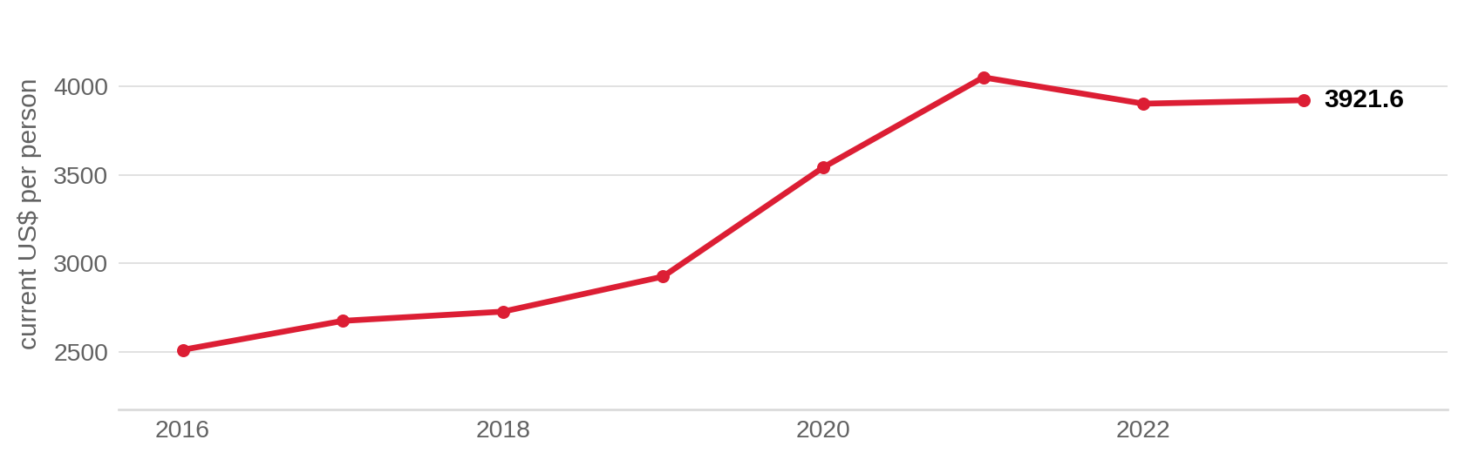
Current health expenditure; nominal US dollars, not inflation-adjusted or PPP-adjusted. Sources: ²⁶
Health workforce density, 2015 to 2024
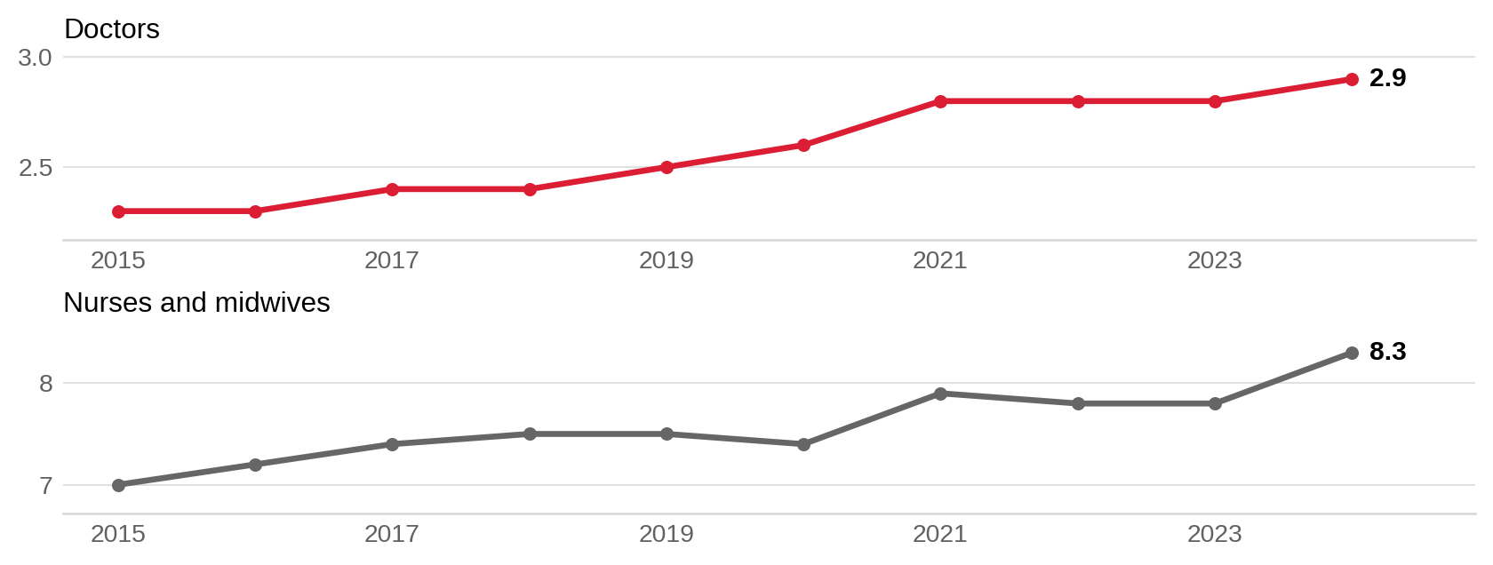
MOH/SingStat registration-based series; nurses include registered and enrolled nurses and midwives. Published per-10,000 rates divided by 10. Sources: ⁷⁴

Market and competition
• Eight private acute hospitals provided 1,649 beds in 2025.^{18,19}
• Private primary care included 2,777 general-practitioner clinics in 2025.¹⁸
• Raffles Hospital supports international patients through clinical appointments and non-medical assistance.²⁴
Hospital bed capacity by ownership and care setting, 2025
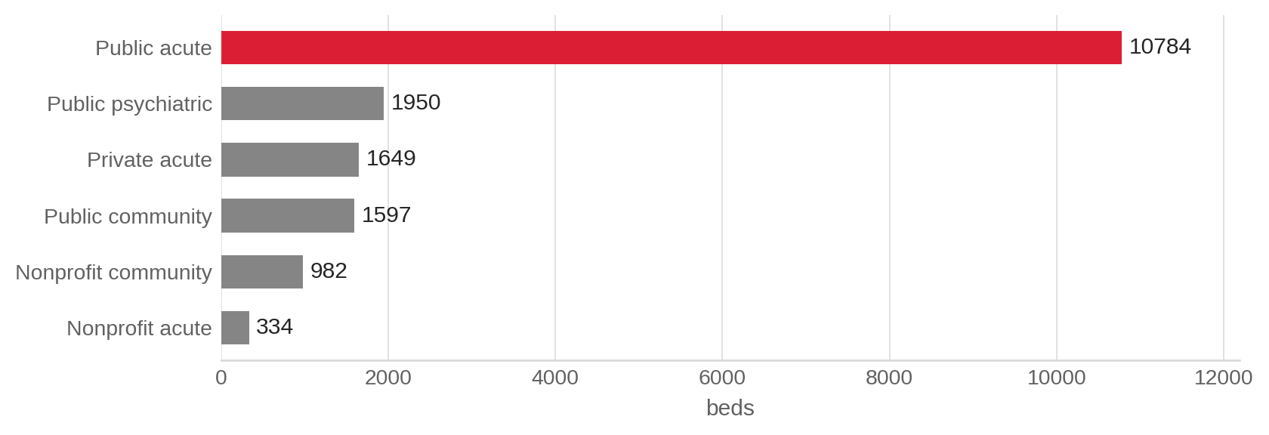
Mutually exclusive hospital-bed categories; nursing-home beds are excluded. Sources: ¹⁹

International institutional collaboration
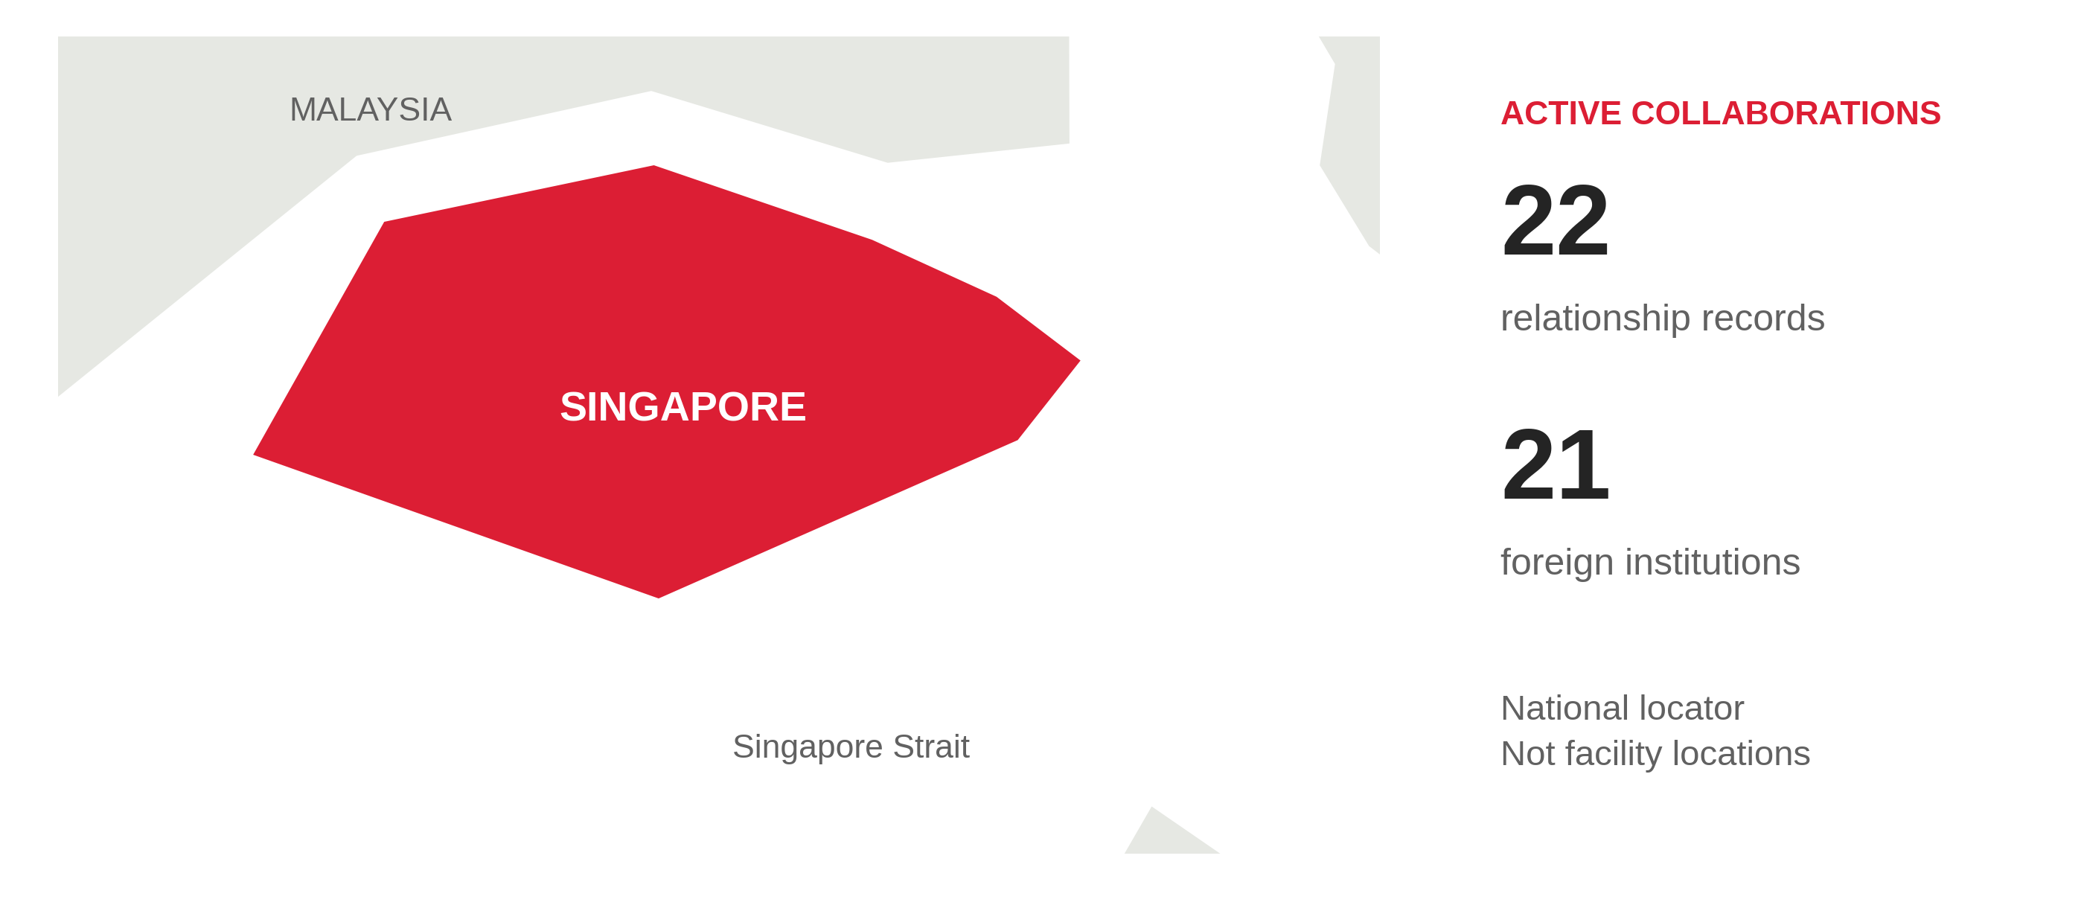
Active external institutional collaborations, reviewed 7 October 2026. Directory totals exclude Cedars-Sinai. Map: Natural Earth, public domain. Counts describe relationships in the country, not hospital ownership or facility locations.

Institution directory
21 foreign institutions with dated evidence of active collaboration. Entries 1 to 21. Detailed evidence appears in the profile and tracker.
Institution | Nature of collaboration
Duke University School of Medicine | Research collaboration, Training and education
Harvard University (Harvard T.H. Chan School of Public Health) | Research collaboration, Training and education
Johns Hopkins Health System | Training and education
Mayo Clinic | Research collaboration
Methodist Le Bonheur Healthcare | Training and education
Michigan Medicine (University of Michigan) | Research collaboration, Training and education
Mount Sinai Health System | Training and education
NYC Health + Hospitals | Training and education
Northwell Health | Training and education
Stanford Health Care | Training and education
Stanford Medicine | Research collaboration, Training and education
Beijing Tsinghua Changgung Hospital | Training and education
CUHK Medical Centre | Training and education
Imperial College London | Training and education
Karolinska University Hospital | Training and education
National Cancer Center Japan | Research collaboration
Ruijin Hospital (Shanghai Jiao Tong University School of Medicine) | Research collaboration
Shanghai Jiao Tong University School of Medicine | Training and education
University Health Network | Training and education
University of Cambridge School of Clinical Medicine | Research exchange through joint symposia
University of Oxford (Oxford University Clinical Research Unit) | Clinical-trial capacity development and training

CSI position and risks

CSI partnerships in Singapore
[MANUAL INPUT REQUIRED]
To be completed by CSI from internal data and relationship assessment.

Opportunities for CSI
[MANUAL INPUT REQUIRED]
To be completed by CSI from internal data and relationship assessment.

Risks and watch items
• More than half of hypertensive residents aged 18 to 74 examined in 2023 to 2024 were previously undiagnosed.¹⁶
• The healthcare workforce is projected to rise from 129,000 in 2024 to approximately 156,000 by 2030.³¹
• Health-information contribution requirements phase in from September 2027 and September 2028.³⁷

Recent developments
2026-10-03
NPHS 2025 reported 87.3% of residents aged 18 to 74 met the sufficient-physical-activity definition.¹⁷
2026-09-09
MOH announced regulatory consolidation under HSA, with transfers scheduled for November 2026 and by end-2027.⁷²
2026-05-06
MOH outlined phased health-record contributions following February 2026 enactment of the Health Information Act.^{37,73}

