Country Profile: Spain

Photo: Diego Delso, CC BY-SA 4.0, via Wikimedia Commons
Table of Contents
Country Overview
Population and Demographics
Government
Economy
Disease Prevalence
Spain Health System
Public Healthcare System
Private Healthcare System
Healthcare Financing
Workforce
Education
Healthcare Outlook
Competitive Landscape
Recent Developments
CSI Assessment

Country Overview

Population and Demographics
Capital | Madrid¹ | Official language | Spanish (Castilian); other Spanish languages are co-official in their autonomous communities²
Population | About 49.8 million (1 July 2026, provisional)³ | Area | 505,983 sq km¹
GDP (PPP), total | About 2.95 trillion international dollars (2025)⁴ | GDP (PPP), per capita | About 59,870 international dollars (2025)⁵
Government type | Parliamentary monarchy² | Head of state | King Felipe VI⁶
Head of government | Prime Minister Pedro Sánchez⁷ | Currency | Euro¹
Urban population | 80.5% (2025)⁸ | Population aged 65 and over | 21.6% (2025)⁹
Total fertility rate | 1.10 births per woman (2024)¹⁰ | Life expectancy at birth | 83.9 years (2024)¹¹
Residents born abroad | 10,291,807 (1 July 2026, provisional)³

Spain had 49,801,559 residents on 1 July 2026, according to provisional figures from the Instituto Nacional de Estadística (INE), the highest number on record.³ The population grew by 104,178 in the second quarter and by an estimated 444,205 over the year, and the growth came from people born abroad, while the number born in Spain fell.³ Residents born abroad numbered 10,291,807 and foreign nationals 7,437,543.³ About 80.5 percent of people live in urban areas.⁸
The population is aging. People aged 65 and over made up 21.6 percent of residents in 2025, the fertility rate was 1.10 births per woman in 2024, and life expectancy at birth was 83.9 years.^{9,10,11} The State of Health in the EU profile puts life expectancy at 84 years in 2024, the third highest in the EU, with women living 86.6 years and men 81.3, and projects the share aged 65 and over to rise from 20 percent in 2024 to 33 percent by 2050.¹² For a foreign academic medical center, this points to sustained demand for chronic, cancer and age-related care in a large, high-income market.

Government
Spain is a parliamentary monarchy with Madrid as its capital.² King Felipe VI is head of state, and the Cortes Generales (the Congress of Deputies and the Senate) hold legislative power.^{2,6} The country is organized into 17 autonomous communities and two autonomous cities.¹ Prime Minister Pedro Sánchez, a Socialist, has led a minority government.¹³ On 5 October 2026 he announced an early general election, and a decree of the same day dissolved the chambers elected on 23 July 2023 and set the vote for 29 November 2026.^{6,13,14} The 2023 state budget has been rolled over into 2026, a third year, under a Council of Ministers decision of 23 December 2025.¹⁵
Health is decentralized. Mónica García is Minister of Health.⁷ The ministry coordinates strategic planning and national regulation, while the health authorities of the 17 autonomous communities run operational planning, purchasing and resource allocation, coordinated through the Interterritorial Council of the National Health System.¹² The regions accounted for 93.6 percent of public health spending in 2024.¹⁶

Economy
Spain's GDP was about 2.95 trillion international dollars at purchasing power parity in 2025, or about 59,870 per person.^{4,5} It accounted for 9.0 percent of EU GDP in 2025.¹ GDP rose 0.7 percent in the second quarter of 2026 and 2.6 percent year on year, driven by domestic demand.¹⁷ In October 2026 the Banco de España raised its growth projections to 2.6 percent for 2026 and 2.2 percent for 2027, citing strong consumption and job creation.¹⁸ Higher energy prices push its inflation forecasts to 3.9 percent in 2026 and 3.7 percent in 2027, and it expects unemployment to fall to 9.7 percent in 2027, a general government deficit of 2.6 percent of GDP in 2026 and public debt of 98.5 percent of GDP in 2026.¹⁸
Services exports are strong: in the second quarter of 2026 the tourism surplus reached 4.8 percent of GDP and the surplus on other services 2.6 percent.¹⁸ The main development program of recent years has been the EU-funded Recovery and Resilience Plan, under which Spain allocated €2.4 billion (US$2.69 billion) to health, including high-tech equipment, prevention, training of health professionals and more rational use of medicines.¹² The deadline for meeting the plan's milestones passed on 31 August 2026, and the Banco de España warns that the end of NextGenerationEU funding and dearer business credit could weigh on investment.¹⁸

Disease Prevalence
Deaths, all causes | 441,270 (2025, provisional)¹⁹ | Share of deaths from tumors | 26.3% (2025)¹⁹
Share of deaths from circulatory diseases | 25.7% (2025)¹⁹ | Share of deaths from respiratory diseases | 12.4% (2025)¹⁹
Leading single cause of death | Ischemic heart disease, 26,711 deaths (2025)¹⁹ | Adults smoking daily | 20% (2020)¹²
Alcohol consumption | 11.1 liters per adult (2023)¹² | Adults with obesity | 15% (2022)¹²
Adults with insufficient physical activity | 62% (2022)¹²

Spain recorded 441,270 deaths in 2025, according to provisional INE data.¹⁹ Tumors caused 26.3 percent of them and diseases of the circulatory system 25.7 percent, followed by respiratory diseases at 12.4 percent, which rose 9.0 percent on 2024.¹⁹ Ischemic heart disease was the most frequent single cause (26,711 deaths), followed by cerebrovascular disease (22,341); lung cancer (23,479) and colon cancer (10,610) led among tumors, and dementia was the leading cause of death among women (15,344).¹⁹
Behavioral and environmental risks account for a quarter of deaths. About 96,000 deaths in 2021 were attributed to behavioral risks such as smoking, diet, alcohol and physical inactivity and another 13,000 to air pollution, together 25 percent of deaths against an EU average of 29 percent.¹² Daily smoking fell from 32 percent of adults in 2001 to 20 percent in 2020, alcohol consumption rose to 11.1 liters per adult in 2023, the fifth highest in the EU, 15 percent of adults were obese in 2022 and 62 percent were insufficiently active.¹² About 5.7 million people were living with cardiovascular disease in 2021, and an estimated 264,000 new cancer cases were expected in 2022.¹² The burden points to demand in oncology, cardiology and dementia care.

Spain Health System

Public Healthcare System
Spain's National Health System (Sistema Nacional de Salud, SNS) provides universal coverage to all residents, including undocumented migrants, and is financed mainly through general taxation.¹² Civil servants, the judiciary and the armed forces have their own mutual funds (MUFACE, MUGEJU and ISFAS).¹² Most primary care is delivered in public health centers, where family doctors act as gatekeepers to specialist and hospital care; private providers work mainly in outpatient specialist and hospital services.¹² Avoidable hospital admissions for congestive heart failure and diabetes are among the lowest in the EU, and in 2024 the Interterritorial Council approved the Primary and Community Care Action Plan 2025-27 to build capacity in primary care.¹²
Unmet needs for medical care were 2.6 percent in 2024, below the EU average of 3.6 percent, but 9.3 percent for dental care.¹² Waiting lists are the main barrier. At 31 December 2025, according to figures the Ministry of Health revised on 24 September 2026, 853,740 patients were waiting for elective surgery, with an average wait of 122 days and 21.6 percent waiting more than six months, and the average wait for a first hospital specialist consultation was 102 days.²⁰ In the 2023 Health Barometer, 69.8 percent of respondents said it took more than 24 hours to get an appointment with a family doctor, with an average wait of nine days.¹²

Private Healthcare System
Private provision is large. In the 2025 National Hospital Catalogue, 440 hospitals were private (57 percent of the total) with 49,614 beds (31 percent), against 335 public hospitals with 110,065 beds.²¹ Private health spending was €37.0 billion (US$41.5 billion) in 2023, or 2.5 percent of GDP and 26.8 percent of total health spending.²¹ Voluntary health insurance paid for 6 percent of health spending, above the EU average of 4.5 percent, and is used both to shorten waits for specialist and hospital care and to cover services outside the SNS package, such as some dental care.¹²
Insurance is growing quickly. Health insurers covered 12.8 million people in 2025, and premiums rose 11.5 percent to €13.3 billion (US$14.9 billion); SegurCaixa Adeslas, Sanitas and Asisa held 60 percent of the market.²¹ About 71 percent of civil servants in the mutual funds chose private care in 2024.²¹ Quirónsalud, owned by Germany's Fresenius through Helios, leads the private hospital market with about 13 percent of sales in a market worth about €22.5 billion (US$25.2 billion) in 2024; Helios Spain's revenue rose 7 percent to €5.43 billion (US$6.08 billion) in 2025, and Fresenius plans new hospitals and expansions during 2026.^{22,23} Fresenius describes the market as highly fragmented, with room for consolidation.²³ Sanitas, part of the Bupa group since 1989, has five owned hospitals and three under construction.²⁴

Healthcare Financing
Current health expenditure, share of GDP | 9.22% (2023); 9.22% in 2012²⁵ | Current health expenditure per capita | US$3,107 (2023, current US$)²⁶
Out-of-pocket share of current health expenditure | 20.9% (2023); 23.2% in 2012²⁷ | Government share of current health expenditure | 73.2% (2023)²⁸
Comparison, current health expenditure share of GDP (2023) | Spain 9.22%, Italy 8.41%, EU 10.00%, Portugal 10.03%, United Kingdom 10.99%, France 11.52%, Germany 11.74%, OECD members 12.75%, United States 16.69%²⁹ | Public health spending (Ministry of Health) | €101.7 billion (US$114 billion), 6.4% of GDP (2024)¹⁶
Private health spending | €37.0 billion (US$41.5 billion), 2.5% of GDP (2023)²¹

Current health expenditure was 9.2 percent of GDP in 2023, the same share as in 2012, and about US$3,107 per person, according to World Bank data.^{25,26} The State of Health in the EU profile puts per capita spending about one fifth below the EU average.¹² In 2023 Spain's share of GDP was above Italy's 8.4 percent but below the EU average, Portugal, the United Kingdom, France, Germany, the OECD average and the United States.²⁹ Out-of-pocket payments were 20.9 percent of current health expenditure in 2023, and general government spending covered 73.2 percent.^{27,28} Patients pay mainly for dental care, outpatient medicines and optical care, but exemptions keep catastrophic spending among the lowest in the EU.¹²
The Ministry of Health puts public health spending at €101.7 billion (US$114 billion) in 2024, 6.4 percent of GDP and €2,084 (US$2,340) per person; the total rose 4.2 percent on 2023.¹⁶ Staff pay took 44.8 percent of it and hospital and specialist services 62.1 percent.¹⁶

Workforce
Physicians per 1,000 people | 4.4 (2023); EU average 4.3¹² | Doctors and nurses in the SNS | 212,201 doctors and 284,232 nurses (2024)³⁰
Physicians per 1,000 people (World Bank) | 4.29 (2022); 3.80 in 2012³¹ | Nurses per 1,000 people | 5.9 (2023); EU average 8.5¹²
Nurses and midwives per 1,000 people (World Bank) | 6.41 (2022)³² | Family doctors, share of physicians | 22% (EU 19%)¹²
Doctors aged 55 and over | 43% (2022)¹² | Hospital beds per 1,000 people | 2.91 (2023)³³

Spain had 4.4 physicians per 1,000 people in 2023, slightly above the EU average of 4.3, and family doctors made up 22 percent of them against 19 percent in the EU.¹² The Ministry of Health counted 212,201 doctors and 284,232 nurses in the SNS in 2024, up 3.3 and 2.5 percent on a year earlier.³⁰ World Bank data put the density at 4.29 per 1,000 in 2022, above France (3.28), Italy (4.19), the United States (3.68) and the OECD average (3.43).³⁴ Nursing is thinner: 5.9 nurses per 1,000 people in 2023 against an EU average of 8.5, although Spain's figure leaves out nurse assistants.¹²
Distribution and age are the main problems. In 2022 primary care physicians ranged from 0.6 to 1.1 per 1,000 people across regions, and 43 percent of doctors were aged 55 and over.¹² The profile cites forecast shortfalls of family doctors and of specialists in geriatrics, psychiatry and radiology.¹² A 2023 technical document lets primary care posts that meet at least five of 13 hard-to-fill criteria qualify for incentives such as bonuses and housing support.¹²

Education
Medicine is a six-year university degree of 360 ECTS credits.^{35,36} Most graduates then specialize through the MIR (médico interno residente) residency system, which they enter through a national examination and which lasts four to five years depending on the specialty.³⁶ The call published on 10 August 2026 offers 9,676 places in medicine for residency starting in 2027, 9,377 of them in public centers and 300 in private ones, and up to 968 of those places may go to applicants without a Spanish residence permit; the examination is set for 23 January 2027.³⁷
Graduate numbers are low by EU standards. Spain produced 13.6 medical graduates per 100,000 people in 2023 against an EU average of 15.2, and 24.0 nursing graduates against 38.6, although the nursing figure leaves out nursing assistants.¹² To expand supply, public universities offered 677 new places for medical students across all years in 2023/24, raising first-year places to 722 (up 12 percent), supported by €52 million (US$58.3 million) from the government.¹² For a foreign academic partner, the push to train more doctors and specialists points to openings in training, fellowships and faculty exchange.

Healthcare Outlook
Demand will keep rising. The share of people aged 65 and over is projected to rise from 20 percent in 2024 to 33 percent by 2050, and 48 percent of women over 65 had multiple chronic conditions in 2022.¹² Hospital medicines are a fast-growing cost: inpatient pharmaceutical spending reached €9.6 billion (US$10.8 billion) in 2023, up 8 percent, partly because costly new medicines such as cancer therapies are given only in hospitals.¹² Fresenius expects the private hospital market to keep growing in 2026 as more people, especially higher earners and those seeking shorter waits, take out insurance.²³
Policy is on hold until a new government forms. The dissolution of the Cortes halted bills in progress, and the doctors' unions postponed an indefinite strike over the Estatuto Marco, the framework law for health service staff, saying the bill had lapsed and a new government would have to restart it.³⁸ The government had also sent a medicines bill and an update of the tobacco law to the Cortes in July 2026.³⁹ EU recovery funding, which paid for health equipment and training, has passed its deadline for milestones.^{12,18} Whoever governs after 29 November will inherit long waiting lists, an aging medical workforce and fast-growing private insurance, which shape the openings for foreign partners in specialist training, digital health and complex care.

Competitive Landscape
Foreign groups are well established in private care. Germany's Fresenius owns market leader Quirónsalud through Helios;²³ Bupa has owned Sanitas, which has five hospitals, since 1989;²⁴ France's Vivalto-Santé is the reference shareholder of Ribera;⁴⁰ and Hospiten runs MD Anderson Cancer Center Madrid, which says it has the backing of the Houston center.⁴¹ Vithas and HM Hospitales are other large groups.²² In 2026 Ribera completed its purchase of HCB Hospitales, Vithas agreed to buy GenesisCare's Spanish oncology centers, pending competition approval, and HM Hospitales signed an alliance with Mexico's Grupo Médico Joya.^{42,43,44}
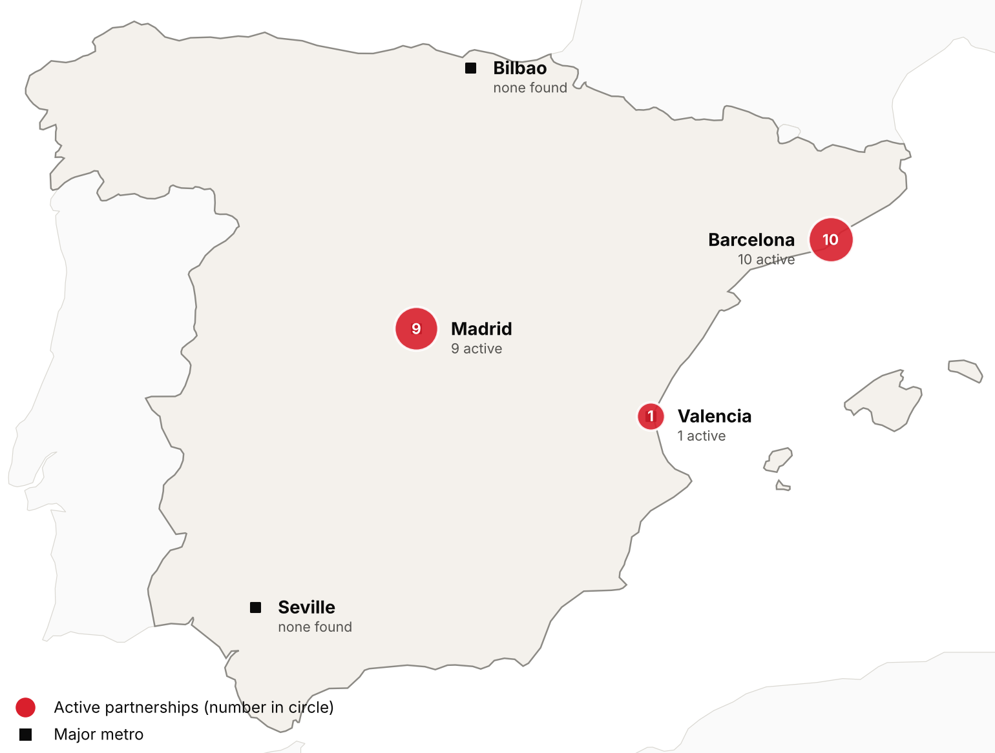
Active foreign health-system partnerships by city of the partner in Spain. Source: CSI partnerships tracker, verified 2026-10-30. Boundaries: Natural Earth; not an official depiction.
Confirmed active partnerships by institution
Institution | Based in | Nature of collaboration | Latest evidence
US academic medical centers
Cleveland Clinic | United States | Training and education | 2025-12⁴⁵
George Washington University (School of Medicine and Health Sciences) | United States | Training and education | 2026-10⁴⁶
Harvard Medical School (Harvard University) | United States | Training and education | 2025-10⁴⁷
Johns Hopkins University (Bloomberg School of Public Health) | United States | Research collaboration | 2025-11⁴⁸
MD Anderson Cancer Center | United States | Clinical affiliation | 2026-09⁴¹
Mount Sinai Health System (Icahn School of Medicine, Mount Sinai Fuster Heart Hospital) | United States | Research collaboration | 2025-08⁴⁹
Penn State College of Medicine and Penn State Health (Beat Childhood Cancer Research Consortium) | United States | Research collaboration | 2025-11⁵⁰
University of Illinois Chicago (College of Applied Health Sciences) | United States | Training and education | 2025-10⁵¹
University of Kansas Medical Center | United States | Training and education | 2026-02⁵²
Other foreign health systems
ABC Medical Center (Centro Médico ABC) | Mexico | Training and education | 2025-08⁵³
Aier Eye Hospital Group | China | Ownership or management | 2026-07⁵⁴
Bupa | United Kingdom | Ownership or management | 2026-03⁵⁵
Burjeel Cancer Institute (Burjeel Holdings) | United Arab Emirates | Clinical affiliation | 2025-06⁵⁶
Cancer Core Europe (Gustave Roussy, DKFZ and NCT Heidelberg, Netherlands Cancer Institute, Karolinska Institutet, Cancer Research UK Cambridge Centre, Istituto Nazionale dei Tumori Milan) | Multiple (France, Germany, Netherlands, Sweden, United Kingdom, Italy) | Research collaboration | 2026-03⁵⁷
Clariane (formerly Korian) | France | Ownership or management | 2025-12⁵⁸
Fresenius Helios (Helios Health) | Germany | Ownership or management | 2026-02⁵⁹
GenesisCare | Australia | Ownership or management | 2026-07⁶⁰
Grupo Médico Joya (Hospitales Joya) | Mexico | Clinical affiliation | 2026-09⁴⁴
Sun Yat-sen University Cancer Center | China | Research collaboration | 2025-12⁶¹
Vivalto Santé | France | Ownership or management | 2026-10⁶²
Only partnerships with dated evidence of activity in the last 24 months are listed. Unclear and recently ended partnerships are in the CSI partnerships tracker.
Spain is a major destination for EU patients. Under the cross-border healthcare directive it treated 234,635 patients in 2021 to 2023 for care not needing prior authorization, more than any other reporting country.⁶³ In 2024 it received the largest reimbursements for unplanned care given to visitors from other European countries, €243 million (US$272 million).⁶⁴ No current official count of international patients was found. Outbound, Spain's system received only 22 requests to authorize planned care abroad in 2021 to 2023, while Catalan plastic surgeons estimate that hundreds a year arrive at emergency departments after cosmetic surgery in Turkey and Latin America.^{63,65}

Recent Developments

2026-10-07 Doctors postpone indefinite strike as the election halts the Estatuto Marco
The doctors' unions CESM, SMA and SME postponed the indefinite strike planned from 28 October, saying the Ministry of Health's Estatuto Marco bill lapses with the dissolution of the Cortes.³⁸ The strike call stays in force, and the unions, who want a statute of their own for doctors, will press the next government.^{38,66}
2026-07-21 Government sends medicines and tobacco bills to the Cortes
The Council of Ministers sent the Cortes a Medicines and Health Products bill replacing the 2015 framework, with conditional early funding for innovative medicines decided in under 65 working days, more generics and biosimilars, and tools against shortages.³⁹ A tobacco bill extends smoke-free areas to bar and restaurant terraces and regulates vapes like cigarettes.³⁹
2026-05-13 Public health spending reached €101.7 billion (US$114 billion) in 2024
The Ministry of Health reported public health spending of €101.7 billion (US$114 billion) in 2024, 6.4 percent of GDP and 4.2 percent more than in 2023.¹⁶ Regional governments accounted for 93.6 percent, and spending per person ranged from €1,658 (US$1,860) in Andalusia to €2,332 (US$2,610) in the Basque Country.¹⁶
2025-07-29 Law creates a State Public Health Agency
Law 7/2025 of 28 July created the State Public Health Agency and amended the 2011 General Public Health Law.⁶⁷ The State of Health in the EU profile describes the agency as a central authority to improve Spain's ability to anticipate and manage public health challenges, after a national surveillance network was launched in June 2024.¹²
2025-04-30 MUFACE signs a new private care contract for civil servants
MUFACE signed a 2025 to 2027 health care contract with Adeslas and Asisa covering 1,014,692 civil servants and dependents who chose private care.⁶⁸ Its €4.81 billion (US$5.39 billion) budget is €1.28 billion (US$1.43 billion) more than the previous contract, and the weighted average premium rises 41.2 percent over three years.⁶⁸

CSI Assessment

Everything below comes from Cedars-Sinai's internal data (patient referral records, finance, relationship history) and human judgment, not from the research agents. Fields left blank are marked and must be completed by the analyst before this profile is used.
Patient Volume & Revenue (most recent FY)
[MANUAL INPUT REQUIRED]
Referral Sources
[MANUAL INPUT REQUIRED]
Relationship History
[MANUAL INPUT REQUIRED]
Complications
[MANUAL INPUT REQUIRED]
Key Contacts
[MANUAL INPUT REQUIRED]
Opportunities
[MANUAL INPUT REQUIRED]
CSI Recommendation
[MANUAL INPUT REQUIRED]

