Country Summary: Spain

Photo: Diego Delso, CC BY-SA 4.0, via Wikimedia Commons
Executive summary of the Spain country profile (2026-10-30). Superscript numbers refer to the numbered sources in Spain_Profile_DRAFT_SOURCES.docx.

At a Glance

49.8 m  Population, 1 July 2026, provisional³ | 59,870  GDP per capita, PPP (international dollars), about, 2025⁵ | 9.22%  Current health expenditure, share of GDP, 2023²⁵ | 20.9%  Out-of-pocket share of current health expenditure, 2023²⁷
4.4  Physicians per 1,000 people, 2023¹² | 83.9  Life expectancy at birth, years, 2024¹¹ | 21.6%  Population aged 65 and over, 2025⁹ | US$3,107  Current health expenditure per capita, 2023, current US$²⁶
Country background
Spain, a parliamentary monarchy with its capital in Madrid, had about 49.8 million residents on 1 July 2026 (provisional).^{2,3} King Felipe VI is head of state, and Prime Minister Pedro Sánchez has led a minority government.^{2,13} Mónica García is Minister of Health.⁷ The economy grew 2.6 percent year on year in the second quarter of 2026, and GDP per person was about 59,870 international dollars (PPP) in 2025.^{5,17} The population is aging: 21.6 percent were 65 or older in 2025, and life expectancy was 83.9 years in 2024.^{9,11} The key risk is political: a snap general election is set for 29 November 2026, and policy is on hold until a new government forms.^{14,38}
Key takeaways for CSI
- Health spending was 9.22 percent of GDP in 2023, unchanged from 2012, and 20.9 percent was out of pocket.^{25,27}
- At 31 December 2025, 853,740 patients were waiting for elective surgery, with an average wait of 122 days.²⁰
- Spain had 4.4 physicians per 1,000 people in 2023, but 43 percent were aged 55 and over in 2022.¹²
- The share aged 65 and over is projected to rise from 20 percent in 2024 to 33 percent by 2050.¹²

Health System

- The tax-funded National Health System covers all residents, and regions made up 93.6 percent of public health spending in 2024.^{12,16}
- Unmet needs for medical care were 2.6 percent in 2024, below the EU average of 3.6 percent.¹²
- The average wait for a first hospital specialist consultation was 102 days at 31 December 2025.²⁰
Spain: health spending and out-of-pocket share, 2012 to 2023
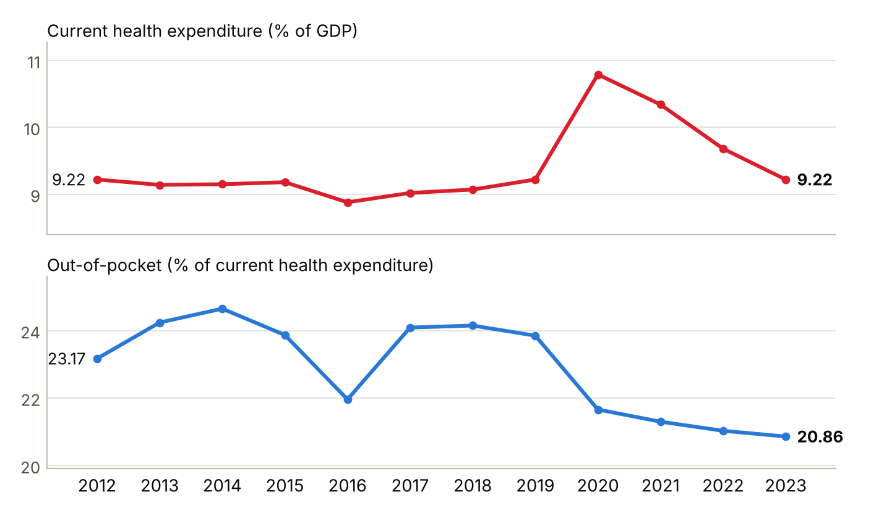
Current health expenditure as a share of GDP, and out-of-pocket spending as a share of current health expenditure; 2023 is the latest year in the series. Sources: ^{25,27}
Physicians per 1,000 people, Spain and comparators (latest year available)
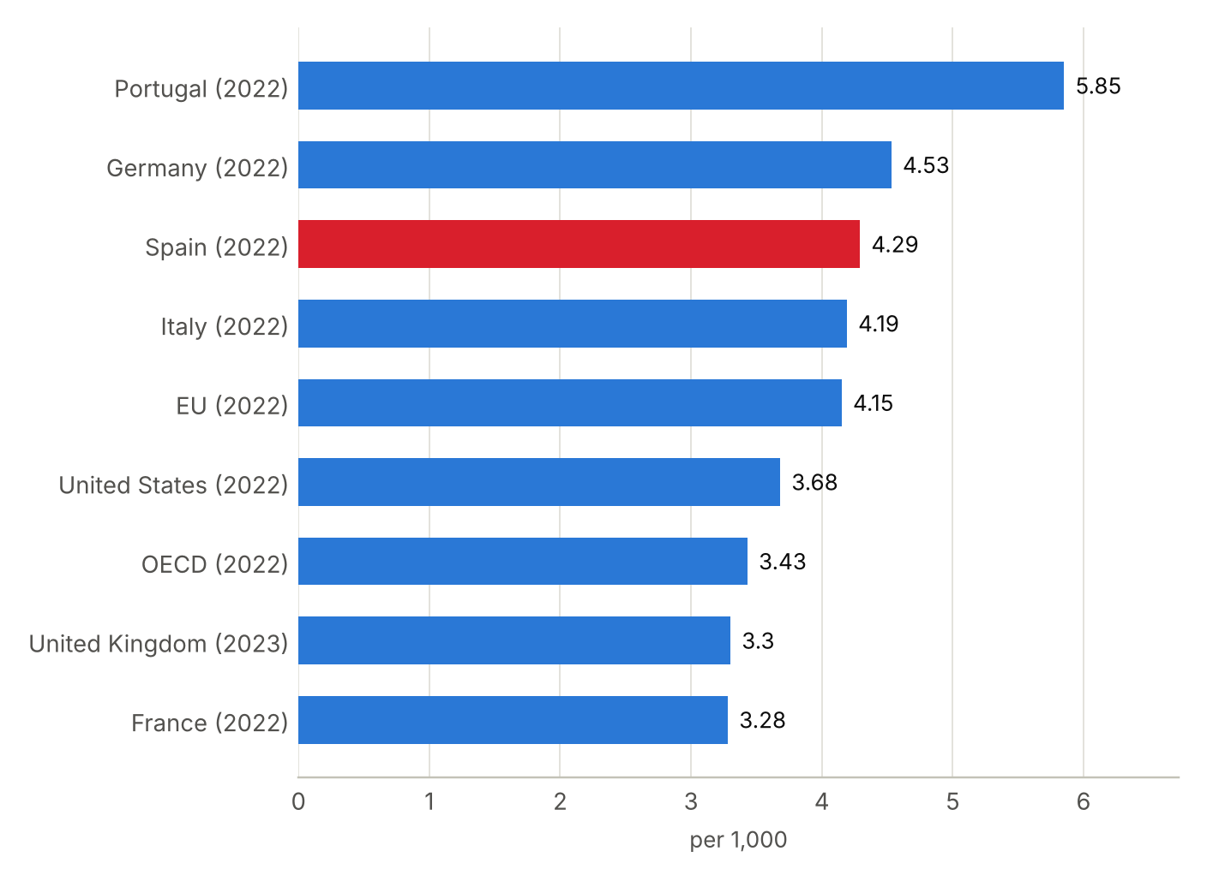
Latest year available for each country in the World Bank series, shown in brackets; comparison years differ (2022 and 2023). Portugal's figure counts all doctors licensed to practise, which overstates practising doctors. Sources: ^{12,34}

Market and Competition

- In 2025, 440 hospitals were private (57 percent of the total), and health insurers covered 12.8 million people.²¹
- Foreign groups are well established: Fresenius owns Quirónsalud, Bupa owns Sanitas, and Hospiten runs MD Anderson Cancer Center Madrid.^{23,24,41}
- The tracker lists 20 active foreign partnerships in Spain, in Barcelona (ten), Madrid (nine) and Valencia (one).
Spain: hospital beds per 1,000 people, 2012 to 2023
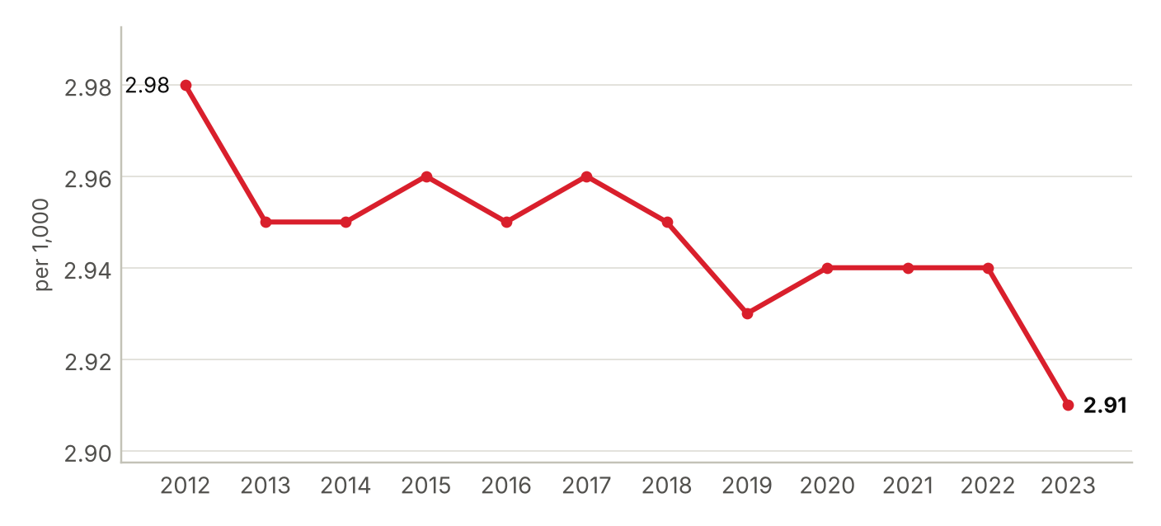
Hospital beds as reported to the World Bank, public and private; 2023 is the latest year in the series. Sources: ³³
Foreign health systems active in Spain
20 foreign institutions with confirmed active partnerships (20 in all): 6 training and education, 6 ownership or management, 5 research collaboration, 3 clinical affiliation. Sources in the profile and the partnerships tracker.
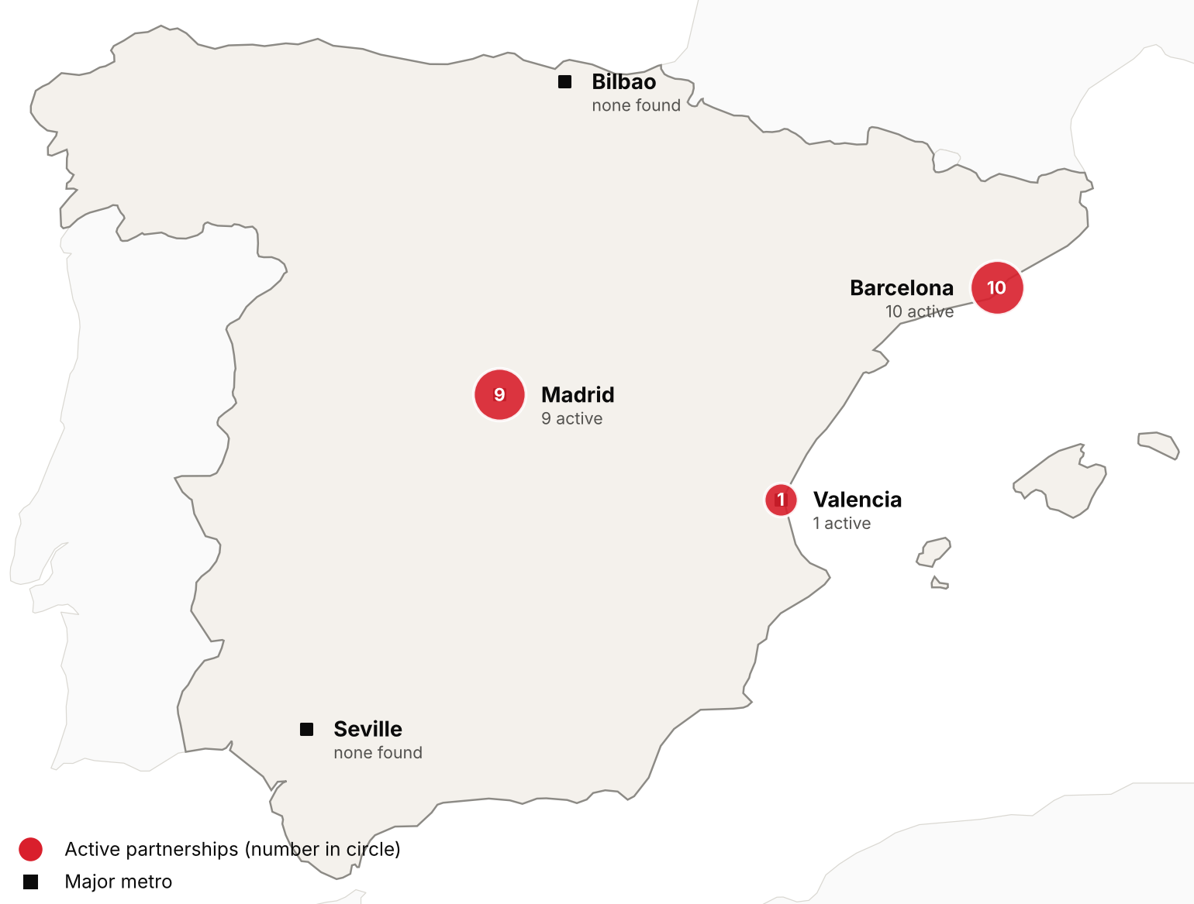
Active foreign health-system partnerships by city of the partner in Spain. Source: CSI partnerships tracker, verified 2026-10-30. Boundaries: Natural Earth; not an official depiction.
Institution | Nature of collaboration
Cleveland Clinic | Training and education
George Washington University (School of Medicine and Health Sciences) | Training and education
Harvard Medical School (Harvard University) | Training and education
Johns Hopkins University (Bloomberg School of Public Health) | Research collaboration
MD Anderson Cancer Center | Clinical affiliation
Mount Sinai Health System (Icahn School of Medicine, Mount Sinai Fuster Heart Hospital) | Research collaboration
Penn State College of Medicine and Penn State Health (Beat Childhood Cancer Research Consortium) | Research collaboration
University of Illinois Chicago (College of Applied Health Sciences) | Training and education
University of Kansas Medical Center | Training and education
ABC Medical Center (Centro Médico ABC) | Training and education
Aier Eye Hospital Group | Ownership or management
Bupa | Ownership or management
Burjeel Cancer Institute (Burjeel Holdings) | Clinical affiliation
Cancer Core Europe (Gustave Roussy, DKFZ and NCT Heidelberg, Netherlands Cancer Institute, Karolinska Institutet, Cancer Research UK Cambridge Centre, Istituto Nazionale dei Tumori Milan) | Research collaboration
Clariane (formerly Korian) | Ownership or management
Fresenius Helios (Helios Health) | Ownership or management
GenesisCare | Ownership or management
Grupo Médico Joya (Hospitales Joya) | Clinical affiliation
Sun Yat-sen University Cancer Center | Research collaboration
Vivalto Santé | Ownership or management

CSI Position, Risks and Recent News

CSI partnerships in Spain
[MANUAL INPUT REQUIRED]
To be completed by CSI from internal data; not researched.
Opportunities for CSI
[MANUAL INPUT REQUIRED]
To be completed by CSI from internal data; not researched.
Risks and watch items
- A snap general election is set for 29 November 2026, and policy is on hold until a new government forms.^{14,38}
- The 2023 state budget has been rolled over into 2026, a third year.¹⁵
- The end of NextGenerationEU funding could weigh on investment.¹⁸
Recent developments
2026-10-07 Doctors' unions postponed the indefinite strike planned from 28 October, saying the Estatuto Marco bill lapses.³⁸
2026-07-21 The government sent the Cortes a Medicines and Health Products bill and a tobacco bill.³⁹
2026-05-13 The Ministry of Health reported public health spending of €101.7 billion (US$114 billion) in 2024, 6.4 percent of GDP.¹⁶

