Country Summary: Indonesia

Photo: Gunawan Kartapranata (Public domain), via Wikimedia Commons
Executive summary of the Indonesia country profile (2026-10-07). Superscript numbers refer to the numbered sources in Indonesia_Profile_DRAFT_SOURCES.docx.

At a Glance

285.7 m  Population, 2025 estimate² | 17,660  GDP per capita, PPP (international dollars), about, 2025⁴ | 2.70%  Current health expenditure, share of GDP, 2023⁴⁰ | 31.1%  Out-of-pocket share of current health expenditure, 2023⁴³
0.52  Physicians per 1,000 people, 2023⁴⁸ | 1.37  Hospital beds per 1,000 people, 2023⁵⁰ | 382  Tuberculosis incidence per 100,000 people, 2024²⁵ | 282.7 m  People covered by national health insurance (JKN), end of 2025³⁰
Country background
Indonesia, with about 285.7 million people in 2025, is a republic led by a directly elected president, and its capital is Jakarta.^{1,2,5} President Prabowo Subianto was sworn in on 20 October 2024 with Vice President Gibran Rakabuming Raka, and Budi Gunadi Sadikin still led the Health Ministry in August 2026.^{5,15} The economy grew 5.11 percent in 2025, and GDP was about 5.05 trillion international dollars at purchasing power parity.^{3,17} The World Bank projects growth of 5.0 percent in 2026.²⁰ Life expectancy at birth was 71.3 years in 2024, 59.4 percent of people lived in urban areas in 2025, and people aged 65 and over made up 7.5 percent.^{7,9,10} Noncommunicable diseases cause about two-thirds of deaths.¹¹ The key risk is JKN finances: the fund's deficit was Rp 17.13 trillion in 2025, and BPJS Kesehatan said it could begin missing claim payments by July 2027 without government intervention.^{31,47}
Key takeaways for CSI
- National health insurance covered 282.7 million people, more than 98 percent of the population, at the end of 2025.³⁰
- Current health spending was 2.70 percent of GDP in 2023, below Malaysia, Thailand, Vietnam and the Philippines.^{40,44}
- Only 27 to 30 of 92 medical faculties could produce specialists, a Health Ministry spokesperson said in August 2024.⁵³
- Private operators ran 1,576 of 2,710 general hospitals, or 58 percent, in 2024.³²

Health System

- Free health checks began on 10 February 2025 at about 10,200 puskesmas.³⁴
- The government plans to renovate 8,001 puskesmas, build 1,988 new ones and upgrade 441 regional hospitals from 2027 to 2029.³⁵
- The World Bank reports that out-of-pocket spending fell from 45 to 31 percent of total health spending.¹¹
Indonesia: health spending and out-of-pocket share, 2012 to 2023
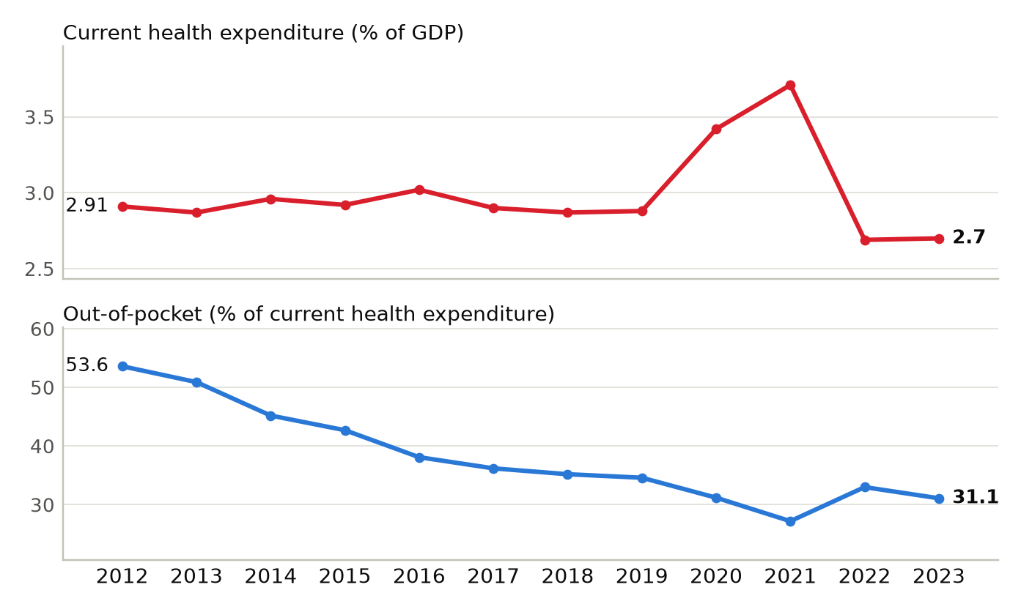
Current health expenditure is shown as a share of GDP; out-of-pocket spending is shown as a share of current health expenditure. Sources: ^{40,43}
Physicians per 1,000 people, Indonesia and comparators
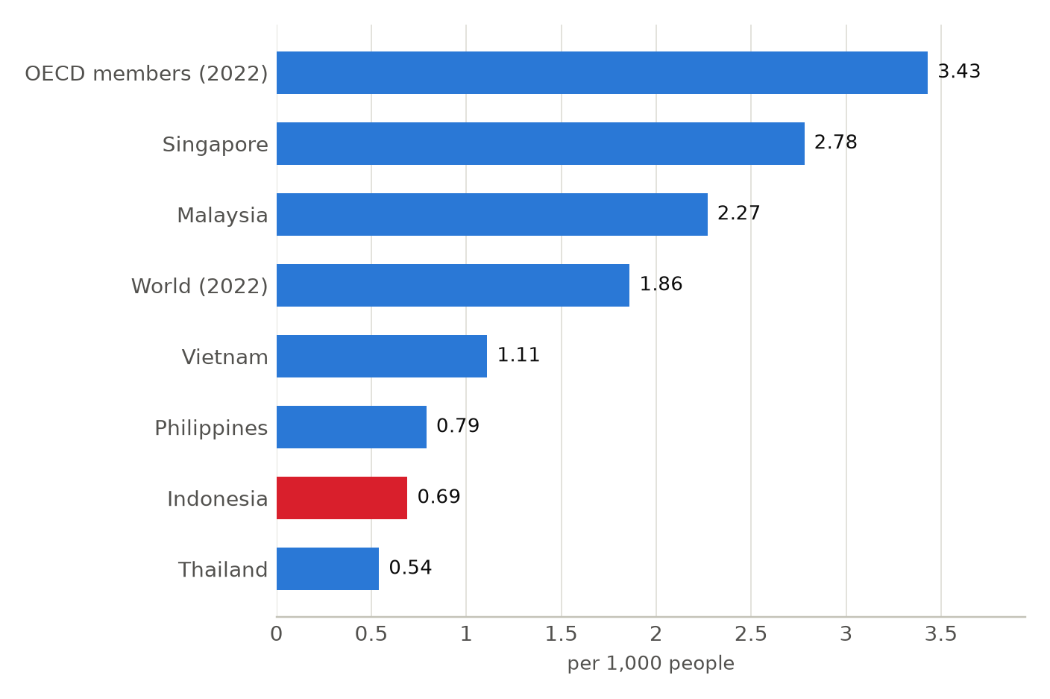
Latest comparable World Bank values: 2021 for countries and 2022 for the OECD members and world aggregates. Indonesia's 2023 value was 0.52. Sources: ⁴⁸

Market and Competition

- Siloam reported 2025 revenue of Rp 12.84 trillion and net profit of Rp 1.11 trillion.³⁶
- Mayapada Group has committed Rp 6.91 trillion through 2032 to a Batam project with India's Apollo Hospitals.^{38,39}
- At Bali International Hospital, Australia's Icon Group runs the cancer center and SingHealth is the academic partner.^{38,57}
Indonesia: hospital beds per 1,000 people, 2012 to 2023
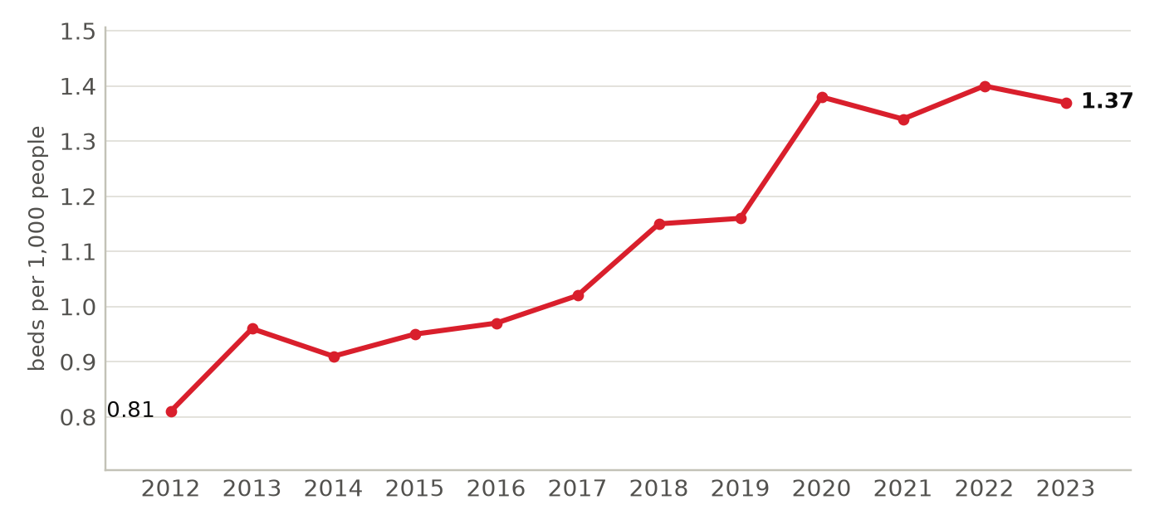
Hospital beds per 1,000 people as published in the World Bank indicator SH.MED.BEDS.ZS. Sources: ⁵⁰
Foreign health systems active in Indonesia
24 foreign institutions with confirmed active partnerships (26 in all): 12 training and education, 8 clinical affiliation, 2 research collaboration, 2 ownership or management, 1 government agreement, 1 advisory and consulting. Sources in the profile and the partnerships tracker.
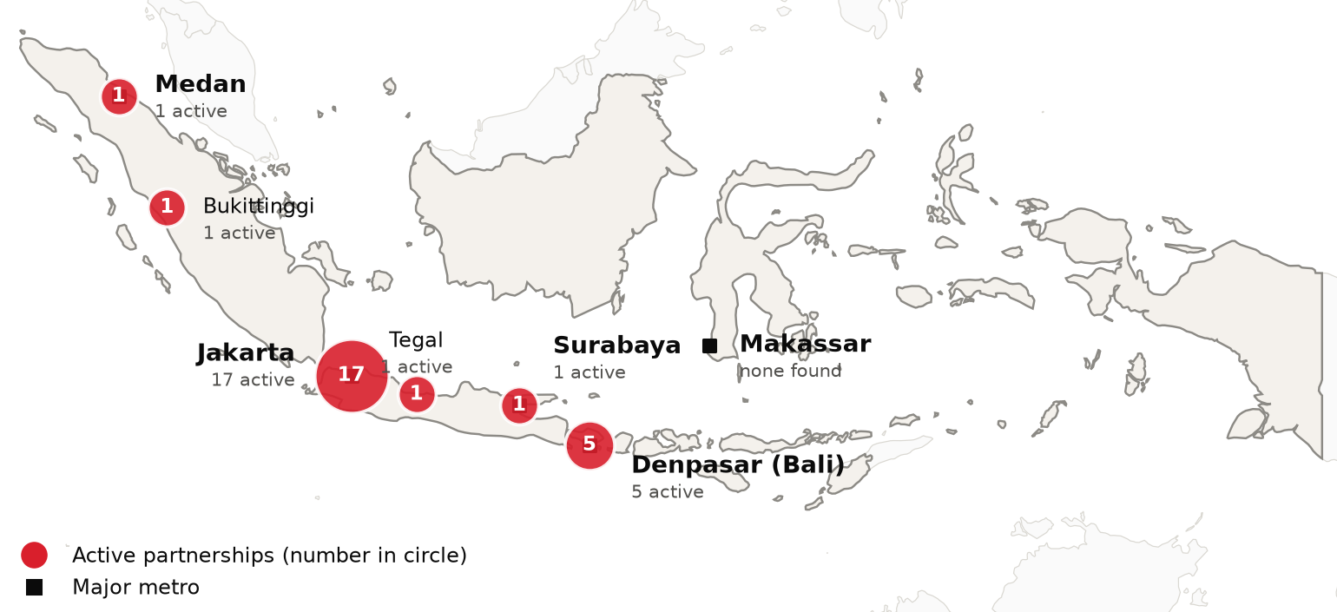
Active foreign health-system partnerships by city of the partner in Indonesia. Source: CSI partnerships tracker, verified 2026-10-07. Boundaries: Natural Earth; not an official depiction.
Institution | Nature of collaboration
Cedars-Sinai | Training and education
Harvard Medical School | Research collaboration
MD Anderson Cancer Center | Advisory and consulting, Government agreement
Mayo Clinic | Clinical affiliation
St. Jude Children's Research Hospital | Training and education
Apollo Hospitals | Clinical affiliation
Asia OneHealthcare (A1Health, formerly Columbia Asia Healthcare) | Ownership or management
Chung Shan Medical University (Taiwan) | Training and education
Hong Kong Asia Medical Group (HKAMG) | Clinical affiliation
Icon Group (Icon Cancer Centre) | Ownership or management
International University of Health and Welfare (IUHW) | Training and education
Monash Health | Training and education
National Center for Global Health and Medicine (NCGM) and Kobe University | Research collaboration
Ramathibodi Hospital, Mahidol University | Training and education
Sapporo Cardio Vascular Clinic | Clinical affiliation
Seoul National University Hospital (SNUH) | Clinical affiliation, Training and education
SingHealth | Training and education
SingHealth Duke-NUS Global Health Institute (SingHealth and Duke-NUS Medical School) | Training and education
Sun Medical Center (Sun Healthcare International) | Clinical affiliation
Taipei Veterans General Hospital | Clinical affiliation
Tokushukai Medical Group | Clinical affiliation
Wuhan Asia Heart Hospital | Training and education
Zhongda Hospital (Southeast University) | Training and education
Zhongshan Hospital (Fudan University) | Training and education

CSI Position, Risks and Recent News

CSI partnerships in Indonesia
[MANUAL INPUT REQUIRED]
To be completed by CSI from internal data; not researched.
Opportunities for CSI
[MANUAL INPUT REQUIRED]
To be completed by CSI from internal data; not researched.
Risks and watch items
- The JKN fund recorded a deficit of Rp 17.13 trillion in 2025, against Rp 7.66 trillion in 2024.⁴⁷
- Physicians numbered 0.52 per 1,000 people in 2023, and the minister cited a 29,000 specialist shortage.^{38,48}
- The 2023 Health Law eliminated the mandatory health spending minimum.¹⁴
Recent developments
2026-06-09 BPJS Kesehatan said monthly deficits are about Rp 2 trillion and it expects a Rp 20 trillion government injection.³¹
2026-08-04 Free health checks reached 73.8 million people in 2026 up to 31 July, against a target of 130 million.¹⁵
2026-08-14 The 2027 draft health budget is up 1.7 percent on the 2026 outlook of Rp 240.8 trillion.⁴⁶

