Country Profile: Australia

Photo: Diliff, CC BY-SA 3.0, via Wikimedia Commons
Table of Contents
Country Overview
Population and Demographics
Government
Economy
Disease Prevalence
Australia Health System
Public Healthcare System
Private Healthcare System
Healthcare Financing
Workforce
Education
Healthcare Outlook
Competitive Landscape
Recent Developments
CSI Assessment

Country Overview

Population and Demographics
Capital | Canberra¹ | Main language | English (the only language used at home by 72.0% of people, 2021 Census)²
Population | About 27.9 million (31 March 2026)³ | Area | 7,741,220 sq km⁴
GDP (PPP), total | About 1.99 trillion international dollars (2025)⁵ | GDP (PPP), per capita | About 71,930 international dollars (2025)⁶
Government type | Constitutional monarchy with ministers responsible to Parliament⁷ | Head of state | The King, represented by Governor-General Sam Mostyn⁷
Head of government | Prime Minister Anthony Albanese⁸ | Currency | Australian dollar⁹
Urban population | 87.7% (2025)¹⁰ | Total fertility rate | 1.48 births per woman (2024)¹¹
Population aged 65 and over | 18.1% (2025)¹² | Life expectancy at birth | 83.1 years (2024)¹³
Born overseas | 27.6% (2021 Census)¹⁴

Australia's population was 27.9 million at 31 March 2026, up 392,700 on a year earlier, a growth rate of 1.4 percent.³ Net overseas migration added 292,100 people over the year and natural increase added 100,600.³ Western Australia grew fastest at 2.1 percent and Tasmania slowest at 0.6 percent.³ In the 2021 Census, 27.6 percent of residents were born overseas, and the most common languages used at home other than English were Mandarin, Arabic, Vietnamese, Cantonese and Punjabi.¹⁴ About 88 percent of people live in urban areas.¹⁰
The population is aging. People aged 65 and over made up 18.1 percent of residents in 2025, the fertility rate was 1.48 births per woman in 2024, and life expectancy at birth was 83.1 years.^{11,12,13} For a foreign academic medical center, this points to steady demand for care of chronic and age-related conditions in a high-income, mostly insured population served largely by the domestic system.

Government
Australia is a constitutional monarchy in which the King is head of state and is represented by Governor-General Sam Mostyn.⁷ Ministers answer to the Australian Parliament, which sits in Canberra.^{1,7} Labor won 94 seats in the House of Representatives at the 2025 federal election, against 43 for the Liberal/National Coalition and 10 for independents, and Anthony Albanese continues as Prime Minister.^{8,15} Mark Butler is the Minister for Health and Ageing, and Jim Chalmers is Treasurer.^{16,17}
Health responsibilities are split. The Commonwealth funds Medicare and the Pharmaceutical Benefits Scheme, while the states own and manage the public hospitals.¹⁸ The two levels settle hospital funding through National Cabinet, which on 30 January 2026 reached a funding agreement that includes a new National Health Reform Agreement addendum.⁸

Economy
Australia is a high-income economy, with GDP of about 1.99 trillion international dollars at purchasing power parity in 2025, or about 71,930 per person.^{5,6} Real GDP rose 0.4 percent in the June quarter of 2026 and 2.1 percent on a year earlier, and grew 2.4 percent over the 2025-26 financial year.¹⁹ Service industries account for over 70 percent of economic activity.¹⁹
The 2026-27 Budget, delivered on 12 May 2026, expects growth to slow from 2.25 percent in 2025-26 to 1.75 percent in 2026-27 because the conflict in the Middle East has raised global oil prices.¹⁷ It forecasts headline inflation of 5 percent through the year to the June quarter of 2026, easing to 2.5 percent a year later, with unemployment at 4.25 percent in the June quarter of 2026.¹⁷ The underlying cash deficit is forecast at A$31.5 billion, or 1.0 percent of GDP, in 2026-27, and health accounts for 16.4 percent of Commonwealth expenses.¹⁷ The government's Future Made in Australia agenda aims to secure and scale domestic industrial capability.¹⁷

Disease Prevalence
Leading cause of death | Dementia, including Alzheimer's disease: 9.4% of deaths (2024)²⁰ | Second leading cause of death | Ischemic heart diseases: 8.7% of deaths (2024); coronary heart disease is the leading cause for men²⁰
Third leading cause of death | Chronic lower respiratory diseases, just over 9,000 deaths (2024)²⁰ | Registered deaths | 187,268 (2024)²¹
People with at least one chronic condition | 49.9% (2022)²² | Mental and behavioral conditions | 26.1% of people (2022)²²
Adults overweight or obese | 65.8% (2022)²² | Adults who are current daily smokers | 10.6% (2022); 22.4% in 2001²²
Adults exceeding the alcohol guideline | 26.8% (2022)²² | Diabetes | 5.3% of people, about 1.3 million (2022)²²
Heart, stroke and vascular disease | 5.2% of people, about 1.3 million (2022)²²

Dementia, including Alzheimer's disease, became Australia's leading cause of death in 2024, at 9.4 percent of deaths, overtaking ischemic heart diseases at 8.7 percent.²⁰ Deaths from dementia have risen 39 percent over a decade, and 62.4 percent of the people who died from it were women.²⁰ Over two-thirds (68.2 percent) of deaths are among people aged over 75.²⁰ Coronary heart disease remains the leading cause of death for men, with 10,153 deaths in 2024, even though its mortality rate has fallen by nearly 90 percent since the 1968 peak, and it is the second leading cause of premature death after suicide.²⁰
Risk factors are common. In 2022, 65.8 percent of adults were overweight or obese, 10.6 percent smoked daily (down from 22.4 percent in 2001), and 26.8 percent exceeded the alcohol guideline.²² Half of the population had at least one chronic condition, and 23.9 percent of people aged 15 and over met the physical activity guidelines.²² The burden points to sustained demand in cardiovascular care, neurology, diabetes care and aged care.

Australia Health System

Public Healthcare System
Australia's public system rests on Medicare, a universal insurance program financed from general tax revenue and a levy, which covers the full cost of public hospital services for citizens, permanent residents and visitors from reciprocal-agreement countries and gives substantial coverage for physician services and pharmaceuticals.²³ The Commonwealth funds care through the Medicare Benefits Schedule and the Pharmaceutical Benefits Scheme, and the states own and manage the public hospitals.²³
In 2023-24 there were 704 public hospitals with 67,280 available beds, or 2.5 per 1,000 people, and total recurrent spending of A$103.1 billion, 94 percent of it funded by governments.²⁴ Public hospitals recorded about 7.5 million separations that year and 9,094,312 emergency department presentations in 2024-25.²⁴
On 30 January 2026 National Cabinet reached an agreement under which the Commonwealth will provide A$25 billion in additional public hospital funding.⁸ The 2026-27 Budget provides A$220.3 billion over five years to the states and territories for public hospital services and the 2026-2031 addendum.²⁵ In primary care, bulk billing incentives were extended to all Australians from 1 November 2025, and the government projects that 9 in 10 GP visits will be bulk billed by 2030.^{26,27}

Private Healthcare System
About 12.8 million people, or 45.8 percent of the population, held private hospital cover at 30 June 2026, and 55.5 percent had general treatment cover.²⁸ Insurers paid A$5.3 billion in hospital benefits in the June 2026 quarter.²⁸ Government policy encourages cover through a premium rebate and an income-based penalty, the Medicare Levy surcharge.¹⁸ Private hospitals are a mix of for-profit and nonprofit operators.¹⁸
The sector's second-largest operator went into receivership in 2025. Healthscope entered receivership in May 2025 after its North American private equity owner, Brookfield, withdrew support, and on 14 September 2026 the receivers announced that 25 hospitals would be divided among Calvary Health Care (14 hospitals), Healthe Care, ACURIO Health and KnG Group.²⁹ Ramsay Health Care, listed on the Australian Securities Exchange since 1997, runs hospitals, clinics and services in Australia, Europe and the United Kingdom.³⁰ The 2026-27 Budget removes the age-based uplift of the private health insurance rebate from 1 April 2027, saving A$3.0 billion over four years.²⁵

Healthcare Financing
Total health spending, 2024-25 | A$290.7 billion, or A$10,614 per person³¹ | Current health expenditure, share of GDP | 10.40% (2023); 8.67% in 2012³²
Current health expenditure per capita | US$6,980 (2023, current US$)³³ | Out-of-pocket share of current health expenditure | 15.8% (2023); 19.9% in 2012³⁴
Out-of-pocket spending, 2023-24 | A$44 billion, or A$1,634 per person³⁵ | Share of health spending by type, 2024-25 | Hospital care 42% (A$123.4 billion); primary health care 32% (A$93.0 billion)³¹
Comparison, current health expenditure share of GDP (2023) | New Zealand 10.13%, United Kingdom 10.99%, Canada 11.19%, OECD members 12.75%, United States 16.69%, Singapore 4.49%³⁶ | Commonwealth health expenses, 2026-27 | A$136.9 billion, 16.4% of Commonwealth expenses¹⁷
Commonwealth assistance to states for public hospitals, 2026-27 | A$37.5 billion¹⁷

Total health spending reached A$290.7 billion in 2024-25, or A$10,614 per person, and governments funded 70 percent of it.³¹ Hospitals took A$123.4 billion, about 42 percent of the total, and primary health care A$93.0 billion, about 32 percent.³¹ Spending in 2023-24 had been A$270.5 billion.³⁵ World Bank data put current health expenditure at 10.4 percent of GDP in 2023, up from 8.7 percent in 2012, while out-of-pocket spending fell from 19.9 percent to 15.8 percent of the total over the same period.^{32,34} Among comparators, the share of GDP in 2023 was higher in Canada, the United Kingdom, the United States and the OECD average, and lower in New Zealand and Singapore.³⁶ Households still paid A$44 billion out of pocket in 2023-24, the largest non-government contribution.³⁵
The Commonwealth budgets A$136.9 billion for health in 2026-27, which includes A$37.5 billion of assistance to the states for public hospitals.¹⁷

Workforce
Physicians per 1,000 people | 4.09 (2022); 3.29 in 2012³⁷ | Nurses and midwives per 1,000 people | 13.45 (2022)³⁸
Hospital beds per 1,000 people | 3.82 (2016, latest World Bank year)³⁹ | Public hospital beds per 1,000 people | 2.5 (2023-24)²⁴
Registered medical practitioners | 148,185 (2024-25), up 3.9% on 2023-24⁴⁰ | First-time medical registrants | 9,072 (2024-25), of whom 4,947 international⁴⁰
Expedited specialist pathway | 178 registered by the end of June 2025, including 171 GPs⁴⁰

Physician density rose from 3.29 per 1,000 people in 2012 to 4.09 in 2022, and nurses and midwives numbered 13.45 per 1,000 in 2022.^{37,38} The medical register held 148,185 practitioners in 2024-25, and 4,947 of the 9,072 first-time registrants were internationally qualified.⁴⁰ An expedited pathway for specialists from the United Kingdom, New Zealand and Ireland opened in October 2024, and 178 applicants had been registered by the end of June 2025, 171 of them GPs.⁴⁰ In the first six months, to April 2025, 86 percent of applications came from the United Kingdom.⁴¹ Distribution is uneven: four in five of the specialists registered in the first six months of the pathway work in major cities, according to Medical Republic.⁴¹

Education
Medical education runs through public and private universities, followed by an accredited internship and residency.²³ The government is adding Commonwealth supported medical places: universities can apply for an additional 100 places from 2026, rising to 150 a year from 2028, with a focus on training more GPs, and the government said it would introduce demand driven places for First Nations medical students from 2026.¹⁶
After graduation, doctors train through the specialist colleges. The Commonwealth-funded Australian General Practice Training Program, for example, offers 3 to 4 years of full-time training.⁴² The 2024 Medical Training Survey had 24,812 respondents, more than half of doctors in training, and 62 percent of trainees said the financial cost of their college training program had led to stress.⁴³
Doctors who trained overseas generally follow a standard pathway: they pass the Australian Medical Council examinations to earn the AMC certificate, then hold provisional registration while completing approved supervised practice before general registration.⁴⁴ The Medical Board advises that Australian graduates have priority for accredited internship positions.⁴⁴ Specialists with approved qualifications from the United Kingdom, New Zealand and Ireland can instead register through an expedited pathway without college assessment, after six months of supervised practice.^{40,41}

Healthcare Outlook
Demand will keep rising as the population ages. People aged 65 and over were 18.1 percent of residents in 2025, and dementia is now the leading cause of death.^{12,20} Policy is aimed at hospital capacity and access. The January 2026 agreement commits about A$25 billion in additional Commonwealth public hospital funding, and the Commonwealth says it will continue to deliver 137 Medicare Urgent Care Clinics.⁸ The 2026-27 Budget funds those clinics on an ongoing basis, at A$1.8 billion over five years, and redirects savings from the private health insurance rebate to aged care.²⁵ The government projects that 9 in 10 GP visits will be bulk billed by 2030.²⁶ The Australian Centre for Disease Control, backed by A$251 million, became a statutory agency on 1 January 2026, with Professor Zoe Wainer as its first Director-General from March 2026.^{45,46,47}
Cost and capacity remain the main constraints. Health is 16.4 percent of Commonwealth expenses in 2026-27, and the budget papers forecast slower growth and higher inflation tied to oil prices.¹⁷ Workforce supply and the pace of hospital reform will shape how much room there is for international partners.

Competitive Landscape
The visible foreign links to Australian health care are mostly research and training ties. Peter MacCallum Cancer Centre signed a second memorandum with Boston's Dana-Farber Cancer Institute in November 2022 and a partnership agreement with Britain's The Christie in April 2024.^{48,49} Victoria announced Melbourne and Boston hospital partnerships in 2016.⁵⁰ The partnerships tracker lists 18 active ties, including Ochsner Health and Emory University with the University of Queensland, Memorial Sloan Kettering with Northern Sydney Local Health District, Weill Cornell Medicine with Monash University and Cleveland Clinic with Epworth HealthCare. Among owners, Healthscope was owned by North American private equity firm Brookfield until its 2025 receivership.²⁹
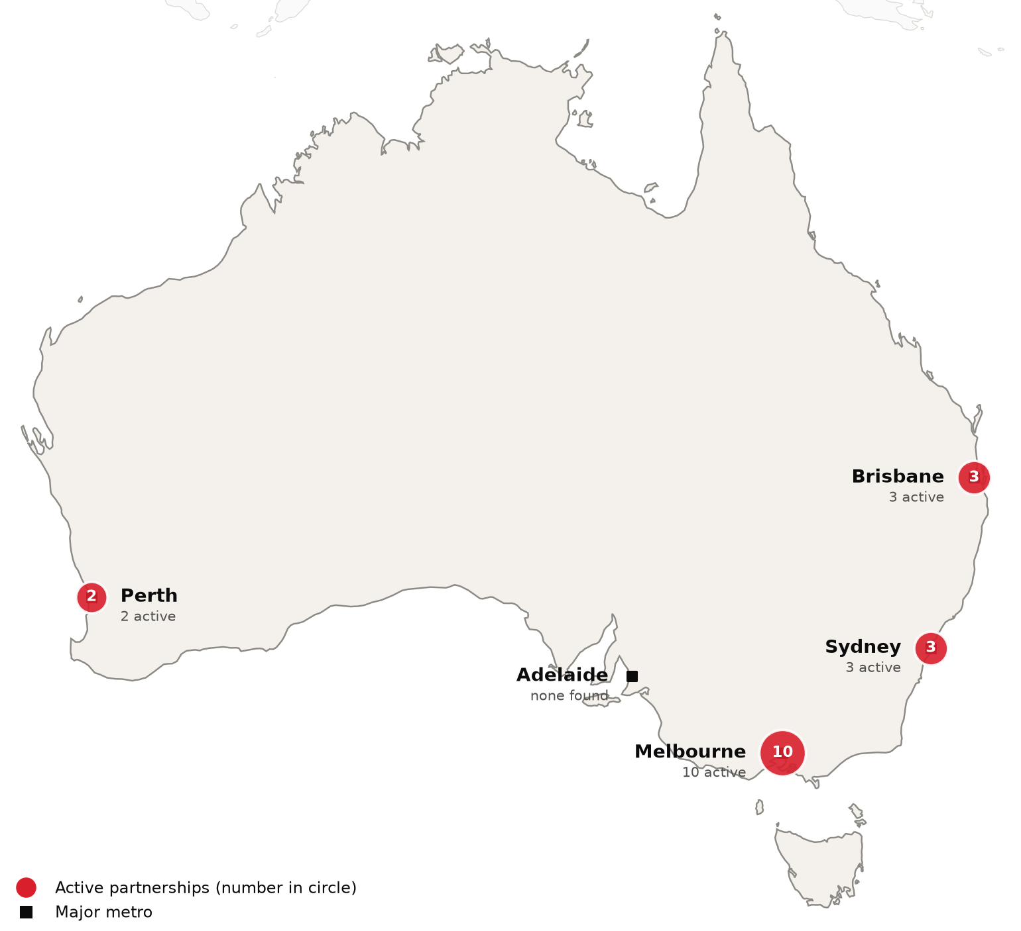
Active foreign health-system partnerships by city of the partner in Australia. Source: CSI partnerships tracker, verified 2026-10-20. Boundaries: Natural Earth; not an official depiction.
Confirmed active partnerships by institution
Institution | Based in | Nature of collaboration | Latest evidence
US academic medical centers
Boston Children's Hospital | United States | Research collaboration | 2025-02⁵⁰
Cleveland Clinic | United States | Training and education | 2026-02⁵¹
Emory University | United States | Research collaboration | 2025-01⁵²
Memorial Sloan Kettering Cancer Center | United States | Research collaboration | 2026-07⁵³
Ochsner Health | United States | Training and education | 2025-12⁵⁴
Weill Cornell Medicine | United States | Research collaboration | 2026-09⁵⁵
Other foreign health systems
Apollo Hospitals | India | Research collaboration | 2024-11⁵⁶
Great Ormond Street Hospital and UCL Great Ormond Street Institute of Child Health | United Kingdom | Research collaboration | 2025-02⁵⁷
Ho Chi Minh City Eye Hospital | Vietnam | Training and education | 2026-04⁵⁸
Hokkaido University (Faculty of Health Sciences) | Japan | Training and education | 2025-07⁵⁹
Manipal Academy of Higher Education (MAHE) | India | Research collaboration | 2026-09⁶⁰
Max Healthcare | India | Research collaboration | 2025-12⁶¹
Sichuan Provincial People's Hospital | China | Research collaboration | 2025-04⁶²
The Chinese Medicine Hospital of Hong Kong | China (Hong Kong) | Research collaboration | 2025-06⁶³
The Christie NHS Foundation Trust | United Kingdom | Training and education | 2025-11⁶⁴
The Hospital for Sick Children (SickKids) | Canada | Research collaboration | 2025-02⁵⁷
University of Galway (BioInnovate Ireland) | Ireland | Research collaboration | 2026-07⁶⁵
West China Hospital, Sichuan University | China | Research collaboration | 2025-04⁶⁶
Only partnerships with dated evidence of activity in the last 24 months are listed. Unclear and recently ended partnerships are in the CSI partnerships tracker.
A 2014 trade report said Australia has a smaller inbound than outbound medical tourism industry.⁶⁷ A 2017 review described a few wealthy Asia-Pacific patients, Epworth HealthCare reported 600 international patients a year from 31 countries, and some Sydney hospitals hold contracts with Pacific islands.⁶⁸ Icon Cancer Centre says international patients need a visa and a referral to be treated in Australia, and it directs Asia-Pacific patients to its concierge service in Singapore, Indonesia and Malaysia.⁶⁹ A 2011 article described residents of Papua New Guinea treaty villages crossing into the Torres Strait to use Queensland Health clinics, and a 2022 study says Queensland Health still triages Papua New Guinea nationals who present there.^{70,71} Outbound, plastic surgeons said in January 2024 that cosmetic tourism had surged in recent years, with online offers to destinations such as Turkey, Thailand and Brazil.⁷²

Recent Developments

2026-09-14 Healthscope's 25 remaining hospitals to be divided among four operators
Receivers announced that 25 Healthscope hospitals and its central services platform will be divided among four operators: Calvary Health Care takes 14, and Healthe Care, ACURIO Health and KnG Group take the rest.²⁹ Healthscope entered receivership in May 2025 after its North American private equity owner, Brookfield, withdrew support.²⁹
2026-05-12 2026-27 Budget funds hospitals, urgent care and a private insurance rebate change
The Budget provides A$220.3 billion over five years to the states for public hospital services and the new funding addendum, and A$1.8 billion over five years for Medicare Urgent Care Clinics on an ongoing basis.²⁵ It removes the age-based uplift of the private health insurance rebate from 1 April 2027.²⁵
2026-01-30 National Cabinet agrees new public hospital funding deal
National Cabinet agreed record funding for state and territory hospitals, including A$25 billion in additional Commonwealth funding for public hospitals, which the Prime Minister said is three times the increase under the last five-year agreement.⁸ Commonwealth funding for state-run public hospitals is to reach a record A$219.6 billion from 2026-27 to 2030-31.⁸
2025-11-05 Legislation for a permanent Australian Centre for Disease Control passes the Senate
Legislation setting out the functions and independence of the Australian Centre for Disease Control passed the Senate, with a director-general appointed by the health minister and operations due to start on 1 January 2026.⁴⁵ An interim centre had operated inside the health department since January 2024, and the government committed A$251 million over four years.^{45,47}
2025-11-01 Bulk billing incentives extended to all Australians
From 1 November 2025, Medicare bulk billing incentives were extended beyond children under 16 and concession card holders to all Australians, and practices that bulk bill every eligible patient can share an extra 12.5 percent incentive payment with their GPs.^{26,27} The government projects that 9 in 10 GP visits will be bulk billed by 2030.²⁶

CSI Assessment

Everything below comes from Cedars-Sinai's internal data (patient referral records, finance, relationship history) and human judgment, not from the research agents. Fields left blank are marked and must be completed by the analyst before this profile is used.
Patient Volume & Revenue (most recent FY)
[MANUAL INPUT REQUIRED]
Referral Sources
[MANUAL INPUT REQUIRED]
Relationship History
[MANUAL INPUT REQUIRED]
Complications
[MANUAL INPUT REQUIRED]
Key Contacts
[MANUAL INPUT REQUIRED]
Opportunities
[MANUAL INPUT REQUIRED]
CSI Recommendation
[MANUAL INPUT REQUIRED]

