Country Profile: Egypt
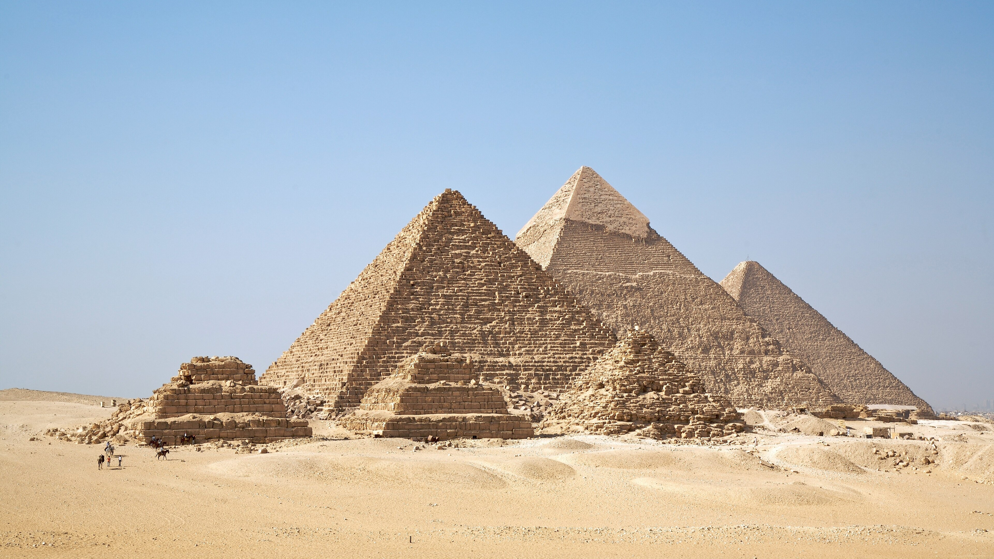
Photo: Ricardo Liberato, CC BY-SA 2.0, via Wikimedia Commons
Table of Contents
Country Overview
Population and Demographics
Government
Economy
Disease Prevalence
Egypt Health System
Public Healthcare System
Private Healthcare System
Healthcare Financing
Workforce
Education
Healthcare Outlook
Competitive Landscape
Recent Developments
CSI Assessment

Country Overview

Population and Demographics
Capital | Cairo¹ | Official language | Arabic¹
Population | About 108.6 million (start of 2026, national count)² | Area | About 1,001,450 sq km³
GDP (PPP), total | About $2.39 trillion (2025)⁴ | GDP (PPP), per capita | About $20,200 (2025)⁵
Government type | Republic with a directly elected president and a bicameral parliament¹ | Head of state | President Abdel Fattah el-Sisi⁶
Head of government | Prime Minister Mostafa Madbouly⁷ | Currency | Egyptian pound (EGP)⁸
Urban population | 42.9% (2025)⁹ | Total fertility rate | 2.41 births per woman (2024, national figure)¹⁰
Infant mortality rate | 20.8 per 1,000 live births (2024)¹¹

Egypt is the most populous Arab country. Its national count reached about 108.6 million at the start of 2026, up from 94.8 million in 2017, and CAPMAS projects it will become the world's 11th most populous country by 2050.² Growth is slowing. The health ministry's total fertility rate fell to 2.41 in 2024 from 2.54 in 2023, and annual births dropped below two million for the first time in nearly two decades.¹⁰ The World Bank's estimate, which draws on UN population modeling, is higher, at about 118 million for 2025.¹² Only about 43 percent of people live in urban areas, and most of the population lives along the Nile valley and delta on a small share of the country's roughly one million square kilometers.^{3,9}
For a foreign academic medical center, the demographic picture points to a very large domestic patient base that is still young but beginning to age, with growing demand for chronic disease care, cardiology, oncology and maternal and child services. The public Healthcare Authority's medical tourism program is still small, earning about $8 million in 2025, so the larger opportunity lies in training, quality systems and specialty programs for a population of this size.¹³

Government
Egypt is a republic with a strong, directly elected presidency under the 2014 Constitution, as amended in 2019. The amendments lengthened presidential terms from four to six years and added an upper chamber, the Senate, alongside the House of Representatives.^{1,14} President Abdel Fattah el-Sisi was sworn in for a third six-year term in April 2024, which runs to 2030.⁶ Prime Minister Mostafa Madbouly leads the cabinet, and a reshuffle in February 2026 kept Khaled Abdel Ghaffar as Minister of Health and Population, no longer also deputy prime minister for human development.^{7,15} The prime minister personally reviews major health reforms, including amendments to the Universal Health Insurance Law that are meant to secure the system's finances before it expands to more governorates.¹⁶ Health policy is therefore set centrally, and decisions on hospitals, insurance and private partnerships generally pass through the cabinet.

Economy
Egypt is one of the largest Arab economies, with GDP of about $2.39 trillion on a purchasing power parity basis in 2025.⁴ The economy is recovering from a severe currency and inflation shock. Consumer price inflation was 14.1 percent in 2025 after 28.3 percent in 2024.¹⁷ On 30 July 2026 the IMF Executive Board completed the seventh review of Egypt's Extended Fund Facility and the second review of its Resilience and Sustainability Facility, unlocking about $1.77 billion and pressing for faster structural reforms and a smaller state footprint.^{18,19} The Fund expects growth of about 4.6 percent in FY2025/26 and 4.4 percent in FY2026/27, and it expects inflation to rise to about 16.7 percent in the second half of 2026, delaying its return to the central bank's target range by about a year.^{18,19} The FY2026/27 budget targets growth of 5.4 percent and raises health spending by 30 percent.²⁰ The government is also courting private capital, and private investment reached 47 percent of total investment in FY2024/25, its highest share in five years, according to the finance ministry.²¹

Disease Prevalence
NCD share of all deaths | About 80%, as stated by the Deputy Health Minister (2025)²² | Cardiovascular share of all deaths | About 44% (2025)²²
Hepatitis C | WHO gold tier on the path to elimination (October 2023)²³

Noncommunicable diseases now dominate Egypt's disease burden. In September 2025 Deputy Health Minister Amr Kandil said they account for about 80 percent of deaths, with cardiovascular disease alone responsible for 44 percent.²² World Bank data put the NCD share of deaths at about 86 percent in 2019, before COVID-19 deaths temporarily lowered the share in 2020 and 2021, so the two sources agree that chronic disease is the central challenge.²⁴ Egypt's past infectious disease burden has shifted sharply. In October 2023 WHO named Egypt the first country to reach the gold tier on the path to eliminating hepatitis C, after it diagnosed 87 percent of people living with the infection and treated 93 percent of those diagnosed.²³ The health authority is now emphasizing cardiac prevention, and it plans seven new cardiac excellence centers under the second phase of universal health insurance, four of them in Minya.²² WHO's national STEPwise survey program tracks risk factors such as raised blood pressure, raised glucose and obesity.²⁵

Egypt Health System

Public Healthcare System
Egypt's public health system is run by several bodies. The Ministry of Health and Population oversees primary care and general hospitals, university hospitals sit under the higher education ministry, and the General Authority for Healthcare operates facilities in governorates that have moved to the new insurance model.^{26,27} University hospitals grew from 88 in 2013 to 147 in 2026, with their annual budget rising from EGP 10 billion to EGP 28 billion.²⁷
The flagship reform is Universal Health Insurance, which separates the purchaser (the Universal Health Insurance Authority) from the providers and contracts with both public and private facilities. Phase one has been completed in six governorates: Port Said, Ismailia, Suez, South Sinai, Luxor and Aswan.¹⁶ Phase two covers Minya, Matrouh, Damietta, Kafr El-Sheikh and North Sinai.²⁸ Minya, with more than six million residents, is the first phase-two governorate and is starting with a one-year trial, supported by projects expected to add about 1,506 hospital beds.^{26,29} Private providers make up 35 percent of contracted providers, and the government is amending the law to put the authority's finances on a sustainable footing.¹⁶

Private Healthcare System
Egypt's private sector is large, fragmented and still concentrated in Greater Cairo and Alexandria. Out-of-pocket payments covered 57 percent of current health spending in 2023, which sustains demand for private clinics and hospitals among those who can pay.³⁰ Cleopatra Hospitals Group, listed on the Egyptian Exchange, reports the largest patient base of any private provider and had about 1,000 operating beds at the end of 2025 across a network that grew to 17 facilities.³¹ It officially opened Cleopatra El Tagamoa in East Cairo on 27 January 2026, after a phased outpatient launch in late December 2025, and plans to expand it to 240 beds during 2026.³² Saudi German Hospital Cairo, part of the Saudi-owned Saudi German Health group, became in 2019 the first provider in Egypt and Africa to join the Mayo Clinic Care Network, and the group expanded its Mayo relationship in October 2025.^{33,34,35} In 2019 the group said it planned to invest EGP 40 to 50 billion in Egypt over 15 years.³⁶ Dar Al Fouad is another leading private hospital in Cairo.³⁷ Private groups are also contracting with the insurance authority, which positions them as long-term partners in the national reform.¹⁶

Healthcare Financing
Current health expenditure, share of GDP | 4.9% (2023)³⁸ | Current health expenditure per capita | $141 (2023)³⁹
Out-of-pocket share of current health expenditure | 57.2% (2023)³⁰ | Government health expenditure, share of GDP | 1.6% (2023)⁴⁰

Egypt spent about 4.9 percent of GDP on health in 2023, or roughly $141 per person, and the figure has stayed between about 4.2 and 5.4 percent since 2010.^{38,39} Households carry most of the cost. Out-of-pocket payments were 57 percent of current health spending in 2023, and domestic government spending was only 1.6 percent of GDP.^{30,40} The 2014 Constitution commits the state to government health spending of at least 3 percent of national output, rising gradually to global rates, so measured public spending remains well short of the constitutional floor.^{1,40} The FY2026/27 budget raises the health allocation by 30 percent, including EGP 47.5 billion for state-funded treatment, health insurance and medicines and EGP 90.5 billion for the Unified Procurement Authority.²⁰ The currency devaluations of 2022 and 2023 cut the dollar value of per capita spending, which is why the 2023 figure is below the 2021 figure of about $177.³⁹

Workforce
Physicians per 1,000 | 0.67 (2020)⁴¹ | Nurses and midwives per 1,000 | 1.79 (2018)⁴²
Hospital beds per 1,000 | 1.06 (2021)⁴³ | Physicians per 1,000, OECD average | 3.43 (2022)⁴¹

Egypt has about 0.67 physicians and 1.79 nurses and midwives per 1,000 people, and 1.06 hospital beds per 1,000.^{41,42,43} The physician ratio is about a fifth of the OECD average of 3.43 and well below Saudi Arabia, Jordan and Turkey.⁴¹ Bed density has fallen from 1.4 per 1,000 in 2011 to 1.06 in 2021 as the population grew faster than capacity.⁴³ Emigration worsens the shortage. The Egyptian Medical Syndicate reports that only 38 percent of doctors licensed in Egypt work in the country, with the rest abroad or on extended leave, and nearly 7,000 doctors left to work abroad in 2023 alone.⁴⁴ This is why the syndicate's register of licensed doctors is far larger than the number the World Bank counts as practicing.^{41,44}

Education
Under a reform approved in 2017, medical education in Egypt is a five-year undergraduate program after secondary school, entered through a competitive score cutoff, followed by a two-year internship, replacing the older system of six years of study and one internship year; postgraduate training follows.⁴⁵ Public universities have long supplied most doctors, and the health ministry puts annual medical graduates at about 9,000.⁴⁴ New private universities are adding capacity. Badya University in New October City, for example, runs schools of medicine, dentistry and physical therapy with technical assistance from the University of Texas Medical Branch.⁴⁶ The government has also launched a plan for a Cairo medical city with 4,000 beds and capacity for more than 4,000 students.²¹ Debate continues over whether private colleges have enough teaching hospitals to train students well.⁴⁷ From 2025, the mandatory government assignment (takleef) of new medical graduates is no longer automatic, and the health ministry now places graduates according to staffing needs.⁴⁸

Healthcare Outlook
Egypt's health policy is organized around Universal Health Insurance, which the government plans to extend to about 13 million people in the second phase, with investment of more than EGP 115 billion.^{28,49} The second phase depends on financing, and the law is being amended so the insurance authority can stay solvent as coverage widens.¹⁶ The state is also trying to bring in private capital through partnerships, including the planned Cairo medical city, for which it is seeking a foreign operator.²¹ A medical tourism brand, In Egypt We Care, was launched in January 2026 to market the Healthcare Authority's facilities to patients abroad.⁵⁰ Budget support is rising, with a 30 percent increase for health in FY2026/27.²⁰ The main constraints are the shortage and emigration of doctors, high out-of-pocket spending and fiscal pressure from IMF-supported adjustment. For foreign partners, the most realistic openings are in clinical training, quality accreditation, specialty centers such as cardiac excellence centers, and management support for new insurance-era hospitals.

Competitive Landscape
Foreign health systems active in Egypt are mostly European, with two American institutions. Mayo Clinic counts Saudi German Hospital Cairo in its Care Network, and the University of Texas Medical Branch supports Badya University's health schools.^{35,51} France's Gustave Roussy licensed its brand to a Cairo cancer center, Italy's Gruppo San Donato agreed to manage the New Heliopolis Hospital, and British, Spanish and Emirati institutions run training and specialty programs.^{52,53,54,55,56}
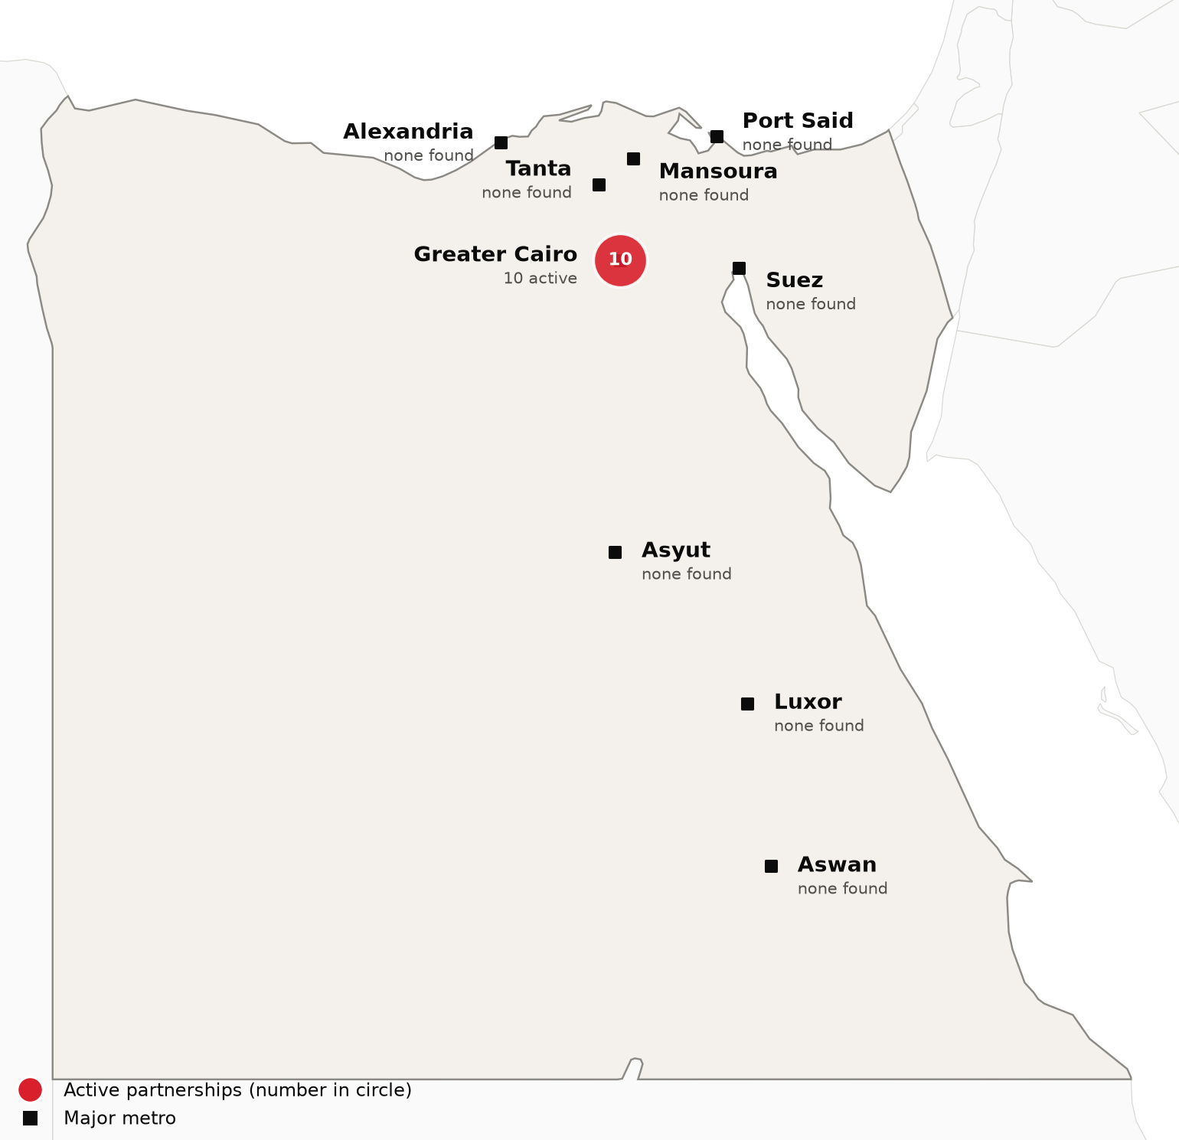
Active foreign health-system partnerships by city of the partner in Egypt. Source: CSI partnerships tracker, verified 2026-10-05. Boundaries: Natural Earth; not an official depiction.
Confirmed active partnerships by institution
Institution | Based in | Nature of collaboration | Latest evidence
US academic medical centers
Mayo Clinic | United States | Clinical affiliation | 2025-10³⁵
University of Texas Medical Branch (UTMB Health) | United States | Training and education | 2026-08⁴⁶
Other foreign health systems
AP-HP Beaujon Hospital (with Université Paris Cité) | France | Research collaboration | 2025-04⁵⁷
Alder Hey Children's Hospital (Alder Hey Global) | United Kingdom | Training and education | 2026-07⁵⁸
Barraquer Ophthalmology Centre | Spain | Clinical affiliation | 2026-02⁵⁵
Burjeel Holdings (Burjeel Medical City, Burjeel Cancer Institute) | United Arab Emirates | Clinical affiliation | 2025-01⁵⁶
Freiburg University Cancer Center | Germany | Clinical affiliation | 2024-12⁵⁹
Gruppo San Donato (with GKSD Group) | Italy | Ownership or management | 2026-09⁶⁰
Gustave Roussy (Gustave Roussy International) | France | Clinical affiliation | 2025-05⁵²
University of Oxford | United Kingdom | Research collaboration | 2024-12⁵⁹
Only partnerships with dated evidence of activity in the last 24 months are listed. Unclear and recently ended partnerships are in the CSI partnerships tracker.
Egypt is only beginning to compete for international patients. The General Authority for Healthcare reported treating about 35,000 patients from 124 countries in 2025, with revenue of about $8 million, up from about $3.7 million in 2024.¹³ Its In Egypt We Care platforms, launched in January 2026, market treatment at the authority's own facilities and handle the patient journey from first inquiry to follow-up care.⁵⁰ At this scale Egypt is better seen as a source of patients for complex care than as a rival to Cedars-Sinai.

Recent Developments

2026-01-20 Government announces a Cairo medical city with 4,000 beds
The government announced a medical city with 4,000 beds, 18 specialized institutes and capacity for more than 4,000 medical students, to be built as a public-private partnership.²¹ Egypt is seeking a foreign partner to operate it.²¹
2026-01-09 Healthcare Authority launches In Egypt We Care medical tourism platforms
The General Authority for Healthcare launched digital platforms for a new medical tourism initiative on 9 January 2026.⁵⁰ The platforms cover the patient journey from inquiry through treatment and follow-up care.⁵⁰
2026-03-28 Healthcare Authority reports about $8 million in medical tourism revenue for 2025
The General Authority for Healthcare reported treating about 35,000 patients from 124 countries in 2025, with revenue of about $8 million, up from about $3.7 million in 2024.¹³
2026-06-13 Minya prepares to launch universal health insurance
The health minister said Minya, home to about seven million people, will be the first governorate in the second phase of universal health insurance, operating at first on a one-year trial basis.²⁹
2026-07-30 IMF completes seventh Egypt review and unlocks about $1.77 billion
The IMF Executive Board completed the seventh Extended Fund Facility review and second Resilience and Sustainability Facility review, releasing about $1.77 billion.^{18,19} It urged faster reforms to support private sector led growth.¹⁸

CSI Assessment

Everything below comes from Cedars-Sinai's internal data (patient referral records, finance, relationship history) and human judgment, not from the research agents. Fields left blank are marked and must be completed by the analyst before this profile is used.
Patient Volume & Revenue (most recent FY)
[MANUAL INPUT REQUIRED]
Referral Sources
[MANUAL INPUT REQUIRED]
Relationship History
[MANUAL INPUT REQUIRED]
Complications
[MANUAL INPUT REQUIRED]
Key Contacts
[MANUAL INPUT REQUIRED]
Opportunities
[MANUAL INPUT REQUIRED]
CSI Recommendation
[MANUAL INPUT REQUIRED]

