Country Summary: Australia

Photo: Diliff, CC BY-SA 3.0, via Wikimedia Commons
Executive summary of the Australia country profile (2026-10-20). Superscript numbers refer to the numbered sources in Australia_Profile_DRAFT_SOURCES.docx.

At a Glance

27.9 m  Population, 31 March 2026³ | 71,930  GDP per capita, PPP (international dollars), about, 2025⁶ | 10.40%  Current health expenditure, share of GDP, 2023³² | 15.8%  Out-of-pocket share of current health expenditure, 2023³⁴
4.09  Physicians per 1,000 people, 2022³⁷ | 2.5  Public hospital beds per 1,000 people, 2023-24²⁴ | 9.4%  Deaths from dementia, the leading cause, 2024²⁰ | 45.8%  Private hospital cover, share of population, 30 June 2026²⁸
Country background
Australia, with about 27.9 million people at 31 March 2026, is a constitutional monarchy whose capital is Canberra.^{1,3} Anthony Albanese continues as Prime Minister after Labor won 94 House seats in 2025, and Mark Butler is Minister for Health and Ageing.^{8,15,16} The Commonwealth funds Medicare while the states run public hospitals.¹⁸ Life expectancy at birth was 83.1 years in 2024, 87.7 percent of people lived in urban areas in 2025, and people aged 65 and over made up 18.1 percent.^{10,12,13} Dementia became the leading cause of death in 2024.²⁰ The key risk is cost: health takes 16.4 percent of Commonwealth expenses in 2026-27, and the Budget forecasts slower growth.¹⁷
Key takeaways for CSI
- Medicare covers the full cost of public hospital services for citizens and permanent residents.²³
- Health spending was 10.40 percent of GDP in 2023, below Canada, the United Kingdom and the United States.^{32,36}
- Dementia became the leading cause of death in 2024, at 9.4 percent of deaths, overtaking ischemic heart diseases.²⁰
- Governments funded 70 percent of the A$290.7 billion in total health spending in 2024-25.³¹

Health System

- The 2026-27 Budget provides A$220.3 billion over five years for state public hospital services.²⁵
- Bulk billing incentives reached all Australians on 1 November 2025, with 9 in 10 GP visits projected by 2030.^{26,27}
- Public hospitals had 67,280 beds in 2023-24, and governments funded 94 percent of their A$103.1 billion recurrent spending.²⁴
Australia: health spending and out-of-pocket share, 2012 to 2023
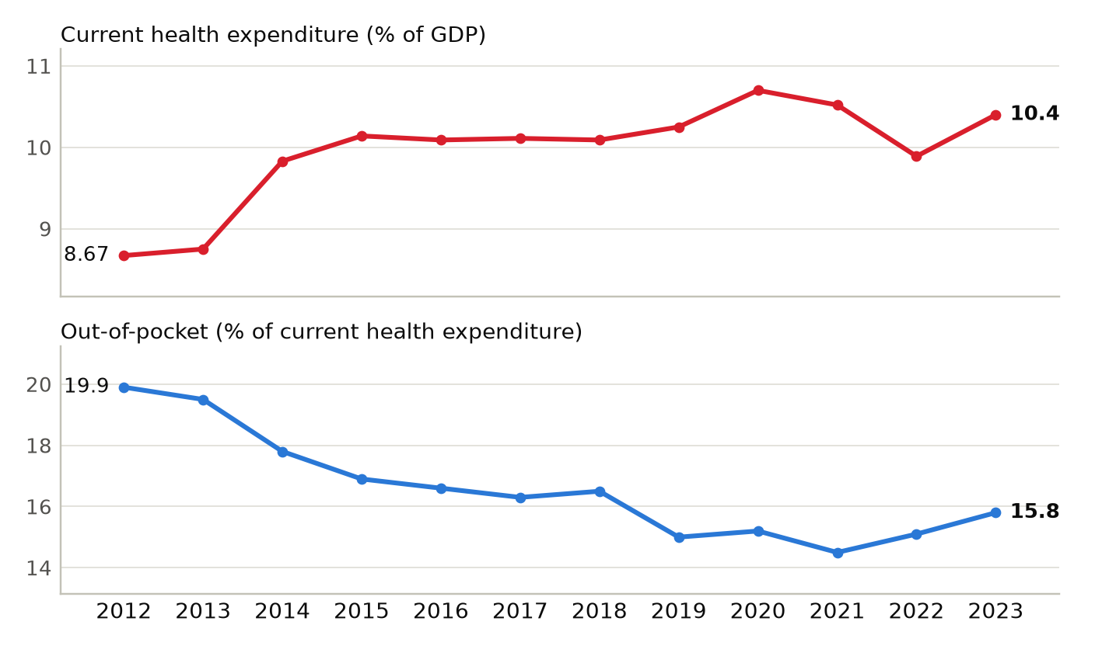
Current health expenditure as a share of GDP, and out-of-pocket spending as a share of current health expenditure. Sources: ^{32,34}
Physicians per 1,000 people, Australia and comparators (latest year available)
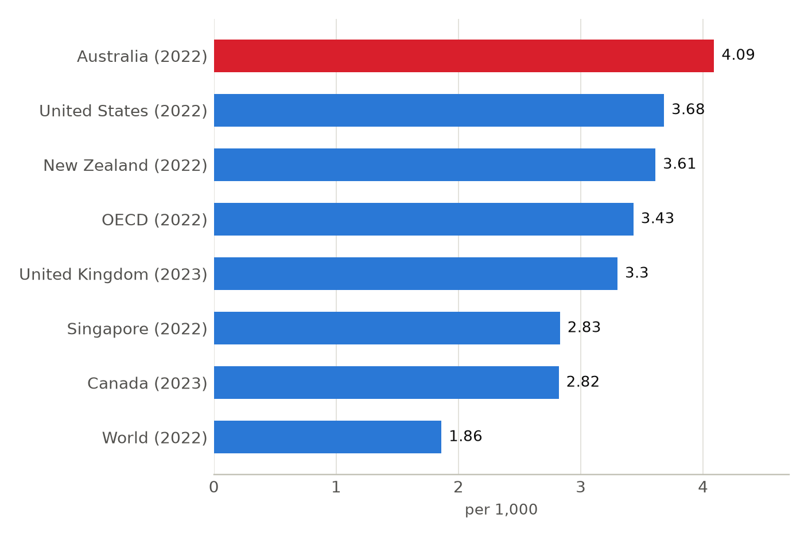
Latest year available for each country in the World Bank series, shown in brackets; comparison years differ (2022 and 2023). Sources: ⁷³

Market and Competition

- Ramsay Health Care, listed on the Australian Securities Exchange since 1997, runs hospitals in Australia, Europe and the United Kingdom.³⁰
- Healthscope, the second-largest operator, entered receivership in May 2025 after Brookfield withdrew support.²⁹
- Peter MacCallum Cancer Centre signed with Dana-Farber in 2022 and The Christie in 2024.^{48,49} The tracker lists 18 active foreign ties.
Australia: hospital beds per 1,000 people, 2008 to 2016
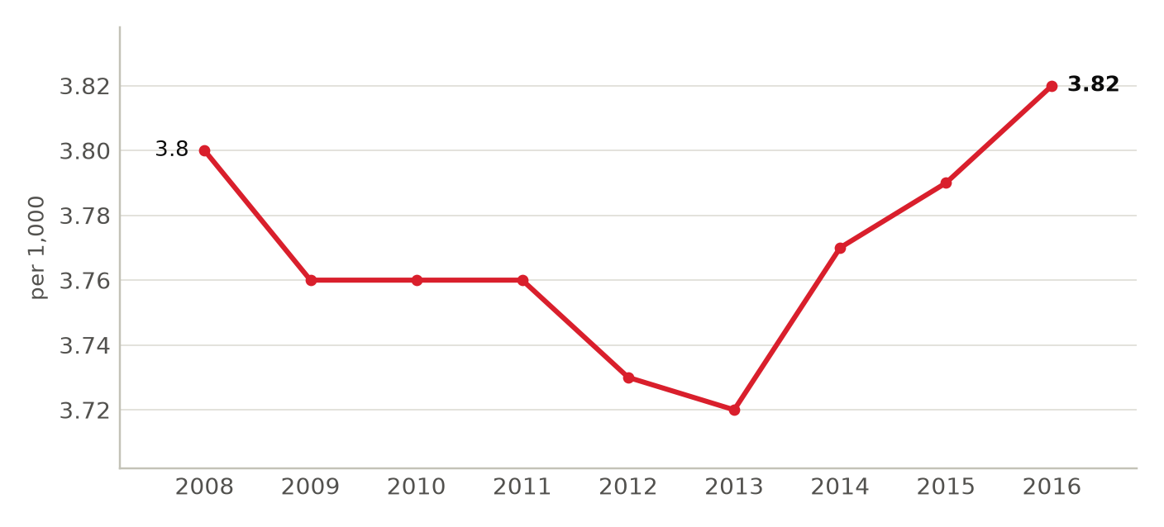
Hospital beds as reported to the World Bank; 2016 is the latest year in the series. Sources: ³⁹
Foreign health systems active in Australia
18 foreign institutions with confirmed active partnerships (18 in all): 13 research collaboration, 5 training and education. Sources in the profile and the partnerships tracker.
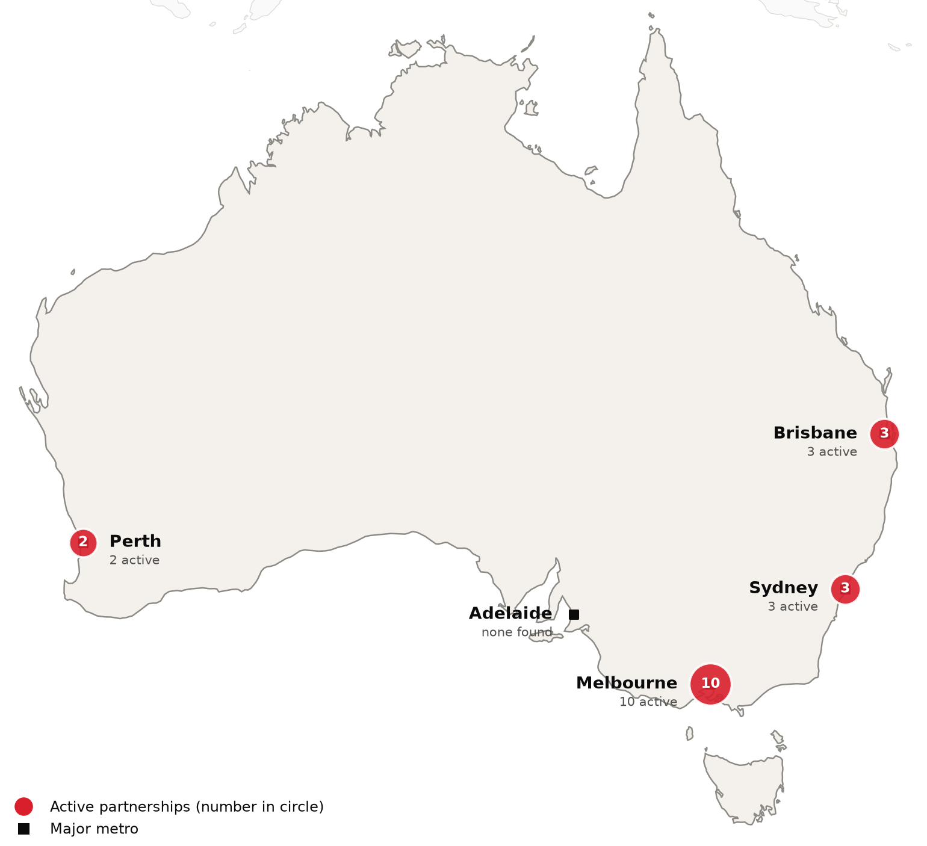
Active foreign health-system partnerships by city of the partner in Australia. Source: CSI partnerships tracker, verified 2026-10-20. Boundaries: Natural Earth; not an official depiction.
Institution | Nature of collaboration
Boston Children's Hospital | Research collaboration
Cleveland Clinic | Training and education
Emory University | Research collaboration
Memorial Sloan Kettering Cancer Center | Research collaboration
Ochsner Health | Training and education
Weill Cornell Medicine | Research collaboration
Apollo Hospitals | Research collaboration
Great Ormond Street Hospital and UCL Great Ormond Street Institute of Child Health | Research collaboration
Ho Chi Minh City Eye Hospital | Training and education
Hokkaido University (Faculty of Health Sciences) | Training and education
Manipal Academy of Higher Education (MAHE) | Research collaboration
Max Healthcare | Research collaboration
Sichuan Provincial People's Hospital | Research collaboration
The Chinese Medicine Hospital of Hong Kong | Research collaboration
The Christie NHS Foundation Trust | Training and education
The Hospital for Sick Children (SickKids) | Research collaboration
University of Galway (BioInnovate Ireland) | Research collaboration
West China Hospital, Sichuan University | Research collaboration

CSI Position, Risks and Recent News

CSI partnerships in Australia
[MANUAL INPUT REQUIRED]
To be completed by CSI from internal data; not researched.
Opportunities for CSI
[MANUAL INPUT REQUIRED]
To be completed by CSI from internal data; not researched.
Risks and watch items
- The Budget forecasts growth slowing to 1.75 percent in 2026-27 because the Middle East conflict raised global oil prices.¹⁷
- Four in five specialists registered in the pathway's first six months work in major cities, Medical Republic reported.⁴¹
- Dementia deaths rose 39 percent over a decade, and 49.9 percent of people had a chronic condition in 2022.^{20,22}
Recent developments
2026-01-30 National Cabinet agreed a new public hospital funding deal with A$25 billion in additional Commonwealth public hospital funding.⁸
2026-05-12 The Budget removes the age-based uplift of the private health insurance rebate from 1 April 2027.²⁵
2026-09-14 Healthscope's 25 hospitals will be divided among four operators, with Calvary Health Care taking 14.²⁹

