Country Profile: India
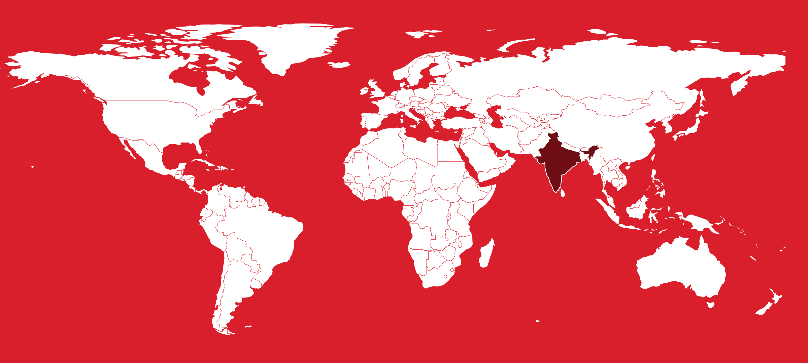
Table of Contents
Country Overview
Population and Demographics
Government
Economy
Disease Prevalence
India Health System
Public Healthcare System
Private Healthcare System
Healthcare Financing
Workforce
Education
Healthcare Outlook
Competitive Landscape
Recent Developments
CSI Assessment

Country Overview

Population and Demographics
Capital | New Delhi¹ | Official languages | Hindi and English^{1,2}
Population | About 1.46 billion (2025 estimate)^{3,4} | Area | 3,287,263 sq km¹
GDP (PPP), total | About US$17.2 trillion in current international dollars (2025, World Bank); about US$15.6 trillion in 2024^{5,6} | GDP (PPP), per capita | About US$11,748 in current international dollars (2025, World Bank); about US$10,719 in 2024^{6,7}
Government type | Federal parliamentary democratic republic^{1,2} | Head of state | President Droupadi Murmu (sworn in on 25 July 2022)⁸
Head of government | Prime Minister Narendra Modi (in office since 2014; sworn in for a third term on 9 June 2024)⁹ | Currency | Indian rupee (INR)¹⁰
Urban population | 35.7% of total (2025, World Bank); 35.4% in 2024^{6,11} | Total fertility rate | 1.9 births per woman (2024, Sample Registration System Statistical Report 2024, released May 2026)^{12,13,14}
Infant mortality rate | 24 per 1,000 live births (2024, Sample Registration System), down from 30 in 2019¹³ | Population aged 60 and over | 10.5% (2022), projected to reach 20.8% by 2050 (UNFPA India Ageing Report 2023)^{15,16}

India's population was about 1.46 billion in 2025, and the UN projects a peak of about 1.7 billion in the early 2060s.^{3,17} The Sample Registration System puts the total fertility rate at 1.9 in 2024, below replacement in every state except six in the north: Bihar, Uttar Pradesh, Madhya Pradesh, Rajasthan, Chhattisgarh and Jharkhand.^{12,13,14} State rates ranged in 2024 from 2.9 in Bihar to 1.2 in Delhi.^{12,14}
India therefore has two demographic profiles. UNFPA expects the 60-plus share to pass 20 percent by 2036 in southern states such as Kerala and Tamil Nadu, and nationally to rise from 10.5 percent in 2022 to 20.8 percent by 2050.^{15,16} The northern states remain younger, with heavy maternal and child health needs, although national infant mortality fell to 24 per 1,000 live births in 2024 from 30 in 2019.¹³
The Census of 2027, the first since 2011, began house-listing in April 2026 and will enumerate the population in February 2027.¹⁸ For a foreign academic medical center, the aging south and west and the National Capital Region are the most natural markets for high-acuity collaboration, while the younger northern states suit public-health and capacity-building work.

Government
India is a parliamentary democratic republic with a federal structure.^{1,2} The President is head of state, and executive power rests with the Prime Minister and the Council of Ministers, who are collectively responsible to the Lok Sabha.^{1,2}
Health care delivery is a state responsibility: 'public health and sanitation; hospitals and dispensaries' is Entry 6 of the State List in the Seventh Schedule.² Medical education sits on the Concurrent List, where Union law prevails in a conflict.² The Union shapes the system through money and regulation; the Fifteenth Finance Commission, for example, earmarked about Rs 70,051 crore in health grants through local governments for FY2021-22 to FY2025-26.¹⁹ States decide whether to join Union schemes: Odisha and Delhi adopted PM-JAY in 2025, and West Bengal's entry in June 2026 completed nationwide rollout.^{20,21,22} Several states also finance their own health insurance schemes.²³ For a foreign partner, the counterparty is often a state government; Cleveland Clinic's June 2026 MediCity MoU, for example, was signed with the Government of Maharashtra.²⁴

Economy
The IMF's July 2026 World Economic Outlook Update describes India as among the fastest-growing major economies, with growth projected at 6.4 percent in FY2026-27.²⁵ Official provisional estimates put real GDP growth at 7.7 percent in FY2025-26, up from 7.1 percent a year earlier, and at 7.8 percent in April to June 2026.^{26,27} The World Bank puts 2025 GDP at about US$17.2 trillion in purchasing-power terms, or about US$11,748 per person.^{5,7} India is therefore a very large market in which a relatively small affluent and insured segment drives demand for premium care.
US trade policy is a major risk. The US raised tariffs on most Indian goods to 50 percent from 27 August 2025 over Russian oil purchases.²⁸ After the US Supreme Court struck down the IEEPA tariffs on 20 February 2026, most Indian goods have faced a 10 percent Section 301 duty since 24 July 2026.^{29,30} Generic pharmaceuticals remain under a Section 232 investigation, and a law signed on 18 September 2026 lets the President impose tariffs of up to 100 percent on the largest buyers of Russian energy, with India among the most exposed.^{31,32,33} The United States took about US$9.5 billion of India's record US$31.1 billion in pharmaceutical exports in FY2025-26.³⁴
The Union Budget 2026-27 gave the Health Ministry Rs 1,06,530 crore, nearly 10 percent above the previous year's revised estimate, and backed five regional medical hubs built with states and private investors.^{35,36}

Disease Prevalence
NCD share of all deaths | 66% (2019, WHO)³⁷ | Probability of dying aged 30 to 70 from the four main NCDs | 23.6% (2021, WHO Global Health Observatory); 23.7% in 2019³⁸
Circulatory diseases, share of medically certified deaths | 38.8% (2024, Medical Certification of Cause of Death report; certified deaths were 23.1% of all registered deaths)³⁹ | Diabetes and prediabetes | About 101 million people with diabetes (11.4%) and 136 million with prediabetes (15.3%) (ICMR-INDIAB, fieldwork 2008 to 2020, published 2023)⁴⁰
Hypertension, adults 15 and over | 24.0% of men and 21.3% of women (NFHS-5, 2019 to 2021)⁴¹ | Anaemia, women aged 15 to 49 | 57% (NFHS-5, 2019 to 2021)⁴²
New cancer cases | About 1.53 million estimated (2024, ICMR National Cancer Registry Programme)⁴³ | Tuberculosis | About 25% of global TB cases; incidence 187 per 100,000 (2024, WHO Global TB Report 2025)^{44,45}
Deaths attributable to air pollution | About 2.1 million (2021, State of Global Air 2024)^{46,47}

Non-communicable diseases now dominate India's disease burden.⁴⁸ The NCD share of deaths rose from 37.9 percent in 1990 to 61.8 percent in 2016 and was 66 percent in 2019, according to WHO.^{37,49} A 30-year-old Indian had a 23.6 percent chance in 2021 of dying before 70 from one of the four main NCDs.³⁸ Circulatory disease caused 38.8 percent of medically certified deaths in 2024, but only 23.1 percent of registered deaths were certified.³⁹
ICMR-INDIAB, published in 2023, estimated 101 million people with diabetes and 136 million with prediabetes.⁴⁰ Air pollution, high blood pressure, diet, high fasting plasma glucose and tobacco are leading risk factors, and air pollution was linked to about 2.1 million deaths in 2021.^{46,47,50,51} ICMR expects cancer cases, about 1.53 million in 2024, to keep rising, led by oral and lung cancer in men and breast and cervical cancer in women.^{43,52}
India had about a quarter of the world's TB cases in 2024 despite a 21 percent fall in incidence since 2015, and 57 percent of women aged 15 to 49 were anaemic in 2019-21.^{42,44,45} For a foreign academic partner, demand is clearest in cardiology, oncology, metabolic and transplant medicine, and pulmonary research.

India Health System

Public Healthcare System
India's public system is tiered. Sub-health centers and primary health centers, many upgraded into Ayushman Arogya Mandirs, feed community health centers, district hospitals, state medical college hospitals and national institutes such as AIIMS, PGIMER Chandigarh and Tata Memorial Centre.^{53,54,55} The Health Ministry reported 1,81,873 operational Ayushman Arogya Mandirs by 30 November 2025, offering 12 service packages including NCD screening and teleconsultation.⁵³
The 2026-27 Union budget gives the National Health Mission Rs 39,390 crore and the PM-Ayushman Bharat Health Infrastructure Mission Rs 4,770 crore.³⁵ PM-JAY, a tax-funded scheme, pays for up to Rs 5 lakh of hospital care per family per year across 1,961 procedures at more than 38,000 empaneled public and private hospitals, and since September 2024 it has covered everyone aged 70 and over.^{56,57}
Capacity is the main weakness. Public facilities from primary health centers to medical colleges had 8,18,661 beds on 31 March 2023, fewer than 0.6 per 1,000 people against the National Health Policy 2017 norm of 2, and supply is far thinner in Bihar and Uttar Pradesh.^{55,58} Public care is much cheaper: average out-of-pocket spending per hospitalization, excluding childbirth, was Rs 6,631 in public hospitals in 2025, against Rs 50,508 in private hospitals.^{59,60} For a foreign academic center, public apex institutions suit research, training and protocol work, while PM-JAY tariffs set the price floor that private partners compete against.

Private Healthcare System
Private hospitals handled 57.9 percent of rural and 64.6 percent of urban hospitalizations in 2025, according to the NSS 80th round, counting those empaneled under government schemes.⁶¹
The corporate chains are consolidating. Manipal Hospitals reported 49 hospitals and 13,037 licensed beds at 31 March 2026, up from 33 hospitals and 9,520 beds two years earlier, and listed in August 2026.^{62,63} Apollo Hospitals reported 10,970 beds in 78 hospitals in India and overseas at March 2026, including managed hospitals and day-surgery and cradle units.^{64,65} Aster DM Quality Care, formed by the July 2026 merger of Aster DM Healthcare with Blackstone-backed Quality Care India, has 39 hospitals and more than 10,600 beds.^{66,67} Max Healthcare had 4,966 operational beds at 31 March 2026 and aims to nearly double bed capacity in five years, and Medanta had about 3,665 installed beds after adding 623 in FY2025-26.^{68,69,70} IHH Healthcare held about 31.17 percent of Fortis in November 2025.⁷¹
EY-Parthenon found revenue and EBITDA growth above 15 percent at leading operators in FY2025-26, occupancy mostly between 60 and 75 percent, and large bed pipelines.^{72,73} KKR agreed in August 2026 to buy Medicover India.⁷⁴ For a foreign academic medical center, these chains are the most likely commercial counterparties for affiliations, second-opinion services and clinical program development.

Healthcare Financing
Total health expenditure, share of GDP | 3.37% on the new 2022-23 base GDP series; 3.28% on the old 2011-12 series (2022-23, National Health Accounts)²³ | Total health expenditure per capita | Rs 6,373 (2022-23, National Health Accounts)^{23,75}
Government health expenditure, share of GDP | 1.48% on the new 2022-23 base GDP series; 1.43% on the old series (2022-23)^{23,76,77} | Government share of total health expenditure | 43.7% (2022-23), up from 28.6% in 2013-14⁷⁶
Out-of-pocket share of total health expenditure | 43.4% (2022-23), up from 39.4% in 2021-22 and down from 64.2% in 2013-14^{75,76} | Government health expenditure per capita | Rs 2,786 (2022-23)⁷⁶
Union Ministry of Health budget | Rs 1,06,530.42 crore (Budget Estimate 2026-27)³⁵ | PM-JAY Union allocation | Rs 9,500 crore (Budget Estimate 2026-27)³⁵
Average out-of-pocket cost per hospitalisation, excluding childbirth | Rs 34,064 overall; Rs 6,631 in public hospitals; Rs 50,508 in private hospitals (2025, NSS 80th round)^{59,60} | Policy target | Government health spending of 2.5% of GDP by 2025 (National Health Policy 2017; also recommended by the Fifteenth Finance Commission)⁷⁸

The National Health Accounts for 2022-23 put total health expenditure at 3.37 percent of GDP, or Rs 6,373 per person, and government spending at 1.48 percent, both on the new GDP series; on the old 2011-12 series the ratios are 3.28 and 1.43 percent.^{23,75,76,77} Government spending is well short of the 2.5 percent target for 2025 set by the National Health Policy 2017.⁷⁸
From 2013-14 to 2022-23 the government share of total health spending rose from 28.6 to 43.7 percent, and the out-of-pocket share fell from 64.2 to 43.4 percent.⁷⁶ The out-of-pocket share had been 39.4 percent in COVID-affected 2021-22, and households paid more again once emergency spending ended.^{75,76,79} Health insurance coverage reached 47.4 percent in rural and 44.3 percent in urban areas in 2025, up from 14.1 and 19.1 percent in 2017-18, yet out-of-pocket spending still averaged Rs 34,064 per hospitalization, excluding childbirth.^{59,60} For a foreign partner, this means a two-tier market: a mass market anchored by PM-JAY rates and a smaller cash-paying, privately insured and international segment that sustains premium tertiary care.

Workforce
Registered allopathic doctors | 13,88,185, about 1.39 million (December 2025, Health Ministry reply to the Rajya Sabha)^{80,81} | Registered AYUSH practitioners | 7,51,768, about 7.52 lakh (December 2025)^{80,82}
Official doctor-population ratio | 1:811 (December 2025; counts allopathic and AYUSH practitioners and assumes 80% of registrants are active)^{80,81} | Registered allopathic doctors per 1,000 people | Roughly 0.95 (2025, calculated from 13.88 lakh registered doctors and the UN 2025 population estimate; the active figure is lower)^{3,80}
Registered nursing personnel | 46.02 lakh, or 2.60 per 1,000 people (31 December 2025); only 14.24 lakh enrolled in the national Nurses Registration and Tracking System (2026)^{83,84} | Public hospital beds | 8,18,661 beds from primary health centers to medical colleges, fewer than 0.6 per 1,000 people (31 March 2023, Health Dynamics of India 2022-23), against a National Health Policy 2017 norm of 2 per 1,000⁵⁵
WHO workforce threshold | 44.5 doctors, nurses and midwives per 10,000 people (4.45 per 1,000), set in the 2016 Global Strategy on Human Resources for Health⁸⁵ | OECD comparators | Roughly 4 practicing doctors, 9.2 nurses and just over 4 hospital beds per 1,000 people (OECD averages, Health at a Glance 2025)^{86,87,88}

India's health workforce remains thin: it had 13.88 lakh registered allopathic doctors in December 2025, fewer than one per 1,000 people, and fewer still practice.^{80,81} The official ratio of one doctor per 811 people counts 7.5 lakh AYUSH practitioners and assumes 80 percent of registrants are active.^{80,81} India had 46.02 lakh registered nursing personnel at 31 December 2025, or 2.60 per 1,000, but only 14.24 lakh were enrolled in the Nurses Registration and Tracking System in 2026, so the number working in India is uncertain.^{83,84}
India is below WHO's threshold of 4.45 doctors, nurses and midwives per 1,000 and far below OECD averages of roughly 4 doctors and 9 nurses per 1,000 reported in 2025.^{83,85,86,87} Shortages are worst in the northern states, and rural community health centers lacked 79.9 percent of their required specialists in March 2023.^{83,89} The Union Budget 2026-27 plans to add 1 lakh allied health professionals over five years and train 1.5 lakh caregivers.^{35,36,90} For a foreign academic partner, workforce development, from nursing programs and fellowships to allied-health and leadership training, is one of the clearest openings.

Education
The National Medical Commission, which replaced the Medical Council of India in September 2020, regulates medical education nationally.⁹¹ Admission to undergraduate medical courses runs through one exam, NEET-UG, conducted by the National Testing Agency.⁹² The agency cancelled the 3 May 2026 sitting on 12 May over alleged irregularities, including a reported question-paper leak, and the government referred the case to the Central Bureau of Investigation.^{93,94} Close to 20 lakh candidates sat the re-examination on 21 June 2026, and 11.21 lakh qualified.^{92,95}
NMC's seat matrix for 2026-27 lists 1,40,664 MBBS seats in 839 colleges, 64,121 of them in government colleges, against 51,348 seats in 2014.^{80,96}
Postgraduate training is the bottleneck. The government reported 82,059 postgraduate seats in December 2025, up from 31,185 in 2014, while NMC counted about 57,500 MD and MS seats for 2025-26.^{80,97} The National Board of Examinations in Medical Sciences, an autonomous body under the Health Ministry, adds DNB and DrNB training in accredited institutions.⁹⁸ In October 2025 the NMC chair indicated that the National Exit Test would not be implemented immediately, and a doctors' federation said mock tests would run for the next three to four years.⁹⁹ Mayo Clinic's advisory role for Adani Health City's two planned medical colleges and the education pillar of Cleveland Clinic's Navi Mumbai MediCity show US institutions using graduate medical education as a way into India.^{24,100}

Healthcare Outlook
India's health policy has a clear direction: primary care through Ayushman Arogya Mandirs, hospital financing through a now-national PM-JAY, and a digital layer. By 10 July 2026 the Ayushman Bharat Digital Mission had created about 93.95 crore ABHA health IDs and linked more than 105 crore health records.^{101,102} This consent-based layer could support remote second opinions, tele-tumour boards and cross-border coordination.
Private hospitals are expanding with public-market capital, as in Manipal's 2026 IPO, and global private equity, as with Blackstone in Aster DM Quality Care and KKR's pending purchase of Medicover India.^{63,66,74} Maharashtra's Navi Mumbai MediCity, anchored by Cleveland Clinic under a June 2026 MoU, and Adani's two Health Cities, advised by Mayo Clinic, are the leading examples of integrated health cities.^{100,103}
Medical value travel is the main uncertainty. Medical arrivals were 6.44 lakh in 2024, below 6.97 lakh in 2019, and Bangladesh, which supplied about 4.8 lakh of them, was hit by visa restrictions after August 2024.^{104,105,106} Other risks include government health spending of only 1.48 percent of GDP in 2022-23, workforce shortfalls, the 2026 NEET cancellation, and possible US tariffs of up to 100 percent on buyers of Russian oil, authorized in September 2026.^{23,33,93} The outlook therefore favors foreign academic centers that bring training, protocols, quality systems and research to Indian partners rather than operating hospitals directly.

Competitive Landscape
CSI's partnerships tracker identified 45 partnerships between foreign health systems and Indian institutions that are active or were active within the past five years: 36 active, 7 unclear and 2 ended. 34 involve US academic medical centers. Most are research and training collaborations, with a few clinical affiliations and almost no ownership stakes, and they cluster in Delhi, Mumbai, Chennai and Pune.
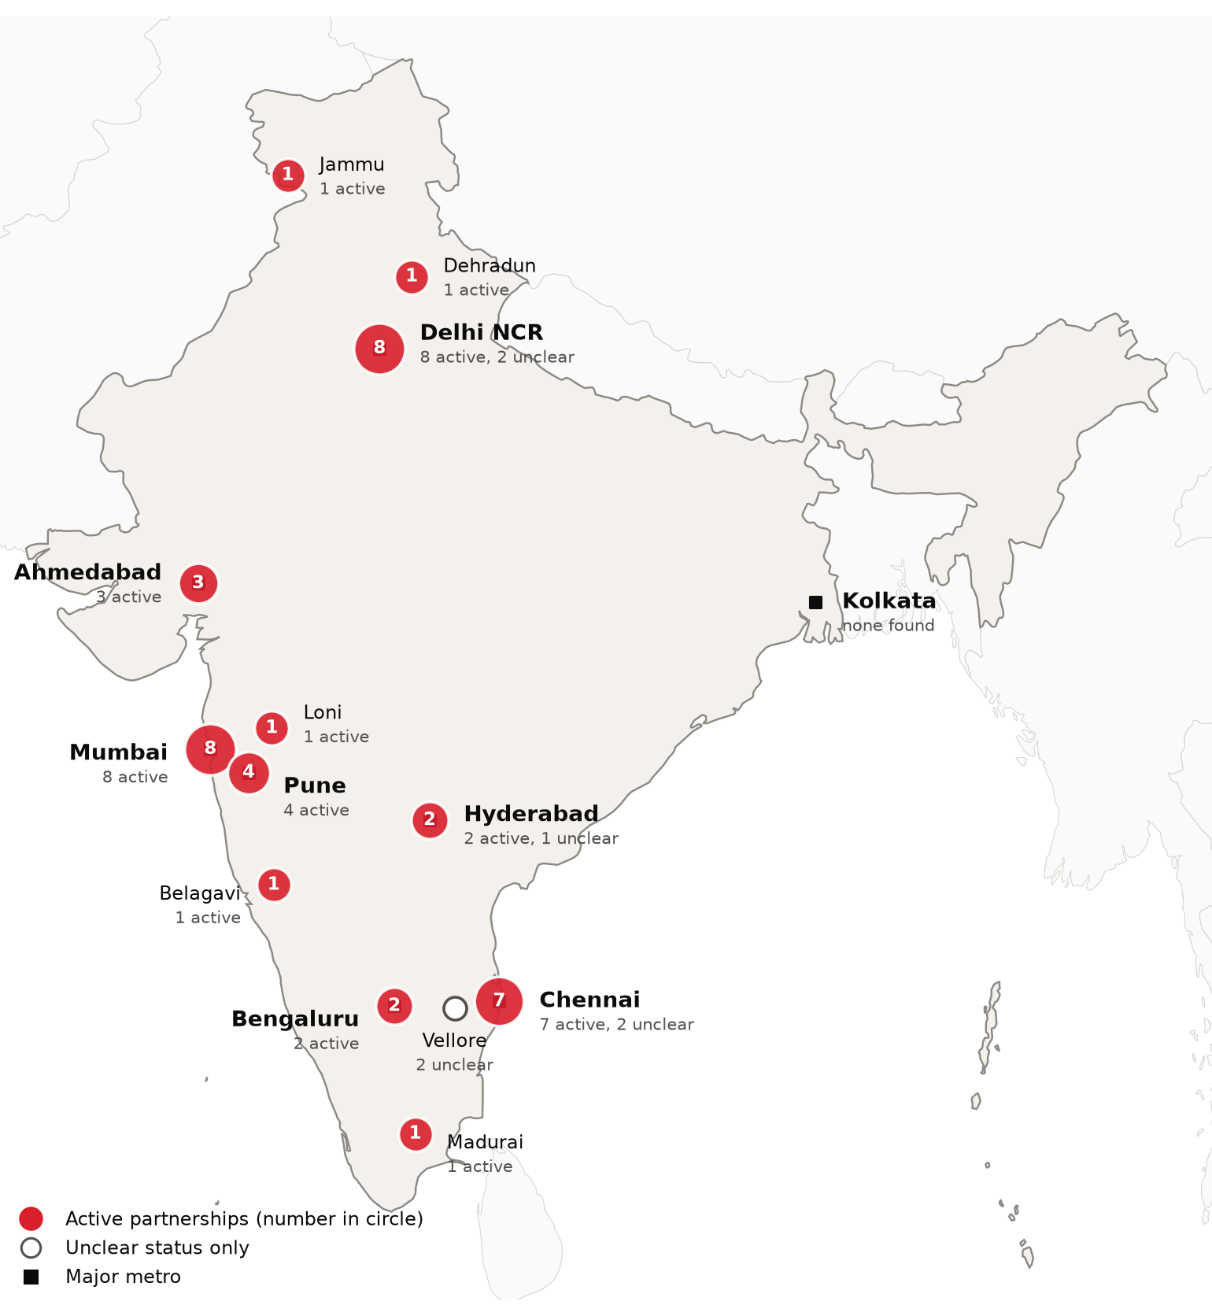
Foreign health-system partnerships by city of the partner in India: active, and unclear where no active partnership exists. Source: CSI partnerships tracker, verified 2026-09-30. Boundaries: Natural Earth; not an official depiction.
Who is doing what
Institution | Partner in India | Type | Status | Latest evidence
US academic medical centers
Children's Hospital of Philadelphia (CHOP) | Amrita Hospital, Faridabad | Training and education | Active | 2024-10¹⁰⁷
Cleveland Clinic | Government of Maharashtra and Arodhan Health City (Navi Mumbai International MediCity); Brookfield Asset Management is a co-signatory investor | Hospital development or joint venture | Active | 2026-06²⁴
Emory University (Emory Global Diabetes Research Center) | IIT Madras Shankar Center of Excellence in Diabetes Research, with AIIMS, Madras Diabetes Research Foundation and others | Research collaboration | Active | 2025-05¹⁰⁸
Hackensack Meridian Health | Apollo Hospitals | Clinical affiliation or network membership | Active | 2025-01¹⁰⁹
Johns Hopkins (University) | Ajit Isaac Foundation, Bengaluru | Training and education | Active | 2026-04¹¹⁰
Johns Hopkins (University) | Dr. D.Y. Patil Medical College and Vidyapeeth, Pune | Research collaboration | Active | 2026-03¹¹¹
Johns Hopkins (University) | IIT Bombay, Koita Centre for Digital Health | Research collaboration | Active | 2025-12¹¹²
Johns Hopkins University (School of Medicine) | Byramjee Jeejeebhoy Government Medical College and Sassoon General Hospitals, Pune (BJGMC-JHU Clinical Research Site) | Research collaboration | Active | 2026-09¹¹³
MD Anderson Cancer Center | Tata Memorial Centre, Mumbai | Research collaboration | Active | 2024-12¹¹⁴
Mayo Clinic | AIIMS New Delhi (Departments of Pathology and Nephrology) | Training and education | Active | 2024-12¹¹⁵
Mayo Clinic | Adani Group (Adani Health City, Ahmedabad and Mumbai; planned Kolkata campus) | Consulting or management | Active | 2026-07¹¹⁶
Mayo Clinic | Lilavati Hospital, GIFT City, Gujarat | Consulting or management | Active | 2026-04¹¹⁷
Mayo Clinic | Lilavati Hospital, Mumbai | Training and education | Active | 2025-09¹¹⁸
Mount Sinai Health System | Ramaiah Memorial Hospital, Bengaluru | Clinical affiliation or network membership | Active | 2026-09¹¹⁹
Rutgers Robert Wood Johnson Medical School (Rutgers Health) | Govind Ballabh Pant Institute of Postgraduate Medical Education and Research (GIPMER), New Delhi | Research collaboration | Active | 2025-09¹²⁰
Stanford Health Care | National Cancer Grid (NCG) India, including Tata Memorial network centres | Training and education | Active | 2025-04¹²¹
Stanford Medicine (Emergency Medicine International, Center for Innovation in Global Health) | Emergency Management and Research Institute (EMRI), India | Research collaboration | Active | 2025-06¹²²
Thomas Jefferson University / Jefferson Health (Jefferson India Center) | KLE Academy of Higher Education and Research (J N Medical College, Belagavi); LV Prasad Eye Institute, Hyderabad (listed by Jefferson, no recent dated activity) | Research collaboration | Active | 2026-04¹²³
UCLA Health | All India Institute of Medical Sciences, New Delhi | Research collaboration | Active | 2025-06¹²⁴
UCLA Health | Federation of Obstetric and Gynaecological Societies of India (FOGSI) and SAFOG | Training and education | Active | 2025-12¹²⁵
UCLA Health | Narendra Modi Medical College, Ahmedabad | Training and education | Active | 2025-06¹²⁴
University of Alabama at Birmingham (Heersink School of Medicine) | Pravara Institute of Medical Sciences (Loni) and Bharati Vidyapeeth Medical College (Pune) | Training and education | Active | 2025-07¹²⁶
University of California San Francisco (Francis I. Proctor Foundation) | Aravind Eye Care System, Madurai | Research collaboration | Active | 2026-08¹²⁷
University of Iowa (Carver College of Medicine, Ophthalmology) | Dr. Shroff's Charity Eye Hospital, New Delhi | Training and education | Active | 2025-02¹²⁸
University of Michigan Medical School / Michigan Medicine | AIIMS Jammu | Training and education | Active | 2025-11¹²⁹
University of Wisconsin-Madison Department of Ophthalmology and Visual Sciences (UW Health) | Dr. Shroff's Charity Eye Hospital, New Delhi | Training and education | Active | 2025-02¹³⁰
Weill Cornell Medicine (Center for Global Health) | Byramjee Jeejeebhoy Government Medical College and Sassoon Hospital, Pune; Deep Griha Society | Research collaboration | Active | 2026-09¹¹³
Cleveland Clinic | Apollo Hospitals Group | Telemedicine or second opinion | Unclear | 2022-01¹³¹
Johns Hopkins (University) | College of Nursing, Christian Medical College Vellore | Training and education | Unclear | 2024-10¹³²
Mayo Clinic | AIG Hospitals, Hyderabad | Clinical affiliation or network membership | Unclear | 2025-02¹³³
Memorial Sloan Kettering | iCliniq, Chennai (MSKCC India) | Telemedicine or second opinion | Unclear | 2021-08¹³⁴
Northwell Health (Center for Global Health) | Christian Medical College (CMC) Vellore | Clinical affiliation or network membership | Unclear | 2023-03¹³⁵
Johns Hopkins (Medicine International) | HCL Healthcare | Consulting or management | Ended 2024 | 2014-02¹³⁶
MD Anderson Cancer Center | Tata Memorial Hospital, Mumbai (Project ECHO Palliative Care Africa II) | Training and education | Ended 2025 | 2025-01¹³⁷
Other foreign health systems
Cambridge University Hospitals NHS Foundation Trust (with Cambridge Global Health Partnerships) | Himalayan Hospital (Dehradun) and Ganga Prem Hospice, Rishikesh, via Rama Foundation | Training and education | Active | 2025-08¹³⁸
Juntendo University (Tokyo) | Saint Hardyal Educational and Orphans' Welfare Society (SHEOWS), Delhi | Research collaboration | Active | 2026-08¹³⁹
King's College London and Guy's and St Thomas' NHS Foundation Trust | P. D. Hinduja Hospital and Medical Research Centre, Mumbai (National Health & Education Society) | Training and education | Active | 2026-05¹⁴⁰
Monash University (Faculty of Information Technology) | Apollo Hospitals and The Apollo University | Research collaboration | Active | 2024-11¹⁴¹
SingHealth | Athulya Senior Care, Chennai | Training and education | Active | 2026-04¹⁴²
University College London | AIIMS New Delhi and IIT Delhi | Research collaboration | Active | 2025-11¹⁴³
University of Leicester and University Hospitals of Leicester NHS Trust | Apollo Hospitals and The Apollo University | Research collaboration | Active | 2026-07¹⁴⁴
University of Leicester, University Hospitals of Leicester NHS Trust and BAPIO Training Academy | Apollo Health Resources (Apollo Hospitals) | Training and education | Active | 2026-07¹⁴⁴
University of Liverpool | Saveetha Institute of Medical and Technical Sciences (SIMATS), Chennai | Research collaboration | Active | 2025-07¹⁴⁵
LMU Klinikum (University Hospital Munich) | AIIMS New Delhi | Research collaboration | Unclear | 2023-09¹⁴⁶
University of Bolton Institute of Medicine (now University of Greater Manchester Medical School) | AIIMS New Delhi | Research collaboration | Unclear | 2024-05¹⁴⁷

India also competes for international patients. Medical-purpose arrivals were 6.44 lakh in 2024, led by Bangladesh with about 4.8 lakh, followed by Iraq, Somalia, Oman and Uzbekistan.^{104,105} Indian chains market lower-cost complex care to the same Gulf, African and Central Asian patients that US centers pursue, and the Union Budget 2026-27 backs five regional medical hubs to strengthen that position.^{36,104,105}

Recent Developments

2026-02-01 Union Budget 2026-27 raises health allocation nearly 10% and backs five regional medical hubs
The Health Ministry received Rs 1,06,530.42 crore, nearly 10 percent above the previous year's revised estimate, including Rs 39,390 crore for the National Health Mission and Rs 9,500 crore for PM-JAY.³⁵ The budget also backed five regional medical hubs and plans to add 1 lakh allied health professionals and train 1.5 lakh caregivers.^{35,36}
2026-05-12 NEET-UG 2026 cancelled over alleged paper leak; re-examination held on 21 June
The National Testing Agency cancelled the 3 May 2026 NEET-UG examination on 12 May over alleged irregularities, including a reported paper leak, and the government referred the case to the CBI.^{93,94} Close to 20 lakh candidates sat the re-examination on 21 June, and 11.21 lakh qualified when results were declared on 16 July 2026.^{92,95}
2026-06-08 West Bengal joins Ayushman Bharat PM-JAY, completing nationwide rollout
West Bengal signed an MoU with the National Health Authority on 8 June 2026 and became the 36th and last state or union territory to implement PM-JAY.^{22,148} About 1.24 crore eligible families in the state gain up to Rs 5 lakh a year in hospital cover.²²
2026-06-10 Maharashtra signs MoU with Cleveland Clinic, Brookfield and Arodhan Health City for Navi Mumbai International MediCity
Maharashtra signed an MoU at Cleveland Clinic's headquarters with Cleveland Clinic, Brookfield Asset Management and Arodhan Health City for a 250-acre healthcare, research, education and medical tourism hub near the new Navi Mumbai airport, with expected investment of about US$1.2 billion.^{24,103,149,150} Cleveland Clinic is named anchor institution, and the project is at MoU stage.^{24,103}
2026-08-05 Manipal Health Enterprises lists after Rs 9,275 crore IPO
Manipal Health Enterprises, with 49 hospitals and 13,037 licensed beds at 31 March 2026, listed on the NSE and BSE at about an 11 percent premium to its Rs 590 issue price.^{62,63,151} The Rs 9,275 crore IPO was subscribed nearly five times, led by qualified institutional buyers.⁶³
2026-08-06 KKR agrees to acquire Medicover India as Sweden's Medicover exits Indian hospitals
KKR agreed to acquire Medicover India, 24 hospitals with about 4,800 beds in South and West India.⁷⁴ Medicover valued the business at EUR 1.2 billion and expects the deal to close in the fourth quarter of 2026, subject to approvals, as it leaves Indian hospitals to focus on Poland, Germany and Romania.^{152,153}
2026-09-23 Ayushman Bharat PM-JAY marks eight years with 13.25 crore funded hospital admissions
On the scheme's eighth anniversary, the Health Minister and the National Health Authority reported 13.25 crore funded hospital admissions worth Rs 2.03 lakh crore through more than 38,000 empaneled hospitals.^{56,57} About 48.5 crore Ayushman cards have been issued, and more than 12 crore families have Rs 5 lakh in annual cover.^{56,57,154}

CSI Assessment

Everything below comes from Cedars-Sinai's internal data (patient referral records, finance, relationship history) and human judgment, not from the research agents. Fields left blank are marked and must be completed by the analyst before this profile is used.
Patient Volume & Revenue (most recent FY)
[MANUAL INPUT REQUIRED]
Referral Sources
[MANUAL INPUT REQUIRED]
Relationship History
[MANUAL INPUT REQUIRED]
Complications
[MANUAL INPUT REQUIRED]
Key Contacts
[MANUAL INPUT REQUIRED]
Opportunities
[MANUAL INPUT REQUIRED]
CSI Recommendation
[MANUAL INPUT REQUIRED]

