Country Summary: Egypt
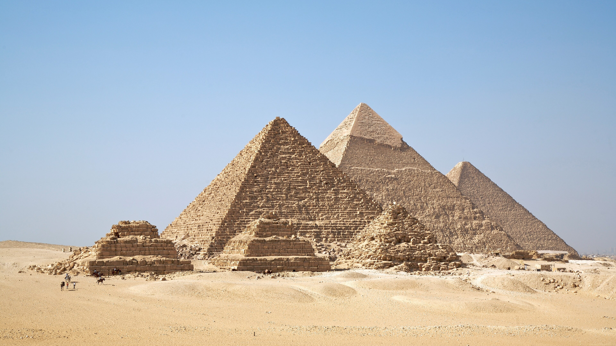
Photo: Ricardo Liberato, CC BY-SA 2.0, via Wikimedia Commons
Executive summary of the Egypt country profile (2026-10-05). Superscript numbers refer to the numbered sources in Egypt_Profile_DRAFT_SOURCES.docx.

At a Glance

108.6 m  Population, start of 2026 (national count)² | $20,200  GDP per capita (PPP), about, 2025⁵ | 4.9%  Health spending, share of GDP, 2023³⁸ | 57.2%  Out-of-pocket share of spending, 2023³⁰
0.67  Physicians per 1,000, 2020⁴¹ | 1.06  Hospital beds per 1,000, 2021⁴³ | 80%  NCD share of all deaths, about, 2025²² | $8 m  International patient revenue, Egypt Healthcare Authority, 2025¹³
Country background
Egypt, with about 108.6 million people at the start of 2026, is a republic with a directly elected president and a bicameral parliament, and its capital is Cairo.^{1,2} President Abdel Fattah el-Sisi was sworn in for a third six-year term in April 2024, and Prime Minister Mostafa Madbouly leads the cabinet.^{6,7} Egypt is one of the largest Arab economies, with GDP of about $2.39 trillion on a purchasing power parity basis in 2025.⁴ Consumer price inflation was 14.1 percent in 2025 after 28.3 percent in 2024.¹⁷ The total fertility rate fell to 2.41 in 2024, and only about 43 percent of people live in urban areas.^{9,10} Deputy Health Minister Amr Kandil said in September 2025 that noncommunicable diseases account for about 80 percent of deaths.²² The key risk is inflation: the IMF expects it to rise to about 16.7 percent in the second half of 2026, delaying its return to the central bank's target range by about a year.^{18,19}
Key takeaways for CSI
- Out-of-pocket payments covered 57 percent of current health spending in 2023, sustaining private demand among those who can pay.³⁰
- Second-phase Universal Health Insurance is planned to reach about 13 million people, with investment of more than EGP 115 billion.^{28,49}
- Only 38 percent of doctors licensed in Egypt work in the country, according to the Egyptian Medical Syndicate.⁴⁴
- Egypt is seeking a foreign operator for a planned Cairo medical city with 4,000 beds.²¹

Health System

- University hospitals grew from 88 in 2013 to 147 in 2026.²⁷
- Phase one of Universal Health Insurance is complete in six governorates; Minya starts phase two with a one-year trial.^{16,26,29}
- Government health spending was 1.6 percent of GDP in 2023, below the Constitution's commitment of at least 3 percent.^{1,40}
Egypt: health spending and out-of-pocket share, 2012 to 2023
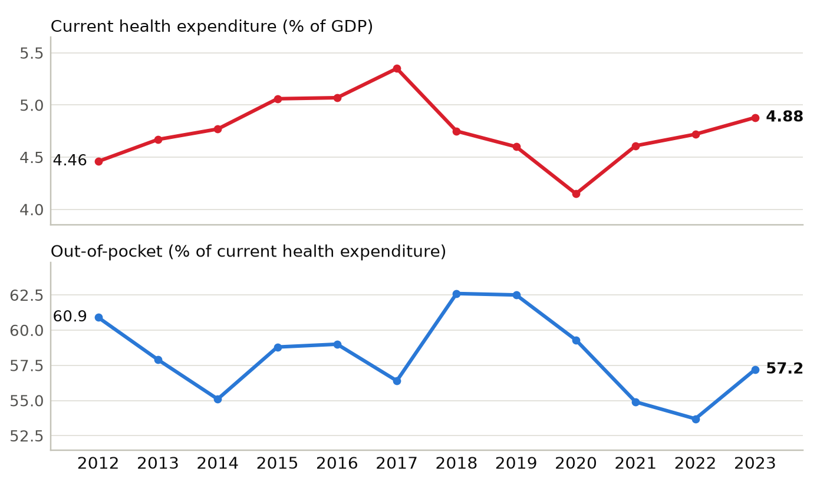
Current health expenditure as a share of GDP, and out-of-pocket spending as a share of current health expenditure. Sources: ^{30,38}
Physicians per 1,000 people, Egypt and comparators (latest year available)
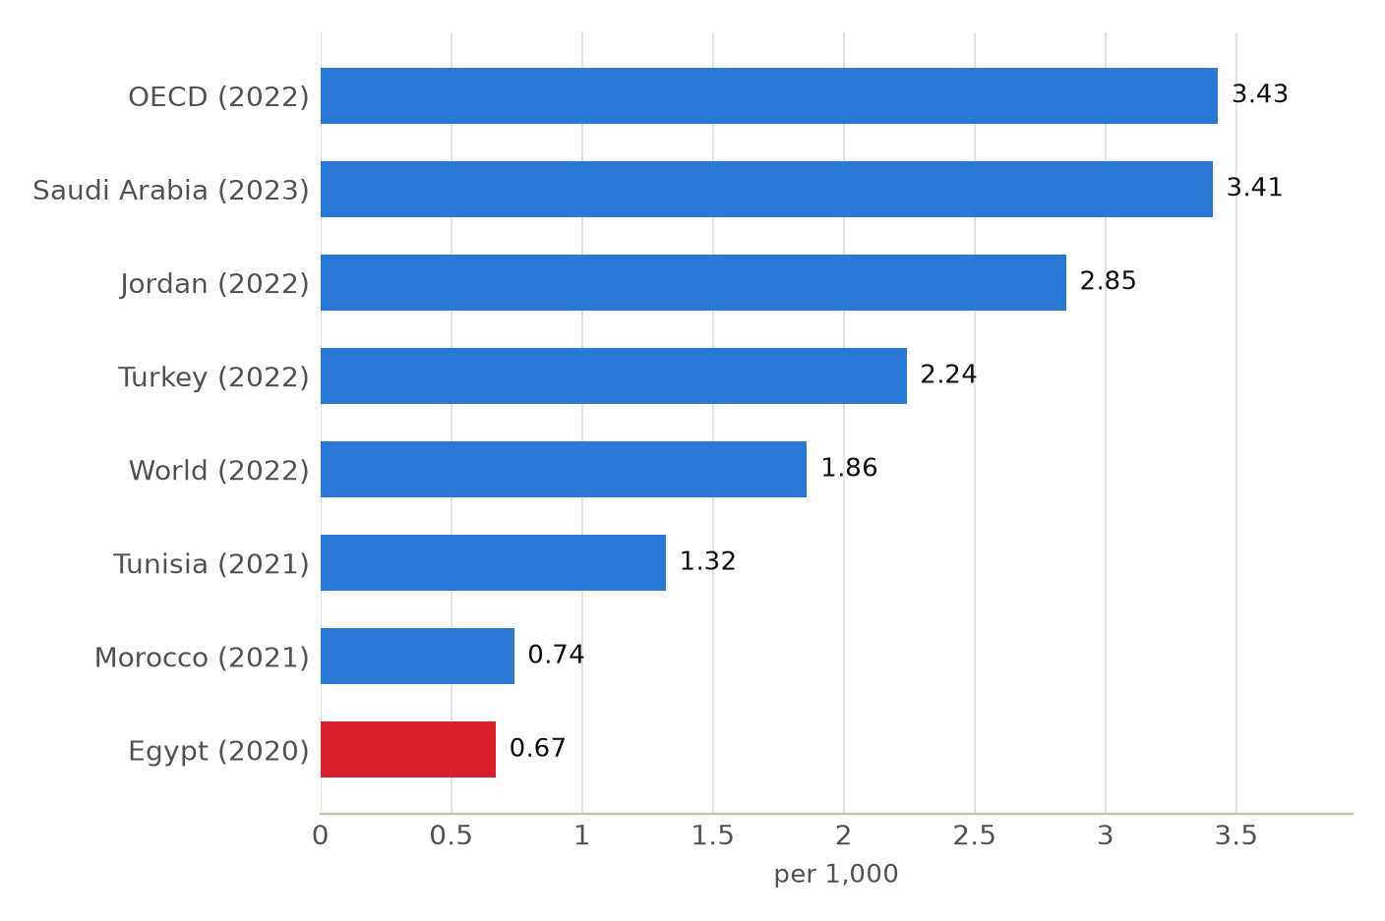
Latest year available for each country in the World Bank series, shown in brackets; comparison years differ (2020 to 2023). Sources: ⁴¹

Market and Competition

- Cleopatra Hospitals Group had about 1,000 operating beds at the end of 2025 across 17 facilities.³¹
- Saudi German Hospital Cairo joined the Mayo Clinic Care Network in 2019; the group expanded the relationship in October 2025.^{33,34,35}
- Private providers make up 35 percent of contracted providers under Universal Health Insurance.¹⁶
Egypt: hospital beds per 1,000 people, 2012 to 2021
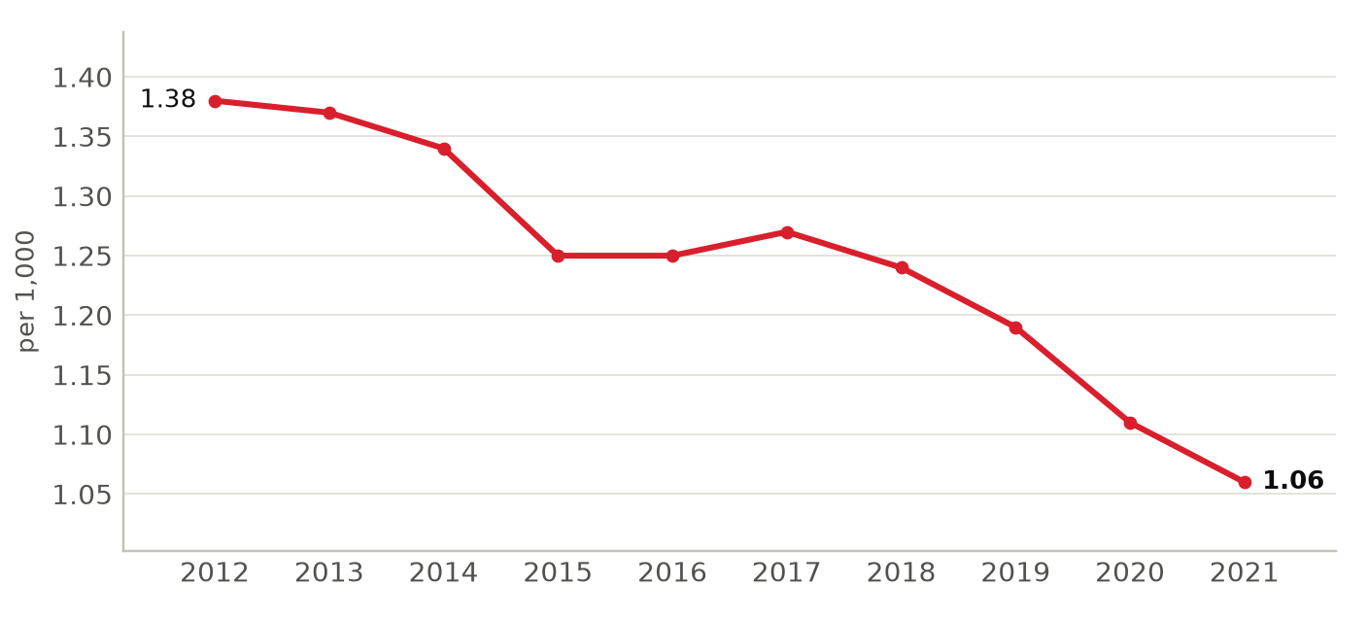
Hospital beds include public and private facilities, as reported to the World Bank. Sources: ⁴³
Foreign health systems active in Egypt
10 foreign institutions with confirmed active partnerships (10 in all): 5 clinical affiliation, 2 training and education, 2 research collaboration, 1 ownership or management. Sources in the profile and the partnerships tracker.
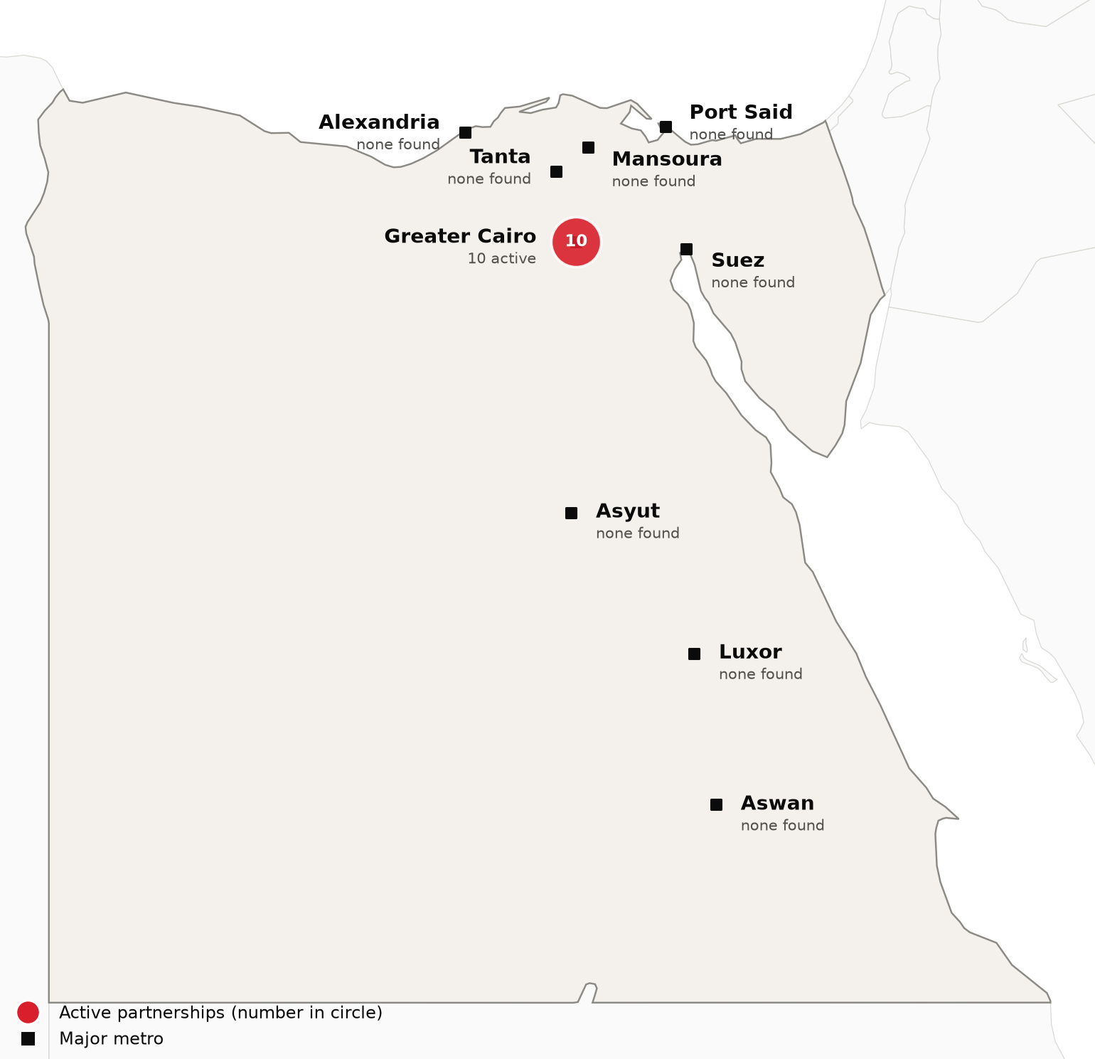
Active foreign health-system partnerships by city of the partner in Egypt. Source: CSI partnerships tracker, verified 2026-10-05. Boundaries: Natural Earth; not an official depiction.
Institution | Nature of collaboration
Mayo Clinic | Clinical affiliation
University of Texas Medical Branch (UTMB Health) | Training and education
AP-HP Beaujon Hospital (with Université Paris Cité) | Research collaboration
Alder Hey Children's Hospital (Alder Hey Global) | Training and education
Barraquer Ophthalmology Centre | Clinical affiliation
Burjeel Holdings (Burjeel Medical City, Burjeel Cancer Institute) | Clinical affiliation
Freiburg University Cancer Center | Clinical affiliation
Gruppo San Donato (with GKSD Group) | Ownership or management
Gustave Roussy (Gustave Roussy International) | Clinical affiliation
University of Oxford | Research collaboration

CSI Position, Risks and Recent News

CSI partnerships in Egypt
[MANUAL INPUT REQUIRED]
To be completed by CSI from internal data; not researched.
Opportunities for CSI
[MANUAL INPUT REQUIRED]
To be completed by CSI from internal data; not researched.
Risks and watch items
- The IMF expects inflation to rise to about 16.7 percent in the second half of 2026.^{18,19}
- Bed density fell from 1.4 per 1,000 in 2011 to 1.06 in 2021 as the population grew faster than capacity.⁴³
- Universal Health Insurance phase two depends on financing, and the law is being amended so the authority stays solvent.¹⁶
Recent developments
2026-03-28 The Healthcare Authority reported treating about 35,000 patients from 124 countries in 2025, with revenue of about $8 million.¹³
2026-06-13 The health minister said Minya, home to about seven million people, will lead phase two on a one-year trial.²⁹
2026-07-30 The IMF Executive Board completed the seventh Extended Fund Facility review, releasing about $1.77 billion.^{18,19}

