Country Summary: Nigeria

Photo: Anass Sedrati, CC BY-SA 4.0, via Wikimedia Commons
Executive summary of the Nigeria country profile (2026-10-21). Superscript numbers refer to the numbered sources in Nigeria_Profile_DRAFT_SOURCES.docx.

At a Glance

237.5 m  Population, 2025 estimate² | 9,530  GDP per capita, PPP (international dollars), about, 2025⁵ | 4.19%  Current health expenditure, share of GDP, 2023⁴⁷ | 71.9%  Out-of-pocket share of current health expenditure, 2023⁴³
0.38  Physicians per 1,000 people, 2023⁵⁹ | 54.6  Life expectancy at birth, years, 2024¹⁰ | 115.6  Under-five deaths per 1,000 live births, 2024³³ | 23 m+  Health insurance enrollment, September 2026³⁹
Country background
Nigeria, a federal presidential republic of 36 states and the Federal Capital Territory, Abuja, had about 237.5 million people in 2025.^{1,2,6} Bola Tinubu has been president since 29 May 2023, and Muhammad Ali Pate is Coordinating Minister of Health and Social Welfare.^{6,15,17,18} The federal government sets regulation, while states and local governments run general hospitals and primary health care centers.¹⁹ Real GDP grew 4.2 percent in the first half of 2026, and inflation eased to 14.63 percent in September 2026.^{6,20} The population is young, with 40.5 percent under 15, and life expectancy at birth was 54.6 years in 2024.^{10,13} The key risk is affordability: an estimated 69.6 percent of Nigerians lived below $4.20 a day in 2025, and households paid most health costs.^{6,43}
Key takeaways for CSI
- Out-of-pocket payments made up 71.9 percent of current health spending in 2023.⁴³
- Practicing doctors fell 16.9 percent to about 55,000 in 2025, largely because of emigration.⁶⁰
- Communicable, maternal, prenatal and nutritional conditions caused 63.7 percent of deaths in 2021, and noncommunicable diseases 27.7 percent.^{26,27}
- Health insurance enrollment passed 23 million in September 2026, roughly 10 percent of the 2025 population.^{2,39}

Health System

- Health spending was 4.19 percent of GDP in 2023, below Kenya, Egypt and South Africa.^{47,52}
- Of 40,368 hospitals and clinics counted in mid-2021, 85.2 percent were primary and only 0.4 percent tertiary.¹⁹
- The United States intends to provide $2.1 billion over five years under a December 2025 health memorandum.⁵⁸
Nigeria: health spending and out-of-pocket share, 2012 to 2023
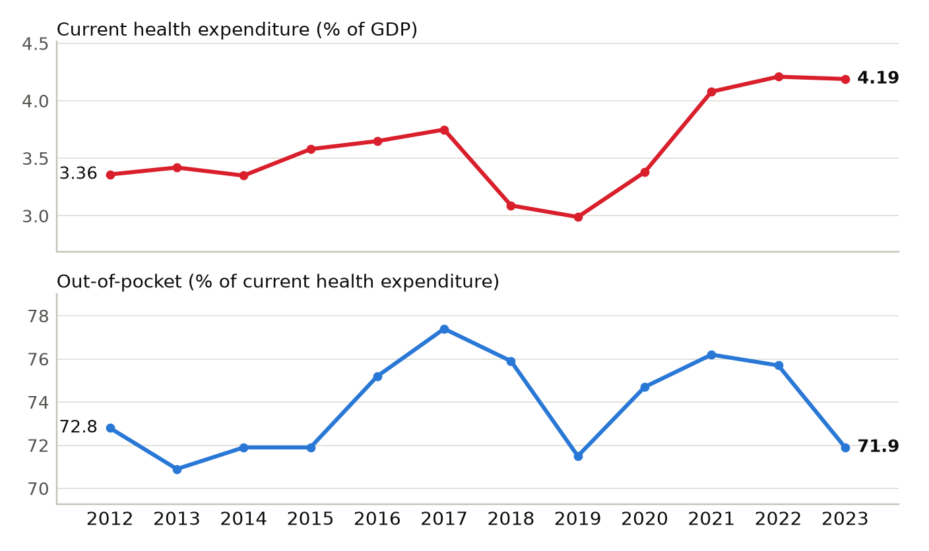
Current health expenditure as a share of GDP, and out-of-pocket spending as a share of current health expenditure. Sources: ^{93,94}
Physicians per 1,000 people, Nigeria and comparators (latest year available)
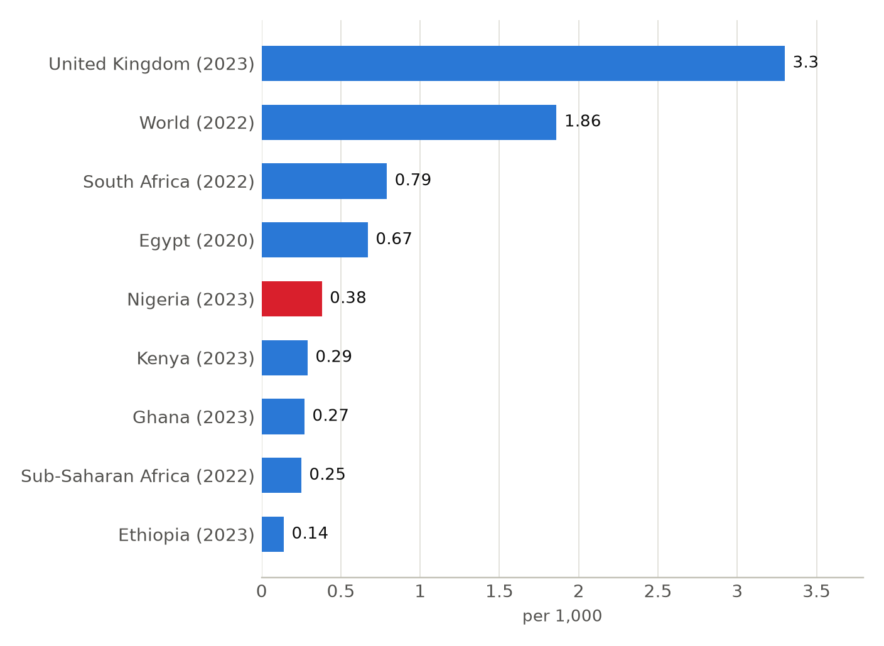
Latest year available for each country or group in the World Bank series, shown in brackets; comparison years differ (2020 to 2023). Sources: ⁶²

Market and Competition

- Evercare built the 165-bed Evercare Hospital Lekki in Lagos, and Padiyath Healthcare is building a 300-bed hospital in Abuja.^{44,45}
- UVA Health supports the kidney transplant program at Federal Medical Centre Umuahia, one of several active U.S. academic ties.⁶⁸
- Central Bank data show $549 million of health travel spending in the first nine months of 2025, up 18 percent.⁸⁸
Nigeria: private health spending per person, 2012 to 2023
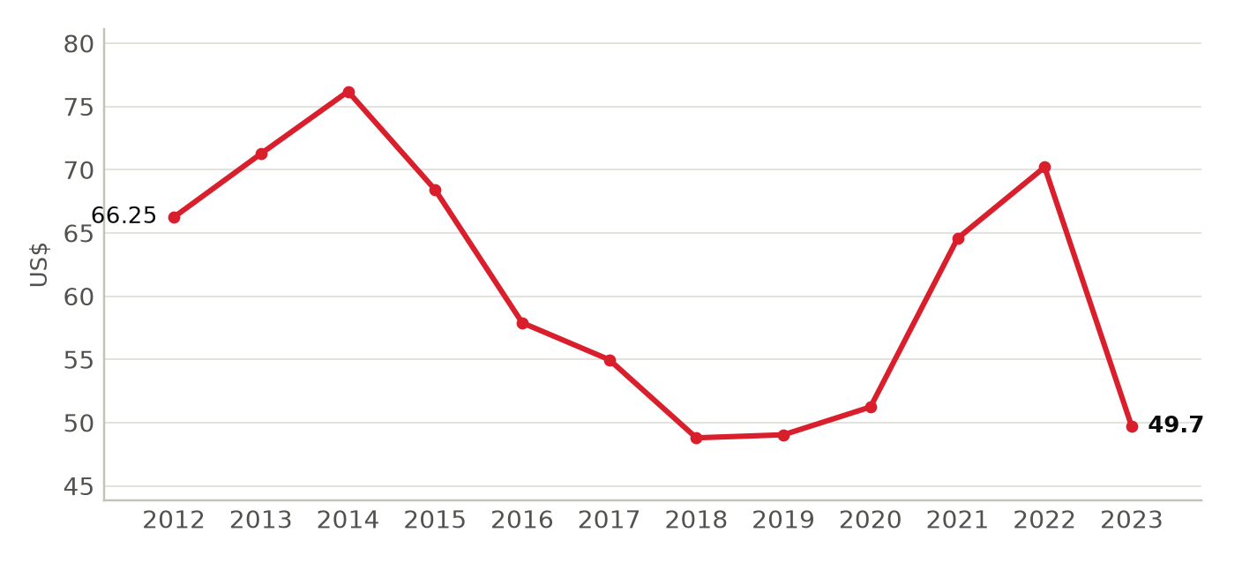
Domestic private health expenditure per capita in current US dollars (mostly household out-of-pocket payments); values move with the naira exchange rate. Sources: ⁹⁵
Foreign health systems active in Nigeria
19 foreign institutions with confirmed active partnerships (21 in all): 7 training and education, 7 research collaboration, 3 advisory and consulting, 3 clinical affiliation, 1 ownership or management. Sources in the profile and the partnerships tracker.
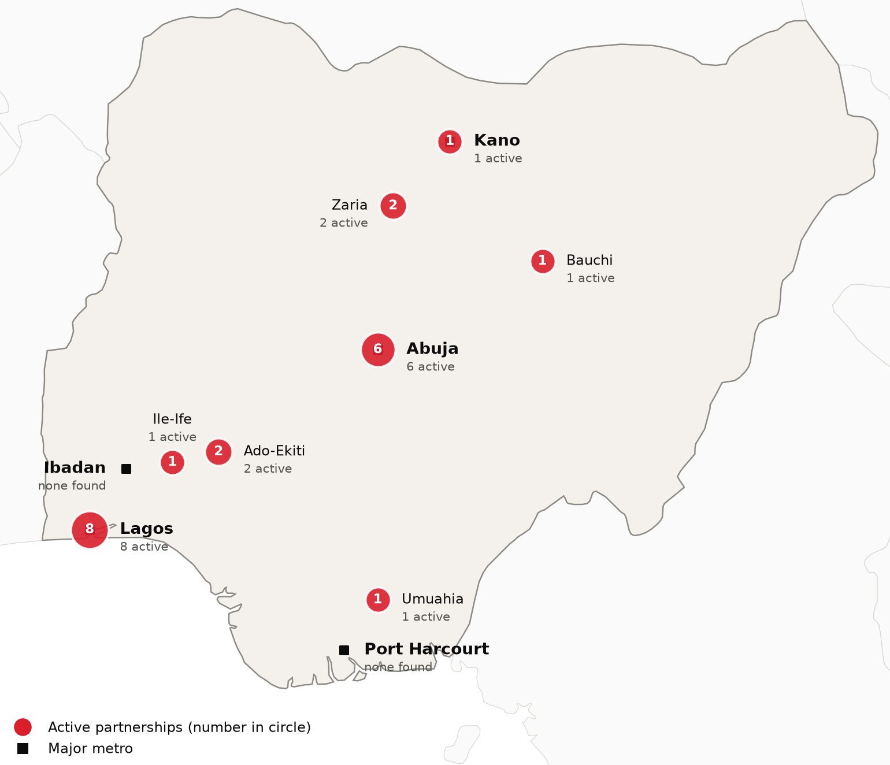
Active foreign health-system partnerships by city of the partner in Nigeria. Source: CSI partnerships tracker, verified 2026-10-21. Boundaries: Natural Earth; not an official depiction.
Institution | Nature of collaboration
Johns Hopkins University (Johns Hopkins Hospital) | Training and education
Mayo Clinic (Mayo Clinic Global Consulting) | Advisory and consulting
Memorial Sloan Kettering Cancer Center | Research collaboration
St. Jude Children's Research Hospital | Clinical affiliation
University of Illinois Chicago (UIC School of Public Health) | Training and education
University of Maryland School of Medicine (Institute of Human Virology) | Research collaboration
University of Miami (Sylvester Comprehensive Cancer Center) | Research collaboration
University of Virginia Health System | Training and education
Vanderbilt University Medical Center (Vanderbilt Institute for Global Health) | Research collaboration
Virginia Commonwealth University (VCU Massey Comprehensive Cancer Center) | Research collaboration
Evercare Group (owned at its 2021 launch by the TPG-managed Evercare Health Fund) | Ownership or management
King's College Hospital NHS Foundation Trust | Advisory and consulting
King's College London | Training and education
Liverpool School of Tropical Medicine | Training and education
Manipal Hospitals | Training and education
The Christie NHS Foundation Trust | Advisory and consulting
The Royal Marsden NHS Foundation Trust | Clinical affiliation
University of Birmingham | Training and education
University of Glasgow | Research collaboration

CSI Position, Risks and Recent News

CSI partnerships in Nigeria
[MANUAL INPUT REQUIRED]
To be completed by CSI from internal data; not researched.
Opportunities for CSI
[MANUAL INPUT REQUIRED]
To be completed by CSI from internal data; not researched.
Risks and watch items
- Presidential and National Assembly elections on 16 January 2027 could change federal priorities.¹⁶
- In 2024, 4,193 doctors and dentists emigrated, and 72.9 percent of surveyed medical and nursing students intended to practice abroad.^{60,64}
- The 2026 budget proposal gave health N2.48 trillion, about 4.2 percent, below the Abuja Declaration's 15 percent target.^{53,54}
Recent developments
2026-02-03 The IFC and NSIA financed MedServe's $154.1 million project for diagnostic, radiotherapy and cardiac catheterization centers.⁴⁶
2026-07-09 Health insurance enrollment reached 22.03 million, up 35 percent in a year, as mandatory provisions are phased in.³⁸
2026-10-20 Nigeria confirmed an imported Ebola Bundibugyo case in Abuja, and 44 contacts are being monitored.^{91,92}

