Country Summary: India
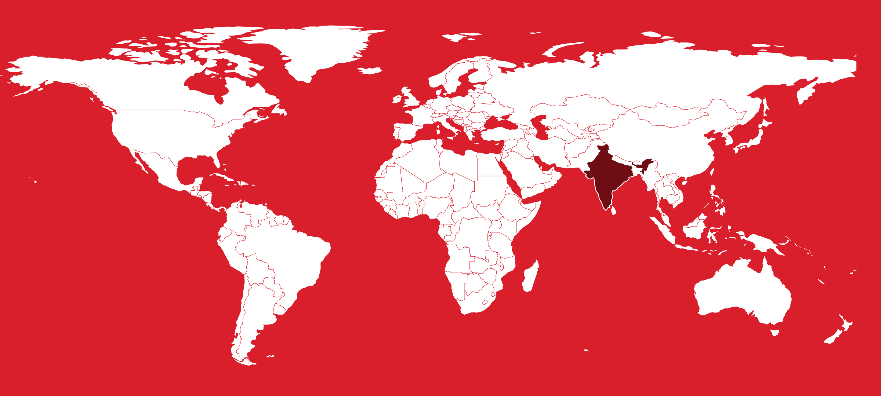
Executive summary of the India country profile (2026-09-24). Superscript numbers refer to the numbered sources in India_Profile_DRAFT_SOURCES.docx.

At a Glance

1.46 bn  Population, 2025 estimate³ | $11,748  GDP per capita (PPP), about, 2025⁷ | 3.37%  Health spending, share of GDP, 2022-23²³ | 43.4%  Out-of-pocket share of spending, 2022-23⁷⁶
0.95  Registered doctors per 1,000, about, 2025⁸⁰ | 132.5 m  PM-JAY admissions funded, 8 years to 2026⁵⁶ | 64.6%  Private share of urban admissions, 2025⁶¹ | 644,000  Medical-purpose arrivals, 2024¹⁰⁴
Key takeaways for CSI
- Two-tier market: PM-JAY rates anchor mass care; a smaller paying and international segment sustains premium care.⁵⁹⁵⁶
- Mount Sinai's exclusive Ramaiah collaboration, reportedly 10 years, is CSI's closest peer model.¹²²¹²⁴
- Private chains are the likeliest commercial partners; state governments are often the counterparty.⁷²²⁴
- Workforce training, from nursing to leadership, is one of the clearest openings.⁸⁰⁸³

Health System

- States run delivery, from 1,81,873 Ayushman Arogya Mandirs to AIIMS and Tata Memorial Centre.²⁵³
- Government health spending was 1.48% of GDP in 2022-23, short of the 2.5% target.²³⁷⁸
- Under one registered doctor and 0.6 public beds per 1,000; rural centers lacked 79.9% of specialists in 2023.⁸⁰⁵⁵⁸⁹
Who pays for health care: share of total health spending
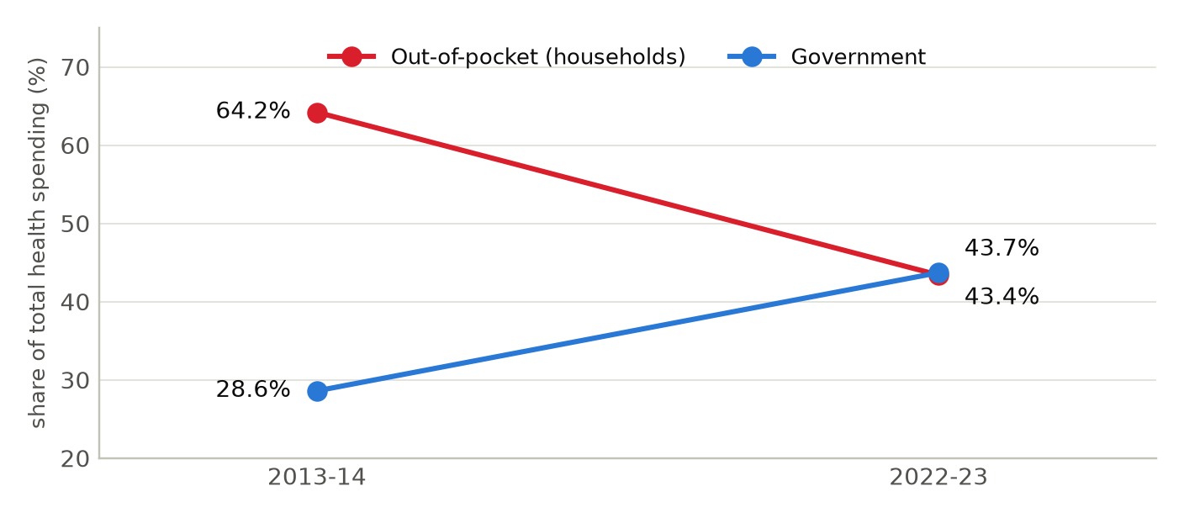
National Health Accounts. In between, the out-of-pocket share dipped to 39.4% in COVID-affected 2021-22 before rising again once emergency government spending ended. Sources: ^{76,75}
Health workforce and beds per 1,000 people: India vs OECD average
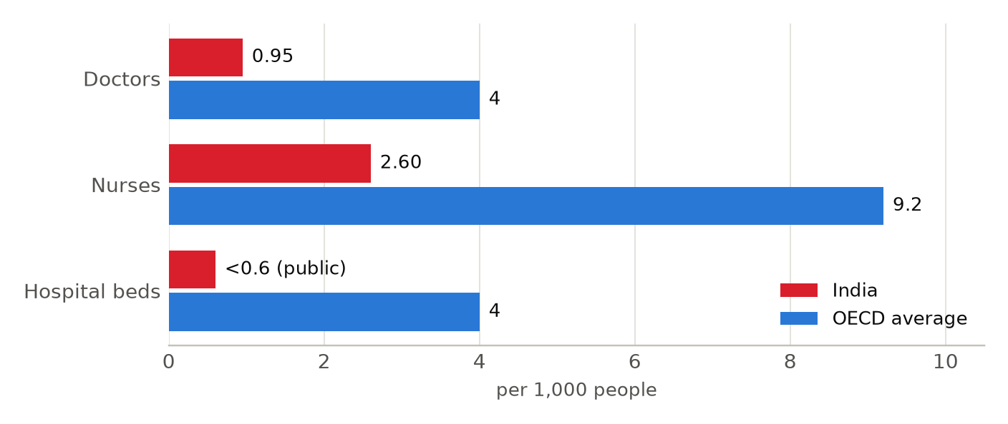
India: registered allopathic doctors (fewer are active) and registered nursing personnel, 2025; beds counts public facilities only, March 2023. OECD: averages from Health at a Glance 2025. Sources: ^{80,3,83,84,55,86,87,88}

Market and Competition

- Manipal (13,037 licensed beds), Apollo (10,970, including overseas) and Aster DM Quality Care (over 10,600) lead.⁶²⁶⁴⁶⁷
- Capital: Manipal's Rs 9,275 crore IPO, Blackstone in Aster, KKR's pending Medicover deal, IHH controlling Fortis.⁶³⁶⁶⁷⁴⁷¹
- Cleveland Clinic anchors Navi Mumbai MediCity under an MoU; Mayo advises Adani's two Health Cities.¹⁰³¹⁰⁰
Largest private hospital groups by beds, 2026
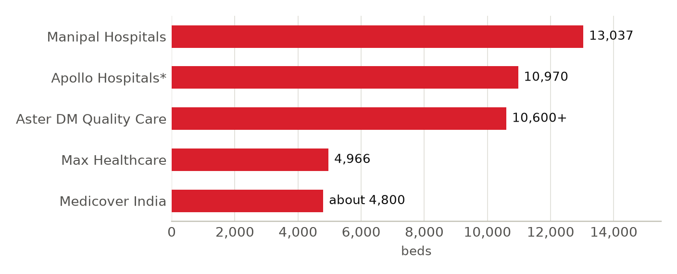
Definitions differ: Manipal licensed beds and Max operational beds (31 March 2026); *Apollo includes managed and overseas hospitals and day-surgery units (March 2026); Aster DM Quality Care after its July 2026 merger; Medicover India is being acquired by KKR. Sources: 62,63,64,65,66,67,68,69,70,74,137
US academic medical centers in India
US institution | Partner in India | Status
Mayo Clinic | AIG, Lilavati, Adani | 2019, 2025; not confirmed
Cleveland Clinic | Maharashtra, Brookfield, Arodhan | MoU signed June 2026
Johns Hopkins | HCL; IIT Bombay | 2014, 2023; not confirmed
Memorial Sloan Kettering | iCliniq | 2021; not confirmed
MD Anderson | Tata Memorial Hospital | Sister agreement 2003; ECHO partner
Mount Sinai | Ramaiah Memorial Hospital | July 2024; 10-year term reported
UCLA Health | Narendra Modi Medical College; AIIMS | 2024; department level
NewYork-Presbyterian | Emergency services | 2007, 2008; none currently listed
UPMC | TeleChikitsa; Citizens Hospital | 2014; not confirmed
Mass General Brigham | Wockhardt Hospitals | About 2001; not confirmed
Houston Methodist; Northwestern | None identified | None listed
US ties are mostly advisory, network or education deals, not ownership; several are less visible than headlines suggest.

Opportunities and Risks for CSI

Opportunities
- Nursing, fellowship and allied-health training, backing budget plans for 1 lakh more allied health professionals.⁸³³⁶
- Affiliations, second-opinion services and clinical program development with corporate hospital chains.⁶²⁷²
- Cardiology, oncology, metabolic and transplant care in the aging south, west and National Capital Region.¹⁵³⁷⁴³
Risks and watch items
- Medical arrivals fell from 6.97 lakh in 2019 to 6.44 lakh in 2024; Bangladesh, the top source, faced visa limits.¹⁰⁴¹⁰⁶
- A 2026 US law allows tariffs up to 100% on the largest Russian energy buyers; generics face Section 232 review.³³³¹
- Thin public funding and staffing; PM-JAY tariffs set the price floor for private partners.²³⁸⁹⁵⁶
Recent developments
2026-06-10 Maharashtra's MoU names Cleveland Clinic anchor of planned US$1.2 billion Navi Mumbai MediCity.²⁴¹⁰³
2026-08-06 KKR agreed to buy Medicover India's 24 hospitals; closing expected fourth quarter 2026.⁷⁴¹³⁷
2026-09-23 PM-JAY turned eight: 13.25 crore funded admissions at over 38,000 empaneled hospitals.⁵⁶⁵⁷

