Country Summary: India

Executive summary of the India country profile (2026-09-24). Superscript numbers refer to the numbered sources in India_Profile_DRAFT_SOURCES.docx.

At a Glance

1.46 bn  Population, 2025 estimate³ | $11,748  GDP per capita (PPP), about, 2025⁷ | 3.37%  Health spending, share of GDP, 2022-23²³ | 43.4%  Out-of-pocket share of spending, 2022-23⁷⁶
0.95  Registered doctors per 1,000, about, 2025⁸⁰ | 132.5 m  PM-JAY admissions funded, 8 years to 2026⁵⁶ | 64.6%  Private share of urban admissions, 2025⁶¹ | 644,000  Medical-purpose arrivals, 2024¹⁰⁴
Country background
India, with about 1.46 billion people in 2025, is a federal parliamentary democratic republic with its capital in New Delhi.^{1,2,3} President Droupadi Murmu is head of state, and Prime Minister Narendra Modi, in office since 2014, began a third term in June 2024.^{8,9} Health care delivery is a state responsibility under the Constitution, and a state government is often the counterparty for a foreign partner.^{2,24} The IMF counts India among the fastest-growing major economies: official provisional estimates put real GDP growth at 7.7 percent in FY2025-26, and the World Bank puts 2025 GDP at about US$17.2 trillion in purchasing-power terms.^{5,25,26} The population is aging: fertility fell to 1.9 in 2024, below replacement, and UNFPA projects the share aged 60 and over to rise from 10.5 percent in 2022 to 20.8 percent by 2050.^{12,15,16} US trade policy is a risk: most Indian goods have faced a 10 percent US duty since 24 July 2026.^{29,30}
Key takeaways for CSI
- Two-tier market: PM-JAY rates anchor mass care; a smaller paying and international segment sustains premium care.^{56,59}
- Mount Sinai's exclusive Ramaiah collaboration, reportedly 10 years, is CSI's closest peer model.^{155,156}
- Private chains are the likeliest commercial partners; state governments are often the counterparty.^{24,72}
- Workforce training, from nursing to leadership, is one of the clearest openings.^{80,83}

Health System

- States run delivery, from 1,81,873 Ayushman Arogya Mandirs to AIIMS and Tata Memorial Centre.^{2,53}
- Government health spending was 1.48% of GDP in 2022-23, short of the 2.5% target.^{23,78}
- Under one registered doctor and 0.6 public beds per 1,000; rural centers lacked 79.9% of specialists in 2023.^{55,80,89}
Who pays for health care: share of total health spending
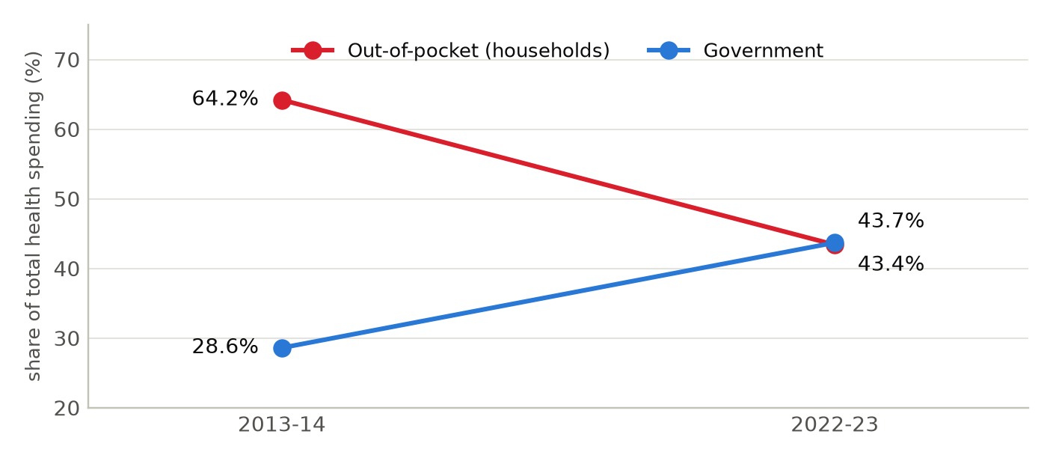
National Health Accounts. In between, the out-of-pocket share dipped to 39.4% in COVID-affected 2021-22 before rising again once emergency government spending ended. Sources: ^{76,75}
Health workforce and beds per 1,000 people: India vs OECD average
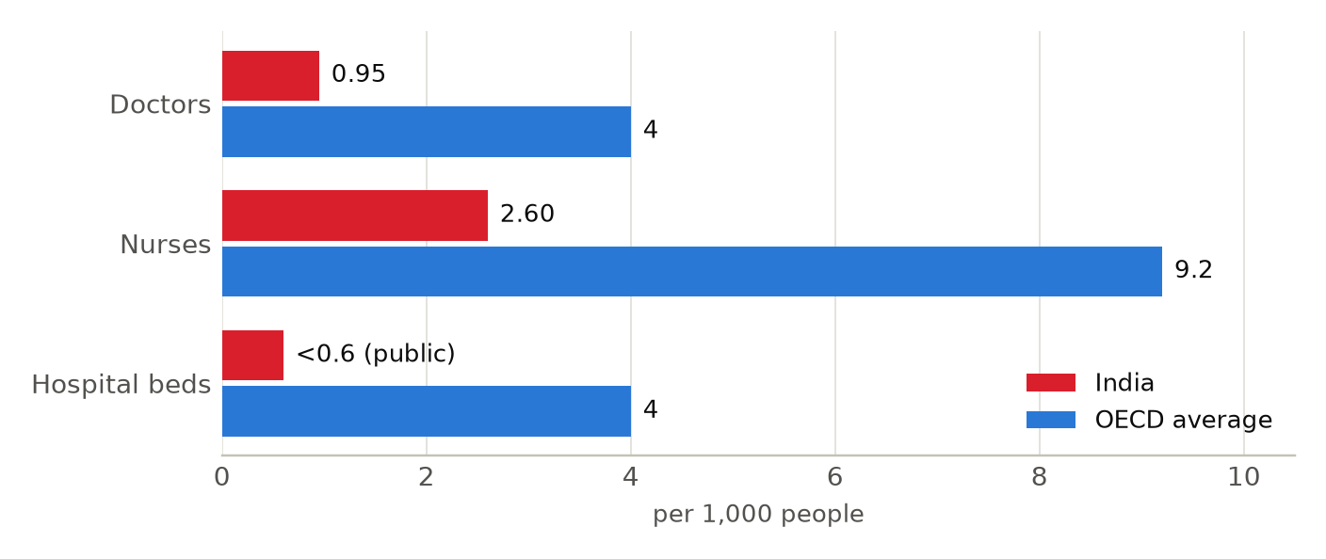
India: registered allopathic doctors (fewer are active) and registered nursing personnel, 2025; beds counts public facilities only, March 2023. OECD: averages from Health at a Glance 2025. Sources: ^{80,3,83,84,55,86,87,88}

Market and Competition

- Manipal (13,037 licensed beds), Apollo (10,970, including overseas) and Aster DM Quality Care (over 10,600) lead.^{62,64,67}
- Capital: Manipal's Rs 9,275 crore IPO, Blackstone in Aster, KKR's pending Medicover deal, IHH controlling Fortis.^{63,66,71,74}
- Cleveland Clinic anchors Navi Mumbai MediCity under an MoU; Mayo advises Adani's two Health Cities.^{100,103}
Where foreign health systems partner in India
45 partnerships active or active within five years: 36 active, 7 unclear, 2 ended. Full list with sources in the profile and the partnerships tracker.
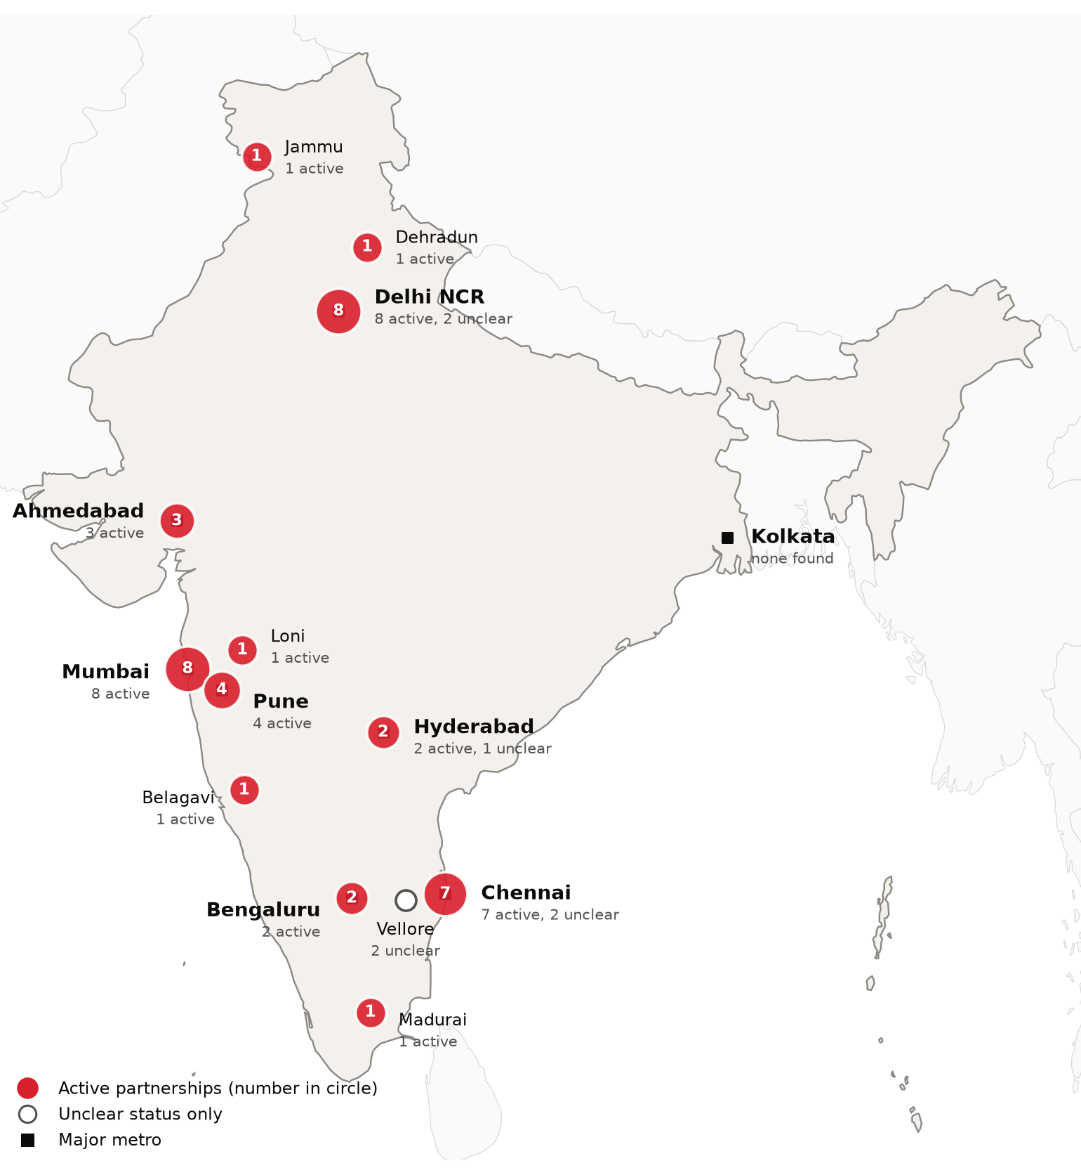
Foreign health-system partnerships by city of the partner in India: active, and unclear where no active partnership exists. Source: CSI partnerships tracker, verified 2026-09-30. Boundaries: Natural Earth; not an official depiction.

Opportunities and Risks for CSI

Potential partners: largest private hospital groups by beds, 2026
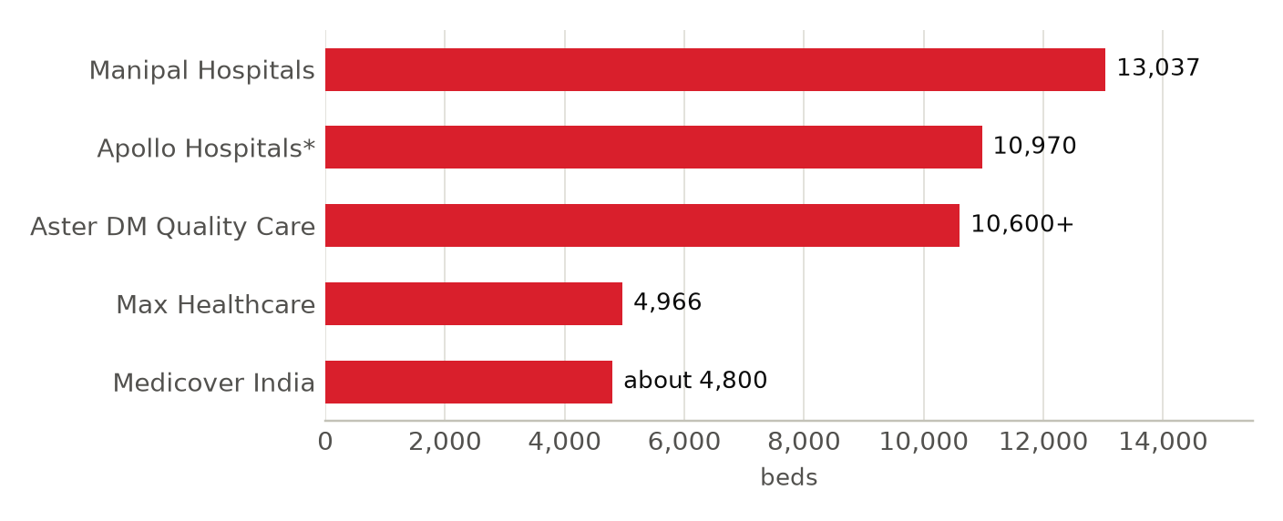
Definitions differ: Manipal licensed beds and Max operational beds (31 March 2026); *Apollo includes managed and overseas hospitals and day-surgery units (March 2026); Aster DM Quality Care after its July 2026 merger; Medicover India is being acquired by KKR. Sources: ^{62,63,64,65,66,67,68,69,70,74}
Opportunities
- Nursing, fellowship and allied-health training, backing budget plans for 1 lakh more allied health professionals.^{36,83}
- Affiliations, second-opinion services and clinical program development with corporate hospital chains.^{62,72}
- Cardiology, oncology, metabolic and transplant care in the aging south, west and National Capital Region.^{15,37,43}
Risks and watch items
- Medical arrivals fell from 6.97 lakh in 2019 to 6.44 lakh in 2024; Bangladesh, the top source, faced visa limits.^{104,106}
- A 2026 US law allows tariffs up to 100% on the largest Russian energy buyers; generics face Section 232 review.^{31,33}
- Thin public funding and staffing; PM-JAY tariffs set the price floor for private partners.^{23,56,89}
Recent developments
2026-06-10 Maharashtra's MoU names Cleveland Clinic anchor of planned US$1.2 billion Navi Mumbai MediCity.^{24,103}
2026-08-06 KKR agreed to buy Medicover India's 24 hospitals; closing expected fourth quarter 2026.^{74,152}
2026-09-23 PM-JAY turned eight: 13.25 crore funded admissions at over 38,000 empaneled hospitals.^{56,57}

