Country Summary: Germany

Photo: Daniel Schwen, CC BY-SA 4.0, via Wikimedia Commons
Executive summary of the Germany country profile (2026-10-30). Superscript numbers refer to the numbered sources in Germany_Profile_DRAFT_SOURCES.docx.

At a Glance

83.5 m  Population, end of 2025, about³ | 75,400  GDP per capita, PPP (international dollars), about, 2025⁶ | 12.27%  Current health expenditure, share of GDP, 2024³² | 10.7%  Out-of-pocket share of current health expenditure, 2024³⁴
4.7  Physicians per 1,000 people, OECD, 2023¹³ | 81.5  Life expectancy at birth, years, 2024¹³ | 23.7%  Population aged 65 and over, 2025¹¹ | US$6,849  Current health expenditure per capita, 2024, current US$³³
Country background
Germany, a federal parliamentary republic of 16 Länder, has its capital in Berlin and had about 83.5 million residents at the end of 2025.³ Federal President Frank-Walter Steinmeier is head of state, and Chancellor Friedrich Merz leads a CDU/CSU and SPD coalition.^{7,8} Carsten Linnemann became federal health minister on 29 July 2026.¹⁵ GDP was about 6.30 trillion international dollars (PPP) in 2025, or about 75,400 per person, after 0.2 percent real growth.^{5,6,18} The population is aging: 23.7 percent were 65 or older in 2025, and life expectancy was 81.5 years in 2024.^{11,13} The main risk is financial: the 2026 stabilization law answers a needed saving of almost €19 billion (US$21.3 billion) for 2027.³⁷
Key takeaways for CSI
- Health spending reached 12.27 percent of GDP in 2024, up from 10.59 percent in 2012; only the US spends more.^{32,36}
- Public sources paid 86 percent of health spending in 2023, against an EU average of 80 percent.¹³
- The 2026 stabilization law answers a saving need of almost €19 billion (US$21.3 billion) for 2027.^{37,44}
- The 65 and over share is projected to reach 28 percent by 2050; 49 percent have multiple chronic conditions.¹³

Health System

- Insurance is mandatory: an estimated 89.0 percent of residents had statutory cover in 2024, and 10.4 percent had private cover.¹³
- Germany had the EU's highest rate of avoidable hospital admissions for chronic conditions in 2023, at 810 per 100,000 people.¹³
- The 16 Länder plan hospitals, and reform adjustments delay full fixed capacity payments until 2030.^{13,38}
Germany: health spending and out-of-pocket share, 2012 to 2024
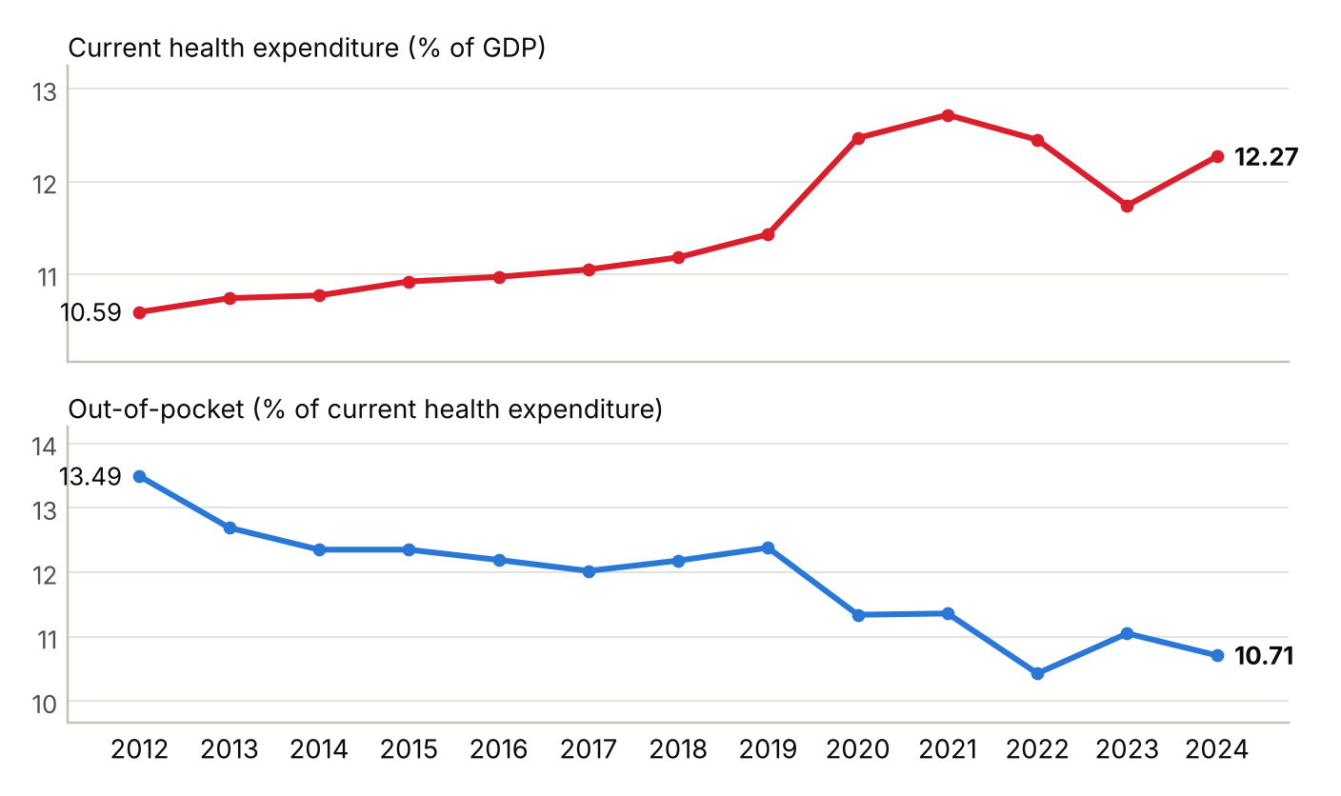
Current health expenditure as a share of GDP, and out-of-pocket spending as a share of current health expenditure; 2024 is the latest year in the series. Sources: ^{32,34}
Physicians per 1,000 people, Germany and comparators (latest year available)
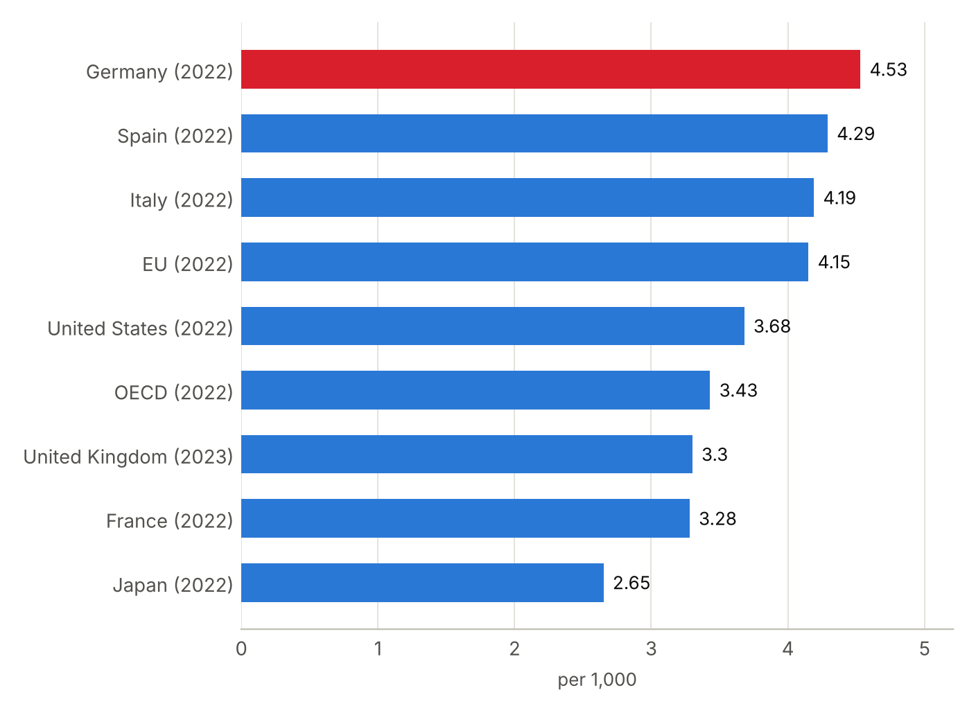
Latest year available for each country in the World Bank series, shown in brackets; comparison years differ (2022 and 2023). OECD and EU are group averages from the same series. Sources: ³⁹

Market and Competition

- In 2025 Germany had 1,807 hospitals: 729 private, 549 nonprofit and 529 public.²⁹
- Helios, Asklepios and Sana lead by beds; Swiss-based Ameos and Turkey's Medicana took over hospitals in 2026.^{30,47,48}
- About 182,200 patients from abroad were treated in 2022, three quarters from neighboring countries.⁶⁷
Germany: hospital beds per 1,000 people, 2010 to 2023
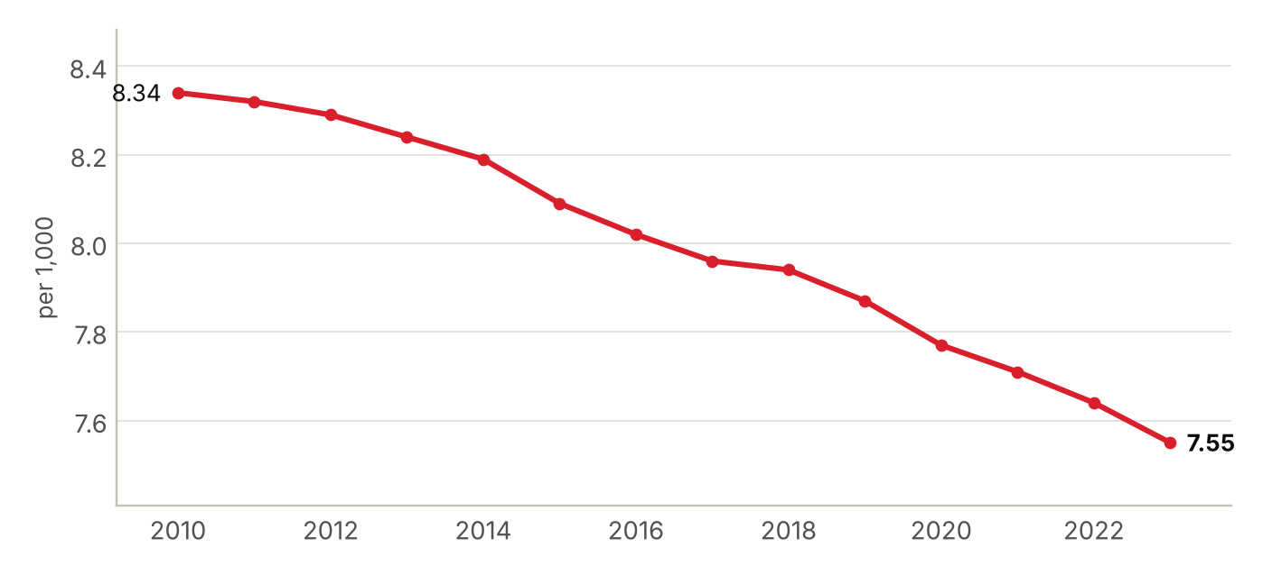
Hospital beds as reported to the World Bank, public and private; 2023 is the latest year in the series. Sources: ⁴¹
Foreign health systems active in Germany
19 foreign institutions with confirmed active partnerships (19 in all): 13 research collaboration, 3 ownership or management, 2 training and education, 1 clinical affiliation. Sources in the profile and the partnerships tracker.
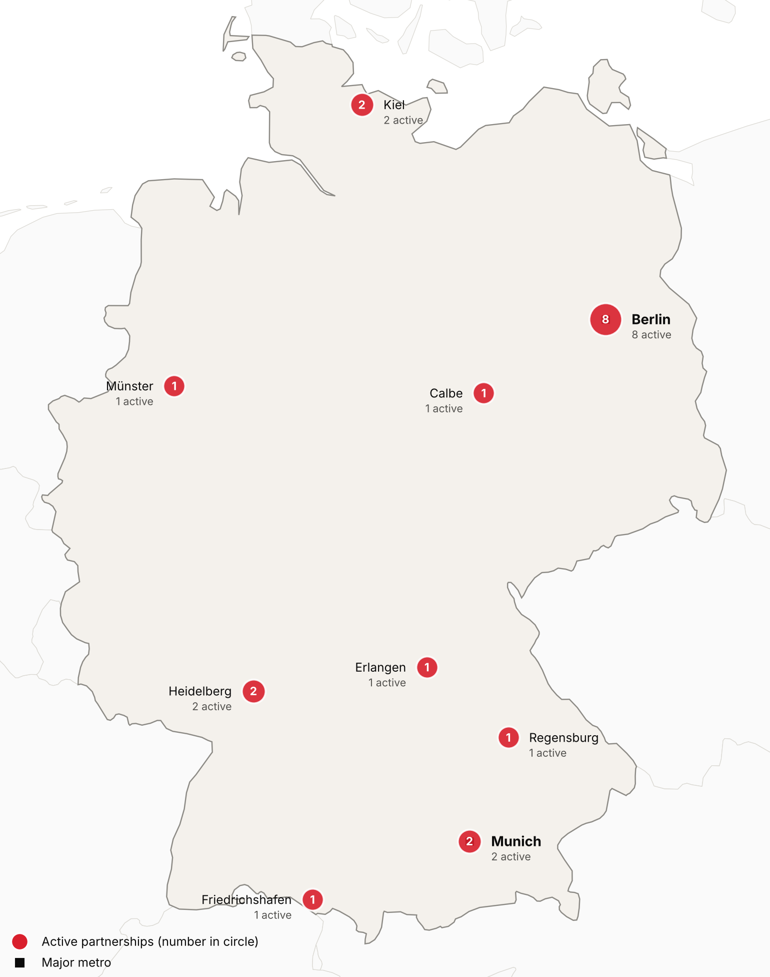
Active foreign health-system partnerships by city of the partner in Germany. Source: CSI partnerships tracker, verified 2026-10-30. Boundaries: Natural Earth; not an official depiction.
Institution | Nature of collaboration
Duke University (Duke Global Health and School of Medicine) | Research collaboration
Harvard University (including Harvard Medical School) | Research collaboration
Mount Sinai Health System (Icahn School of Medicine at Mount Sinai) | Research collaboration
Northwestern University (Feinberg School of Medicine) | Research collaboration
University of California San Francisco (Quantitative Biosciences Institute) | Research collaboration
University of Kansas (University of Kansas Medical Center) | Research collaboration
Vanderbilt University Medical Center (Vanderbilt Health) | Research collaboration
AMEOS Gruppe | Ownership or management
Institute of Science Tokyo | Training and education
Karolinska University Hospital and Karolinska Institutet | Research collaboration
Lithuanian University of Health Sciences (LSMU), Kaunas | Research collaboration
Medicana Health Group | Ownership or management
Medicover | Ownership or management
Medisch Spectrum Twente (MST) | Clinical affiliation
Samsung Comprehensive Cancer Center (Samsung Medical Center) | Research collaboration
Sheba Medical Center | Research collaboration
Tongji Hospital (Huazhong University of Science and Technology) | Research collaboration
West China Hospital, Sichuan University | Research collaboration
Zhejiang Cancer Hospital | Training and education

CSI Position, Risks and Recent News

CSI partnerships in Germany
[MANUAL INPUT REQUIRED]
To be completed by CSI from internal data; not researched.
Opportunities for CSI
[MANUAL INPUT REQUIRED]
To be completed by CSI from internal data; not researched.
Risks and watch items
- Statutory insurance finances remain tense, and structural problems must still be solved, the health minister said.⁴⁵
- Growth is weak: GDP grew 0.2 percent in 2025, and the Bundesbank projects 0.5 percent for 2026.^{18,21}
- Almost a quarter (23.4 percent) of working doctors were 60 or older in 2025.³¹
Recent developments
2026-10-14 Estimators expect the average additional contribution to stay at 2.9 percent in 2027, and Minister Linnemann called the situation tense.⁴⁵
2026-07-29 Carsten Linnemann replaced Nina Warken as federal health minister, and Warken moved to head the Chancellery.^{15,16}
2026-07-10 Parliament passed the contribution stabilization law, in force from 30 July, tying spending growth to income growth.^{37,44}

