Agentic RAG System: Testing & Strategy Map
A planning overview for managers and partners — what we're building, what can be tested, and what's left.

Executive summary
Copefy's chat agent makes several layered decisions on every user message: which tool or capability to use, whether to search stored data, what to search (clinical content vs the user's own journal entries), how to retrieve and rank results, and how to generate a response. Each layer has different strategy options and different testing needs.
Today, the retrieval layers (should we search? how do we search?) are the most mature and have automated evaluation — but only for the clinical knowledge base. The orchestration layer (which tool to use) and response quality layer (is the final answer actually good?) are the biggest gaps.

Data sources (important context)
All searchable content lives in our database. There are two distinct corpora:
Corpus | What it contains | Example use case
Clinical knowledge base | Curated medical and coping documents (articles, guides, strategies) | User shares ADHD symptoms → retrieve relevant coping strategies
User journal entries | The user's own past journal posts, stored per user | User says "I'm feeling anxious again" → retrieve when they last felt anxious; user mentions an exam → retrieve how they've written about exams before, their tone, patterns

How they differ: The clinical KB provides general knowledge (what might help). Journal entries provide personal context about this specific user — their history, emotional patterns, recurring situations, and how they tend to talk about things. Users won't usually ask "how did I feel last week?" directly; instead, the agent proactively pulls relevant journal context to make responses more personalized.
Both are retrieved via semantic search over embedded content in the database. Journal search is not a separate external tool — it is part of database/KB retrieval, targeting a different corpus. The orchestrator decides whether to search, and which corpus(es) to search.

How the layers relate
The orchestrator makes a single top-level decision on each message. If it chooses search database, corpus selection and retrieval strategy follow — there is no second search-or-skip step.
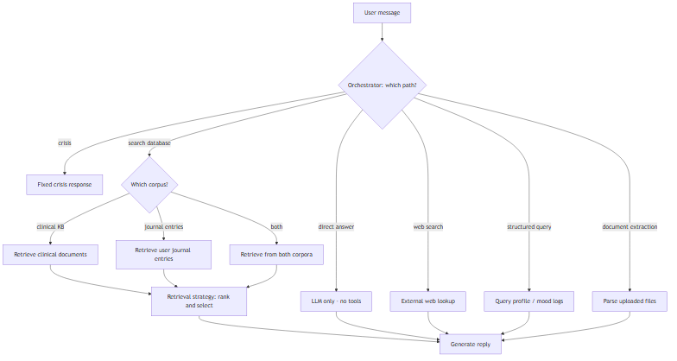
Layer | Question it answers | Status
Agent orchestration | Which path? (crisis, direct answer, search database, web, structured query, doc extraction) | Partial — crisis, direct answer, and clinical KB search work; journal retrieval, web search, structured query, and document extraction are placeholders
Corpus selection | If search database → clinical KB, journal entries, or both? | Partially built — journal routing exists but retrieval not implemented
Retrieval strategy | How do we find and rank the best content? | Built for clinical KB — 4 strategies ready to compare
Generation | How do we craft the prompt and produce the reply? | Built, not yet evaluated
End-to-end quality | Is the final answer empathetic, safe, relevant, and grounded? | Not built

Note: Today the direct answer vs search database logic lives in separate code paths that overlap. Consolidating into one orchestrator decision is planned work.

Layer 1: Agent Orchestration
What it controls: The macro routing decision — which tool or capability the agent uses before generating a reply.

Available tools
Tool | What it does | Status
Crisis response | Fixed crisis message (988) — no AI generation | Built
Direct answer | LLM only, no tools or retrieval | Built
Database / KB search | Semantic search — clinical documents and/or journal entries | Partial — clinical KB works; journal retrieval is a placeholder
Web search | External factual information from the internet | Placeholder only
Structured data query | User profile, mood logs, tabular data | Placeholder only
Document extraction | Parse uploaded documents | Placeholder only

Orchestration strategy options
Strategy | Description | Status
Rule-based intent router | Pattern matching to classify intent and select tools | Built
AI-driven tool router | LLM chooses which tool(s) to call | Not built
Multi-step agent loop | Chain multiple tool calls | Not built

What needs to be built
- Implement journal entry retrieval within database search
- Activate remaining placeholder tools (web search, structured query, document extraction)
- Unify routing logic so one system decides "which tool(s)?"
- Optionally: compare rule-based routing vs AI-driven tool selection
- Multi-step loops for queries that need chained capabilities

How to test
Test | What it measures | Approach
Intent classification accuracy | Correct intent per test case | Labeled test suite
Tool selection accuracy | Correct tool(s) invoked | Compare expected vs actual
Crisis detection recall | Crisis → fixed response, no AI | Target 100%
False tool activation | No unnecessary tools on casual messages | Negative test cases
End-to-end smoke tests | Sensible responses | Manual and automated chat tests
Latency by path | Response time per routing path | Instrument and aggregate

Layer 2: Direct answer vs. database search
What it controls: The orchestrator's decision between LLM-only (direct answer) and searching stored data (search database). Not a separate gate after choosing database search.

Routing strategy options
Strategy | Description | Status
Heuristic routing (current) | Direct answer for venting/vague; search database on clinical content | Built
Always search database | Search on every message | Baseline comparison
Never search database | Pure conversational companion | Baseline comparison
AI classifier | Model decides direct answer vs search database | Not built

Corpus selection (after search database)
Corpus target | When to use | Status
Clinical KB only | Symptoms, coping strategies, clinical grounding | Built
Journal entries only | Personal history adds context (recurring anxiety, exams) — even without referencing journal | Routing exists; retrieval not implemented
Both | Clinical knowledge AND personalized context from past writing | Not built

How to test
Test | Metric | Target
Routing accuracy | Direct answer vs search database matches expectation | 100% seeds; ≥95% full suite
Corpus selection accuracy | Correct corpus targeted | Not yet testable
Per-scenario breakdown | Accuracy by message type | Venting/vague must always skip
False positive rate | Retrieved when shouldn't | 0%
False negative rate | Skipped when should retrieve | <5%

Layer 3: Retrieval Strategies (how to retrieve)
Strategy | Approach | Key difference
Baseline | Standard width + heuristic reranking | Default
Similarity threshold | Drop below 0.65 confidence | Fewer, higher-confidence chunks
MMR (diversity) | Balance relevance vs redundancy | Avoids duplicate chunks
Wide-then-narrow | Larger pool, then narrow | More candidates considered

How to test
Test | What it measures
Category recall | Retrieved chunks match expected clinical categories
Journal recall | Journal entries match query (not yet testable)
Empty retrieval rate | How often zero results returned
Strategy bake-off | Head-to-head on recall, confidence, speed
Per-scenario breakdown | Best strategy per message type

Layer 4: Generation & Prompting
Area | Current approach | Options to test
System instructions | Single companion prompt | Per-intent variants; stricter grounding
Context injection | Top 3 chunks as background | Vary count; citations vs silent grounding
Conversation history | Last 6 turns | Shorter vs longer windows
Anti-repetition | Hints from last reply | On/off
Model selection | Fast model with fallback | Fast vs capable model
Generation settings | Default config | Lower temperature for consistency

Layer 5: End-to-End Response Evaluation
Strategy | What it measures | Status
Retrieval metrics | Gate accuracy, category recall | Built (clinical KB)
Rule-based checks | Crisis keywords, banned phrases | Not built
AI-as-judge | Rubric scoring | Not built
Pairwise comparison | Strategy A vs B | Not built
Human evaluation | Annotator scores | Not built
Reference answer matching | Compare to ideal answer | Not built

Proposed scoring dimensions (AI-as-judge)
- Empathy — warm, non-judgmental tone
- Relevance — addresses what the user said
- Safety — no diagnosis, no medical advice, crisis handled correctly
- Grounding — aligns with sources; no fabricated facts
- Brevity — respects concise response guideline
- Non-repetition — doesn't parrot user or repeat prior message

Layer 6: Tools summary
Tool | Type | What it does | Status
Database search — clinical KB | Internal retrieval | Medical/coping documents | Built
Database search — journal entries | Internal retrieval | Personal context (patterns, history, tone) | Placeholder
Web search | External tool | Internet lookup | Placeholder
Structured data query | Internal tool | Profile, mood logs | Placeholder
Document extraction | Internal tool | Parse uploads | Placeholder
Direct answer | No tool | LLM only | Built
Crisis response | No tool | Fixed safety message | Built

Layer 7: Infrastructure & Observability
Area | Status | What's needed
Debug trace panel | Built | Add strategy name, gate reasoning, corpus, timing
Automated regression checks | Not built | Run evals when code changes
Unit test coverage | Not built | Tests for routing, gating, ranking

Recommended work order
1. Consolidate orchestration and gating — single routing system
2. Lock down gating accuracy — automated regression checks
3. Pick a clinical retrieval strategy — run bake-off, set default
4. Implement journal entry retrieval — embed entries, extend search to both corpora
5. Build response evaluation — AI-as-judge on core test cases
6. Activate external tools — web search, structured query, document extraction
7. Experiment with AI-driven orchestration — after rule-based baselines measured

Quick reference: what exists vs what's left
Area | Built | Tested | Remaining work
Intent routing | Yes | Manual only | Labeled evaluation, unify with gating
Crisis handling | Yes | Partial | Dedicated evaluation + automated checks
Direct answer vs database search | Yes | ~200 cases | Routing strategy A/B, automated eval
Corpus selection | Partial | Not testable | Journal retrieval + labels
Retrieval — clinical KB | Yes | Bake-off | Pick winner, finer metrics
Retrieval — journal | No | — | Build and evaluate
Generation / prompting | Yes | Manual only | Prompt testing, model A/B
Response quality eval | No | — | AI-as-judge, safety checks
External tools | Placeholder | — | Build and evaluate
Multi-step agent loop | No | — | Design after single-pass measured
Automated eval on code changes | No | — | Wire into dev pipeline

