Homework 5

Kiara Hodo

12/1/2021

## Note for Brooke: Remember we tried to get rid of the warnings and messages and couldn’t

# Reading Data into R

library(readr)

## Warning: package 'readr' was built under R version 4.0.5

homicide_data <- read_csv("~/Fall 21 CSU/R Programming/Final Project/data/homicide-data.csv")

## Rows: 52179 Columns: 12

## -- Column specification --------------------------------------------------------  
## Delimiter: ","  
## chr (9): uid, victim_last, victim_first, victim_race, victim_age, victim_sex...  
## dbl (3): reported_date, lat, lon

##   
## i Use `spec()` to retrieve the full column specification for this data.  
## i Specify the column types or set `show_col_types = FALSE` to quiet this message.

homicide_data

## # A tibble: 52,179 x 12  
## uid reported_date victim_last victim_first victim_race victim_age  
## <chr> <dbl> <chr> <chr> <chr> <chr>   
## 1 Alb-000001 20100504 GARCIA JUAN Hispanic 78   
## 2 Alb-000002 20100216 MONTOYA CAMERON Hispanic 17   
## 3 Alb-000003 20100601 SATTERFIELD VIVIANA White 15   
## 4 Alb-000004 20100101 MENDIOLA CARLOS Hispanic 32   
## 5 Alb-000005 20100102 MULA VIVIAN White 72   
## 6 Alb-000006 20100126 BOOK GERALDINE White 91   
## 7 Alb-000007 20100127 MALDONADO DAVID Hispanic 52   
## 8 Alb-000008 20100127 MALDONADO CONNIE Hispanic 52   
## 9 Alb-000009 20100130 MARTIN-LEYVA GUSTAVO White 56   
## 10 Alb-000010 20100210 HERRERA ISRAEL Hispanic 43   
## # ... with 52,169 more rows, and 6 more variables: victim_sex <chr>,  
## # city <chr>, state <chr>, lat <dbl>, lon <dbl>, disposition <chr>

# Filtering down to Atlanta

library(dplyr)

## Warning: package 'dplyr' was built under R version 4.0.5

##   
## Attaching package: 'dplyr'

## The following objects are masked from 'package:stats':  
##   
## filter, lag

## The following objects are masked from 'package:base':  
##   
## intersect, setdiff, setequal, union

atl_homicides <- homicide_data %>%  
 filter(city == "Atlanta")  
atl_homicides

## # A tibble: 973 x 12  
## uid reported_date victim_last victim_first victim_race victim_age  
## <chr> <dbl> <chr> <chr> <chr> <chr>   
## 1 Atl-000756 20070110 BIRDSONG ERNEST Black 29   
## 2 Atl-000757 20070110 REED MICHAEL Black 29   
## 3 Atl-000758 20070114 FELICIANO JOHNNY Hispanic 36   
## 4 Atl-000759 20070114 SPENCER CHARLES Black 26   
## 5 Atl-000760 20070120 POPE LUKE Black 75   
## 6 Atl-000761 20070128 LEARY ERNEST Black 22   
## 7 Atl-000762 20070204 HUNT BRUCE Black 40   
## 8 Atl-000763 20070215 TURNER DEANDRA Black 1   
## 9 Atl-000764 20070225 BATEMAN DEMARIO Black 25   
## 10 Atl-000765 20070225 MILLS TERRY Black 25   
## # ... with 963 more rows, and 6 more variables: victim_sex <chr>, city <chr>,  
## # state <chr>, lat <dbl>, lon <dbl>, disposition <chr>

# Seperating Data into Solved and Unsolved

library(forcats)

## Warning: package 'forcats' was built under R version 4.0.5

library(sf)

## Warning: package 'sf' was built under R version 4.0.5

## Linking to GEOS 3.9.1, GDAL 3.2.1, PROJ 7.2.1

unsolved <- atl_homicides %>%  
 mutate(unsolved = disposition %in% c("Closed without arrest", "Open/No arrest"))

# Making lower layer map of GA (Tigris package)

library(tigris)

## Warning: package 'tigris' was built under R version 4.0.5

## To enable   
## caching of data, set `options(tigris_use_cache = TRUE)` in your R script or .Rprofile.

ga_counties <- counties(state = "GA", cb = TRUE, class = "sf")

## | | | 0% | | | 1% | |= | 1% | |= | 2% | |== | 2% | |== | 3% | |== | 4% | |=== | 4% | |=== | 5% | |==== | 5% | |==== | 6% | |===== | 7% | |===== | 8% | |====== | 8% | |====== | 9% | |======= | 9% | |======= | 10% | |======= | 11% | |======== | 11% | |======== | 12% | |========= | 12% | |========= | 13% | |========== | 14% | |========== | 15% | |=========== | 15% | |=========== | 16% | |============ | 16% | |============ | 17% | |============ | 18% | |============= | 18% | |============= | 19% | |============== | 19% | |============== | 20% | |=============== | 21% | |=============== | 22% | |================ | 22% | |================ | 23% | |================= | 24% | |================= | 25% | |================== | 25% | |================== | 26% | |=================== | 27% | |=================== | 28% | |==================== | 28% | |==================== | 29% | |===================== | 29% | |===================== | 30% | |===================== | 31% | |====================== | 31% | |====================== | 32% | |======================= | 32% | |======================= | 33% | |======================= | 34% | |======================== | 34% | |======================== | 35% | |========================= | 35% | |========================= | 36% | |========================== | 37% | |========================== | 38% | |=========================== | 38% | |=========================== | 39% | |============================ | 40% | |============================= | 41% | |============================= | 42% | |============================== | 42% | |============================== | 43% | |============================== | 44% | |=============================== | 44% | |=============================== | 45% | |================================ | 45% | |================================ | 46% | |================================= | 47% | |================================= | 48% | |================================== | 48% | |================================== | 49% | |=================================== | 49% | |=================================== | 50% | |=================================== | 51% | |==================================== | 51% | |==================================== | 52% | |===================================== | 52% | |===================================== | 53% | |====================================== | 54% | |====================================== | 55% | |======================================= | 55% | |======================================= | 56% | |======================================== | 57% | |======================================== | 58% | |========================================= | 58% | |========================================= | 59% | |========================================== | 59% | |========================================== | 60% | |========================================== | 61% | |=========================================== | 61% | |=========================================== | 62% | |============================================ | 62% | |============================================ | 63% | |============================================= | 64% | |============================================= | 65% | |============================================== | 65% | |============================================== | 66% | |=============================================== | 67% | |=============================================== | 68% | |================================================ | 68% | |================================================ | 69% | |================================================= | 69% | |================================================= | 70% | |================================================= | 71% | |================================================== | 71% | |================================================== | 72% | |=================================================== | 72% | |=================================================== | 73% | |==================================================== | 74% | |==================================================== | 75% | |===================================================== | 75% | |===================================================== | 76% | |====================================================== | 77% | |====================================================== | 78% | |======================================================= | 78% | |======================================================= | 79% | |======================================================== | 79% | |======================================================== | 80% | |======================================================== | 81% | |========================================================= | 81% | |========================================================= | 82% | |========================================================== | 82% | |========================================================== | 83% | |=========================================================== | 84% | |=========================================================== | 85% | |============================================================ | 85% | |============================================================ | 86% | |============================================================= | 86% | |============================================================= | 87% | |============================================================= | 88% | |============================================================== | 88% | |============================================================== | 89% | |=============================================================== | 90% | |================================================================ | 91% | |================================================================ | 92% | |================================================================= | 92% | |================================================================= | 93% | |================================================================== | 94% | |================================================================== | 95% | |=================================================================== | 95% | |=================================================================== | 96% | |==================================================================== | 96% | |==================================================================== | 97% | |==================================================================== | 98% | |===================================================================== | 98% | |===================================================================== | 99% | |======================================================================| 99% | |======================================================================| 100%

fulton_atl <- ga_counties %>%  
 filter(COUNTYFP == 121)  
fulton_atl

## Simple feature collection with 1 feature and 9 fields  
## Geometry type: MULTIPOLYGON  
## Dimension: XY  
## Bounding box: xmin: -84.85071 ymin: 33.50251 xmax: -84.09769 ymax: 34.18629  
## Geodetic CRS: NAD83  
## STATEFP COUNTYFP COUNTYNS AFFGEOID GEOID NAME LSAD ALAND  
## 1 13 121 01694833 0500000US13121 13121 Fulton 06 1364208323  
## AWATER geometry  
## 1 19715145 MULTIPOLYGON (((-84.84931 3...

?tracts

## starting httpd help server ...

## done

fulton_tracts <- tracts(state = "GA", county = 121, cb = TRUE)

## | | | 0% | |= | 2% | |== | 3% | |==== | 6% | |===== | 7% | |====== | 9% | |======= | 11% | |========= | 13% | |========== | 14% | |============ | 16% | |============ | 18% | |============== | 20% | |=============== | 21% | |================= | 24% | |================= | 25% | |=================== | 27% | |==================== | 29% | |====================== | 31% | |======================= | 32% | |======================== | 34% | |========================= | 36% | |=========================== | 38% | |============================ | 39% | |============================= | 42% | |============================== | 43% | |================================ | 45% | |================================= | 47% | |================================== | 49% | |=================================== | 50% | |===================================== | 52% | |====================================== | 54% | |======================================= | 56% | |======================================== | 57% | |========================================== | 60% | |=========================================== | 61% | |============================================ | 63% | |============================================= | 64% | |=============================================== | 67% | |================================================ | 68% | |================================================= | 70% | |================================================== | 72% | |==================================================== | 74% | |===================================================== | 75% | |====================================================== | 77% | |======================================================= | 79% | |========================================================= | 81% | |========================================================== | 82% | |=========================================================== | 85% | |============================================================ | 86% | |============================================================== | 88% | |=============================================================== | 90% | |================================================================ | 92% | |================================================================= | 93% | |=================================================================== | 95% | |==================================================================== | 97% | |===================================================================== | 99% | |======================================================================| 100%

library(ggplot2)

## Warning: package 'ggplot2' was built under R version 4.0.5

ggplot() +   
 geom_sf(data = fulton_atl) +  
 geom_sf(data = fulton_tracts)

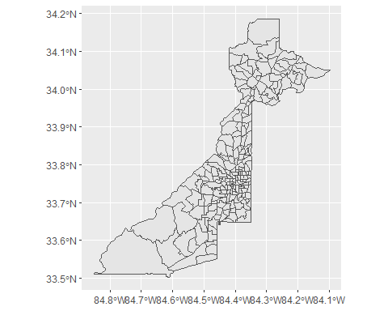

fulton_homicdes <- st_as_sf(unsolved, coords = c("lon", "lat")) %>%   
 st_set_crs(4269)

# Making dots on map

?fct_lump  
?factor  
  
fulton_homicdes %>%  
 count(victim_race)

## Simple feature collection with 5 features and 2 fields  
## Geometry type: MULTIPOINT  
## Dimension: XY  
## Bounding box: xmin: -84.53808 ymin: 33.6487 xmax: -84.29533 ymax: 33.85196  
## Geodetic CRS: NAD83  
## # A tibble: 5 x 3  
## victim_race n geometry  
## * <chr> <int> <MULTIPOINT [°]>  
## 1 Asian 4 ((-84.42312 33.74716), (-84.35902 33.77443), (-84.36645 33.~  
## 2 Black 884 ((-84.52335 33.66132), (-84.52335 33.66132), (-84.515 33.67~  
## 3 Hispanic 20 ((-84.35952 33.6498), (-84.3532 33.72194), (-84.3502 33.711~  
## 4 Other 4 ((-84.36087 33.69718), (-84.41449 33.73358), (-84.37011 33.~  
## 5 White 61 ((-84.35953 33.65044), (-84.35611 33.66001), (-84.32959 33.~

race_homicides <- fulton_homicdes %>%  
 dplyr::mutate(victim_race = forcats::fct_lump(victim_race, n = 3)) %>%  
 dplyr::count(victim_race)  
  
  
library(viridis)

## Warning: package 'viridis' was built under R version 4.0.5

## Loading required package: viridisLite

## Warning: package 'viridisLite' was built under R version 4.0.5

fulton_race_map <- ggplot() +   
 geom_sf(data = fulton_tracts, color = "lightgray") +   
 geom_sf(data = race_homicides, aes(color = victim_race)) +  
 scale_color_viridis(name = "Victim's Race", discrete = TRUE)   
  
fulton_race_map

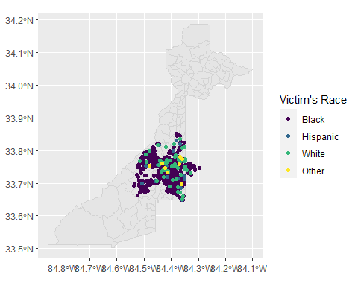

fulton_case_map <- ggplot() +   
 geom_sf(data = fulton_tracts, color = "lightgray") +   
 geom_sf(data = fulton_homicdes, aes(shape = disposition)) +  
 scale_color_viridis(name = "Case Disposition", discrete = TRUE)   
  
fulton_case_map

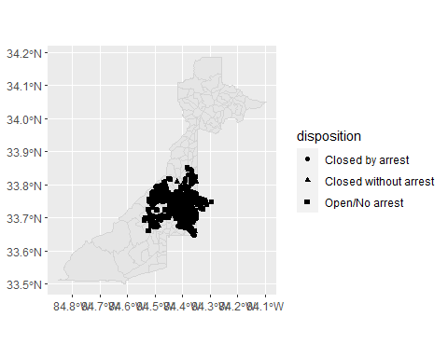 # Faceting Maps

fulton_race_map + facet_grid(victim_race ~ .)

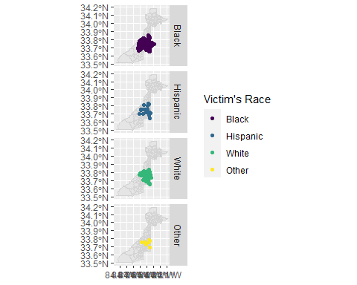

fulton_case_map + facet_grid(disposition ~ .)

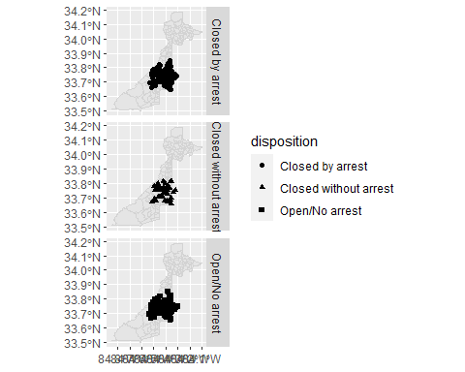

fulton_case_map + facet_grid(disposition ~ victim_race)

