User Scenarios List
short description of all the user scenarios
Nr | Name | Description
US_01 | Create account | User: A new user registers on the Librario platform by filling out a registration form with name, email, and password.
US_02 | Log in | User: All users (Member, Staff, Admin) log in using email and password.
US_03 | Log out | User: A logged-in user logs out to end their session securely.
US_04 | Update profile | User: A logged-in user updates their display name or annual reading goal.
US_05 | Change password | User: A logged-in user changes their password by verifying their current one first.
US_06 | Reset password | User: A user who forgot their password resets it via an email link.
US_07 | Upload profile picture | User: A logged-in user uploads a photo to personalize their profile.
US_08 | View profile | User: A logged-in user views their own account details (name, email, role, goal, join date).
US_09 | Manage user accounts | Administrator: The admin searches for users, views their details, and changes role or status.
US_10 | Deactivate account | Administrator: The admin deactivates a user account so the user can no longer log in.
User Scenarios Extended
US_01: Create account:
- User navigates to the registration page.
- User enters name, email, and password.
- System validates all fields and checks email uniqueness.
- System hashes the password and creates the account.
- User is logged in and redirected to the dashboard.
- If email already exists: System displays error 'Email already exists'.
- If required fields are empty: Form highlights missing fields.

US_02: Log in:
- User navigates to the login page.
- User enters email and password.
- System verifies credentials using BCrypt.
- System stores session data and redirects to the dashboard.
- If credentials are invalid: System shows 'Invalid email or password'.
- If account is deactivated: System shows 'Account deactivated. Contact an administrator.

US_03: Log out:
- User clicks the Logout button in the navigation bar.
- System clears all session data from sessionStorage.
- User is redirected to the login page.
- If session already expired: User is silently redirected to login.

US_04: Update profile:
- User navigates to the Stats page.
- User edits the name or reading goal field.
- User submits the form.
- System saves the changes and shows a confirmation message.
- If name field is left blank: Existing name is preserved.

US_05: Change password:
- User navigates to the Stats page, Change Password section.
- User enters current password, new password, and confirmation.
- System verifies the current password.
- System saves the new BCrypt-hashed password.
- Success message is displayed.
- If current password is wrong: Error 'Current password is incorrect'.
- If new passwords do not match: Inline validation error shown.
- If new password is under 6 characters: Error message displayed.

US_06: Reset password:
- User clicks 'Forgot password' on the login page.
- User enters their registered email address.
- System sends a time-limited reset link to that email.
- User clicks the link and enters a new password.
- System saves the new hashed password.
- If email not found: Generic message shown (prevents enumeration).
- If link expired: User must request a new reset link.

US_07: Upload profile picture:
- User navigates to profile settings.
- User selects an image file (JPG or PNG).
- System validates the file format and size (max 2 MB).
- System resizes and stores the image.
- Profile picture is updated and displayed.
- If file is too large: Error message with size limit shown.
- If format is unsupported: Format error message displayed.

US_08: View profile:
- User navigates to their profile page.
- System retrieves the user's name, email, role, reading goal, and join date.
- Data is displayed in a structured layout.
- If data is temporarily unavailable: A friendly error message is shown.

US_09: Manage user accounts:
- Admin navigates to the Admin Panel.
- Admin searches for users by name or email.
- System returns a list of matching users with details.
- Admin can change a user's role or toggle their active/inactive status.
- Changes are saved immediately.
- If no users match the search: 'No users found' message is shown.
- If a non-admin accesses the panel: Redirected to the dashboard.

US_10: Deactivate account:
- Admin finds the target user in the Admin Panel.
- Admin clicks the 'Deactivate' button.
- System sets IsActive = false for that user.
- User can no longer log in.
- Admin can reactivate the account by clicking 'Activate'.
- If admin attempts to deactivate their own account: System prevents the action.

Use Cases
UC_01: Create account
UC Name | UC_01 — Create account
Dependency | None
Actors | Primary actor: User (new visitor)  Secondary actor: Email Validation Service
Preconditions | User has not previously registered. System is accessible.
Description of the Main Sequence | - User opens the registration page.  - User enters name, email, and password.  - System validates all fields for completeness and email uniqueness.  - System hashes the password with BCrypt and creates the user record.  - User is logged in and redirected to the dashboard.
Description of the Alternative Sequence | - Email already registered: System returns error 'Email already exists'.  - Required fields missing: Form highlights empty fields.  - Password too short: Inline hint shown.
Non-functional requirements | Registration must complete within 3 seconds. Passwords must be stored as BCrypt hashes. System must prevent duplicate email addresses.
Postconditions | A new Member account is created and the user is authenticated.

UC_02: Log in
UC Name | UC_02 — Log in
Dependency | UC_01 — account must exist
Actors | Primary actor: User  Secondary actor: None
Preconditions | User has a registered, active account.
Description of the Main Sequence | - User navigates to the login page.  - User enters email and password.  - System verifies credentials using BCrypt.  - System stores session data (userId, name, role) and redirects to dashboard.
Description of the Alternative Sequence | - Invalid credentials: Error 'Invalid email or password'.  - Account deactivated: Error 'Account deactivated. Contact an administrator'.
Non functional requirements | Login response must be under 2 seconds. Credentials must never be stored in plain text.
Postconditions | User is authenticated and session is active.

UC_03: Log out
UC Name | UC_03 — Log out
Dependency | UC_02
Actors | Primary actor: User  Secondary actor: None
Preconditions | User is currently logged in.
Description of the Main Sequence | - User clicks the Logout button in the header.  - System clears session storage.  - User is redirected to the login page.
Description of the Alternative Sequence | - Session already expired: User is silently redirected to login.
Non functional requirements | Logout must complete instantly (< 0.5s). All session data must be cleared completely.
Postconditions | Session is terminated. User must log in again to access the platform.

UC_04: Update profile
UC Name | UC_04 — Update profile
Dependency | UC_02
Actors | Primary actor: User  Secondary actor: None
Preconditions | User is logged in.
Description of the Main Sequence | - User navigates to Stats page.  - User edits name and/or reading goal fields.  - User submits the changes.  - System validates and saves. Confirmation message shown.
Description of the Alternative Sequence | - Name field submitted empty: Existing name is preserved.
Non functional requirements | Changes must be saved within 2 seconds.
Postconditions | Profile is updated with the new values.

UC_05: Change password
UC Name | UC_05 — Change password
Dependency | UC_02
Actors | Primary actor: User  Secondary actor: None
Preconditions | User is logged in and knows their current password.
Description of the Main Sequence | - User navigates to the Change Password section on Stats page.  - User enters current password, new password, and confirmation.  - System verifies current password with BCrypt.  - System saves new BCrypt hash.  - Success message is displayed.
Description of the Alternative Sequence | - Current password wrong: Error 'Current password is incorrect'.  - New passwords do not match: Inline validation error.  - New password under 6 characters: Error message shown.
Non functional requirements | New password must be stored as BCrypt hash. Change must complete within 2 seconds.
Postconditions | Password is updated. Next login requires the new password.

UC_06: Reset password
UC Name | UC_06 — Reset password
Dependency | None — user is not logged in
Actors | Primary actor: User  Secondary actor: Email Service
Preconditions | User has a registered email address.
Description of the Main Sequence | - User clicks 'Forgot password' on login page.  - User enters their email address.  - System sends a time-limited reset link to that email.  - User clicks the link and enters a new password.  - System saves the new BCrypt hash.
Description of the Alternative Sequence | - Email not found: Generic message shown (prevents user enumeration).  - Reset link expired: User must request a new link.
Non functional requirements | Reset link must expire after 30 minutes and be invalidated after first use.
Postconditions | Password is updated. Old sessions are invalidated.

UC_07: Upload profile picture
UC Name | UC_07 — Upload profile picture
Dependency | UC_02
Actors | Primary actor: User  Secondary actor: File Storage Service
Preconditions | User is logged in.
Description of the Main Sequence | - User navigates to profile settings.  - User selects an image file (JPG/PNG).  - System validates format and size (max 2 MB).  - System resizes the image to 200×200px and stores it.  - Profile picture is updated and displayed.
Description of the Alternative Sequence | - File too large: Error message with size limit shown.  - Unsupported format: Format error message displayed.
Non functional requirements | Upload must complete within 5 seconds. Image must be resized server-side.
Postconditions | Profile picture is saved and displayed on the user's profile.

UC_08: View profile
UC Name | UC_08 — View profile
Dependency | UC_02
Actors | Primary actor: User  Secondary actor: None
Preconditions | User is logged in.
Description of the Main Sequence | - User navigates to their profile page.  - System retrieves name, email, role, reading goal, and join date.  - Data is displayed in a structured layout.
Description of the Alternative Sequence | - Data temporarily unavailable: Friendly error message shown.
Non functional requirements | Profile page must load within 1.5 seconds.
Postconditions | User can see all their current profile information.

UC_09: Manage user accounts
UC Name | UC_09 — Manage user accounts
Dependency | UC_02 — admin must be authenticated
Actors | Primary actor: Administrator  Secondary actor: None
Preconditions | Admin is logged in. Users exist in the system.
Description of the Main Sequence | - Admin navigates to Admin Panel.  - Admin searches for users by name or email.  - System returns a list of matching users.  - Admin views user details and can change role or toggle status.
Description of the Alternative Sequence | - No results found: 'No users found' message shown.  - Non-admin attempts access: Redirected to dashboard.
Non functional requirements | User list must load within 2 seconds. Role changes must apply immediately.
Postconditions | Target user's role or status is updated in the system.

UC_10: Deactivate account

UC Name | UC_10 — Deactivate account
Dependency | UC_09
Actors | Primary actor: Administrator  Secondary actor: None
Preconditions | Admin is logged in. Target user account exists.
Description of the Main Sequence | - Admin finds the target user in Admin Panel.  - Admin clicks 'Deactivate'.  - System sets IsActive = false for that user.  - User can no longer log in.
Description of the Alternative Sequence | - Admin reactivates account: IsActive reset to true.  - Admin attempts to deactivate own account: System prevents the action.
Non functional requirements | Status change must take effect immediately. Action must be logged for audit trail.
Postconditions | Target user account is deactivated. Active sessions are terminated.

Use Case Diagrams

Functional Requirements
Req# | Requirement | Comments | Priority | Date | Reviewed / Approved
FR_01 | The system shall allow new users to register with a unique email, name, and password. | Email uniqueness enforced at database level. | 1 | 01/04/2026 | Kiara Karriqi
FR_02 | The system shall authenticate users using email and BCrypt-hashed password verification. | Plain-text passwords must never be stored or logged. | 1 | 01/04/2026 | Kiara Karriqi
FR_03 | The system shall store user session data in sessionStorage and clear it completely on logout. | Session includes userId, name, and role. | 1 | 01/04/2026 | Kiara Karriqi
FR_04 | The system shall allow logged-in users to update their display name and annual reading goal. | Empty name field must preserve existing name. | 2 | 01/04/2026 | Kiara Karriqi
FR_05 | The system shall require users to verify their current password before setting a new one. | New password must be at least 6 characters. | 1 | 01/04/2026 | Kiara Karriqi
FR_06 | The system shall send a time-limited password reset link to the user's registered email. | Link must expire after 30 minutes and be invalidated after use. | 2 | 01/04/2026 | Kiara Karriqi
FR_07 | The system shall accept JPG/PNG profile pictures up to 2 MB and resize them to 200×200px. | Unsupported formats or oversized files must be rejected with an error. | 3 | 01/04/2026 | Kiara Karriqi
FR_08 | The system shall display the user's name, email, role, reading goal, and account creation date on the profile page. | Data must reflect the latest saved values. | 2 | 01/04/2026 | Kiara Karriqi
FR_09 | The system shall allow administrators to search users by name or email and change their role or active status. | Role changes must take effect immediately without requiring re-login. | 1 | 01/04/2026 | Kiara Karriqi
FR_10 | The system shall prevent deactivated users from logging in and must not allow an admin to deactivate their own account. | Deactivation sets IsActive = false immediately. | 1 | 01/04/2026 | Kiara Karriqi
Non-Functional Requirements

Req# | Category | Requirement
NFR_01 | Performance | All account operations (login, register, profile update) must respond within 3 seconds under normal load.
NFR_02 | Security | All passwords must be stored as BCrypt hashes. Plain-text passwords must never be logged or stored anywhere in the system.
NFR_03 | Security | Session data must be cleared completely on logout. Sessions must not persist after browser close.
NFR_04 | Security | Password reset links must expire after 30 minutes and be invalidated after first use to prevent reuse attacks.
NFR_05 | Usability | Registration and login forms must provide inline validation feedback without a full page reload.
NFR_06 | Usability | Error messages must be user-friendly and must not expose internal system details such as stack traces or database errors.
NFR_07 | Reliability | The authentication system must maintain 99.5% uptime. Planned maintenance windows must not exceed 1 hour per month.
NFR_08 | Scalability | The system must handle at least 100 concurrent authenticated users without performance degradation.
NFR_09 | Compliance | User data must be handled in accordance with GDPR. Users must be able to request deletion of their account and personal data.
NFR_10 | Auditability | All admin actions (role changes, account deactivations) must be logged with timestamp, admin ID, and affected user ID.

Activity Diagrams
workflow for each user scenario — User/System swimlanes
AD_01: Create Account
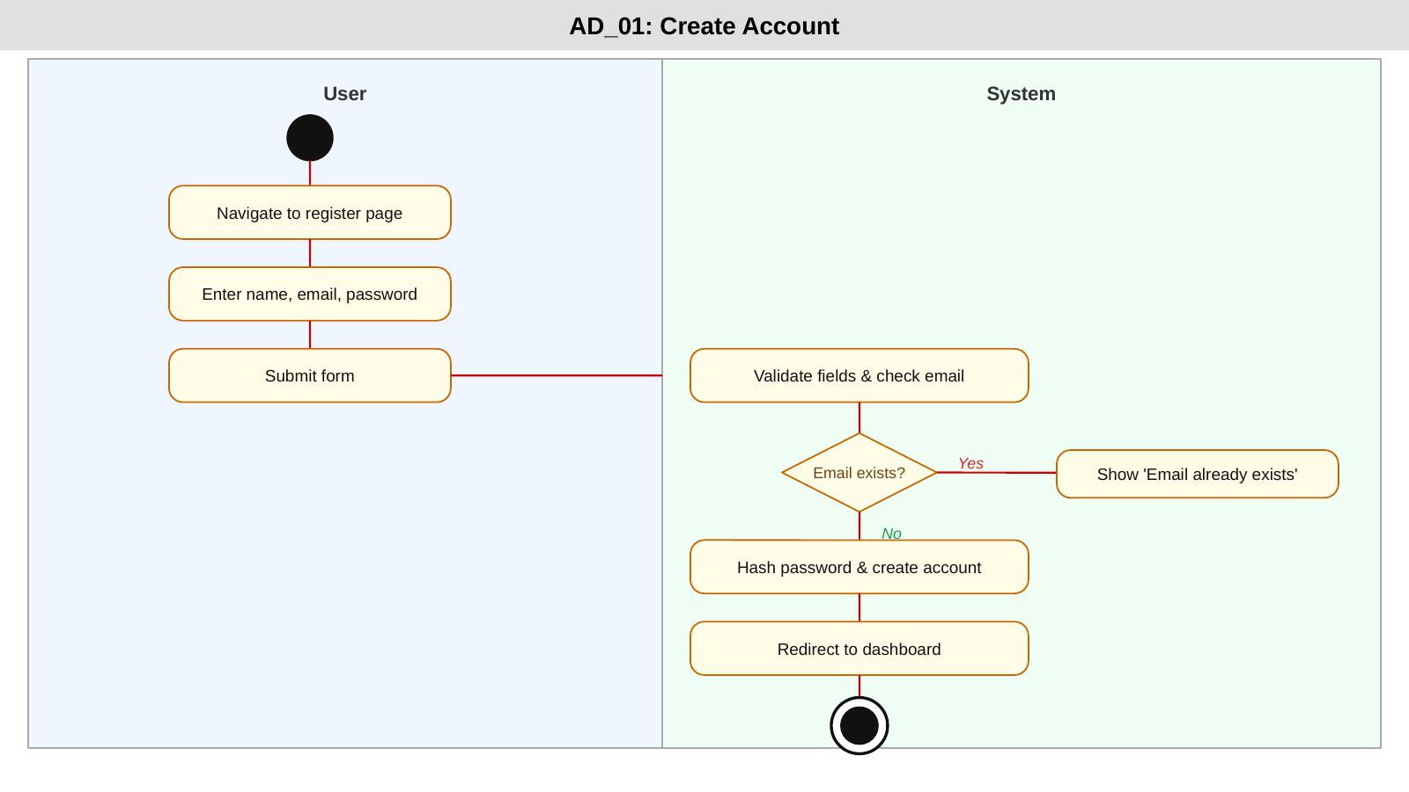

AD_02: Log In
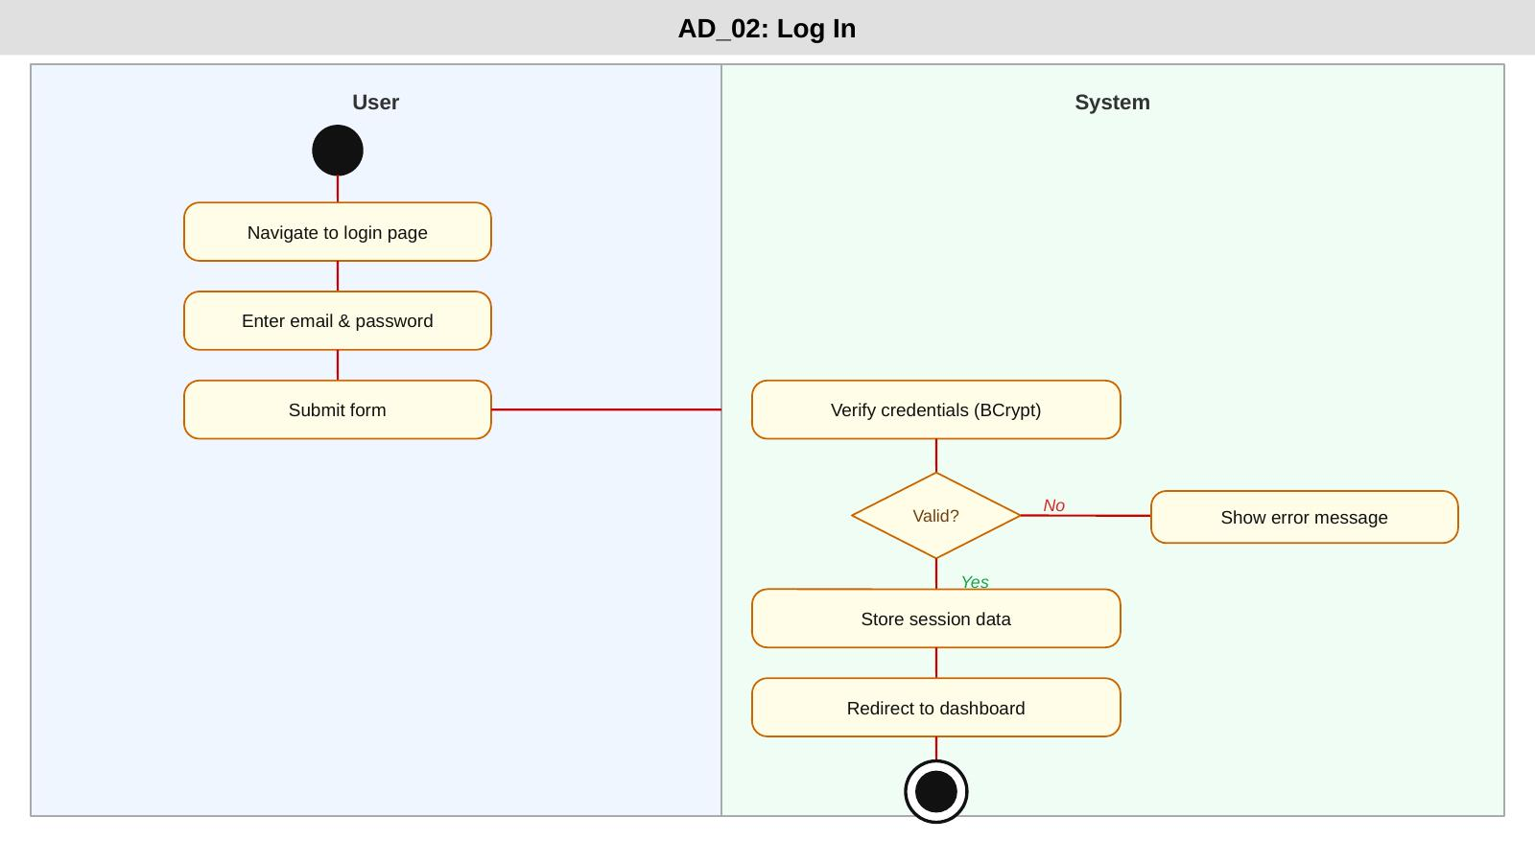

AD_03: Log Out
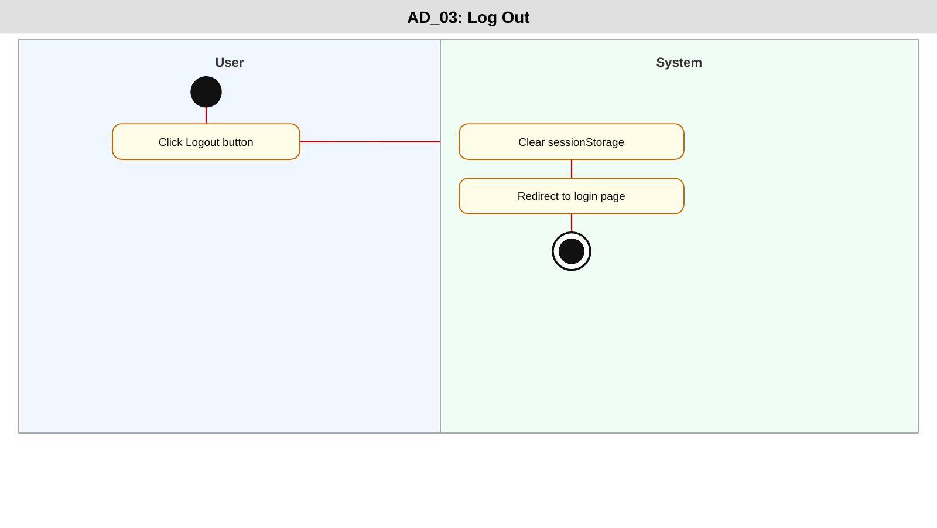

AD_04: Update Profile
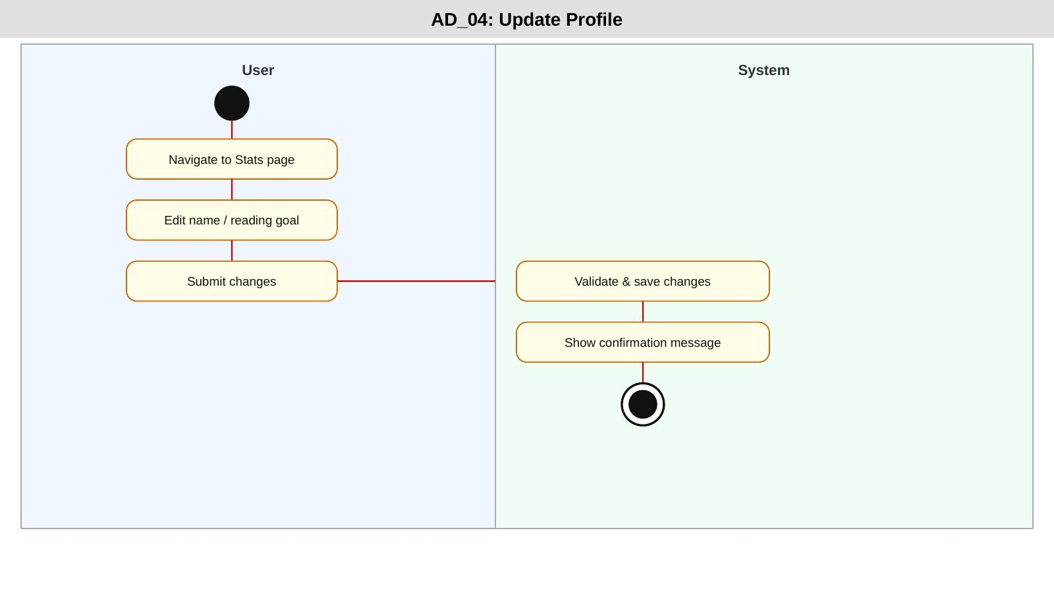

AD_05: Change Password
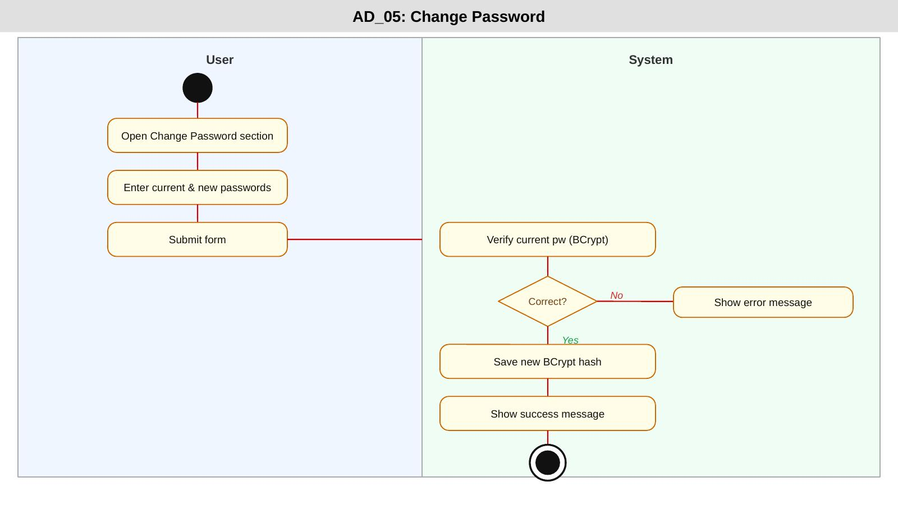

AD_06: Reset Password
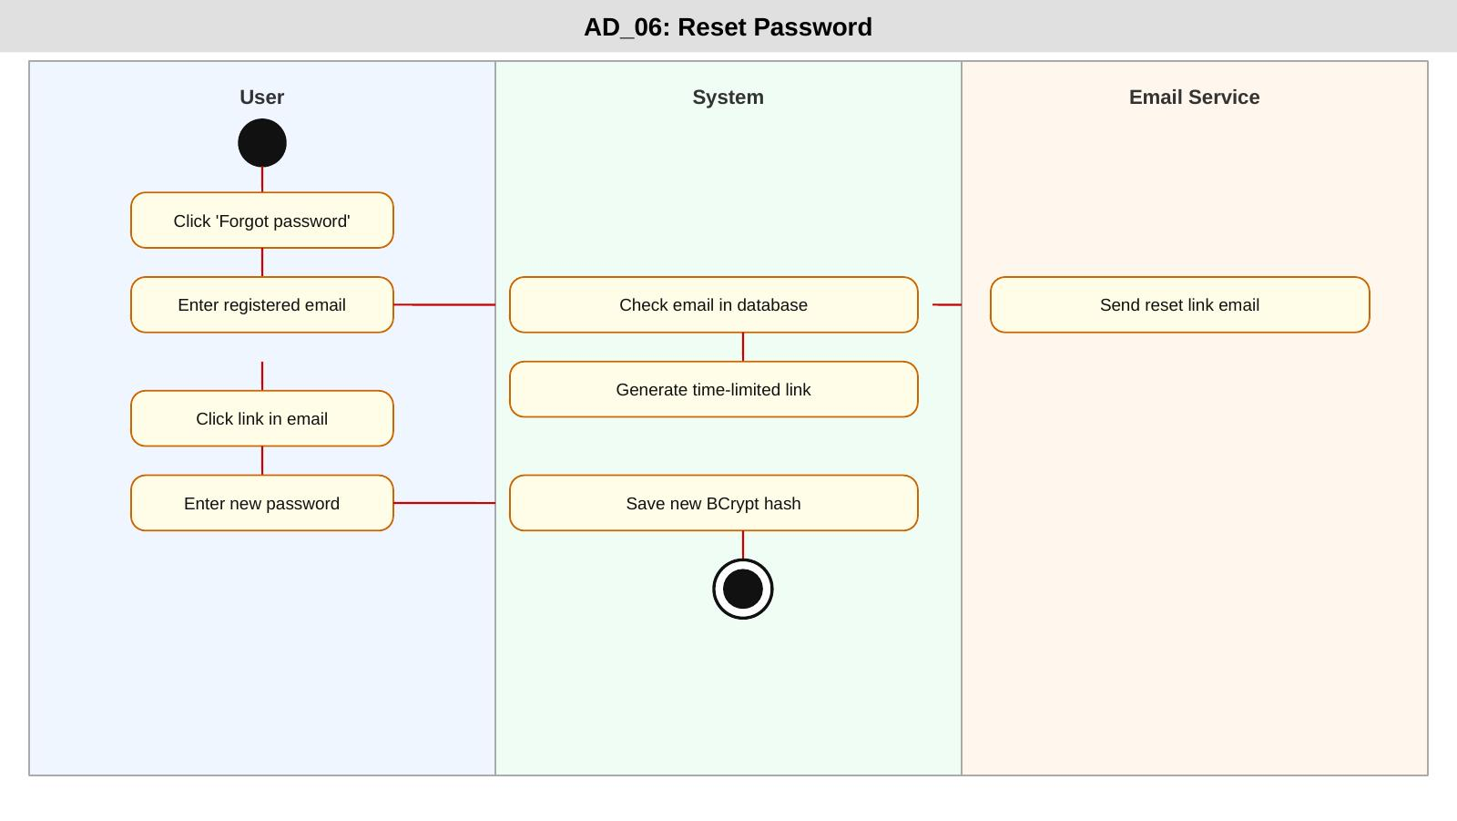

AD_07: Upload Profile Picture
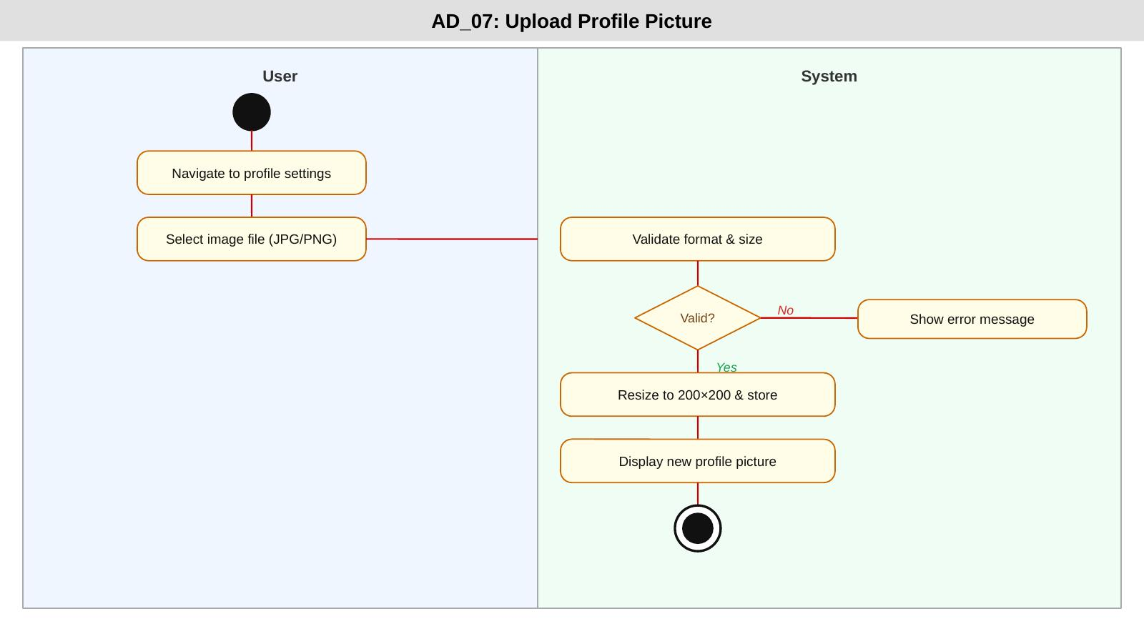

AD_08: View Profile
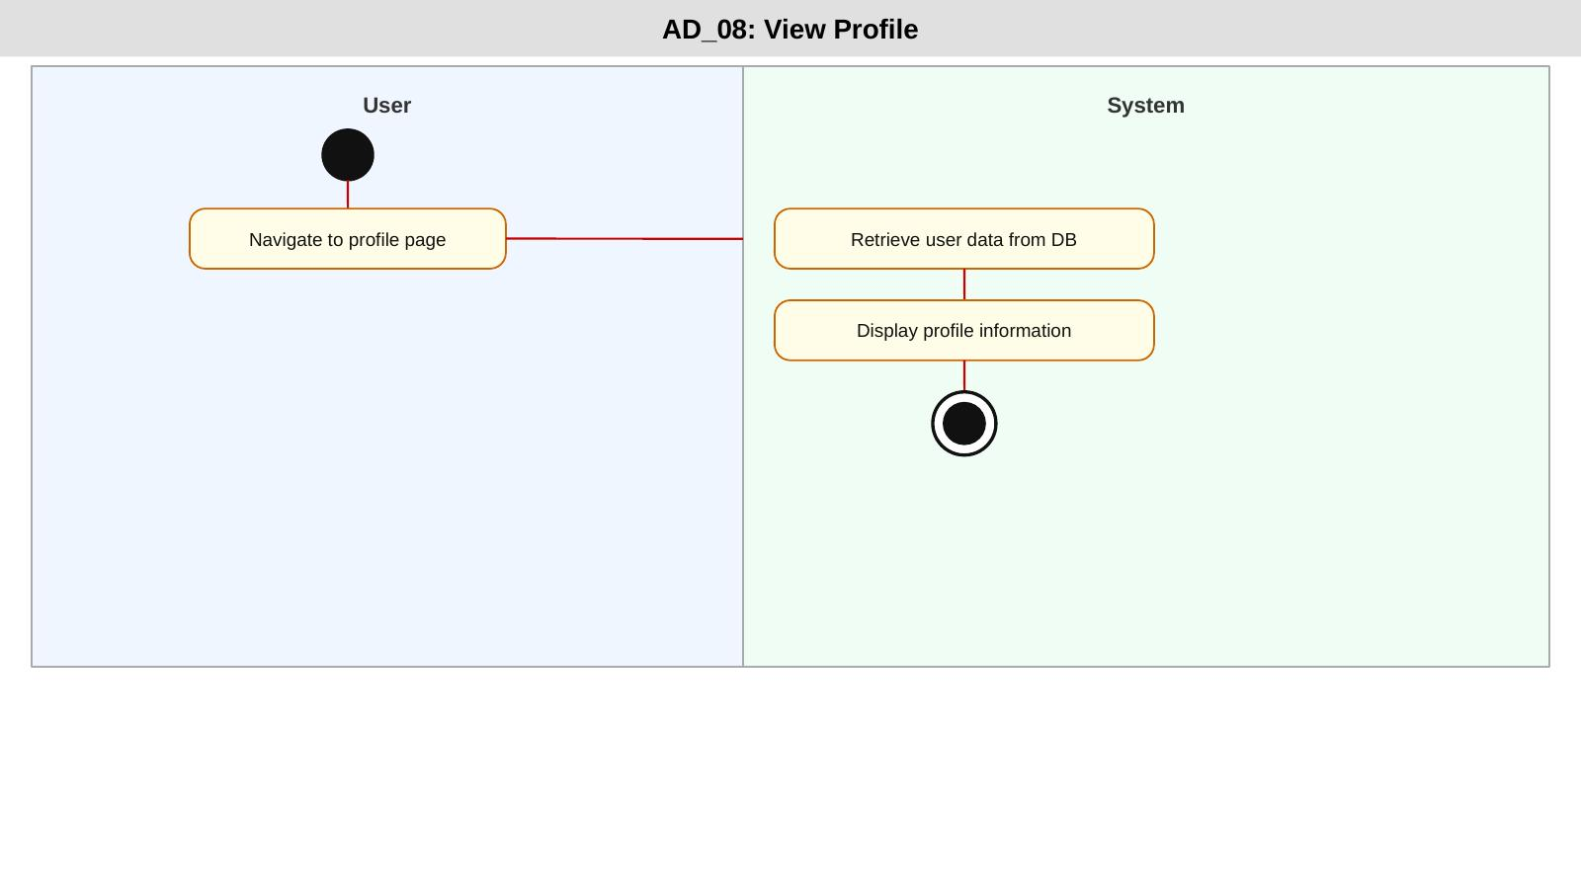

AD_09: Manage User Accounts
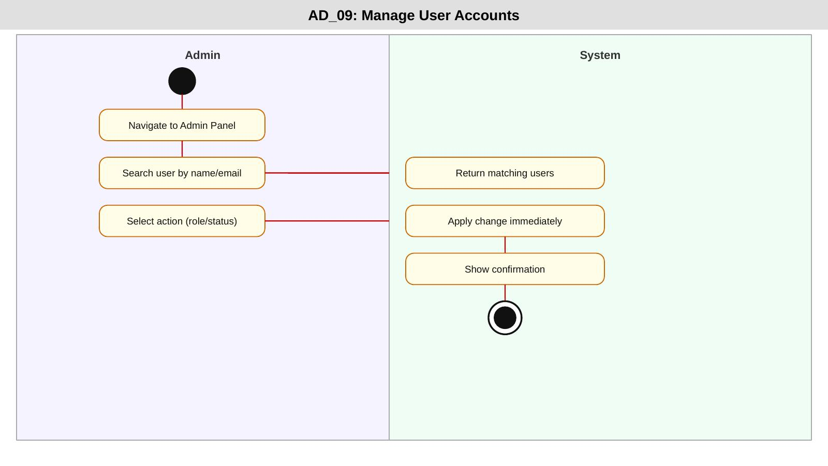

AD_10: Deactivate Account
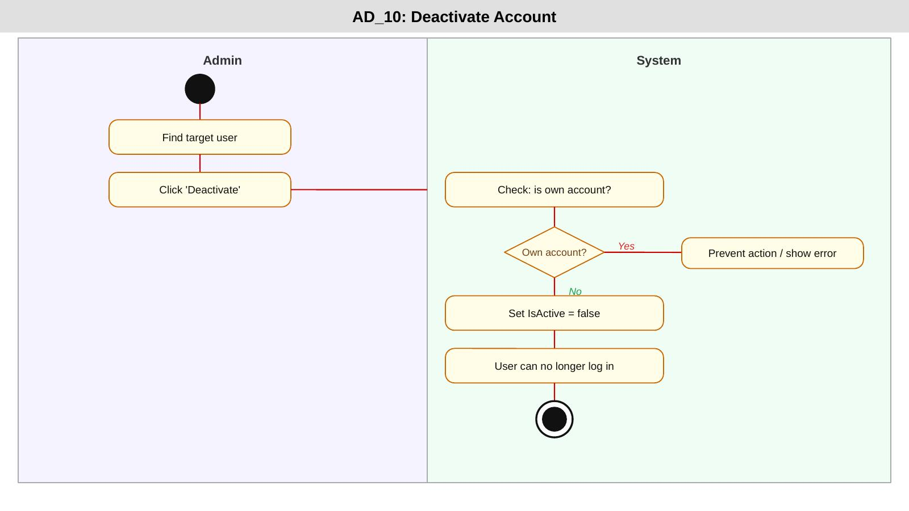

Sequence Diagrams
interaction between actors and system components
SD_01: Create Account
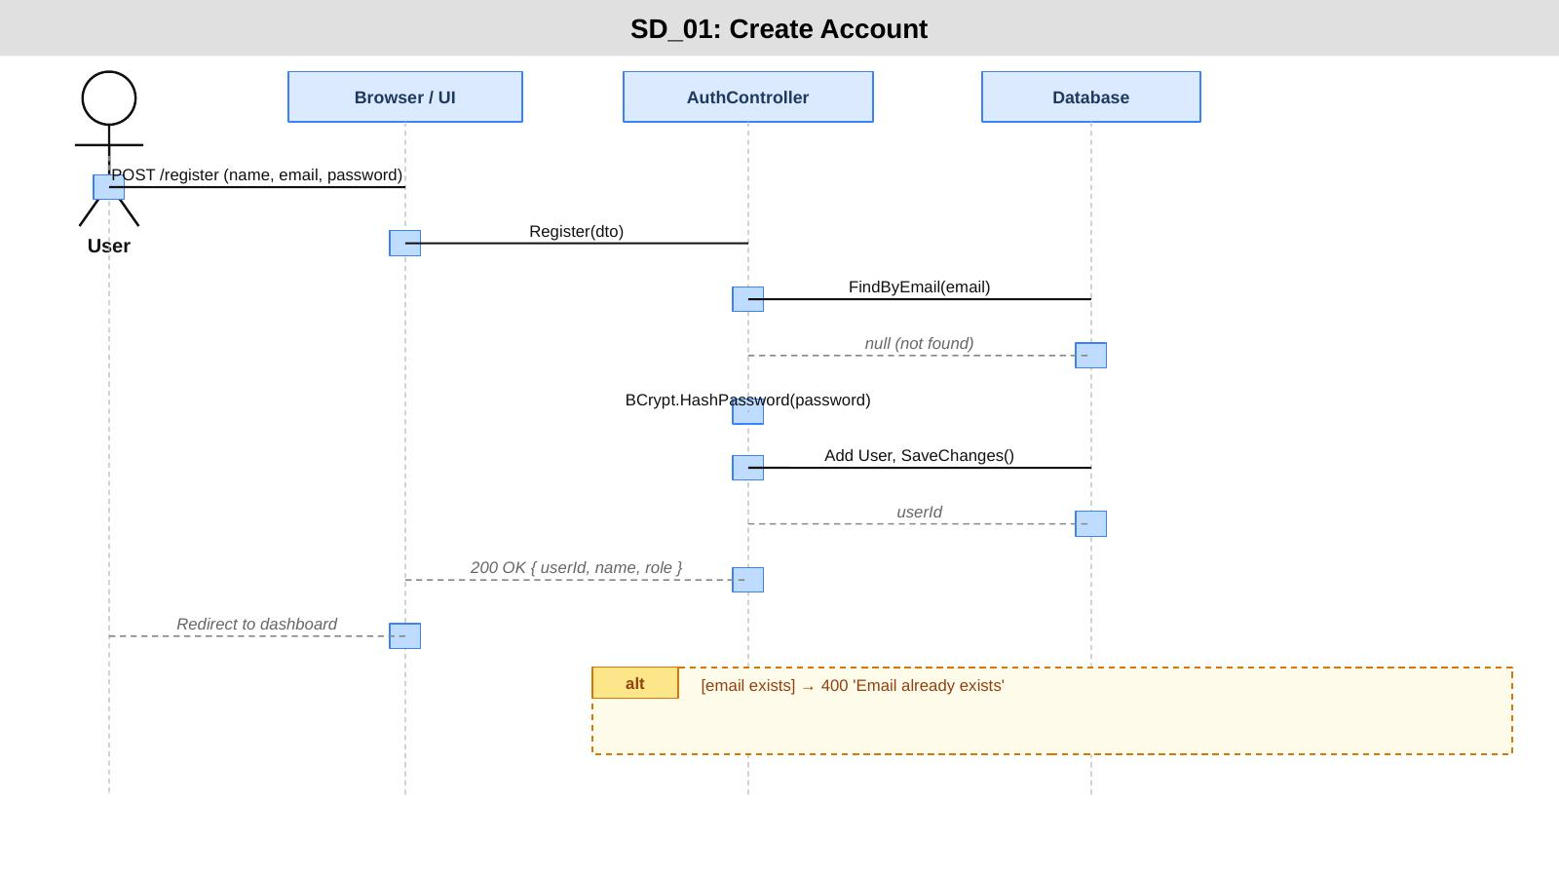

SD_02: Log In
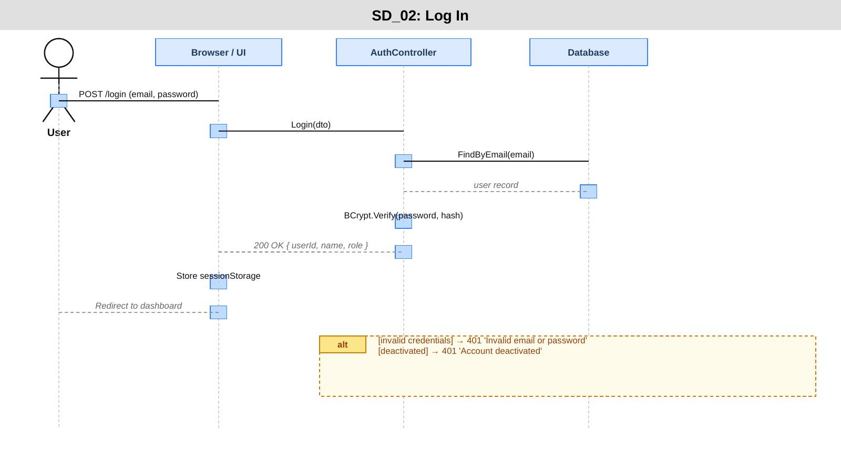

SD_03: Log Out
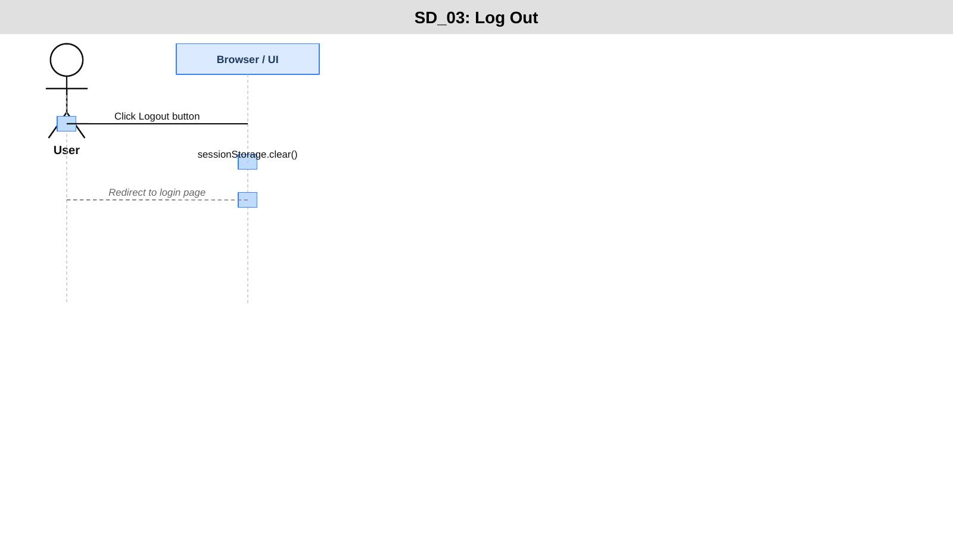

SD_04: Update Profile
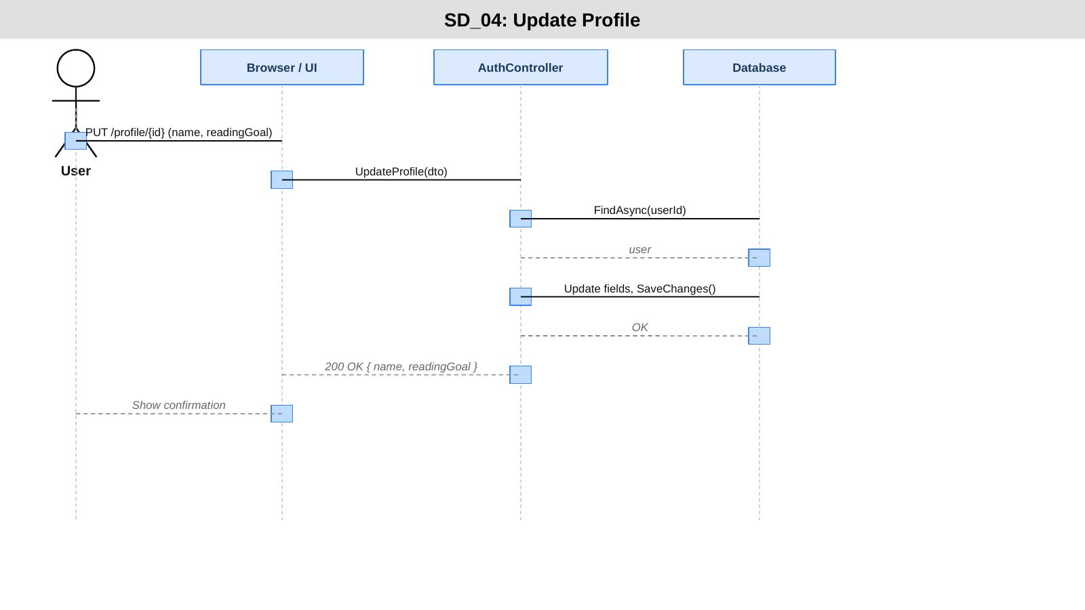

SD_05: Change Password
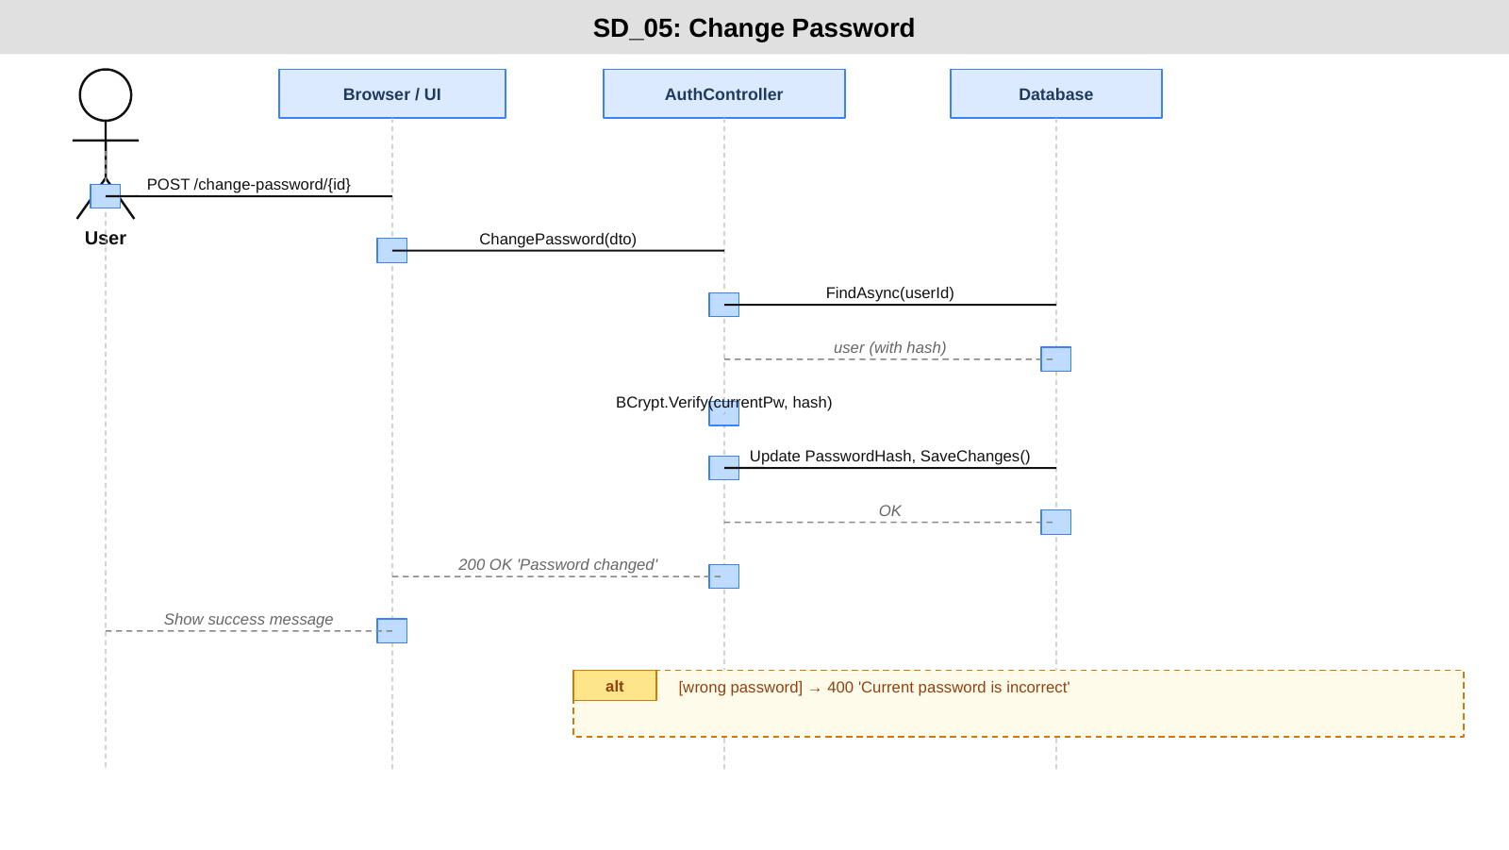

SD_06: Reset Password
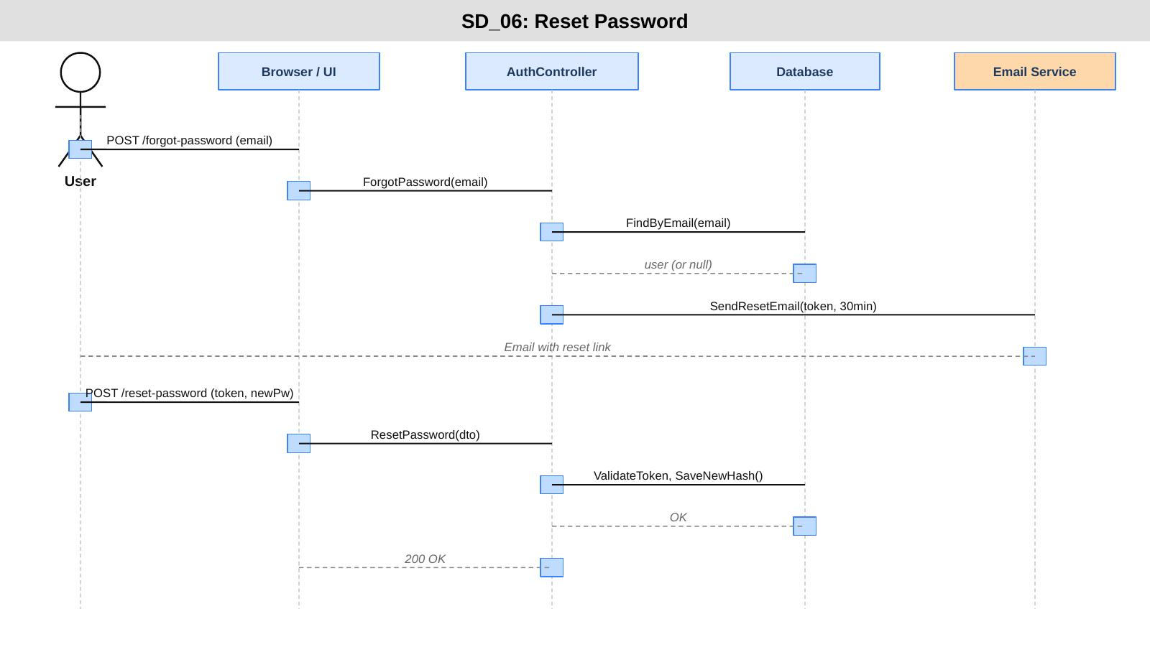

SD_07: Upload Profile Picture
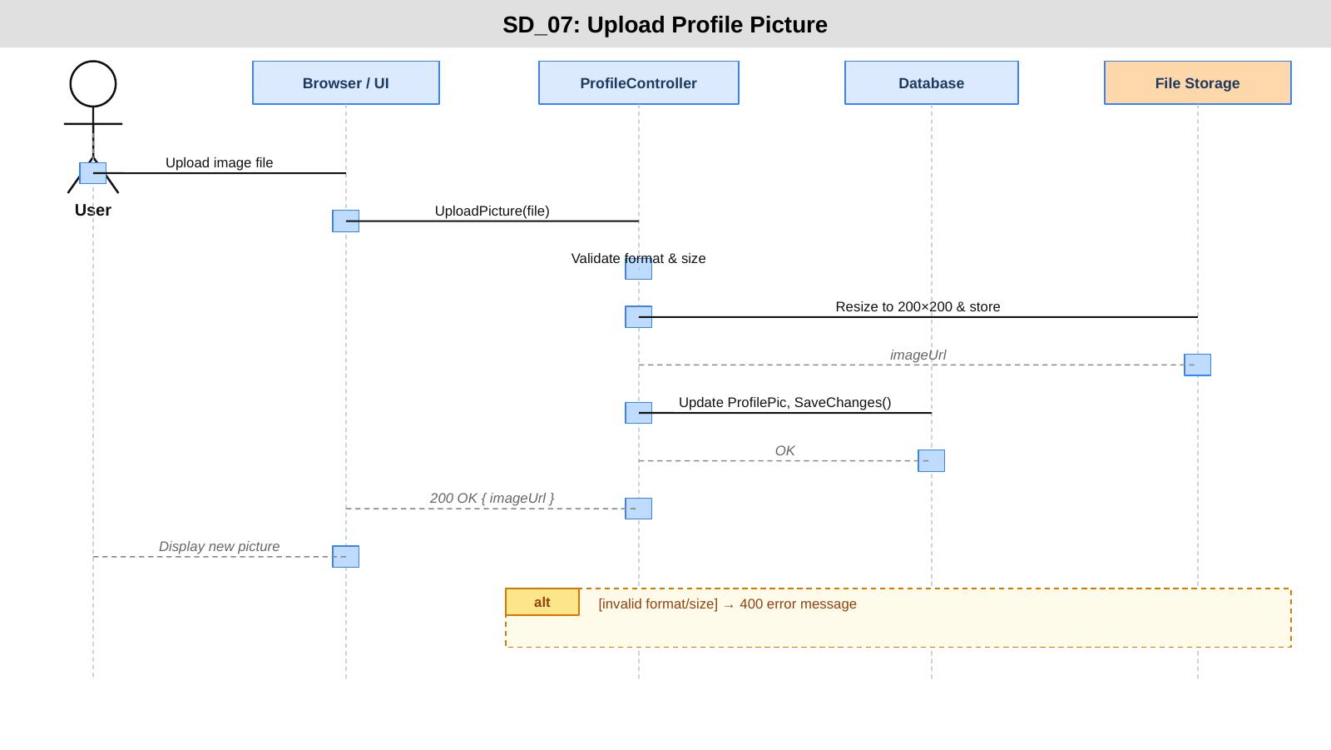

SD_08: View Profile
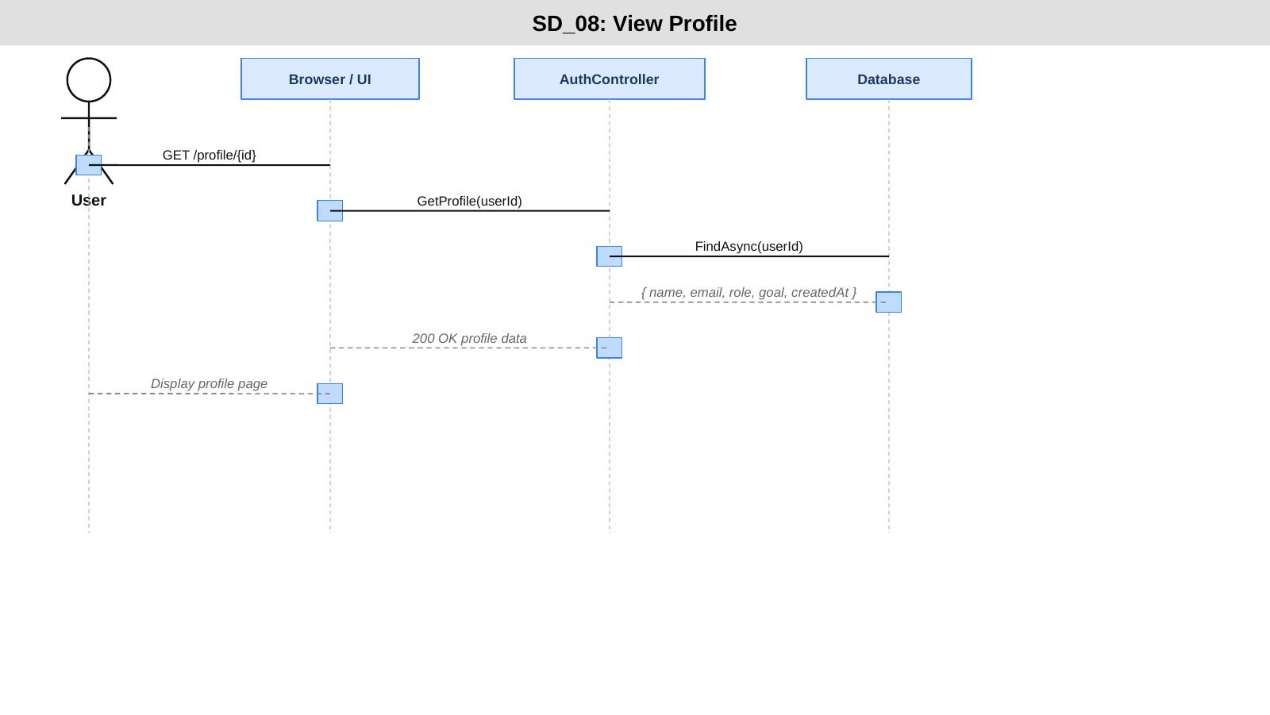

SD_09: Manage User Accounts
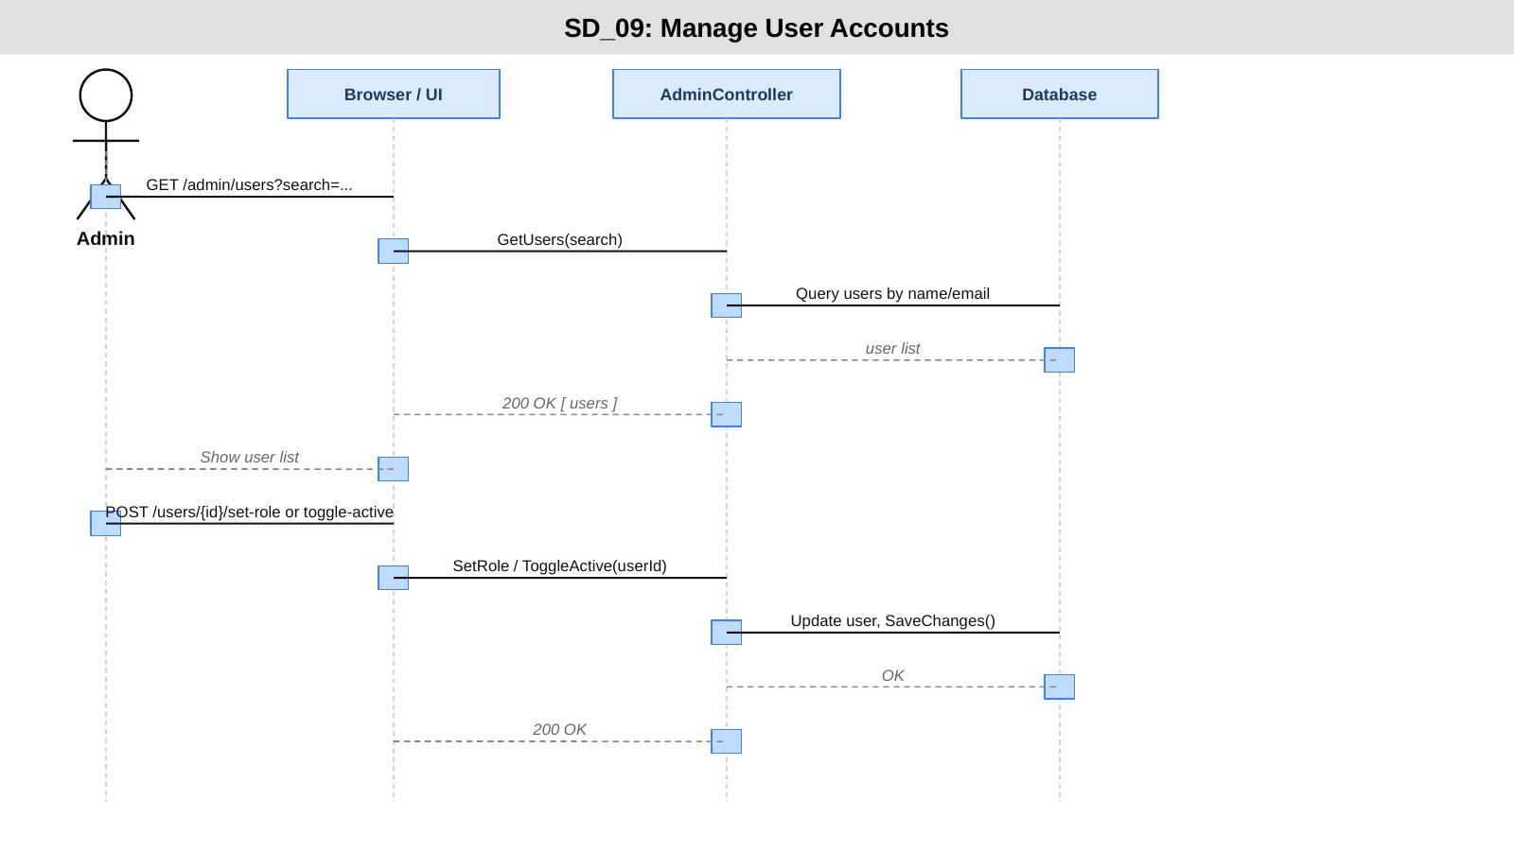

SD_10: Deactivate Account
