LIBRARY MANAGEMENT SYSTEM
Requirements Specification & Software Design
A web-based library management platform built with ASP.NET Core 7 & SQLite

Course
Software Engineering
Group Members
Kiara Karriqi
Xhim Zotaj
Migert Blloshmi
Haris Kockici
Meriklesta Hasanaj
Kasem Bilal Kasemi

Table of Contents
The following sections describe the Library Management System in full: from executive overview through requirements, design diagrams, and implementation evidence.

Table of Contents 3
1. Executive Summary 7
1.1 Project Overview 7
1.2 Purpose and Scope of this Specification 7
In Scope 7
Out of Scope 7
2. Product / Service Description 9
2.1 Product Context 9
2.2 User Characteristics 9
Member 9
Library Staff 10
Administrator 10
2.3 Assumptions 10
2.4 Constraints 11
2.5 Dependencies 11
3. Requirements 12
3.1 Functional Requirements 12
3.1.1 Member Requirements (FR-01 – FR-22) 12
3.1.2 Staff Requirements (FR-23 – FR-31) 15
3.1.3 Administrator Requirements (FR-32 – FR-35) 16
3.2 Non-Functional Requirements 18
3.2.1 Performance 18
3.2.2 Security 18
3.2.3 Reliability 18
3.2.4 Usability 19
3.2.5 Maintainability 19
3.2.6 Compatibility and Deployment 20
3.2.7 Internationalization 20
3.3 Domain Requirements 21
4. Software Design 22
4.1 Use Cases 22
4.1.1 Member Use Cases 22
4.1.2 Staff Use Cases 29
4.1.3 Administrator Use Cases 32
4.2 Use Case Diagrams 34
4.2.1 General Use Case Diagram 34
4.2.2 Member Use Case Diagram 35
4.2.3 Staff Use Case Diagram 36
4.2.4 Administrator Use Case Diagram 37
4.3 Activity Diagrams 38
4.3.1 Register Account (UC-01) 38
4.3.2 Log In (UC-02) 39
4.3.3 Submit Borrow Request (UC-07) 40
4.3.4 Reject Borrow Request (UC-25) 41
4.3.5 Renew an Active Loan (UC-10) 42
4.3.6 Process Book Return (UC-26) 43
4.3.7 Write a Book Review (UC-13) 44
4.3.8 Add Book to Wishlist (UC-14) 45
4.3.9 Register for an Event (UC-21) 46
4.3.10 Book a Study Room (UC-18) 47
4.4 Sequence Diagrams 48
4.4.1 Register Account 48
4.4.2 Log In 49
4.4.3 Submit Borrow Request 50
4.4.4 Reject Borrow Request 51
4.4.5 Renew an Active Loan 52
4.4.6 Process Book Return 53
4.4.7 Write a Book Review 54
4.4.8 Add Book to Wishlist 55
4.4.9 Register for an Event 56
4.4.10 Book a Study Room 57
4.5 State Diagrams 58
4.5.1 Loan 58
4.5.2 Reservation 59
4.5.3 Borrow Request 60
4.5.4 Fine 61
4.5.5 Book Donation 62
4.5.6 Book (catalog availability) 63
4.5.7 User Account 64
4.5.8 Book Review 65
4.5.9 Room Booking 66
4.5.10 Cash Deposit 67
4.6 Class Diagram 68
4.7 Entity-Relationship Diagram and Relational Schema 69
4.7.1 Entity-Relationship Diagram 69
4.7.2 Relational Schema 70
4.8 Component Diagram 71
4.9 Deployment Diagram 72
5. Implementation 73
5.1 Technology Stack 73
5.1.1 Backend 73
5.1.2 Frontend 73
5.1.3 Database 74
5.2 Architecture 74
5.2.1 API Architecture (REST) 74
5.2.2 Cross-Cutting Concerns 75
6. Software Screenshots 76
6.1 Authentication & Registration 76
Login Page 76
Registration Page 77
6.2 Member Portal 78
Member Dashboard 78
Catalog (Browse & Search) 78
Borrow Request Flow 80
My Loans & Pending Requests 81
Overdue Loans View 82
Borrow Block Notice 83
Study Room Booking 84
Notifications Centre 85
Personal Reading Stats 86
6.3 Staff Dashboard 87
Pending Borrow Requests 87
Active Loans 87
Check-in / Check-out 88
Book Condition Assessment 88
Return Submission 89
Fine Payment Confirmation 89
6.4 Administrator Console 90
User Management 90
Review Moderation View 90
7. Conclusion 91

1. Executive Summary

1.1 Project Overview
Libraries are still essential community hubs, yet many continue to rely on paper-based borrowing slips, single-purpose desktop applications, or fragmented digital tools to manage their day-to-day operations. The result is friction for everyone involved: members cannot easily check what is on the shelves, staff lose time on manual approvals and overdue tracking, and administrators have no clear view of overall library activity.
The Library Management System (LMS) described in this document is a web-based platform that addresses these gaps. It gives members a self-service interface for searching the catalog, borrowing books, reserving unavailable titles, booking study rooms, registering for events, and tracking their own reading activity. It gives staff a single dashboard for approving borrow requests, processing returns, moderating reviews, and handling cash deposits and fine payments. It gives administrators full control over users, fine policy, and library-wide statistics.
The system is implemented as an ASP.NET Core Web API backed by a SQLite database, with a lightweight HTML / CSS / JavaScript frontend served directly by the same backend. This design keeps deployment simple — a single executable plus a static folder — while remaining production-credible.

1.2 Purpose and Scope of this Specification
This document specifies, in detail, what the Library Management System does and how it is built. It covers the user roles served by the platform, the functional and non-functional requirements that drive development, the detailed software design (use cases, activity, sequence, state, class, ERD, component, and deployment diagrams), and the implementation evidence (technology stack and screenshots of the running system).

In Scope
- Self-service member features: catalog search, borrow requests, reservations, wishlist, fines view, room bookings, donations, events, reading stats, and recommendations.
- Staff workflows: approving and rejecting borrow requests, processing returns with book-condition assessment, settling cash deposits, confirming cash fine payments, moderating reviews, reviewing donations, and managing the catalog.
- Administrator capabilities: user management, fine waivers, fine-policy configuration, and library-wide statistics.
- A REST HTTP API, a SQLite-backed data layer, and a static HTML / CSS / JavaScript frontend.

Out of Scope
- Online payment processing — all fine and deposit transactions are handled in cash at the desk and recorded by staff.
- Inter-library loans across multiple library branches.
- Hardware integrations such as RFID, barcode scanners, or self-checkout kiosks.
- Native mobile applications — access is browser-based only.

2. Product / Service Description
The Library Management System is a self-contained web application. It does not depend on any external library catalog, payment gateway, or authentication provider. All data is created, stored, and consumed inside the platform's own SQLite database, and all user-facing screens are served by the application itself.

2.1 Product Context
The platform serves a single library. Three role-based interfaces share the same backend: a member-facing portal for everyday borrowing activity, a staff dashboard for desk operations, and an administrator console for users and policy. Although the data model and APIs are general enough to be extended (e.g., multi-branch support, online payments), the current scope is a single library running a single deployment.

2.2 User Characteristics
The system serves three categories of user, each with a distinct dashboard and a distinct set of permissions:

Member
- Registers, logs in, and changes password.
- Searches books by title or author and filters by category and availability.
- Submits and cancels borrow requests; views and renews active loans.
- Reserves unavailable books, tracks queue position, and cancels reservations.
- Writes a 1–5 star review after returning a book (one review per book).
- Adds and removes books from a personal wishlist and is notified when a wishlisted book becomes available.
- Views personal fines and requests cash payment confirmation.
- Books study rooms (maximum 2 active bookings, maximum 2 hours per slot) and cancels at least 30 minutes before the slot start.
- Donates books for staff review and tracks donation status (Pending / Approved / Rejected).
- Views library events; registers and unregisters.
- Views personal notifications and marks them as read.
- Views personal reading statistics (total loans, monthly activity, reading-goal progress, top 5 categories).
- Views personalized book recommendations and dismisses unwanted ones.

Library Staff
- Reviews pending borrow requests; approves them (collecting a cash deposit) or rejects them with a reason.
- Checks out books to members and processes returns, recording the book's condition (Good / MinorWear / SignificantDamage / MajorDamage / Lost) and applying damage fees automatically.
- Manages cash deposits collected for borrow requests — returns them when books come back, or forfeits them with a documented reason.
- Confirms cash fine payments at the desk.
- Moderates book reviews and removes inappropriate ones (the review author is notified).
- Reviews donation submissions from members and approves or rejects them.
- Adds new books to the catalog (title, ISBN, author, category, total copies).
- Creates library events for members to register for.
- Views all active loans, overdue loans, and pending pickups in a single dashboard.
- Receives notifications when new borrow requests, donations, or returns need attention.

Administrator
- Manages all users — views the full list, searches by name or email, activates and deactivates accounts, and changes roles (Member / Staff / Admin).
- Waives fines with a documented reason; affected members receive a notification.
- Updates the fine policy (daily rate, grace period, borrow-block threshold).
- Views library-wide statistics: total loans this month, overdue books, outstanding and collected fines, total active members, and the top 10 most-borrowed books.
- Has access to everything a Staff member can do (approving requests, managing returns, deposits, donations, events, reviews, etc.).

2.3 Assumptions
- Members and staff access the system through a modern web browser; an Internet connection (or a local network with the server reachable) is required.
- All cash transactions (deposits, fine payments) happen physically at the library desk; the system records, but does not process, payments.
- Library staff trust the condition assessment performed at the desk; the system automates the resulting fee, not the assessment itself.
- Members are responsible for keeping their email address current, because all notifications are linked to the email used at registration.

2.4 Constraints
- The backend targets a single .NET 7 runtime and a single SQLite file; multi-server replication is out of scope for this version.
- The frontend is intentionally a static HTML / CSS / JavaScript bundle: there is no build step, no framework runtime, and no client-side routing library.
- Authentication is session-based via sessionStorage on the client; the API itself does not currently issue or validate JWTs.
- All monetary values are stored and displayed in Euros (€) with two decimal places.

2.5 Dependencies
- A book must exist in the catalog before any borrow request, reservation, wishlist entry, review, or donation can refer to it.
- A review can only be submitted after the corresponding loan has been returned, and only once per member per book.
- A deposit settlement (return or forfeit) requires the underlying loan to first be checked back in.
- A fine confirmation by staff requires the member to first have requested the cash payment on their own fines page.

3. Requirements
Requirements are split into functional requirements (what the system must do, grouped by actor) and non-functional requirements (qualities the system must exhibit, such as performance, security, and maintainability). Each functional requirement includes a reference to the API endpoint (or endpoints) that implements it in the source code; this provides a direct trace from specification to implementation.

3.1 Functional Requirements

3.1.1 Member Requirements (FR-01 – FR-22)
Req # | Requirement | Description | Implementation
FR-01 | Account Registration | The system shall allow a new user to register an account by providing name, email, and password. The system shall reject registration if the email is already in use. | POST /api/Auth/register
FR-02 | Authentication | The system shall authenticate users by verifying email and password, and shall return the user's role (Member / Staff / Admin) upon successful login. | POST /api/Auth/login
FR-03 | Password Change | The system shall allow authenticated users to change their password after verifying the current password. | POST /api/Auth/change-password/{userId}
FR-04 | Book Search | The system shall allow members to search the catalog by book title or author name, returning all matching active books. | GET /api/Books
FR-05 | Category Filtering | The system shall allow members to filter the catalog by category. Filters shall be combinable with search and availability filters. | GET /api/Books + GET /api/categories
FR-06 | Book Details View | The system shall display detailed information for each book, including title, author, category, ISBN, total copies, available copies, average rating, and user reviews. | GET /api/Books/{id} + GET /api/Reviews/book/{bookId}
FR-07 | Borrow Request Submission | The system shall allow members to submit a borrow request for a book with a chosen duration between 1 and 30 days. The system shall reject requests if the book has no available copies, if the member already has 5 active loans, if the member has an active borrow block due to unpaid fines at or above the configured threshold, or if the member already has a pending request for the same book. | POST /api/borrowrequest
FR-08 | Borrow Request Cancellation | The system shall allow members to cancel their own borrow requests while the request status is Pending. | POST /api/borrowrequest/{id}/cancel
FR-09 | Personal Loan History | The system shall display each member's complete loan history including borrow date, due date, return date, status, and renewal count. | GET /api/Loans/user/{userId}
FR-10 | Loan Renewal | The system shall allow members to renew an active loan up to 2 times, extending the due date by 14 days each time. The system shall reject renewal if another member has reserved the book or if the member has unpaid fines exceeding the threshold. | POST /api/Loans/{loanId}/renew
FR-11 | Book Reservation | The system shall allow members to reserve books, assigning a FIFO queue position based on reservation order. A reservation expires automatically after 3 days. The system shall reject the request if the member already has 3 active pending reservations or already has a pending reservation for the same book. | POST /api/Reservations
FR-12 | Reservation Cancellation | The system shall allow members to cancel their own pending reservations. | DELETE /api/Reservations/{id}
FR-13 | Book Review Submission | The system shall allow members to submit a review (rating from 1 to 5 stars and optional text up to 500 characters) only after returning a book. The system shall prevent submitting more than one review per book per member. | POST /api/Reviews
FR-14 | Wishlist Add | The system shall allow members to add books to their personal wishlist. The system shall enforce uniqueness per member and per book. | POST /api/Wishlist
FR-15 | Wishlist Remove | The system shall allow members to remove books from their personal wishlist. | DELETE /api/Wishlist/{userId}/{bookId}
FR-16 | Personal Fine View | The system shall display each member's fines including amount, reason, status (Unpaid / Pending / Paid / Waived), and the related book. | GET /api/Fines/user/{userId}
FR-17 | Fine Payment Request | The system shall allow members to mark an unpaid fine as paid in cash, changing its status to Pending for staff confirmation. | POST /api/Fines/{fineId}/request-payment
FR-18 | Room Booking | The system shall allow members to book a study room. The system shall enforce a maximum of 2 active bookings per member and a maximum slot duration of 2 hours. The system shall reject overlapping bookings for the same room. | POST /api/Rooms/book
FR-19 | Room Booking Cancellation | The system shall allow members to cancel a room booking only when the current time is more than 30 minutes before the slot start. | DELETE /api/Rooms/bookings/{id}
FR-20 | Book Donation Submission | The system shall allow members to submit a book donation with title, author, condition, and notes. Donations shall be created with status Pending pending review. | POST /api/Donations
FR-21 | Event Registration | The system shall allow members to register for upcoming library events. If the event still has available capacity, the registration is confirmed; otherwise the member is placed on a waitlist with an assigned position, and is automatically promoted to confirmed when another member unregisters. | POST /api/Events/{eventId}/register
FR-22 | Reading Stats and Recommendations | The system shall display each member's reading statistics including total loans, monthly activity, reading goal progress, and top categories. The system shall also generate personalized book recommendations based on borrowing history, and allow members to dismiss unwanted recommendations. | GET /api/Stats/member/{userId} + GET /api/Stats/recommendations/{userId}

3.1.2 Staff Requirements (FR-23 – FR-31)
Req # | Requirement | Description | Implementation
FR-23 | Pending Request View | The system shall display all pending borrow requests to staff, including member name, book title, requested duration, and timestamp. | GET /api/borrowrequest/pending
FR-24 | Borrow Request Approval | The system shall allow staff to approve a pending borrow request by recording the deposit amount and optional notes. Approval shall create an active loan, decrement available copies, and notify the member. | POST /api/borrowrequest/{id}/approve
FR-25 | Borrow Request Rejection | The system shall allow staff to reject a pending borrow request with a documented reason. The system shall notify the member of the rejection. | POST /api/borrowrequest/{id}/reject
FR-26 | Book Return Processing | The system shall allow staff to process book returns by selecting the book's condition (Good / MinorWear / SignificantDamage / MajorDamage / Lost) and optional notes. The system shall automatically apply damage fees according to the fine policy and overdue fines if the loan is returned past its due date. | POST /api/Loans/return/{loanId}
FR-27 | Deposit Settlement | The system shall allow staff to either return a held deposit to the member upon successful book return, or forfeit the deposit with a documented reason. The member shall be notified of either action. | POST /api/deposits/{id}/return + POST /api/deposits/{id}/forfeit
FR-28 | Cash Fine Payment Confirmation | The system shall allow staff to confirm cash fine payments received at the desk. Confirmation shall change the fine status to Paid and record the confirming staff member. | POST /api/Fines/{fineId}/confirm-payment
FR-29 | Review Moderation | The system shall allow staff to remove inappropriate book reviews. Removal shall soft-delete the review, recalculate the book's average rating, and notify the review author. | DELETE /api/Reviews/{id}
FR-30 | Donation Approval or Rejection | The system shall allow staff to approve a pending donation (adding the book to the catalog) or reject it with a documented reason. The donor shall be notified of the decision. | POST /api/Donations/{id}/approve + POST /api/Donations/{id}/reject
FR-31 | Book Catalog Management | The system shall allow staff to add new books to the catalog by providing title, ISBN, author, category, and total copies. The system shall reject duplicate ISBN entries. | POST /api/Books

3.1.3 Administrator Requirements (FR-32 – FR-35)
Req # | Requirement | Description | Implementation
FR-32 | User Management | The system shall allow administrators to view all users, search by name or email, activate or deactivate accounts, and change user roles (Member / Staff / Admin). An administrator shall not be permitted to deactivate their own account. | GET /api/Admin/users + POST /api/Admin/users/{userId}/toggle-active + POST /api/Admin/users/{userId}/set-role
FR-33 | Fine Waiver | The system shall allow administrators to waive a fine by providing a documented reason. The waived fine shall record the administrator's ID and the member shall be notified. | POST /api/Fines/{fineId}/waive
FR-34 | Fine Policy Configuration | The system shall allow administrators to update the core fine policy via PUT /api/Fines/policy: daily overdue rate, grace period (days), and borrow-block threshold. Damage-fee values (minor wear, significant damage, major damage, lost) and suspension settings are persisted in the FinePolicy entity and seeded with defaults but are not currently exposed through the policy-update endpoint. Updated values shall apply to all future fine calculations. | PUT /api/Fines/policy
FR-35 | Library-Wide Statistics | The system shall provide administrators with library-wide statistics including total loans this month, total overdue loans, outstanding and collected fine totals, total active members, and the top 10 most-borrowed books. | GET /api/Stats/admin

3.2 Non-Functional Requirements
Non-functional requirements describe the quality attributes of the system. They are grouped into seven categories: performance, security, reliability, usability, maintainability, compatibility and deployment, and internationalization.

3.2.1 Performance
Req # | Name | Description
NFR-01 | Response Time | The system shall respond to standard API requests (search, list, view) within 2 seconds under normal load.
NFR-02 | Search Performance | The catalog search shall return results within 1 second for typical library collections.

3.2.2 Security
Req # | Name | Description
NFR-03 | Password Storage | The system shall store user passwords as hashes, never in plain text. (Implementation: BCrypt.Net-Next 4.0.3, verified in Program.cs.)
NFR-04 | Role-Based Access Control | The system shall define three distinct roles (Member, Staff, Admin) and enforce role-based UI restrictions client-side via auth.js, which redirects unauthenticated users to /login.html and conditionally renders role-specific pages based on the role stored in sessionStorage. Server-side authorization (e.g., [Authorize] attributes, JWT middleware) is not enforced in the current version and is identified as a hardening item before any production deployment.
NFR-05 | Self-Protection | The system shall prevent an administrator from deactivating their own account.
NFR-06 | Soft Delete | The system shall use soft deletion for books and reviews to preserve historical data and audit trails. (Implementation: Book.IsActive, BookReview.IsDeleted in Models.cs.)
NFR-07 | Server-Side Validation | The system shall validate all user input on the server side before persisting data, including range constraints (review rating 1–5, loan duration 1–30 days, room booking ≤ 2 hours, maximum 2 renewals, maximum 2 active room bookings per member).

3.2.3 Reliability
Req # | Name | Description
NFR-08 | Data Integrity | The system shall enforce referential integrity through foreign key constraints and unique indexes (one review per member-book pair, one wishlist entry per member-book pair, one event registration per member-event pair). (Implementation: HasIndex(...).IsUnique() in LibraryDbContext.OnModelCreating.)
NFR-09 | Transactional Consistency | Each multi-step write operation (book return, borrow-request approval) is committed via a single SaveChangesAsync call so that all entity changes within that call succeed or fail together. Multi-call distributed transactions across separate SaveChanges invocations are not used in the current version.
NFR-10 | Automatic Overdue Processing | The system shall automatically process overdue loans via a background service without requiring manual intervention. (Implementation: OverdueProcessorService registered as IHostedService in Program.cs.)

3.2.4 Usability
Req # | Name | Description
NFR-11 | Browser Compatibility | The frontend shall work correctly on the latest versions of Chrome, Firefox, Safari, and Edge.
NFR-12 | Responsive Feedback | The system shall provide visual feedback for user actions (toasts, status badges, loading states) within 300 ms of the action.
NFR-13 | Error Messaging | The system shall display clear, user-friendly error messages in plain language when an operation fails, without exposing technical stack traces.
NFR-14 | Notification Visibility | The system shall display unread notifications via a persistent widget visible on all member-facing pages. (Implementation: notifications-widget.js in FrontEnd/.)

3.2.5 Maintainability
Req # | Name | Description
NFR-15 | Code Organization | The backend organizes endpoints by domain, with each controller annotated [ApiController] and [Route("api/[controller]")]. Auth, Books, Loans, BorrowRequest, and the OverdueProcessorService live in dedicated files; the remaining 12 domain controllers (Reservations, Fines, Reviews, Wishlist, Rooms, Donations, Events, Notifications, Stats, Admin, Authors, Categories) are co-located in AllControllers.cs as separate classes within the same file for build-time compactness. Each controller remains independently modifiable.
NFR-16 | Database Migrations | The system shall use Entity Framework Core migrations to track and apply schema changes in a versioned, reproducible manner. (Verified: six migrations present under LibraryAPI/Migrations/.)
NFR-17 | Configurable Policies | Configurable values (fine rates, grace period, borrow block threshold) shall be stored in the database and editable by administrators without redeploying the application. (Implementation: FinePolicy entity in Models.cs.)

3.2.6 Compatibility and Deployment
Req # | Name | Description
NFR-18 | Backend Stack | The backend shall run on .NET 7, using ASP.NET Core Web API and Entity Framework Core 7.0.20 with SQLite as the database engine. (Verified in LibraryAPI.csproj: TargetFramework net7.0.)
NFR-19 | Frontend Stack | The frontend shall be implemented as static HTML, CSS, and JavaScript files servable from any standard web server, with no build step required. (Verified: FrontEnd/ folder served via UseStaticFiles in Program.cs.)
NFR-20 | API Architecture | The system shall expose a RESTful HTTP API. The default development port shall be 5273. (Verified in Properties/launchSettings.json.)

3.2.7 Internationalization
Req # | Name | Description
NFR-21 | Currency Format | The system shall display monetary values in Euros (€) with two decimal places. (Implementation: decimal(10,2) columns in Models.cs for Fine.AmountDue, Deposit.Amount, FinePolicy.DailyRate.)
NFR-22 | Timestamps | The system shall store all timestamps in UTC and display them in the user's local date format. (Implementation: DateTime.UtcNow defaults across Models.cs.)

3.3 Domain Requirements
A small number of constraints are imposed by the library-management domain itself rather than by user request or technical preference. They appear throughout the system as invariants and business rules:
- Borrow lifecycle: a member cannot borrow a book directly. They submit a borrow request; staff approve it (collecting a cash deposit) and only then is a Loan created. This mirrors the physical desk handover process.
- Renewal limits: a loan may be renewed at most twice, each renewal extending the due date by 14 days. A renewal is blocked if the book has been reserved by another member or if the borrower has unpaid fines exceeding the configured threshold.
- Reservation queue: when a book has zero available copies, members may reserve it. Reservations are FIFO, recorded with a QueuePosition; reservations affect renewal eligibility for the current borrower.
- Reviews are post-loan only: a member can only review a book they have actually borrowed and returned, and only once per book. This is enforced by a unique (UserId, BookId) index on the BookReview table.
- Fines and deposits are settled in cash at the desk. The system records intent (Pending) and confirmation (Paid / Returned / Forfeited) but does not transfer money itself.
- Soft delete preserves history: books and reviews are never hard-deleted; instead, IsActive (for books) or IsDeleted (for reviews) is toggled, so loan history and audit trails remain intact.

4. Software Design
This section describes the system's software design through a series of complementary views: use cases (textual and visual), behavioural diagrams (activity, sequence, state), structural diagrams (class, ERD, component), and a deployment diagram. Together they cover what users can do, how the system reacts, what shapes the data, and where the components run.

4.1 Use Cases
Thirty-five use cases describe every meaningful interaction with the system, grouped by actor: Member (UC-01 – UC-22), Staff (UC-23 – UC-31), and Administrator (UC-32 – UC-35). Each card lists the actor, the goal, the preconditions, the main flow, and the postconditions.

4.1.1 Member Use Cases
UC-01 — Register Account
Actor | Member (new)
Goal | Create a new library account
Preconditions | Email is not already registered
Main Flow | 1. Opens the registration page  2. Enters name, email, and password  3. Submits the form  4. Proceeds to login
Postconditions | New member account exists in the system; the member can log in.

UC-02 — Log In
Actor | Member
Goal | Access personal account
Preconditions | Account exists and is active
Main Flow | 1. Opens login page  2. Enters email and password  3. Submits credentials  4. Accesses personal dashboard
Postconditions | Member is authenticated; userId, role, and name are persisted to the session for subsequent requests.

UC-03 — Change Password
Actor | Member
Goal | Update account password
Preconditions | Member is logged in
Main Flow | 1. Opens account settings  2. Enters current password  3. Enters new password  4. Submits the change
Postconditions | Password hash is updated; future logins require the new password.

UC-04 — Search Books by Title or Author
Actor | Member
Goal | Find a specific book in the catalog
Preconditions | Catalog has at least one book
Main Flow | 1. Opens the catalog page  2. Types a keyword in the search field  3. Reviews the results
Postconditions | Matching books are displayed; if none match, an empty-state message is shown.

UC-05 — Filter Catalog by Category
Actor | Member
Goal | Browse books of a specific category
Preconditions | Categories exist
Main Flow | 1. Opens the catalog page  2. Selects a category from the dropdown  3. Browses the filtered results
Postconditions | Catalog view is restricted to books of the chosen category.

UC-06 — View Book Details
Actor | Member
Goal | See full information about a book
Preconditions | Book exists and is active
Main Flow | 1. Opens the catalog  2. Clicks on a book  3. Reviews details (author, category, copies, rating, reviews)
Postconditions | Detail panel displays the requested book with all related information.

UC-07 — Submit Borrow Request
Actor | Member
Goal | Request to borrow a book for 1–30 days
Preconditions | Book has at least one available copy; member has no borrow block
Main Flow | 1. Selects a book from the catalog  2. Chooses duration (1–30 days)  3. Submits the request  4. Waits for staff approval
Postconditions | BorrowRequest is created with status Pending and is visible to staff; the book's AvailableCopies is decremented to reserve the copy for the 48-hour pickup window. The copy is restored if the request is rejected, cancelled, or expires.

UC-08 — Cancel Borrow Request
Actor | Member
Goal | Withdraw a pending request
Preconditions | Request is still pending
Main Flow | 1. Opens "My Requests" page  2. Selects the pending request  3. Clicks "Cancel"
Postconditions | Request status changes to Cancelled.

UC-09 — View Personal Loans
Actor | Member
Goal | See all current and past loans
Preconditions | Member is logged in
Main Flow | 1. Opens "My Loans" page  2. Reviews the list with borrow date, due date, return date, and status
Postconditions | Loan list is displayed; member can act on each active loan (renew, review when returned).

UC-10 — Renew an Active Loan
Actor | Member
Goal | Extend the due date by 14 days
Preconditions | Loan is active; fewer than 2 renewals used; no other reservations for the book; no unpaid fines over threshold
Main Flow | 1. Opens "My Loans" page  2. Locates an active loan  3. Clicks "+14d"  4. Confirms the renewal
Postconditions | Loan DueDate is extended by 14 days; RenewalCount is incremented.

UC-11 — Reserve an Unavailable Book
Actor | Member
Goal | Get in queue for a currently borrowed book
Preconditions | Book has zero available copies; member has no existing pending reservation for the same book
Main Flow | 1. Opens the catalog  2. Selects an unavailable book  3. Clicks "Reserve"  4. Notes the queue position
Postconditions | Reservation is created with status Pending and assigned QueuePosition.

UC-12 — Cancel Reservation
Actor | Member
Goal | Remove themselves from a queue
Preconditions | Reservation is pending
Main Flow | 1. Opens "My Reservations" page  2. Selects a reservation  3. Clicks "Cancel"
Postconditions | Reservation status is set to Cancelled; remaining queue positions shift up.

UC-13 — Write a Book Review
Actor | Member
Goal | Share opinion about a returned book
Preconditions | Member has returned the book; member has not already reviewed it
Main Flow | 1. Opens "My Loans" page  2. Clicks "Review" on a returned loan  3. Selects 1–5 stars  4. Optionally writes a comment (max 500 chars)  5. Submits the review
Postconditions | BookReview is persisted; the book's AverageRating and ReviewCount are recomputed.

UC-14 — Add Book to Wishlist
Actor | Member
Goal | Save a book for later interest
Preconditions | Book is not already in the wishlist
Main Flow | 1. Opens the catalog  2. Locates a book  3. Clicks "♡ Wishlist"
Postconditions | Wishlist entry is created (unique per member-book pair).

UC-15 — Remove Book from Wishlist
Actor | Member
Goal | Clean up the wishlist
Preconditions | Book is in the member's wishlist
Main Flow | 1. Opens "My Wishlist" page  2. Locates a book  3. Clicks "Remove"
Postconditions | Wishlist entry is deleted.

UC-16 — View Personal Fines
Actor | Member
Goal | See all outstanding and past fines
Preconditions | Member is logged in
Main Flow | 1. Opens "My Fines" page  2. Reviews fines with amount, reason, status, and related book
Postconditions | Fines list is displayed; outstanding totals are visible to the member.

UC-17 — Request Fine Payment Confirmation
Actor | Member
Goal | Notify staff that fine was paid in cash at the desk
Preconditions | Fine status is Unpaid
Main Flow | 1. Pays the fine in cash at the desk  2. Opens "My Fines" page  3. Selects the unpaid fine  4. Clicks "Mark as paid (cash)"
Postconditions | Fine status changes to Pending, awaiting staff confirmation.

UC-18 — Book a Study Room
Actor | Member
Goal | Reserve a room for a study session
Preconditions | Member has fewer than 2 active bookings; chosen slot is ≤ 2 hours
Main Flow | 1. Opens the rooms page  2. Selects a room, date, start time, and end time  3. Submits the booking  4. Reviews confirmation
Postconditions | RoomBooking is created with status Confirmed; member sees it under their bookings.

UC-19 — Cancel a Room Booking
Actor | Member
Goal | Free up a reserved slot
Preconditions | Booking exists; current time is more than 30 minutes before slot start
Main Flow | 1. Opens "My Room Bookings" page  2. Selects a booking  3. Clicks "Cancel"
Postconditions | Booking status is set to Cancelled; the slot becomes available for others.

UC-20 — Submit a Book Donation
Actor | Member
Goal | Donate a book to the library
Preconditions | Member is logged in
Main Flow | 1. Opens "Donations" page  2. Enters book title, author, condition, and notes  3. Submits for review  4. Waits for the decision
Postconditions | BookDonation is created with status Pending pending staff review.

UC-21 — Register for an Event
Actor | Member
Goal | Reserve a spot at a library event
Preconditions | Event is upcoming and has available capacity
Main Flow | 1. Opens "Events" page  2. Selects an event  3. Clicks "Register"
Postconditions | EventRegistration is created; capacity is decremented (or waitlist position assigned).

UC-22 — View Personal Reading Stats and Recommendations
Actor | Member
Goal | Track reading habits and discover new books
Preconditions | Member is logged in
Main Flow | 1. Opens "Stats" page  2. Reviews total loans, monthly activity, reading goal progress, and top categories  3. Browses recommended books  4. Optionally dismisses unwanted recommendations
Postconditions | Stats panel is displayed; dismissed recommendations are persisted and excluded going forward.

4.1.2 Staff Use Cases
UC-23 — View Pending Borrow Requests
Actor | Staff
Goal | See all requests awaiting action
Preconditions | Staff is logged in
Main Flow | 1. Opens Staff Dashboard  2. Goes to "Pending Requests" tab  3. Reviews requests with member name, book title, requested duration, and timestamp
Postconditions | List of pending borrow requests is displayed to the staff member.

UC-24 — Approve a Borrow Request
Actor | Staff
Goal | Collect deposit and hand over the book
Preconditions | Request is pending; book has an available copy
Main Flow | 1. Opens "Pending Requests" tab  2. Selects a request  3. Enters deposit amount and optional notes  4. Clicks "Approve"  5. Hands the book to the member
Postconditions | BorrowRequest status becomes Approved, a Loan is created, and a Deposit is recorded with status Held. The member is notified. (AvailableCopies was already decremented when the request was submitted, to reserve the copy during the 48-hour pickup window.)

UC-25 — Reject a Borrow Request
Actor | Staff
Goal | Decline a request with a reason
Preconditions | Request is pending
Main Flow | 1. Opens "Pending Requests" tab  2. Selects a request  3. Enters a rejection reason  4. Clicks "Reject"
Postconditions | BorrowRequest status becomes Rejected, the rejection reason is stored, and the member is notified.

UC-26 — Process Book Return (Check-in)
Actor | Staff
Goal | Mark a loan as returned and assess the book
Preconditions | Loan is active or overdue
Main Flow | 1. Opens "Check-in/out" tab  2. Locates the loan  3. Inspects the returned book  4. Selects condition (Good / MinorWear / SignificantDamage / MajorDamage / Lost)  5. Optionally adds notes  6. Submits the return
Postconditions | Loan status becomes Returned, AvailableCopies is incremented, damage and/or overdue Fines are created based on policy, and the held Deposit becomes settleable.

UC-27 — Return or Forfeit a Deposit
Actor | Staff
Goal | Settle the cash deposit after a return
Preconditions | Deposit exists in Held status
Main Flow | 1. Opens "Deposits" tab  2. Selects a held deposit  3. Either: clicks "Return" and refunds the cash to the member  4. Or: enters a reason and clicks "Forfeit"
Postconditions | Deposit status becomes Returned or Forfeited; the member is notified.

UC-28 — Confirm Cash Fine Payment
Actor | Staff
Goal | Verify that a member has paid a fine in cash
Preconditions | Fine has status Pending
Main Flow | 1. Receives cash from the member  2. Opens "Fine Payments" tab  3. Locates the pending fine  4. Confirms the amount received
Postconditions | Fine status becomes Paid; ConfirmedByStaffId and PaidAt are recorded.

UC-29 — Moderate Book Review
Actor | Staff
Goal | Remove inappropriate reviews
Preconditions | Review exists and is visible
Main Flow | 1. Opens "Reviews" tab  2. Identifies an inappropriate review  3. Clicks "Remove"
Postconditions | Review is soft-deleted (IsDeleted = true), the book's AverageRating is recomputed, and the review author is notified.

UC-30 — Approve or Reject a Book Donation
Actor | Staff
Goal | Decide whether to accept a donated book
Preconditions | Donation is in Pending status
Main Flow | 1. Opens "Donations" tab  2. Reviews the donation details  3. Either: clicks "Approve" to accept the book into the catalog  4. Or: enters a rejection reason and clicks "Reject"
Postconditions | Donation status becomes Approved (a new Book is added to the catalog) or Rejected; the donor is notified.

UC-31 — Add a New Book to the Catalog
Actor | Staff
Goal | Make a new book available for borrowing
Preconditions | Author and category exist
Main Flow | 1. Opens "Add Book" tab  2. Enters title, ISBN, author, category, and number of copies  3. Submits the form
Postconditions | New Book entity is created with TotalCopies = AvailableCopies; it appears in the catalog.

4.1.3 Administrator Use Cases
UC-32 — Manage Users
Actor | Admin
Goal | View, search, activate/deactivate, and change user roles
Preconditions | Admin is logged in
Main Flow | 1. Opens "User Management" section  2. Searches by name or email if needed  3. Selects a user  4. Either: toggles active status  5. Or: changes role (Member / Staff / Admin)
Postconditions | User account is updated; the admin cannot deactivate their own account.

UC-33 — Waive a Fine
Actor | Admin
Goal | Cancel a fine with a documented reason
Preconditions | Fine exists and is not yet waived
Main Flow | 1. Opens the fines list  2. Selects a fine  3. Enters a waiver reason  4. Clicks "Waive"
Postconditions | Fine status becomes Waived; WaivedByAdminId, WaivedAt, and WaiverReason are recorded; the member is notified.

UC-34 — Update Fine Policy
Actor | Admin
Goal | Change daily fine rate, grace period, or borrow-block threshold
Preconditions | Admin is logged in
Main Flow | 1. Opens fine policy settings  2. Updates one or more values  3. Submits the changes
Postconditions | FinePolicy row is updated; new values apply to all subsequent fine calculations.

UC-35 — View Library-Wide Statistics
Actor | Admin
Goal | Monitor overall library activity
Preconditions | Admin is logged in
Main Flow | 1. Opens admin stats page  2. Reviews total loans this month, total overdue, outstanding/collected fines, total active members, and top 10 most-borrowed books
Postconditions | Aggregate statistics are displayed for the admin to review.

4.2 Use Case Diagrams
Four use case diagrams provide a graphical overview of the actors and the system functionality available to each role. The general diagram presents the full picture; the per-actor diagrams break out the same information for Member, Staff, and Administrator.

4.2.1 General Use Case Diagram
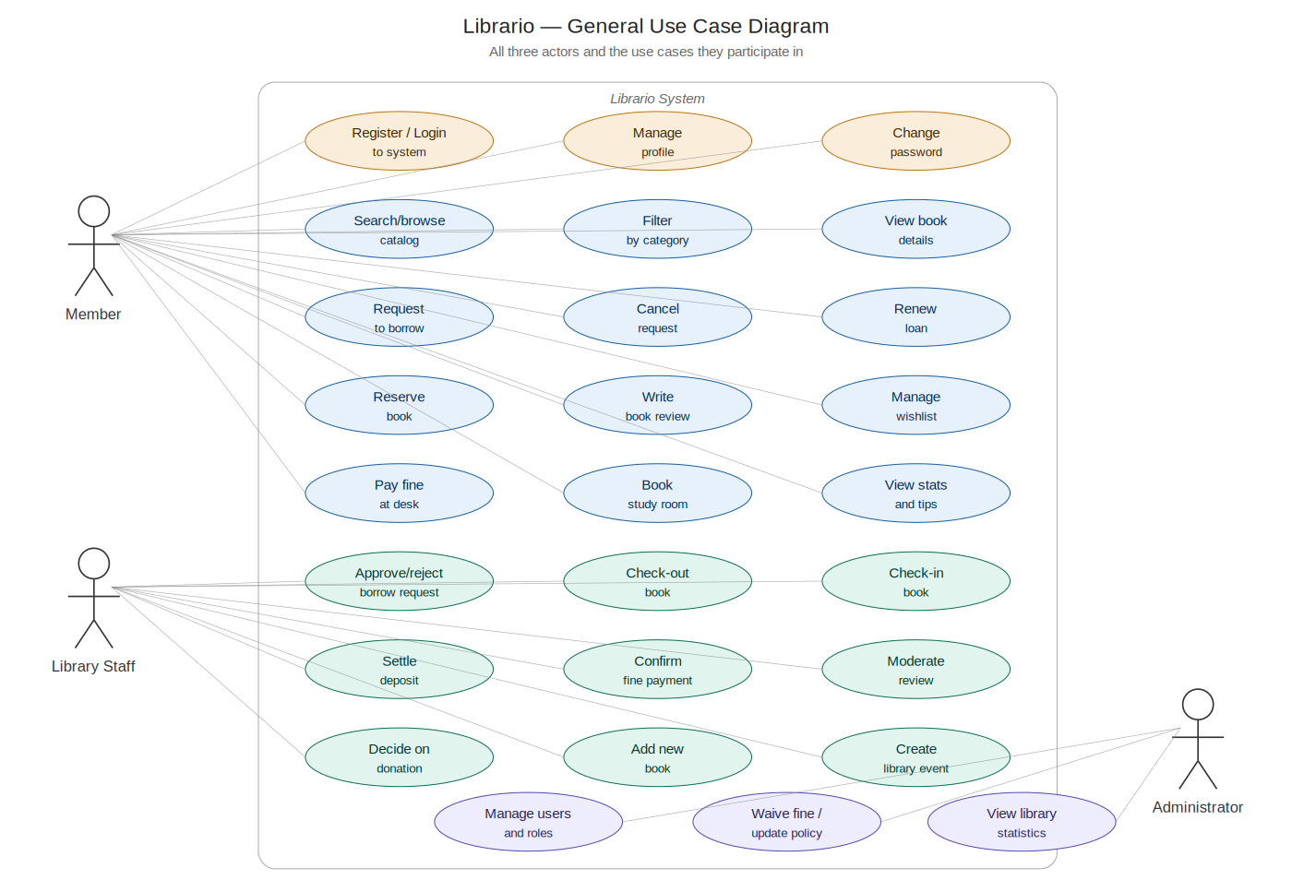
Figure 4.1 — Overall use case diagram for the Library Management System, showing all three actors and the full set of supported operations.

4.2.2 Member Use Case Diagram
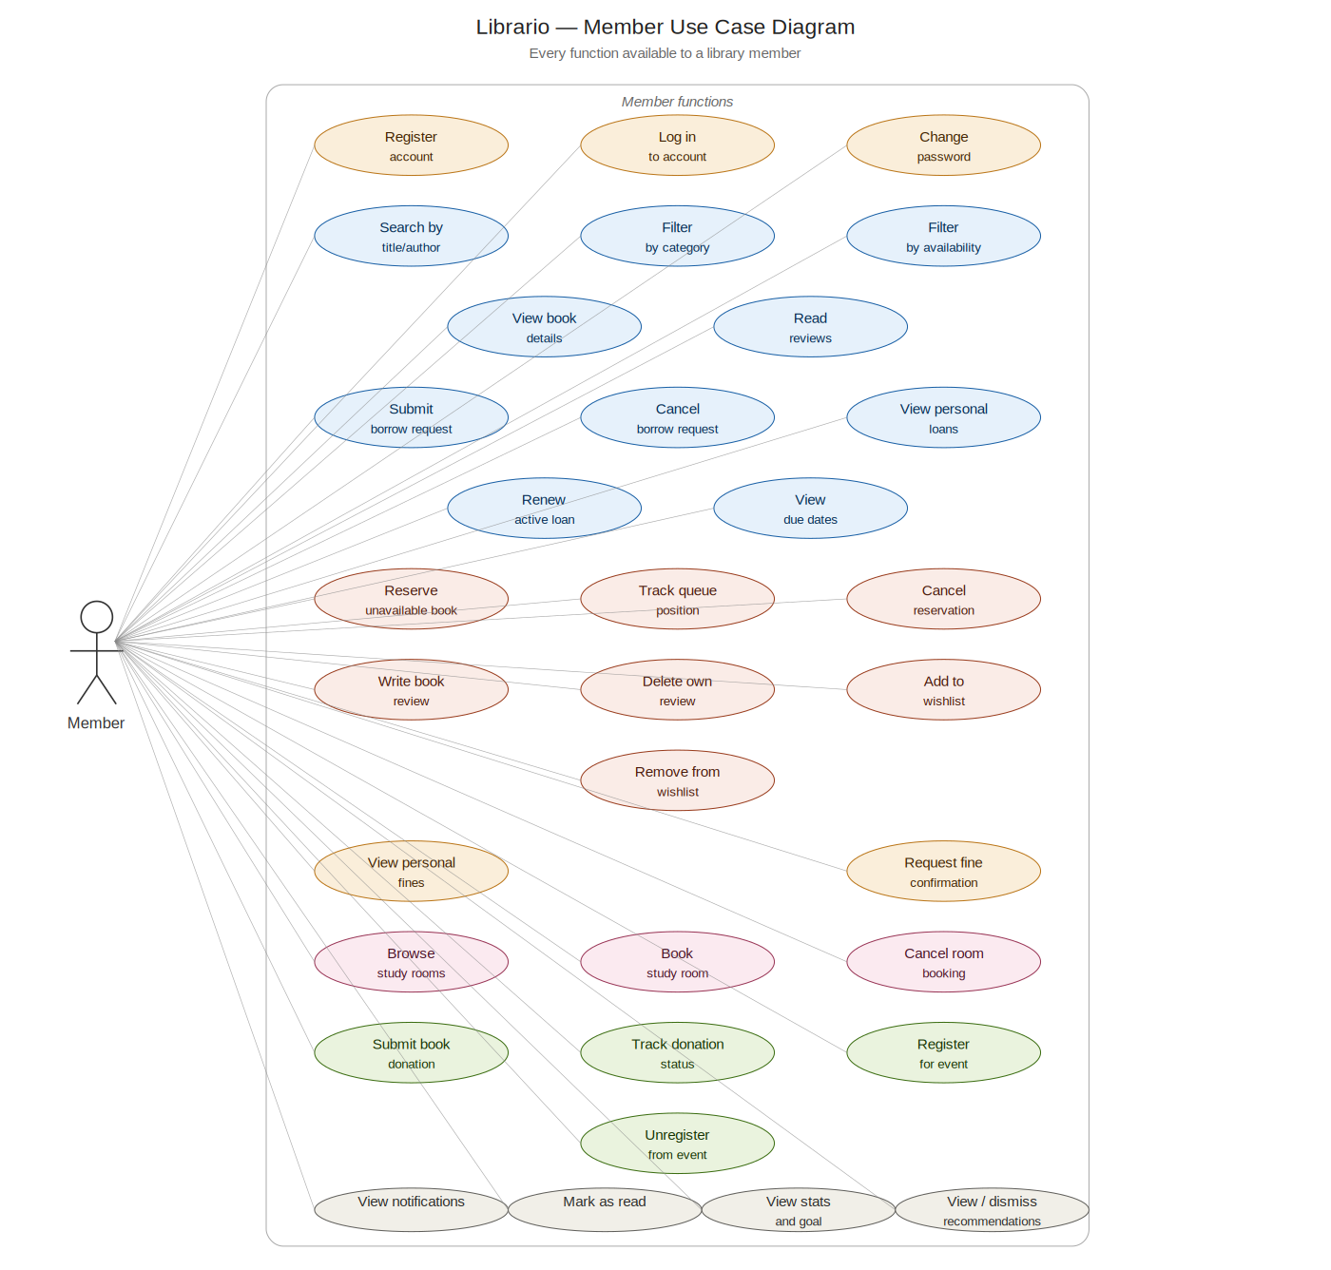
Figure 4.2 — Member use case diagram (UC-01 through UC-22).

4.2.3 Staff Use Case Diagram
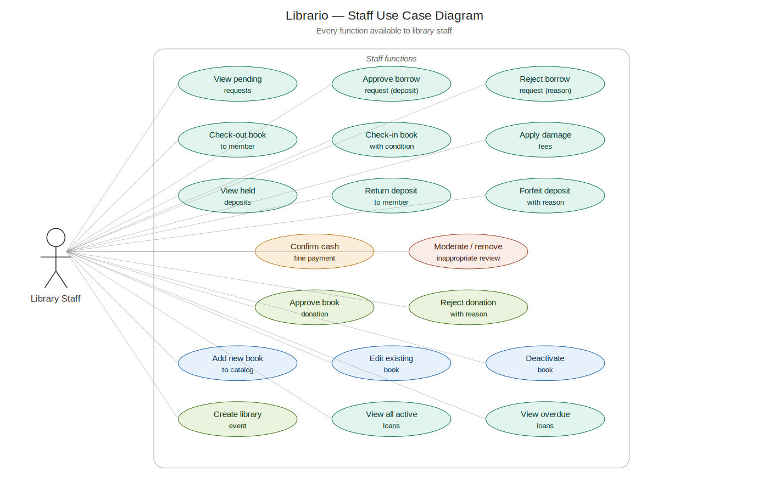
Figure 4.3 — Staff use case diagram (UC-23 through UC-31).

4.2.4 Administrator Use Case Diagram
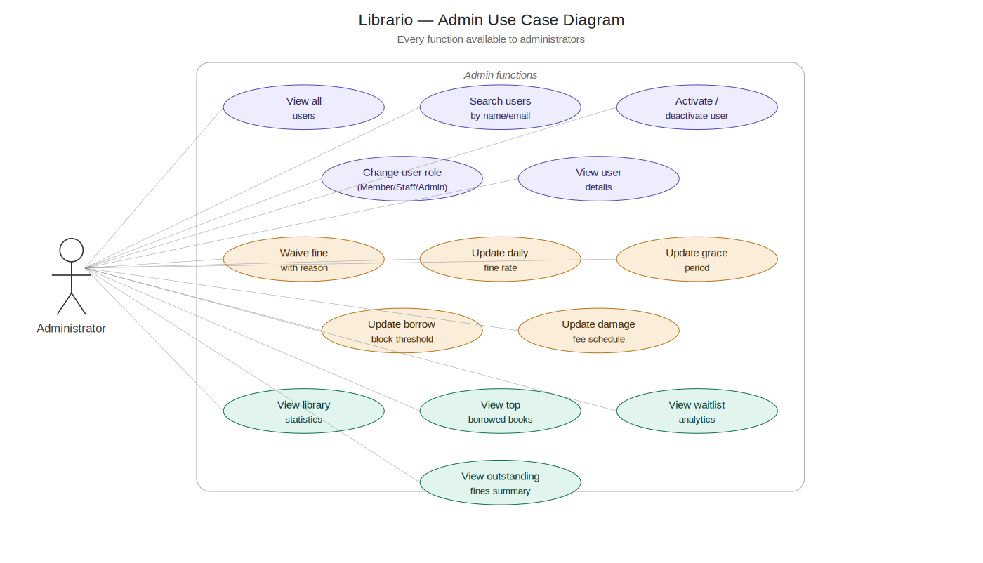
Figure 4.4 — Administrator use case diagram (UC-32 through UC-35).

4.3 Activity Diagrams
Activity diagrams model the workflow of each major operation as a sequence of actions, decisions, and parallel branches. The ten diagrams below cover the most behaviourally interesting flows in the system, from account registration through loan renewal, book return, and study-room booking.

4.3.1 Register Account (UC-01)
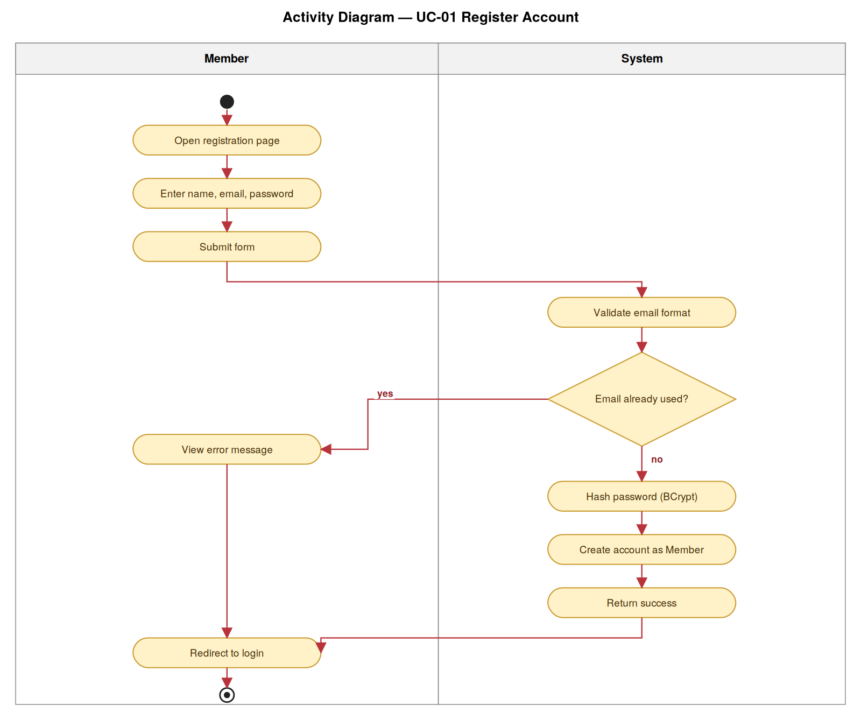
Figure 4.5 — Activity diagram for Register Account.

4.3.2 Log In (UC-02)
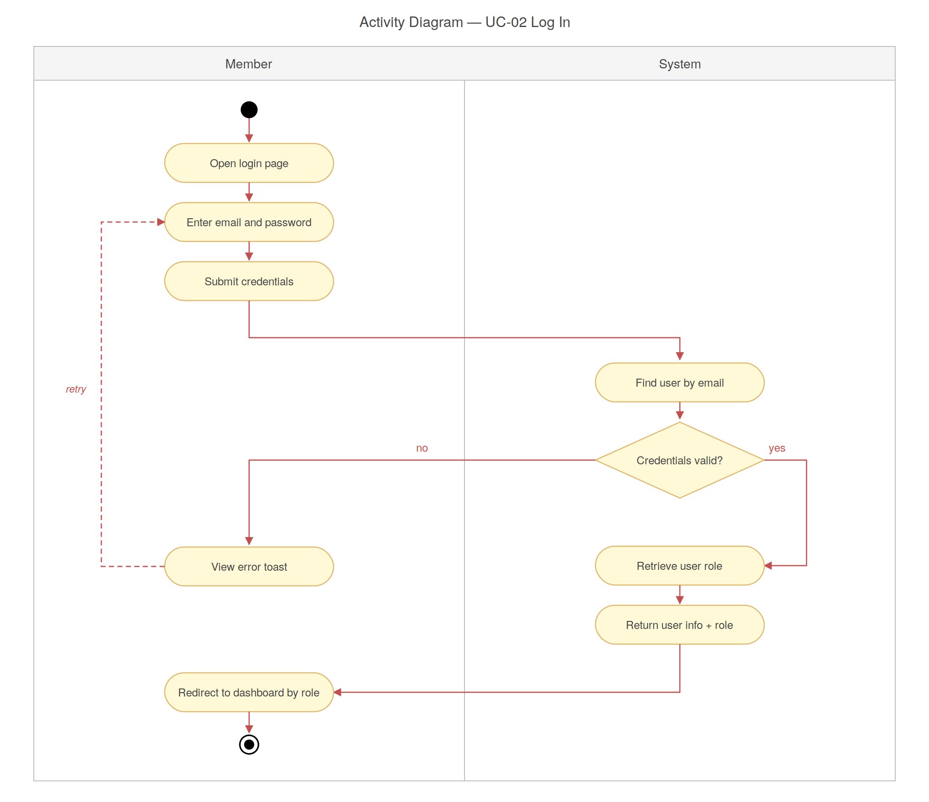
Figure 4.6 — Activity diagram for Log In.

4.3.3 Submit Borrow Request (UC-07)
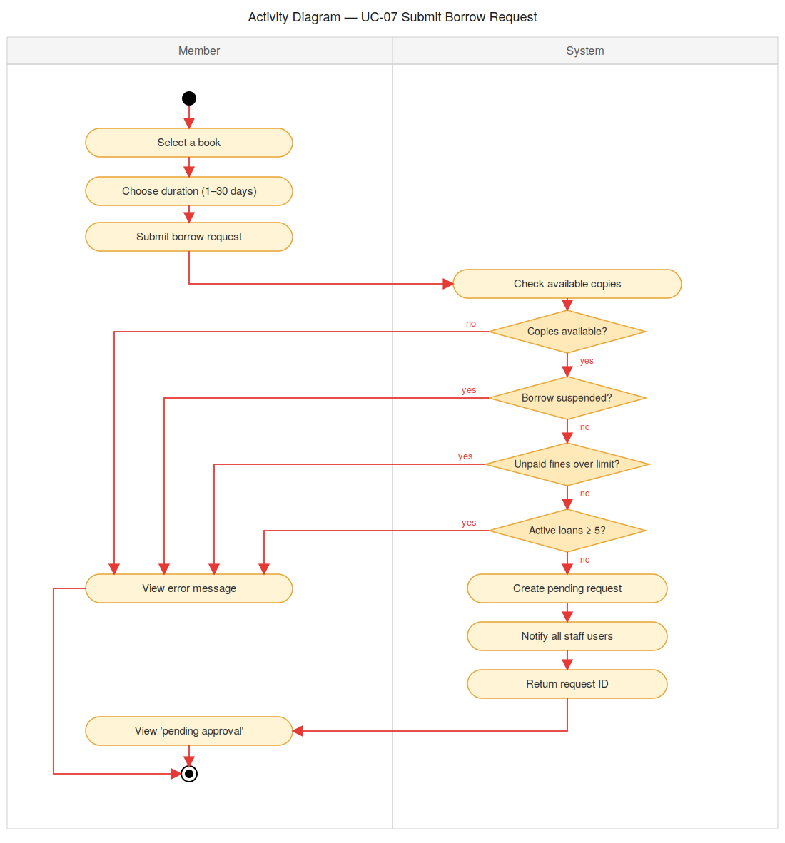
Figure 4.7 — Activity diagram for Submit Borrow Request.

4.3.4 Reject Borrow Request (UC-25)
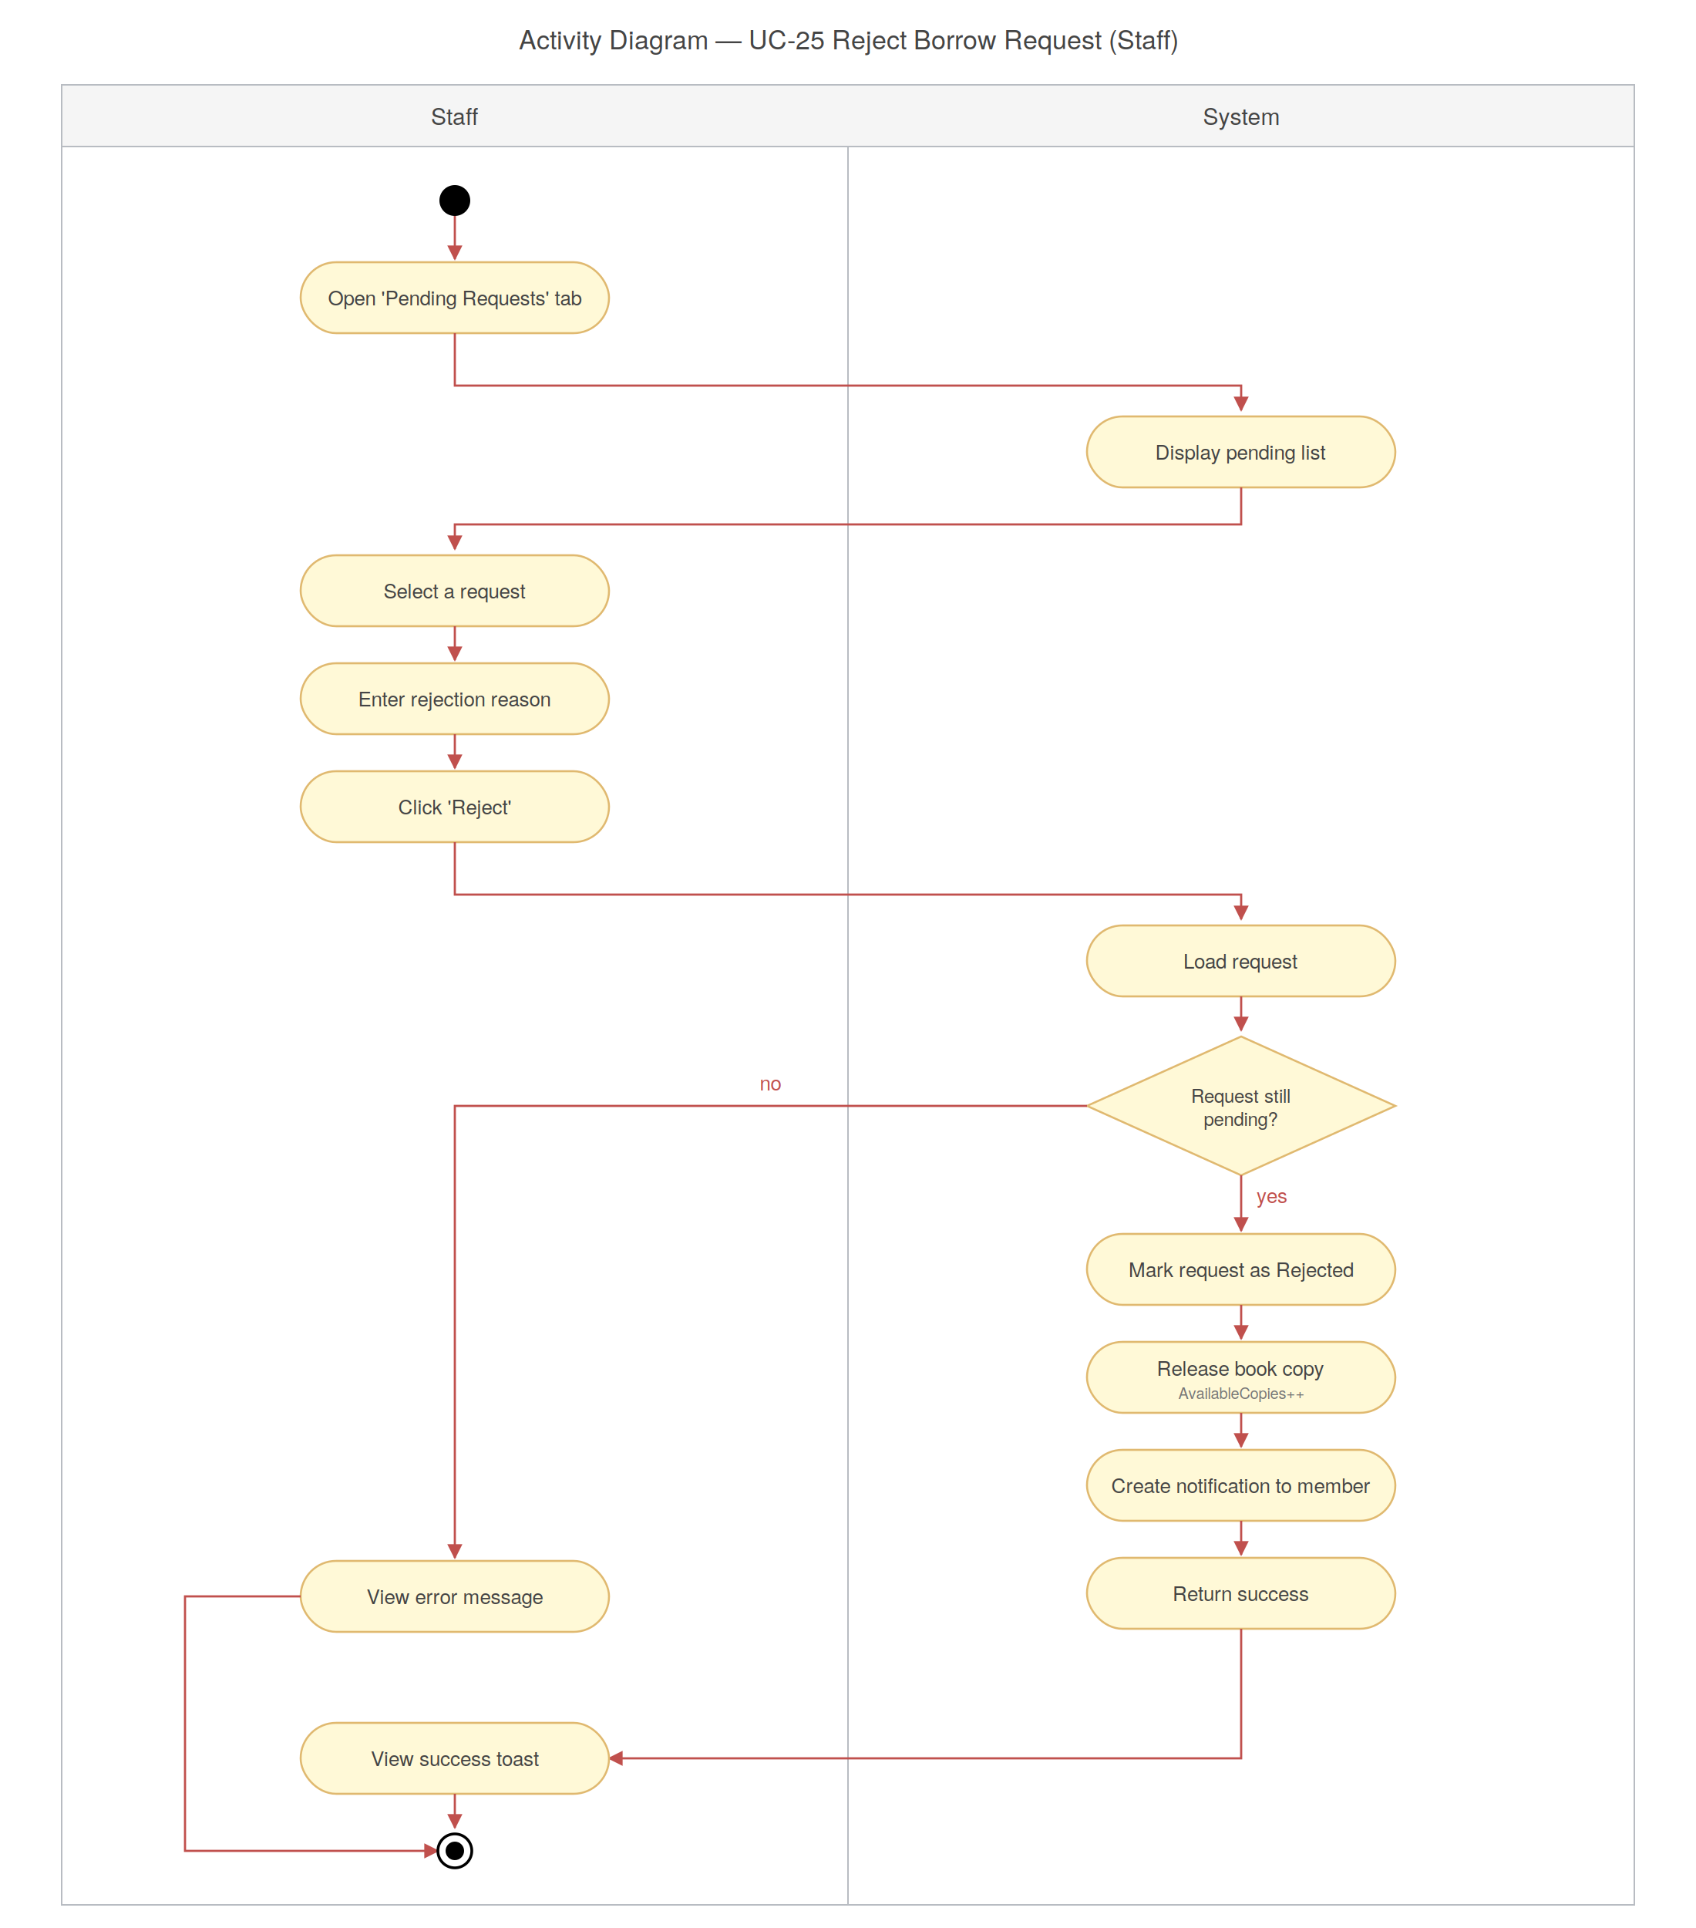
Figure 4.8 — Activity diagram for Reject Borrow Request.

4.3.5 Renew an Active Loan (UC-10)
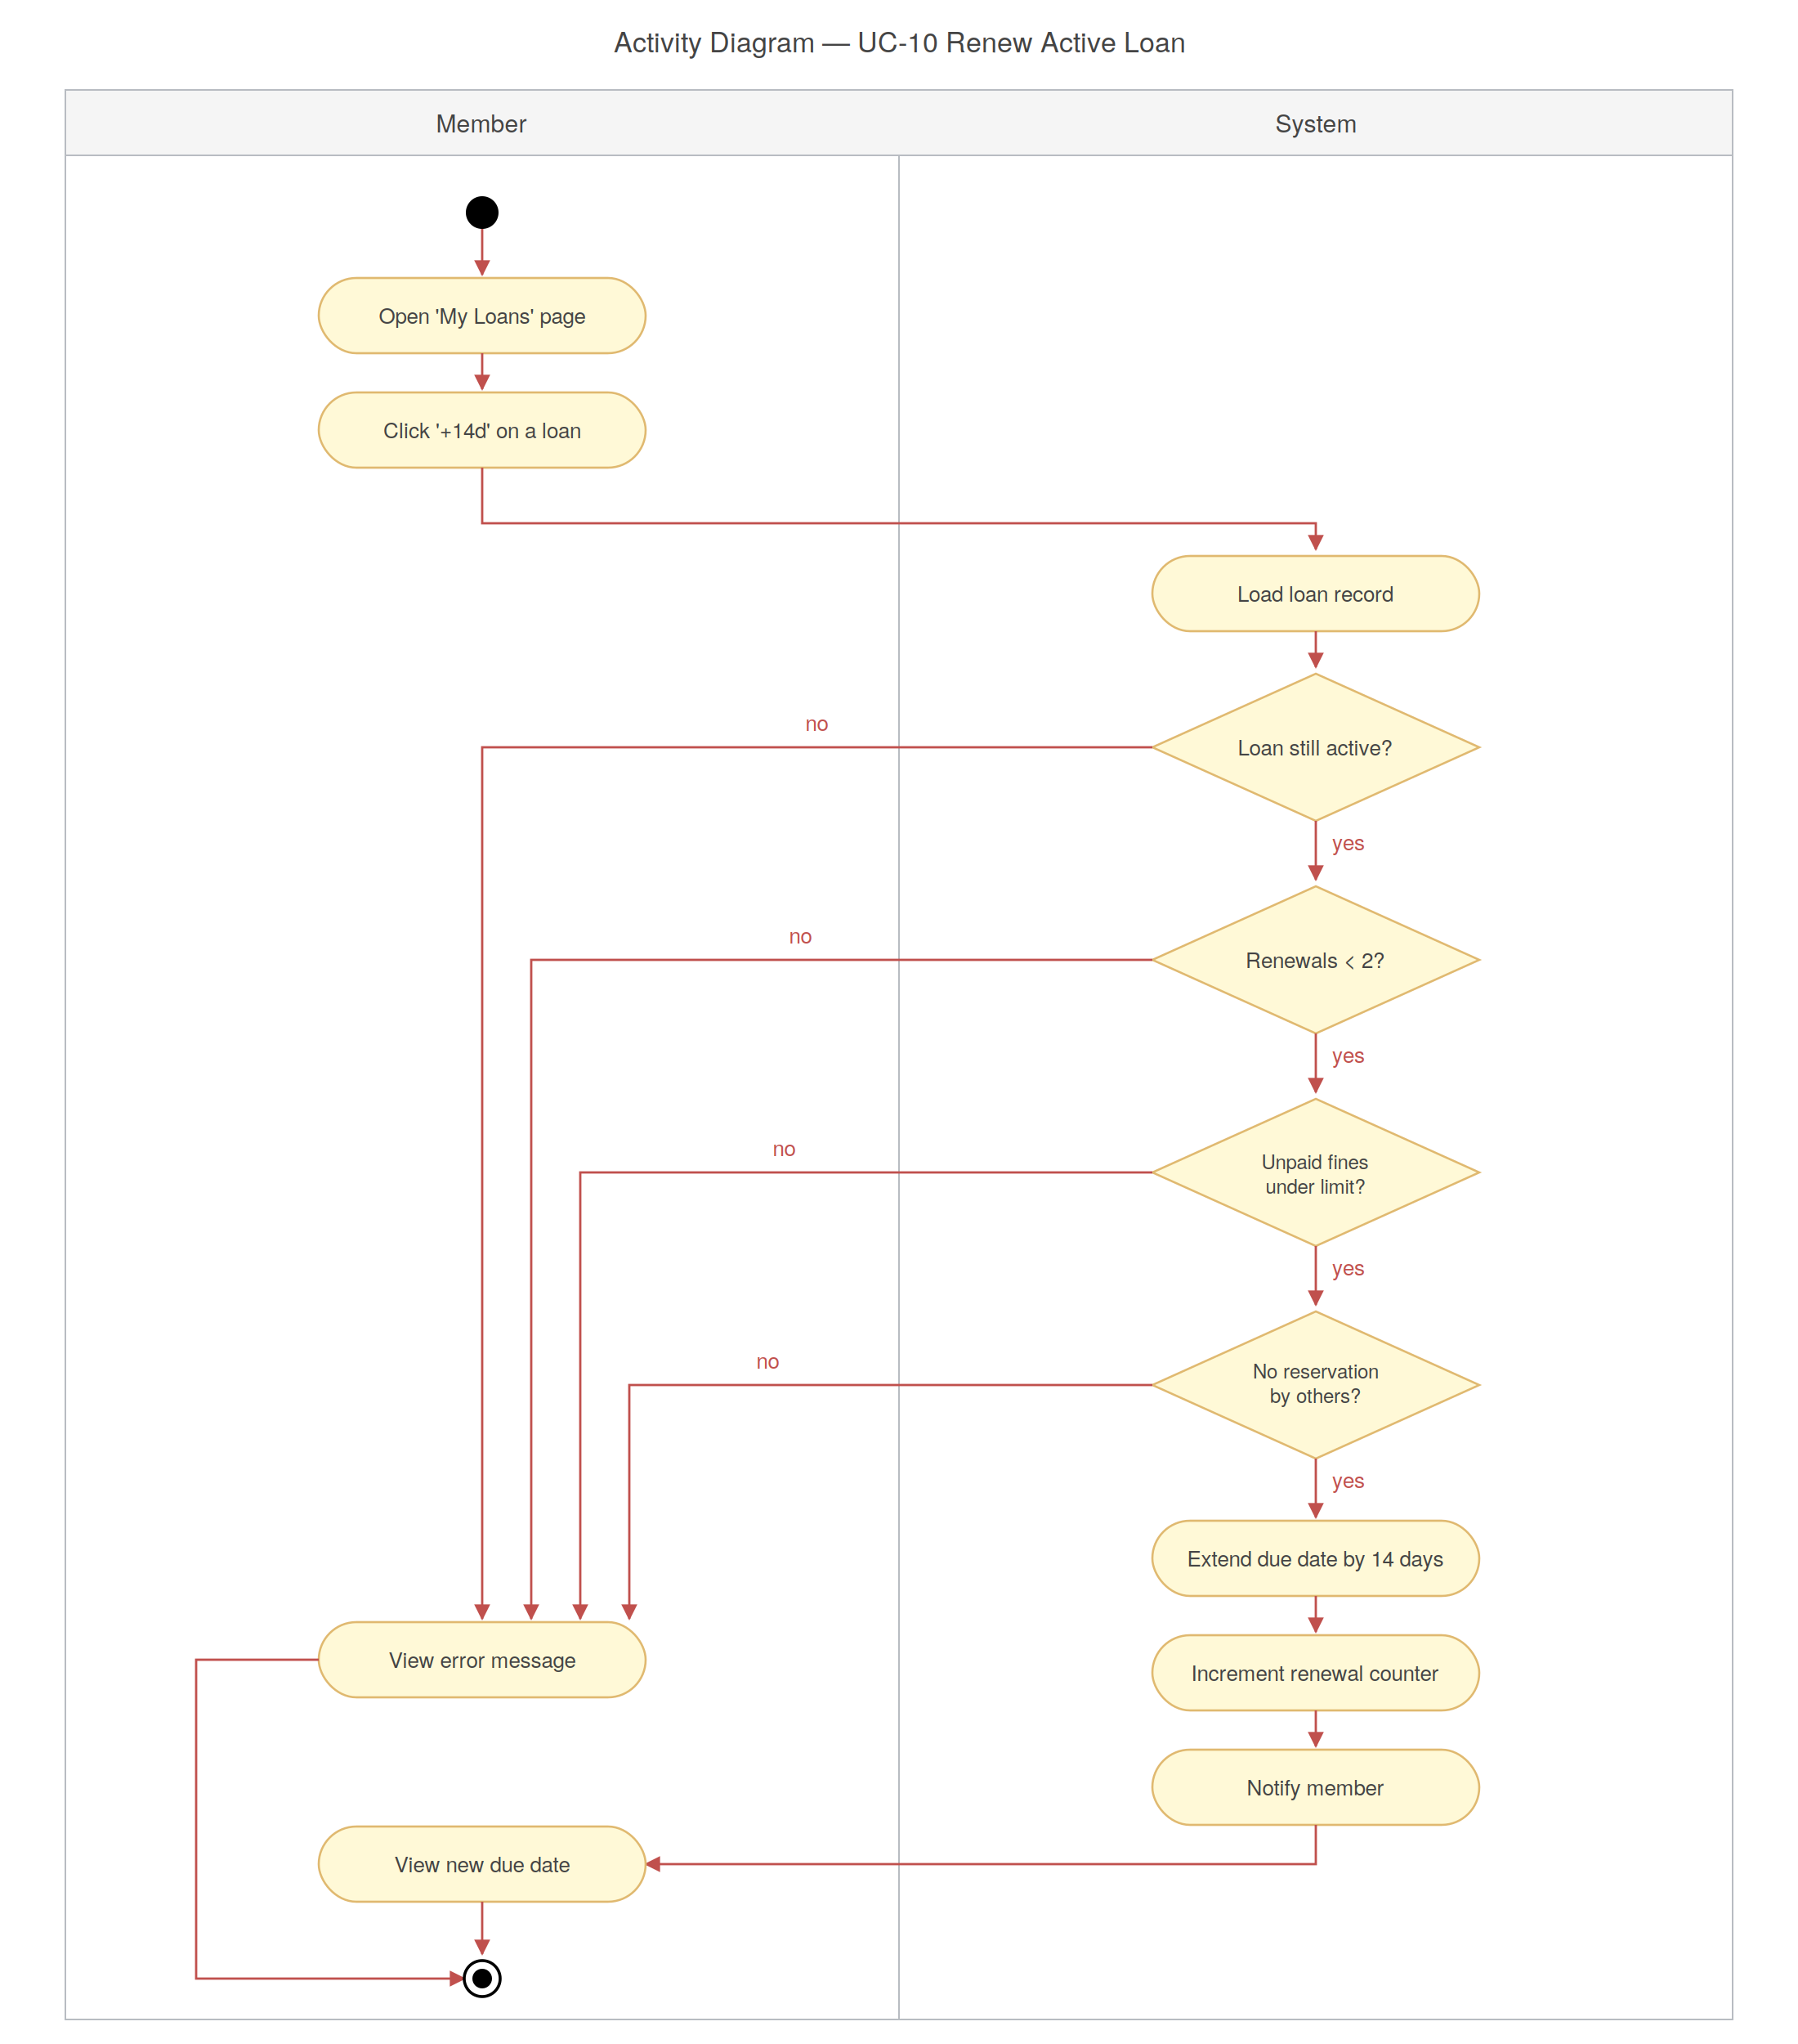
Figure 4.9 — Activity diagram for Renew an Active Loan.

4.3.6 Process Book Return (UC-26)
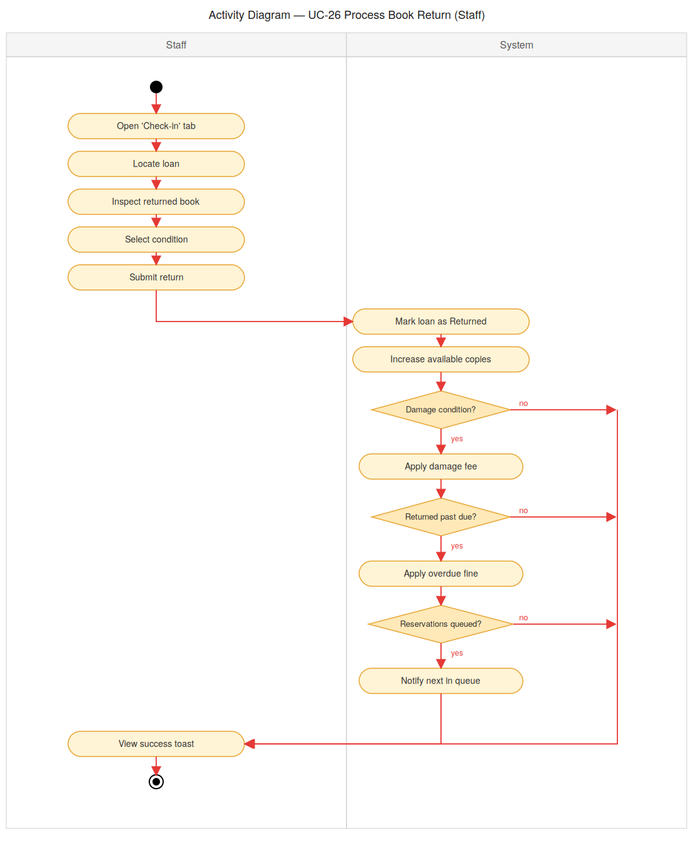
Figure 4.10 — Activity diagram for Process Book Return.

4.3.7 Write a Book Review (UC-13)
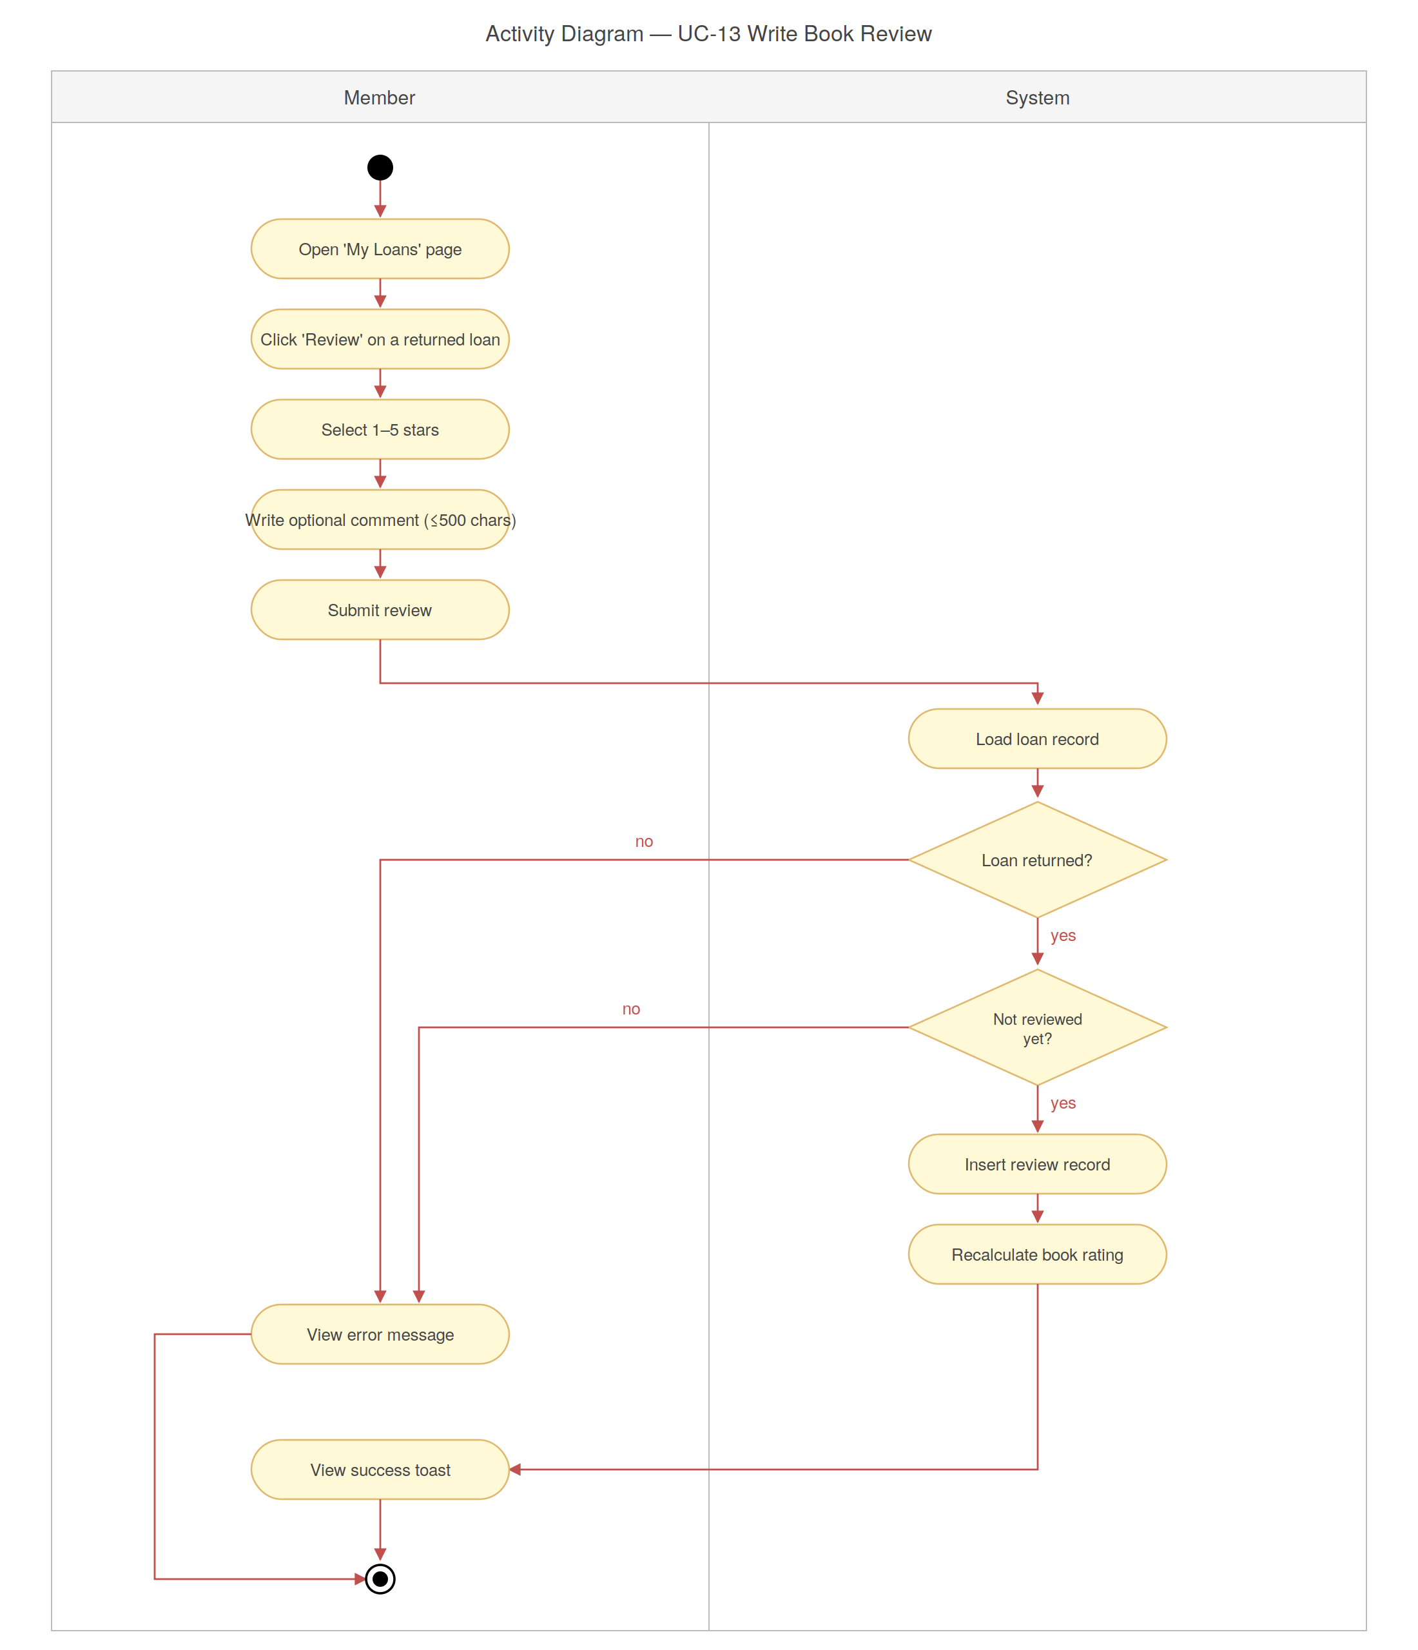

Figure 4.11 — Activity diagram for Write a Book Review.

4.3.8 Add Book to Wishlist (UC-14)
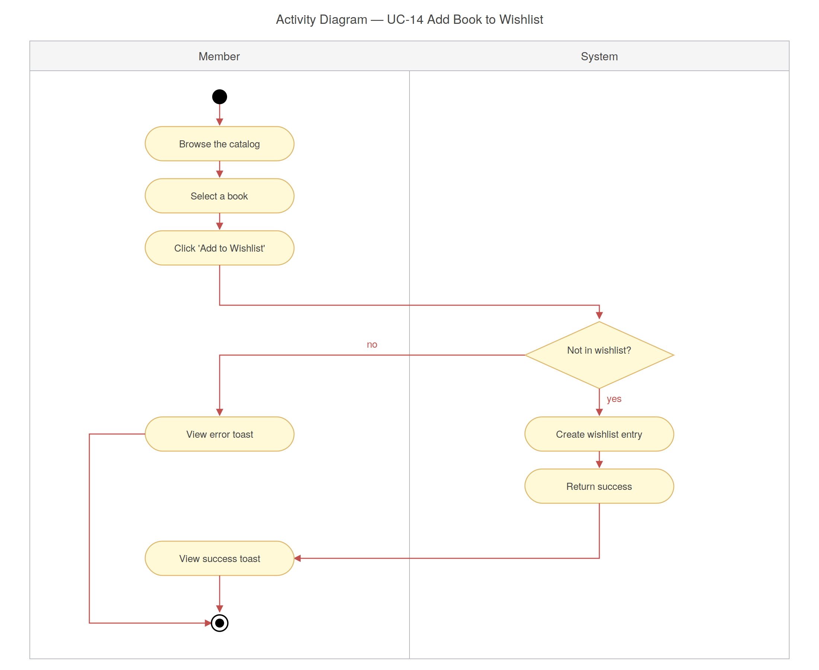
Figure 4.12 — Activity diagram for Add Book to Wishlist.

4.3.9 Register for an Event (UC-21)
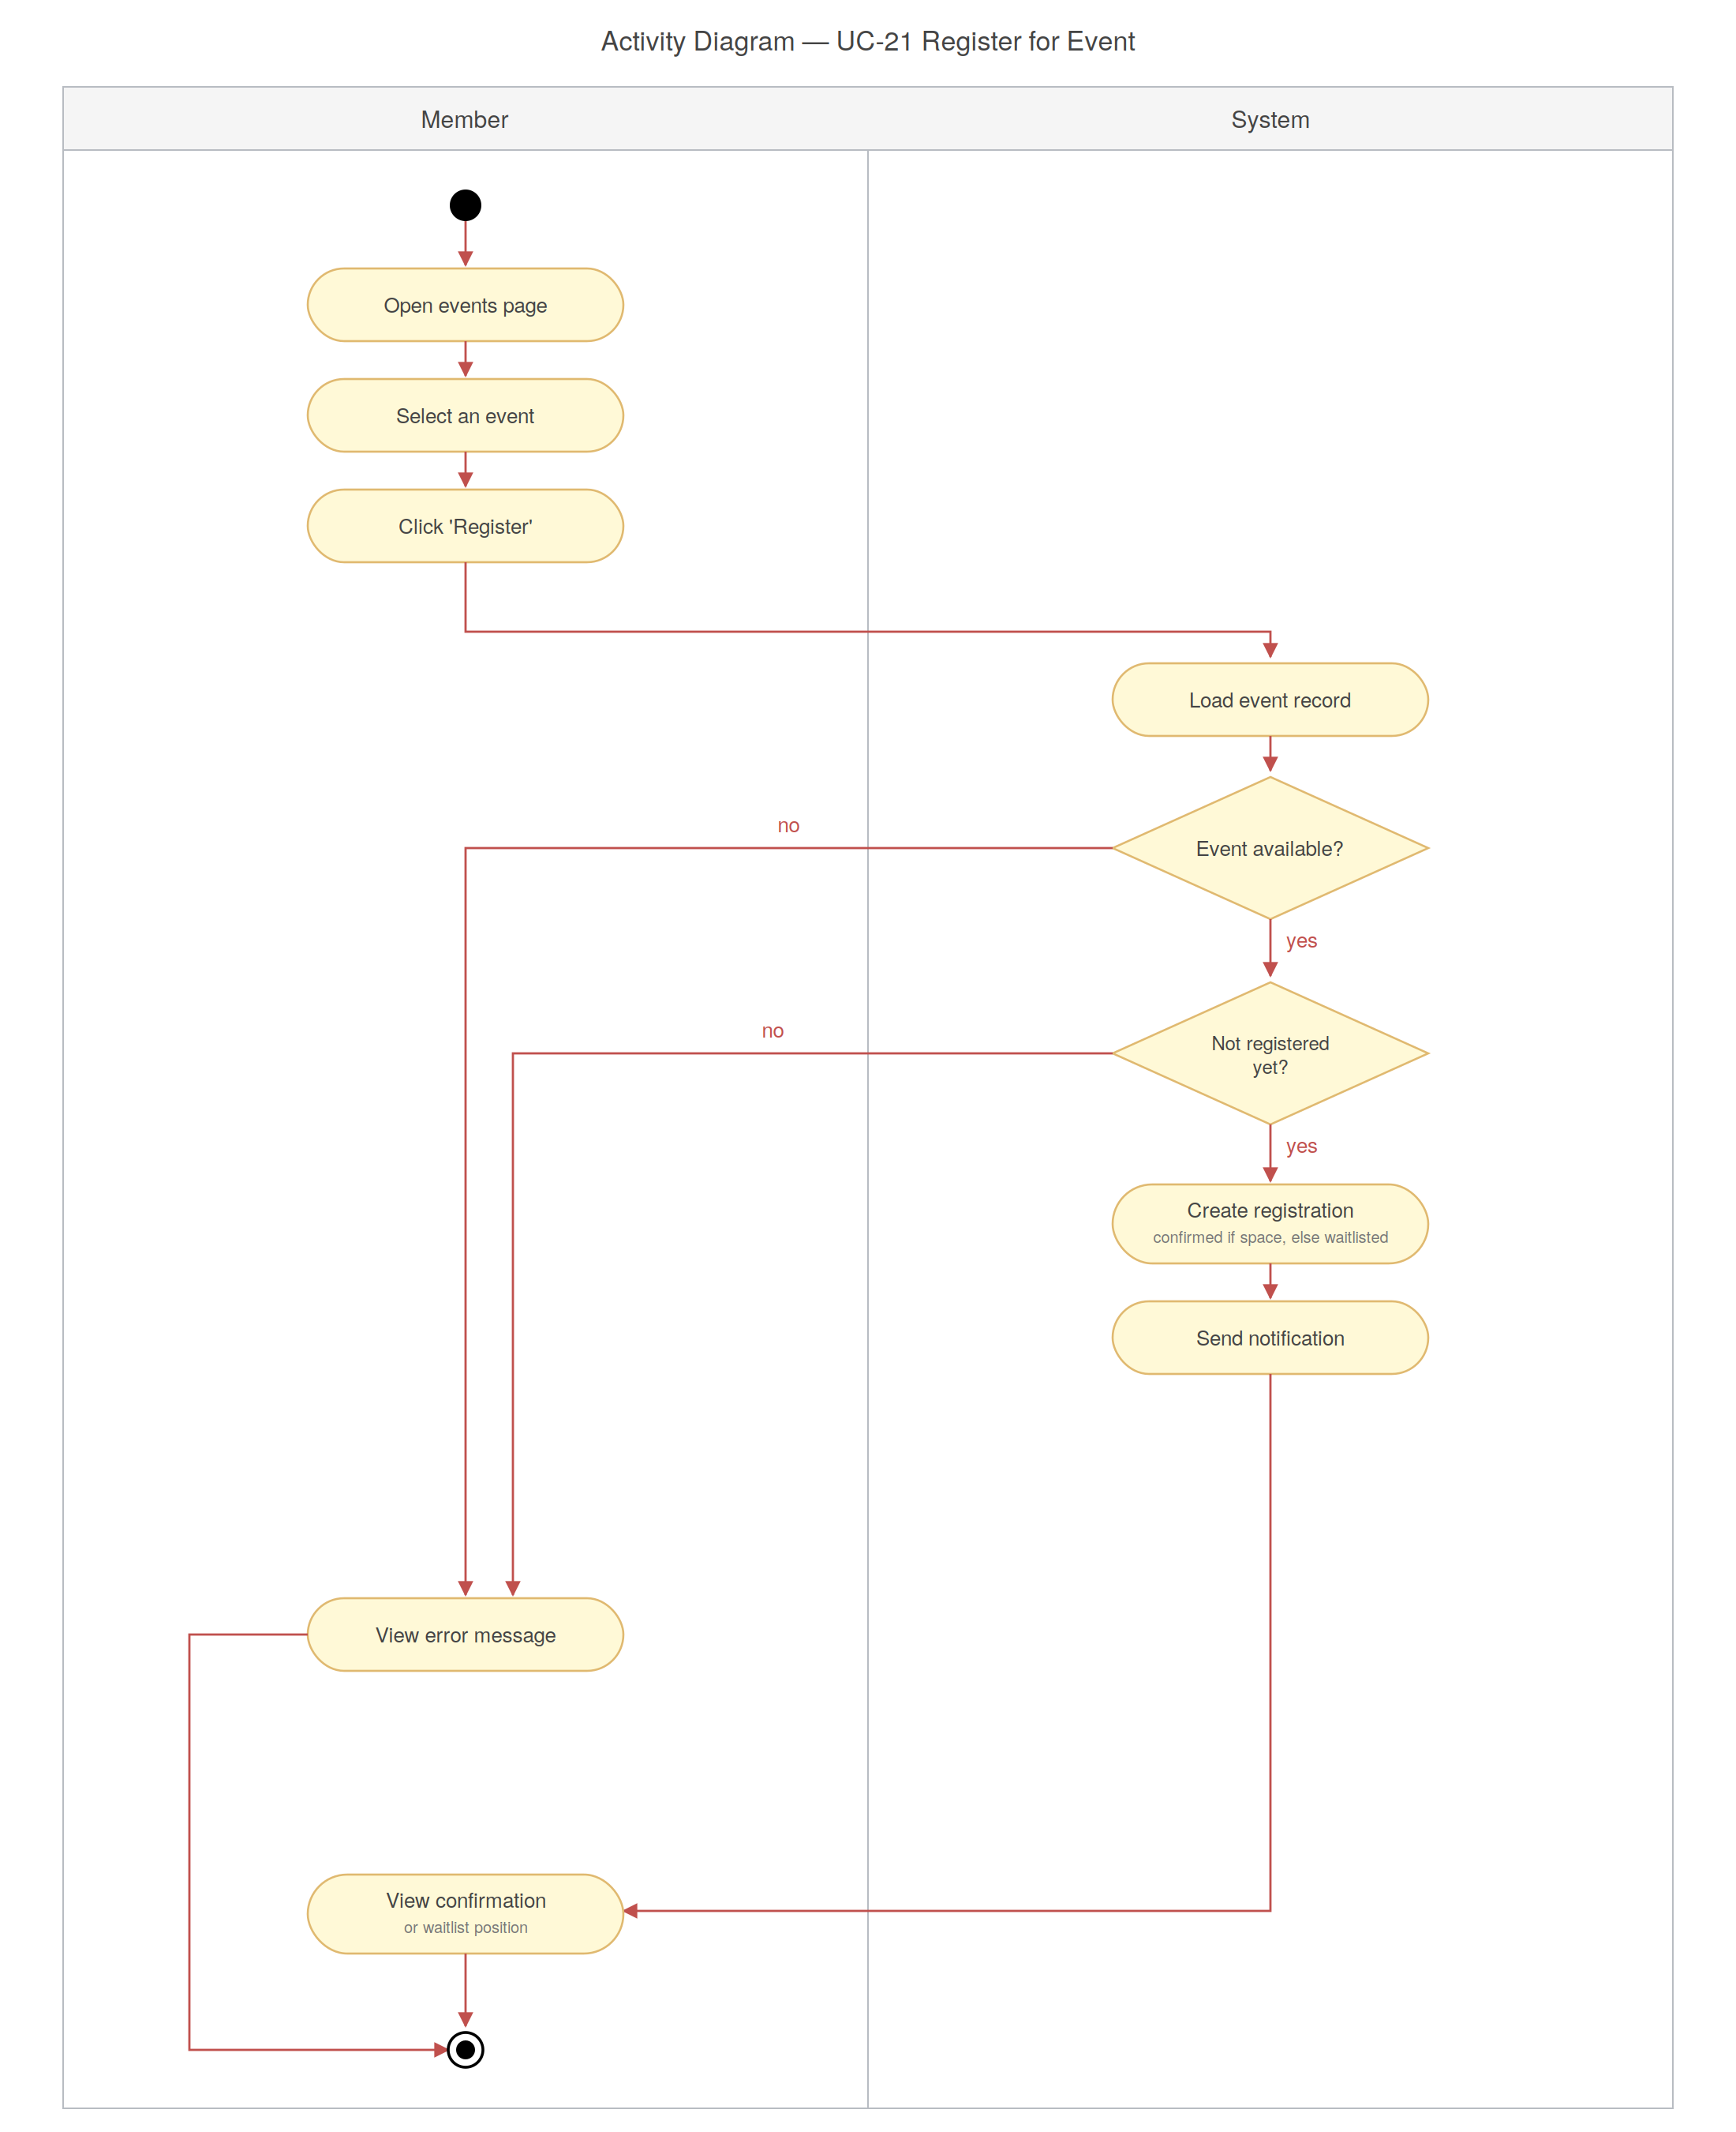
Figure 4.13 — Activity diagram for Register for an Event.

4.3.10 Book a Study Room (UC-18)
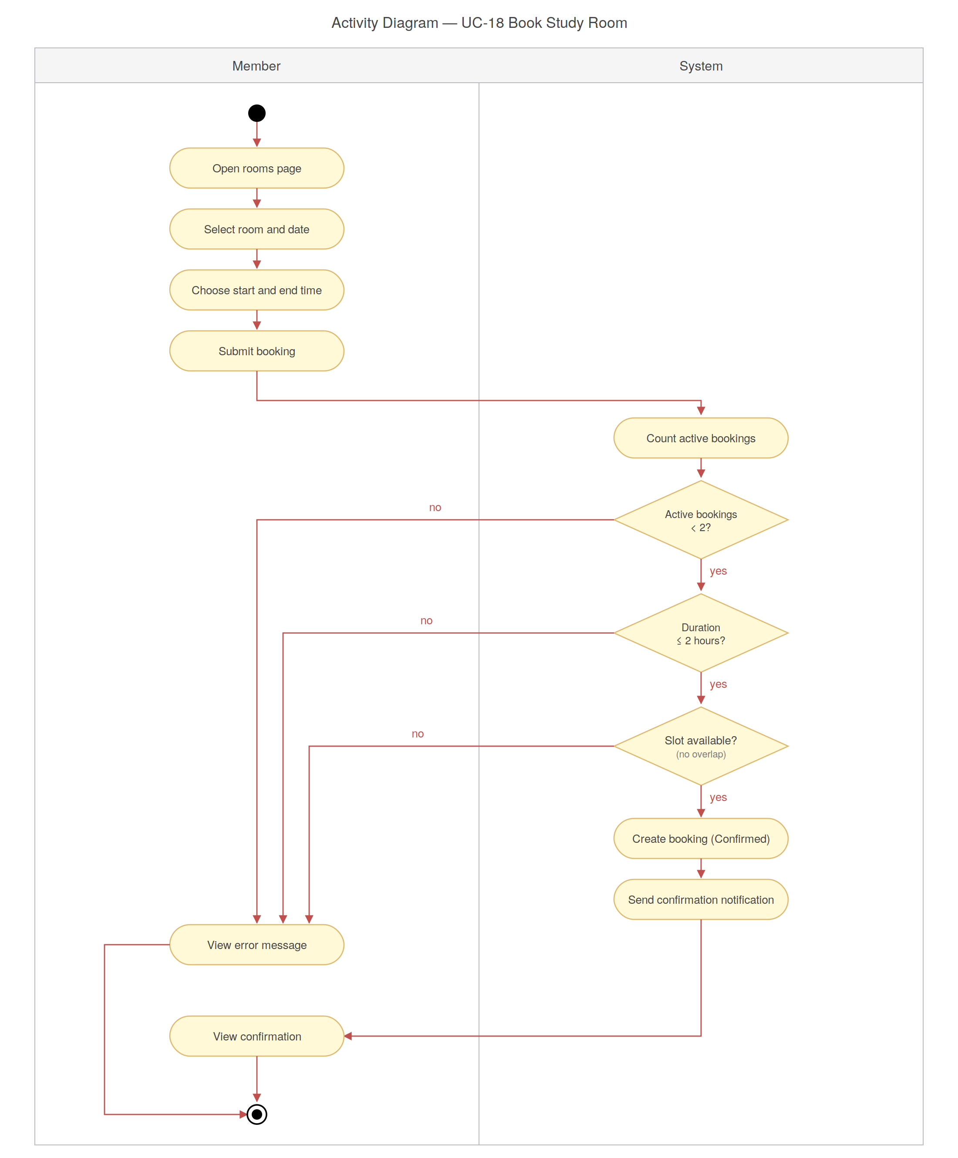
Figure 4.14 — Activity diagram for Book a Study Room.

4.4 Sequence Diagrams
Sequence diagrams trace the messages that flow between the browser, the API controllers, the data layer, and the database for each major operation. They make the call order explicit and surface the synchronous versus asynchronous boundaries.

4.4.1 Register Account
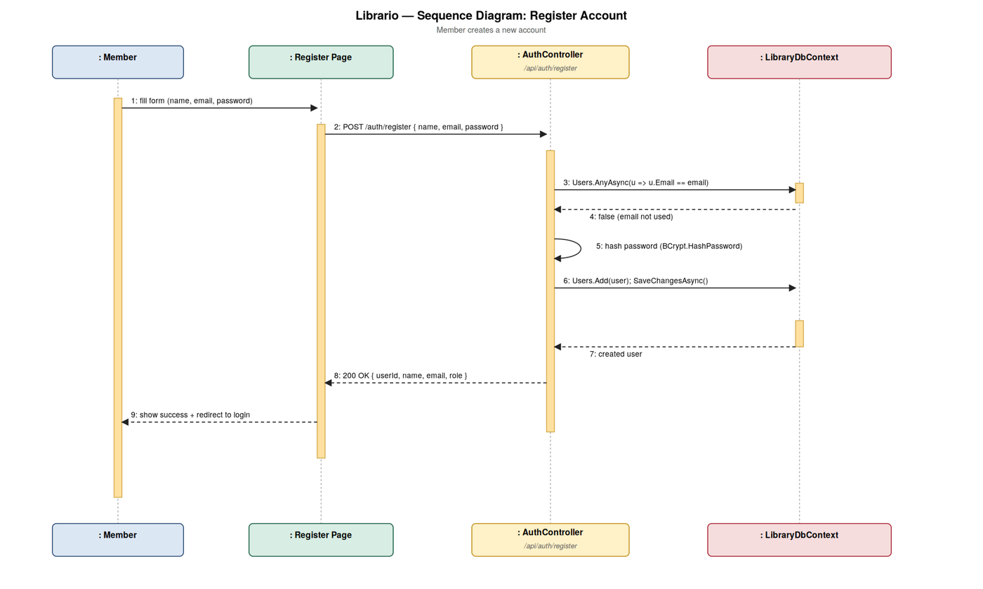
Figure 4.15 — Sequence diagram for Register Account.

4.4.2 Log In
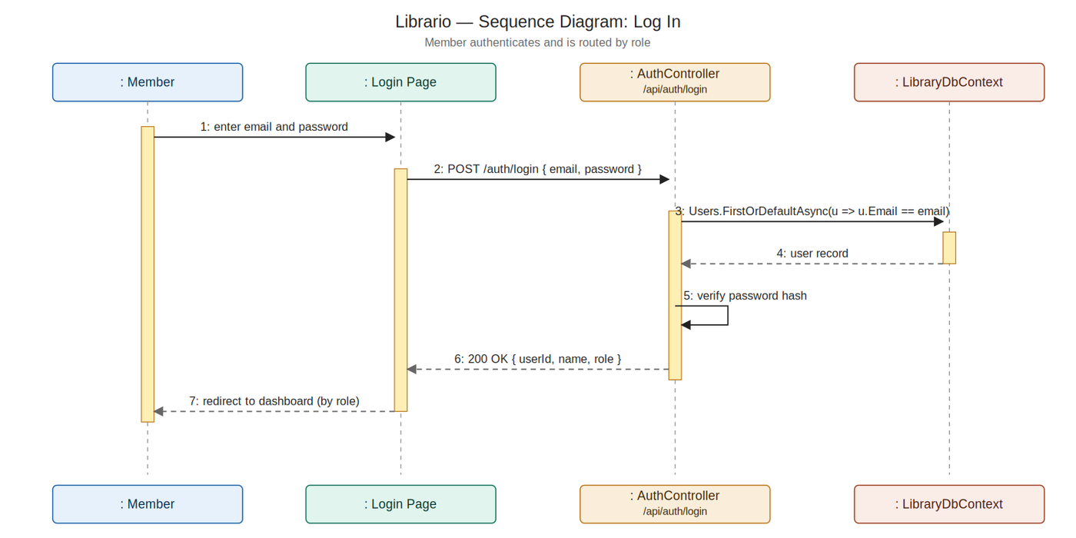
Figure 4.16 — Sequence diagram for Log In.

4.4.3 Submit Borrow Request
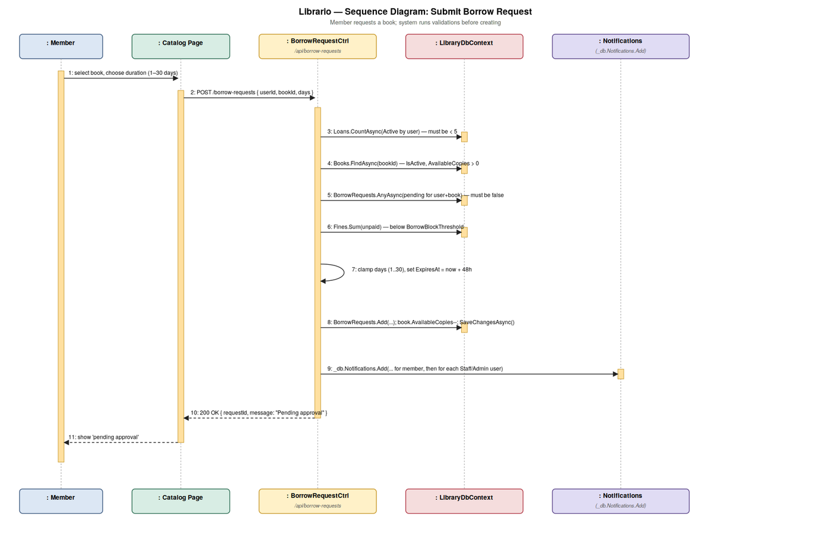
Figure 4.17 — Sequence diagram for Submit Borrow Request.

4.4.4 Reject Borrow Request
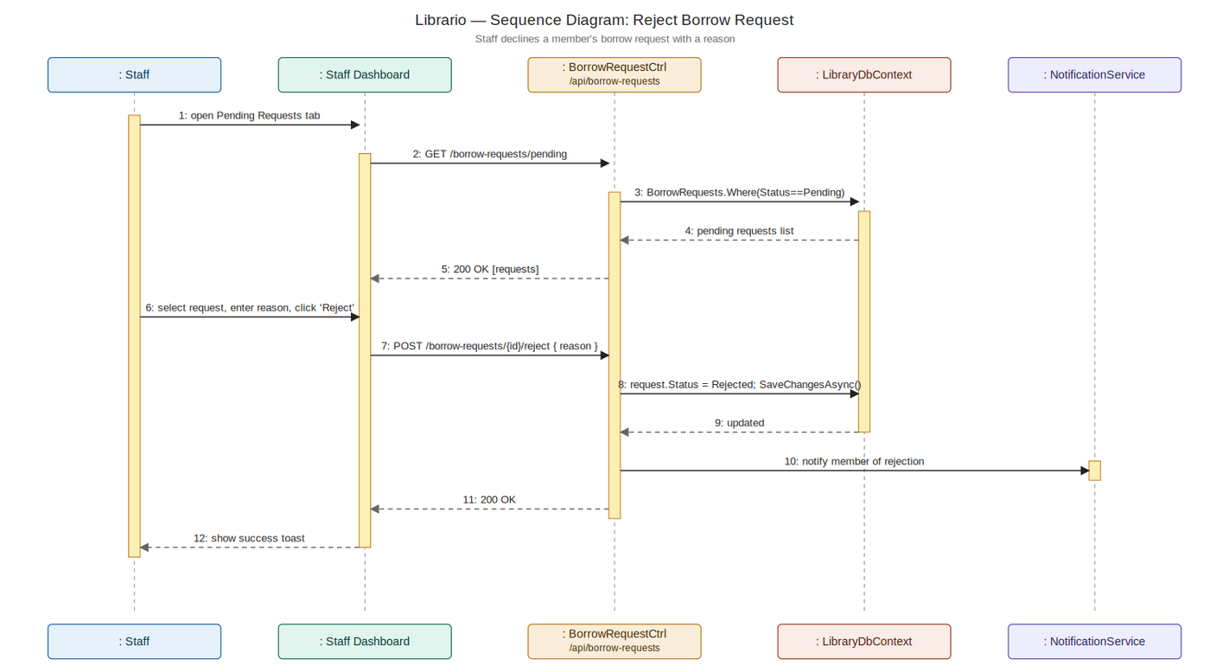
Figure 4.18 — Sequence diagram for Reject Borrow Request.

4.4.5 Renew an Active Loan
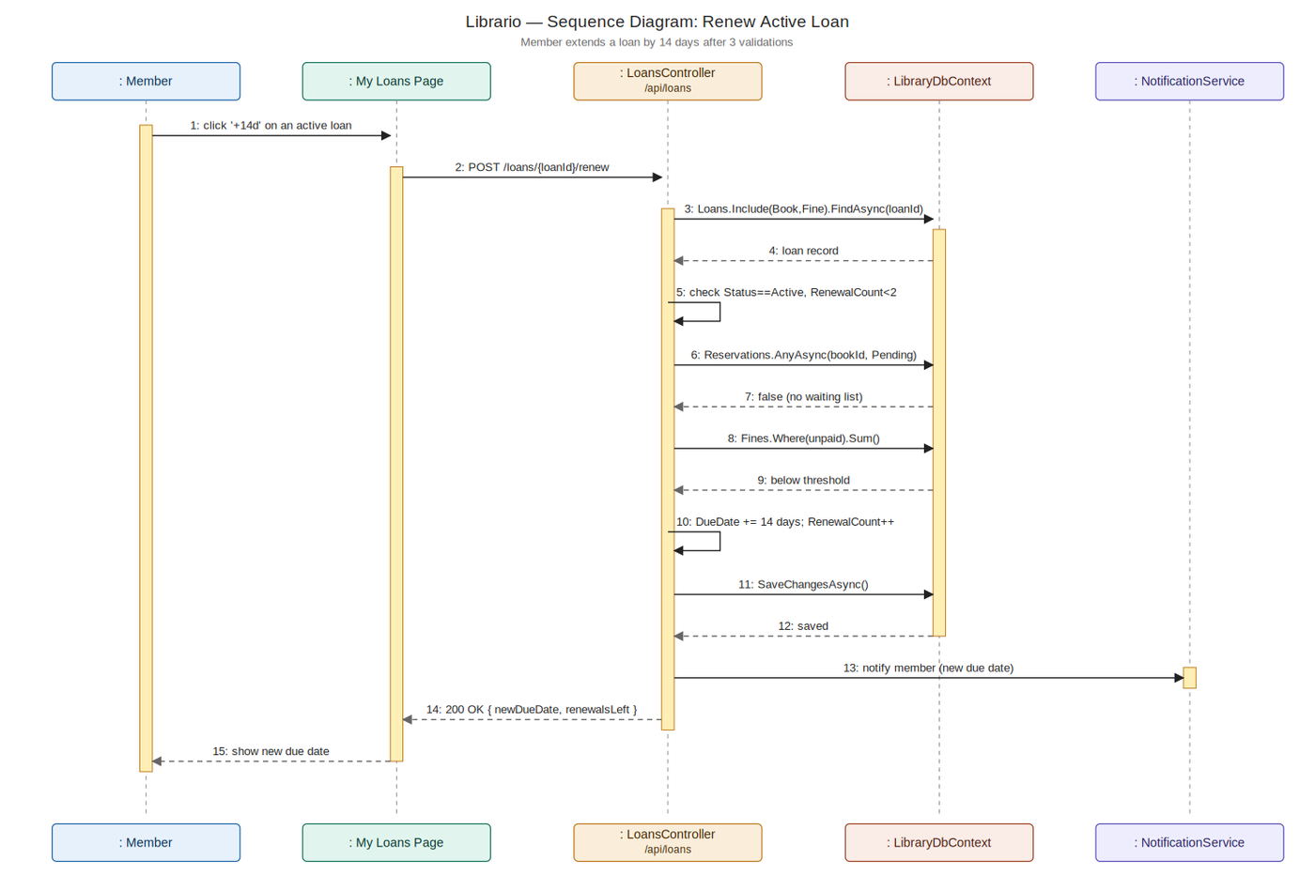
Figure 4.19 — Sequence diagram for Renew an Active Loan.

4.4.6 Process Book Return
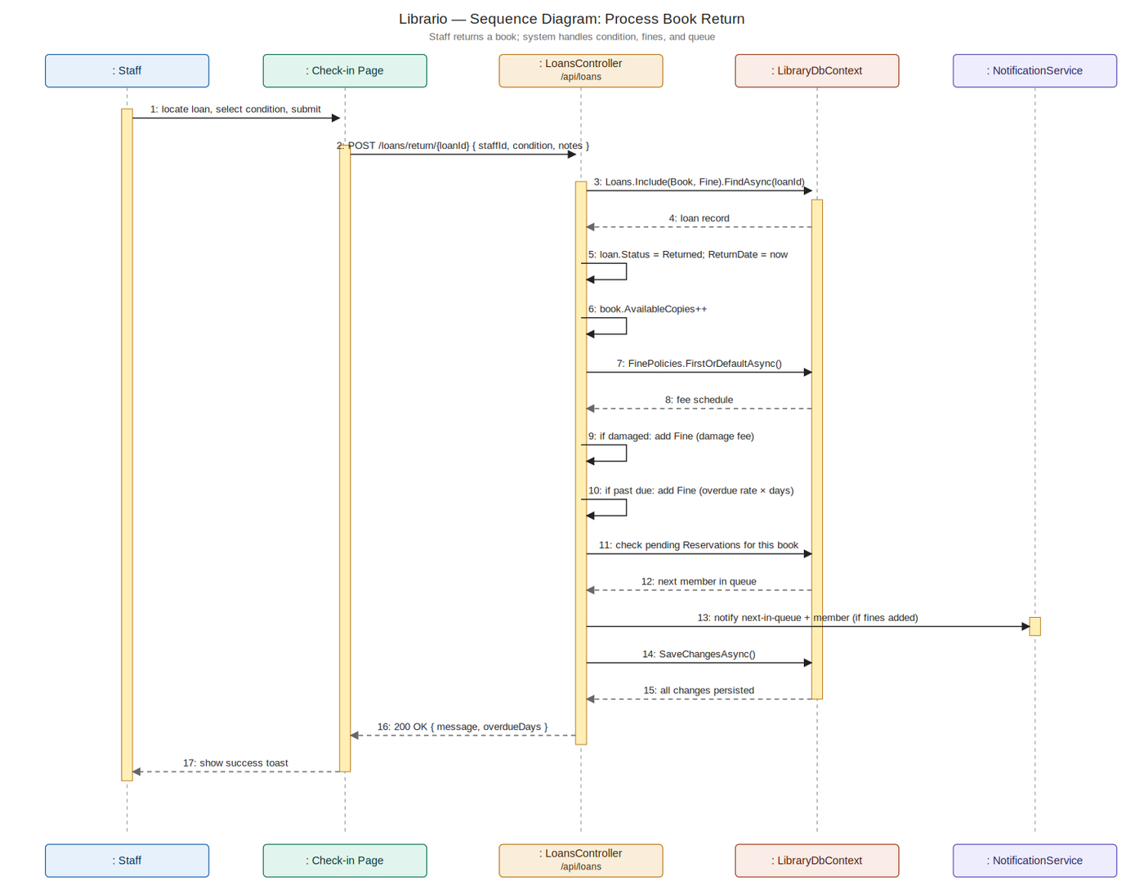
Figure 4.20 — Sequence diagram for Process Book Return.

4.4.7 Write a Book Review
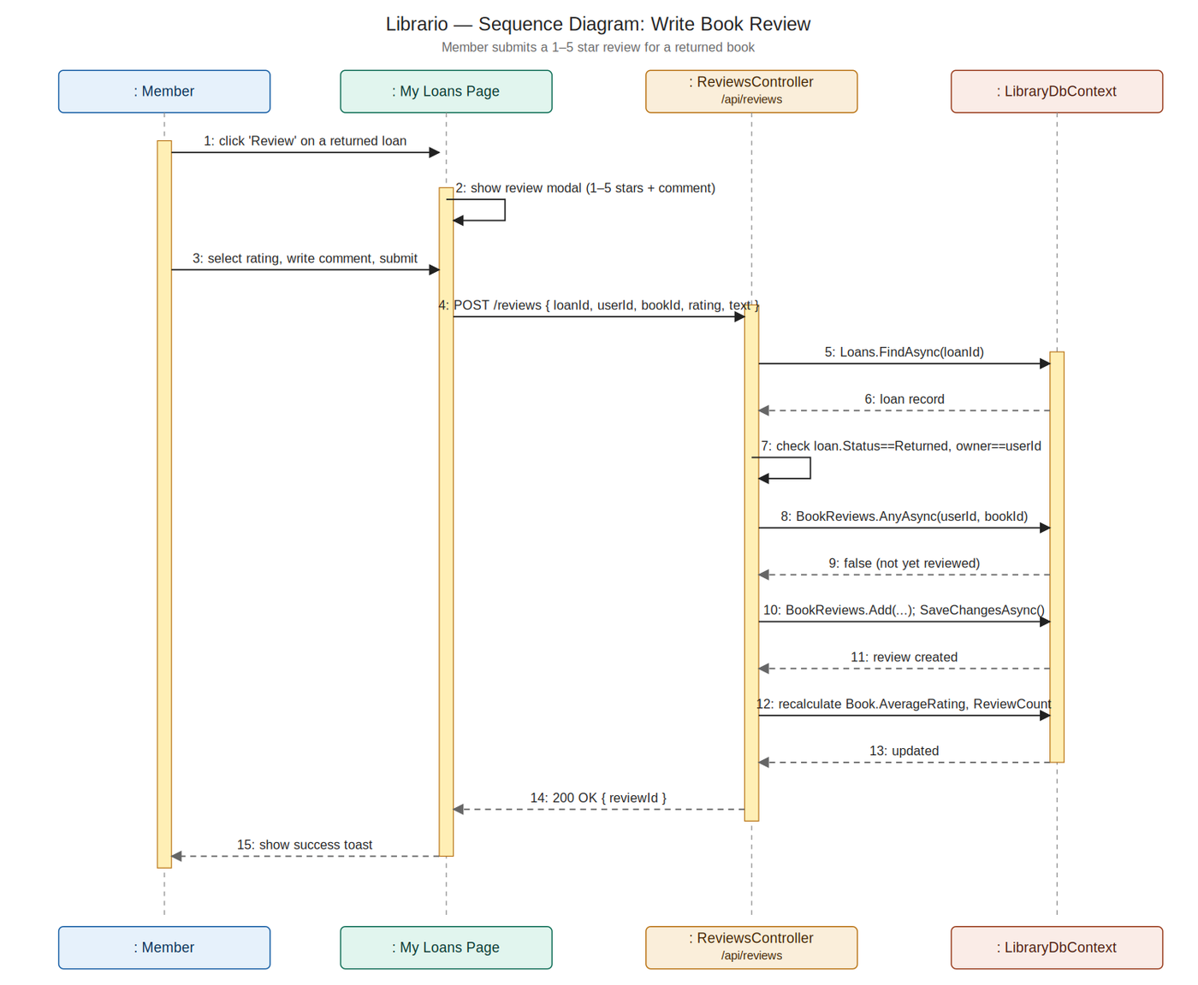
Figure 4.21 — Sequence diagram for Write a Book Review.

4.4.8 Add Book to Wishlist
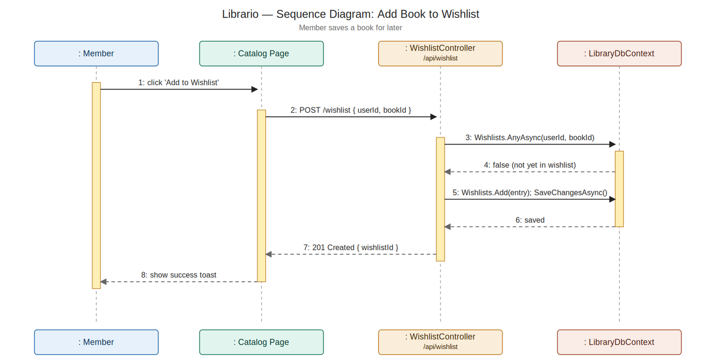
Figure 4.22 — Sequence diagram for Add Book to Wishlist.

4.4.9 Register for an Event
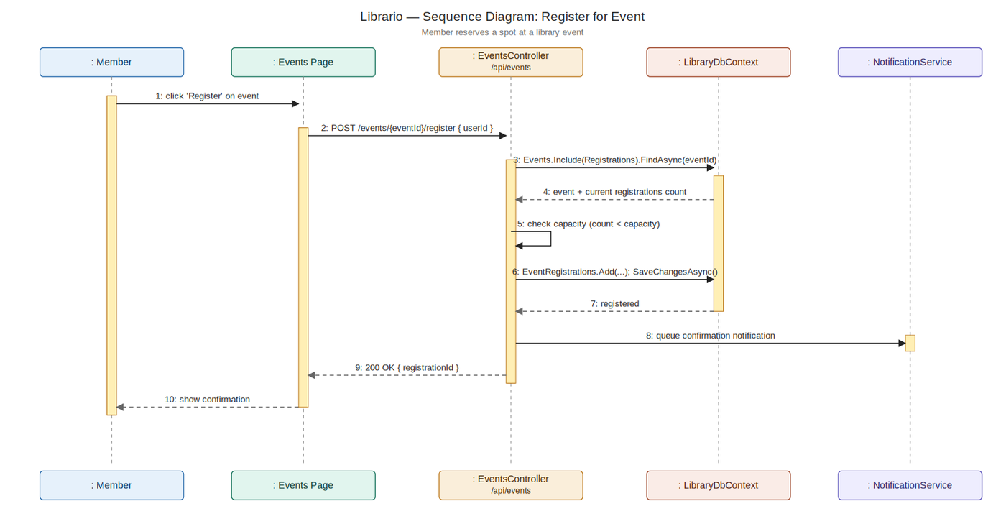
Figure 4.23 — Sequence diagram for Register for an Event.

4.4.10 Book a Study Room
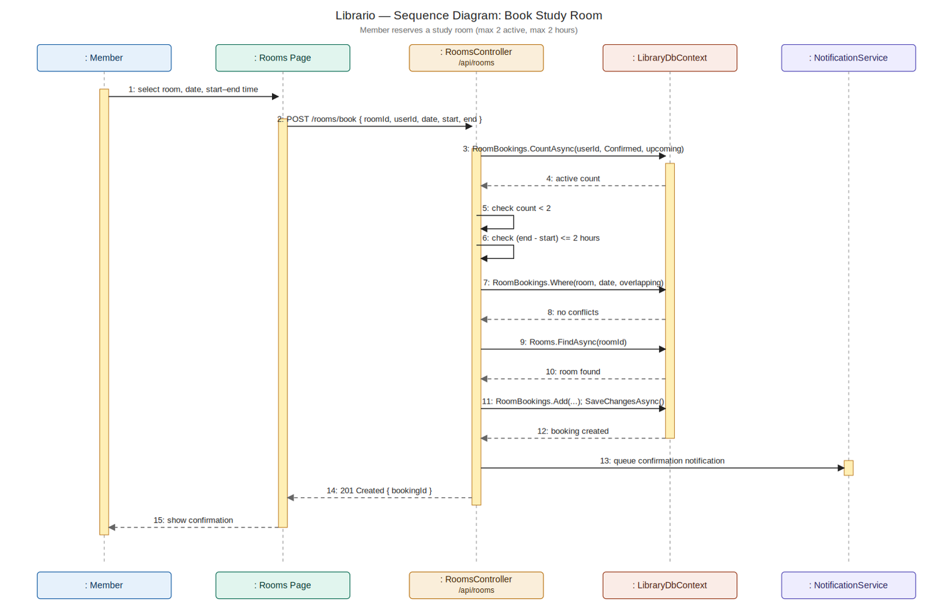
Figure 4.24 — Sequence diagram for Book a Study Room.

4.5 State Diagrams
Each major domain entity has a well-defined lifecycle: a loan moves from Active to Returned or Overdue; a reservation moves from Pending to Fulfilled, Cancelled, or Expired; a deposit moves from Held to Returned or Forfeited. The state diagrams below capture every legal transition for each entity, providing a single source of truth for the state machines enforced by the controllers.

4.5.1 Loan
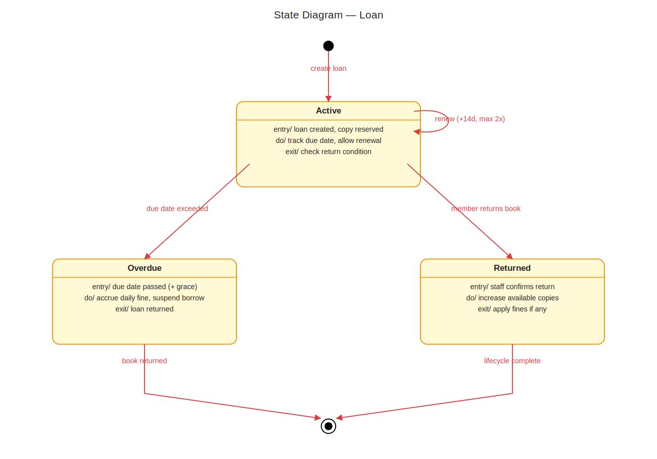
Figure 4.25 — State diagram for Loan.

4.5.2 Reservation
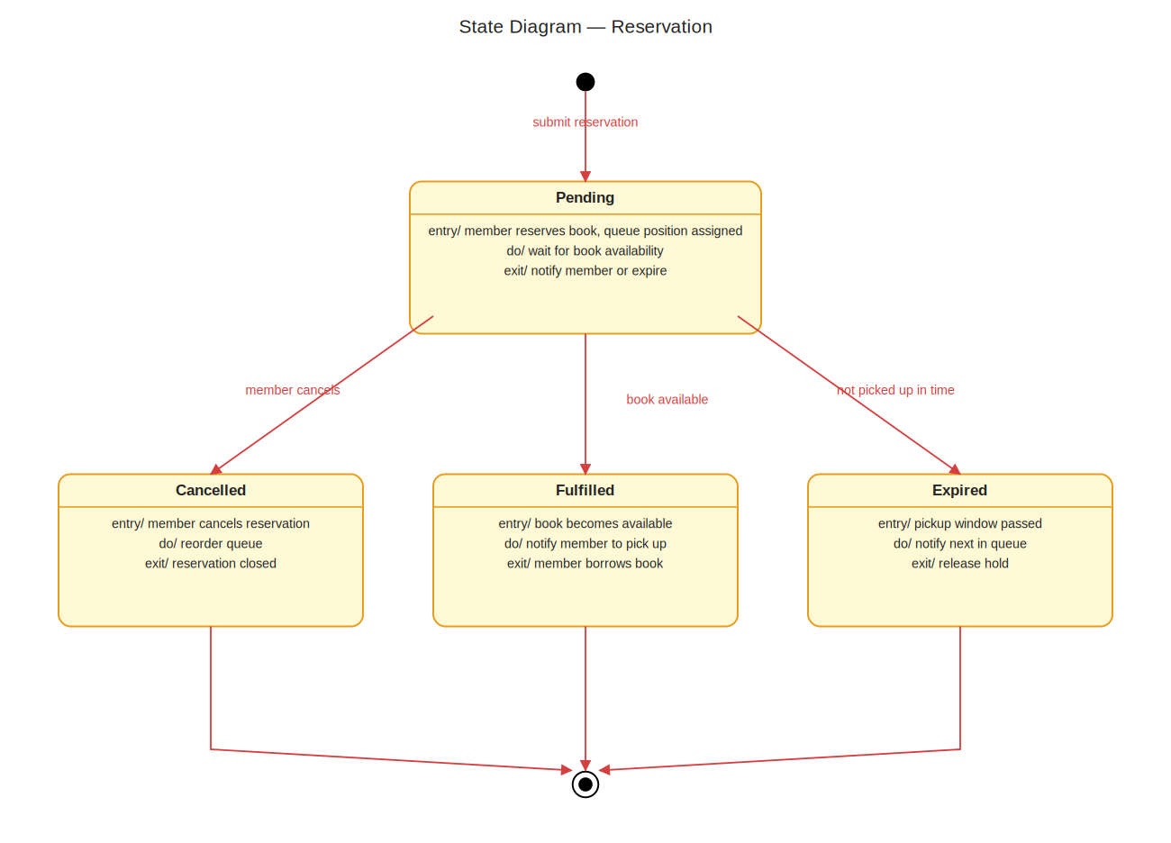
Figure 4.26 — State diagram for Reservation.

4.5.3 Borrow Request
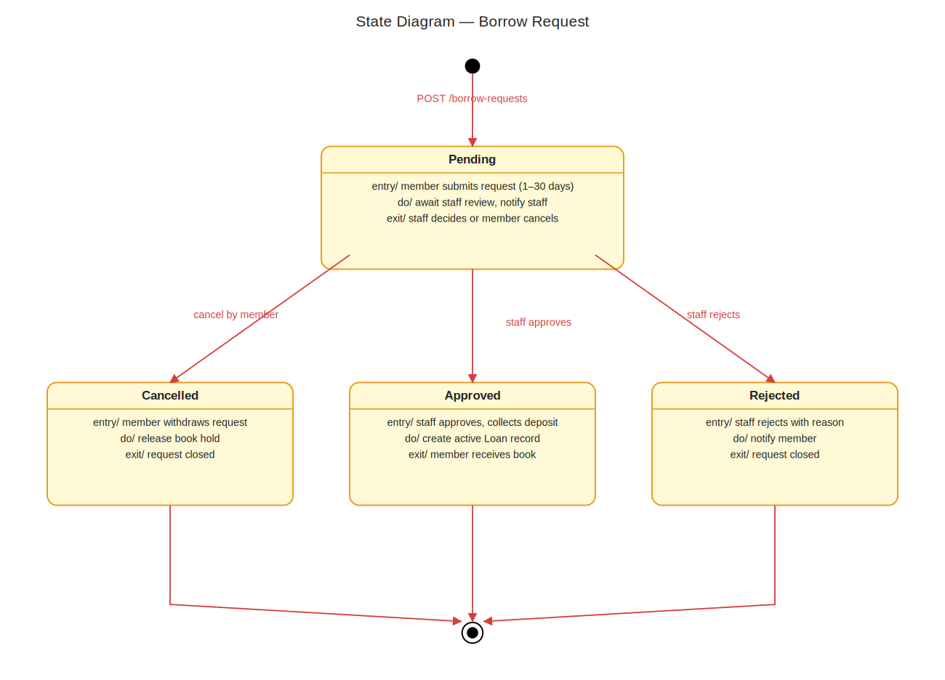
Figure 4.27 — State diagram for Borrow Request.

4.5.4 Fine
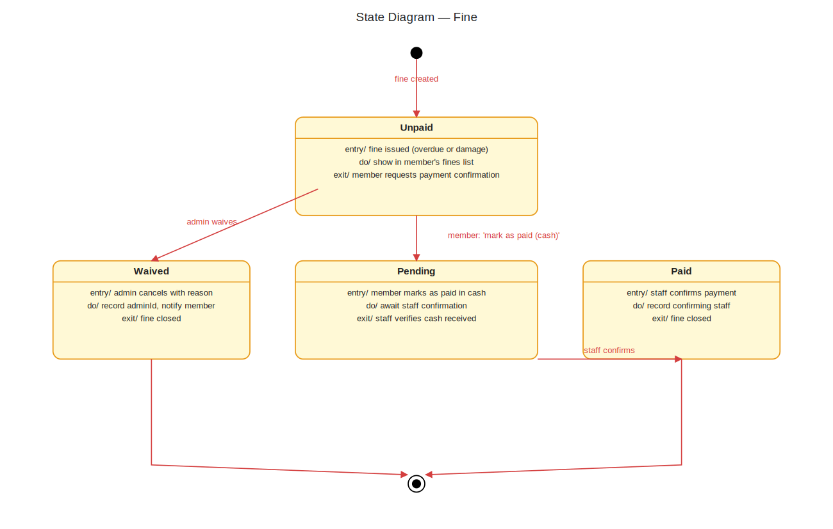
Figure 4.28 — State diagram for Fine.

4.5.5 Book Donation
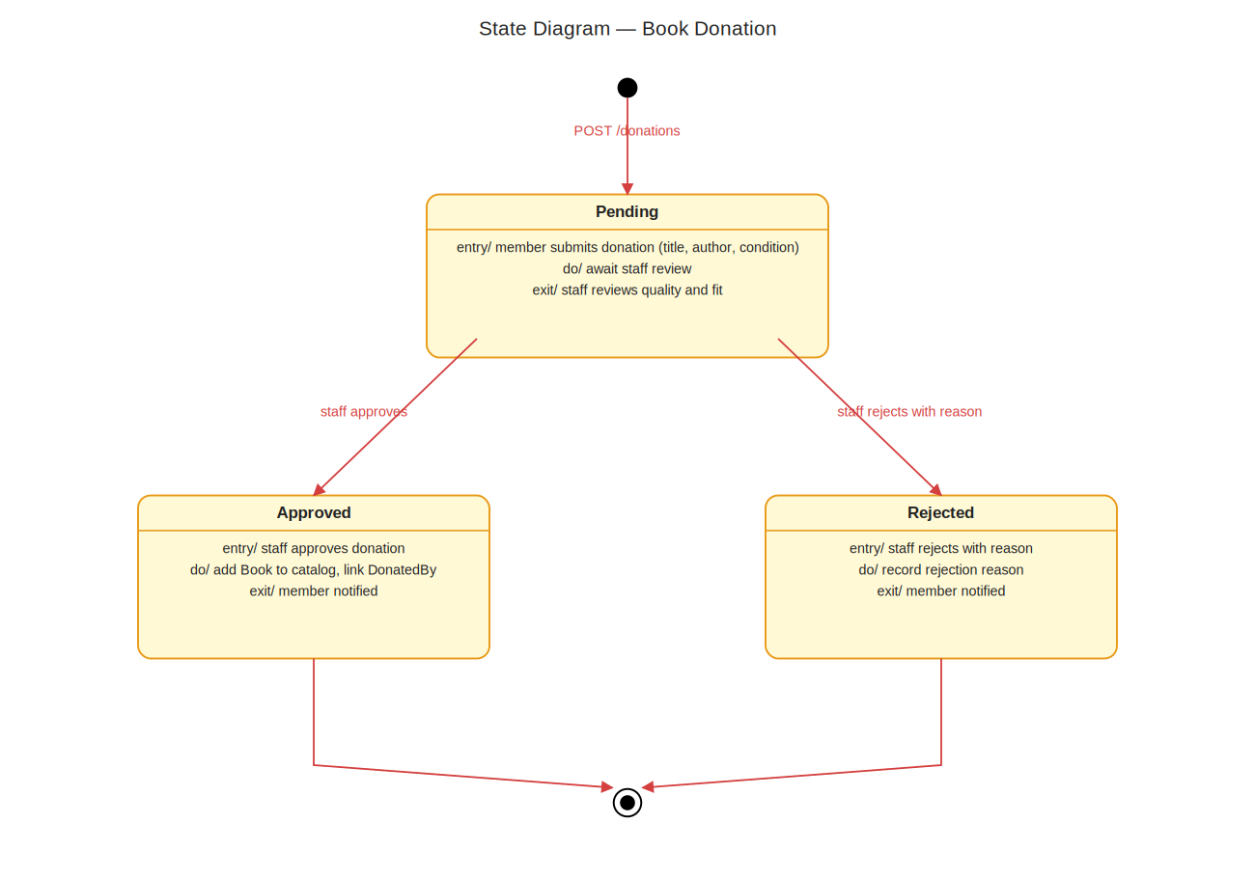
Figure 4.29 — State diagram for Book Donation.

4.5.6 Book (catalog availability)
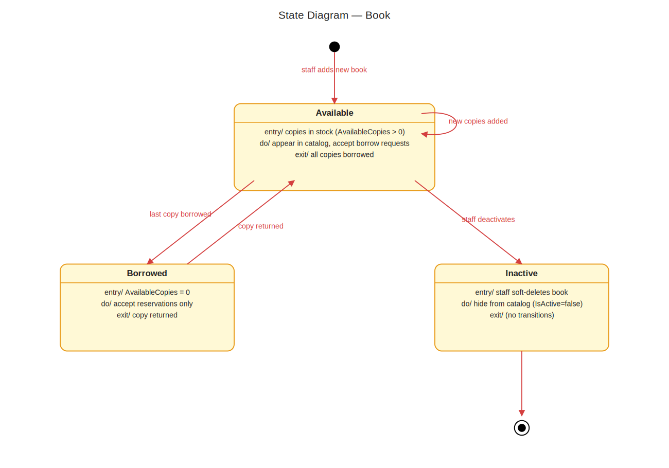
Figure 4.30 — State diagram for Book (catalog availability).

4.5.7 User Account
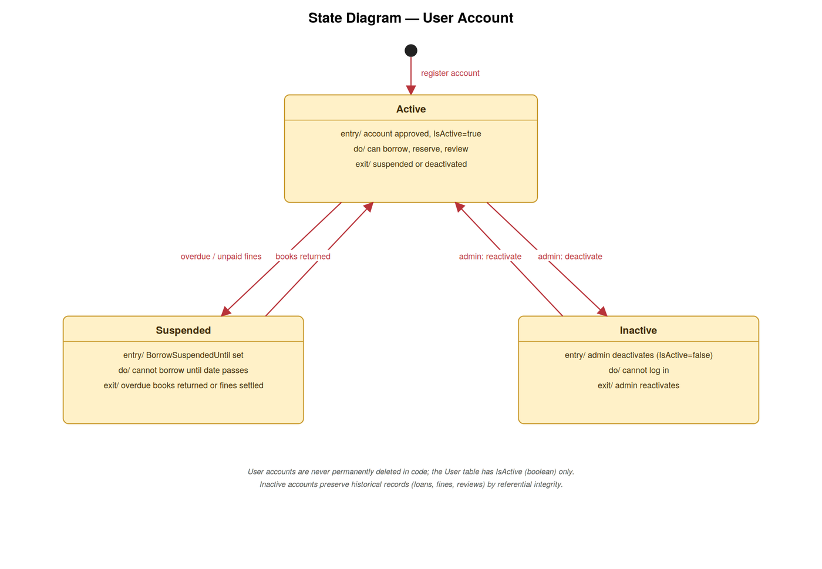
Figure 4.31 — State diagram for User Account.

4.5.8 Book Review
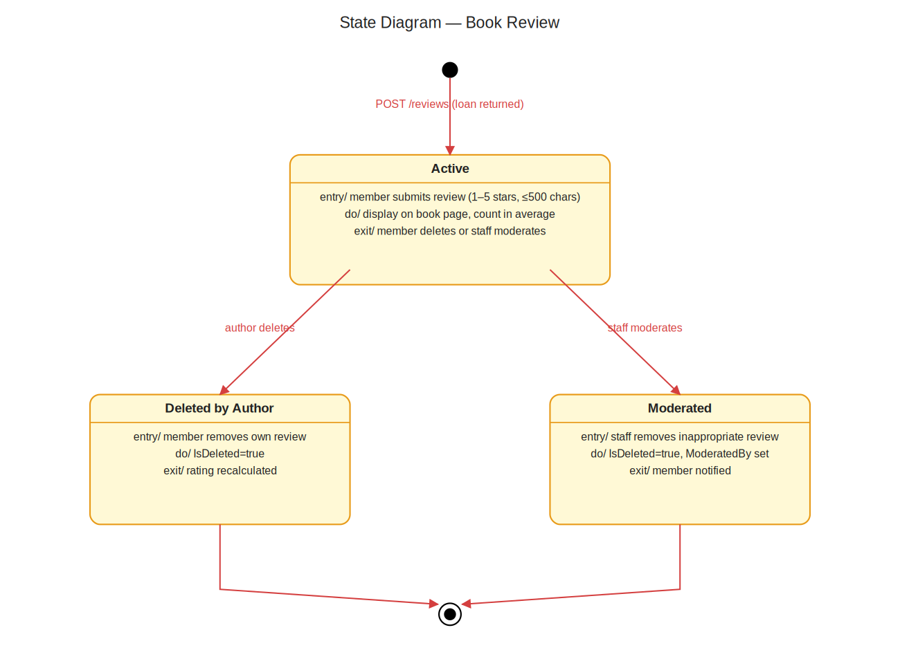
Figure 4.32 — State diagram for Book Review.

4.5.9 Room Booking
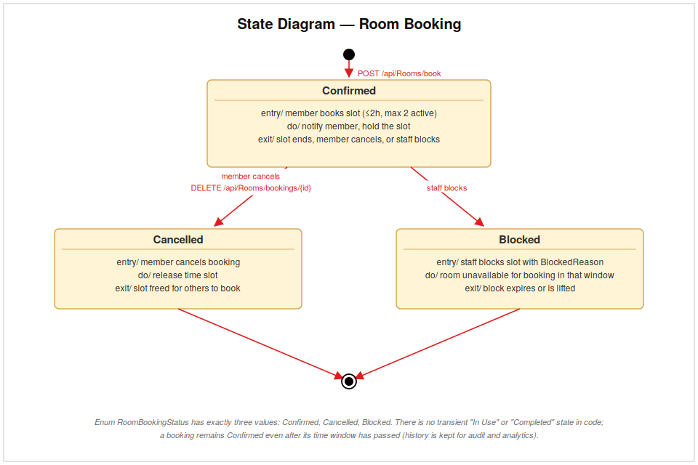
Figure 4.33 — State diagram for Room Booking.

4.5.10 Cash Deposit
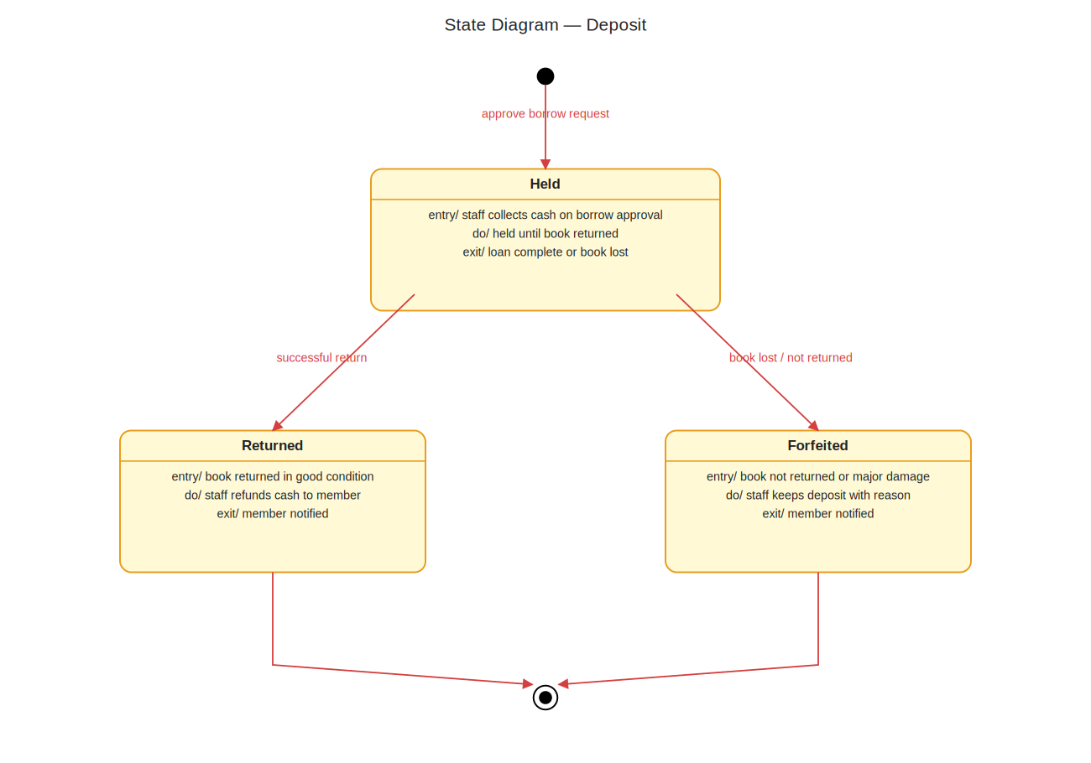
Figure 4.34 — State diagram for Cash Deposit.

4.6 Class Diagram
The class diagram shows the C# entity types defined in LibraryAPI/Models/Models.cs and the relationships between them. The model groups around four main clusters: user identity (User with role enum), the catalog (Book, Author, Category), the borrowing lifecycle (BorrowRequest, Deposit, Loan, Reservation, Fine, FinePolicy), and member engagement (BookReview, Wishlist, BookDonation, LibraryEvent, EventRegistration, RoomBooking, Notification, DismissedRecommendation).

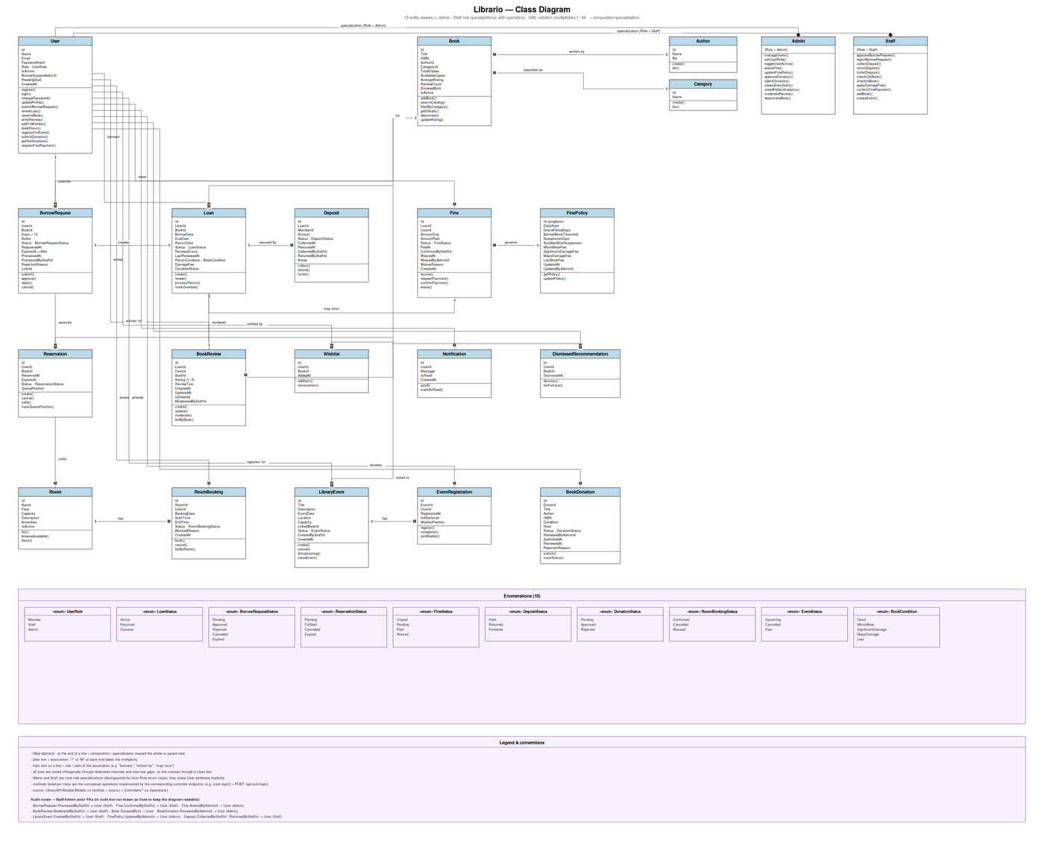

Figure 4.35 — Class diagram of the domain entities.

4.7 Entity-Relationship Diagram and Relational Schema
The ERD shows the conceptual database design with entities, their attributes, and the cardinality of the relationships between them. The relational schema (RS) shows the same model after translation into concrete SQL tables — with primary keys, foreign keys, and the unique indexes that enforce the business invariants noted in the requirements section (e.g., a single review per member-book pair).

4.7.1 Entity-Relationship Diagram

Figure 4.36 — Entity-relationship diagram (conceptual model).

4.7.2 Relational Schema
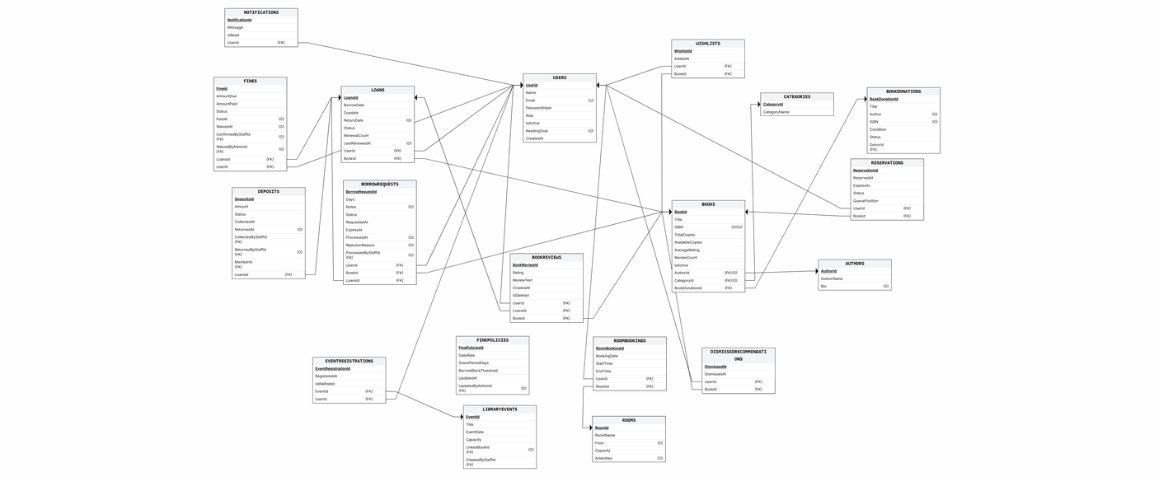
Figure 4.37 — Relational schema (logical model).

4.8 Component Diagram
The component diagram shows the major build-time components of the system and the interfaces between them: the static frontend (HTML pages plus JavaScript helpers such as auth.js, dialog.js, and notifications-widget.js), the ASP.NET Core Web API (controllers grouped by domain), the Entity Framework Core data-access layer (LibraryDbContext and the entity classes), the SQLite database file (library.db), and the OverdueProcessorService background worker.
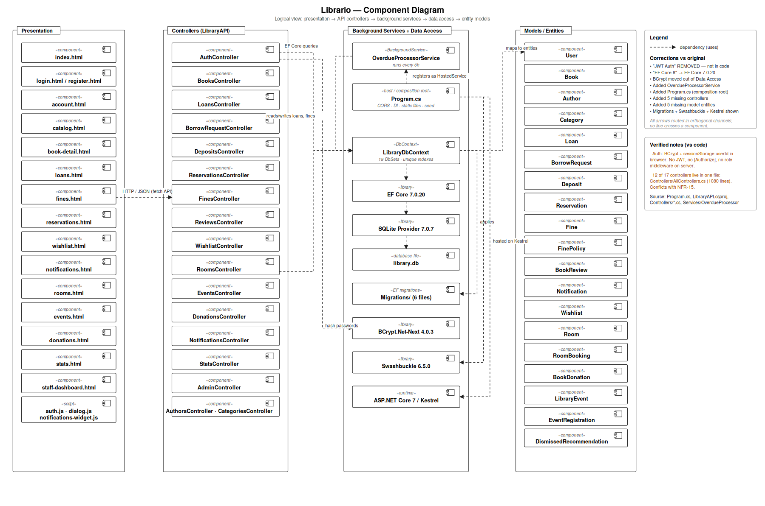
Figure 4.38 — Component diagram of the Library Management System.

4.9 Deployment Diagram
The deployment diagram shows the runtime nodes and the artifacts deployed on each. In this configuration, a single host runs the ASP.NET Core process (which serves both the REST API on port 5273 and the static frontend files); the same host stores the SQLite database file alongside the application. Browsers on members', staff', and administrators' devices communicate with the host over HTTP.
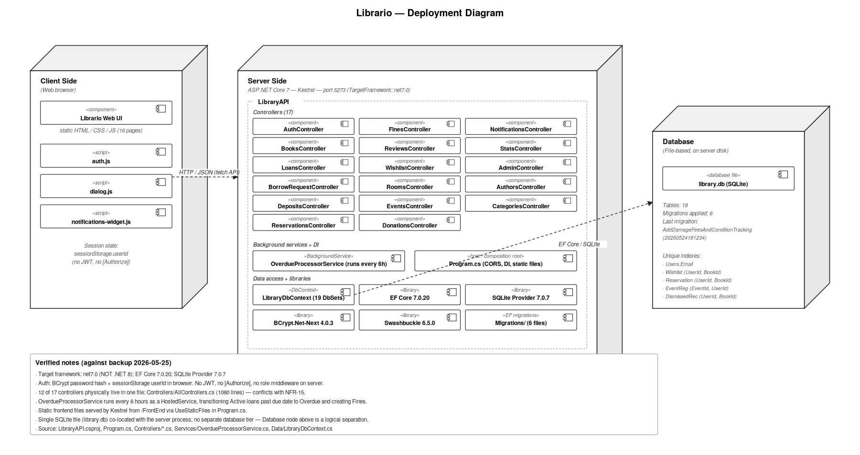
Figure 4.39 — Deployment diagram showing the runtime topology.

5. Implementation
This section describes how the system is built — the technology stack chosen for each layer, the architectural pattern that ties them together, and the configurable seed data that bootstraps a working instance.

5.1 Technology Stack
The implementation evidence below is sourced directly from the project files (LibraryAPI.csproj, Program.cs, Properties/launchSettings.json). Each entry reflects what is actually present in the codebase as of the version covered by this report.

5.1.1 Backend
Runtime | .NET 7 (TargetFramework: net7.0)
Web framework | ASP.NET Core Web API
ORM / Data access | Entity Framework Core 7.0.20
Database engine | SQLite (Microsoft.EntityFrameworkCore.Sqlite 7.0.7)
Password hashing | BCrypt.Net-Next 4.0.3
API documentation | Swashbuckle.AspNetCore 6.5.0 (Swagger / Swagger UI)
Background services | IHostedService — OverdueProcessorService
Default development port | HTTP 5273 (HTTPS 7132)

The backend is organized as a single ASP.NET Core Web API project (LibraryAPI/). Controllers are grouped by domain — Auth, Books, Loans, BorrowRequest, Deposits, Reservations, Fines, Reviews, Wishlist, Rooms, Donations, Events, Notifications, Stats, Admin, Authors, and Categories — each living in its own [ApiController]. The Models folder holds all entity classes (with C# enums for finite states such as LoanStatus, FineStatus, DepositStatus, BookCondition, etc.). The Data folder holds the LibraryDbContext, which configures every DbSet, every unique index, and every foreign-key cascade behaviour. A background OverdueProcessorService runs as IHostedService to mark overdue loans without manual intervention.

5.1.2 Frontend
Markup | Static HTML5 — one file per major view
Styling | Plain CSS (FrontEnd/style.css)
Scripting | Vanilla JavaScript (no framework, no build step)
Shared modules | auth.js (session helpers), dialog.js (modals), notifications-widget.js
Pages | login.html, register.html, index.html, catalog.html, loans.html, reservations.html, wishlist.html, fines.html, rooms.html, donations.html, events.html, notifications.html, stats.html, account.html, staff-dashboard.html

The frontend is deliberately framework-free. Every page is a static HTML file that loads style.css and a small number of JavaScript modules; there is no Node-based build pipeline, no transpilation step, and no client-side router. The frontend is served as static files by the same ASP.NET Core process that hosts the API (UseStaticFiles in Program.cs), so deployment is a single artifact.

5.1.3 Database
Engine | SQLite — file-based, single library.db
Schema management | Entity Framework Core migrations (6 migrations present)
Notable migrations | InitialCreate, BorrowRequestAndDeposit, FixupBorrowRequestAndDeposit, AddLoanRenewal, AddSuspensionAndOverdueFields, AddDamageFeesAndConditionTracking
Constraints | Unique indexes on (UserId, BookId) for Wishlist, BookReview, DismissedRecommendation; (EventId, UserId) for EventRegistration; foreign keys with explicit OnDelete behaviours
Seed data | Bootstrapped on first run from Program.cs — Admin / Staff / Member test accounts, 6 categories, 5 authors, 9 books, 4 study rooms, default FinePolicy

5.2 Architecture
The system follows a classic layered architecture: a thin client (the HTML / JavaScript frontend), a Web API layer (controllers), a service layer (background services and shared helpers), a data-access layer (LibraryDbContext and entity classes), and a storage layer (SQLite). Communication between client and server is exclusively over HTTP using JSON request and response bodies.

5.2.1 API Architecture (REST)
Every controller follows the convention [Route("api/[controller]")], so endpoints are grouped predictably (for example, GET /api/Books/{id}, POST /api/borrowrequest, POST /api/Loans/{loanId}/renew). Request and response bodies are JSON; status codes follow standard HTTP semantics (200 OK, 201 Created, 400 Bad Request, 404 Not Found, 409 Conflict, etc.). CORS is enabled globally via an AllowFrontend policy so the frontend can call the API from any origin during development.

5.2.2 Cross-Cutting Concerns
- Authentication and session: passwords are hashed with BCrypt on registration and verified on login; the userId, role, and name returned by /api/Auth/login are stored in browser sessionStorage by auth.js.
- Authorization: role enforcement is performed client-side by auth.js -- pages are redirected to /login.html when the session is missing, and role-specific UI elements (staff dashboard, admin console) are gated by the role value stored in sessionStorage. The Web API itself does not currently apply [Authorize] attributes or JWT/cookie middleware; this is a known limitation appropriate for the academic scope of this version and would be the first hardening step before a production deployment.
- Notifications: a Notification table records every event the user cares about (request approved, fine waived, room booking cancelled). The frontend's notifications-widget.js polls /api/Notifications/{userId} and surfaces unread counts on every member page.
- Background processing: OverdueProcessorService runs on a timer, finds loans past their due date, flips their status to Overdue, and creates the corresponding Fine entries based on the active FinePolicy.
- Soft delete: removing a book or a review never deletes the row — it toggles IsActive / IsDeleted. This preserves loan history, review trails, and statistical accuracy.

6. Software Screenshots
The following screenshots are captured directly from the running application. Each screenshot is grouped by user role so that the visual evidence parallels the actor breakdown used in the requirements and use-case sections.

6.1 Authentication & Registration

Login Page
Login screen — users authenticate by email and password; auth.js sends POST /api/Auth/login and stores userId, role, and name in sessionStorage.
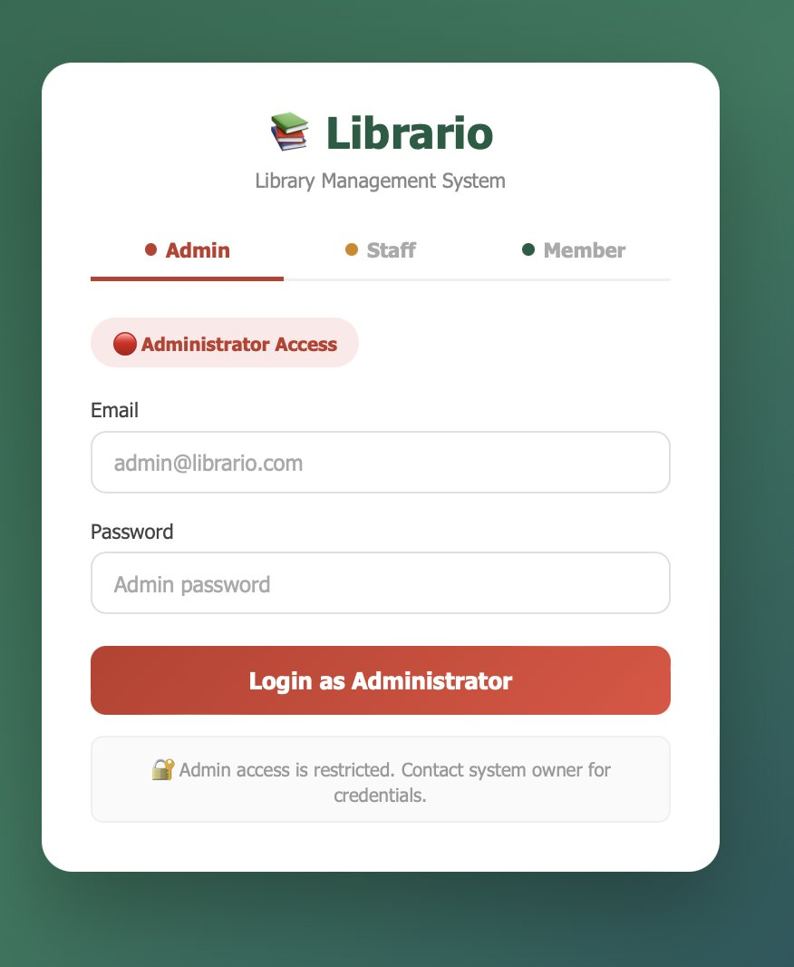
Figure 40 — Login Page.

Registration Page
New-member registration — collects name, email, and password and submits POST /api/Auth/register. The system rejects already-registered emails.
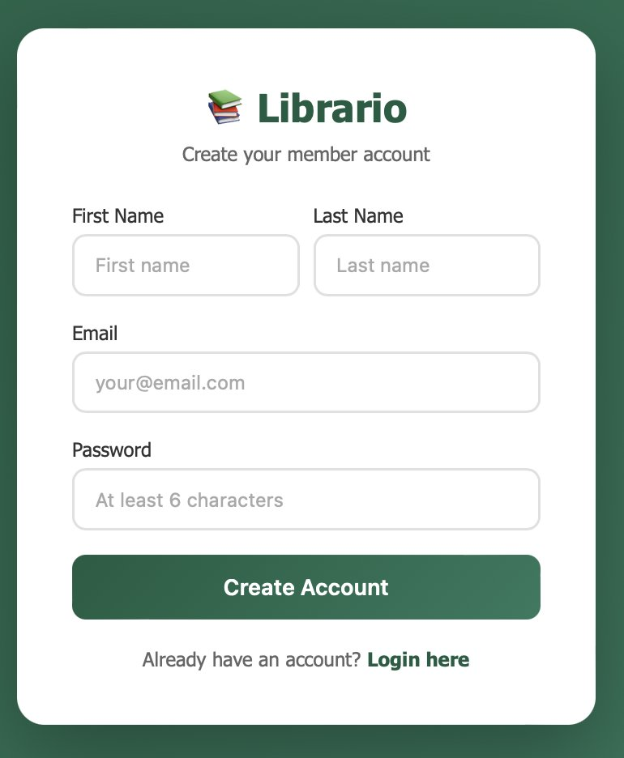
Figure 41 — Registration Page.

6.2 Member Portal

Member Dashboard
Member home view after login, showing quick links to catalog, loans, fines, and notifications.
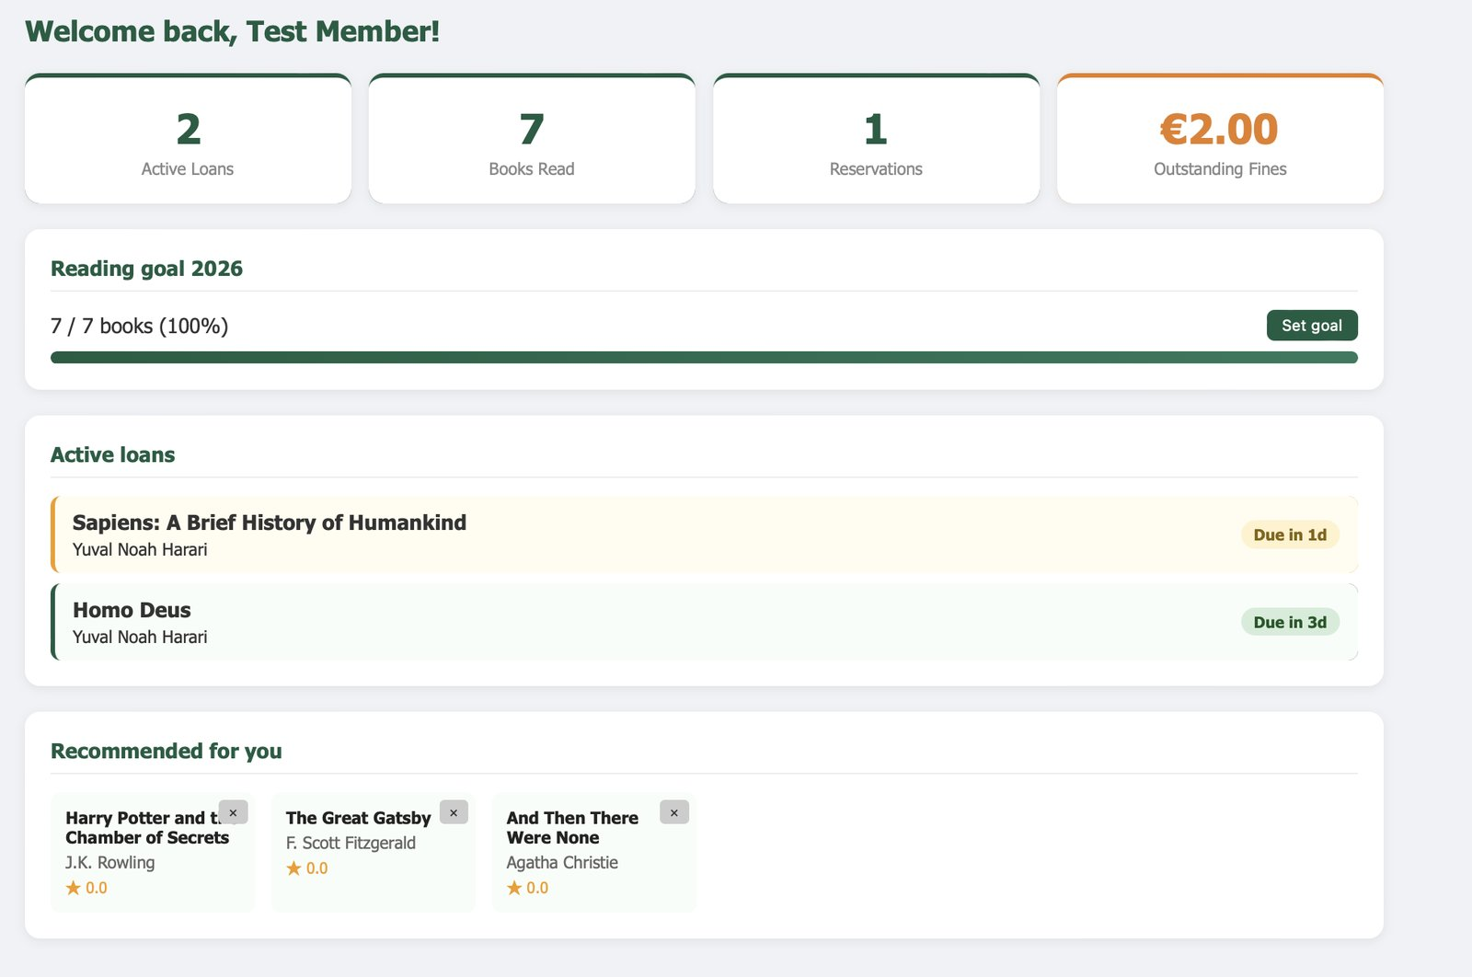
Figure 42 — Member Dashboard.

Catalog (Browse & Search)
Catalog page with search by title or author, category filter, and per-book actions (request, reserve, wishlist).
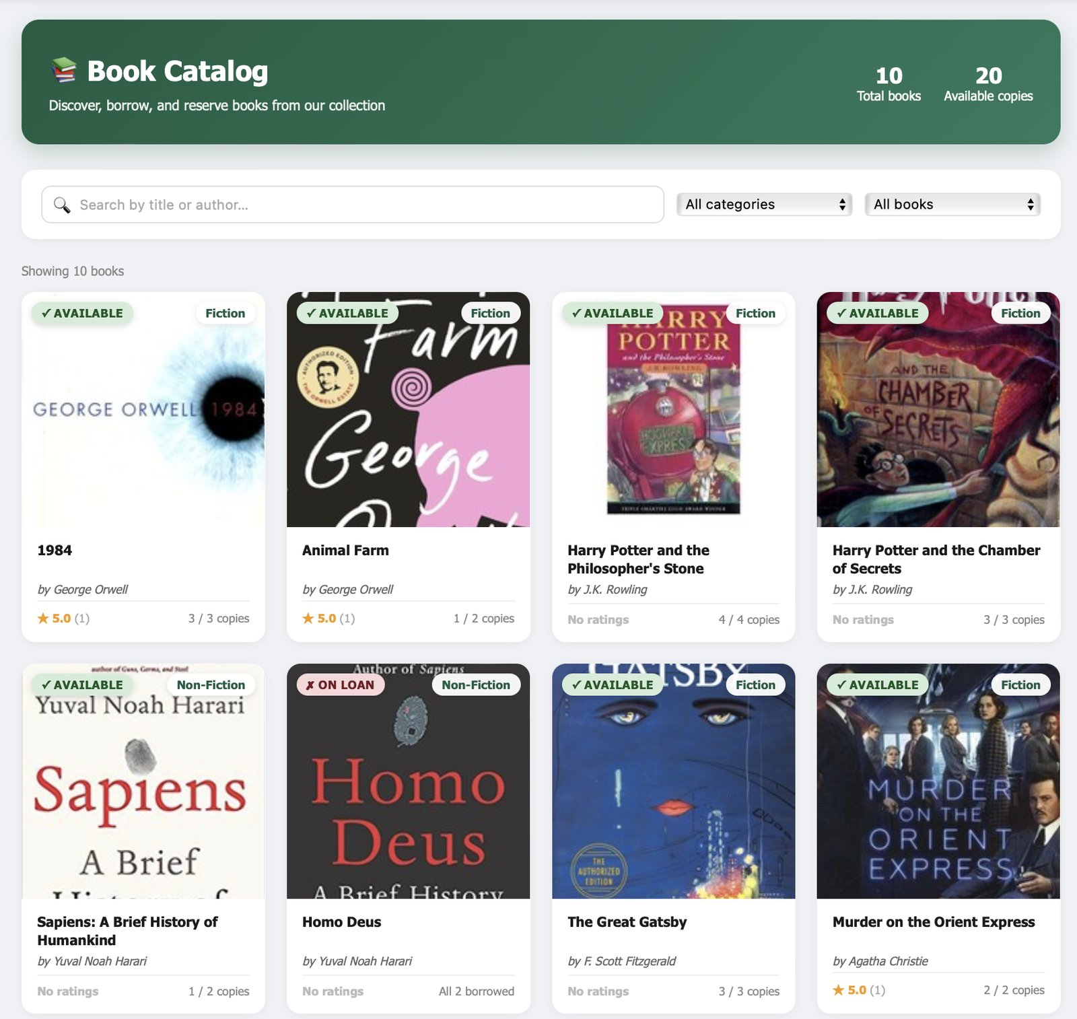
Figure 43 — Catalog (Browse & Search).

Borrow Request Flow
The borrow-request dialog: member selects a duration between 1 and 30 days and submits a request for staff approval.
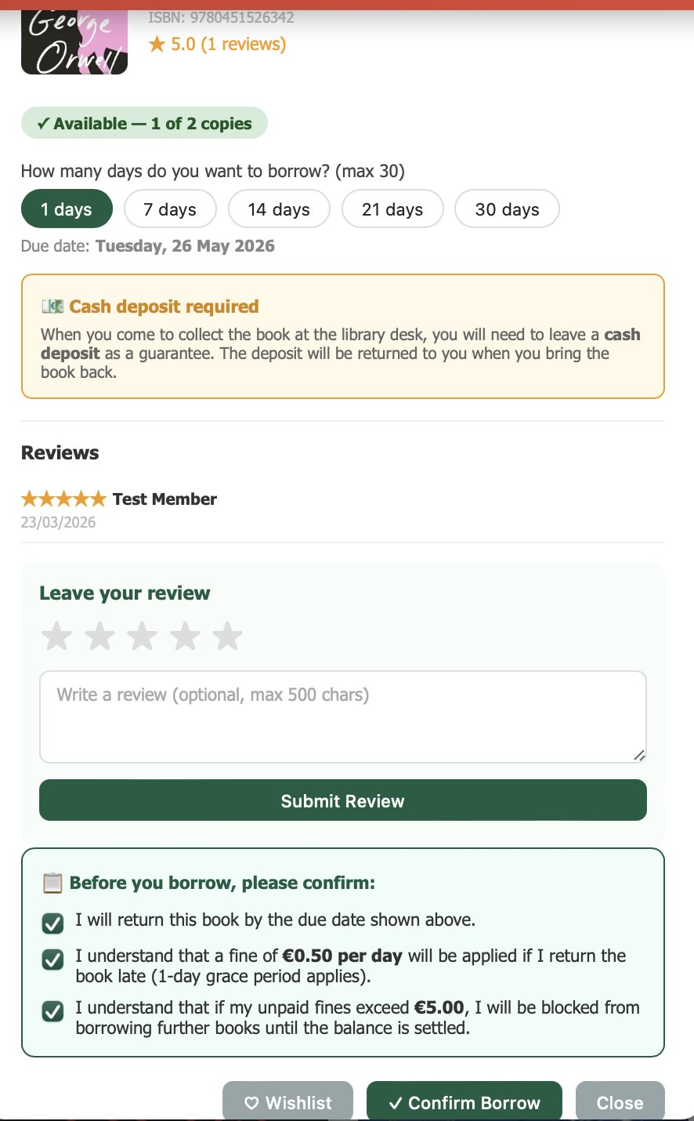
Figure 44 — Borrow Request Flow.

My Loans & Pending Requests
Active and historical loans alongside any pending borrow requests still awaiting staff approval.
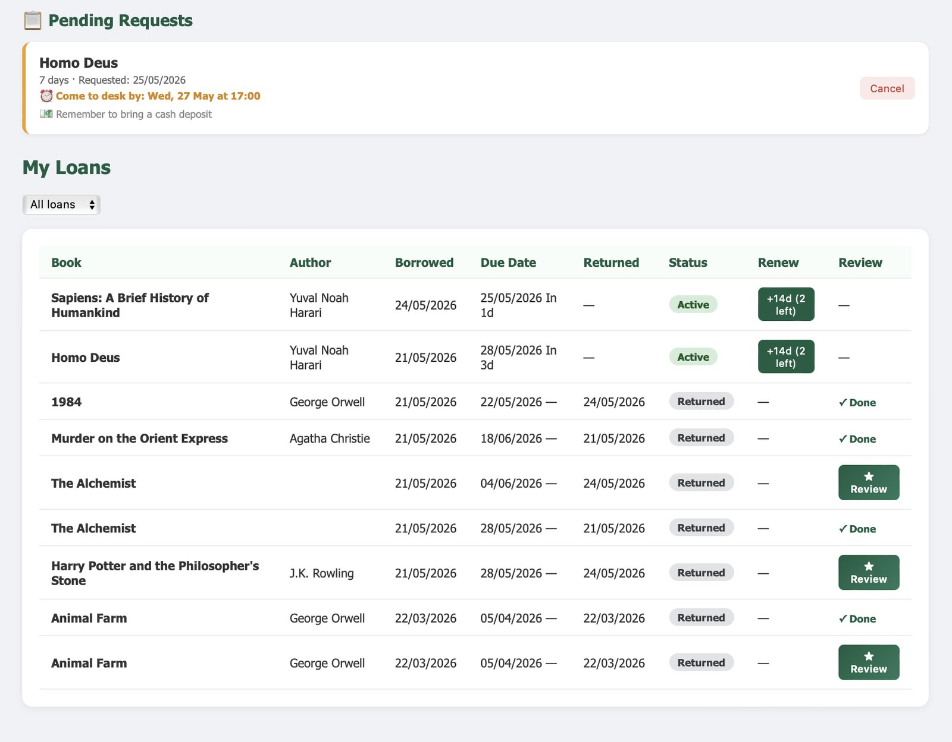
Figure 45 — My Loans & Pending Requests.

Overdue Loans View
Overdue loans flagged on the member side, including the resulting fine and remediation actions.
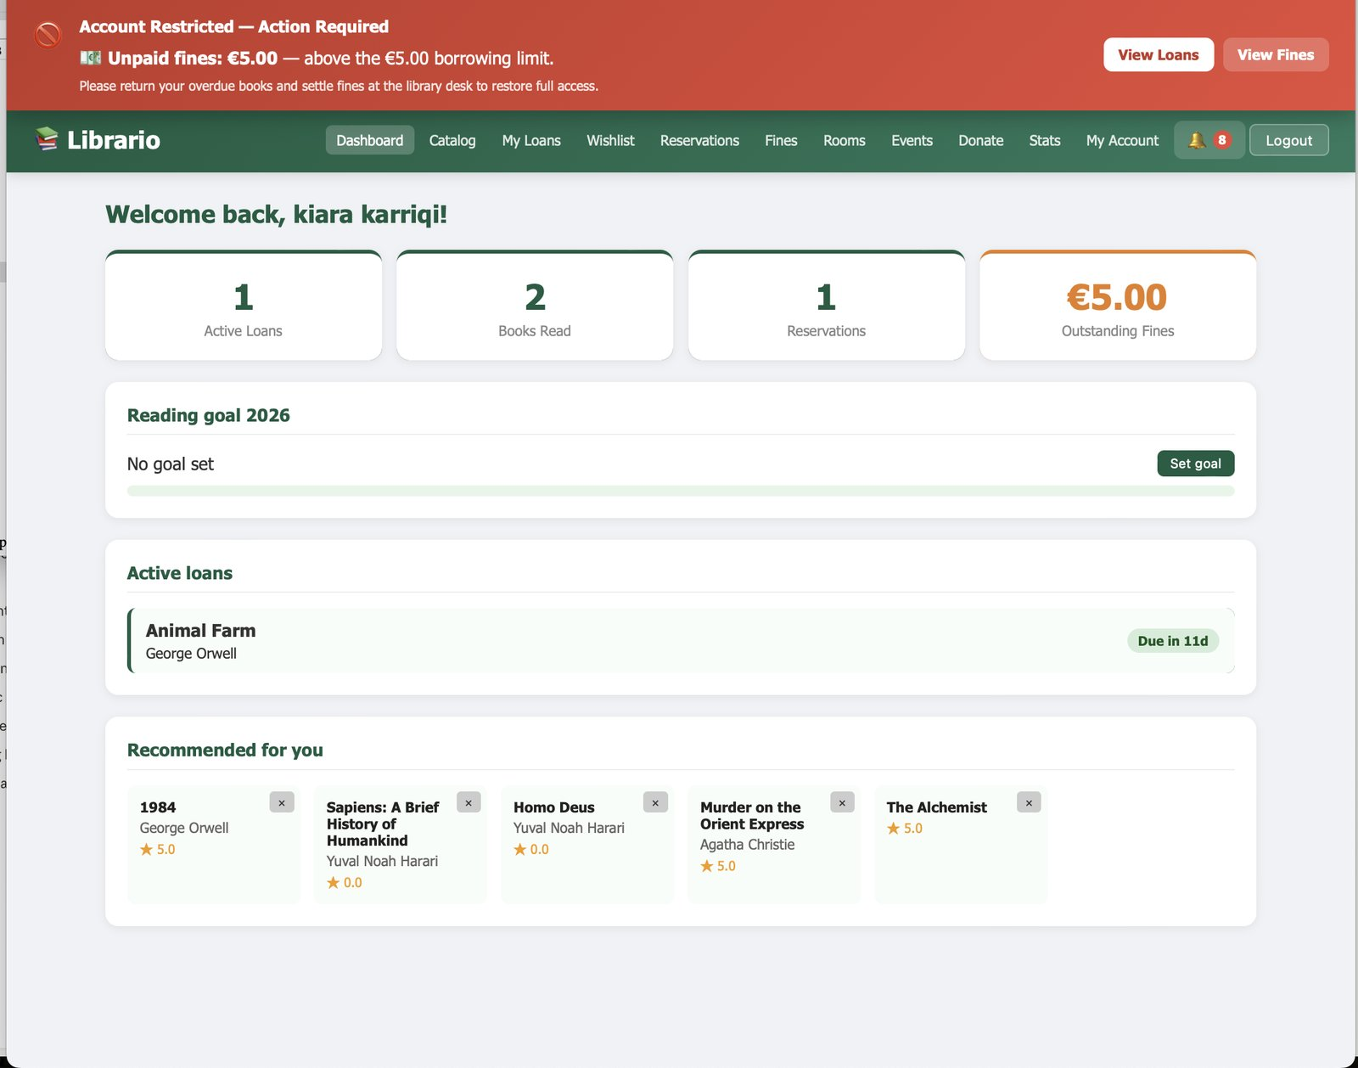
Figure 46 — Overdue Loans View.

Borrow Block Notice
Error state shown when a member tries to renew or borrow while their fines exceed the BorrowBlockThreshold from FinePolicy.
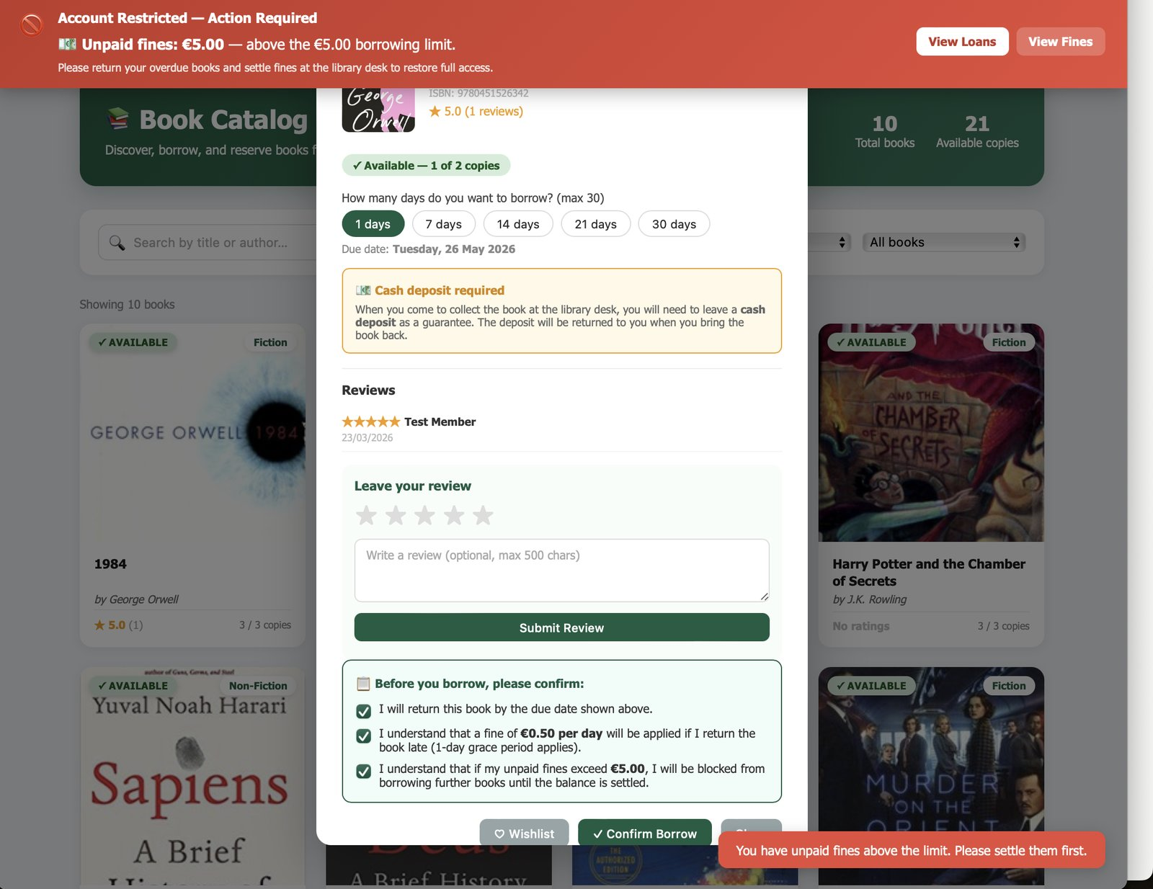
Figure 47 — Borrow Block Notice.

Study Room Booking
Study-room booking page — member picks a room, date, and a slot of up to 2 hours; the system enforces a maximum of 2 active bookings per member.
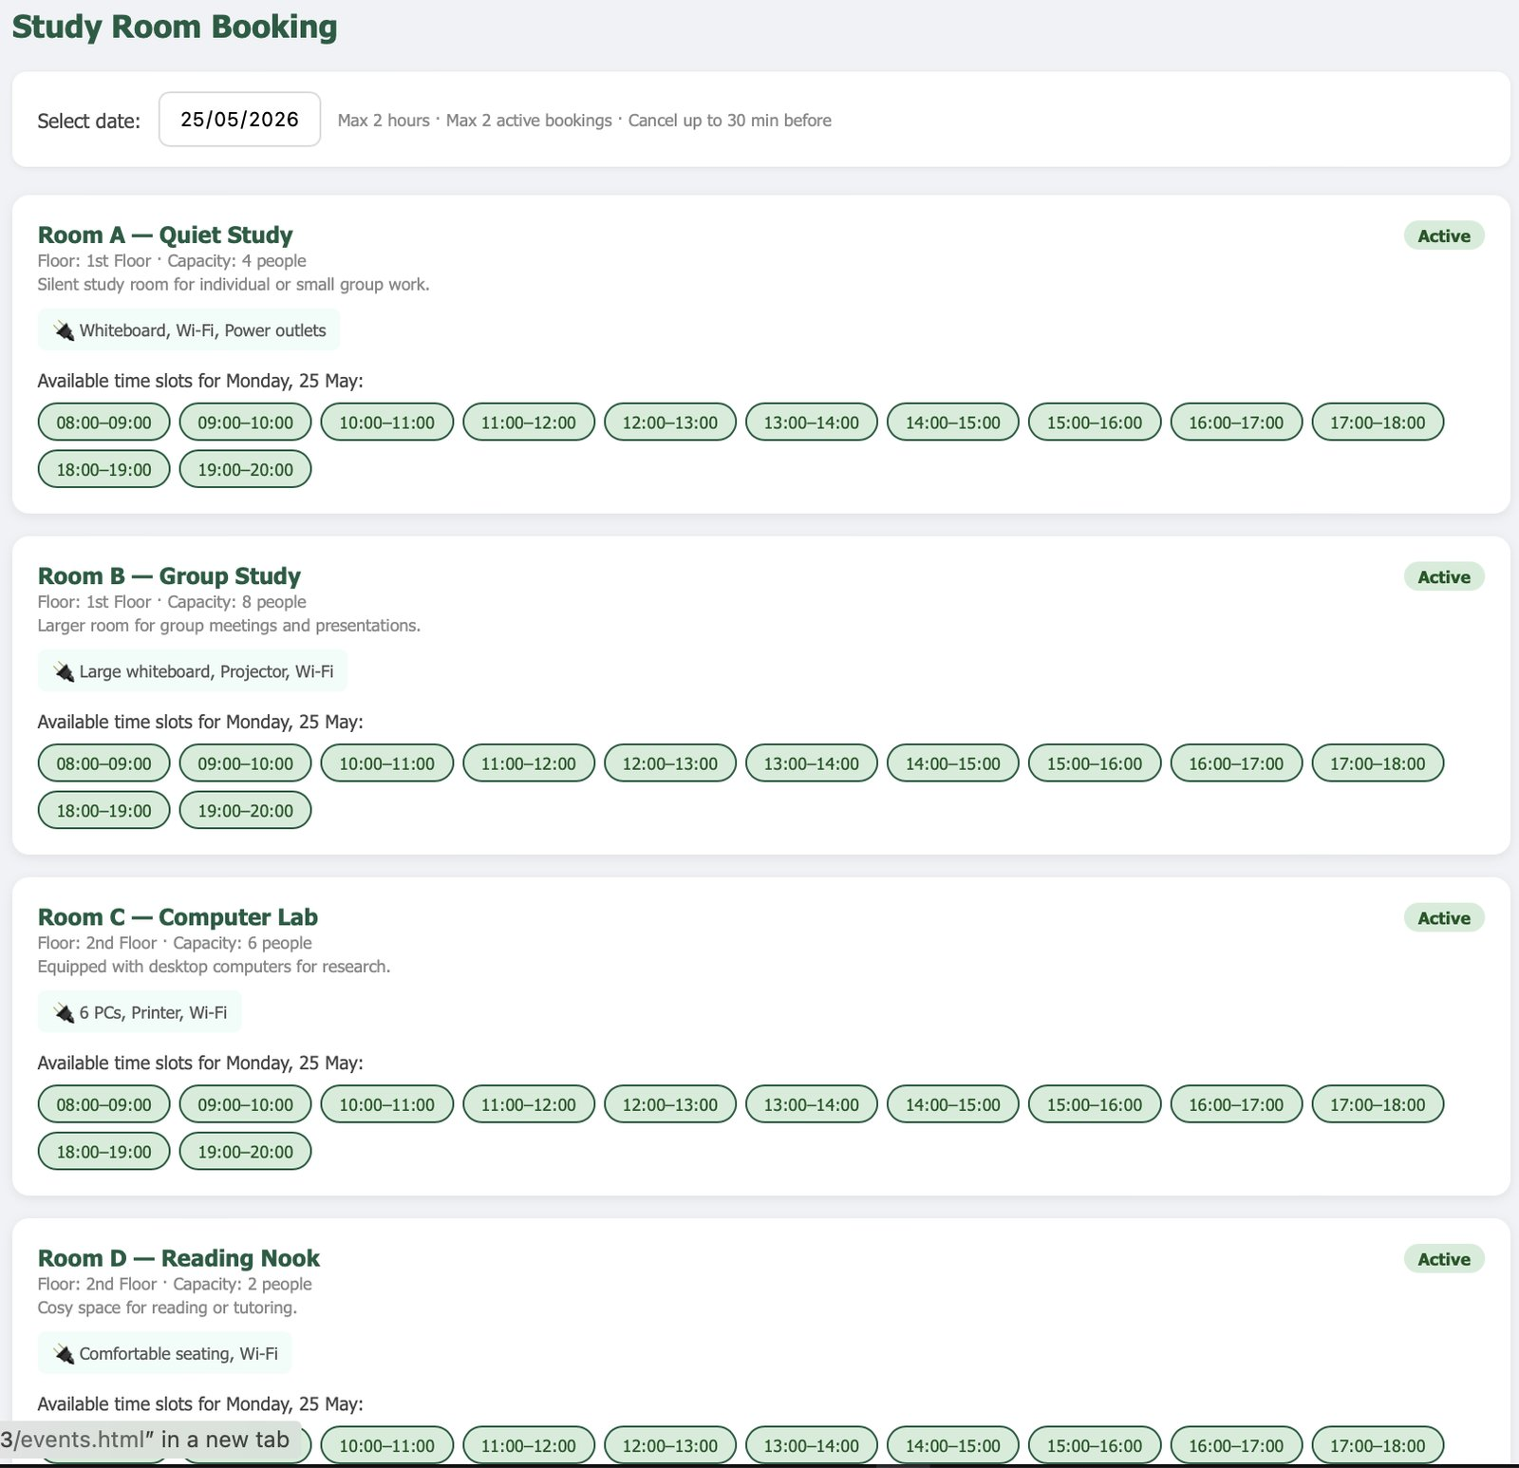
Figure 48 — Study Room Booking.

Notifications Centre
Notification feed populated by the Notification table; the unread count is also surfaced by the persistent notifications widget.
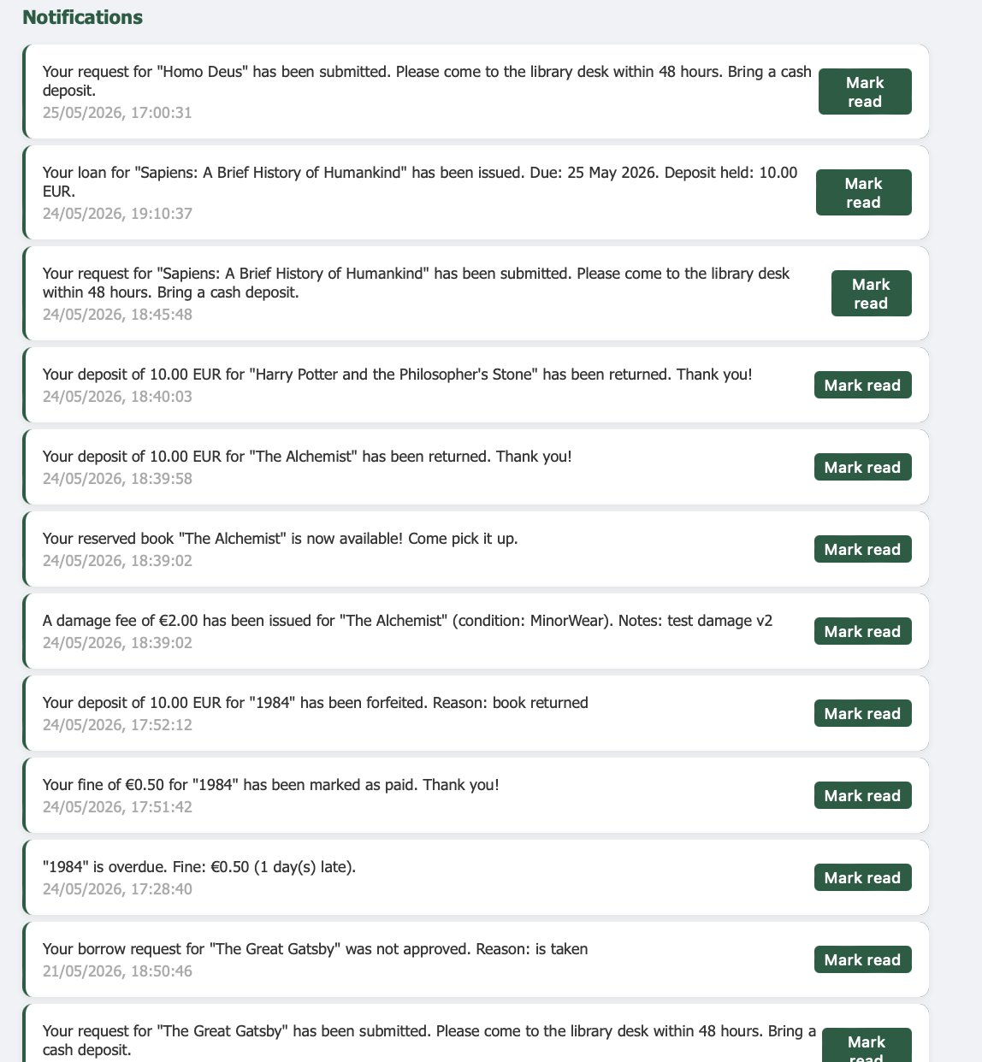
Figure 50 — Notifications Centre.

Personal Reading Stats
Reading-stats dashboard with total loans, monthly activity, reading-goal progress, top categories, and personalized recommendations.
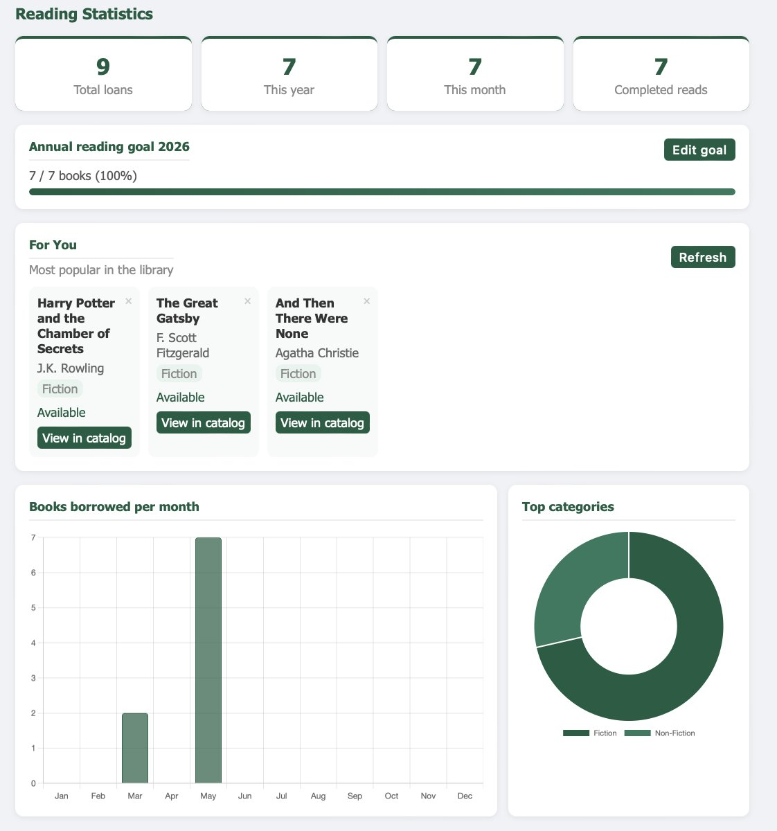
Figure 51 — Personal Reading Stats.

6.3 Staff Dashboard

Pending Borrow Requests
Pending requests tab — staff see member name, book, requested duration, and timestamp, and choose Approve or Reject.
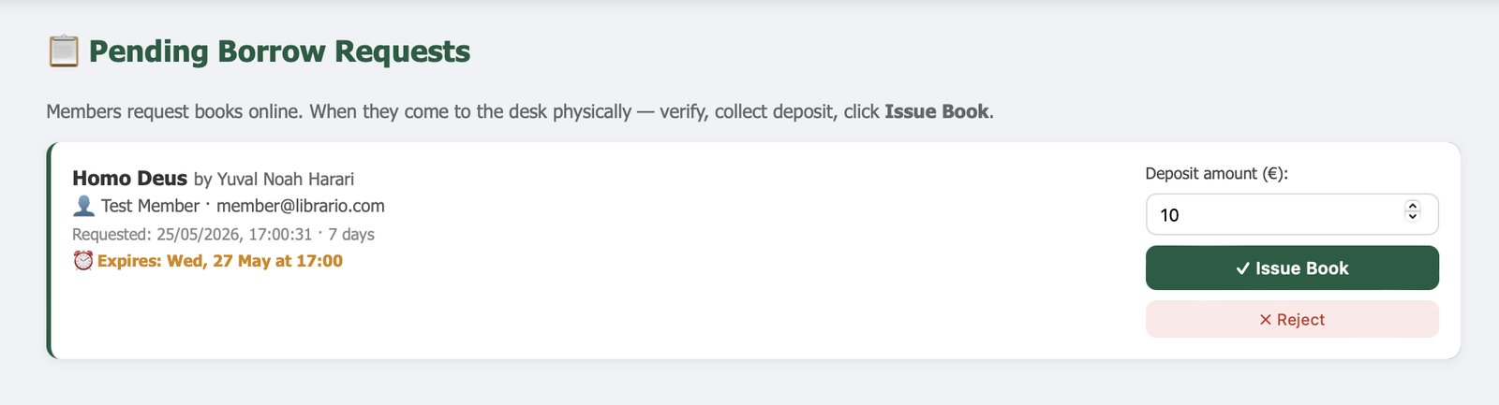
Figure 52 — Pending Borrow Requests.

Active Loans
All active loans in one view, with due date and renewal count, for desk reference.
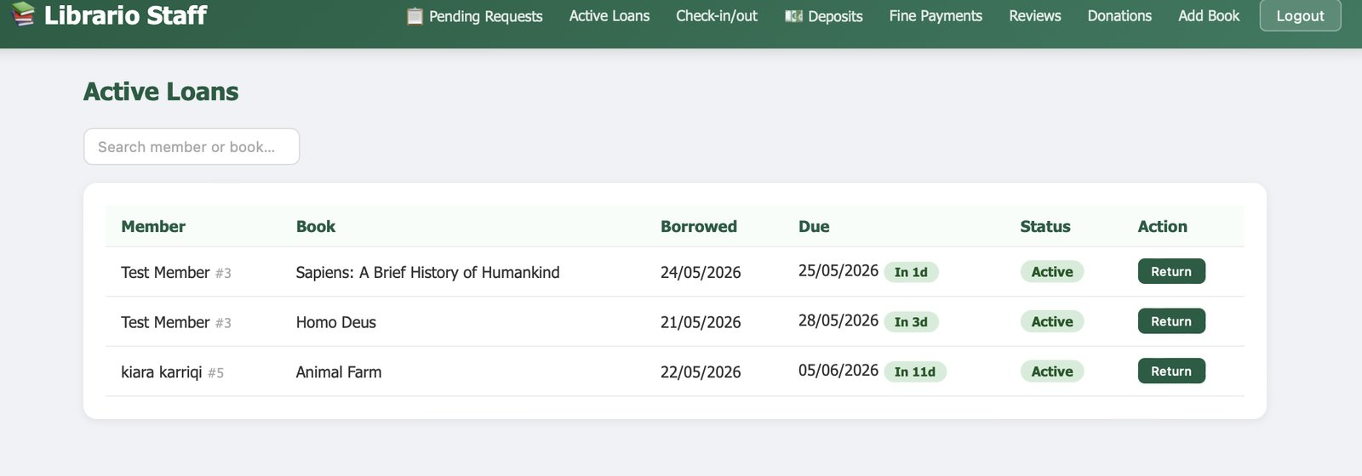
Figure 53 — Active Loans.

Check-in / Check-out
Single screen for processing returns and (when applicable) check-outs against an approved request.
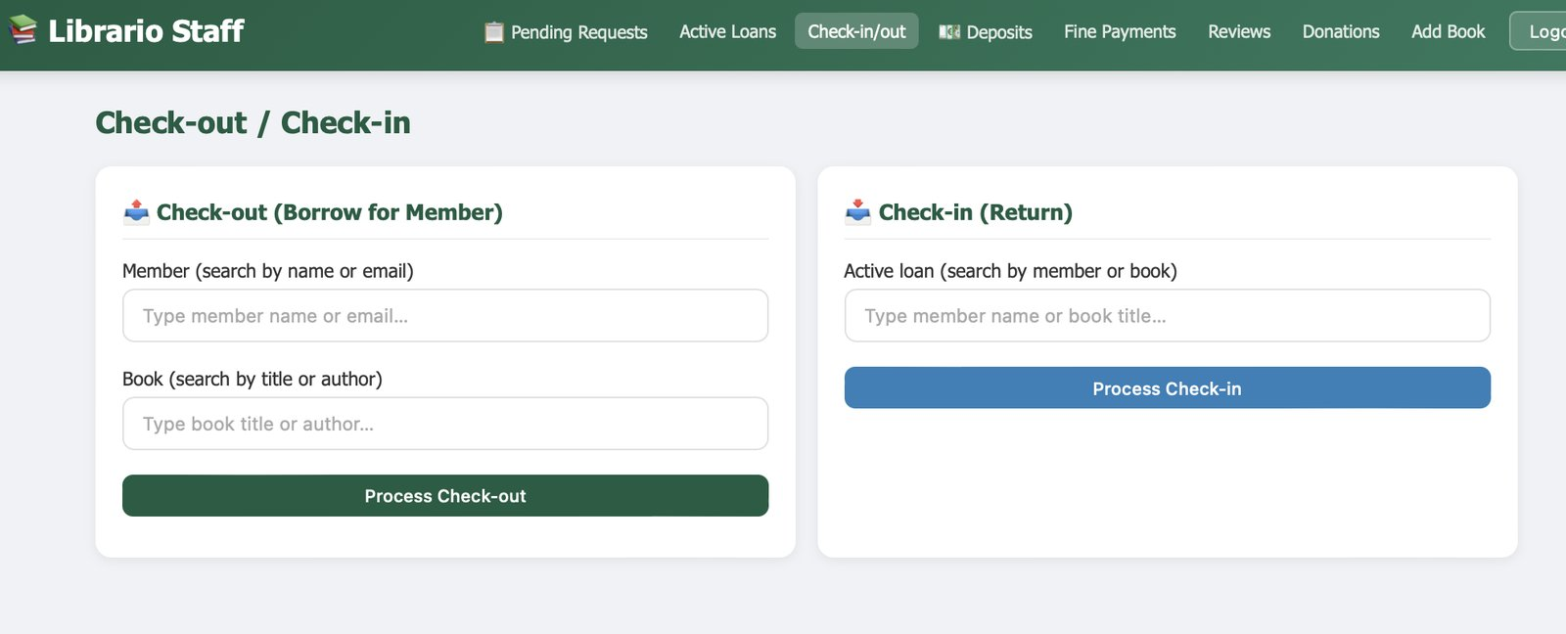
Figure 54 — Check-in / Check-out.

Book Condition Assessment
During return processing staff classify the book's condition (Good / MinorWear / SignificantDamage / MajorDamage / Lost); damage fees apply automatically per FinePolicy.
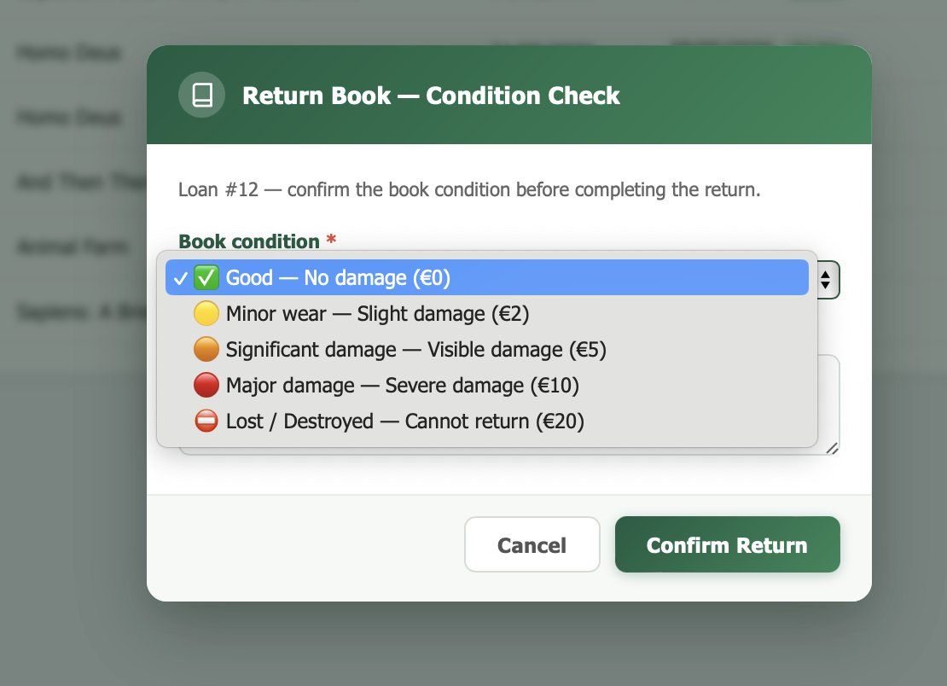
Figure 55 — Book Condition Assessment.

Return Submission
Final return-confirmation step — submits POST /api/Loans/return/{loanId} with the chosen condition and optional notes.
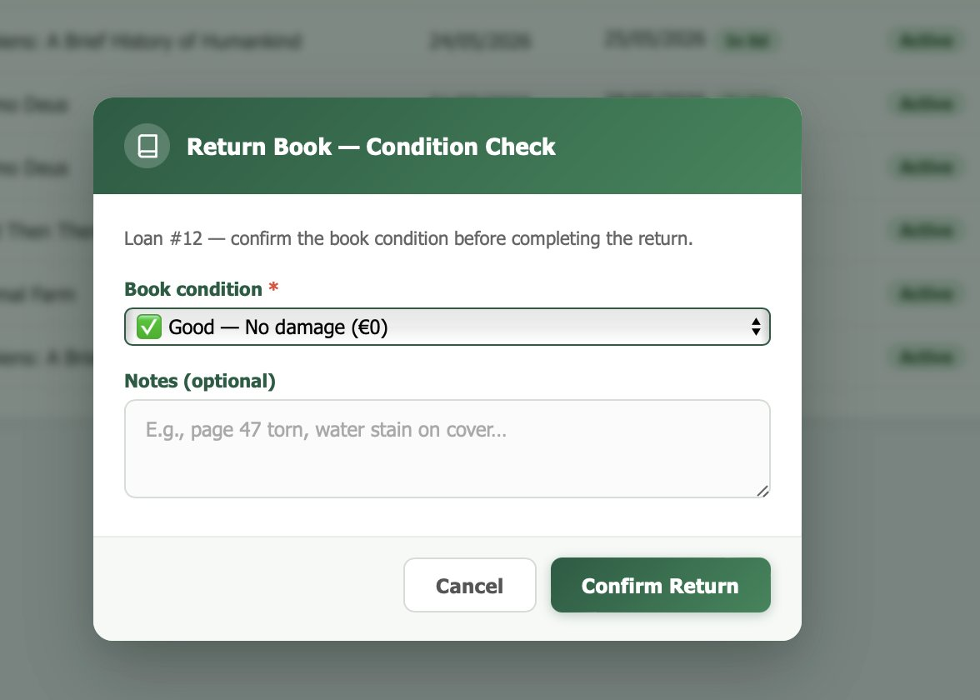
Figure 56 — Return Submission.

Fine Payment Confirmation
Staff confirm cash fine payments received at the desk; the fine status flips from Pending to Paid and ConfirmedByStaffId is recorded.
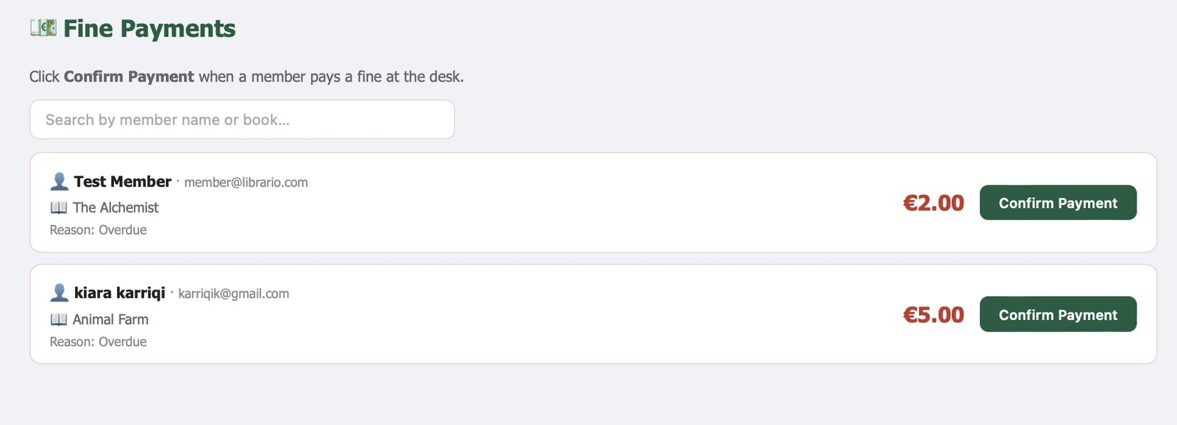
Figure 57 — Fine Payment Confirmation.

6.4 Administrator Console

User Management
Admin user-management table — search by name or email, toggle active status, and change role. An admin cannot deactivate their own account (NFR-05).
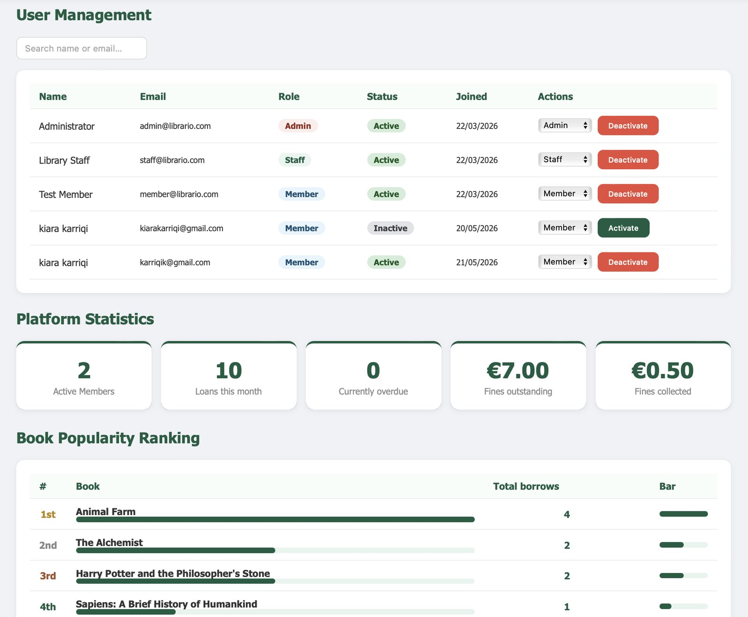
Figure 58 — User Management.

Review Moderation View
Administrator review-moderation screen for soft-deleting inappropriate book reviews.
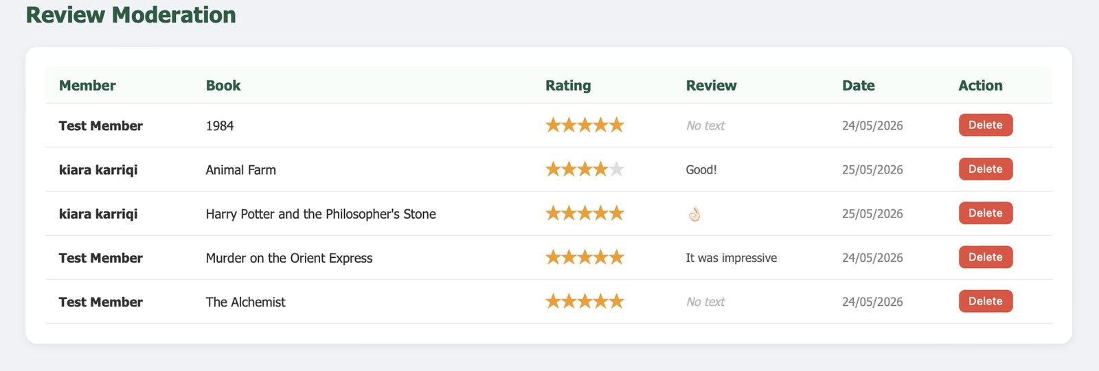
Figure 59 — Review Moderation View.

7. Conclusion
The Library Management System set out to replace the friction of paper-based borrowing and fragmented digital tools with a single, coherent web platform that serves members, staff, and administrators through dedicated interfaces backed by a shared data model. This document has walked through that platform end-to-end: from the high-level project context and user characteristics, through the detailed functional and non-functional requirements, into the software design — use cases, activity, sequence, state, class, ERD, component, and deployment diagrams — and finally into the technology stack and screenshots of the running application.
Across every section the goal has been the same: to keep the specification honest and faithful to what was actually built. Each requirement traces to a concrete part of the system, each diagram reflects a real entity or flow, and each screenshot shows the working interface as a member, staff member, or administrator would see it.
Building the platform reinforced a number of lessons that go beyond the immediate scope of a library application. Designing the borrow-request lifecycle made it clear how valuable explicit, well-defined states are: when a request, a loan, a deposit, or a fine can only move along legal transitions, the rest of the system becomes far easier to reason about and far harder to break. Separating staff approval from the act of borrowing kept the digital workflow aligned with the physical one at the desk, instead of forcing one to imitate the other. Treating fines and deposits as recorded intent rather than as live payments kept the system honest about what software can and cannot do on its own.
On the engineering side, organizing the backend by domain made each controller a small, self-contained unit of work, which made adding new features (donations, room bookings, recommendations) far less disruptive than it would have been in a single monolithic controller. Keeping the frontend as plain HTML, CSS, and JavaScript meant that the focus stayed on the data and the flow rather than on a framework, and that the entire application can be served by the same process that hosts the API.
Some areas were intentionally left out of this version and remain natural extensions for the future: online payment processing, multi-branch support, mobile-native clients, RFID and barcode integration at the desk, and richer analytics on borrowing patterns. None of them block the current scope, and the data model is general enough that each could be added without restructuring what already exists.
In its current form, the Library Management System delivers what it promised in the executive summary: a clean, role-aware platform that members can use to discover and borrow books on their own terms, that staff can use to keep desk operations under control, and that administrators can use to monitor and steer the library as a whole. The specification and design captured in this document should, together with the source code, give any future developer enough context to maintain, extend, or evaluate the system without needing to start from scratch.

