**Wagura James Kiarie**

**P15/1667/2019**

**Internship Report at IMS Guru Ltd**

**Introduction.** 1

Background 1

Objectives 2

Naive objectives. 2

Rethinking the Naive Objectives. 2

Why these Objectives? 2

**Description of the Company and Sections.** 3

Company details 3

Products and Services. 3

Organizational Structure and Departments. 4

**Activities Done.** 5

1. **Understanding the company software** 6

2. **Web development** 6

3. **Data collection** 6

4. **Mobile Development** 7

5. **Software documentation** 7

**Interests** 8

**Conclusions and Recommendations** 8

## **Introduction.**

### Background

In accordance to CSC 331, I was to find an internship in a tech company in order to put my computer science theories in practice.

After weeks of putting out my CV, I got 3 opportunities:

1. IMS Guru Ltd.
2. The Jitu company
3. Kenya National Library Service – Nakuru (KNLS).

I chose the first option, IMS Guru Ltd, because:

1. It was located in Nairobi, where I live.
2. It is a pure software development company.
3. It is not a large bureaucratic company, It is more of a lean company. Communication is fast and open, I get to work with the initial company developers directly. This is a huge PLUS.

I took the Internship for a period of nine weeks.

I did not use a physical logbook. I however have 3 online versions:

1. [Summarized online logbook](https://kiarie404.github.io/Attachment_journal/simplified_online_log/book/index.html)
2. [Detailed online logbook](https://kiarie404.github.io/Attachment_journal/)
3. [Scanned and stamped copy of the summarized online logbook](https://raw.githubusercontent.com/kiarie404/Attachment_journal/main/documents/scanned_log/Logbook Wagura James Kiarie P15.1667.2019.pdf)

### Objectives

I will handle this topic in two forms :

1. I will explain my own initial objectives, which are naive. -- I will include them to explain why I ended up with the final objectives.
2. I will explain more realistic objectives, now that I have been through an actual internship.

#### Naive objectives.

In the ideal path, I wanted to learn Robotics and Embedded systems in Rust. In reality however, robotics internships for inexperienced developers are scarce. I could not find anyone who uses Rust Language in production in Kenya.

I wished to work in a start-up-like company, where I could see how talent acquisition, fund management and customer on-boarding happened.

#### Rethinking the Naive Objectives.

Working with Harsha, CEO at IMS, changed my initial perspective about my objectives. As a result, I decided to focus on the following:

1. Learn web development.
2. Learn mobile development
3. Learn people relations / communication. — customers, co-workers
4. Learn how to work with a team — how to collaborate with fellow developers and other non-developers.

### Why these Objectives?

1. It does not matter whether I do web development or robotics: I will still learn how to develop software either way. Skills gained in either field will be transferable to the other.
2. Web and mobile development are popular, It would be great to test them out and see if I end up liking them.
3. Communication skills are important. For interacting with clients, investors and fellow workmates.
4. Learning how to collaborate with other people with different specialties will be indispensable in my future projects. Collaborating through git and github with fellow developers was what I concentrated on the most.

## **Description of the Company and Sections.**

### Company details

|  |  |
| --- | --- |
| **General Details** |  |
| **Company Name** | IMS Guru Ltd. |
| **Website** | imsguru.com |
| **Location** | Maruti Heights, Langata, Nairobi |
| **Mail** | info@imsguru.com |
| **Contact** | 0722554455 |

|  |  |
| --- | --- |
| **Supervisor Details** |  |
| **Name** | Harsha Mandapati. |
| **Position** | CEO, Director at IMS Guru |
| **IT related Specialty** | Developer(web, mobile and systems) |
| **Non-IT specialty** | Management, Finance, Training |
| **Mail** | info@imsguru.com |
| **Contact** | 0722554455 |

### Products and Services.

Products offered by IMS include:

1. MFI Expert – a core banking software.
2. IMS Expert – an ERP system for SMEs and NGOs.
3. Sanyiko – a software application that helps automate farm produce aggregation.
4. M-Pesa Link – an M-Pesa API integration software.
5. BIMS – a utility billing system (But the company is not under any contract to maintain this software)

Services offered by the company include:

1. Outsourced IT management.
2. Data security.
3. Big data & Analytics.
4. Web development

### Organizational Structure and Departments.

Before I showcase the organizational structure and departments, I would like to point out that IMS Guru is not made up of a definitive generic structure. The structure is flexible, it changes according to different circumstances.

Further explanation as to why I ended up with the final Organizational structure:

* **Positions are loosely defined-** Let us take the position of “R&D Manager”. This is a position that is intentionally loosely defined. It is hard to know which topics the manager should handle ; legal topics? Technical topics? Advertising?

In the end, it falls upon the whole team to decide what is worth researching. It is up to them to decide when and for how long the R&D position exists.

* **Roles are assigned in accordance to circumstances**

Let us imagine that the company is building a new mobile App. The CEO happens to also be an experienced App developer. At such a time the CEO may also hold the title “lead developer” for some time. On the other hand the sales manager is assumed to have good research skills, so he might be made R&D manager regarding customer acquisition.

* **A person can have multiple roles**

Let us imagine that the new App has been launched and new customers have been onboarded. The actual developers will also take over the role of customer support or sales people. In the end, you temporarily have a person who is a web developer as well as a lead-support.

* **Two or more people can have the same role/ position**

If for example a major bug breaks a mobile application, all developers regardless of speciality, will assume the role of mobile developer.

A true example : Harsha, the CEO, is also a web and mobile developer. Sometimes when they are closing a big deal, he may act as the Product Lead.

Another Example: John, a developer,introduced a new feature in the Sanyiko App to accommodate the needs of Fishermen. Since he is the one who introduced the new feature, he was appointed as the lead Product-support and trainer temporarily.

So the structure below is not definitive:

Figure 1: THe IMS Guru Organizational Structure

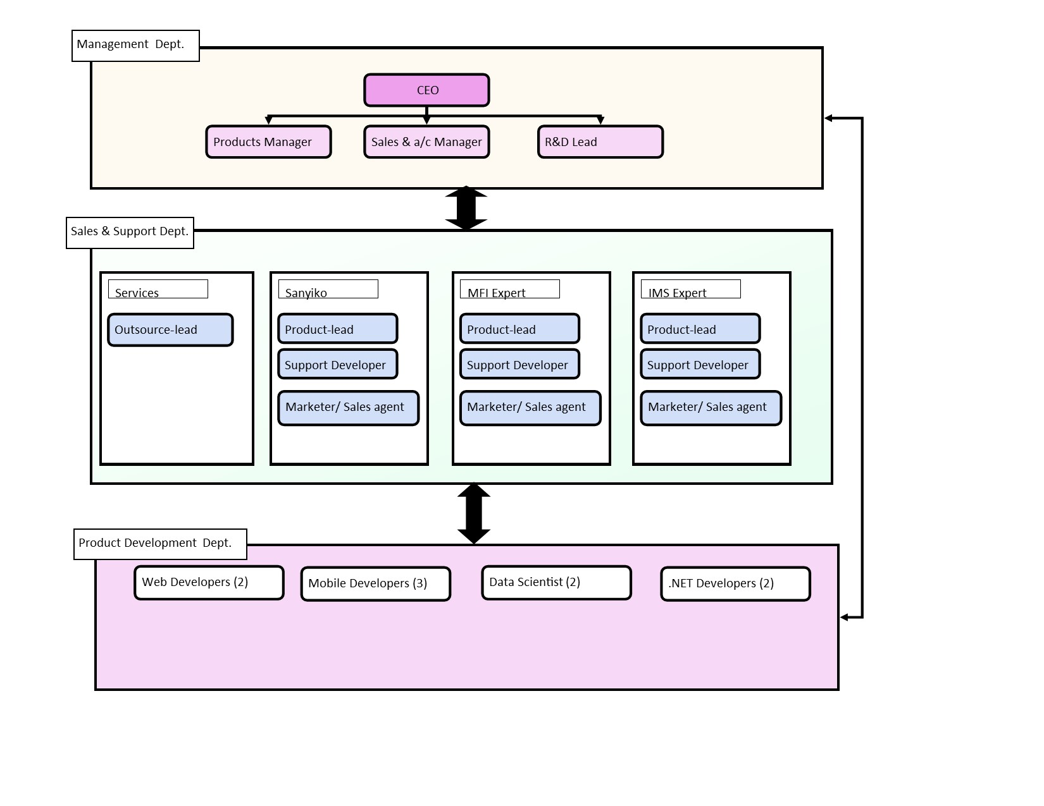

## **Activities Done.**

All activities listed here have been recorded in both the online logbooks and scanned logbook.

Here are the respective links:

1. [Summarized online logbook](https://kiarie404.github.io/Attachment_journal/simplified_online_log/book/index.html)
2. [Detailed online logbook](https://kiarie404.github.io/Attachment_journal/)
3. [Scanned and stamped copy of the summarized online logbook](https://raw.githubusercontent.com/kiarie404/Attachment_journal/main/documents/scanned_log/Logbook Wagura James Kiarie P15.1667.2019.pdf)

However, I have written a summarized list below.

## **Understanding the company software**

In the first 2 weeks. I concentrated on:

1. Understanding the five software products provided by IMS ie: MFI expert, IMS expert, Sanyiko, BIMS and Mpesa Link.

Later on, with Harsha’s direction, I decided to focus on Sanyiko App because its did not require mastering Finance jargon as compared the other products. For example, the core banking system had a lot of domain jargon that went over my head.

1. Understanding the User interface of the Sanyiko App so that I may be able to provide customer support.
2. Finding bugs in the Sanyiko phone and web application.

## **Web development**

I managed to build two websites for the company:

1. [imsguru.com](http://imsguru.com)
2. [Sanyiko.com](http://sanyiko.com)

As I built the above websites, I did the following activities.

1. Learnt how to evaluate the performance of a website. I had to evaluate the websites that I wanted to replace.
2. Increased the performance of both websites. (sanyiko.com and imsguru.com)
3. Implemented Search Engine Optimization on Sanyiko.com.
4. Implemented Spam filtering in imsguru.com.
5. Learnt Javascript and CSS.
6. Learnt how to use Wordpress as a CMS for our websites.

## **Data collection**

A new client, ASL Credit Limited, began to use one of our products — MFI Expert system.

ASL credit needed help to migrate their operations and records from a manual system to a digital system. So I was tasked to help them out. Dennis Mutethia, my fellow IT colleague at IMS, accompanied me to ASL for a period of 4 days.

Considering that we did not have sufficient microfinance domain knowledge, we worked together with the domain experts at ASL Credit and we managed to migrate 460 un-digitized loans in 4 workdays.

## **Mobile Development**

At IMS Guru, all mobile applications were made using the Nativescript JS framework.

So for some days, I began trying to build a simple App using Javascript and the Nativescript framework.

However, I found Nativescript to have the following flaws:

* Its documentation is neither clear nor exhaustive. It is not beginner friendly.
* It does not have enough open-source support in comparison to other tools such as React Native and Flutter.
* Its basic plugins are no longer maintained.

So I tested out React Native for some days because I already had some experience in Javascript and React.

Later on I moved to using Flutter because :

* It has better beginner-friendly documentation as compared to both React native and Nativescript.
* It uses the Dart language ; a safer language than javascript. I prefer statically typed languages over dynamic languages.
* I liked its philosophy that everything is a widget. This results in Apps that are more modular.

I did not build a substancial App, but I learnt a lot about *How to choose the right technology for my future team.*

A worthy technology should :

1. Have elaborate documentation. Documentation that is so good that it feels like it is spoon-feeding you.
2. Have enough online support.
3. Have solid principles that will last for some time. Principles that solve concrete problems. For example, I think the widget approach of Flutter is well-thought out as compared to how Nativescript approached UI design.

## **Software documentation**

The last project I did at IMS was creating a documentation website for the MFI Expert.

I used the following software:

1. Mdbook – a documentation software made in Rust. In fact it is the same tool I have used to make my online Logbook.
2. Github – I used github to temporarily host the website, that way, we could collaborate with the product manager.
3. Git – I used git as my basic version control system.

## **Interests**

I found web development and mobile development interesting.

Web development looks promising ; Lots of possibilities to what kind of solutions one can build.

I gained interest in Web Assembly : (wasm) the 4th Standard language of the Internet. Ie (HTML, CSS, Javascript and WASM). I am fascinated that wasm will bring about true cross-platform applications. I hope we re-write the web with it.

I found mobile App development too fickle of a technology, it is so dynamic. So many tools that experience so many changes within a short time. It is almost as if a developer has to figure out how to solve both domain problems and responsivity considerations. It may seem odd to say this, but I currently do not see mobile development as a foundational technology.

In hindsight, I do not intend to pursue either of them. My initial and current interests have always been low-level programming, robotics and embedded systems. Like the computer science Greybeards of yore.

I intend to use the skills I learnt to learn the Rust Programming language and focus on low-level systems.

## **Conclusions and Recommendations**

In the last days Harsha gave me a green light to learn Rust and Web Assembly. I believe that is the future of programming and I hope my fellow classmates will also hitch this tech ride. It is solid.

As for how this attachment process is handled, I am proposing it to be [digitized as follows](https://github.com/kiarie404/attachment_website)