EG3401 Neural Network Firing Patterns
Name: Kiana Ruiz Pasieka
Modelling: 3-neuron leaky integrate-and-fire network

Introduction
Neuronal systems exhibit complex behaviour arising from interactions between external inputs and synaptic connections, which determine how neurons respond to stimuli. Computational modelling provides a controlled framework to study these effects.
This study uses a simplified three-neuron leaky integrate-and-fire (LIF) model to investigate how firing behaviour develops within a small network. By varying external input and synaptic connectivity, the model explores how excitation–inhibition balance influences spike timing and overall network dynamics.

Mathematical Model and Assumptions
The membrane potential of each neuron evolves according to a first-order differential equation:
$$\frac{dV_{i}}{dt}​​=​\frac{-\left(V_{i​}-V_{rest​}\right)+R\left(I_{ext,i​}+I_{syn,i​}\right)}{τ_{m}}​$$
where $V_{i}$ is the membrane potential of neuron $i$, $V_{rest}$ is the resting potential, $I_{ext, i }$ is the external input current, $I_{syn, i }$is the synaptic input, $R$ is the membrane resistance, and $τ_{m_{}}$is the membrane time constant [1][7].
This equation captures the balance between membrane leakage and input-driven excitation. If the input is insufficient, the neuron approaches a steady subthreshold value and if sufficiently large, the threshold is reached and a spike is generated. The model neglects detailed ion channel dynamics, allowing focus on higher-level firing behaviour [2][3].
The membrane potential and time were normalised as:
$$\tilde{V}=\frac{V-V_{rest}}{V_{th}-V_{rest}}, \tilde{t}=\frac{t}{τ_{m}}$$
A key parameter that emerges is the ratio:
$${\tilde{τ}}_{s}=\frac{τ_{s}}{τ_{m}}=0.5$$
This indicates that synaptic activity decays faster than membrane dynamics, supporting stability.
Synaptic input is given by:
$$I_{syn,i}=\sum_{j}{W_{ij}s_{j}}$$
where $W_{ij}$ represents the synaptic weight from neuron j to neuron i, and $s_{j}$ is the synaptic activity of the presynaptic neuron. The sign of each weight determines whether the effect is excitatory or inhibitory [4]. Positive values of $W_{ij}$promote firing, whereas negative values delay or suppress it.
The synaptic activity variable decays according to:
$$\frac{ds_{j}}{dt}=-\frac{​s_{j​​}}{τ_{s}​}$$
where $s_{j}$ is the synaptic activity of neuron $j$, and $τ_{s}$ controls the rate at which this activity decays. [1]
To model plasticity, synaptic weights are updated using a Hebbian learning rule:
$$W_{ij​}=W_{ij}​+η\left(pre_{j​}⋅post_{i}​\right)-λW_{ij​}$$
where η is the learning rate controlling weight strengthening, and λ is the decay parameter preventing unbounded growth. This rule reflects activity-dependent synaptic strengthening and stabilisation mechanisms described in biological systems [6][7]. The model is non-spatial, with no representation of geometry or signal propagation, and is therefore treated as a lumped system.

Implementation
The model was implemented in MATLAB using an explicit Euler integration scheme to solve the system of coupled differential equations. For each neuron, the membrane potential was updated at every time step according to:
$$V_{i}(t+Δt)=V_{i}(t)+Δt\frac{-(V_{i}(t)-V_{rest})+I_{ext,i}(t)+I_{syn,i}(t)}{τ_{m}}$$
where $Δt=0.1$ms. This time step was chosen to be sufficiently small relative to the membrane and synaptic time constants so that the rapid voltage changes near threshold could be captured without introducing large numerical error [7]. After each update, any neuron whose membrane potential exceeded the threshold voltage was recorded as having fired, and its membrane potential was reset to $V_{reset}$.
To ensure numerical stability, the time step was analysed using the stability condition for Euler integration. For a leaky system, stability requires:
$$Δt<2τ_{m}$$
With $τ_{m}=20$ms, this gives $Δt<40$ms. The chosen value of $Δt=0.1$ms is therefore highly conservative, providing a safety margin of approximately 400×. A convergence check was also performed by comparing results at different time steps. Spike timings remained consistent with only minor variation (<0.5ms), confirming that the solution is numerically stable.
Synaptic activity variables were updated in the same Euler framework using their exponential decay equation. Whenever a neuron fired, its synaptic activity variable was incremented, allowing that spike to contribute temporarily to the input received by other neurons.
Hebbian learning was applied after spike detection at each time step. Upper and lower bounds were also imposed on excitatory and inhibitory weights respectively, and self-connections were removed by setting the diagonal elements of the matrix to zero.
The external input ($I_{ext}$) consisted of a constant drive with a small oscillatory component. This introduces slight temporal variation in firing patterns [4], enabling subthreshold behaviour, sustained firing, and activity-dependent changes in synaptic strength.

Parameter | Meaning | Typical Value
τₘ / tau_m | Membrane time constant | 20 ms
τₛ / tau_syn | Synaptic time constant | 10 ms
/ V_th | Threshold voltage | -50 mV
η / eta | Learning rate | 0.0015–0.15
λ / weightDecay | Decay rate | 0.0003–0.003
V_rest | Resting potential | -65mV
V_reset | Reset potential after spike | -70mV

Results and Analysis
To quantify network behaviour, the firing rate was calculated as:
$$f=\frac{\text{number of spikes}}{\text{total time}}$$
The effects of external input, synaptic coupling, and plasticity were then examined through a series of simulations.
The baseline simulation produced no firing activity, with all neurons remaining below the threshold. As a result, no spikes were generated, and synaptic weights decayed gradually due to the absence of correlated activity.
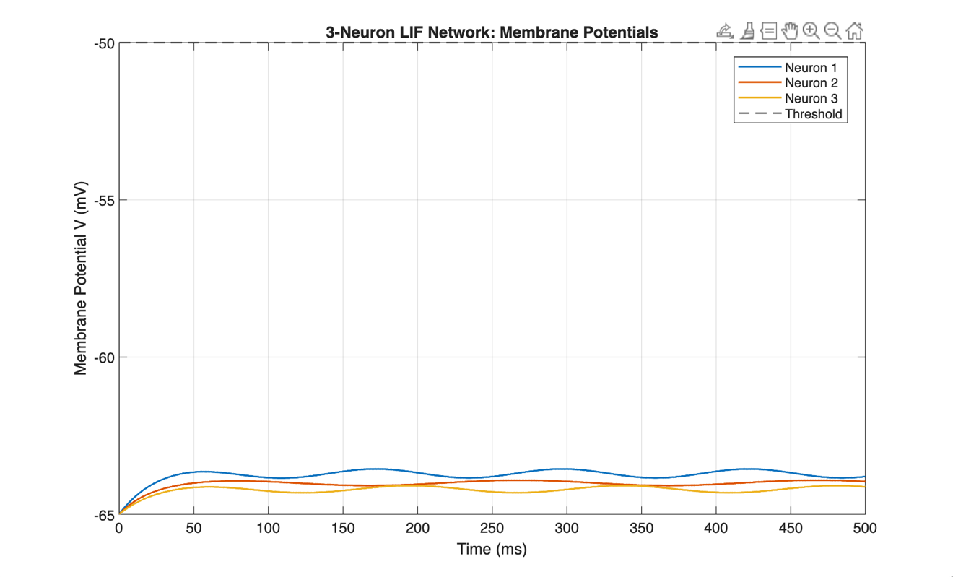
Figure 1: Membrane potentials under baseline conditions. Membrane potentials remain below threshold, and no spike events were observed, confirming subthreshold behaviour.

Increasing the external input current produced a clear transition from subthreshold behaviour to active firing. Membrane potentials rose more rapidly, eventually exceeding the threshold and generating spikes. Initially, isolated firing events were observed, followed by repeated spiking as input was increased further. These results reflect the expected behaviour of the model, where increasing external input produces sustained firing and demonstrates that external excitation is a key determinant of neuronal activation [2].
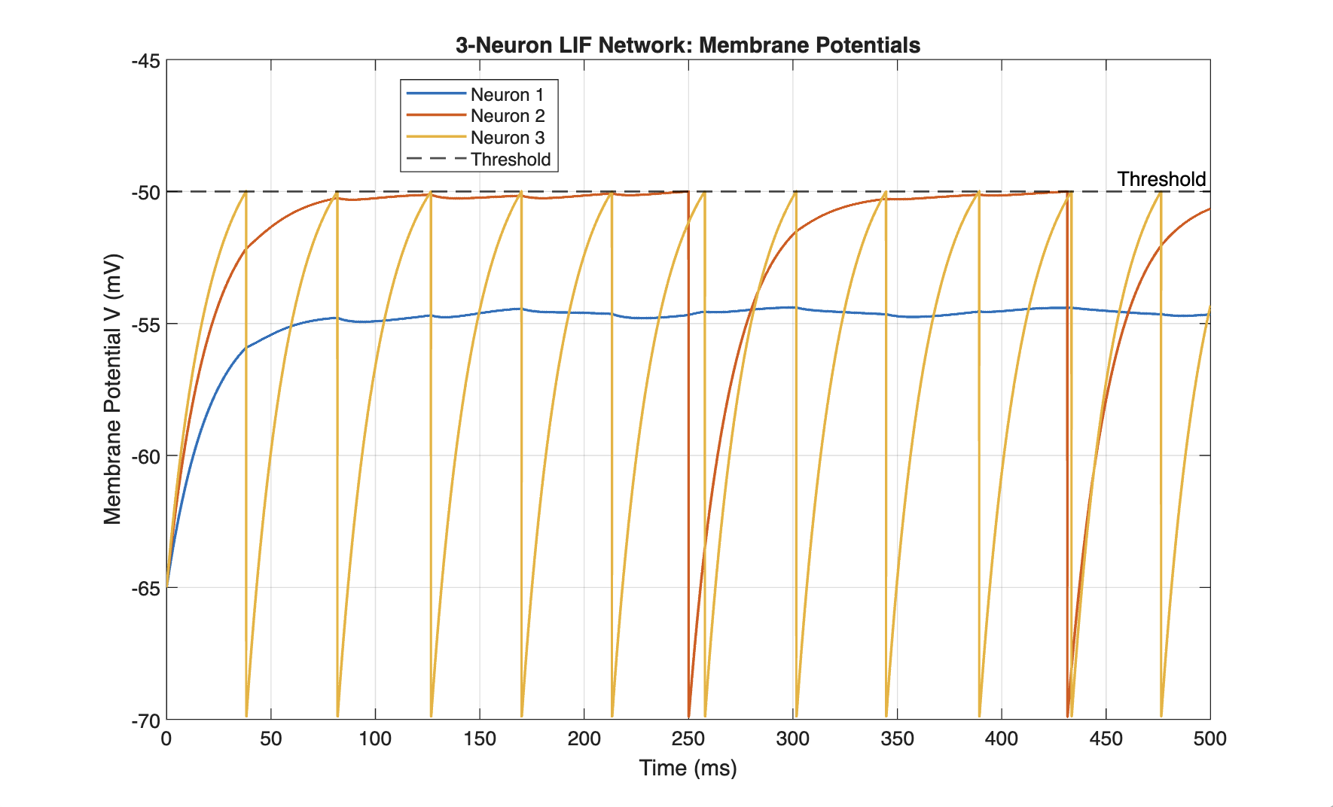
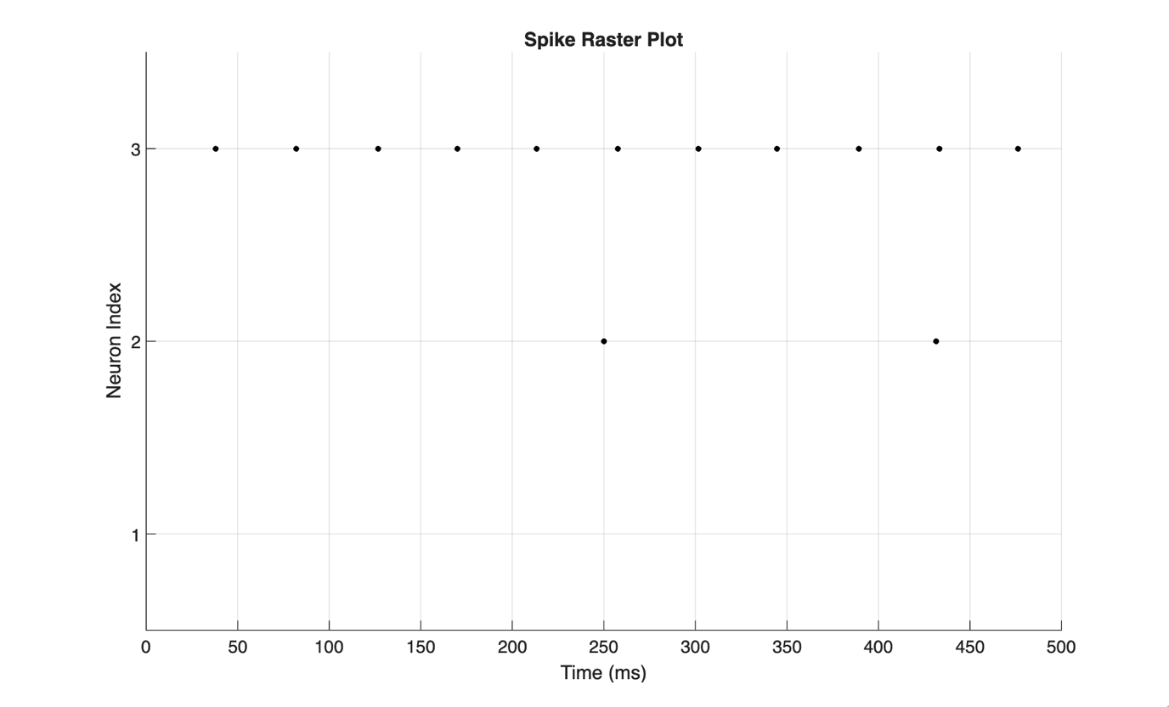Figures 2 and 3: Membrane potentials and spike plot with increased external input, showing the transition from subthreshold behaviour to sustained firing.

The role of synaptic coupling was then explored by modifying individual weights. Increasing the inhibitory connection from neuron 3 to neuron 2 by –4 ($W_{2,3}=-4.9$) produced a strong suppressive effect. Each spike from neuron 3 generated a large negative synaptic input, reducing the rate of increase of neuron 2’s membrane potential. As a result, neuron 2 exhibited delayed or suppressed firing, from ~250ms to ~470ms (Figures 2-4). This demonstrates that inhibitory connections regulate spike timing by opposing excitatory input and controlling the speed at which neurons reach threshold.
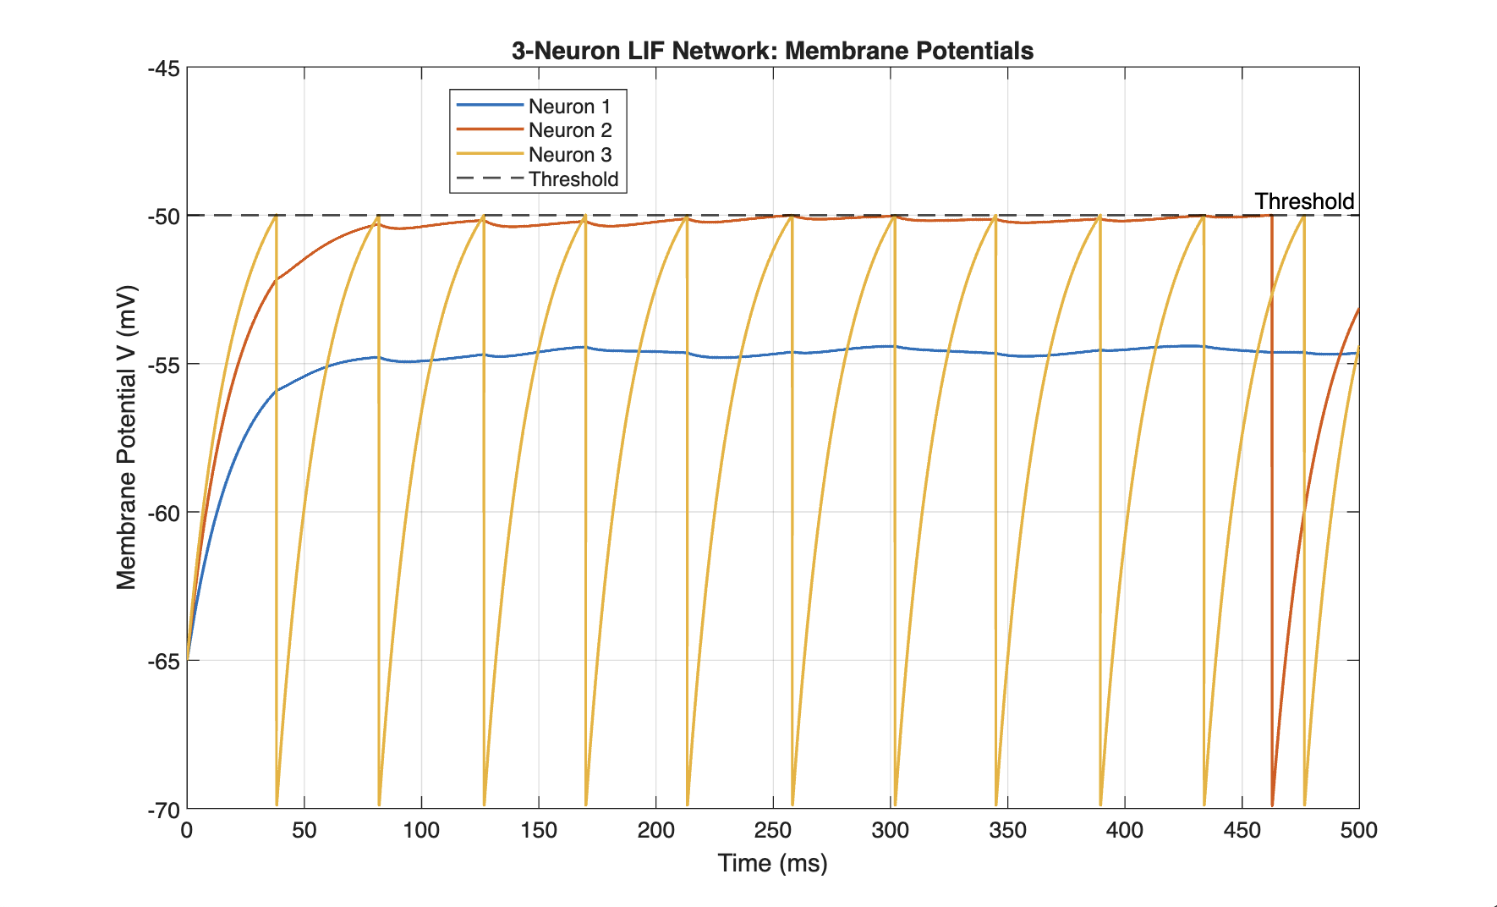
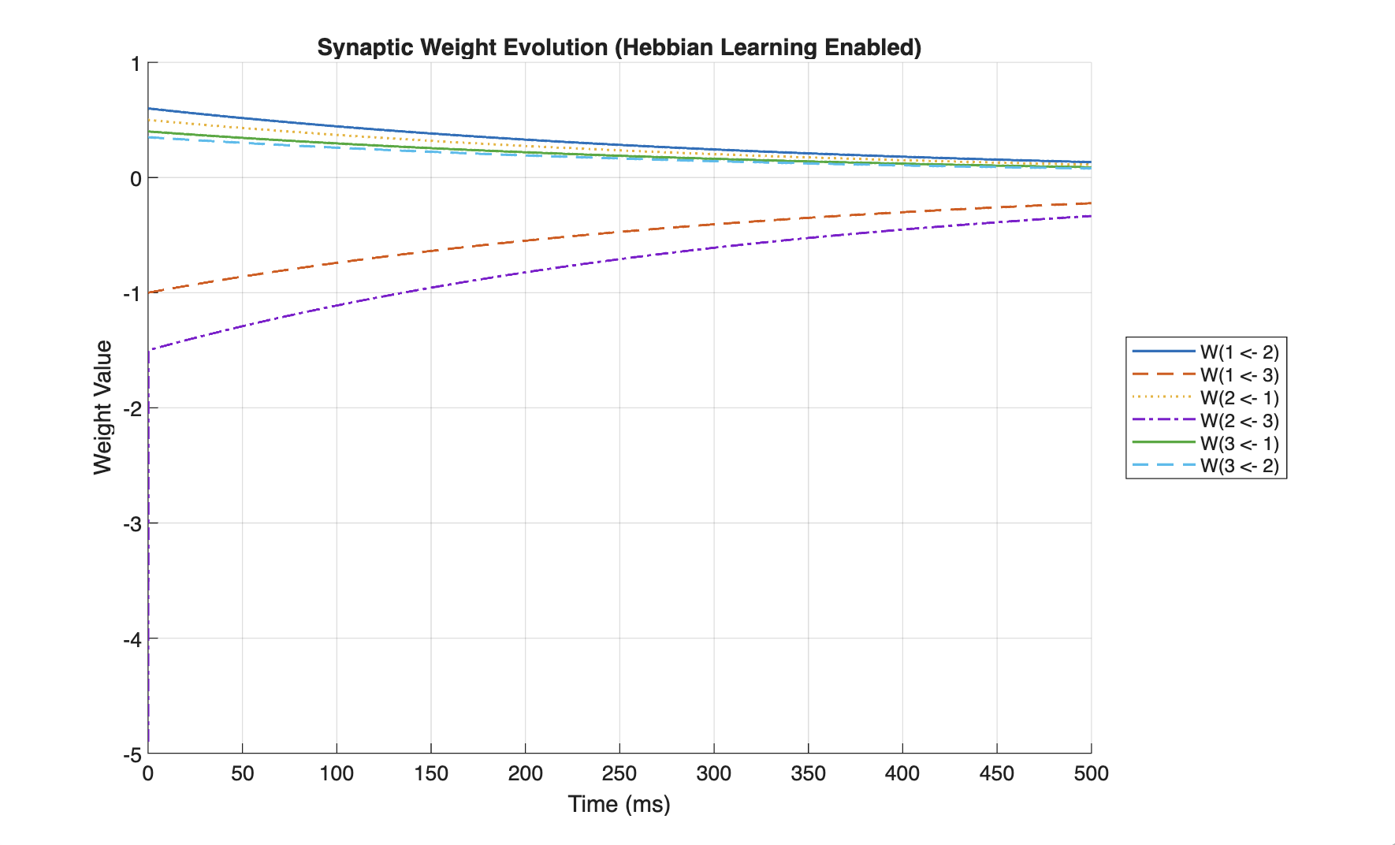Figures 5 and 6: Effect of strong inhibitory coupling on membrane potential dynamics and spike timing.

In contrast, increasing the excitatory connection from neuron 1 to 3 by +2 ($W_{3,1} =2.4$), amplified network activity. The corresponding synaptic weight exhibited a rapid initial increase followed by gradual decay. This behaviour arises from the Hebbian update rule, where coincident activity between neurons strengthens connections, while the decay term limits growth. As a result, neuron 3 became more responsive to inputs from neuron 1, increasing its likelihood of firing.
Increasing the learning rate from η = 0.0015 to η = 0.15 produced step-like synaptic weight increases (≈0.05-0.1 per event). These updates occur when presynaptic and postsynaptic activity overlap, particularly in neurons 2 and 3 (Figures 3-4). The decay term balances growth with stabilisation.

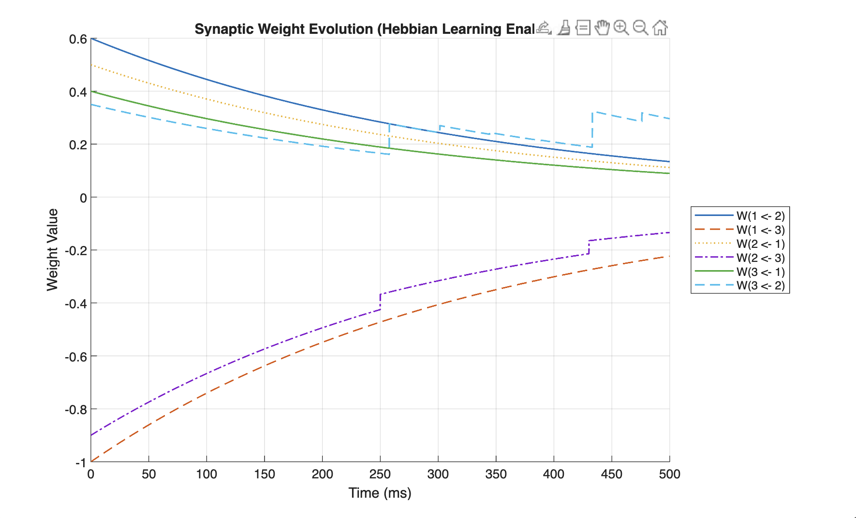Figure 5: Synaptic weight evolution under increased learning rate (η = 0.15), showing step-like updates driven by correlated neuronal activity.

Increasing decay (λ = 0.003) with low learning rate (η = 0.0015) produces smooth weight decay toward zero. Hebbian updates are minimal, synaptic interactions reduce, and the network becomes driven by external input rather than internal coupling.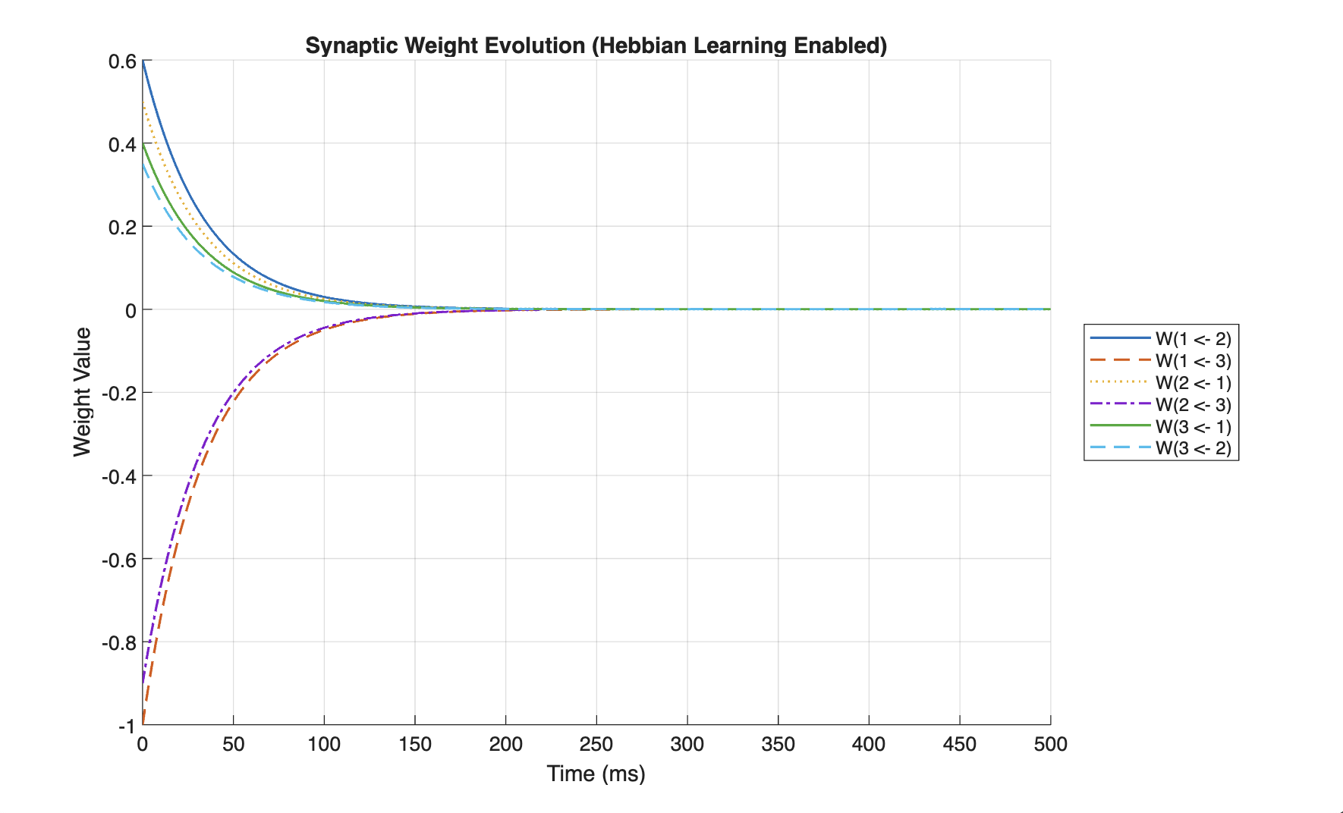Figure 6: Synaptic weight evolution under increased decay (λ = 0.003), showing smooth convergence towards zero and suppression of Hebbian effects.

Finally, a synchronisation experiment was conducted by driving neurons 1 and 2 with identical inputs. This produced highly correlated firing, as observed in both membrane potential traces and spike raster plots. The time difference between spikes of neurons 1 and 2 remained below 1 ms, confirming strong synchronisation. The corresponding synaptic weights between these neurons exhibited consistent increases over time, demonstrating activity-dependent strengthening. In contrast, connections involving neuron 3 remained relatively unchanged.
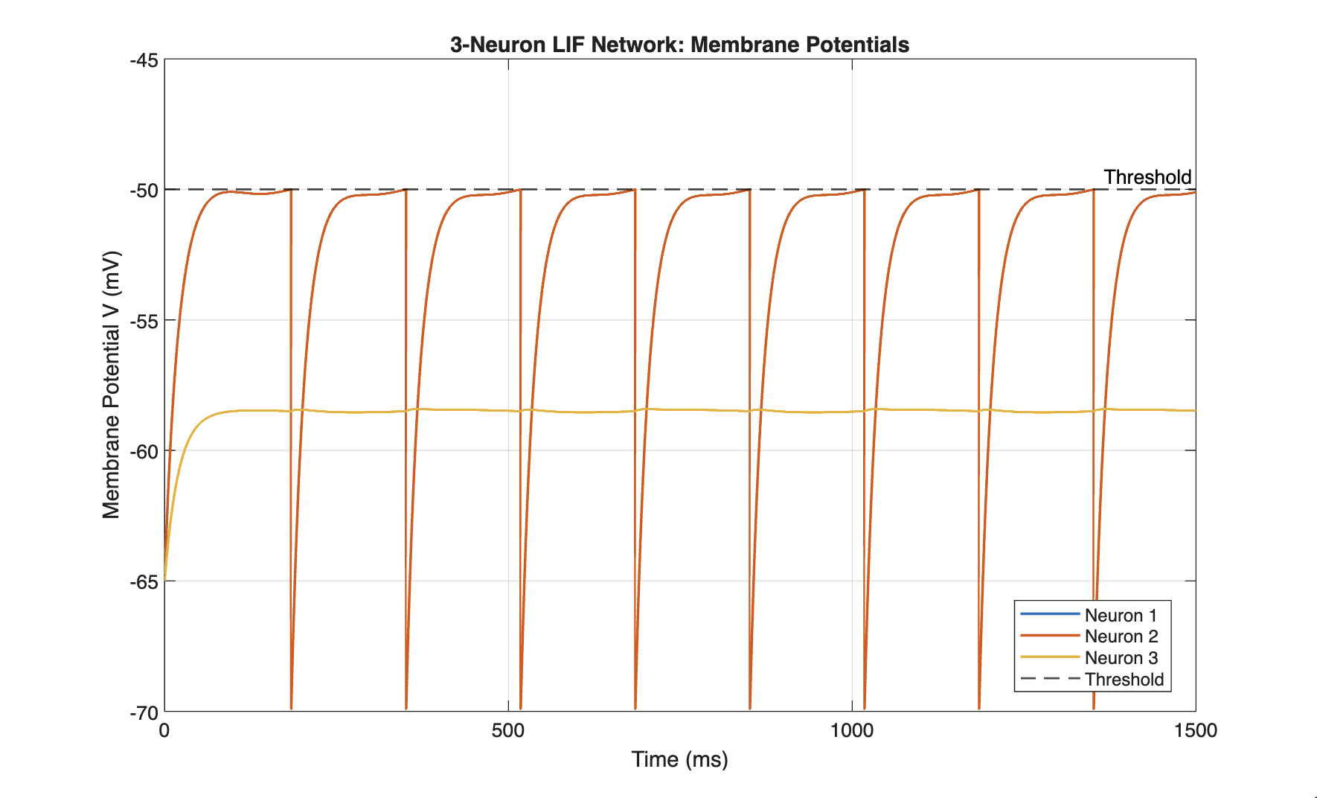

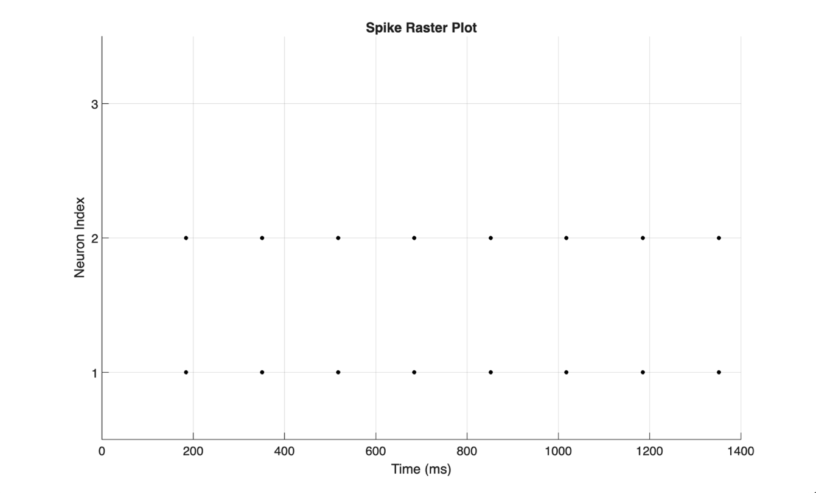
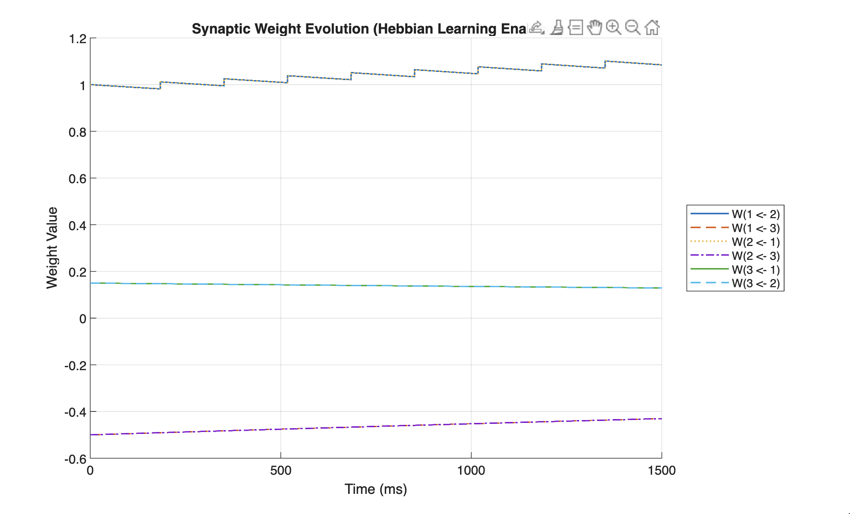Figures 7–9: Membrane potentials, spike raster plot, and synaptic weight evolution during synchronised input.

Model Validation
To verify that the model behaves correctly, results were compared with known analytical behaviour of a single LIF neuron.
For a constant input, the membrane potential is expected to approach a steady-state value:
$$V_{∞}=V_{rest}+RI_{ext}$$
If this value remains below threshold, no spikes should occur. This was observed in the baseline case, where neurons remained subthreshold. When the predicted steady-state voltage exceeded threshold, the neurons fired regularly, consistent with the theoretical LIF response.
Additionally, spike timing behaviour was consistent across simulations, confirming that the numerical implementation correctly captures threshold crossing and reset dynamics. The predicted steady-state voltage matches the observed transition from subthreshold behaviour to sustained firing, confirming consistency between analytical LIF theory and simulation results.

Discussion
The results demonstrate that neuronal firing behaviour is governed by a balance between external input, synaptic coupling, and plasticity mechanisms. External input determines whether neurons can reach threshold [2].
Inhibitory connections play a critical role in regulating spike timing and preventing excessive excitation. By introducing negative input, they slow membrane potential growth and can suppress firing entirely. This balance between excitation and inhibition is fundamental to stable neural function [4][5]. In contrast, excitatory connections promote activity propagation, enabling neurons to influence one another and produce coordinated behaviour.
The inclusion of Hebbian learning introduces adaptive dynamics, allowing the network to evolve based on activity patterns [6]. Connections strengthen when a postsynaptic neuron fires while the presynaptic neuron has been recently active. Correlated firing therefore reinforces synaptic connections, while the decay term ensures stability by preventing excessive growth, resulting in a system that is both adaptive and stable.
Importantly, the results show that synaptic weights influence not only whether neurons fire, but also when they fire. Changes in inhibitory strength directly altered spike timing, demonstrating that network connectivity plays a key role in temporal dynamics. This aligns with biological neural systems, where precise timing of spikes is critical for information processing [1][3].
Overall, the model reproduces the expected threshold, timing, and plasticity behaviour of the leaky integrate-and-fire framework. Subthreshold inputs produce passive decay, increased excitation leads to sustained firing, inhibition regulates spike timing, and correlated activity strengthens synaptic connections. While the model captures these key features, it simplifies biological neurons by neglecting ion channel behaviour and spatial structure. As a result, it provides insight into general firing mechanisms but cannot fully represent the complexity of real neural systems [3].

Conclusion
This study shows that a three-neuron LIF model captures key features of neuronal behaviour, including threshold-driven firing, synaptic interaction, and activity-dependent plasticity. External input governs firing onset, while synaptic weights influence interactions and timing. Overall, the results demonstrate how simple mechanisms can produce complex network dynamics.

References
[1] W. Gerstner, W. M. Kistler, R. Naud, and L. Paninski, Neuronal Dynamics: From Single Neurons to Networks and Models of Cognition. Cambridge University Press, 2014.
[2] P. Dayan and L. F. Abbott, Theoretical Neuroscience: Computational and Mathematical Modeling of Neural Systems. MIT Press, 2001.
[3] E. M. Izhikevich, Dynamical Systems in Neuroscience: The Geometry of Excitability and Bursting. MIT Press, 2007.
[4] N. Brunel, “Dynamics of sparsely connected networks of excitatory and inhibitory spiking neurons,” Journal of Computational Neuroscience, vol. 8, pp. 183–208, 2000.
[5] S. Roy et al., “Towards spike-based machine intelligence with neuromorphic computing,” Nature, vol. 575, pp. 607–617, 2019.
[6] N. Caporale and Y. Dan, “Spike timing–dependent plasticity: A Hebbian learning rule,” Annual Review of Neuroscience, vol. 31, pp. 25–46, 2008.
[7] E. Rahman, EG3401 Biological System Modelling: Lecture 8 – Time-Domain Modelling & Numerical ODE Solutions, City, University of London, 2025.

Appendix A: MATLAB Code
clear; clc; close all;

% Parameters
N = 3;
T = 500;
dt = 0.1;
time = 0:dt:T;
nSteps = numel(time);

% Membrane parameters
tau_m = 20;
V_rest = -65;
V_reset = -70;
V_th = -50;

% Synapse parameters
tau_syn = 10;
I_ext = [10.5; 15.0; 17.5];
I_osc_amp = [0.20; 0.10; 0.15];
I_osc_freq = [8; 5; 7];

% Connectivity
W = [0.00, 0.60, -1.00;
0.50, 0.00, -4.90;
0.40, 0.35, 0.00];

% Hebbian learning
eta = 0.15;
traceTau = 30;
weightDecay = 0.0003;
W_max_exc = 1.5;
W_min_inh = -1.5;

% State Initialisation
V = V_rest * ones(N,1);
s = zeros(N,1);
preTrace = zeros(N,1);
V_hist = zeros(N, nSteps);
spikes = zeros(N, nSteps);
W_hist = zeros(N, N, nSteps);
V_hist(:,1) = V;
W_hist(:,:,1) = W;

% Simulation Loop
for k = 2:nSteps

% External drive: baseline + small oscillation
I_t = I_ext + I_osc_amp .* sin(2*pi*I_osc_freq*(time(k)/1000));

% Membrane potential ODE
V = V + dt * (-(V - V_rest) + I_t + W*s) / tau_m;
V_for_plot = V;

% Detect spikes and reset to V_reset
fired = V >= V_th;
spikes(:,k) = fired;
V(fired) = V_reset;

% Synaptic activity and presynaptic trace
s = s + dt * (-s / tau_syn);
s(fired) = s(fired) + 1;
preTrace = preTrace + dt * (-preTrace / traceTau);
preTrace(fired) = preTrace(fired) + 1;

% Hebbian updates to strengthen when post spikes and pre was recently active
W = W + eta * (spikes(:,k) * preTrace') - weightDecay * W;

W(:, 1:2) = min(max(W(:, 1:2), 0), W_max_exc); % presynaptic neurons 1 and 2 are excitatory
W(:, 3) = max(min(W(:, 3), 0), W_min_inh); % presynaptic neuron 3 is inhibitory

% No self-connections
W(1:N+1:end) = 0;
V_hist(:,k) = V_for_plot;
W_hist(:,:,k) = W;
end

% Plot 1: Membrane potentials
figure('Name','Membrane Potentials','Color','w');
plot(time, V_hist(1,:), 'LineWidth', 1.3); hold on;
plot(time, V_hist(2,:), 'LineWidth', 1.3);
plot(time, V_hist(3,:), 'LineWidth', 1.3);
yline(V_th, '--k', 'Threshold', 'LineWidth', 1.0);
xlabel('Time (ms)');
ylabel('Membrane Potential V (mV)');
title('3-Neuron LIF Network: Membrane Potentials');
legend({'Neuron 1','Neuron 2','Neuron 3','Threshold'}, 'Location','best');
ylim([V_reset -45]);
grid on;

% Plot 2: Spike raster plot
figure('Name','Spike Raster','Color','w');
hold on;
for i = 1:N
spikeTimes = time(spikes(i,:) == 1);
plot(spikeTimes, i*ones(size(spikeTimes)), 'k.', 'MarkerSize', 10);
end
xlabel('Time (ms)');
ylabel('Neuron Index');
title('Spike Raster Plot');
yticks(1:N);
ylim([0.5, N+0.5]);
grid on;

% Plot 3: Weight evolution
figure('Name','Synaptic Weights Over Time','Color','w');
hold on;
plot(time, squeeze(W_hist(1,2,:)), '-', 'LineWidth', 1.2);
plot(time, squeeze(W_hist(1,3,:)), '--', 'LineWidth', 1.2);
plot(time, squeeze(W_hist(2,1,:)), ':', 'LineWidth', 1.2);
plot(time, squeeze(W_hist(2,3,:)), '-.', 'LineWidth', 1.2);
plot(time, squeeze(W_hist(3,1,:)), '-', 'LineWidth', 1.2);
plot(time, squeeze(W_hist(3,2,:)), '--', 'LineWidth', 1.2);
xlabel('Time (ms)');
ylabel('Weight Value');
title('Synaptic Weight Evolution (Hebbian Learning Enabled)');
legend({'W(1 <- 2)','W(1 <- 3)','W(2 <- 1)','W(2 <- 3)','W(3 <- 1)','W(3 <- 2)'}, 'Location','eastoutside');
grid on;

