**Mental health and support Programs**

**Problem Statement**

Statistics shows that *single mothers* in Seattle, King County, and Pierce County face significant challenges, including mental health issues, substance abuse, incarceration, domestic violence, homelessness, and the complexities of re-integrating into society. These challenges are compounded by systemic barriers to accessing affordable housing, stable employment, and consistent mental health care, leaving many unable to break the cycles of instability and dependence.

**Homelessness Statistics**

King County

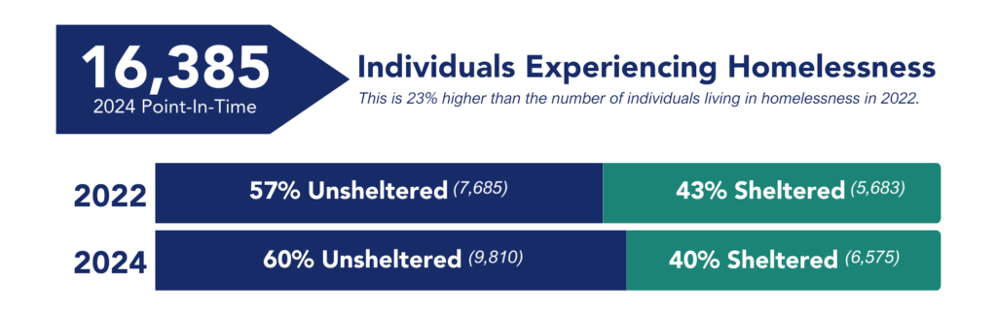The 2024 PIT count found that on any given night in King County, there are an estimated 16,385 individuals experiencing homelessness.  This is 23% higher than the 2022 PIT estimate, which when adjusted for population growth during the same period, represents a 12% increase over changes expected due to population increase.

According to statistics shown above, homelessness in King County increased by 23% from 2022 to 2024, with over 60% of individuals living unsheltered. In this analysis, most of the individuals living unsheltered are single mothers. Research indicates that single mothers make up a significant portion of the homeless population. For this estimate, we will assume that single mothers constitute about **40%** of the unsheltered homeless population based on trends seen in other counties and national averages for homelessness among families. So, the estimate for single mothers among the unsheltered in King County would be:  
 unsheltered single mothers.9,831×40%=3,932 unsheltered single mothers.

Pierce County

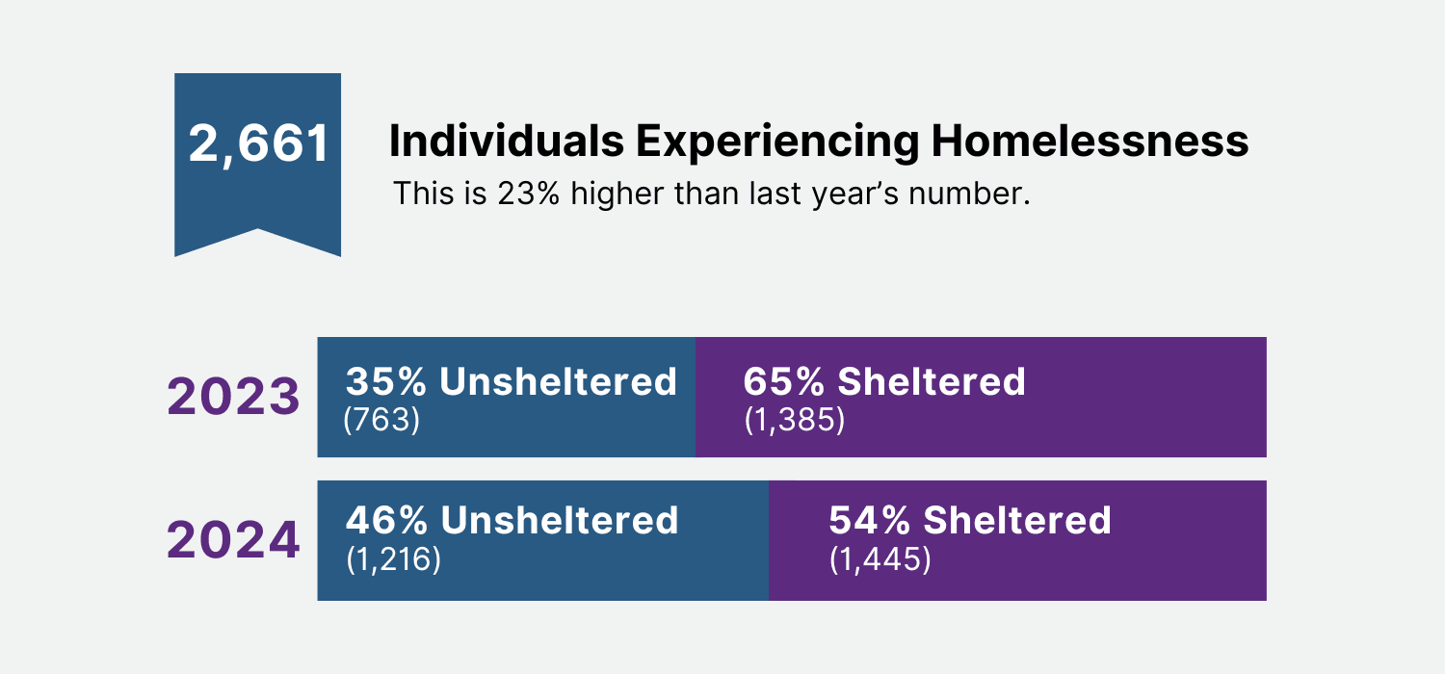On January 26, Pierce County leaders, service providers, and volunteers surveyed people experiencing homelessness during the annual Point-in-Time (PIT) count. The count is required by the U.S. Department of Housing and Urban Development (HUD) to effectively allocate funds to support efforts to end homelessness.

In Pierce County, according to statistics, it has similar patterns as King County, with substance abuse identified as the most common disability among the homeless population. Single mopthers are most affected according to the statistics. An estimated **50%** of the homeless population in Pierce County is likely to be single mothers, which would be around **1,250 single mothers** experiencing homelessness in 2024.

This estimate is based on general trends and may vary depending on the specifics of local surveys and demographic data.

The lack of affordable housing and accessible mental health resources exacerbates the difficulties for *single mothers* trying to provide for their families and rebuild their lives.

**Housing Needs:**

In the next 20 years Washington needs 1.1 million more homes. Almost 650,000 will need to be affordable for low-income households. Almost 240,000 renter households in Washington are considered extremely low-income, earning less than 30% of the median income in the area where they live. In washington, single mothers have come out I large number and have spoken of instances they have been forced to move many times due to excessive rent increases. And I see how this is impacting so many people. Rent increases cause instability. And I’m working with seniors whose rent is

more than they get on social security.” Brianna Vazquez a single mom says.

**Mental Health and Substance Use:**

Pierce County

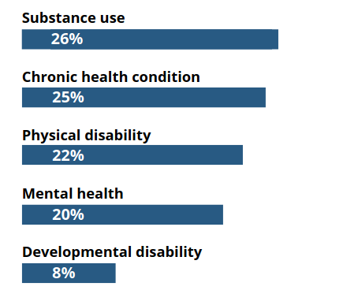

According to statistics, substance is the most commonly reported disabilities. Some people however reported multiple disabilities.

These statistics highlight the pressing need for targeted mental health and support programs for *single mothers* in these regions. Addressing the intersection of homelessness, mental health, and substance use is crucial for effective intervention and support. Of these, **60%** of them are single mothers likely to be struggling with **substance abuse**.

This estimate aligns with the pressing need for targeted mental health, substance abuse treatment, and housing support services for single mothers, particularly those facing homelessness.

**The Plan**

With the statistics above, single mothers are much affected and hence we have to come up with a plan to help the single mother be back to the society and be accepted back to the society. Our mission is to o provide holistic mental health support, resources, and community connections to single mothers facing challenges such as mental health issues, substance abuse, incarceration, and re-entry into society, empowering them to rebuild their lives and achieve lasting stability.

### ****Program Objectives:****

1. Improve mental health outcomes through evidence-based therapy and peer support.
2. Enhance participants' ability to cope with stress, anxiety, and trauma.
3. Provide access to resources for housing, employment, and parenting support.
4. Foster self-sufficiency and long-term community integration.

Here are steps that we can follow so as to help single mothers facing various challenges such as mental health issues, substance abuse, parenting, and economic hardships nad can help them be accepted back to the society.

1. Group therapy sesssions
2. Parenting workshops
3. Life skills training
4. Mentorship programme
5. Substance abuse support
6. Women health and Wellness

**1. Group Therapy Sessions (Weekly)**

* Opening mindfulness exercise (10 minutes)
* Discussion on a weekly topic (e.g., managing anxiety, coping with PTSD)
* Sharing and peer support (30 minutes)
* Closing grounding activity (10 minutes)

#### ****2. Parenting Workshops (Bi-weekly)****

* Positive discipline techniques
* Managing stress as a single parent
* Nurturing emotional intelligence in children

#### ****3. Life Skills Training (Monthly)****

* Financial literacy and budgeting
* Job readiness (resume building, interview skills)
* Navigating housing applications and legal systems

#### ****4. Mentorship Program****

* Graduates of the program become certified mentors for incoming participants.
* Mentors undergo training in active listening, motivational interviewing, and crisis management.
* Continuing education for mentors ensures they stay equipped to support mentees.

#### ****5. Substance Abuse Support****

* Group support modeled on the 12-step program
* Referral to inpatient and outpatient rehabilitation services
* Education on relapse prevention

#### ****6. Women’s Health & Wellness****

* Hormonal changes and mental health
* Nutrition for stress management
* Exercise programs for physical and mental well-being