**Medical Scribing application**

**In the healthcare industry, accurate and efficient documentation of patient encounters is critical for maintaining high-quality care and complying with regulatory standards. However, medical professionals often face challenges with manual documentation processes, including:**

1. **Time-Consuming Tasks**: Physicians spend a significant portion of their workday on administrative tasks, such as transcribing patient notes, which reduces the time available for patient care.
2. **Error-Prone Documentation**: Manual note-taking or dictation transcription often leads to errors, especially when dealing with complex medical terminologies and abbreviations.
3. **Inefficient Workflow**: Existing solutions for documentation are not always tailored to healthcare environments, lacking features like real-time transcription, medical terminology support, and integration with Electronic Health Record (EHR) systems.
4. **Compliance Issues**: Ensuring compliance with healthcare data regulations such as HIPAA and GDPR adds complexity to developing secure and reliable documentation systems.

### ****Objective****

To develop a **Medical Scribes Application** that streamlines the process of recording, transcribing, and managing medical documentation while addressing the specific needs of healthcare professionals. The application will use advanced speech-to-text technologies tailored for medical conversations.

### ****Key Goals****

1. **Accurate Transcription**: Enable precise transcription of medical conversations, including support for specialized terminologies and multiple languages.
2. **Improved Efficiency**: Reduce the time spent by medical professionals on documentation by automating transcription and providing editing tools.
3. **Data Organization**: Facilitate the categorization and management of transcribed notes by patient ID, appointment type, and medical conditions.
4. **Regulatory Compliance**: Ensure that all operations meet the required data privacy and security standards.

NLP – Natural language processing.

Medical Natural Lnaguage processing will come in handy when developing the application.  **Medical NLP is used in the healthcare industry by a wide range of healthcare professionals, including physicians, nurses, pharmacists, and administrators. It helps them streamline workflows, improve predictive analytics and reduce administrative burden. In particular, NLP in healthcare can help medical practitioners save time by automatically extracting the data they need within medical records. This allows them to more quickly identify important information that would otherwise take manual effort to locate. Additionally, natural language processing in healthcare has been used to automate the summarization of clinical notes for improved decision-making support and data mining for population health insights. As a result of its many applications in healthcare settings, the NLP system has become an essential part of clinical workflow optimization and clinical trial matching efforts across the sector.**

****Users**  
For our aplication we expect the main users to be;**

**Dr B – Records the audio to be transcribed**

**Virtual assistants – Uploads the audio and gets the texts from the audio**

****Process flow.****

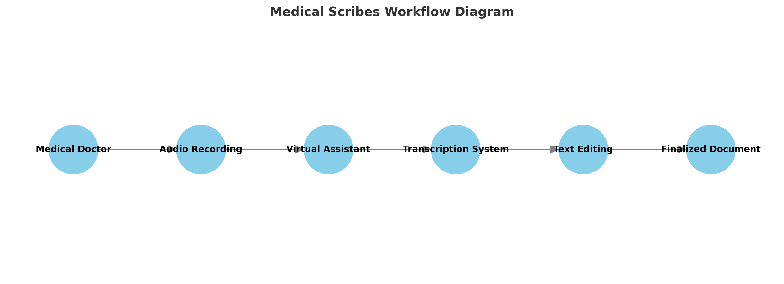

**Here is a basic diagram showing the workflow for your Medical Scribes Application:**

1. **Medical Doctor**: Starts by recording the audio during or after a patient session.
2. **Audio Recording**: The recorded file is created and shared.
3. **Virtual Assistant**: Uploads the audio file to the transcription system.
4. **Transcription System**: Processes the audio and generates text.
5. **Text Editing**: The Virtual Assistant reviews and edits the transcription.
6. **Finalized Document**: The final output is saved or integrated into the required system.