

**KARATINA UNIVERSITY**

**SCHOOL OF PURE AND APPLIED SCIENCES**

**DEPARTMENT OF COMPUTER SCIENCE AND**

**INFORMATICS**

**Course:** Bachelor of science in computer science

**Name:** Kibet David

**Reg No:** P101/1230G/16

**Host Institution:** Moi University

**Attachment Period:**6th May, 2019 to 26th July, 2019.

**Report Submission Date:**24th July, 2019.

**DECLARATION**

I hereby declare that this report is my own original work done perfectly based on the knowledge acquired mostly from my industrial attachment supervisor. No one has the authority to possess it unless he/she has got an approved permission from the department of Information and Communication Technology (ICT) Moi University and the department of computer science and informatics Karatina University.

**Name: Kibet David**

Sign: ______________________ Date: ________________________

**The project to be approved by:**

**Industrial Supervisor’s name: Mr. Samuel Shitote**

Sign: _____________________ Date: ________________________

**ACKNOWLEDGMENT**

I, first could like to thank my almighty creator for the gift of life he has granted me for the entire period of my industrial attachment.Secondly, I would like to express my gratitude to my parents for their support in the success of my life and also throughout the entire period of the attachment more so financially.I also honor my industrial supervisor Mr. Samuel Shitote and the entire department of Information and Communication Technology (ICT) for their advice and guidance throughout my entire period of the industrial attachment. I will also not forget to thank all my fellow attachees and Moi University fraternity in general for their participation in the success of this period.

**EXECUTIVE SUMMARY**

As part of the programmes set by the University for each and every undergraduate to attend an industrial attachment, Information and Communication Technology(ICT) Moi University main campus provided me with an opportunity to undergo my attachment. This helps in putting into practice all the theoretical part of work done and also gaining experience in various organizations outside the institution world. This report provides all the tasks undertaken during my entire period of attachment including all the sessions and practical’s more so on the networking field. At some point, some of the tools used are diagrammatically shown and illustrated.

**Table of Contents**

**CHAPTER ONE: INTRODUCTION** 1

**1.1 History of the organization** 1

**1.2 Main functions or core activities of Moi University** 2

**1.3 Vision, mission statement and core values of Moi University** 2

**1.3.1 Vision** 2

**1.3.2 Mission** 2

**1.3.3 Moi University Core Values** 2

**1.4 Organizational structure of Moi Institution** 3

**1.5 Duties and responsibilities of the key personnel in Moi University** 3

**1.5.1 Vice Chancellor** 3

**1.5.2 Dean of Students** 4

**1.5.3 ICT Director** 4

**1.5.4 Academic Director** 4

**CHAPTER TWO: HOST ATTACHMENT DEPARTMENT** 5

**2.0 History of MUICT** 5

**2.1. Key functions/ activities of MUICT** 5

**2.2 Vision, Mission, and Goals of MUICT** 5

**2.2.1 Vision** 5

**2.2.3 Goals** 6

**2.3 Staff establishment of MUICT** 6

**2.3.1 ICT Director** 7

**2.3.2 ICT Planning** 8

**2.3.3 System’s Administrator** 8

**2.3.4 ICT Trainer** 8

**CHAPTER THREE: ATTACHMENT ACTIVITIES AND EVALUATION OF PERIOD** 9

**3.1. Main objectives for the attachment exercise.** 9

**3.2. Outline of duties done** 9

**3.3 Network installation** 9

**3.3.1Router** 10

**3.3.2 Switch** 10

**3.3.3 Bridge** 11

**3.3.4 Repeater** 12

**3.3.5 Wireless Access Point (WAP)** 12

**3.4 Cables and cabling** 12

**3.4.1 Unshielded Twisted Pair (UTP) Cable** 13

**3.4.2 Shielded Twisted Pair (UTP) Cable** 14

**3.4.3 Coaxial Cable** 15

**3.5 Computer, printer repair and maintenance** 16

**3.6 Web development using JOOMLA Content Management System (CMS)** 17

**3.7 Integrated Development Environments** 17

**3.8 Success/ failure of the attachment exercise** 18

**3.9 Challenges encountered during the attachment period.** 19

**3.11. Recommendations** 20

**3.12 References** 20

# **CHAPTER ONE: INTRODUCTION**

## **1.1 History of the organization**

Moi University was established in 1984 by an Act of Parliament (Moi University Act, 1984) as the second public university in Kenya. Kenyans were involved in providing their views which were collected by the Presidential Working Party, chaired by Prof. Collins B. Mackay. President Daniel Toroitich arap Moi not only he being a professional teacher but also as the Head of nation, pioneered the idea of a university in a rural setting.

This institution admitted only 83 students as the first group to join the institution on 1st October, 1984 who were transferred from the Department of Forestry of the University of Nairobi. The 83 students were forced to start their studies at Kaptaget Hotel where they also housed themselves in the same place. This was due to the reason that the institution had no buildings already.

The University is located in Kesses, 35 kilometers from Eldoret Town, and 310 kilometers Northwest of Nairobi, the capital city of Kenya. The contributions from the entire Moi University fraternity, government investment, strategic partnerships, and the visionary leadership of the University Council and Management has led to tremendous expansion of Moi University. These achievements are a testament to the resilience and fortitude of every faculty and staff member who enabled change at a pace and on a scale never experienced before in the country.

Moi University has experienced phenomenal growth since 1984 leading to the establishment of several constituent colleges across the country. Maseno University, Masinde Muliro University of Science and Technology, Maasai Mara University, University of Kabianga, University of Eldoret, Karatina University and Rongo University are among of those universities of which all of these have grown to fully fledged Universities.

The institution constructed several schools namely School of Science, Education, Arts and Social Sciences, Business and Economics, Agriculture and Natural Resources, Information Sciences, Human Resource Development, Engineering, Medicine, Public Health, Nursing, Dentistry, Law, Tourism, Hospitality and Events Management, Aerospace, Biological and Physical Sciences and Agricultural Sciences after more facilities were developed and needs were recognized.

## **1.2 Main functions or core activities of Moi University**

* Providing universal teaching and learning service – Moi University provides relevant and up to date academic programmes both to the undergraduate and the postgraduate and more provides a friendly environment for further and enhanced research.
* Providing consultancy – This institution has more programmes that enhance and provides consultancy especially to their students.
* Enhancing community services - Moi University works hand in hand with all its fraternity in enhancing the betterness of the whole community.

## **1.3 Vision, mission statement and core values of Moi University**

### **1.3.1 Vision**

To be the University of choice in nurturing innovation and talent in science, technology and development.

### **1.3.2 Mission**

To preserve, create, and disseminate knowledge, conserve and develop scientific, technological and cultural heritage through quality teaching and research; to create conducive work and learning environment; and to work with stakeholders for the betterment of society.

### **1.3.3 Moi University Core Values**

* Fostering teamwork, innovation, networking, tolerance, and a culture of peace.
* Embracing excellence, transparency & accountability.
* Practicing professionalism, meritocracy, equality, integrity and social justice.
* Maintaining self-respect, discipline, responsibility, institutional loyalty, national patriotism & international competitiveness.
* Continual improvement of services in order to remain competitive and relevant.

## **1.4 Organizational structure of Moi Institution**

Vice chancellor

Director ICT

DVC Students

DVC Academic, Research and Extension

DVC Administration, Planning and Development

DVC Finance and Resource Mobilization

Administration Council

`

## **1.5 Duties and responsibilities of the key personnel in Moi University**

### **1.5.1 Vice Chancellor**

* Providing leadership, academic and administrative to whole Moi University departments and fraternity
* Securing a financial base sufficient to allow the delivery of Moi University's mission, visions and objectives.
* Carrying out and conducting certain important ceremonial and civic duties such as Moi University Graduation.
* Representing the University externally, both within this nation and the overseas.

### **1.5.2 Dean of Students**

* Counseling and placement of students.
* Resolution of conflict between students and halls and hostels of residence as well as conflicts involving students outside of halls and hostels.
* Making representation to the University about ways of enhancing the quality of student's life.
* Ensuring that maintenance of cordial relations among the various student groups and the student body as a whole, to ensure that they obtain maximum benefit from their University experience.

### **1.5.3 ICT Director**

* Acquiring and developing ICT infrastructure.
* Implementing and maintaining ICT department and all its related systems.
* facilitating access, use, utilization and sharing of information/knowledge using automated systems.

### **1.5.4 Academic Director**

* Oversees the admission of new students, and in liaison with the Directors office organize for the orientation of new students
* Working in collaboration with coordinators of schools to ensure that teaching is carried out effectively while liaising with the respective academic offices at Main Campus
* Ensuring that university examinations are carried out within the stipulated Senate rules and regulations.

# **CHAPTER TWO: HOST ATTACHMENT DEPARTMENT**

## **2.0 History of MUICT**

Information and Communication Technology (ICT) Center is a directorate that was established in 1998 within the office of the Vice Chancellor of Moi University. Information and Communication Technology (ICT) is a field that combines both computing and telecommunication. Computer technology includes hardware and software, while telecommunication technology includes; Fiber optics communications, microwave, antenna communication system and GSM. These are used in the acquisition, processing, storage, retrieval and dissemination of information in various formats such as audio, video and text.

The first director was Prof. Alex M. Muumbo who was in office until 2014. In 2014, Prof. Edwin Ataro succeeded Prof. Alex Muumbo as the Director until 2017. The directorate is currently headed by Dr. John K. Tarus who is the interim Director.

## **2.1. Key functions/ activities of MUICT**

The directorate's functional units are as follows:

* Database Administration
* End-User Support
* ICT End-User Training
* ICT Operations and Maintenance
* ICT Planning and Development
* Information System Support
* Systems Administration
* Website Design and Maintenance

## **2.2 Vision, Mission, and Goals of MUICT**

### **2.2.1 Vision**

To be a center of excellence in ICT innovation and provision of quality services in Moi University

**2.2.2 Mission**

To effectively conceive, develop, implement, utilize, and manage appropriate information systems in order to provide integrated and coordinated quality ICT services to Moi University in line with its Vision, Mission and Objectives.

### **2.2.3 Goals**

The ICT Directorate endeavors to:

* To provide quality ICT services to the University
* To manage, control and maintain ICT infrastructure in the University
* To advise the University authorities on all ICT matters
* To formulate ICT policies for the University
* To Interpret ICT policies and related matters for the University administration

## **2.3 Staff establishment of MUICT**

The information and communication technology department is the most reliable department in Moi University since it participates in controlling all the systems of the institution. The main servers of the institution are located in this department carefully controlled by various personnel.

Technical Staff Pool

ICT Trainer

Assistant

Assistant

Assistant

Assistant

Assistant

Information Systems support

Web Master

End user support

Assistant

Interschool ICT committe

Maintenance and Operations

Interschool ICT committe

System Administrator

Deputy Director Information Systems

Deputy Director maintenance

Interschool ICT committee

ICT director

Vice Chancellor

Assistant

committe

Assistant

### **2.3.1 ICT Director**

It is headed by Dr. John K. Tarus. Some of his roles are as follows:

* providing efficient and effective service to the end-user community in the University with regard to processing of information communication and technology.
* Implementing and maintaining ICT department and all its related systems.

### 

### **2.3.2 ICT Planning**

It is headed by Dr. Philip K. Chumo. Some of his roles are as follows:

* Proposing design improvements to the Organization’s ICT architecture.
* working with the ICT Business Partner to integrate requirements into the ICT strategic framework.

### **2.3.3 System’s Administrator**

It is headed by Mr. David K. Biwott. Some of his roles are as follows:

* Monitor the efficiency and effectiveness of various systems.
* Create a backup and recovery policy.
* Maintaining institutional systems.
* Password and identity management.
* Installing softwares on various systems.

### **2.3.4 ICT Trainer**

It is headed by Ms. Susan Sang. Her main duty is to train staff in the use of software packages and information systems that are used in an organization. Some of the other roles are as follows:

* Evaluating effectiveness of training programs, using surveys, questionnaires, interviews and observation, in order to plan future courses or to amend existing ones.
* Production of written manuals and user guides.

# **CHAPTER THREE: ATTACHMENT ACTIVITIES AND EVALUATION OF PERIOD**

## **3.1. Main objectives for the attachment exercise.**

* To acquire as well as gain more skills and experience based on various fields of study in the department of computer science and informatics.
* To convert the theoretical part of my knowledge into practical part of it.
* To gain and acquire skills of team work in the job sector.

## **3.2. Outline of duties done**

Duties were assigned to as from different areas either to tackle it as a group or individually depending on the weight of the work. It was with under less supervision from our ICT trainers who at some point accompanied as to various fields especially during the first time to the field but after some time each one of us could be assigned to various department to solve existing challenges alone unaccompanied by the ICT trainers. These actually improved our skills and experience in various fields which includes the following:

* Network installation
* Computer, printer repair and maintenance
* Database design and administration
* Web development using JOOMLA Content Management System (CMS)
* Working with Integrated Development Environments
* Troubleshooting of internet signals

## **3.3 Network installation**

Networking involves the practice of exchanging data between different devices over a shared medium in an information system. Devices can be connected to a Local Area Network (LAN) or to a Wide Area Network (WAN) through the help of the internet.

During my first week of the industrial attachment, l was introduced to the organization network structure as well as various devices as well as tools used in the field of networking of which some of these devices are as follows:

### **3.3.1**Router

This is a device that routes data packets between computer networks based on their IP addresses. Its main function is to perform traffic directions between various computers. They connect LANs and WANs together and have a dynamically updating routing table based on which they make decisions on routing the data packets. When a data packet comes in on one of the lines, the router reads the network address information in the packet to determine its ultimate destination.

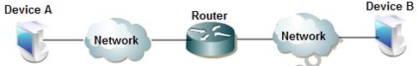

Routers are of different types which includes; Broadband Routers, Wireless Routers, Edge Router, Subscriber Edge Router, Inter-provider Border Router, Core Router and wired and wireless routers**.**

### **3.3.2 Switch**

It isa device that receives incoming data packets and redirects them to their destination on a local area network (LAN). It also centralizes communications among multiple connected devices in one Local Area Network(LAN) (Spurgeon & Zimmerman, 2013). It is capable of inspecting incoming messages as they are received and directing them to a specific communications port.

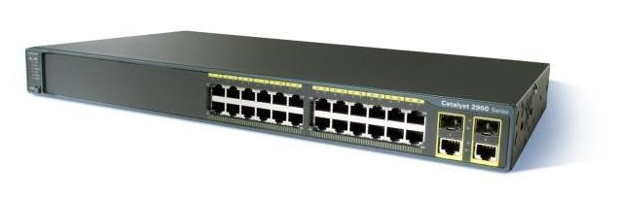

It comes in different types such as Unmanaged Switch, Managed switch, PoE Switch and Stackable Switch

* **Unmanaged switch**- It permits devices on the network to connect with each other, such as computer to computer or printer to computer in one location. It does not necessarily need to be configured or watched. If you want to add more Ethernet ports, you can use these plug and play types of switches in networking.
* **Managed switch**- This type of switch can be customized to enhance the functionality of a certain network. They offer some features like QoS (Quality of Service), Simple Network Management Protocol (SNMP) and so on.
* **POE switch-** It utilizes Power over Ethernet technology. It simplifies the cabling cable in that when connected with multiple other network devices, PoE switches can support power and data transmission over one network cable at the same time.
* **Stakeable switch**- It provides a way to simplify and increase the availability of the network in that instead of configuring, managing, and troubleshooting eight 48-port switches individually, you can manage all eight like a single unit using a stackable Switches. With a true stackable switch, those eight switches (total 384 ports) function as a single switch.

### **3.3.3 Bridge**

It is a repeater with add on functionality of filtering content by reading the MAC addresses of source and destination. It is also used for interconnecting two LANs working on the same protocol. It has a single input and single output port, thus making it a 2 port device. There are two types of bridges;

* Transparent Bridges :- These are the bridge in which the stations are completely unaware of the  
  bridge’s existence
* Source Routing Bridges: - In these bridges, routing operation is performed by source station and the frame specifies which route to follow.

### 3.3.4 Repeater

This type of networking device operates at the physical layer. It regenerates the signal over the same network before the signal becomes too weak or corrupted so as to extend the length to which the signal can be transmitted over the same network. Its importance is that it does not amplify the signal. When the signal becomes weak, they copy the signal bit by bit and regenerate it at the original strength. It is a 2 port device.

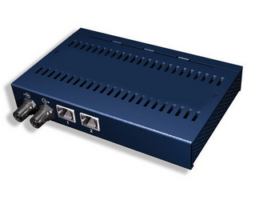

### 

### **3.3.5 Wireless Access Point (WAP)**

Thus is a device that allows other Wi-Fi devices to connect to a wired network. It connects to a router as a standalone device. It allows devices to connect to a wireless network without any cables connected to it. An access point connects to a wired router, switch, or hub via an Ethernet cable, and projects a Wi-Fi signal to a designated area. It is also used to provide network connectivity in office environments, allowing people to work anywhere in the office while connected to a network.

## **3.4 Cables and cabling**

Cables are networking devices used to connect two or more devices such as computers and printer mainly for the purpose of sharing data and information. Different networks use different types of cables depending on the topology. There exist several types of cables some which are shown and illustrated below;

* Unshielded Twisted Pair (UTP) Cable
* Shielded Twisted Pair (STP) Cable
* Coaxial Cable
* Fiber Optic Cable
* Wireless LANs

### **3.4.1 Unshielded Twisted Pair (UTP) Cable**

This are most type of cables we used in transmission of internet signal in most of the departments. It is one of the guided transmission media. It consists of a number of twisted pairs with simple plastic casing. This type of guided transmission media is divided into different categories based on the quality grade. One of the most used category is category 6 which in most cases is referred to as cat 6. It is a standardized cable for Gigabit Ethernet and other network physical layers that is backward compatible with the category5/5e and category3 cable standards. The standard connector for unshielded twisted pair cabling is an RJ-45 connector.



There exist some tools used in the installation of the Unshielded Twisted Pair(UTP) of which some of the tools we were privileged to be provided by the Moi University Information and Communication Technology (ICT) are as follows;

**Punch-down tool**

This type of tool is used for inserting wire into insulation-displacement connectors on punch down blocks, patch panels, keystone modules, and surface mount boxes. This tool cuts off the excess wire once already inserted into the max-module of the face plate.

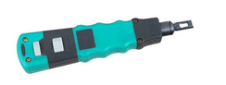

**Crimping tool**

This is a device used to conjoin two pieces of metal by deforming one or both of them in a way that causes them to hold each other. The result of the tool's work is called a crimp.To use this crimping tool, each wire is first placed into the connector. Once all the wires are in the jack, the connector with wires are placed into the crimping tool, and the handles are squeezed together. Crimping punctures the plastic connector and holds each of the wires, allowing for data to be transmitted through the connector.

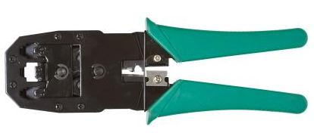

### **3.4.2 Shielded Twisted Pair (UTP) Cable**

Shielded Twisted Pair (STP) is also one of the guided transmission pair. There are two main purpose for these shielding;

* To reduce cross talk
* To limit the effects of external interference.

This shield also improves the cable's transmission and interference characteristics.

There are three different configurations of the Shielded Twisted Pair (STP).

(a) Each pair of wires is individually shielded with foil.

(b) There is a foil or braid shield inside the jacket covering all wires (as a group).

(c) There is a shield around each individual pair, as well as around the entire group of wires (referred to as double shield twisted pair).

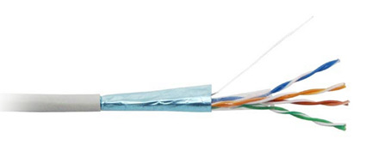

### **3.4.3 Coaxial Cable**

This type of cable has two conductors that share the same axis. A solid copper wire runs down the center of the cable, and this wire is surrounded by plastic foam insulation. The foam is surrounded by a second conductor, wire mesh tube, metallic foil, or both. The wire mesh protects the wire from EMI. It is often called the shield. A tough plastic jacket forms the cover of the cable, providing protection and insulation.

**3.4.4 Fiber Optic Cable**

This type of cable transmits light signalrather than electrical signals. It is enormously more efficient than the other network transmission media (DeCusatis & DeCusatis, 2010). We used three main types of tools while installing the fiber optic cable;

**Splicing fiber optic too****l** – eg. fiber optic cleaver, fusion splice, fiber splice protection sleeves.

**Test fiber optic tool** – eg fiber optic power meter, light sources, fault locator, optical identifier and optical time domain reflectometer.

**Cleaning fiber optic tool** – eg fiber optic cleaners for connectors and ferrules, alcohol and wipes.

An optical transmission system has three components: the transmission medium (*ultra-thin fiber of glass or fused silica)*, the light source (either a *LED (Light Emit Diode) or a laser diode)* and the detector (*photo diode*, which generates an electrical pulse when light falls on it). Fiber optic cable has got three main advantages; Noise resistance, less signal attenuation and high bandwidth.

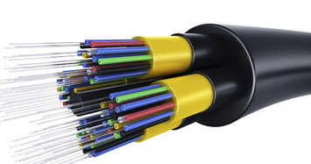

There also existed some tools that we used during the installing of fiber optic cables, some of which are explained below;

**Laser Light tool** – It is a small gadget that is used to test the effectiveness of the installed fiber optic cable. Through the pig tails cables joined with the fiber optic cables, this tool produces a reddish color when lit hence from the other end of the cable one is able to see this color also hence indication of effective termination of the fiber optic cable.

**Fiber Stripper** – This tool is used for cleaving the excess protruding fiber core.



## 

## **3.5 Computer, printer repair and maintenance**

This involved repairing absolute computers from various departments as well as different schools located at Moi University. The repairing process involved replacing their Random Access Memory(RAM), CMOS batteries, Hard Disks as well as their motherboards. On the other part there were several printers, HP (LaserJet, Office Jet), Epson (Stylus, Workforce Pro, etc), Ricoh (Aficio Laser Printers) (Shimomura & Kimita, 2012)just to mention a few to be repaired. Some of the printers failed to be detected by several computers and we were forced to install drivers on them for it to be detected by the desktop machines/computers.

## **3.6 Web development using JOOMLA Content Management System (CMS)**

We were involved with attending several sessions undertaken by our industrial supervisor Mr. Samuel Shitote where he introduced as with understanding more about designing websites using various Content Management System (CMS). Among the Content Management System (CMS) we were lucky to learn more and interact with it is Joomla. We learned more from these sessions among understanding Joomla as a free and open-source content management system (CMS) for publishing web content . It has both the font-end and the back-end where the administrator interacts more from the back-end point where he/she mostly uses PHP programming Language and also MYSQL database.

During the sessions, we learned how to install Joomla regardless of the Operating system one is working on.

## **3.7 Integrated Development Environments**

Apart from relying on our supervisors or even our trainers, among-st ourselves we were lucky to learn more about various Integrated Development Environments such as Django and Laravel.

**Django -** Django being a Python Web framework is the recent Framework that encourages rapid development of various apps. Applications developed or designed using these framework takes lesser time to be introduced to the market as well as it operates in a perfect way. The interesting part of it is that this framework allows developers to write less codes but these codes perform greater functionalities. It provides developers with several libraries as well as several packages hence reducing more tasks that could have forced them to undertake before the app performs its role.

**Laravel -** Laravel also is one of the recent used PHP framework. This framework easens several tasks such as authentication, routing, sessions, and caching. From this sessions, I was lucky to interact more with this framework and developed just a small project that works just like how the Instagram performs its role. The project can a little bit be illustrated by the sketch below;

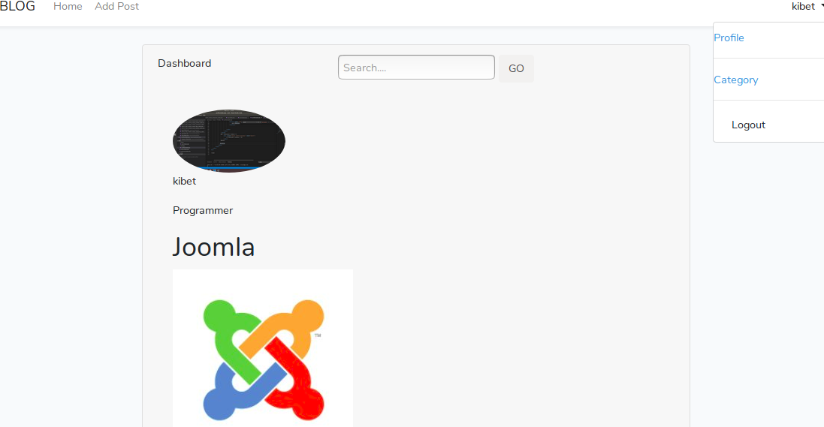

**Installation of Enterprise Resource Planning(ERP) System**

It was towards the end of the industrial attachment period that the organization were in the process of implementing the use of the new Enterprise Resource Planning(ERP) System. As part of the Information and Communication Technology(ICT) department attachee, I took part in installation of these system in various departments specifically in the schools of Education, Arts and also Bussiness. Regardless of various challenges of incompatibility of most of the computers in those schools due to their specks, I was able to overcome various of these challenges where the incompatibility of the existing operating system, I was forced to upgrade them by installation the compatible windows 10 operating system. I went further to configure the system by changing IP addresses as well as the domain names.

## **3.8 Success/ failure of the attachment exercise**

The industrial attachment had a positive impact in that I was able to transform all the theory part of work learned back in school into the practical part of it.

I was also able to gain a bit of experience as far as various fields are concerned such as networking, database interaction and also web design applying or using various existing Content Management System (CMS) such as Joomla that l was privileged to interact with.

## **3.9 Challenges encountered during the attachment period.**

Different sessions planned such as learning and putting into practice interaction with Content Management System(CMS) during the first week of the attachment, were affected by various unplanned programmes such as the implementation and installation of the Enterprise Resource Planning(ERP) system

.Dangerous infrastructures located in the organization that affected us during the installation of various networks in that some of the room’s ceilings were worn-out hence being risky to climb on them.

Allocated rooms for the attaches was most of the time set for various training session to different personnel regarding the installation and use of the Enterprise Resource Planning(ERP) system.

Inappropriate specks and incompatibility of the properties of various desktop computers brought up a challenge while installing the Enterprise Resource Planning(ERP) system.

**3.10 How the challenges were overcome /solved?**

Ensuring that each attachee avails himself or herself as early as 7:45am each day so that the assigned supervisors can be able to undertake us on various sessions before they attend their various training or duties hence able to learn cover more regardless of all encountered challenges,

Apart from using the ceilings to pass various cables while undertaking our networking duties, we decided to lay various cables through the underground hence reducing or minimizing the risk issues of the infrastructures.

Requesting our industrial supervisor to allocate us a different room where we were less disturbed by the unplanned training.

Upgrading the operating systems of the incompatible computers from windows 7 to windows 10 so that they can be compatible with the required installation of Enterprise Resource Planning(ERP) system.

## **3.11. Recommendations**

Call for the institution to accommodate more of their own students to be attached to specifics areas in the institution specifically on the ICT departments for the reason other than attending the industrial attachment, they will improve more facilities in the institution such as more network installation.

The institution to put more emphasis on networking and enhance on the practical part of it as it is the most practical field as far as most industrial attachment exercise is concerned.

## **3.12 References**

DeCusatis, C., & DeCusatis, C. J. S. (2010). *Fiber Optic Essentials*. Elsevier.

Shimomura, Y., & Kimita, K. (2012). *The Philosopher’s Stone for Sustainability: Proceedings of the 4th CIRP International Conference on Industrial Product-Service Systems, Tokyo, Japan, November 8th - 9th, 2012*. Springer Science & Business Media.

Spurgeon, C. E., & Zimmerman, J. (2013). *Ethernet Switches*. O’Reilly Media, Inc.