
MOI UNIVERSITY
MAIN CAMPUS
SCHOOL OF INFORMATION SCIENCES
DEPARTMENT OF INFORMATION TECHNOLOGY
COURSE TITLE: PRACTICAL ATTACHMENT REPORT
ATTACHMENT STATION: MOI UNIVERSITY MAIN CAMPUS ICT DEPARTMENT
BY
NAME: DANIEL MAINA
REG NO: C/IS/255/14
SUPERVISED BY:
SR. DR. C. NABUSHAWO

AN ATTACHMENT REPORT SUBMITED TO THE SCHOOL OF INFORMATION SCIENCES IN PARTIAL FULFILLMENT OF THE REQUIREMENTS FOR THE DEGREE IN BACHELOR OF SCIENCES IN INFORMATION SCIENCE

DECLARATION

This report is my own original work and has not appeared in any previous work or submitted to the school of Information Sciences for the fulfillment for the award of Bachelor’s degree in Information Sciences.

NAME: DANIEL MAINA
REG NO: C/IS/255/14
DATE: 29th JUNE 2019
SIGN: …………………………………….

ACKNOWLEDGMENT
The success of the attachment period is followed by the advice and support I got from different people.
I give credit to my Industrial Attachment supervisor, friends and fellow students who helped me make this period a success. My special gratitude goes to the Information Communication Technology department at Moi University main campus for granting me an opportunity to serve this period at their hub.
I wish I could list down all of you by name but to you who gave me your time and effort to make this project a success, receive my sincere gratitude.
ABSTRACT
Practical Industrial attachment forms part of the requirements set by the University for an individual to receive recognition for undergraduate studies. It helps individual gain insights of what the job market looks like and also helps one apply the theory learn t in class into practice.
As such, I was attached at Moi University main campus at the ICT training lab and this document is a report of all the major undertakings during the period. The methods of study included observation, coaching and direct participation.
TABLE OF CONTENTS

1.0 INTRODUCTION

NAME: Moi University, Main Campus
ADDRESS: P.O BOX 3900-30100, ELDORET
Type of Organization
Moi University is a higher-learning institution in Kenya.
1.3 Part of the Organization to which you where Attached
Department of ICTs, Administration block, Main Campus. I was attached at the ICT Training Room located at the Administration block but performed duties assigned to me within and outside Campus.

1.4 Name and Position of Host Supervisor
Name: Samuel Shitote
Position: ICT Trainer
Dates of training
Start Date: 5th May 2019
End Date: 28th June 28, 2019
1.5 Name of School Supervisor and Dates of Visit
Name: Sr. Dr. C. Nabushawo
Dates of Visit: 27th June 29, 2019
I had a visit from Dr. C. Nabushawo a lecturer at the School if Information Sciences with whom I shared the experiences I had during the attachment period.

CHAPTER TWO

2.0 HOST INSTITUTION
2.1.0 Brief History
Moi University was established in 1984 by an Act of Parliament (Moi University Act, 1984) as the second public university in Kenya. This was on the recommendation of a Presidential Working Party, chaired by Prof. Collins B. Mackay, which had collected views from Kenyans about the desirability of the same. Courtesy of his deep and altruistic concern for an interest in the advancement of education at all levels in Kenya, not only as a professional teacher but as Kenya’s Head of State, President Daniel Toroitich arap Moi pioneered the idea of a university in a rural setting.
The University is located in Kesses, 35 kilometers from Eldoret Town, and 310 kilometers Northwest of Nairobi, the capital city of Kenya. Moi University has expanded tremendously over the past decade and this can be attributed to the commitment of the entire Moi University fraternity, government investment, strategic partnerships, and the visionary leadership of the University Council and Management. These achievements are a testament to the resilience and fortitude of every faculty and staff member who enabled change at a pace and on a scale never experienced before in the country.
Since its establishment in 1984, the University has experienced growth and has lead to the establishment of several constituent colleges across the country. Most of these constituent colleges have grown to become fully pledged universities in Kenya namely Maseno University, Masinde Muliro University of Science and Technology, Maasai Mara University, University of Kabianga, University of Eldoret, Karatina University and Rongo University.
As facilities were developed and needs were recognized, new Schools were added, namely Science, Education, Arts and Social Sciences, Business and Economics, Agriculture and Natural Resources, Information Sciences, Human Resource Development, Engineering, Medicine, Public Health, Nursing, Dentistry, Law, Tourism, Hospitality and Events Management, Aerospace, Biological and Physical Sciences and Agricultural Sciences. Recently, with intent to harmonize programmes and optimize available scarce human resources, the University re-established the School of Post Graduate Studies and moved programmes previously under the School of Human Resource Development to the School of Information Sciences and School of Business and Economics.
2.1.1 Mission, Vision and Core Values of Moi University
Vision
To be the University of choice in nurturing innovation and talent in science, technology and development
Mission
To preserve, create, and disseminate knowledge, conserve and develop scientific, technological and cultural heritage through quality teaching and research; to create conducive work and learning environment; and to work with stakeholders for the betterment of society.
Core Values
- Promotion and defense of intellectual and academic freedom, scholarship and relentless search for truth
- Fostering teamwork, innovation, networking, tolerance, and a culture of peace embracing excellence, transparency & accountability.
- Practicing professionalism, meritocracy, equality, integrity and social justice.
- Maintaining self-respect, discipline, responsibility, institutional loyalty, national patriotism and international competitiveness.
- Continual improvement of services in order to remain competitive and relevant

CHAPTER TWO: HOST ATTACHMENT DEPARTMENT

2.2.0 Moi University ICTs Department

2.2.1 Brief History about MUICT Centre
Information and Communication Technology (ICT) Centre is a directorate that was established in 1998 within the office of the Vice Chancellor of Moi University. The department is headed by a director who oversees proper implementation of ICT activities across the University and satellite campuses.
The first director was Prof. Alex M. Muumbo who was in office until 2014. In 2014, Prof. Edwin Ataro succeeded Prof. Alex Muumbo as the Director until 2017. The directorate is currently headed by Dr. John K. Tarus who is the interim Director.
ICT as a field combines Computing and Telecommunication as its core components. Computer Technology concerns with Hardware and Software while Telecommunication technology includes all aspects of Fiber optics communications, microwave, antenna communication system and GSM.

2.2.2 Functional Units
The directorate's functional units that form the ICT directorate are as follows:
- Database Administration
- End-User Support
- ICT End-User Training
- ICT Operations and Maintenance
- ICT Planning and Development
- Information System Support
- Systems Administration
- Website Design and Maintenance

2.2.3 Vision, Mission, and Goals of MUICT
Vision
To be a center of excellence in ICT innovation and provision of quality services in Moi University
Mission
To effectively conceive, develop, implement, utilize, and manage appropriate information systems in order to provide integrated and coordinated quality ICT services to Moi University in line with its Vision, Mission and Objectives.
Goals
The ICT Directorate endeavors to:
- To provide quality ICT services to the University
- To manage, control and maintain ICT infrastructure in the University
- To advise the University authorities on all ICT matters
- To formulate ICT policies for the University

2.2.4 Financial Arrangements
The University main source of funding is the national Budget and is dependent on the size of the national budget among other factors. The directorate hence acquires most of its funding from the allocation within the central vote of the University for capital expenditure such as staffing and other activities of the Directorate.
Additionaly, the students also pay connectivity fee which aids in paying for the internet bandwidth, currently provided by KENET. The Directorate also gets its funding from donors. At the moment VLIR IUC program has a partnership with Moi University. Some of the funding goes towards implementation of ICT projects.

2.2.5 Current Organizational Structure
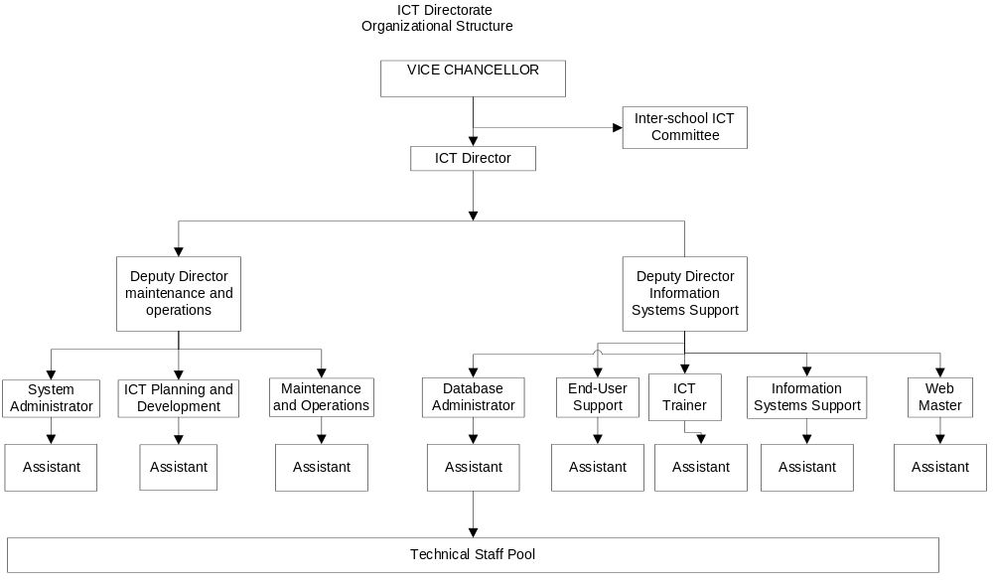

Figure 2.1 Current organizational structure

CHAPTER THREE

3.0 WORK PROGRAMME
3.1 OUTLINE OF THE WORK DONE
During the attachment period, there was no specific work program that was assigned on us, rather, every day there was a different task to work on either as a group or as an individual with the help of the ICT Trainers. During the eight weeks attachment period, I performed tasks across the various departments which reinforced and build my skills in the following areas:

- Network design and Installation
- Database design and administration
- Web development using JOOMLA Content Management System and Django
- Computer repair and maintenance
- Setting up Integrated Development Environments and dependencies installation
- Network troubleshooting and scaling
- Network Security and Quality of Service
- Web-application Security and Hosting

3.2 Networking
I did a lot of hands on in the field of Networking. During the first week, I was introduced to the physical and logical design schema s of the University Network Infrastructure. During the second week of training, the ICT department conducted sessions on Networking basics, Network Site Survey and common networking tools. Additionally, we had handson sessions where we were equipped with skills for working with and configuring Fibre Networking Technology. The details of these sections are discussed in the section below:

3.2.1 Networking Basics
A network connects computers, mobile phones, peripherals, and even IoT devices. Switches, routers, and wireless access points are the essential networking basics. Through them, devices connected to your network can communicate with one another and with other networks, like the Internet. The University Network infrastructure is laid in a way that supports resiliency and Flexibility while maintaining proper standards in security and performance.
3.2.2 Network Devices
In a typical network infrastructure, a network consists of Switches, routers, wireless access and physical cabling points to perform very different functions in a network.
Switches
Switches are the foundation of most business networks. A switch acts as a controller, connecting computers, printers, and servers to a network in a building or a campus.
Switches allow devices on your network to communicate with each other, as well as with other networks, creating a network of shared resources. Through information sharing and resource allocation, switches save money and increase productivity.
There are two basic types of switches to choose from as part of your networking basics: managed and unmanaged.
- An unmanaged switch works out of the box but can't be configured. Home-networking equipment typically offers unmanaged switches.
- A managed switch can be configured. You can monitor and adjust a managed switch locally or remotely, giving you greater control over network traffic and access.
Moi University network consists of managed and unmanaged switches each sitting either at the core, distribution and access layer. This is because different switches support different funtionalities and as such has different capabilities. The diagram below shows a Catalyst-3560g-48ps-switch model.

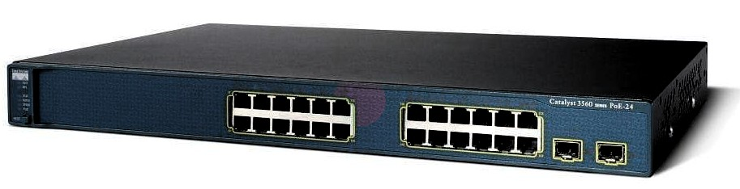
Figure 2 Catalyst 3560g SwitchRouters
Routers connect multiple networks together. They also connect computers on those networks to the Internet. Routers enable all networked computers to share a single Internet connection, which saves money.
A router acts a dispatcher. It analyzes data being sent across a network, chooses the best route for data to travel, and sends it on its way.
Routers connect your business to the world, protect information from security threats, and can even decide which computers receive priority over others.
Beyond those basic networking functions, routers come with additional features to make networking easier or more secure. Depending on your needs, for example, you can choose a router with a firewall, a virtual private network (VPN), or an Internet Protocol (IP) communications system. The diagram below depicts a typical Campus Network with a Cisco 7200 Series with capabilities for efficient access technologies such as ATM/DSL, T1/E1 Serial, or Packet over SONET (POS).

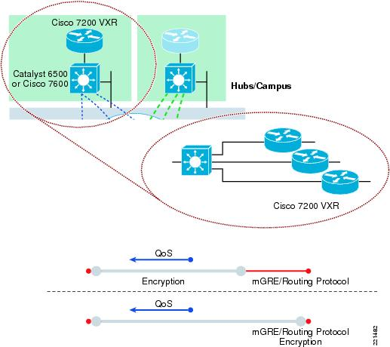

Figure 3 Campus Network using a Cisco 7200 Series Router
Wireless Acess Points
An access point allows devices to connect to the wireless network without cables. A wireless network makes it easy to bring new devices online and provides flexible support to mobile workers. This has been achieved following the growth and proliferation of Wireless Technology. An access point acts like an amplifier for the network. While a router provides the bandwidth, an access point extends that bandwidth so that the network can support many devices, and those devices can access the network from farther away.But an access point does more than simply extend Wi-Fi. It can also give useful data about the devices on the network, provide proactive security, and serve many other practical purposes.Access points support different IEEE standards. Each standard is an amendment that was ratified over time. The standards operate on varying frequencies, deliver different bandwidth, and support different numbers of channels.
The figure below shows a typical Wireless Network Infrastructure.

Figure 4 Campus Wireless Infrastructure

Cables and Cabling Technology
Cable is the medium through which information usually moves from one network device to another. There are several types of cable which are commonly used with LANs. In some cases, a network will utilize only one type of cable, other networks will use a variety of cable types. The type of cable chosen for a network is related to the network's topology, protocol, and size. Understanding the characteristics of different types of cable and how they relate to other aspects of a network is necessary for the development of a successful and scalable network.
The following sections discuss the most common types of cables used in networks.
- Unshielded Twisted Pair (UTP) Cable
- Shielded Twisted Pair (STP) Cable
- Coaxial Cable
- Fiber Optic Cable
- Unshielded Twisted Pair (UTP) Cable
Twisted pair cabling comes in two varieties: shielded and unshielded. Unshielded twisted pair (UTP) is the most popular and is generally the best option for school networks (See Figure. 5).
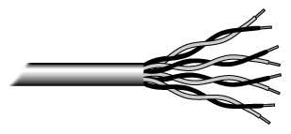

Fig.5. Unshielded twisted pair
The quality of UTP may vary from telephone-grade wire to extremely high-speed cable. The cable has four pairs of wires inside the jacket. Each pair is twisted with a different number of twists per inch to help eliminate interference from adjacent pairs and other electrical devices. The tighter the twisting, the higher the supported transmission rate and the greater the cost per foot.

Unshielded Twisted Pair Connector
The standard connector for unshielded twisted pair cabling is an RJ-45 connector. This is a plastic connector that looks like a large telephone-style connector . A slot allows the RJ-45 to be inserted only one way. RJ stands for Registered Jack, implying that the connector follows a standard borrowed from the telephone industry. This standard designates which wire goes with each pin inside the connector.
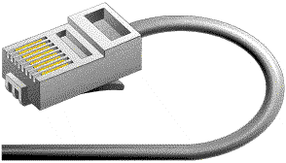

Figure 6 RJ-45 Connector

Shielded Twisted Pair (STP) Cable
Although UTP cable is the least expensive cable, it may be susceptible to radio and electrical frequency interference (it should not be too close to electric motors, fluorescent lights, etc.). If you must place cable in environments with lots of potential interference, or if you must place cable in extremely sensitive environments that may be susceptible to the electrical current in the UTP, shielded twisted pair may be the solution. Shielded cables can also help to extend the maximum distance of the cables.
Shielded twisted pair cable is available in three different configurations:
- Each pair of wires is individually shielded with foil.
- There is a foil or braid shield inside the jacket covering all wires (as a group).
- There is a shield around each individual pair, as well as around the entire group of wires (referred to as double shield twisted pair).

Fiber Optic Cable
Fiber optic cabling consists of a center glass core surrounded by several layers of protective materials (See Figure. 7). It transmits light rather than electronic signals eliminating the problem of electrical interference. This makes it ideal for certain environments that contain a large amount of electrical interference. It has also made it the standard for connecting networks between buildings, due to its immunity to the effects of moisture and lighting.
Fiber optic cable has the ability to transmit signals over much longer distances than coaxial and twisted pair. It also has the capability to carry information at vastly greater speeds. This capacity broadens communication possibilities to include services such as video conferencing and interactive services. The cost of fiber optic cabling is comparable to copper cabling; however, it is more difficult to install and modify. 10BaseF refers to the specifications for fiber optic cable carrying Ethernet signals.
The center core of fiber cables is made from glass or plastic fibers. A plastic coating then cushions the fiber center, and kevlar fibers help to strengthen the cables and prevent breakage. The outer insulating jacket made of teflon or PVC.



Figure. 7. Fiber optic cable

3.2.3 Networking Tools
The staff from Moi university department of ICTs also carried out a section on networking tools which really impacted on us. Networking tools are essential pieces of equipment in the creation and management of networks. The following section discusses the key tools involved in the design and maintenance of Networks.
Crimping Tool
A crimping tool is a device used to conjoin two pieces of metal by deforming one or both of them in a way that causes them to hold each other. The result of the tool's work is called a crimp. A good example of crimping is the process of affixing a connector to the end of a cable. For instance, network cables and phone cables are created using a crimping tool (shown below) to join the RJ-45 and RJ-11 connectors to the both ends of either phone or Cat 5 cable.
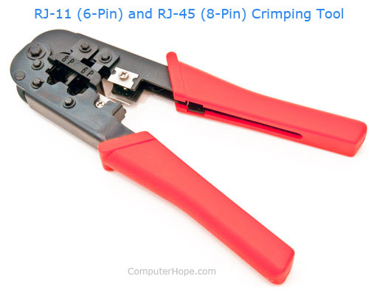
Figure 8 Network Crimping Tool.

Punch Down tool
A punch down tool, also called a krone tool, is a hand tool used to connect telecommunications and network wires to a patch panel, punch down block, keystone module, or surface mount box. The "punch down" part of the name comes from punching a wire into place using an impact action. It consists of a handle, a spring mechanism, and a removable slotted blade. When the punch down tool connects a wire, the blade cuts off the excess wire.


Figure 9 Network Punch-down Tool

3.2.4 Setting up of a Network in Different Areas
During the attachment period, we installed and extended the network in different weeks as shown below
- Week three- students centre guidance and counseling seven offices
- Week six- finance offices in the administration block
- Week six- careers office in the students centre
- Week seven- school of information sciences underground flow area around two computer labs, graduate computer lab and outside SR4

The section below highlights the steps followed during the installation of the extended Local Area Network.

Assembling of Tools
The following tables shows tools assembled during the design of the Campus LAN.

UTP cable Cat 6e (indoor and outdoor) | PVC conduit pipe
PVC trunking | Fiber tray with pairs of adapter
Pattress box | Fiber cable
Cisco Switch | Fiber connectors
Fiber patch cord | Cat 6 Ethernet max module
Wireless access point | Ethernet double face plate
Network cabinet | Driller
UTP patch cords | Punch down
Cable ties (100pcs) | Ethernet patch panel
Masking tape (black) | Steel nails 1”
Conta glue | Raw bolts 10mm
Ethernet UTP cat 6/5 cable | uninterruptible power supply

- Post survey
We did a post survey to determine a suitable-centralized position to install a cabinet, where to lay trunks or conduits and locations to drill so as cables to run across all offices. This was the first step to ensure that the site where the installation was done was secure and effective.

- Assembling and Installation of Network Cabinet
The Network Cabinet houses the Switches and Patch Panel. It organizes the way cables run to the different termination endpoints.
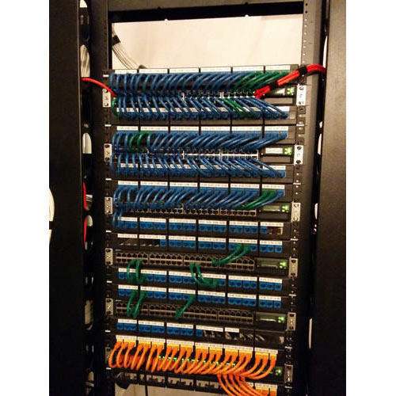

Figure 10 Network cabinet

- Tunnel drilling
We drilled tunnels for cables to pass through and reach required offices using a driller. This allowed us to mount the cable cabinet to the wall.

- Laying of UTP cables
A pair of UTP cables was laid starting from the place where the cabinet was installed to each office within guidance and counseling offices. For proper management of cables we used cable ties.
- Lying of trunks, flex and conduits
Trunks, flex and conduits are used to run UTP cables both indoors and outdoors. It protects cables from unnecessary contact with damage agents. We used conta glue to fix them in the along the wall.
- Fixation of pattress box and termination of the cable
We fixed pattress box, terminated cables with max module and closed it with double face plate. I terminated end point using color code T568B standard as shown in the diagram below. We also terminated UTP cable end using color code T568B standard and fixed it to the cabinet for neat management of cables.

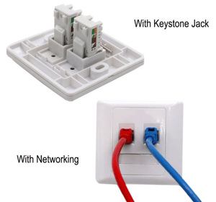

Figure 11. 86Type-RJ45-Dual-Face-Plate-Wall-Sockets

3.3 Content Management System
The Industrial Supervisor Mr. Shitote delivered to us sessions on Content Management System using Joomla. During the sessions, we learned installation of Joomla and its dependencies and also the due process of creating a website using Joomla.
Introduction
JOOMLA is an open source Content Management System (CMS), which is used to build websites and online applications. It is free and extendable which is separated into front-end and back-end templates (administrator). JOOMLA is developed using PHP, Object Oriented Programming, software design patterns and MySQL (used for storing the data). Joomla revolves around Modules and Plugins provided by the different Templates available online for free or for purchase through a payment gateway.

3.4 REPAIR AND MAINTENANCE
With the help of Moi University ICTs staff, we carried out repair and maintenance in different offices within the university premises. We were in a position to repair broken printers and Personal Computers.

3.5 Linux System Administration
The Senior Database Administrator Mr. Luke Rotich also delivered sessions on Linux Operating Systems administration. Through the sessions, we learnt basic linux configurations to advanced Linux functionalities such as Web hosting and Virtualization.

3.6 Python Django Web Framework
During the Attachment period, I had the opportunity to deliver sessions on Python and Django Web Framework. Python Programming as a language has in the recent years received recognition in the Software Development domain. As such, I was in a position to deliver talks on Django and Python and also made a simple project as shown below:

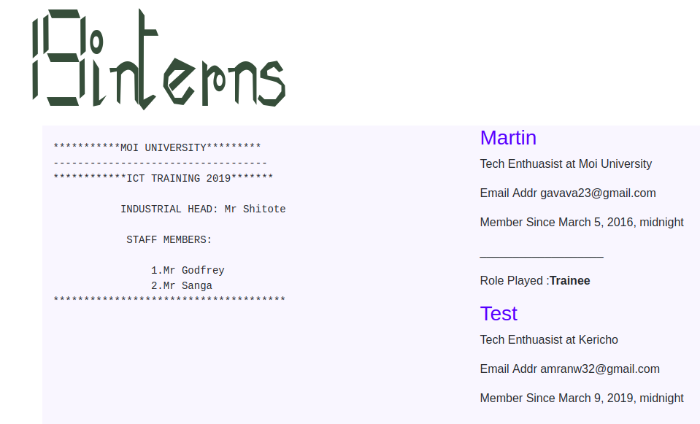
Fig 11. Django-powered website

CHAPTER FOUR
4.0 CONCLUSION AND RECOMMENDATION
4.1 Introduction
Industrial attachment is a crucial step towards ensuring an understanding of career objectives and more so ensuring that the theoretical concepts taught in class are brought into practice. It is an avenue where graduates acquire skills and also stands as a chance to focus on more productive aspects on one’s career path.
The section below highlights some of the key challenges that I faced during the attachment period.
Challenges
Limited access to organizations critical infrastructure due to controlled access. For example the Server Room Short period of attachment. The period of attachment was only limited to two months (8 weeks) which hindered exploration of the different campus network infrastructure core components such as Web-servers and Mail Servers.

Limited training sessions from the department due to their work schedule. Due to the limited amount of time that was available, we were not in a position to extensively cover most of the ICT concepts that ensured survival of business processes.

Recommendations
Call for close interaction between Students from the students of Information Sciences and students from the Computer Science department. This will help exchange ideas and also develop startups within the Campus.
Introduction of Programming, Networking and Graphics design hubs at the School of Information Sciences to foster research and development in Technology.
Additionally, the following units at the school of information sciences should also be made more practical:
1. Database Design and Administration
2. Network Design and Administration
3. Website design
4. Artificial Intelligence
5. Data Mining and Advanced Databases.

References
Verma, Dinesh C. "Simplifying network administration using policy-based management." IEEE network 16.2 (2002): 20-26.
"Virtual Backbone Routers" (PDF). IronBridge Networks, Inc. September, 2000. Archived (PDF) from the original on 16 July 2011. Retrieved 15 January 2011.
"Core Network Planning". Microsoft Technet May 28, 2009. Archived from the original on 2 October 2010. Retrieved 15 January 2011.

