# Cloud Orchestration and Automation Report

Name

Institution Affiliation

Course

Date

Contents

Cloud Orchestration and Automation Report 1

1.0 Executive Summary 4

2.0 Introduction 5

2.1 Overview 5

**2.2 Industry Approaches Overview** 6

3.0 AWS CloudFormation Feature Review 7

3.2 Summary 8

4.0 Cloud Formation Templates Workshop 9

5.0 Step 2: Deploy Compute in the Cloud 10

**5.1 Deploying an Elastic HPC Clusters** 10

6.0 Step 3: Deploy Databases in the Cloud 14

**6.1 Create a Template to Deploy a Data Warehouse** 14

7.0 Step 4: Deploy Developer Tools in the Cloud 17

7.1 Create a Template to Automatically Deploy Developer Tools 17

9.0 Step 6: Deploy Messaging in the Cloud 22

10 Step 7: Deploy Storage and Content Delivery in the Cloud 23

11.0 Step 8: Deploy Website(s) and Web App(s) in the Cloud 25

12.0 Recommendations 27

13 Conclusion 29

14 References 30

# 1.0 Executive Summary

The cloud environment at BallotOnline has come a long way and currently includes infrastructure, platforms, and software. It is also constantly being improved as the business's requirements change. Because each workflow necessitates a large number of resources, the way applications are established and deployed, as well as the method data is processed, has become extremely difficult to manage. We can simply prevent BallotOnline from mismanaging its infrastructure, applications, and data by employing cloud orchestration. Orchestration is a method of arranging, coordinating, and administering complex computer systems, services, and workflows in an optimal and automated fashion. AWS is BallotOnline's preferred cloud service provider, and it offers CloudFormation, a cloud orchestration tool. BallotOnline will be able to easily construct services that require a group of linked resources to be deployed in an ordered manner using CloudFormation.

# 2.0 Introduction

## 2.1 Overview

BallotOnline successfully moved its infrastructure and apps to the cloud utilizing Amazon Web Services (AWS). BallotOnline, like the majority of firms that have previously migrated to the cloud, is having trouble managing its numerous cloud-based resources as new advancements are introduced. Because cloud systems are made up of large amounts of data from many cloud settings, it's difficult to set up and maintain uniform development processes because they rely on diverse systems. Orchestration and automation are essential for future additions to BallotOnline's cloud environment, and they must be deployed. BallotOnline's next step is to add cloud orchestration and automation to aid in the management of its many resources. What separates cloud automation from cloud orchestration is what is automated. Cloud automation is the administration of a single workflow activity, whereas cloud orchestration is the organization and coordination of a set of automated activities. In other words, cloud orchestration is the end-to-end automation of service deployment in a cloud-based environment because it takes a collection of automated processes and merges them into a single workflow that fully automates the delivery of the service from the original request to completion. It reduces the time it takes to manage repetitive processes by automating them and reducing human error. It makes the company nimbler and emphasizes continuous integration processes. It aids businesses in cost-cutting. It also improves the security and visibility of cloud infrastructures. BallotOnline would be able to quickly deploy new systems and manage the interconnections and interactions across all IT infrastructure and apps using cloud orchestration.

## **2.2 Industry Approaches Overview**

Many cloud service providers, such as Amazon AWS, Google Cloud Platform, IBM Cloud, and Microsoft Azure, as well as third-party suppliers, now offer cloud automation and orchestration solutions. We can observe two of the many various methods of cloud orchestration by comparing the leaders in cloud computing, Amazon AWS, and Google Cloud Platform. CloudFormation is an AWS cloud orchestration tool that allows AWS resources to be quickly generated and managed. The JSON or YAML templates are utilized. Google Cloud Platform, on the other hand, offers Google Deployment Manager, with templates in YAML, Jinja, and Python. At AWS, a configuration instance is referred to as a stack, but in Google, it is referred to as a deployment. AWS and Google both can handle any type of resource. As you can see, there aren't many distinctions, and both firms have simple cloud orchestration methodologies.

# 3.0 AWS CloudFormation Feature Review

AWS CloudFormation is one of the most powerful and advanced orchestration tools on the market. It allows you to automate the setting of AWS resources using a text file that you can use across multiple accounts and regions. We will be able to design resource templates that specify sets of AWS resources to be provided at BallotOnline using AWS Cloud Formation.

Templates, stacks, and changesets are all significant concepts in CloudFormation, and they form the foundation of the system. The infrastructure is described in a template, which is a JSON or YAML file. A template can be thought of as a blueprint for creating Amazon Web Services resources. Format Version, Description, Metadata, Parameters, Mappings, Conditions, Transform, Resources, and Outputs make up a template. The Resources section is the only one that is required because it defines the stack resources. In case you need to roll back after making a change, templates contain a built-in feature that allows you to version manage the infrastructure. The infrastructure may also be duplicated easily and fast with repeatability. It allows you to spend less time managing resources and more time working on AWS-based apps. An S3 bucket or your local workstation can both be used to trigger a template. This means that CloudFormation performs API calls to the APIs of the services defined in the template to start and configure them.

A stack is a collection of resources defined in a template that can be modified. CloudFormation, on the other hand, includes a changeset, which is a summary of the proposed modifications, to ensure that there is a little negative impact on the environment. By constructing, updating, and deleting stacks and changesets, you may create, update, and remove a collection of resources. This allows you to see how these changes will affect essential resources before performing the change.

# 3.2 Summary

BallotOnline will be able to quickly manage and provision any enhancements to its cloud infrastructure by using JSON or YAML templates that specify resource stacks if it chooses AWS CloudFormation as its cloud orchestration solution. CloudFormation simplifies infrastructure administration, especially for multiple resources that must be set up to function together seamlessly. CloudFormation will also enable version control of the infrastructure, making it much easier to trace changes. Cloud orchestration through AWS CloudFormation is required for BallotOnline to properly utilize and benefit from its cloud-based architecture.

# 4.0 Cloud Formation Templates Workshop

BallotOnline's website is its primary customer-facing output. Creating a website from scratch for each location, on the other hand, might be time-consuming and unnecessary. BallotOnline will be able to simply deploy its website in different regions by using CloudFormation templates for VPCs in dual regions with EC2 Instances running LAMP stacks. A Linux server, Apache HTTP Server, MySQL database, and PHP make up a LAMP stack. This establishes a single source of truth for all resources used and aids in the standardization of all infrastructure components.

# 5.0 Step 2: Deploy Compute in the Cloud

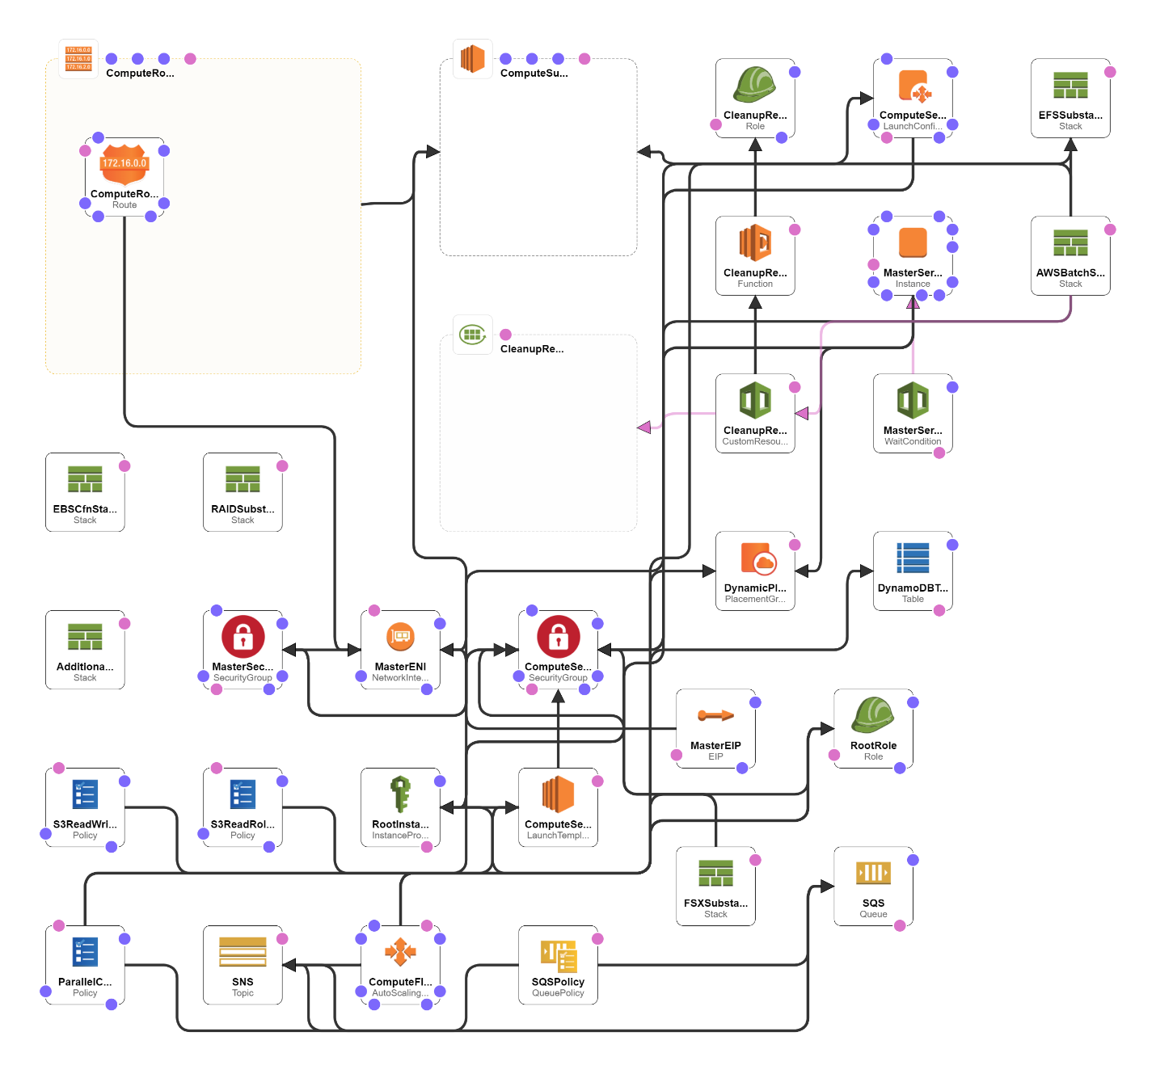

## **5.1 Deploying Elastic HPC Clusters**

A high-performance computing (HPC) cluster is made up of hundreds to thousands of compute servers (nodes) that are networked together and work in parallel to boost processing speed. ParallelCluster, an open-source technology supplied as a Python package by AWS, is a completely elastic HPC cluster in the cloud. BallotOnline will be able to easily build up an Elastic HPC Cluster whenever needed by constructing a CloudFormation template that will provide and configure all of the resources for this ParallelCluster. BallotOnine will be able to process vast amounts of electronic data with ease as a result of this. Using helper scripts, the CloudFormation template must be able to automatically launch an EC2 instance with AWS CLI installed and configured, as well as Python and pip (CFN-init, cfn-signal, cfn-get-metadata, and cfn-hup). It must also be able to upgrade the Python package parallelcluster. The template should allow the user to choose pcluster setup parameters, region id, VPC name, Subnet, and EC2 KeyPair before launching the AWS parallel cluster. The cluster can then be created by the user. The user can then sign in and perform a test.

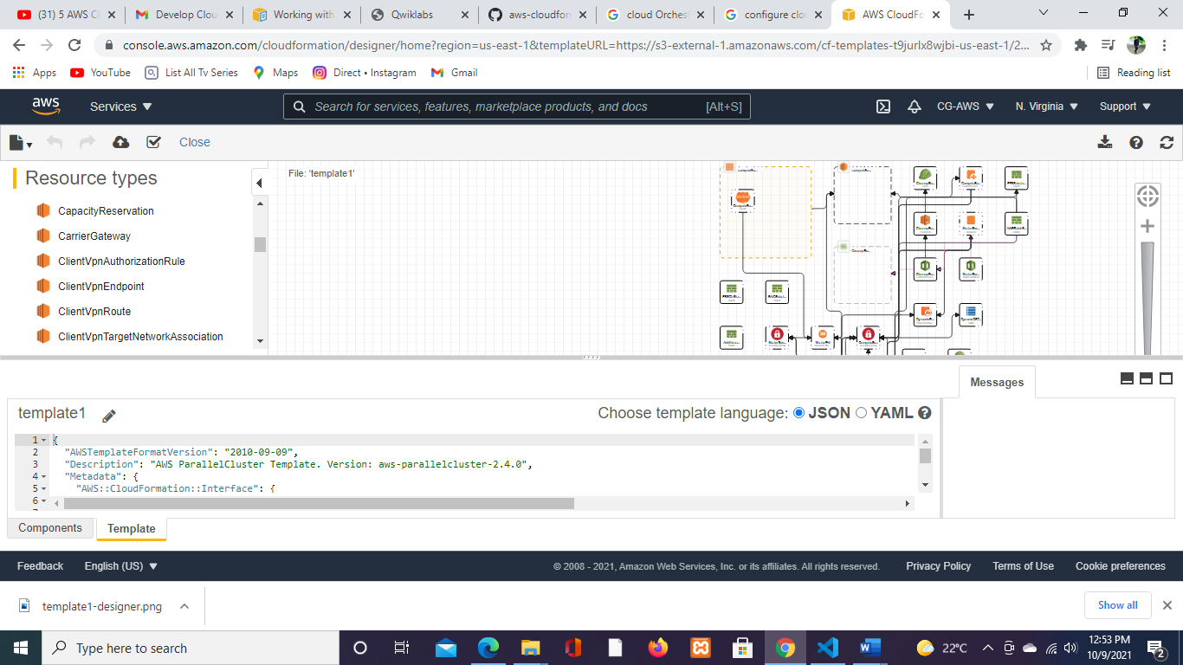

1. Set up AWS CLI on EC2 Instance and install AWS Parallel Cluster
   * curl "https://awscli.amazonaws.com/awscli-exe-linux-x86_64.zip" -o "awscliv2.zip"
   * unzip awscliv2.zip
   * sudo ./aws/install
   * AWS --version
   * Configure AWS CLI
2. Install AWS ParallelCluster
   * sudo pip install --upgrade AWS-parallelcluster
3. Configure and Launch AWS ParallelCluster • pcluster configure
   * cat ~/.parallelcluster/config
   * Customize the AWS ParallelCluster Config File
4. Launch the AWS ParallelCluster
   * pcluster create HelloCluster
5. Sign In to Your Cluster
   * Using the public IP sign into the host
   * qhost
6. Submit and Run a Simple Parallel MPI Job Create the mpi_hello_world Executable vi med mpi_hello_world.c
7. Create the Job Submittal File
8. Launch the job
   * qsub hw. job
   * cat hello_all.out
9. Create an Amazon EBS Volume Snapshot for Cluster Reusability
   * Go to the Amazon EC2 console and select the master instance with the name Master
   * Scroll down to the block devices section of the instance description and click /dev/sdb
   * To see the volume dashboard, click the volume ID
   * From the Action drop-down list, select Create Snapshot.
   * Create a tag with the Name key and a value of Hello World, and enter the following description: This is a Snapshot of the Hello World software.
   * Click Create Snapshot.
   * Save the snapshot ID number to use in Step 8. You can copy it and save it in a text file.
   * Edit the ParallelCluster config file (~/.parallelcluster/config)

# 6.0 Step 3: Deploy Databases in the Cloud

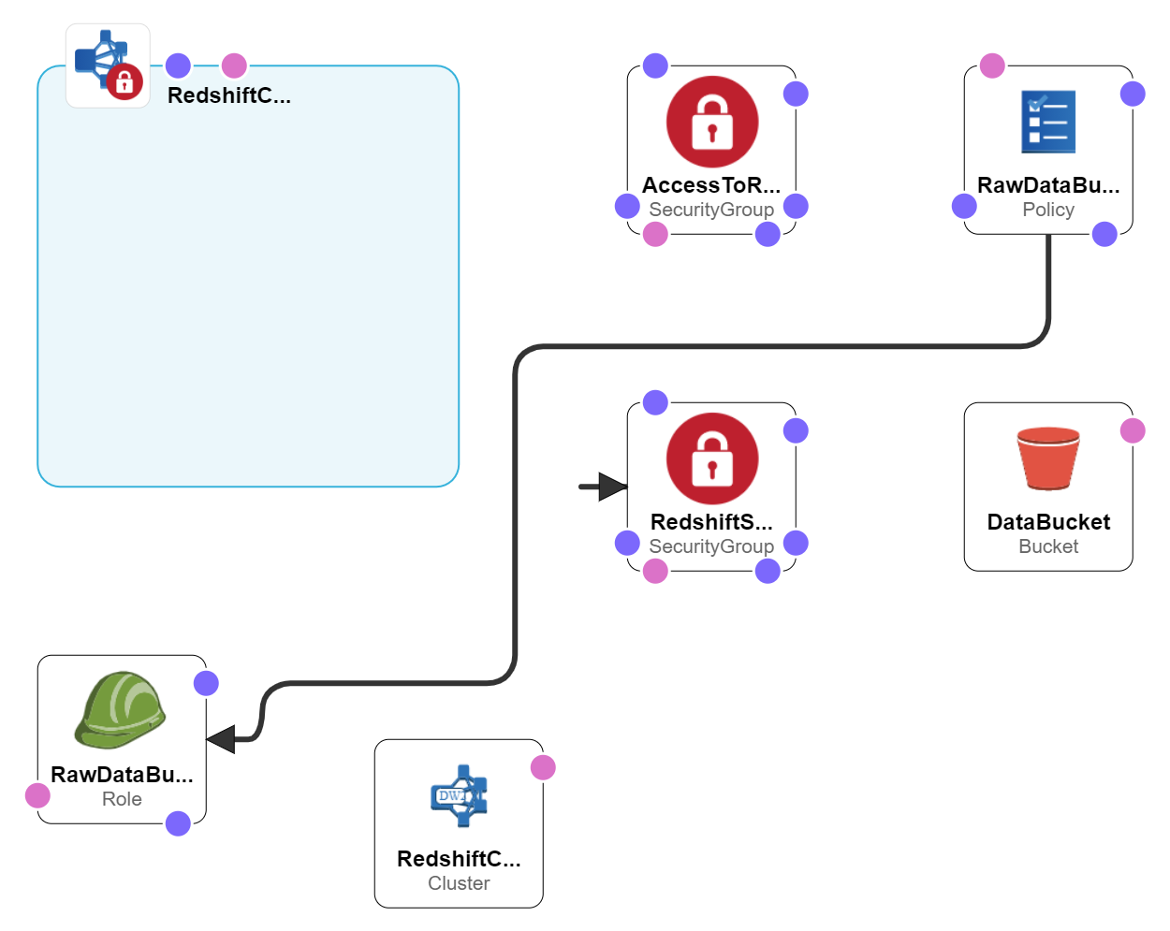

## **6.1 Create a Template to Deploy a Data Warehouse**

A data warehouse is a centralized store of integrated data that can be used for reporting and data analysis to help businesses make better decisions. Because it is regarded as a core component of business intelligence, it is critical to the company's performance. AWS' Redshift is a fully managed, cloud-based data warehouse. It is a cost-effective way for BallotOnline to gather and store all of its data, as well as analyze it using various business intelligence tools. Even though putting up a Redshift cluster is rather straightforward, it does necessitate the use of several resources.

Because the system requires a VPC, Subnet, an S3 bucket, and the requisite access protocols and security groups, BallotOnline may use CloudFormation templates to provision and manage its Redshift clusters. Four CloudFormation templates must be created: one for the IAM redshift role, one to grant the user access to the query editor, one to construct a VPC with a subnet, routing table, and InternetGateway, and one to bring up the Redshift cluster and security group. 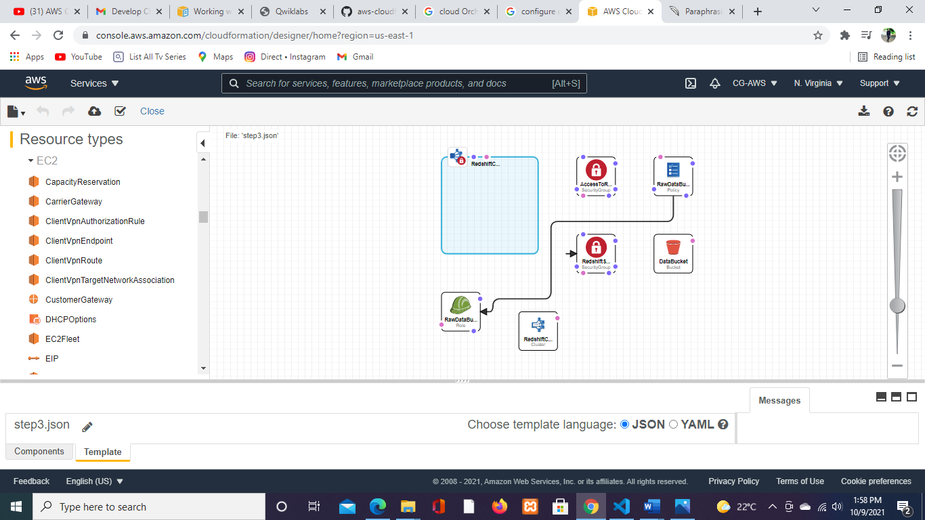

**1.** Create an IAM Role for Amazon Redshift

**2.** Create a Cluster

1. Authorize Access to the Cluster
2. Connect to the Cluster
   * Enable access to the query editor for the user in IAM
   * Login into the console as the user
   * Connect to the Database
3. Create a new table by selecting Public as the Schema and running the query
4. Load Sample Data and run queries • Create Tables
   * Upload the files to an S3 bucket and queries will be run load this data to the DW
   * Run command to load data to DW
   * Run the following Select statements to see if data has been loaded

# 7.0 Step 4: Deploy Developer Tools in the Cloud

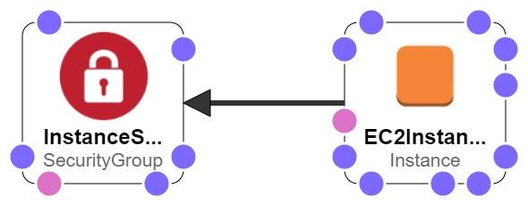

## 7.1 Create a Template to Automatically Deploy Developer Tools

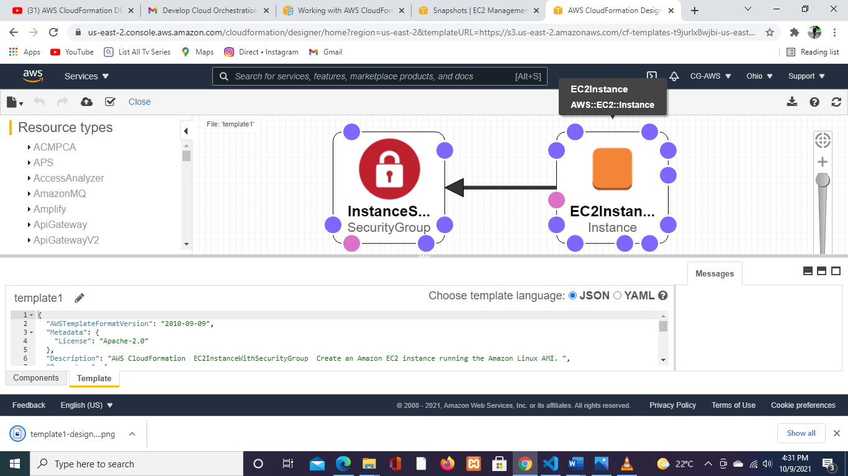

BallotOnline would be utilizing Jenkins which is a free and open-source automation server for software development related to building, testing, and deploying, facilitating continuous integration and continuous delivery. It integrates and is very compatible with AWS resources.

Setting up a Jenkins instance in AWS requires a configured VPC, IAM user, an EC2 instance with a keypair. Because of these multiple resources, BallotOnline can use CloudFormation templates to facilitate bringing up Jenkins Instances. Templates will need to be created, one for VPC and its configuration, one for the user account with appropriate permissions, and one to launch an EC2 instance and Jenkins configured with the security group.

1. Create a Security Group for Your Amazon EC2 Instance
   * Go To EC2 Console in the Ohio Region (us-east-2)
   * Security Group
2. Launch Your EC2 Instance with the security group
3. Install and Configure Jenkins

* Add Jenkins Repo
* Import Key
* Install Jenkins
* Start Jenkins

**8.0 Step 5: Deploy Machine Learning in the** Cloud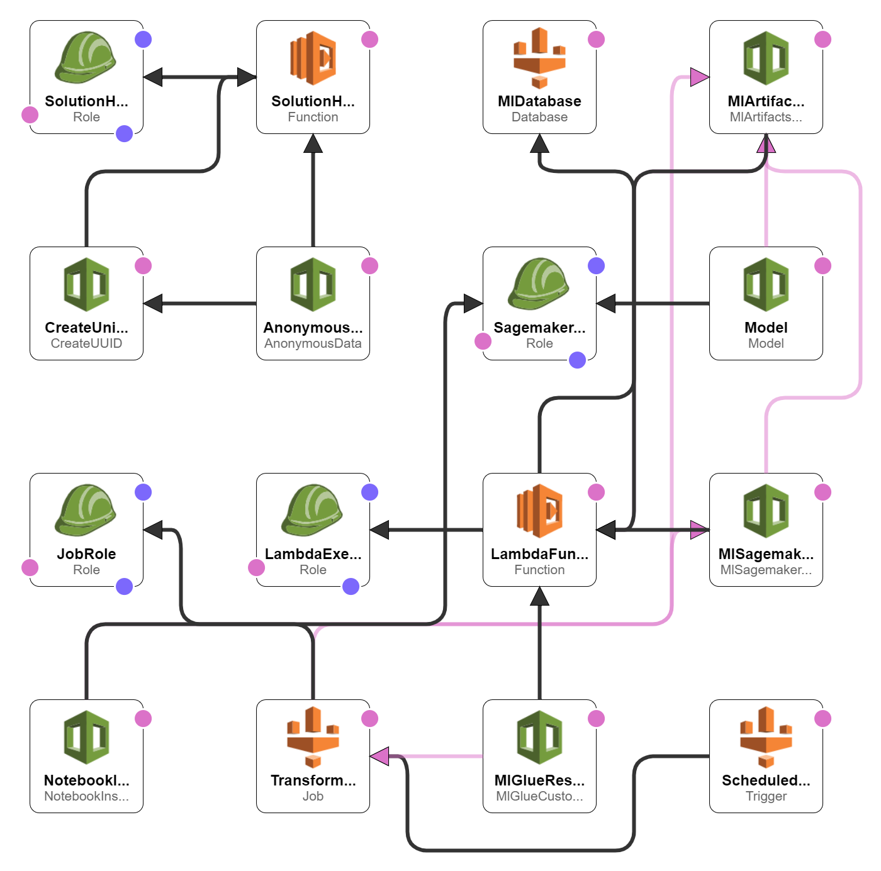

Machine learning is a branch of artificial intelligence (AI) that allows computers to learn and improve on their own without having to be explicitly programmed. Machine learning is concerned with the creation of computer programs that can access data and learn on their own. Amazon SageMaker is a cloud-based machine learning platform that allows customers to quickly design, train, and deploy machine learning (ML) models, according to AWS. Sagemaker can help BallotOnline because it is friendly to developers and data scientists, allowing them to quickly construct, train, test, and deploy machine learning processes.

All SageMaker resources can be provisioned using CloudFormation. A VPC with a subnet and routing table, as well as an IAM Role and a Notebook Instance, are required to deploy SageMaker. As a result, BallotOnline may develop a Cloudformation template for Sagemaker deployments. You may go to the SageMaker console and prepare the data on Jupyter once it's been delivered.

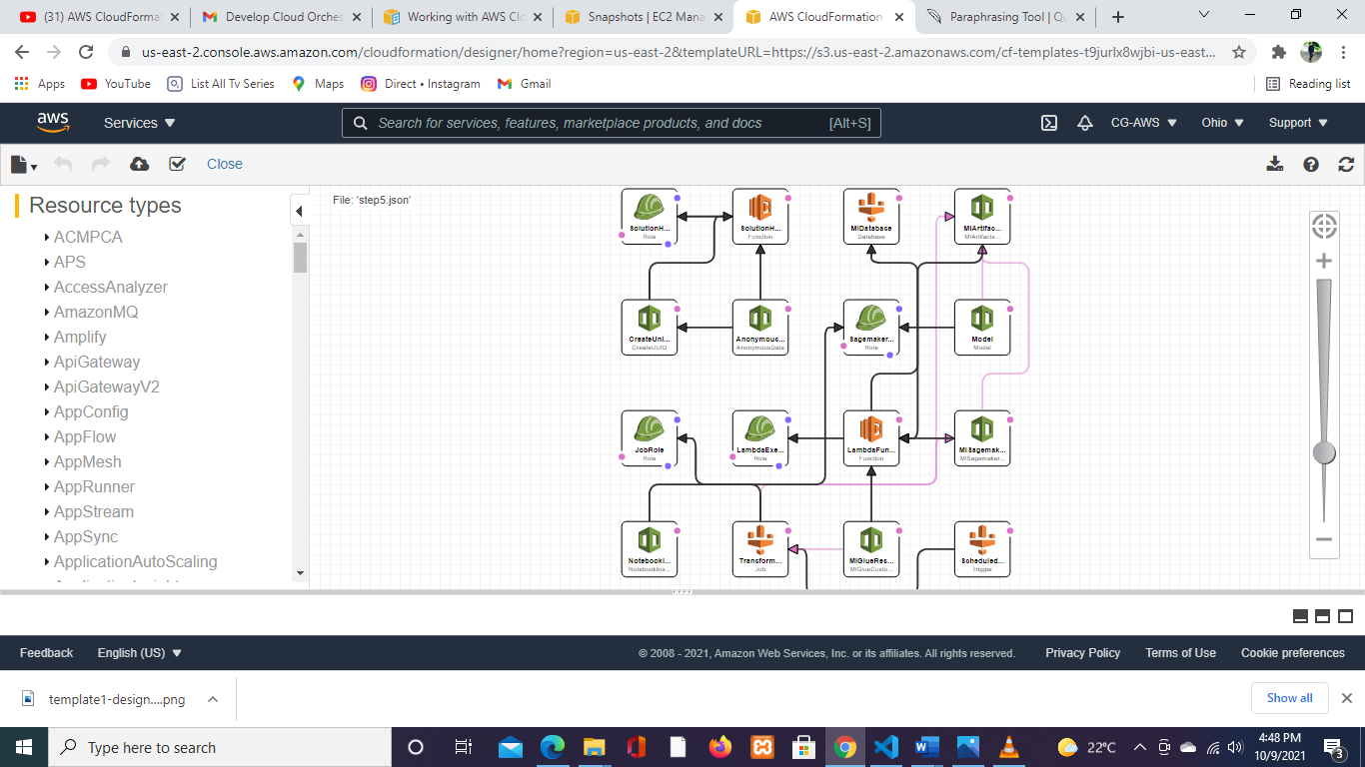

1. Create an Amazon SageMaker notebook instance

* IAM Role- AmazonSageMaker-ExecutionRole for any S3Bucket

1. Prepare the data
   * Open Jupyter and create a cond_python3notebook and import libraries and define environment variables
   * Create an S3 Bucket to store data- sidrasagemakerbucket
   * Download data to sagemaker instance
   * Split data into training (70%) data and test data (30%)
2. Train the model from the data
   * We need to use Amazon SageMaker pre-built XGBoost algorithm model which is a gradient boosting library so we need to reformat data
   * Create an instance of the XGBoost model (an estimator), and define the model’s hyperparameters.
   * Now train the model using gradient optimization on an ml.m4.xlarge
3. Deploy the model
   * + Create an endpoint where the model is deployed so you can access it
     + Test to see if customers enrolled in bank product
4. Evaluate model performance

Compare Actual vs Predicted values in the confusion matrix

# 9.0 Step 6: Deploy Messaging in the Cloud

AWS SES is an email platform that allows you to send and receive emails on a registered domain. BallotOnline's business users also desire their internal email system, therefore AWS SES is critical to the company's success. BallotOnline would benefit from automating this procedure using CloudFormation because setting up an SES mailbox necessitates various resources. When setting up Simple Email Service, we need to use Route 53 to register and validate a domain, create an AWS SES receipt rule, and designate an S3 bucket to which the emails will be saved. We'll need to include a VPC, subnet, route table, and internet gateway in the cloud creation template, as well as a Route 53 record set, S3 bucket, S3 bucket policy, and SES Receipt Rule.

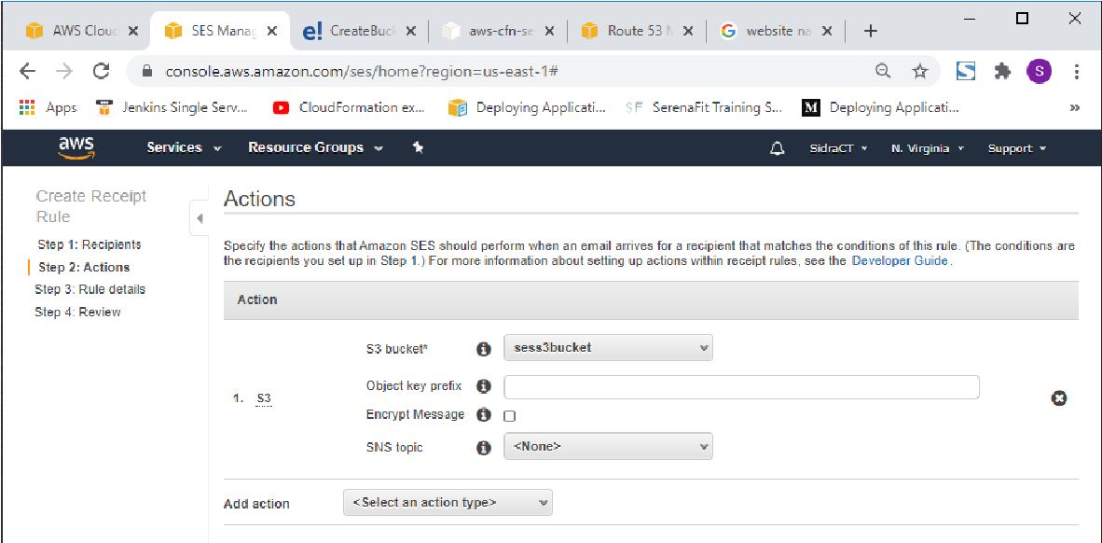

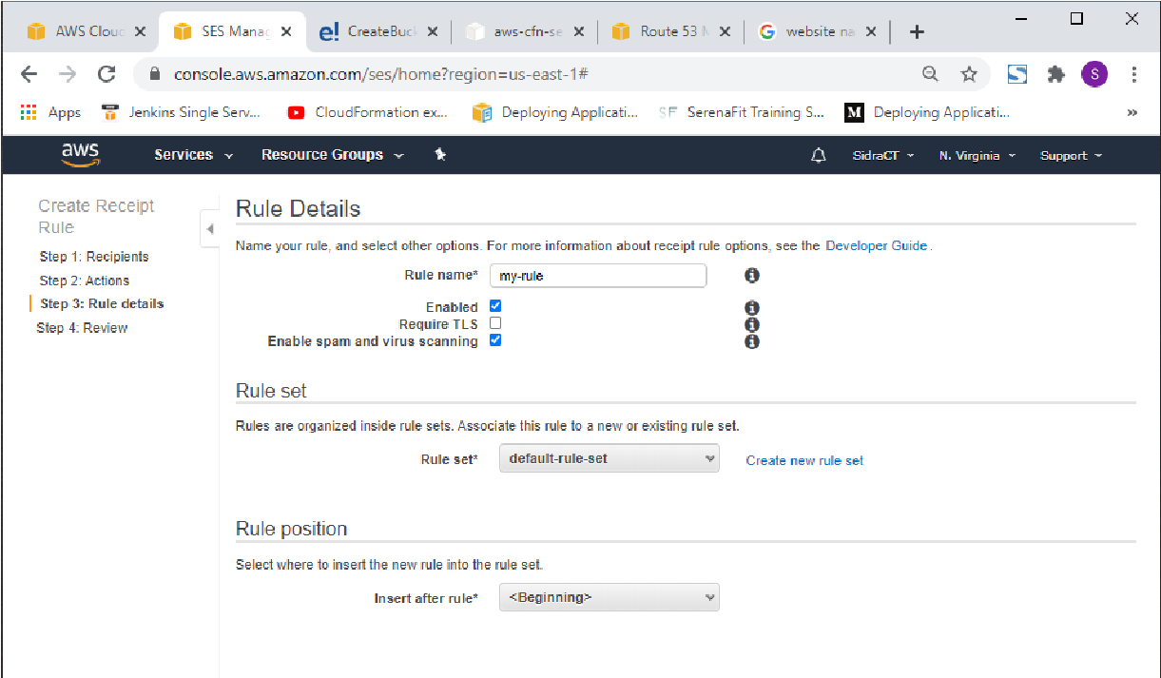

10 Step 7: Deploy Storage and Content Delivery in the Cloud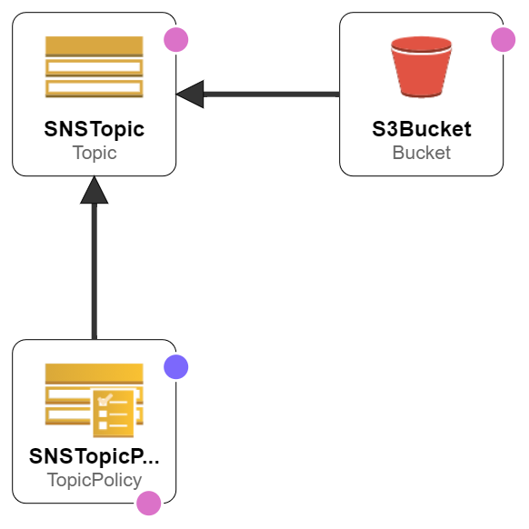

BallotOnline is a global voting solutions provider that handles sensitive data and is bound by international rules and regulations. BallotOnline must archive and backup data regularly, and this data must also adhere to certain laws and regulations. BallotOnline may do this operation by leveraging Amazon Glacier Vault, which offers vault lock policies for compliance controls. The utilization of various resources necessitates the creation of a CloudFormation template. A virtual private network (VPC) with a subnet, routing table, and internet gateway is required. Vault is specified as BackupVault in CloudFormation. To establish the required role for Vault, we'll need to create a cloud formation template. We'll also need a backup vault for storage, a BackupSelection for the resources that need to be backed up, and a Backup Plan for compliance standards.

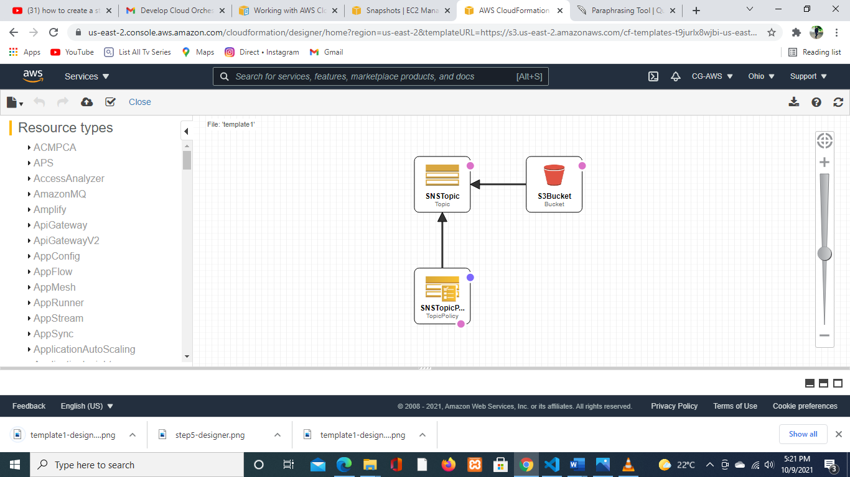

Create a Vault in Amazon S3 Glacier

1. Establish a Vault Compliance Policy.

Using a vault lock policy, the Vault Lock makes it simple to establish and enforce compliance rules.

# 11.0 Step 8: Deploy Website(s) and Web App(s) in the Cloud

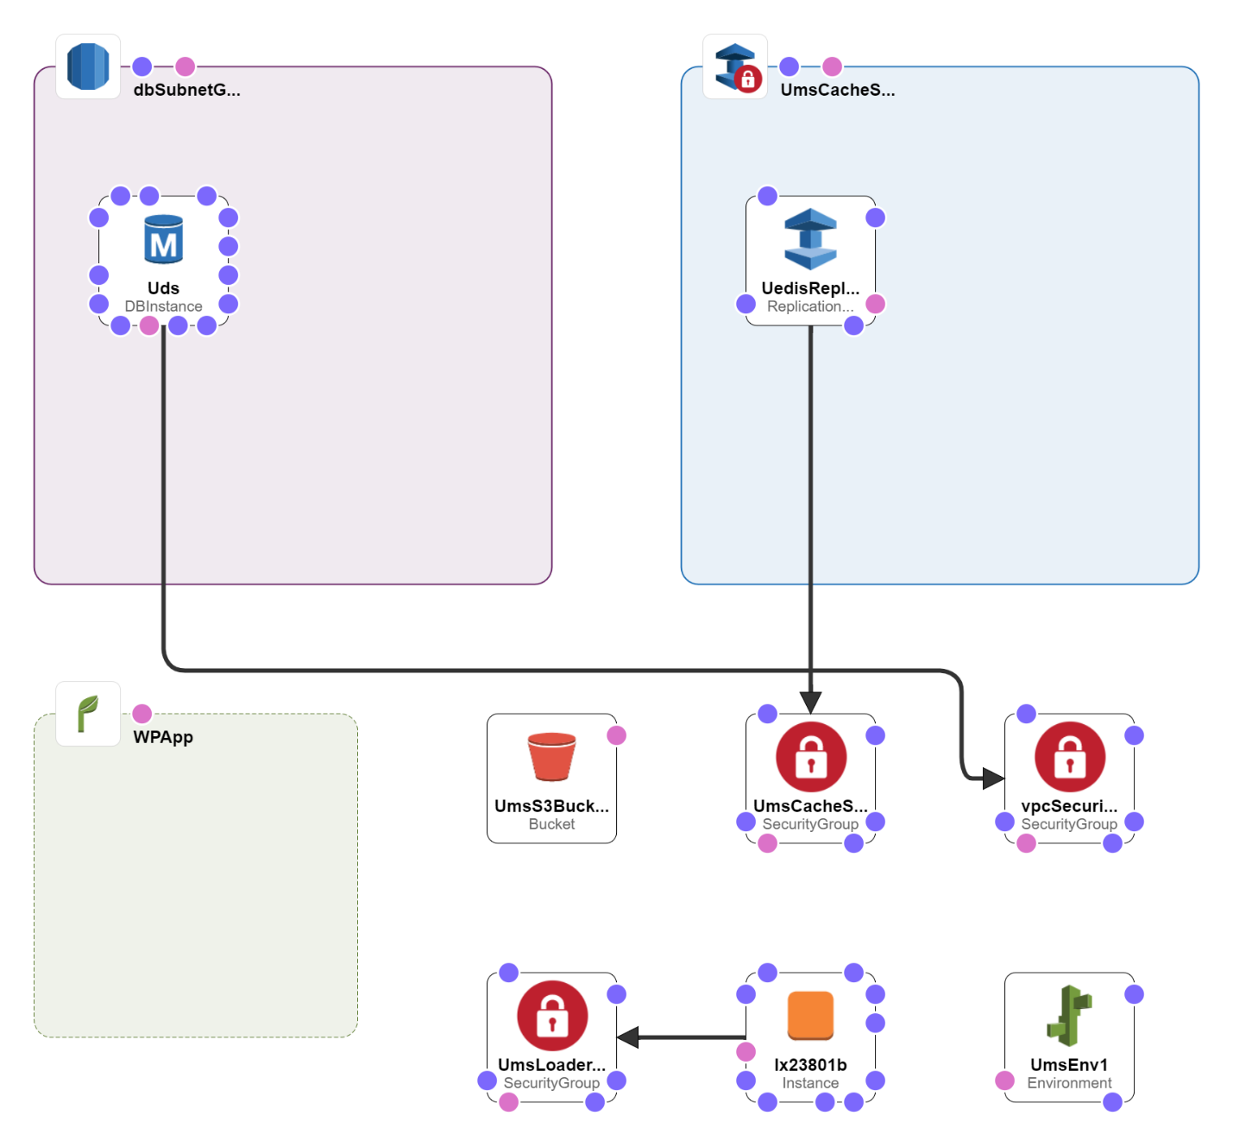

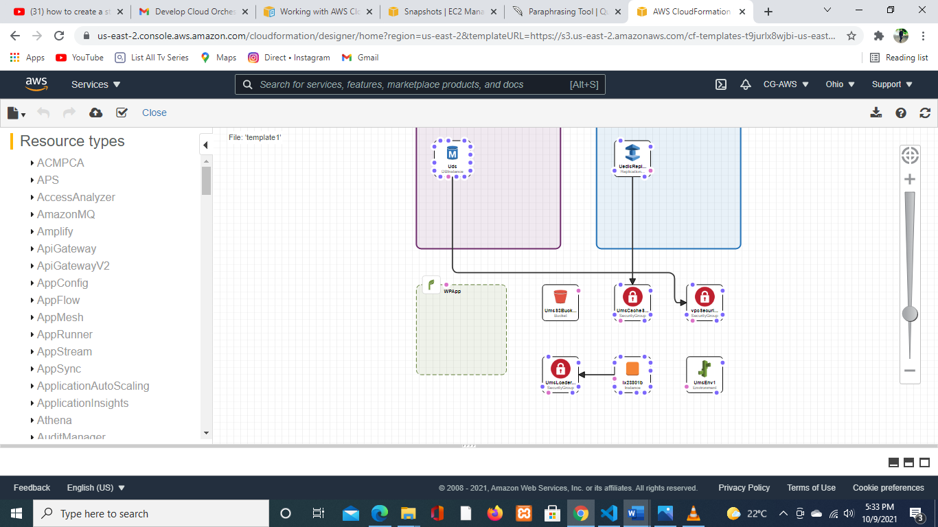

1. Create an Amazon RDS database instance.

Elastic Beanstalk does not terminate or monitor instances launched using Amazon RDS because they are fully independent of Elastic Beanstalk and your Elastic Beanstalk environments.

The Amazon RDS console will be used in the following steps:

Using the MySQL engine, create a database.

Make a Multi-AZ deployment possible. During system backups, this generates a standby in a different Availability Zone (AZ) to offer data redundancy, eliminate I/O freezes, and reduce latency spikes.

1. Create an Elastic Beanstalk environment via the Elastic Beanstalk console.
2. You can configure the environment to connect to the database after it has been launched, and then deploy the WordPress code to the environment.

Using the managed PHP platform, create an Elastic Beanstalk application.

Allow the default settings and sample code to be used.

to start a new environment (console)

The Elastic Beanstalk console should now be open.

Select the platform and platform branch that correspond to the language used by your application for Platform.

Choose Sample application for Application code.

Select Review and then Launch.

Examine the possibilities. Choose the available option you want to utilize, then click Create app when you're ready.

# 12.0 Recommendations

BallotOnline will be able to successfully integrate cloud orchestration and automation by following a set of suggestion principles. We'll concentrate on CloudFormation recommendations because it's the technology of choice for orchestration and automation at BallotOnline.

Any upgrades to BallotOnline's cloud infrastructure will be simple to manage and provision using CloudFormation because the core of the cloud architecture already incorporates best practices. Without cleaning up any current processes that do not follow best practices, cloud orchestration processes cannot be fully adopted.

Using IAM in CloudFormation is critical since it allows users to create, remove, and view stacks. Only the relevant BallotOnline workers should have access to make these changes.

It's critical to keep an eye on AWS Account Limits to ensure that the stacks can create all of the resources required without exceeding the dedicated limit. Otherwise, BallotOnline may face financial penalties.

Make templates that can be reused to duplicate stacks. The stacks can be changed when you construct them by including the parameters, mappings, and conditions sections.

Instead of embedding credentials in the template, use Dynamic References. Dynamic references are a simple and effective approach to refer to external values stored and handled by other services.

Validate templates before deploying them to catch syntax and some semantic errors, such as circular dependencies, before any resources are created.

Use AWS-Specific Parameter Types because this allows CloudFormation to quickly validate values for AWS-specific parameter types before creating your stack.

• Use CloudFormation to manage all stacks because a mismatch between your stack's template and the present state of your stack resources can result in issues if you update or delete thestack.

Before updating stacks, create changesets to confirm that the updates are compatible and have no impact on the infrastructure.

• Use stack policies to safeguard essential stack resources from unintentional updates, which might cause resources to be interrupted or replaced.

# 13 Conclusion

Finally, BallotOnline will tremendously benefit from adopting cloud orchestration to provision its cloud infrastructure. BallotOnline would be able to quickly deploy new systems and manage the interconnections and interactions across all IT infrastructure and apps using cloud orchestration. We can see how effortlessly it connects with all of the services provided by AWS, which is BallotOnline's cloud service provider of choice, by generating and deploying AWS CloudFormation templates for various use cases.

With the growing requirement for IT framework in Cloud formation, several open-source arrangements, such as AWS to provide IaaS, are gaining traction in academia and industry. Designers must deal with a variety of challenges when authorizing a minor modification in the code to confirm a bug fix without the use of a framework raise instrument. It's also difficult for a scientist to build up a cloud provisioning base for experimental purposes without adequate AWS knowledge. The proposed toolbox-based work approach aids analysts, as well as engineers, in quickly and efficiently implementing AWS-based cloud settings. cloud situations in a timely and efficient manner. It also assists professionals in dire and in-house evidence of idea organizations without having to worry about the finer points. It reduces manual efforts to a bare minimum while maintaining the consistency of the entire cycle, resulting in a response that is robotized and human error-free. Last but not least, it is used to set up demos in the academic section for trial purposes as well as to disseminate cutting-edge work in the distributed computing domain.

# 14 References

Amazon Web Services documents

<https://docs.aws.amazon.com/>

S. Dowell, A. Barreto, J. B. Michael, and M. T. Shing (2011, June). Interoperability between clouds. The 6th International Conference on System of Systems Engineering was held in 2011. (pp. 258-263). IEEE.

S. V. Gogouvitis, H. Mueller, S. Premnadh, A. Seitz, and B. Bruegge (2018). Container orchestration allows for seamless computing in industrial systems. Generations to Come

System of Computers.P. Kumar, V. Rangasamy, J. Jeyapaul, and B. J. Lillie (2018). Patent No. 10,129,078 issued by the United States of America. The United States Patent and Trademark Office is located in Washington, DC.

A. Qadeer, A. Waqar Malik, A. Ur Rahman, H. Mian Muhammad, A. Ahmad, A. Qadeer, A. Waqar Malik, A. Ur Rahman, A. Ur Rahman, A. Ur Rahman, A. Ur Rahman, A. Ur Rahman, A. Ur Rahman (2020). For the deployment of cloud services, virtual infrastructure orchestration is used. The Computer Journal, vol. 63, no. 2, pp. 295-307.

R. Lovas (2015). For crowd computing, orchestrated service deployment, maintenance, and debugging in IaaS clouds.

R. Ranjan, B. Benatallah, S. Dustdar, and M. P. Papazoglou (2015). Overview, challenges, and future perspectives for cloud resource orchestration programming. IEEE Internet Computing, vol. 19, no. 5, pp. 46-56