Research Component

Mosca’s Theorem X+Y > Z where X is Data Shelf Life, Y is migration time and Z is time for a CRQC to become available.

For the mentioned example. X (Data shelf life) is 30 years, Y (migration timeline) can be within 3 to 5 years. As for CRQC availability, most estimates put at 2030 or by 2033-2035^{[1]}. So Z can be from 5 to 10 years.

Migration deadline
30 + 3 > 10 OR 30+5 > 5
This makes it a critical risk, migration should begin immediately.

For best case scenario, assuming that Z=10, while Y=3, then migration can start by 2032, however this doesn’t take into consideration HNDL attacks.

As for worst case scenario, assuming Z=5, while Y=5, then data is already at risk since migration should have started at 2025.

[1] https://postquantum.com/post-quantum/crqc/#timeline-for-crqc-realization

Project Component

CBOM for a simple web application

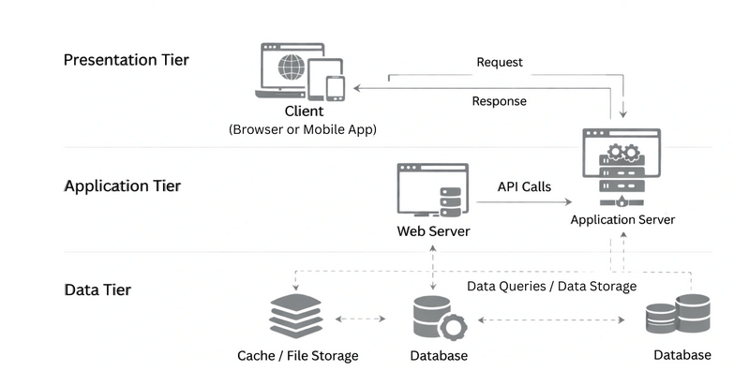

CBOM

Component | Crypto Algorithm | Library/Tool Used | Key Length  Cert Type | Protocol | PQC Readiness | Immediate Action  Needed
Web Server (Apache HTTP server2.2) | ECDHE-RSA-AES256-GCM-SHA384 | OpenSSL 1.0 | RSA 2048-bit cert | TLS 1.2 | Not Ready | - Upgrade Apache HTTP server to 2.4  - Upgrade to OpenSSL 3.5, disable TLS 1.1
Application Server (JBoss) | RSA256 (RSA + SHA256) | Java | RSA 2048-bit | HTTPS | Not Ready | Prepare for PQC
Database | AES-128 | Built-in DB encryption | 128-bit | Local Encryption | No | Upgrade to AES-256
File Storage /Cache | AES-256 | N/A | 256-bit | Local | N/A | Rotate keys

Migration Plan

Task | Action | Complexity | Status
Update Database | Upgrade Crypto Algorithm from AES-128 to AES-256 | Simple | Can be Initiated
Update Web server | Upgrade web server to latest version for example apache 2.4 using openssl 3.5 | Medium | Can be Initiated
 | Upgrade Keys and Certificates to use PostQuantum or Hybrid Algorithms | Complex | Can be Initiated
Update Application Server | Monitor Redhat announcements to verify once Jboss supports PQC algorithms | Complex | Pending

