Association Organizational Chart
Shoe Association — Executive Leadership, Administrative Staff, Member Factories, and Workshop Trades
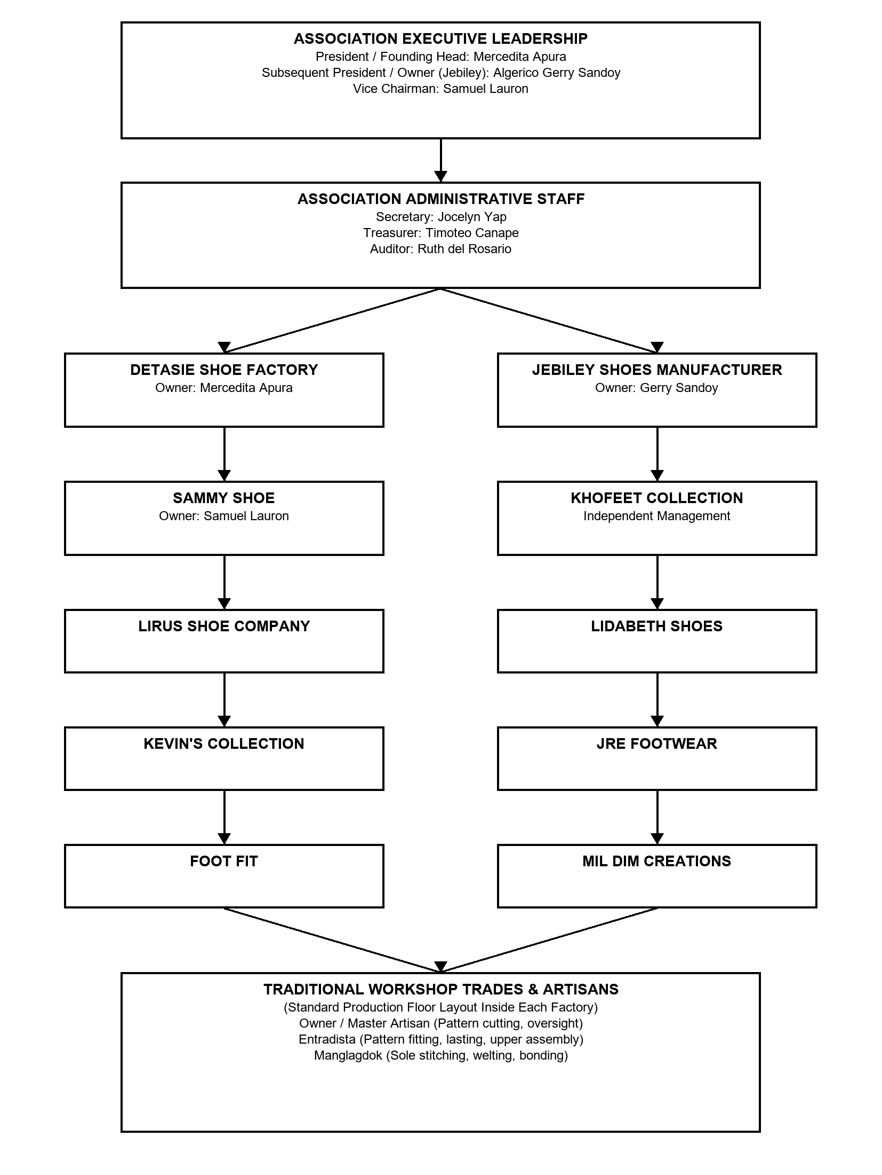

Structure (text version)
- ASSOCIATION EXECUTIVE LEADERSHIP
- President / Founding Head: Mercedita Apura
- Subsequent President / Owner (Jebiley): Algerico Gerry Sandoy
- Vice Chairman: Samuel Lauron
- ASSOCIATION ADMINISTRATIVE STAFF
- Secretary: Jocelyn Yap
- Treasurer: Timoteo Canape
- Auditor: Ruth del Rosario
- DETASIE SHOE FACTORY
- Owner: Mercedita Apura
- JEBILEY SHOES MANUFACTURER
- Owner: Gerry Sandoy
- SAMMY SHOE
- Owner: Samuel Lauron
- KHOFEET COLLECTION
- Independent Management
- LIRUS SHOE COMPANY
- LIDABETH SHOES
- KEVIN'S COLLECTION
- JRE FOOTWEAR
- FOOT FIT
- MIL DIM CREATIONS
- TRADITIONAL WORKSHOP TRADES & ARTISANS
- (Standard Production Floor Layout Inside Each Factory)
- Owner / Master Artisan (Pattern cutting, oversight)
- Entradista (Pattern fitting, lasting, upper assembly)
- Manglagdok (Sole stitching, welting, bonding)
Source: docs/diagrams/org-chart.drawio (open in draw.io / app.diagrams.net to edit).

