House# R470, Sec 7-D/2,North Karahi, Karachi,
Pakistan. 75850.
Mobile #:+ 92-345-2081626
+92-323-2081626
E-mail: junaid.usman@live.com
https://sa.linkedin.com/in/junaid-usman-2a165733

Objective
Desire to become a team member of a reputable driven Organization that will utilize and enhance my strong analytical and problem solving abilities and career growth.

Qualification

MBA (Master in business administration) 2009-2011
Master’s in Business Administration in MIS from Pakistan Air Force Karachi Institute of Economics & Technology
(PAF-KIET)

BS (Computer science) 2003-2007
Bachelor’s of Computer Science from Federal Urdu University.

Intermediate (H.S.C) 2000-2002
Intermediate from Govt Degree College
Specialties
- Oracle Fusion HCM Implementation/Support
- Oracle Core-HR Implementation
- Oracle Payroll Implementation.
- Oracle Self Service Implementation.
- Oracle Absence Management Implementation
- Oracle Time & Labor Implementation.
- Oracle Performance Management Implementation.
- Oracle Learning Management Implementation.
- Oracle Forms Development (HCM,SCM and Financial)
- Oracle Reports Development (HCM,SCM and Financial)
- Data Migration & Integration
- Forms Personalization
- Customization Forms for Oracle EBS 11i,R12
- Oracle API's / Open Interfaces
- Oracle SQL / PL/SQL
- Oracle BI Publisher
- Oracle XML Publisher
- Oracle Alerts
- Oracle Database 9i,10g,11g
- Oracle Workflow

Experience

iAMPLIFY consulting Solutions Pvt(Ltd)
Working as AM-IT Oracle Fusion HCM Team Lead from Nov-2018 to till date.

INFOTECHGROUP pRIVATE lIMITED
Worked as Sr.Oracle SCM Techno-Functional Consultant from Dec-2014 to Oct-2018.

JaFFER BUSINESS SYSTEM (division of Jaffer broters pvt ltd.)
Worked as Sr.Tecno-Functional Consultant from Jan-2008 to Nov-2014.
Projects:
Dubai Islamic Bank  Oracle HCM Functional & Technical Support  Modules (Core-HR, Payroll, OLM, Self-Service, i-recruitment, OPM, i-expense) | iACS | 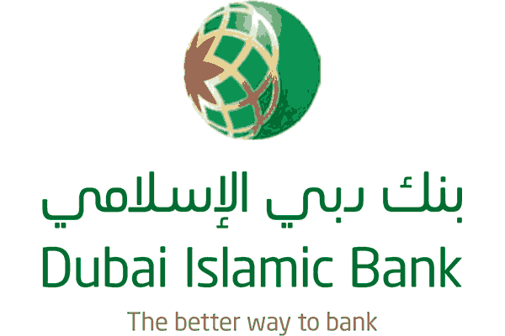
State Bank Of Pakistan  Worked as Project Manager and HCM Team Lead.  Oracle Application and Database upgrade from 11i to R12.2.8  Modules (AP,PO,INV,GL,,FA,CM) and Integration with Custom Applications | iACS | 
Meezan Bank Limited (MBL) –Upgrade & Support On going Project  Oracle Database and Application Upgrade Project and support.  Modules (HR,Payroll,Self-Service) and Integration with Custom Applications | iACS | 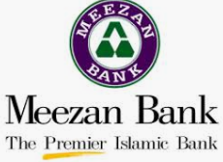
Faysal Bank Limited (FBL) – On going Support  Functional and Technical Support of Oracle HCM ,SCM and Financtial Modules Modules | iACS | 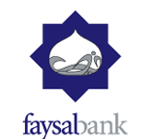
Pakistan International Airline (PIA)  Implementation of Oracle HCM,SCM & Financial and Support. | INFOTECH | 
Obeikan Investment Group (Onsite Saudi Arabia)  (2015 to 2016)  Implementation of Oracle (HRMS ,Payroll, Self-service, Absence Management and Oracle Time & Labor) | INFOTECH | 
Obeikan Investment Group (SIG Combiblock –Onsite Dubai)  Implementation of Oracle HCM (HRMS ,Payroll, Self-service and Oracle Time & Labor) | INFOTECH | 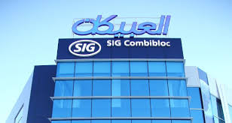
Saleh & Abdul Aziz Abahsain Co. LTD (SAUDI-ARABIA) (2013-2014)  Online Techno-Functional support Oracle EBS 12.1.2 (SCM & Financial). | Jaffer Brothers | 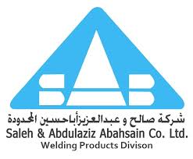
SriLanka Airline Project (SriLanka)  Implementation of Oracle EBS R12.1.2. SCM and Financial.Integration with custom applications. | Jaffer Brothers | 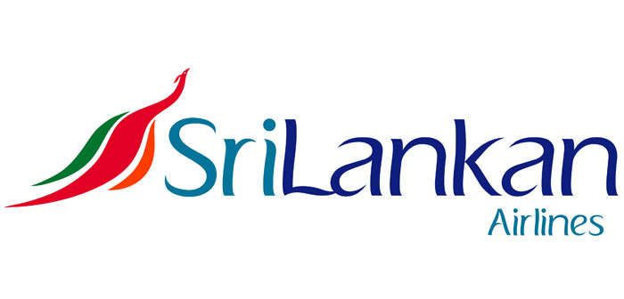
Al-Mutlaq Group (SAUDI-ARABIA) (2012-2013)  Oracle EBS 11i to R12.1.3 upgrade project. | Jaffer Brothers | 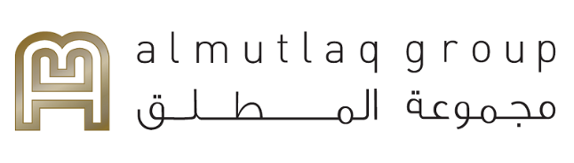
Jaffer Brothers (PVT) LTD (R12 Upgrade Project)  Upgrade Oracle EBS 11i to R12. | Jaffer Brothers | 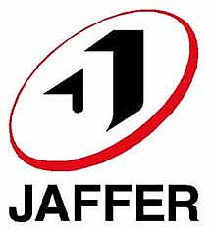
Shirazi Trading Company (PVT) LTD (2011)  Implementation of Oracle EBS R12.1.2, SCM, Financial and LCM Modules. | Jaffer Brothers | 
Greenstar Social Marketing Pakistan (Guarantee) Limited (2011)  Implementation of Oracle EBS 11i , SCM and Discrete Manufacturing. | Jaffer Brothers | 
Civil Aviation Authority Pakistan (2010)  Implementation of Oracle EBS R12 , SCM and Financial. | Jaffer Brothers | 
Pak-Arab Pipe Line (PAPCO)  Implementation of Oracle EBS R12 , SCM and Financial. | Jaffer Brothers | 
Dr. Ziauddin Hospital (2008-2010)  Implementation of Oracle EBS 11i , SCM ,Financial ,Custom development of Pharmacy and Laboratory System. | Jaffer Brothers | 
HINOPAK MOTORS LIMITED  Oracle EBS Technical Support. | Jaffer Brothers | 
Engro Polymer & Chemicals  Oracle EBS Technical Support. | Jaffer Brothers | 

Computer Literacy
Language  - C/C++  - PL/SQL  - Visual C #.Net  - HTML/Java Script | Oracle tools  - Oracle Developer 6i,9i,10g  - PL/SQL Developer  - Toad  - XML Publisher/BI Publisher
database  Oracle 9i,10g,11i , 11.1.0.7.0  SQL Server 2000  Microsoft Access | oracle APPLICATION  Oracle 11i r10 & r12 (E-Business Suit), R12.1.3  Modules (OM, INV, AR, AP,PO,GL,FA,BOM),CRM,HCM
Operating systems  - Windows 7  - Windows Vista Ultimate/XP/2007/Me/98 SE | Office Software  - Ms Office Word 2010/2007/XP/2003/97  - Ms Office Excel 2010/2007/XP/2003/97  - Ms Office Access 2010/2007/XP/2003/97  - Ms Office Power Point 2010/2007/XP/2003/97

Major Courses
- Financial Management.
- Managerial & Cost Accounting.
- Strategic Management.
- Method of Business Research.

Personal Information
- Father’s Name : Muhammad Usman (Late)
- Date of Birth : : 15TH Apr 1984
- Religion : Islam
- Marital Status : Married
- Nationality : Pakistani
- Domicile : Karachi ,Sind(U)
- C.N.I.C. # : 42101-3987816-1

