SRIVITTAL VANAMALA Email:srivittal.vanamala@gmail.com
Associate Manager- FICO / S4 HANA FINANCE (Certified)
Mobile: +91 9849981178
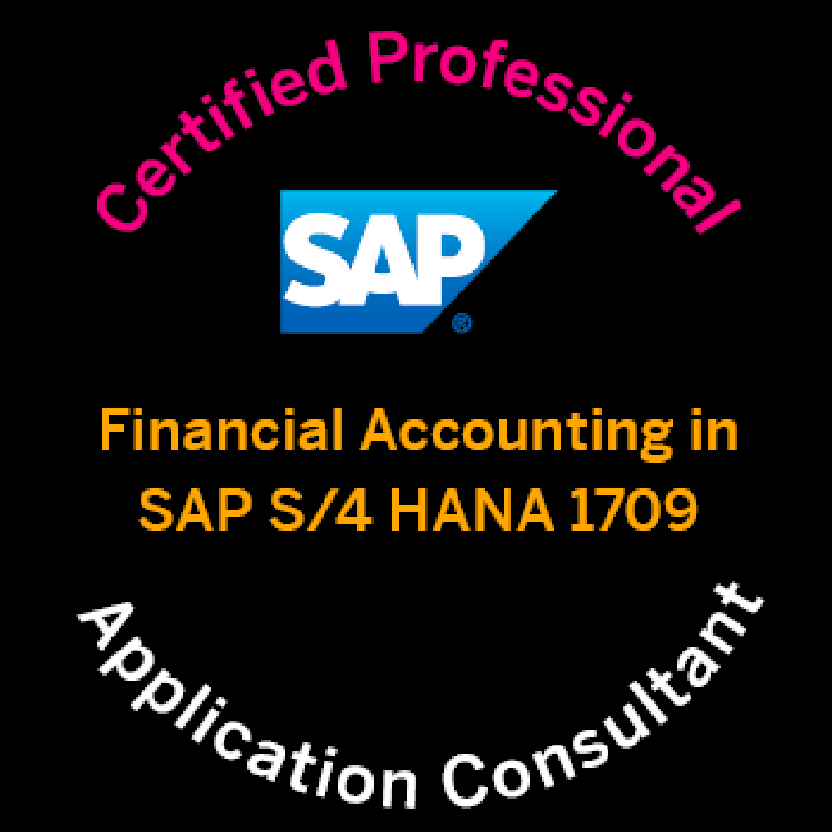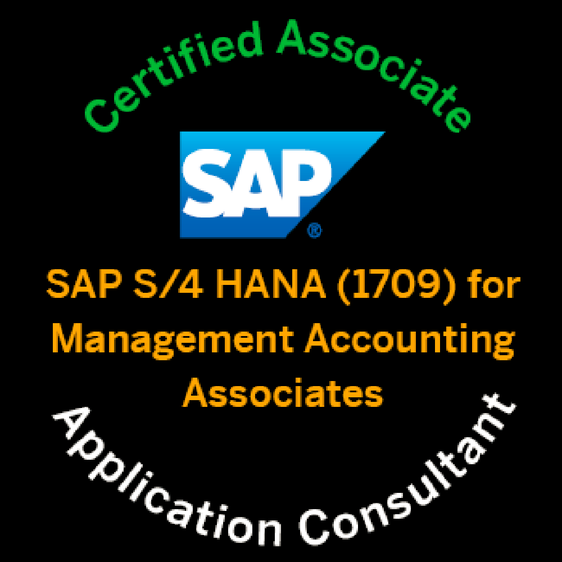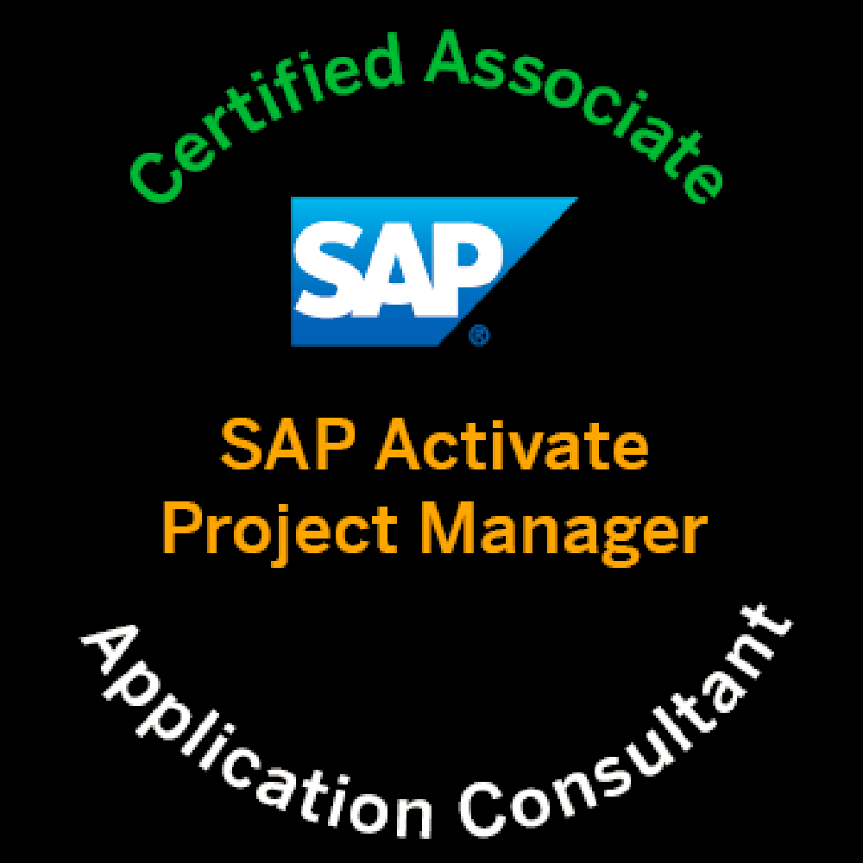

Srivittal Vanamala working as Associate Manager. I have 18 years of overall experience and 13 years in SAP FICO, S/4 HANA Finance in implementing the finance solution to the client in various industries from SAP version 4.6C, also Involved in implementation of Central finance 1809 in testing the business processes and have done 6+ Implementations, 2 Rollouts and supported business processes after go-Live with 5 years of Strong domain experience in accounting service industry.

PROFILE SUMMARY:

- 13 plus years of experience in SAP FI/CO and SAP HANA Finance delivery for an implementation project.
- Worked in Agile Methodology in implementing the S/4 HANA FINANCE projects as a lead and ASAP methodology in implementing projects till ECC.
- Worked with the client in client location CANADA in designing the org / Reporting structure in Finance.
- Involved in pre-sales to provide effort estimations for Finance and controlling business process.
- Provided training on S/4 HANA Finance to scale up the team to work on the implementation projects.

Work experience involved:

- SAP Financials & Controlling modules FI-GL, FI-AP, FI-AR, Asset Accounting, COPC and COPA and Integration with MM & SD
- Project Systems, WBS Elements, Status Profile, Planning Profile, Budget Profile and Settlement Profile
- Integration between SAP & other external tools ARIBA, Concur (Employee expense), VERTEX and INNOWERA.
- Maintained EDI settings for intercompany supported Functional Specifications for inbound and outbound files.
- Tools used for supporting the implementations/Testing/ Project delivery / Documentation HPQC, REMEDY, SERVICE MANAGER, PEREGRINE
- Implemented several SAP NOTES in fixing the issues in several business process as part of early deployment of Simple Finance/S4 HANA Finance
- Handled regression release test schedules.
- Involved in Financial Closing Cockpit Template configuration.
- Experience in Central Finance.
- Involved in RPA (Robotic Process Automation) for Jobs Monitoring.

EMPLOYMENT HISTORY:

Company | Role | Duration
Accenture – Hyderabad | Associate Manager – SAP S4 Hana Finance. | April 2021 to Till Date
Kagool – Hyderabad | Senior FI/CO Consultant. | May 2020 to April 2021
Deloitte – Hyderabad | S/4 HANA FI/CO Lead / Sr. Consultant. | Sep 2019 to May 2020
Capgemini – Hyderabad | S/4 HANA FI/CO Consultant /Lead / Manager. | July 2010 to Sep 2019
Heritage Foods – Hyderabad | SAP FI/CO Lead. | Nov 2009 to June 2010.
CSC (Computer Science Corporation) PVT Ltd – Hyderabad | SAP FI/CO Consultant. | May 2008 To Nov 2008.
SLK Marketing - Hyderabad | Accounts Manager. | May 2006 To Apr 2008
Franklin Templeton (India) PVT Ltd – Hyderabad | Process Associate. | Apr 2005 to Apr 2006.
WebHelp Global Services PVT Ltd – Hyderabad | Accountant Executive. | Apr 2003 to Dec 2004

EDUCATION QUALIFICATION:

- Master’s in business administration from Symbiosis University in 2002
- Bachelor of Commerce from Osmania University, Hyderabad in 1999

SAP Projects details:

Project # 8

Duration : From January 2022 to till date
Organization : Accenture
Client : Bookings.com
Project : Implementation
Environment : S/4 Hana Finance 2020
Role : SAP FI/CO – Associate Manager.

Company Profile:
Booking.com was formed when Bookings.nl, founded in 1996 by Geert-Jan Bruinsma, merged in 2000 with Bookings Online, founded by Sicco and Alec Behrens, Marijn Muyser and Bas Lemmens, which operated as Bookings.org. The name and URL were changed to Booking.com and Stef Noorden was appointed as its CEO. In 1997, Bruinsma wanted to post an ad in De Telegraaf, the Dutch newspaper with the highest circulation. The ad was rejected since De Telegraaf only accepted ads with a phone number, not with a website. In 2002, Expedia refused to buy bookings.nl.
In July 2005, the company was acquired by Priceline Group (now called Booking Holdings) for $133 million, and later it cooperated with ActiveHotels.com, a European online hotel reservation company, purchased by Priceline Group 9 months earlier for $161 million in Sept 2004.

Roles and Responsibilities:

- Involved in implementation of S/4 HANA Finance – G/L and Asset Accounting Module.
- Involved in FDD (Functional Design Document) & FSD – (Functional Specification Document).
- Build FI -GL, AP, AR, House Bank & Asset Accounting and CO– Cost Center Accounting, And Internal Order Accounting & Profit Center Accounting, PS, and IM Modules
- Prepared the configuration documents, Test cases, Handled business process testing.
- Prepared the document on the issues faced in the configuration and Testing the scenarios and placed it in the share folder for future reference.
- Involved in FI Workflow documents and Asset Retirement workflows.
- Implemented several SAP notes in fixing the issues in Business processes.

Project # 7

Duration : From April 2021 to December 2021
Organization : Accenture
Client : Phillips 66
Project : Support
Environment : S/4 Hana Finance 1709
Role : SAP FI/CO – Associate Manager.

Company Profile:

The Phillips66 American multinational energy company headquartered
in Westchase, Houston, Texas. It debuted as an independent energy company when ConocoPhillips executed a spin-off of its downstream and midstream assets. Its name dating back to 1927 as a trademark of the Phillips Petroleum Company, the newly-reconfigured Phillips 66 began trading on the New York Stock Exchange on May 1, 2012, under the ticker PSX. The company is engaged in producing natural gas liquids (NGL) and petrochemicals. The company has approximately 14,000 employees worldwide and is active in more than 65 countries.[5] Phillips 66 is ranked No. 23 on the Fortune 500 list and No. 67 on the Fortune Global 500 list as of 2018.

Roles and Responsibilities:

- Leading the Support Team for SAP FI/CO Module.
- Giving day-to-day support for any SAP FI/CO issues.
- Preparing Incident Status Report Daily.
- Preparing Consolidation Incident Status Report monthly to the client.
- Monitoring/Solving the tickets with in SLA.
- Receiving and documenting the SAP problems reported in FI/CO
- Assisting users in functional navigation & functional understanding.
- Root cause Analysis and resolving the issues.
- Status reporting on Issues resolved & pending.
- Supporting Enhancement Team.
- Communicate with the Onsite Team on the daily calls on the Action Items.

Project # 6

Duration : From May 2020 to April 2021
Organization : Kagool Data Private Limited
Client : Smiths Detection
Project : Enhancement
Environment : SAP ECC 6.0
Role : SAP FI/CO Senior Consultant

Company Profile:

Smith’s Detection is a global leader in detection and screening technologies for the protection of people and assets, supporting safety, security and freedom of movement in today’s world.
We work with customers in a broad range of markets including aviation, ports & borders, defense and urban security, providing complete solutions that address existing and emerging threats.
Smith’s Detections reputation is underpinned by extensive experience, differentiated technology, and a strong track record of success.

Roles and Responsibilities:

- Involved on Integration between third party system Concur and SAP System for Inbound and Outbound files through middleware MuleSoft.
- SAP to Concur Integration for Outbound files of WBS and Service Orders.
- Concur to SAP Integration for Inbound files of Employee Expenses file.
- Involved on the Workflow process on FB60 invoices postings.
- Involved on the Workflow process of Scheduling Automatic Payment Program – F110S.
- Implemented TCS tax compliance for the Smiths Indian Company Code.
- Involved in Implementation and Integration - GST e-invoice with GSP government Portal for the Smiths Indian Company Code.
- Worked on Kagool Product - Velocity (The Velocity is the tool through which we can extract the data from SAP-to-SAP System or Non-SAP to SAP System).
- Prepared the FSDs and involved in the Unit Testing, SIT and UAT.

Project # 5

Duration : From September 2019 to May 2020
Organization : Deloitte India Private Limited
Client : Google
Project : Central Finance 1809 Implementation
Environment : SAP S/4HANA Finance
Role : SAP S/4 HANA Finance Senior Consultant

Company Profile:

Google LLC is an American multinational technology company that specializes in Internet-related services and products, which include online advertising technologies, search engine, cloud computing, software, and hardware. It is considered one of the Big Four technology companies, alongside Amazon, Apple, and Facebook .

Roles and Responsibilities:

- Document Validation and Balance Validation after initial load.
- Execute End to End Inter Company Scenarios from source to Cfin System.
- Error handling via AIF in execution process.
- Triggering COBK and AUFK posting.
- Maintaining missing key mappings for scenarios in Cfin System.
- Configuration Changes.
- Fix Defects and rerun postings.
- Implement SAP Notes.
- Preparing the FSD’s for the requirements.
- Testing the Custom Reports.

Project # 4

Duration : From April 2016 to September 2019
Organization : Capgemini India Private Limited
Client : Meijer (US)
Project : Green field implementation / Support
Environment : SAP S/4HANA Finance
Role : SAP FICO Consultant / Manager (Present)

Company Profile:

Meijer, Inc. is a regional American supercenter chain with its corporate headquarters in Walker, Michigan. Founded in 1934 as a supermarket chain, Meijer is credited with pioneering the modern supercenter concept in 1962. About half of the company's 200 stores are located in Michigan's Lower Peninsula, with additional locations in Illinois, Indiana, Ohio, Wisconsin, and Kentucky. Meijer is the 26th-largest retailer in the United States.

Roles and Responsibilities:

- Leading the CR Team - SAP FI/CO, PS, and IM modules.
- Implemented S/4 Hana, Involved in preparation of Business Blueprint.
- Involved in FDD (Functional Design Document) & FSD - Functional Specification Document.
- Build FI -GL, AP, AR, House Bank & Asset Accounting and CO, Cost Center Accounting and Internal Order Accounting & Profit Center Accounting, PS, and IM Modules
- Prepared the configuration documents, Test cases, Handled business process testing.
- Prepared the document on the issues faced in the configuration and testing the scenarios and placed it in the share folder for future reference.
- Involved in Workflow Parking document testing using SAP FIORI
- Implemented several SAP notes in fixing the issues in Business processes.

Project #3

Duration : From June 2010 to April 2016
Organization : Capgemini India Private Limited
Client : Royal Bank of Canada (Canada and US)
Project : Support and Enhancement
Environment : SAP ECC 6.0
Role : SAP FICO Consultant

Company Profile:

The Royal Bank of Canada (RBC) is the largest bank in Canada. The bank serves over 16 million clients and has 78,000 employees worldwide. The company corporate headquarters are located in Toronto, Ontario. The bank was founded in 1864 in Halifax, Nova Scotia. RBC's Institution Number (or bank number) is 003.

Roles and Responsibilities:

- Worked in L2 & L3 support and Enhancements (CR team – Change Request).
- Implemented CR on Leased assets – Integrated with third party systems like JLL & CBRE.
- Involved in preparing the Functional Specifications for inbound and outbound files.
- Handled regression schedules along with responsible for Finance for testing.
- Configured WBS master data and tested both inbound and outbound files.
- Responsible for the document review – FDD, Training documents
- Responsible for change control within Finance on modification of the existing programs.

Project #2

Duration : From November 2009 to June 2010.
Organization : Capgemini India Private Limited
Client : Heritage Foods India PVT LTD.
Project : Implementation
Environment : SAP ECC 6.0
Role : SAP FICO Consultant

Company Profile:

The Heritage Group, founded in 1992 by Sri Nara Chandra Babu Naidu, is one of the fastest growing Private Sector Enterprises in India, with three-business divisions viz., Dairy, Retail, Bakery and Agri under its flagship Company Heritage Foods (India) Limited (HFIL), one infrastructure subsidiary - Heritage Infra Developers Limited and other associate Companies viz., Heritage Fin lease Limited, Heritage International Limited and Heritage Agro Merine Private Limited. The annual turnover of Heritage Foods crossed Rs.347crores in 2006-07 and is aiming for Rs.700crores during 2007-08 headquarters in Hyderabad Andhra Pradesh.

Roles and Responsibilities:

- Comprehensive understanding, forecasting & conducting gap-analysis on the business process.
- Implemented FI sub modules: New G/L, AR, AP, Bank Accounting (EBS) and AA.
- Implemented CO sub modules, Cost Element Accounting, Cost Center Accounting, Internal Orders, Profit Center Accounting and product costing, COPA, and Material Ledger.
- Prepared Functional specifications for RICEF objects.
- Responsible for testing the SAP FI/CO Module for zero defects/errors during pre & Post implementation and addressing the pain points during the implementation.
- Providing Post-Implementation Support.
- Effective integration of SAP FI/CO Module and testing end to end Operations.
- Imparting training to the end users and preparing training material.

Project #1

Duration : From May 2008 to November 2008
Organization : CSC
Client : Delphi
Project : Rollout Project
Environment : SAP ECC 6.0
Role : SAP FICO Consultant

Company Profile:

Delphi is a leading global supplier of mobile electronics and transportation systems, including powertrain, safety, steering, thermal, and controls & security systems, electrical/electronic architecture, and in-car entertainment technologies. Engineered to meet and exceed the rigorous standards of the automotive industry, Delphi technology is also found in computing, communications, consumer electronics, energy and medical applications.

Headquartered in Troy, Mich., Delphi has approximately 169,500 employees and operates 156 wholly
owned manufacturing sites in 34 countries with sales of $22.3 billion in 2007.

Roles and Responsibilities:

As a Team member worked in the project Rollout. The scope of work would involve Configuration, data migration, Unit testing, integration testing and documentation of the same, documentation of end user training procedures and preparation of training manuals and functional troubleshooting.

- Define Account Determination, Screen layout rules and Asset classes.
- Creation of Depreciation Areas and Depreciation Keys
- Making setting for Asset purchase
- Mass Retirement and Reload/Reacquisition of Assets through Worklist
- Recalculate Depreciation and Validate new depreciation areas.
- Asset sale, setting for loss/gain.
- Acquisition of Low value assets
- Settlement Rule - Modify asset for the settlement rules.
- Asset Retirement, Transfer of Assets
- Revaluation of Assets
- Validations Reports for Business
- Rectified the business issues.
- Solved out the solutions for the validation business process.
- Create the AUC Assets though Internal Orders settle to Main Asset.
- Involved in Mock Cutover, where validations will be done on the processed mock Cutover data.
- Resolving the tickets related to Product Costing and CO-PA

NON-SAP EXPERIENCE SUMMARY:

Company #3

Duration : April 2006 to May 2008
Organization : SLK Marketing
Designation : Accounts Manager
Environment : Tally
Location : Hyderabad

Roles and Responsibilities:

- Operate as the point of contact for all matters specific to your customers.
- Build and maintain strong, long-lasting customer relationships.
- Clearly communicate the progress of monthly/quarterly initiatives to the Management.
- Preparation of Accounts Payable and Receivable Statements every week
- Interacting with Vendors and Customers for Outgoing and Incoming Payments
- Preparation of BRS and Passing the required entries.
- Generating of MIS reports
- Analyzing of Financial Statements
- Verifying Ledgers and other subsidiary books
- Supervising the maintenance of Stock reports

Company #2

Duration : From April 2005 to April 2006
Organization : Franklin Templeton (INDIA) PVT LTD.
Designation : Process Associate
Location : Hyderabad

Roles and Responsibilities:

- Checking complex financial transactions.
- Checking financial & non-financial transactions.
- Re-indexing documents to correct department.
- Interaction with customer service outbound team.
- Interaction with authorization desk team.
- Giving feedback to the Processors.
- Good Order Review (Determine- if all required information is on the request).
Checking another - processors work for accuracy and completeness

Company #1

Duration : From April 2003 to Dec 2004
Organization : Webhelp Global Services PVT LTD
Designation : Accounts Executive
Location : Hyderabad

Roles and Responsibilities:

- Maintenance of GL Records.
- Bookkeeping and General Ledger Maintenance.
- Preparation of Trail Balance sheets and Final Accounts.
- Preparation of weekly reports and monthly financial status of the unit.
- Finalization of the Accounts at Monthly, Quarterly and Yearly basis.

