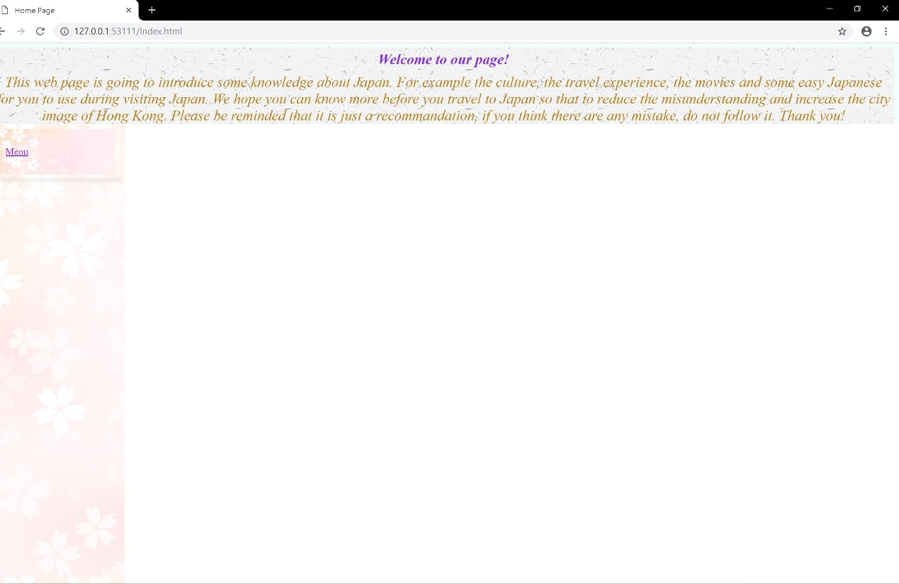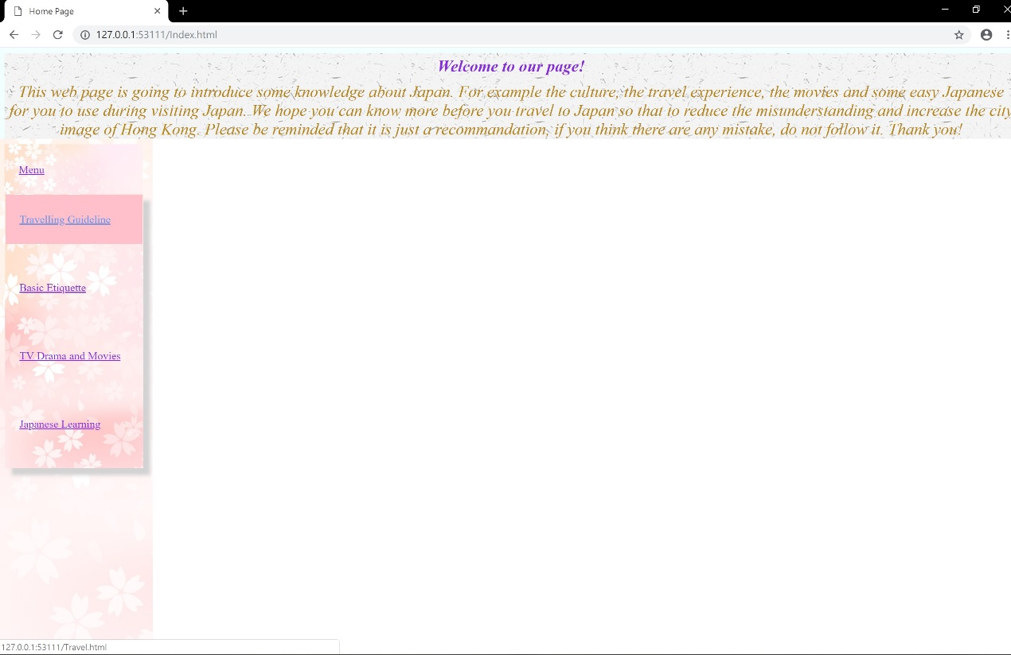

In the index page, frameset is used to separate the page into 3 part. The first part is the welcome speech and the second part is the menu, the third part is the content. When the menu list is drop down and the mouse touch the choice, the word will change from violet to lightskyblue color and the box is change to lightpink color.

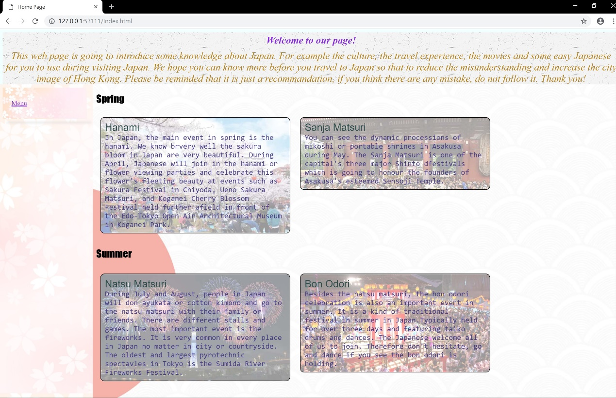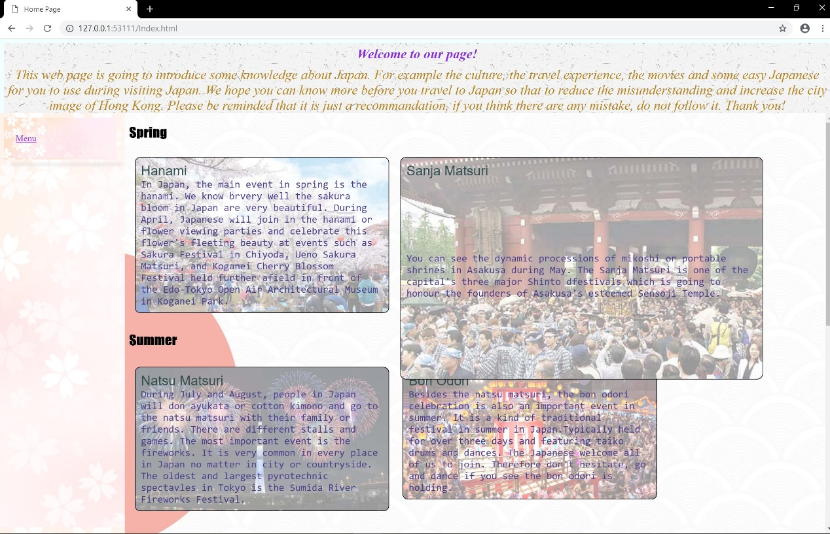

In the travel page, the font family of fantasy is used in the header. The pictures of the activities are used for the background image of the box. When the mouse touch the box, it’s width will enlarge to 50%.

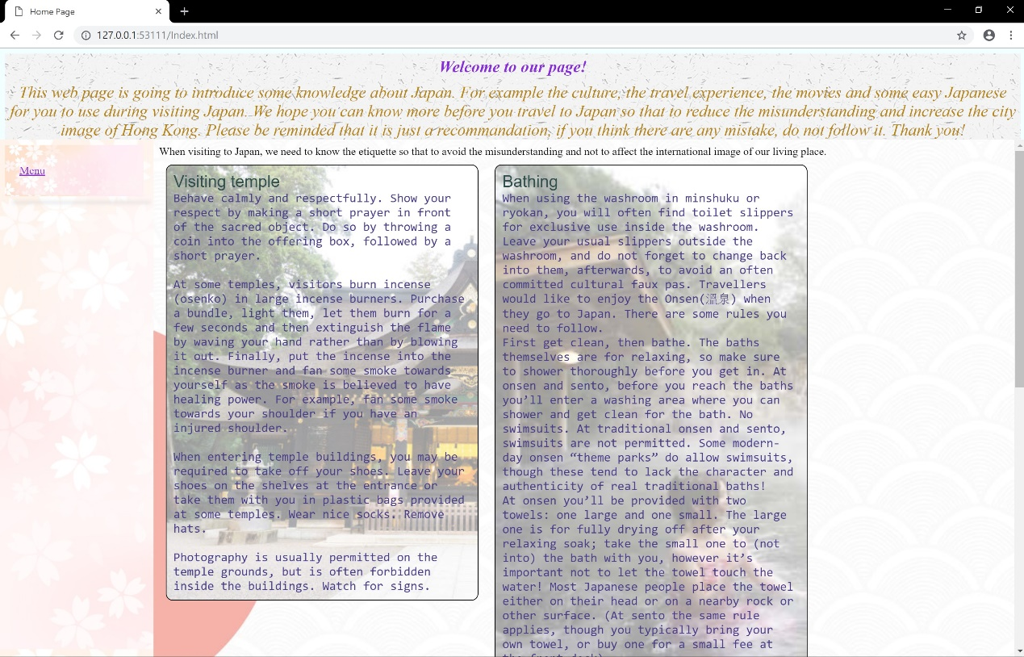

The page has used the media query. When the width of the screen is larger than 1200px, the screen will like the above picture. The width of the box will be 35%.

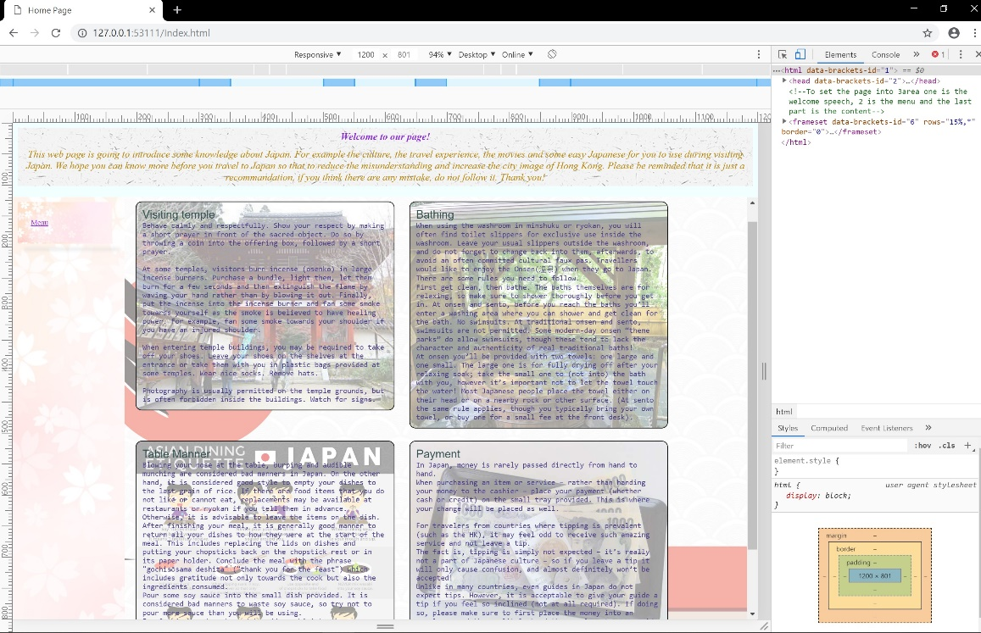

When the width of the screen is less than or equal to 1200px, the screen will like the above picture. The width of the box will be 40%.

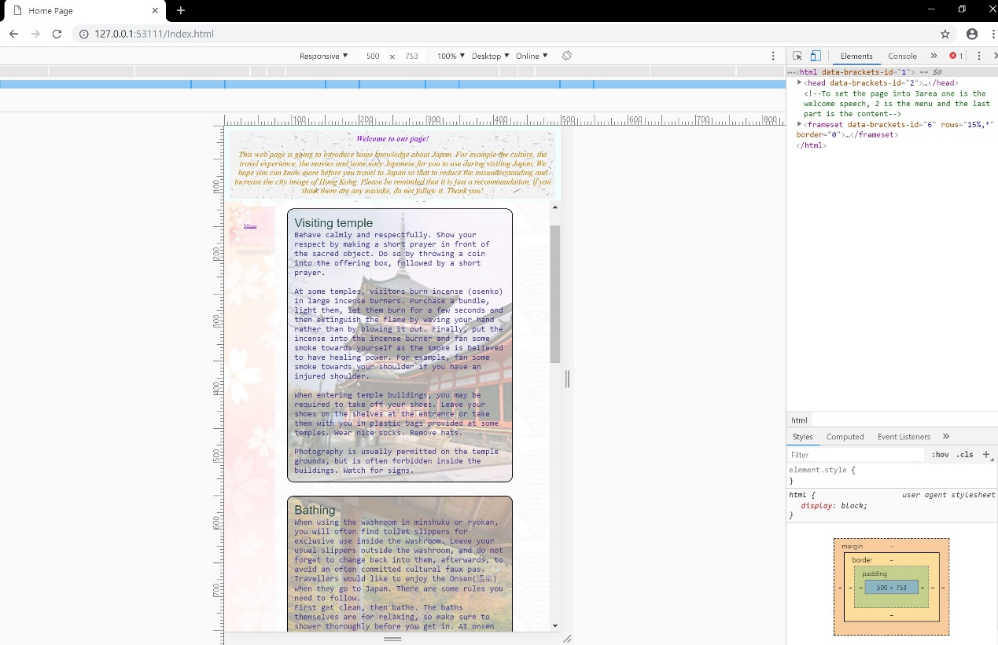

When the width of the screen is larger than 500px, the screen will like the above picture. The width of the box will be 80%.

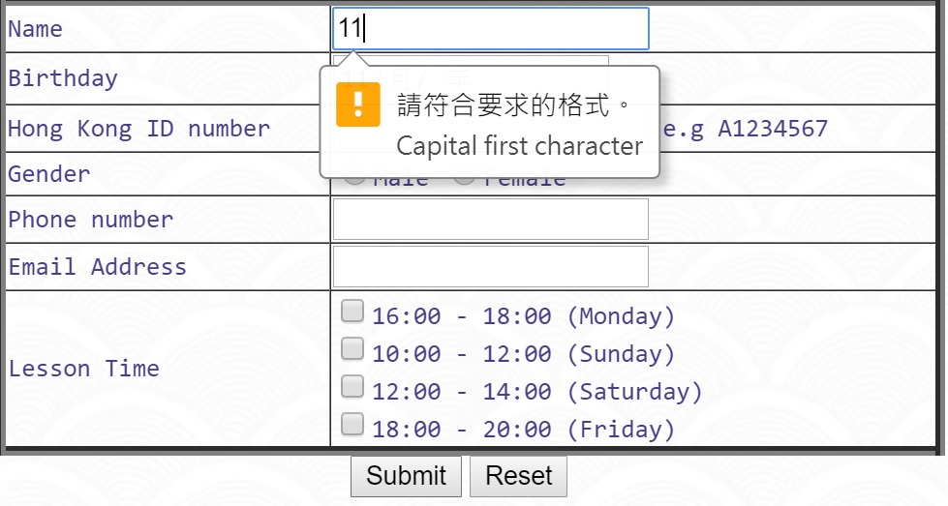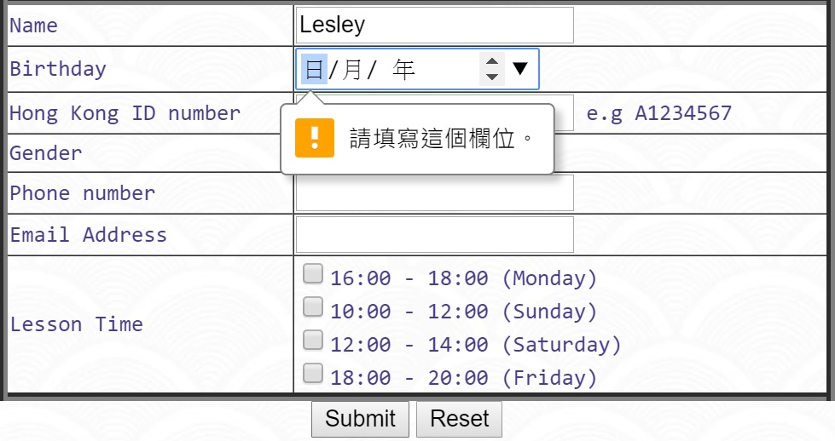

For the form of the Japanese class, the input form is used. Each row has its pattern. The name should be start with capital letter. The birthday should in the date form. The HKID number must be 1capital letter with 7 digit number. The phone number can only be 8 digit of number. The email address should according to the format of email(e.g [abc@gmail.com](mailto:abc@gmail.com)).

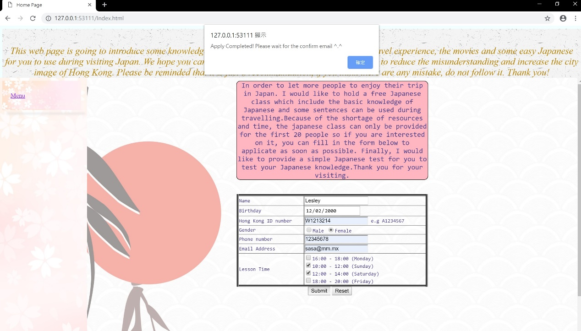

When all the information are filled in, the function of message(i.e the successful apply message) will show on the screen.

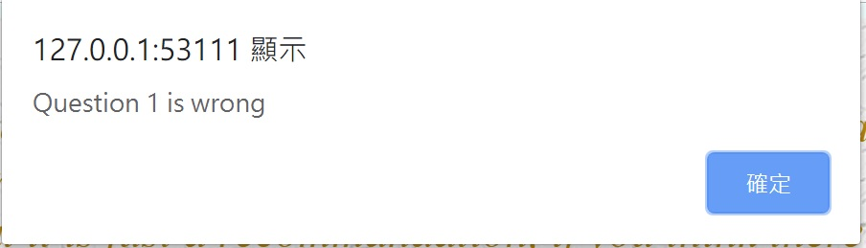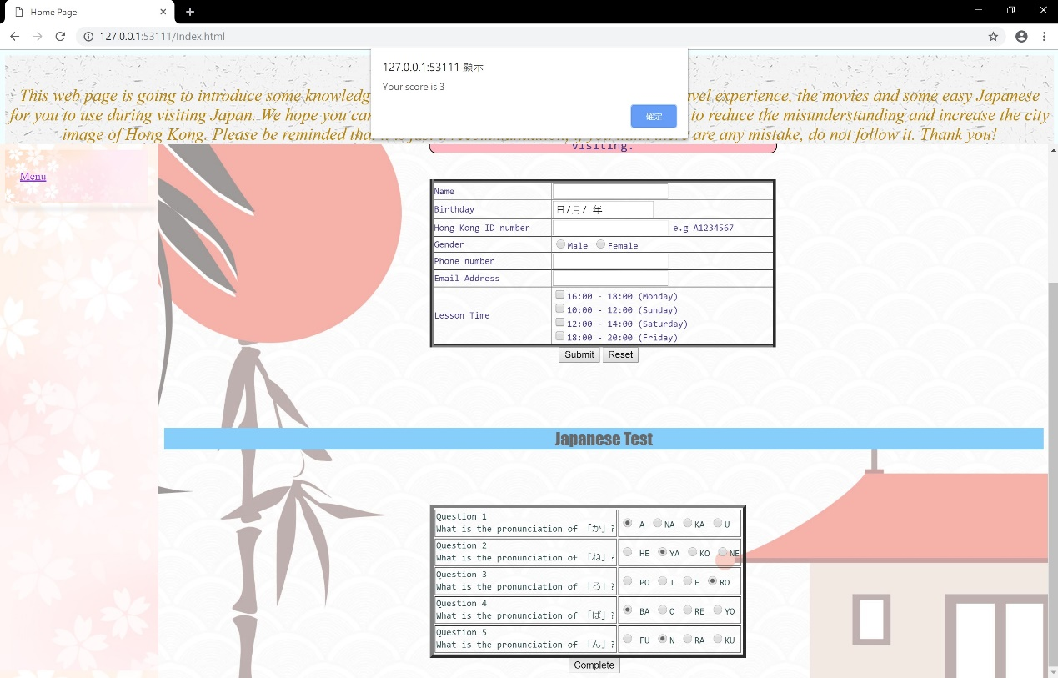

There is a simple Japanese test for user. It is the radio button, user can only choose 1answer. After they click the complete button, the function checkAns() will run. When the answer is wrong, the message will show. Finally, it will add up the correct answer and show the score of the test.