zabbix server, provisioned by Vagrant provisioner
Zabbix agents on both VMs, provisioned by Vagrant provisioner

Vagrant.configure("2") do |config|
config.vm.define "server" do |srv|
srv.vm.box = "zabbix"
srv.vm.hostname = "zabbix.loc"
srv.vm.network "private_network", ip: "192.168.33.100"
srv.vm.provider "virtualbox" do |v|
v.memory = "3072"
v.cpus = "2"
end
srv.vm.provision "shell", inline: <<-SHELL
echo "SERVER PROVISION"
yum install -y git
git clone https://github.com/kickman2l/files.git
yum install -y http://repo.zabbix.com/zabbix/3.2/rhel/7/x86_64/zabbix-release-3.2-1.el7.noarch.rpm
yum install -y httpd httpd-devel
yum install -y mariadb-server mariadb
yum install -y php php-cli php-common php-devel php-pear php-gd php-mbstring php-mysql php-xml
yum install -y zabbix-server-mysql zabbix-web-mysql zabbix-agent zabbix-java-gateway
cp -i /home/vagrant/files/zb.conf /etc/httpd/conf.d/
systemctl start mariadb
mysql -u root -Bse "create database zabbix character set utf8 collate utf8_bin;"
mysql -u root -Bse "grant all privileges on zabbix.* to zabbix@localhost identified by 'zabbix';"
zcat /usr/share/doc/zabbix-server-mysql-*/create.sql.gz | mysql -u root zabbix
rm -f /etc/zabbix/zabbix_server.conf
cp /home/vagrant/files/zabbix_server.conf /etc/zabbix/
rm -f /etc/httpd/conf.d/zabbix.conf
cp /home/vagrant/files/zabbix.conf /etc/httpd/conf.d/
cp /home/vagrant/files/zabbix.conf.php /etc/zabbix/web/
systemctl start zabbix-server
systemctl enable zabbix-server
systemctl start zabbix-agent
systemctl enable zabbix-agent
systemctl start httpd
systemctl enable httpd
systemctl start mariadb
systemctl enable mariadb
SHELL
end
config.vm.define "agent" do |node|
node.vm.box = "zabbix"
node.vm.hostname = "agent.loc"
node.vm.network "private_network", ip: "192.168.33.110"
node.vm.provider "virtualbox" do |v|
v.memory = "1024"
v.cpus = "1"
end
node.vm.provision "shell", inline: <<-SHELL
yum install -y git
git clone https://github.com/kickman2l/files.git
yum install -y http://repo.zabbix.com/zabbix/3.2/rhel/7/x86_64/zabbix-release-3.2-1.el7.noarch.rpm
yum install -y zabbix-agent
rm -f /etc/zabbix/zabbix_agentd.conf
cp /home/vagrant/files/zabbix_agentd.conf /etc/zabbix/
systemctl start zabbix-agent
systemctl enable zabbix-agent
SHELL
end
config.vm.synced_folder ".", "/vagrant", type: "virtualbox"
config.vm.provision "shell", inline: <<-SHELL
echo "192.168.33.100 zabbix.loc puppet" >> /etc/hosts
echo "192.168.33.110 agent.loc node" >> /etc/hosts
SHELL
end

Configure zabbix to work on the server directly without /zabbix
http://zabbix-server/zabbix -> http://zabbix-server

<VirtualHost *:80>
ServerName zabbix.loc
DocumentRoot "/usr/share/zabbix"

<Directory "/usr/share/zabbix">
Options Indexes FollowSymLinks MultiViews
AllowOverride None
Require all granted
</Directory>
</VirtualHost>

Using Zabbix UI:
Create User group “Project Owners”

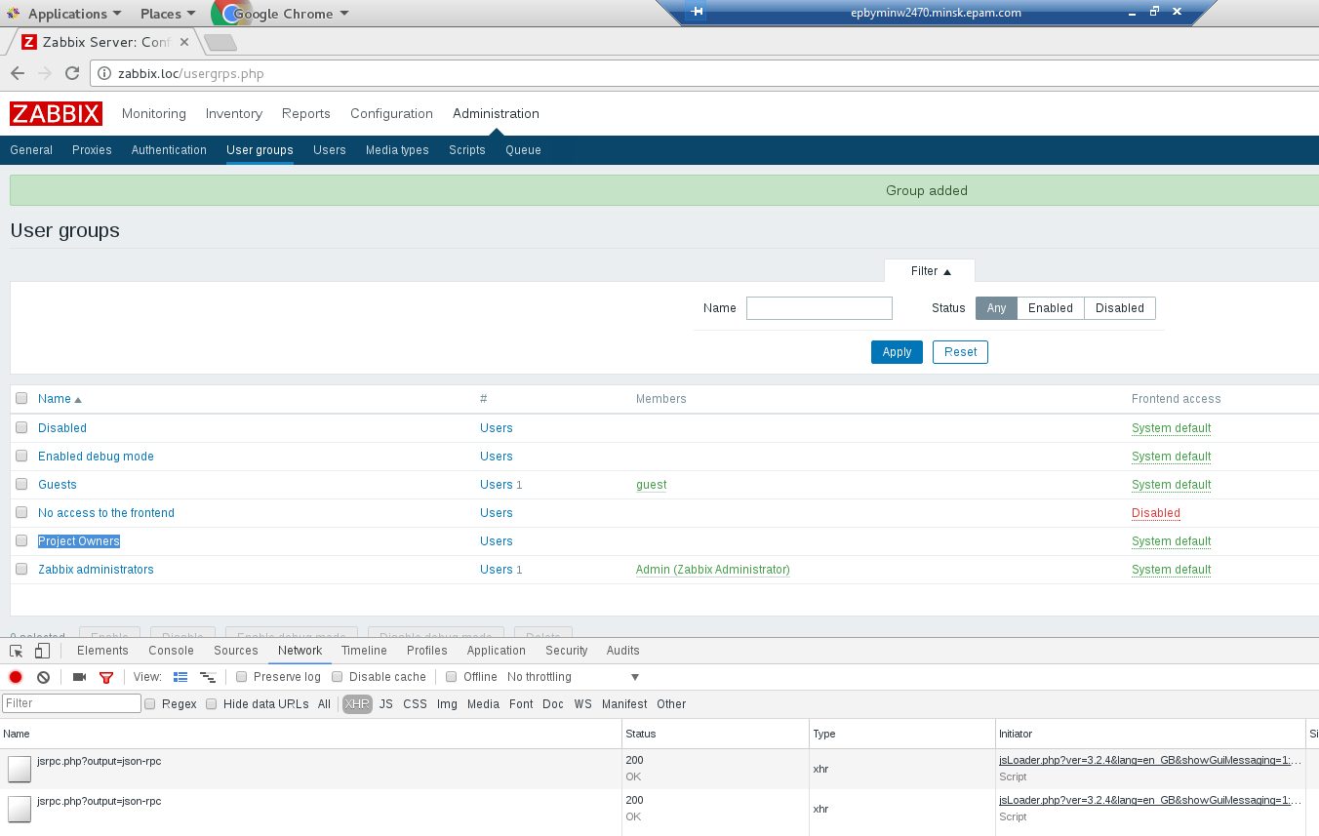

Create User (example “Siarhei Beliakou”), assign user to “Project Owners”, set email

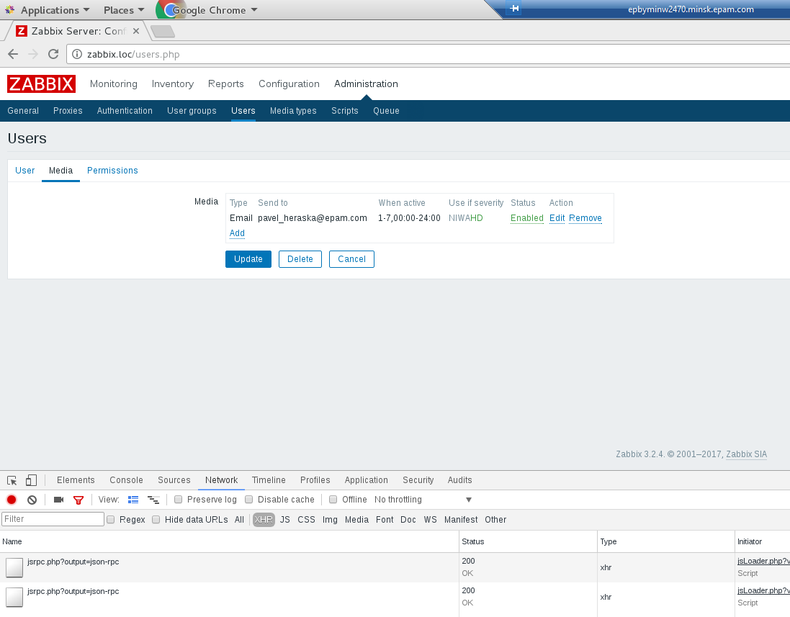
Add 2nd VM to zabbix: create Host group (“Project Hosts”), create Host in this group, enable ZABBIX Agent monitoring

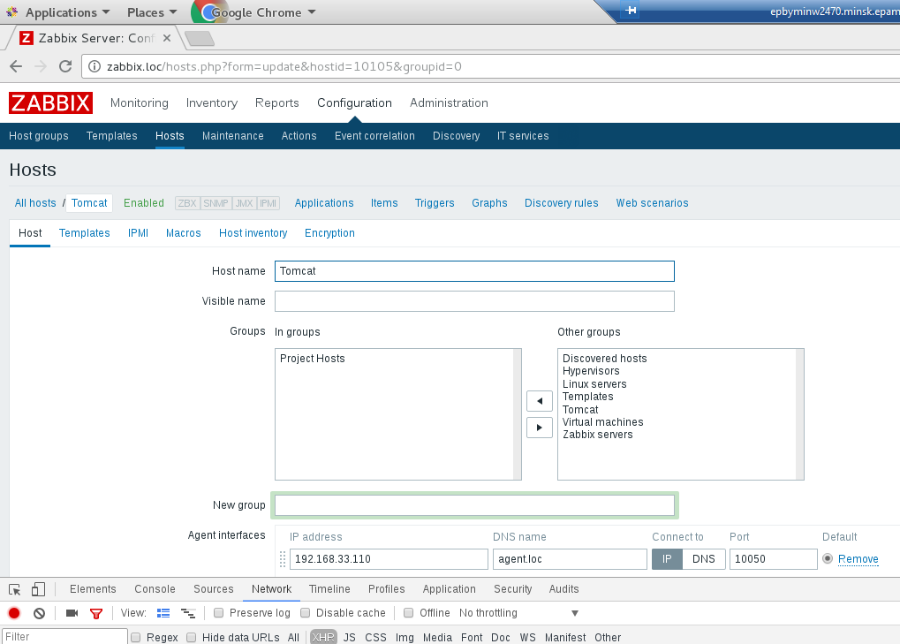

Assign to this host template of Linux

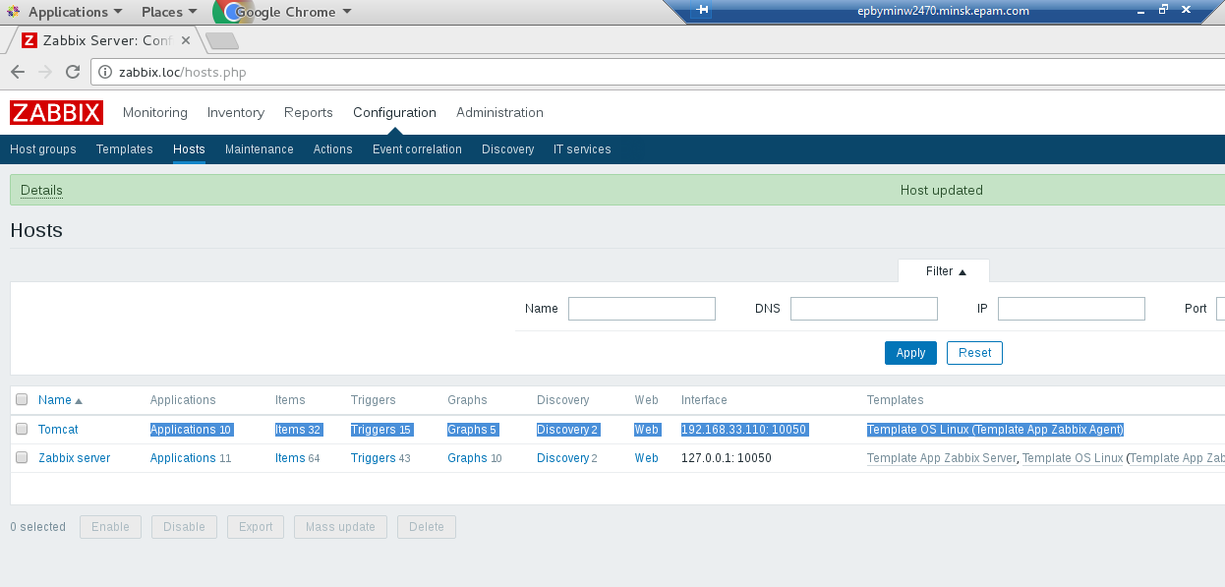

Create custom checks (CPU Load, Memory load, Free space on file systems, Network load)

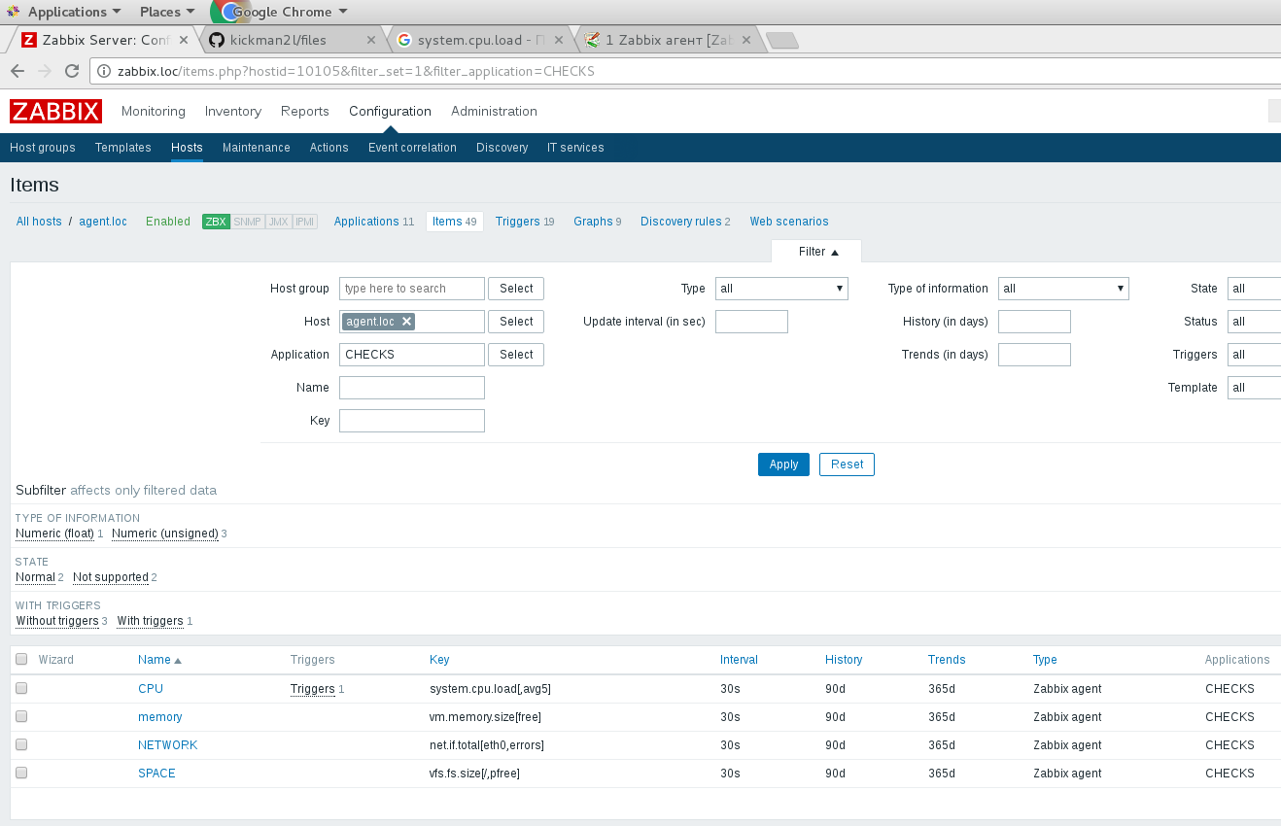

Create trigger with Severity HIGH, check if it works (Problem/Recovery)

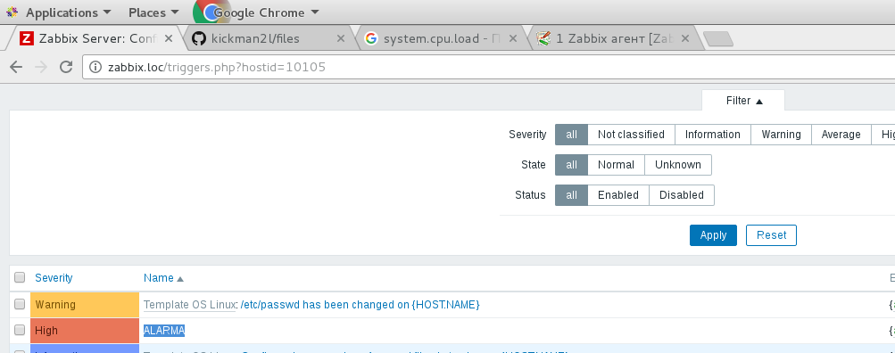

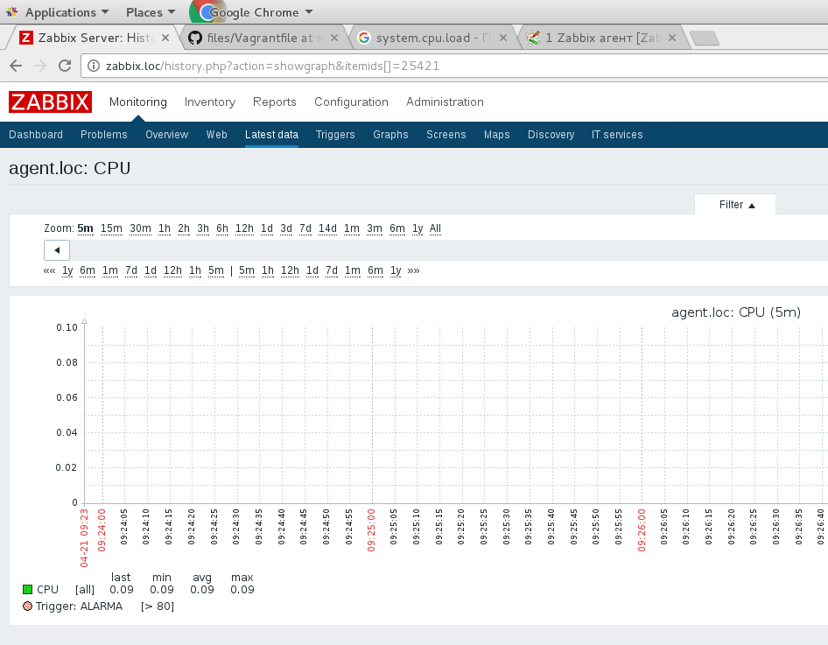

Create Action to inform “Project Owners” if HIGH triggers happen

