Zabbix java.

1. Configure Zabbix to examine Java parameters via Java Gateway.

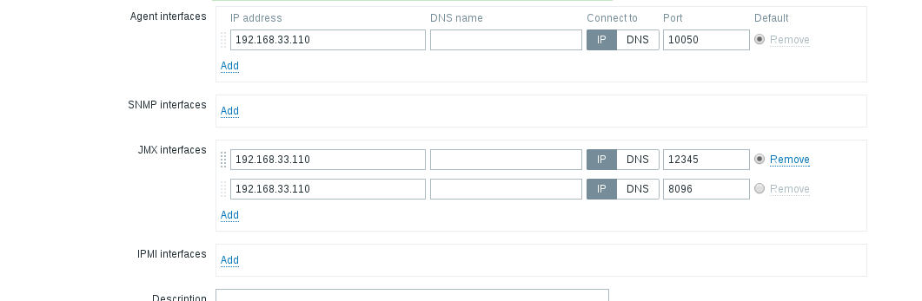
JMX interfaces are configured.

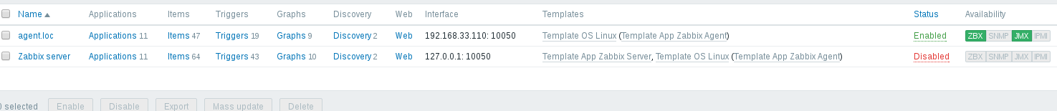
JMX interface connected.

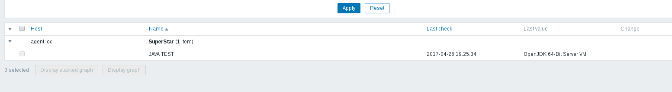
Receiving parameter via JMX.

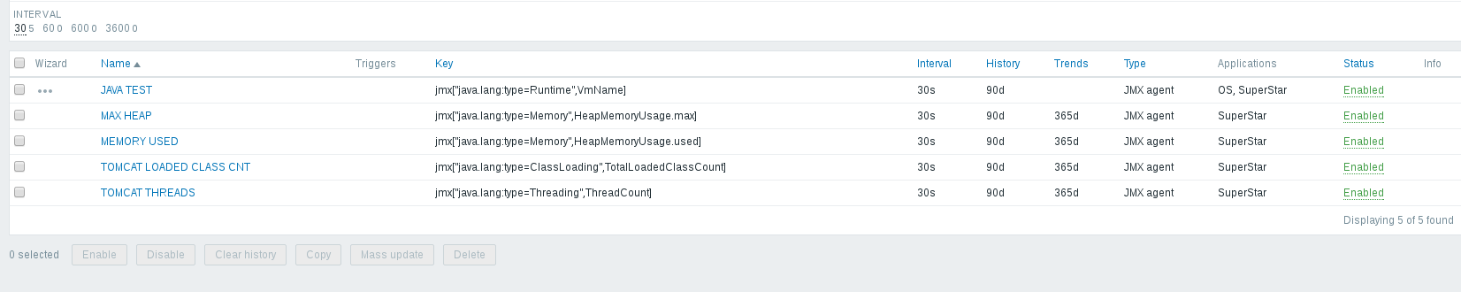
Configured items.

2.Configure triggers to alert once these parameters changed.

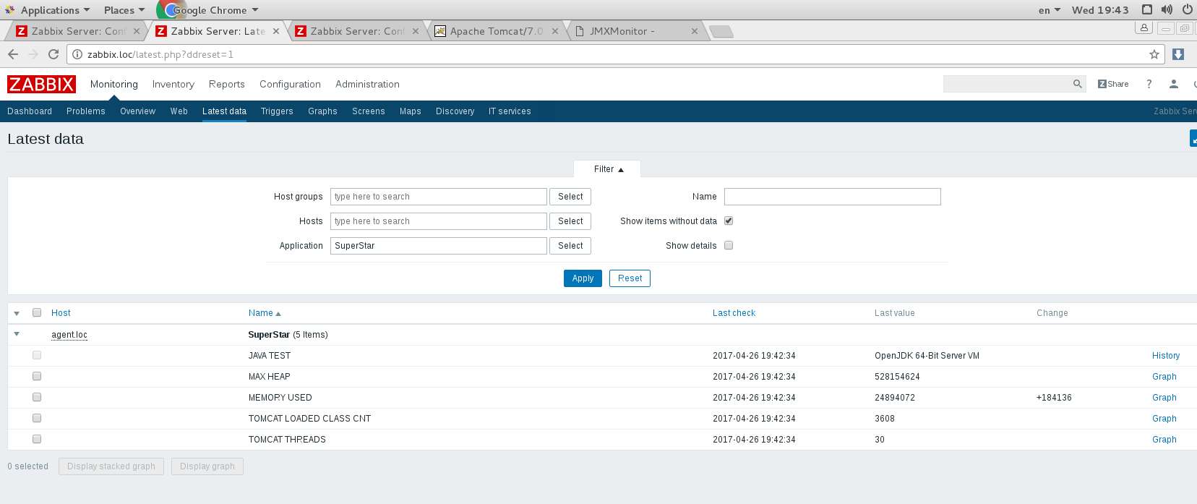
Parameters received values.

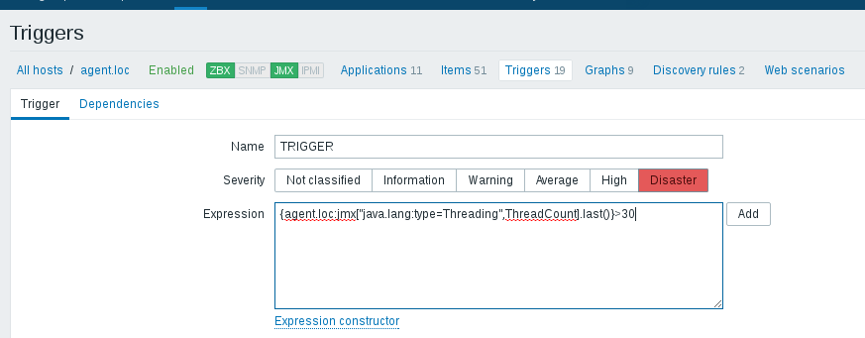
Creating trigger Threads count.

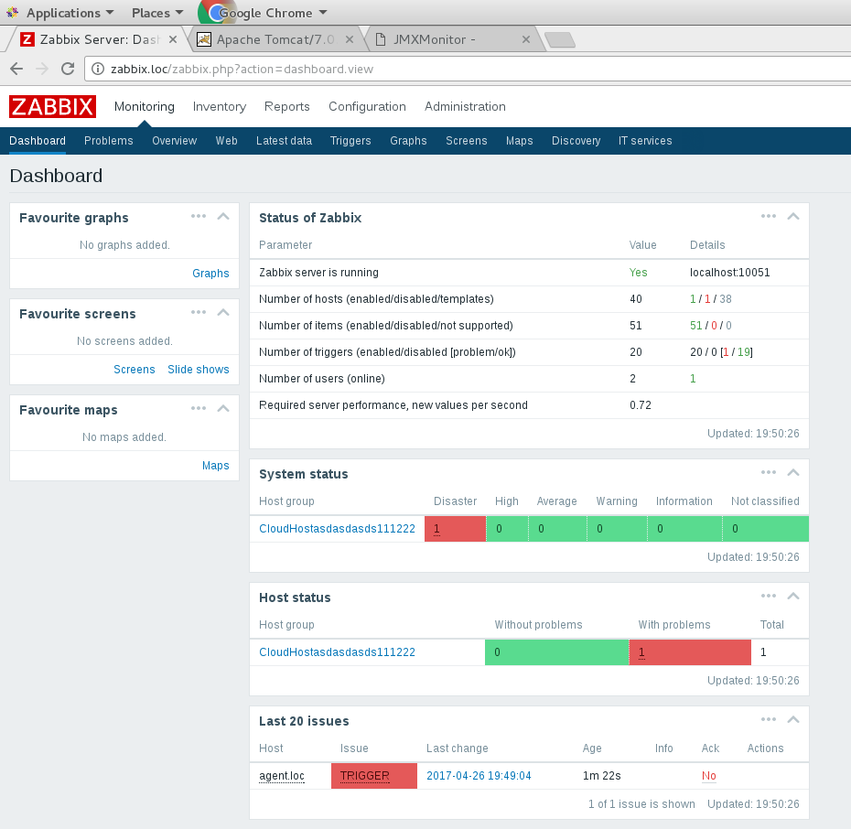
After refreshing page received trigger alert.

Zabbix. WEB.

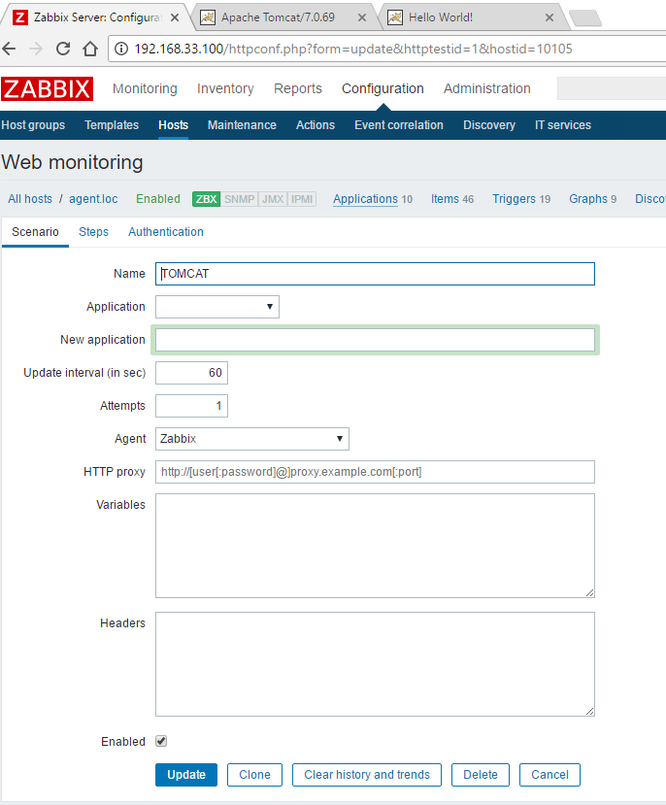
Creating scenario.

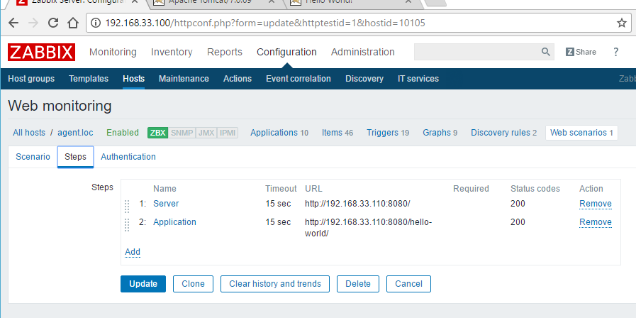
Creating steps for web monitoring.
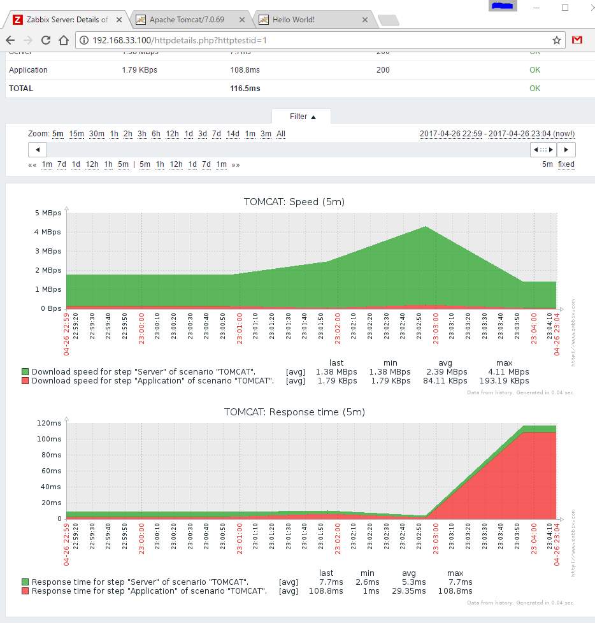
Real time monitoring server and application.

