Zabbix. Basics.

1. Create User group “Project Owners”

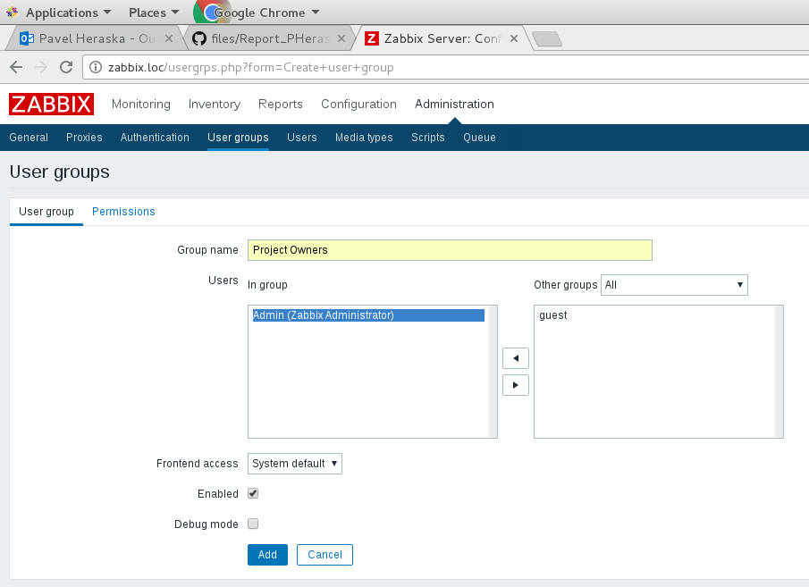
Creating users group “Project Owners” in administratost group.

2. Create User (example “Siarhei Beliakou”), assign user to “Project Owners”, set email.

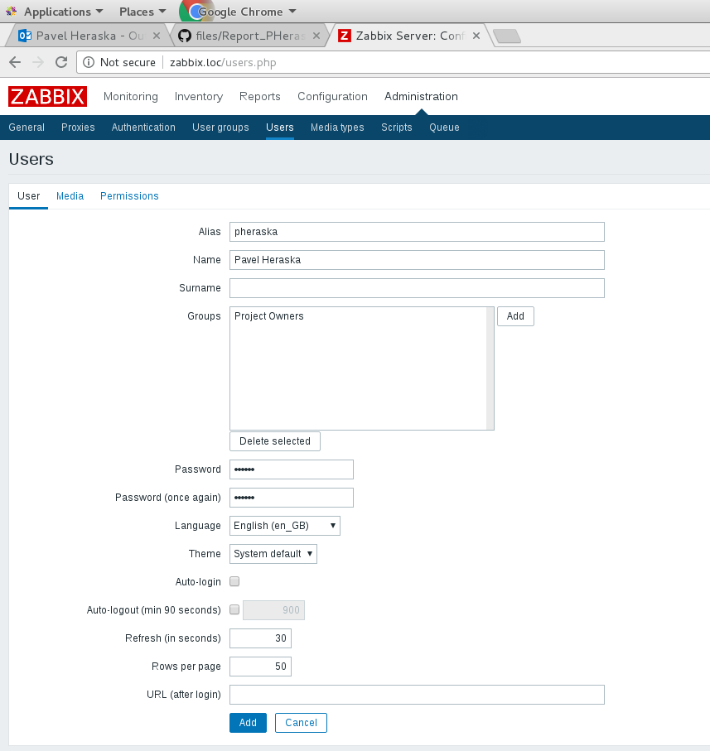
Creating user Pavel Heraska and assign to group.

3. Add 2nd VM to zabbix: create Host group (“Project Hosts”), create Host in this group, enable.

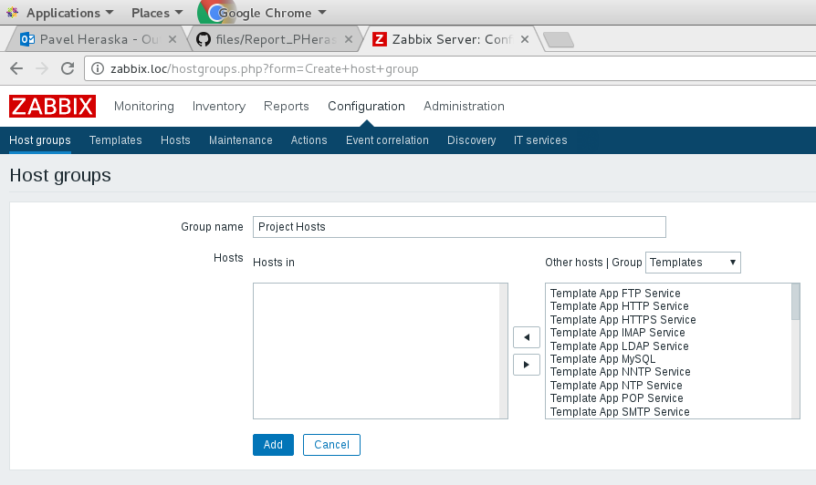
Creating host group.

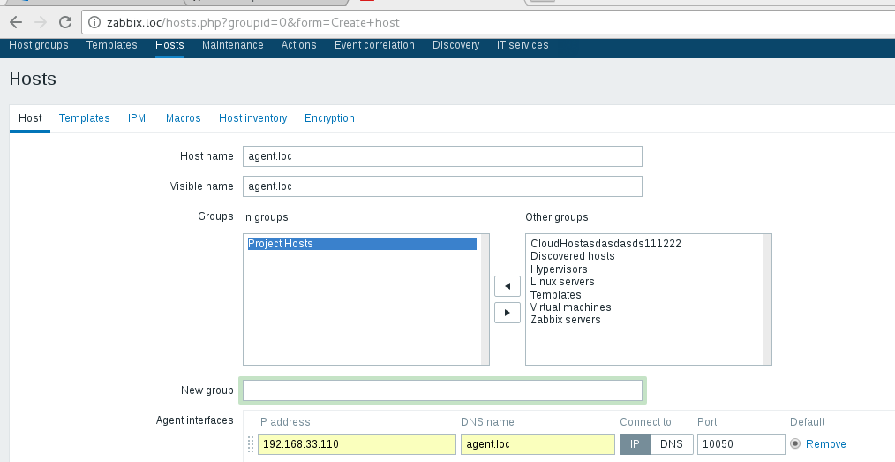
Creating host with “Project Hosts” group.

4. Assign to this host template of Linux

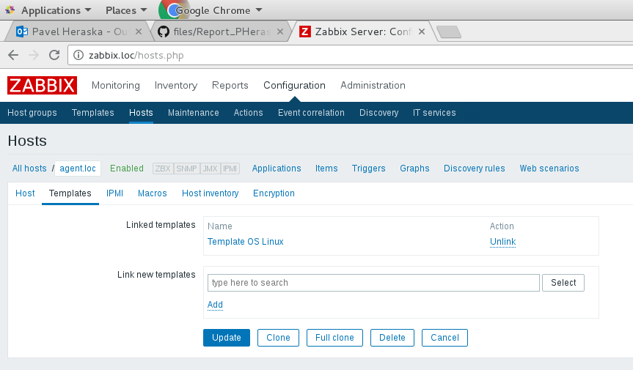
Assign template to host.

5. Create custom checks (CPU Load, Memory load, Free space on file systems, Network load)

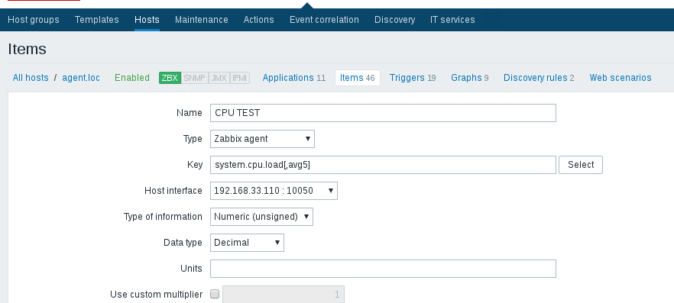
Creating custom check. CPU.

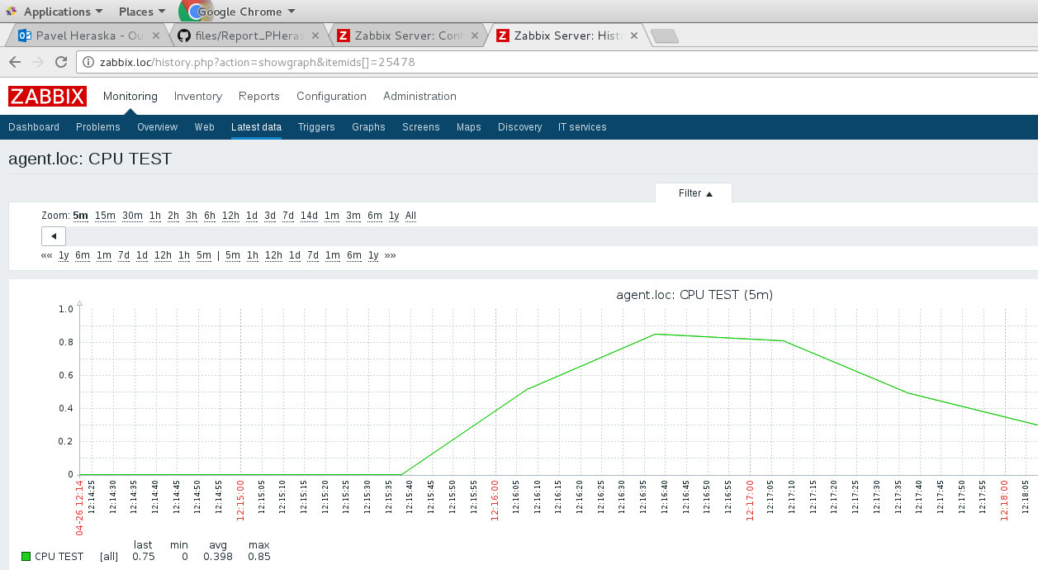
Checking with graph.

6. Create trigger with Severity HIGH, check if it works (Problem/Recovery)

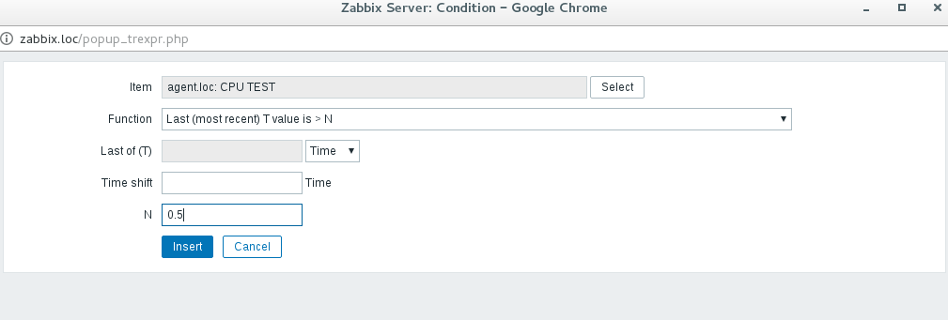
Creating expression.

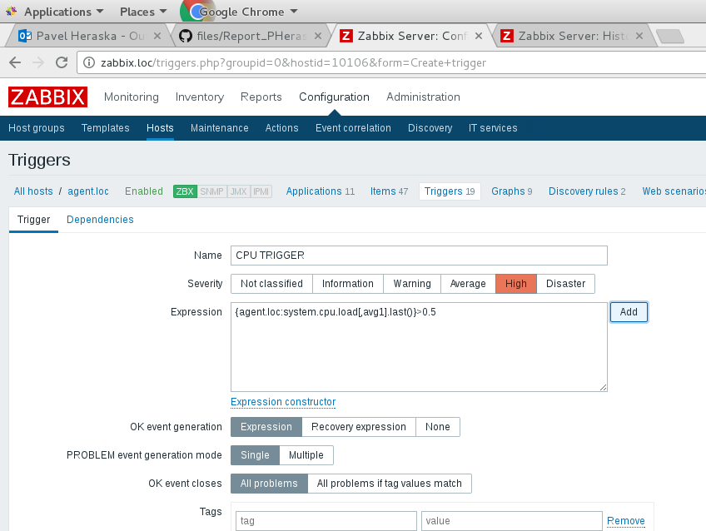
Creating trigger.

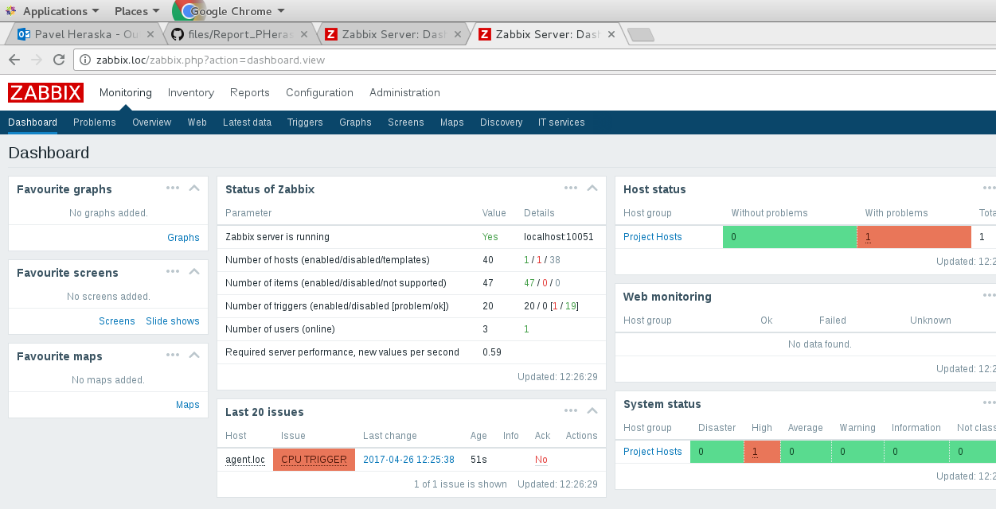
Trigger result.

7. Create Action to inform “Project Owners” if HIGH triggers happen

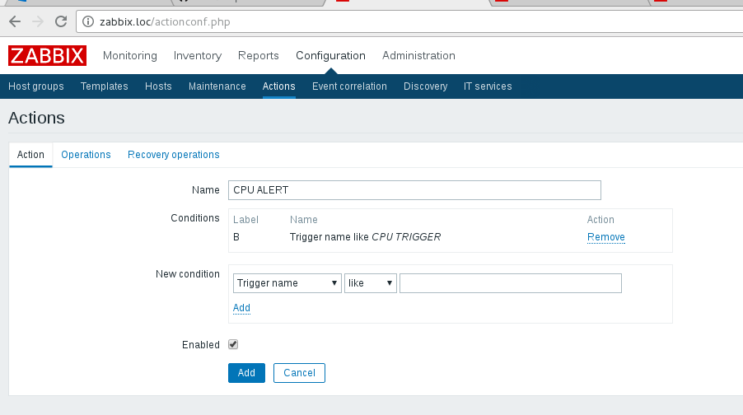
Creating action on trigger.

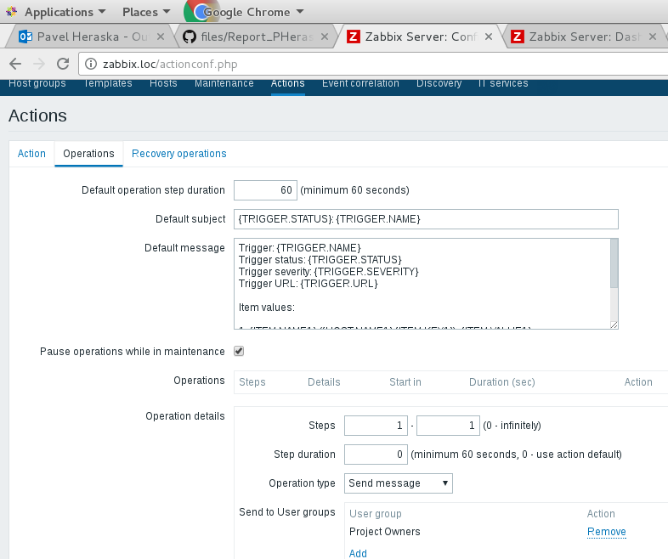
Operations settings.

8. Configure “Network discovery” so that, 2nd VM will be joined to Zabbix (group “Project Hosts”, Template “Template OS Linux”)

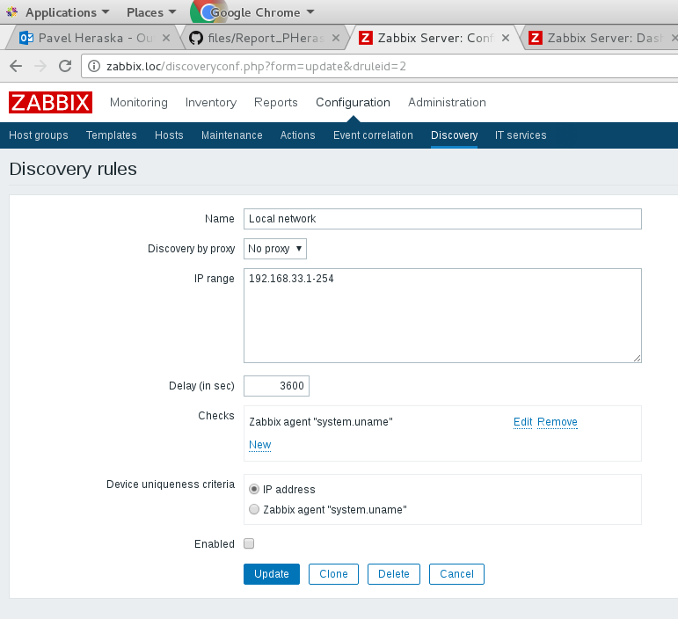
Setting discovery rules.

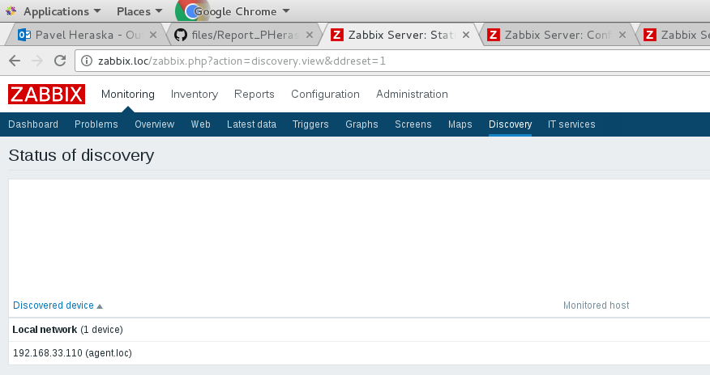
Discovered host.

Zabbix. Tools.

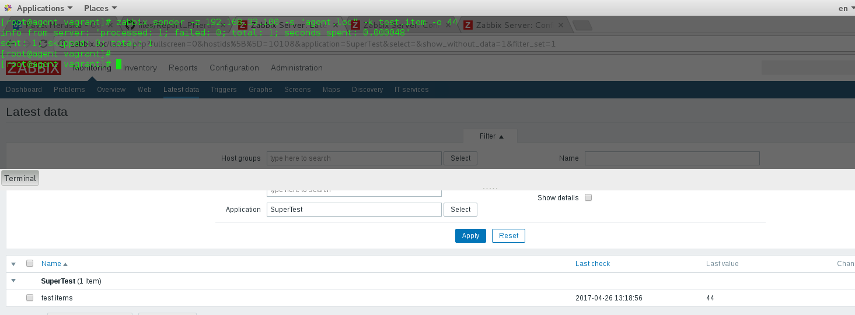
Zabbix send to servers item.

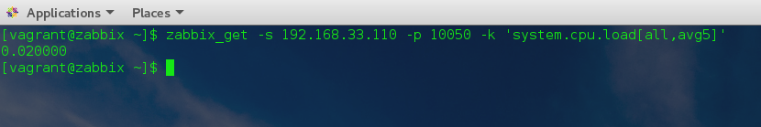
Zabbix get from client.

