

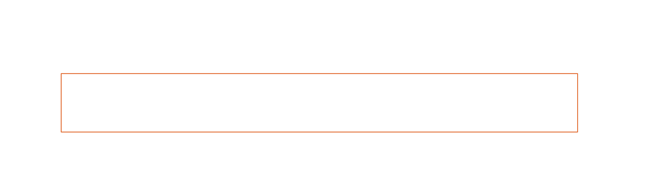


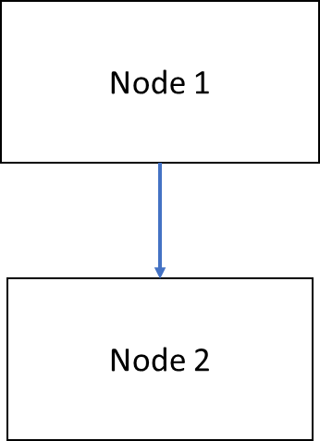


― Sommaire ―

Objectives
Description
The objective of the project is to create a mock workflow server, called MCQ. It must be able to simulaite the actions done by the actual workflow. This will be useful for testing using complex workflows that cannot be installed locally.
Workflow
A workflow is a graph of nodes, connected by arcs. A token can enter a node or leave one through the arcs. When a token enters a node, an action is triggered.
MCQ will mock actual workflows, limited to 2 steps, for example :
Token in MCQ will enter the workflow in Node 1, trigger the execution of the action, then move to node 2.
Specifications
Configuration
The mock server must be configurable through a configuration file. This file can be specified on the command line as an option, or from a default location (~/.mcq/config.cfg by default).
If the specified file does not exist, it must print a warning on standard error.
The file must be structured in sections. One section must allow configuration of system properties :
Network port
Python path
Module containing actions to be executed
Other sections can be used to define which action will be exectuted for which node, and the node in which the token will be placed.

Messages
The messages recieved by MCQ follow the grammar below.

MESSAGE ::= "<" PAYLOAD ">"
PAYLOAD ::= TAG (SPACE ATTRIBUTE)?
SPACE ::= ' '+
TAG ::= NAME
NAME ::= LETTER +
LETTER ::= 'a'..'z' | 'A'..'Z'
CHARACTER ::= anything except '<', '>', ' ', '\r', '\n'
ATTRIBUT ::= NAME '=' CHARACTER+

If the server recieves a message that does not conform to this syntax, it must send the the client the value : "<MESSAGE>Invalid message</MESSAGE>"
Handling of requests
MCQ must listen on the port defined in configuration (by default, 6666).
When a client sends a request, the serveur must accept it and stand ready to accept other requests while it processes the first one.
After request is completed, MCQ must return the result of the request to client.

LANCE requests
The LANCE request starts a token in the workflow.
It has the following mandatory attributes :
ID : the ID of the token
M : the node of the workflow to start the token in.
It can have any other attributes added, these are passed to the application.
Exemple : to start the token 'Token1' in the node (module) 'Process.node1', with additionnal parameter 'COLOR=GREEN'
<LANCE ID=Token1 M=Process.node1 COLOR=GREEN>
The client expects the following answer if the operation has been successful:
<MESSAGE>OK</MESSAGE>
If the node is not defined in configuration, it must give the following answer:
<MESSAGE>Unknown node</MESSAGE>

When recieving the request, MCQ must :
Accept immediately new connexions
Parse the request and send an error message if it doesn't conform to the grammar
Create the token object
Check if the node is defined in the configuration
Send the client the reply and close the connection
Execute the action configured for the node
Place the token in the following node according to the workflow.
TRACE requests
The TRACE requests lists tokens with a specific ID or in a specific module. The form of the TRACE request is :
<TRACE ID=token-id>
Supposing the token token-id exists in the node Process.node, the answer is :
<TRACE DC=1561406849>\n
<LISM M=Process.node>\r\n
<DOC ID=token-id APP=Process USER=nil TYPE=nil DATEL=nil NBP=1 PRI=0 ETAT=ATTENTE ALIAS=Process.node NBJ=1 MES="nil" HDEB="10/08/2010 14:39:26">\r\n
</LISM>\r\n
</TRACE>\n'
In the reply,
ETAT can be "EN_COURS", meaning the action is still running for the token or "ATTENTE", meaning the token is waiting (action has been done and no other action is to be taken.
HDEB is the time when the token has entered the module.
"\r" stands for the character "Cariage return" and "\n" for newline. Linebreaks in the example above are not significant.
Use example
Some workflows are very complicated to replicate in a developpement setup. They can, for exemple, convert an image into text in XML format, requiring manual intervention.
In that case, MCQ will take the place of the real workflow. Il will accept the token and return an XML test file as the result (without doing any conversion work). The process then can use this test file as the result of conversion and continue end-to-end tests.
For the exemple, we will have two node :
Conversion.start
Conversion.end
The fisrt call to MCQ will be :
<LANCE ID=some-id>
MCQ will reply :
<MESSAGE>OK</MESSAGE>
Then, following calls to MCQ will be :
<TRACE ID=some-id>
The reply of MCQ will be :
<TRACE DC=1561406849>\n
<LISM M=Conversion.start>\r\n
<DOC ID=some-id APP=COnversion USER=nil TYPE=nil DATEL=nil NBP=1 PRI=0 ETAT=EN_COURS ALIAS=Conversion.start NBJ=1 MES="nil" HDEB="16/07/2019 11:46:45">\r\n
</LISM>\r\n
</TRACE>\n'
The client will continue polling MCQ with the request :
<TRACE ID=some-id>

After a while (when the action for Conversion has terminated, the reply will be :
<TRACE DC=1561406849>\n
<LISM M=Conversion.end>\r\n
<DOC ID=some-id APP=COnversion USER=nil TYPE=nil DATEL=nil NBP=1 PRI=0 ETAT=ATTENTE ALIAS=Conversion.end NBJ=1 MES="nil" HDEB="16/07/2019 11:49:23">\r\n
</LISM>\r\n
</TRACE>\n'
Since the token is in the node "Conversion.end", the client can stop polling and use the result of the conversion.

