## Census transform

Why is the Census Transform Good for Robust Optic Flow Computation?

Stereo Matching using Census Transform of Adaptive Window Sizes with Gradient Images

## Integral image

Fast Variable Window for Stereo Correspondence using Integral Images

Rapid Object Detection using a Boosted Cascade of Simple Features

## Joint matching cost

Stereo Matching Algorithm Based on Joint Matching Cost and Adaptive Window

Fast Stereo Matching using Adaptive Window based Disparity Refinement

# Refinement

## Consistency check

Efficient Stereo with Multiple Windowing(part4)

Occlusions and Left-Right Consistency

Occlusions create points that do not belong to any conjugate pairs. In many cases, occlusions occur at depth discontinuities: indeed, one may observe[1] hat occlusions on one image correspond to disparity jumps on the other. Although evidences have been reported[2] that occlusions help the human visual system in detecting object boundaries, in computational stereo they are a major source of errors.

A key observation to address the occlusion problem is that matching is not a symmetric process: when searching for conjugate pairs, only the visible points in one image are matched. If the role of left and right images is reversed, new conjugate pairs are found. The so-called left-right consistency constraint[3] states that feasible conjugate pairs are those found with both direct and reverse matchings. It is worthwhile noting that the latter is equivalent to the uniqueness constraint, which states that each point on one image can match at most one point on the other image. Consider for instance an occluded point, e.g., B, in the left image of Fig. 2: although it has no corresponding point in the right image, the SSD minimisation matches it to some point (C‘) anyhow. One can see that the latter point, in turn, corresponds to a different point in the left image, but this information is available only by searching from right to left.

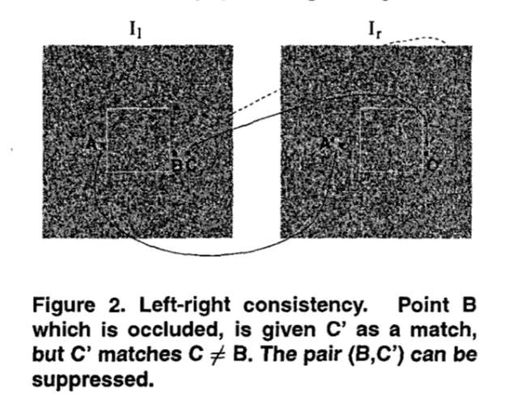

Figure 2. Left-right consistency. Point B which is occluded, is given C’ as a match, but C’ matches C != B. The pair (B,C’) can be suppressed.

In our approach, occlusions are detected by checking the left-right consistency, and suppressing unfeasible matches accordingly. For each point on the left image the disparity dl(x) is computed as described in The SSD Correlation Algorithm. The process is repeated after reversing the two images. If $d_{l}\left(x\right)= -d_{r}(x+d_{l}(x))$ the point keeps its computed left disparity, otherwise it is marked as occluded and a disparity is assigned heuristically: following[4], we assume that occluded areas, occurring between two planes at different depth, take the disparity of the deeper plane.

## Small “hole” filling

ITERATIVE REFINEMENT FOR REAL-TIME LOCAL STEREO MATCHING

Local Stereo Matching with Improved Matching Cost and Disparity Refinement (part 2 B)

“Small hole” filling: According to our observation, remaining artifacts are mainly composed of some “small holes” and outliers around object boundary, as shown in Fig. 4. “Small holes” are dark regions with disparities much smaller than their neighbors. They can be detected by comparing disparities with their neighbors. After detecting hole-pixel, we use the most appropriate disparity in its neighborhood (both horizontal and vertical) to update it.

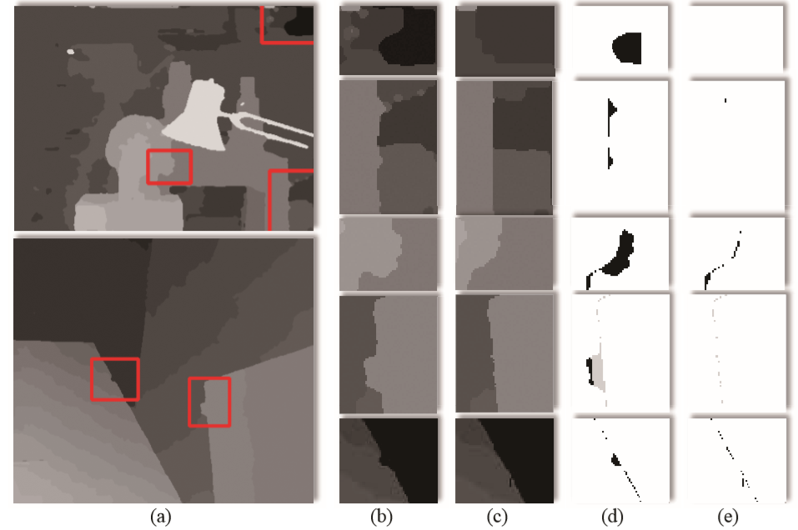

Fig. 4. “Remaining artifacts” before and after RADAR, the first row represents “small hole”; the 2nd to 4th rows represent convex regions; the last row represents concave region. (a) Disparity maps before RADAR. (b) Close-up of rectangles in (a). (c) Results after RADAR. (d) Error maps of (b). (e) Error maps of (c).

Commonly, the hole-pixel p is updated by the pixel with smaller disparity (background pixel), but if the pixel on the smaller disparity side of p is also invalid (hole-pixel), it should be updated by the pixel on the other side, as shown in follows,

$$d_{p}^{*}=\left\{\begin{aligned}\max\left\{d_{p}^{'},d_{p}^{"}\right\}, d_{p}^{'}∙d_{p}^{"}≤d_{tres}^{2} \\ \min\left\{d_{p}^{'},d_{p}^{"}\right\}, d_{p}^{'}∙d_{p}^{"}≥d_{tres}^{2}\end{aligned}\right.$$

$$d_{tres}=ρ∙d_{max}$$

where $d_{p}^{'}$ and $d_{p}^{"}$ are the nearest (taking one direction as an example) pixels’ disparities larger than $d_{tres}$, and $d_{max}$ is the maximum disparity, while $ρ$ is an empirical penalty of 1/7. The updated disparity is denoted as .

## ~~Majority vote~~

Real-Time and Accurate Stereo: A Scalable Approach with Bitwise Fast Voting on CUDA

1. D. Geiger, B. Ladendorf, and A. Yuille. Occlusions and binocular stereo. International Journal of Computer Vision, 14:211-226, 1995.
2. K. Nakayama and S. Shimojo. Da Vinci stereopsis: Depth and subjective occluding contours from unpaired image points. Vision Research, 30: 181 1-1825, 1990.
3. P. Fua. Combining stereo and monocular information to compute dense depth maps that preserve depth discontinu- ities. In Proceedings of the International Joint Conference on Artificial Intelligence, Sydney, Australia, August 1991
4. J. J. Little and W. E. Gillett. Direct evidence for occlusions in stereo and motion. Image and Vision Computing, 8(4):328-340, 1990.