

**Department of Electrical Engineering and Computer Science**

**Spring 2021**

**Automated Locker for Curbside Pickup**

**Test Document**

**Professor:** Dr. Hari Kalva

hkalva@fau.edu

**Sponsor:** Mahesh Neelakanta

mahesh@fau.edu

**Group 8 Members:**

**Project Manager:** Jacob Highbridge

jhighbridge2018@fau.edu

**Electrical Engineer:** Brandon Boukzam

bboukzam2014@fau.edu

**Computer Engineer:** Christian Cruz

cruzc2018@fau.edu

**Computer Science:** Yingqi Feng

yfeng2016@fau.edu

**Computer Science:** Tony You

[tyou2017@fau.edu](mailto:tyou2017@fau.edu)

# Testing Guide:

Note: For best results, please use a computer tablet or mobile device to test admin interface

1. On your main computer, create a username and password to log into the administrator page
   1. First, connect to the locker database through MySQL Workbench
   2. Once at the Query page, enter this query:  
      USE lockers;  
      INSERT INTO `lockers`.`admin` (`aid`, `aname`, `aemail`, `password`) VALUES ('1', 'test_librarian', 'librarian@email.com', '235711');
   3. This has now created a username and password for you to log into the website  
      (Note, we do not have a way to register on the site, being that access to this site should be restricted to only certain people)
2. Next, with your tablet or mobile device, log into administrator web page
   1. Enter your instance IPv4 address into the address bar of your browser, followed by “/admin/index.php”  
      
   2. Log in using the credentials that were entered into the database  
      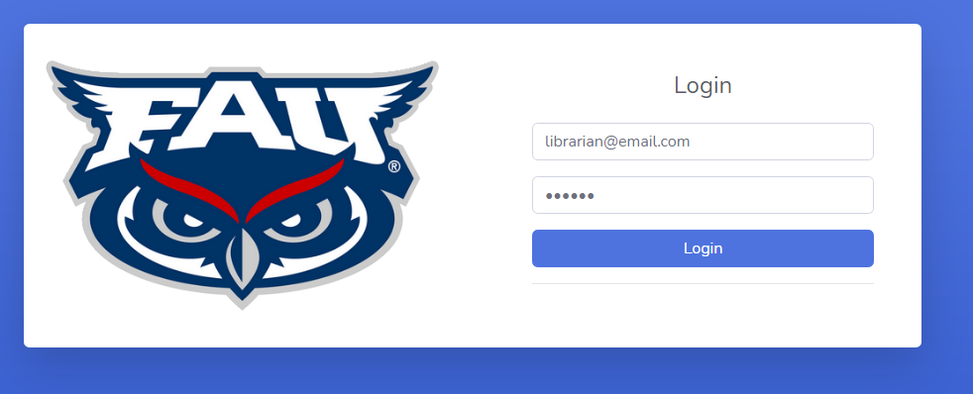
3. Testing Order Form
   1. Create a locker request using the Student Form section of the web page
   2. You may enter any name, and a personal email address to retrieve any emails
   3. Pictured below is an example of an order for testing: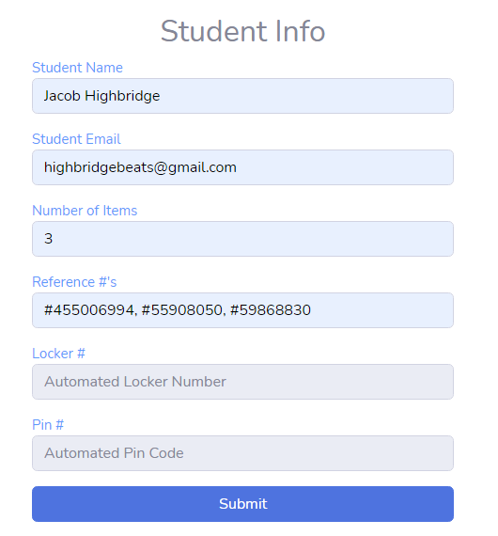
   4. After hitting the submit button, you should see this message pop up:
      1. In this case, the order was assigned to locker 2, because locker 1 was already occupied by another test order
   5. Heading over to the Locker Access section of the web page, you should now be able to view your locker order, waiting for confirmation.  
      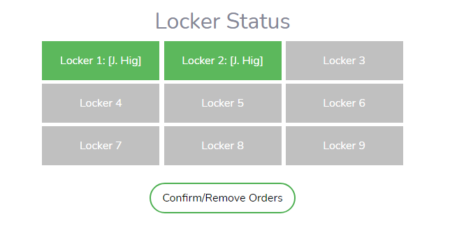
4. Confirming Order and Accessing Locker as Librarian
   1. Clicking on any lockers that are NOT not in-use will select them
   2. You may select multiple locker blocks at once before confirming them, like so:  
      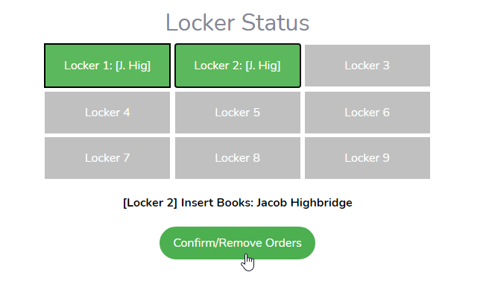
   3. This will result in the emails being sent out for both of these lockers, and a QR code being generated to access both of these lockers at the same time:  
      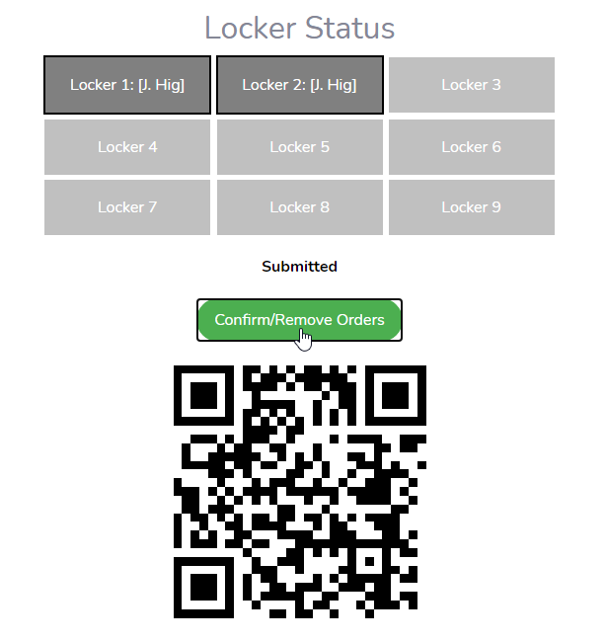
   4. Now, take your take your tablet to the Locker Kiosk, and tap the QR Code button and hold your tablet to the camera to scan your code:  
      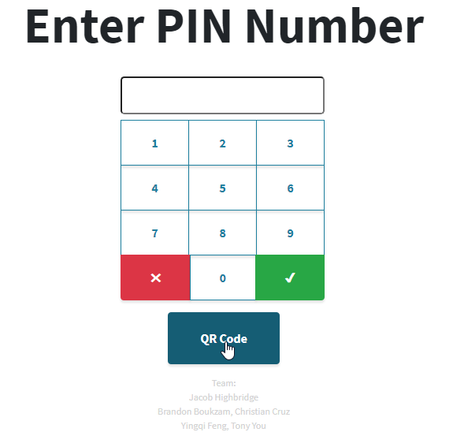
   5. A successful scan will bring you to the next page, showing this:  
      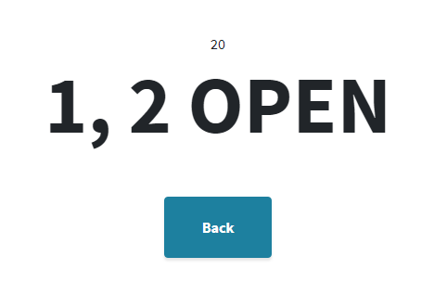
   6. From here, the respective lockers will release their locks for 30 seconds. Please pull the locker doors back, and fill with the required order materials.
   7. In case there are any accidents, in-use lockers may also be re-accessed by selecting, and then pressing the Access Locker button: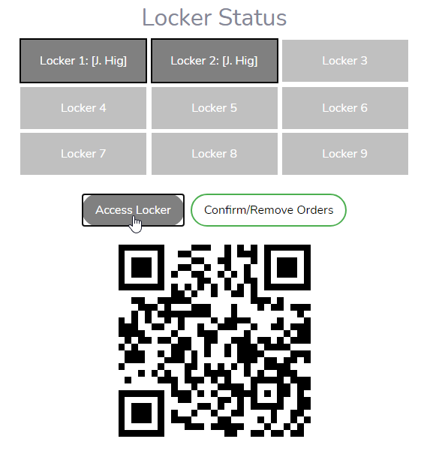
   8. Locker Order History is also available to view in the Locker History section of the web page: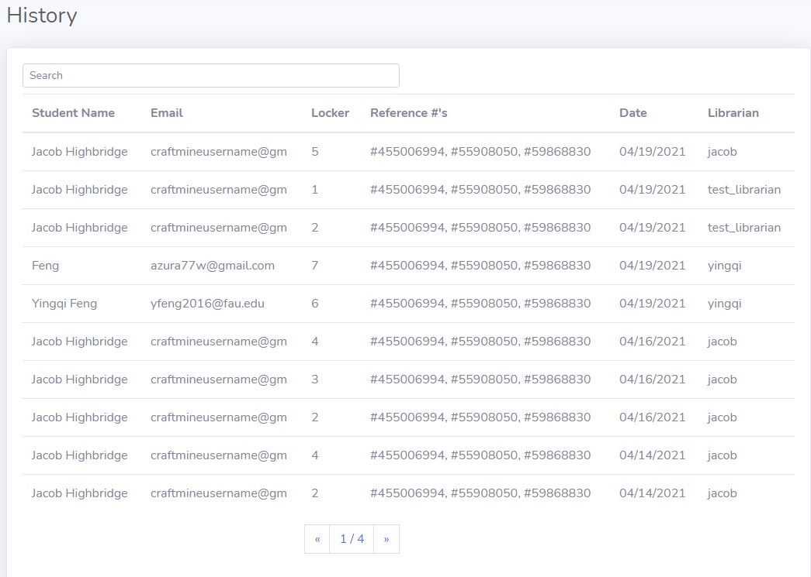
5. Accessing Locker Order as a Student
   1. Once your order has been confirmed and filled, an email is sent to you
   2. Navigating to your entered email address, you will have received this email:  
      
   3. The content of this email should include your 6 digit pin number, and a QR code for access:  
      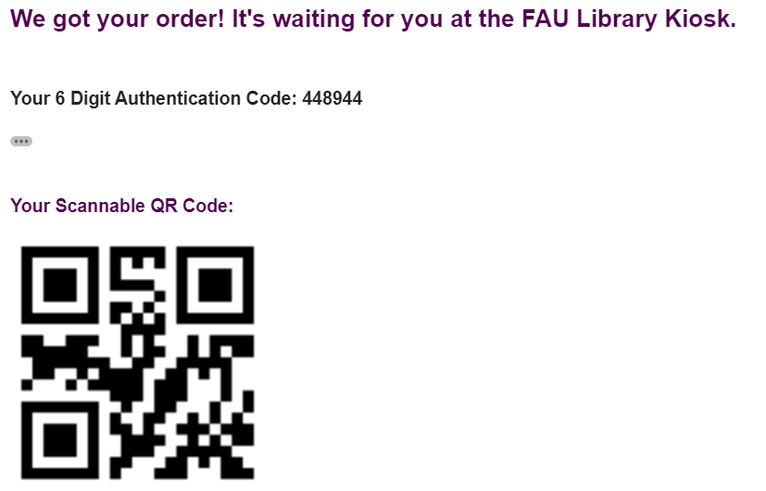
   4. Whether this code is scanned or manually entered does not matter. It is the same 6-digit code.
   5. Once arriving at the Library Kiosk again, please enter the code to access your locker:  
      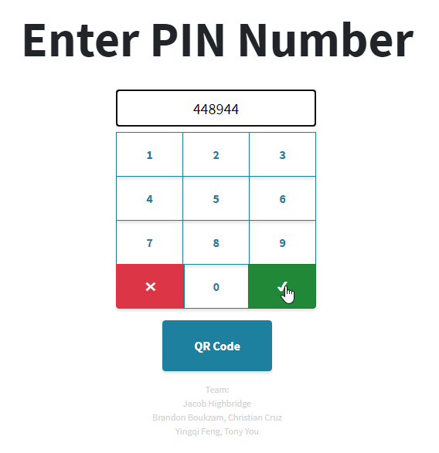
   6. And thus, your locker door is unlocked for 30 seconds:  
      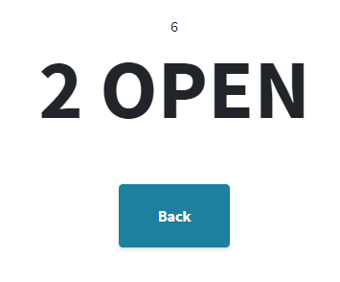
   7. Checking back at the Locker Access page, we should now see that locker 2 is no longer in-use:  
      