1)

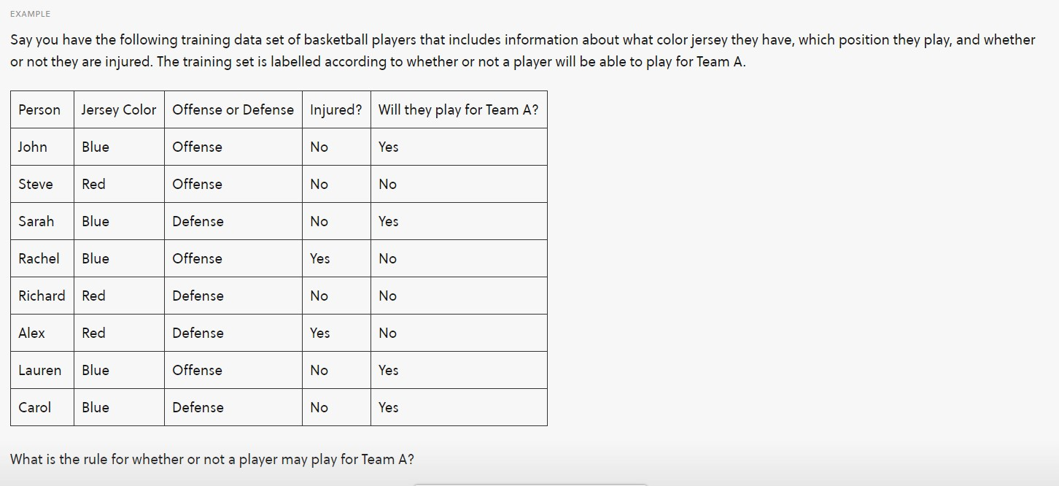

1. The length of these trees exhibit a normal distribution. The tree that you measure is 120 cm. Given the following information, do you think this tree length is uncommon for this type of tree? (Mean: 100; Standard deviation: 10)
2. You are interested in how uniform the lengths of socks are that are produced at a factory. You measure the distribution and see that there is a normal distribution for the length of the socks.Is it likely sock is above 25? (Mean:20 Standard deviation: 10.5)
3. In a powerlifting competition the mean avg dead lift weight is 400lbs with a standard deviation of 80lbs. What would be the minimum he should get on a dead lift to get a pro-card? To get a pro card he has to be in the top 4% of the competition.

5)

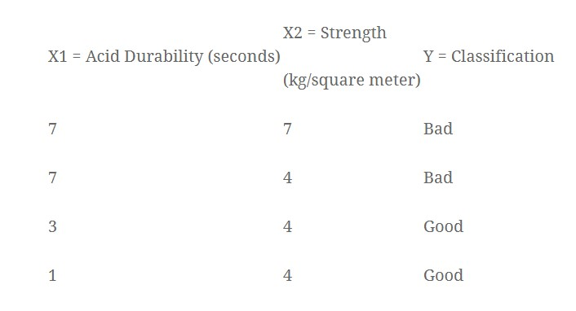

How will you classify x1=3 x2=7? (using KNN classifier)

Sol)

-Decide K value (3 can be suitable in this case)

-Find Distance between the query instance (x1=3 x2=7) and all training examples  
-sort them is ascending order of distance and select the first K neighbour   
-Now check how many of the K nearest neighbours fall in good and in bad

-Use the modal class for predicting value of the query instance

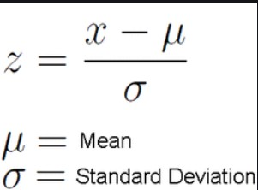

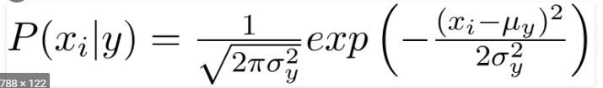

<https://www.calculator.net/z-score-calculator.html?c2z=2&c2p=&c2pg=&c2p0=&c2pin=&c2pout=&calctype=converter&x=73&y=34#converter>

The following link helps convert Z score to probability