+—————————————-+

| CompSci 143A |

| PROJECT 0: Getting Real |

| DESIGN DOCUMENT |

+—————————————-+

---- **AUTHOR** ----

Keshav Bhalla <[bhallak1@uci.edu](mailto:bhallak1@uci.edu)>

---- **PRELIMINARIES** ----

**Booting Pintos**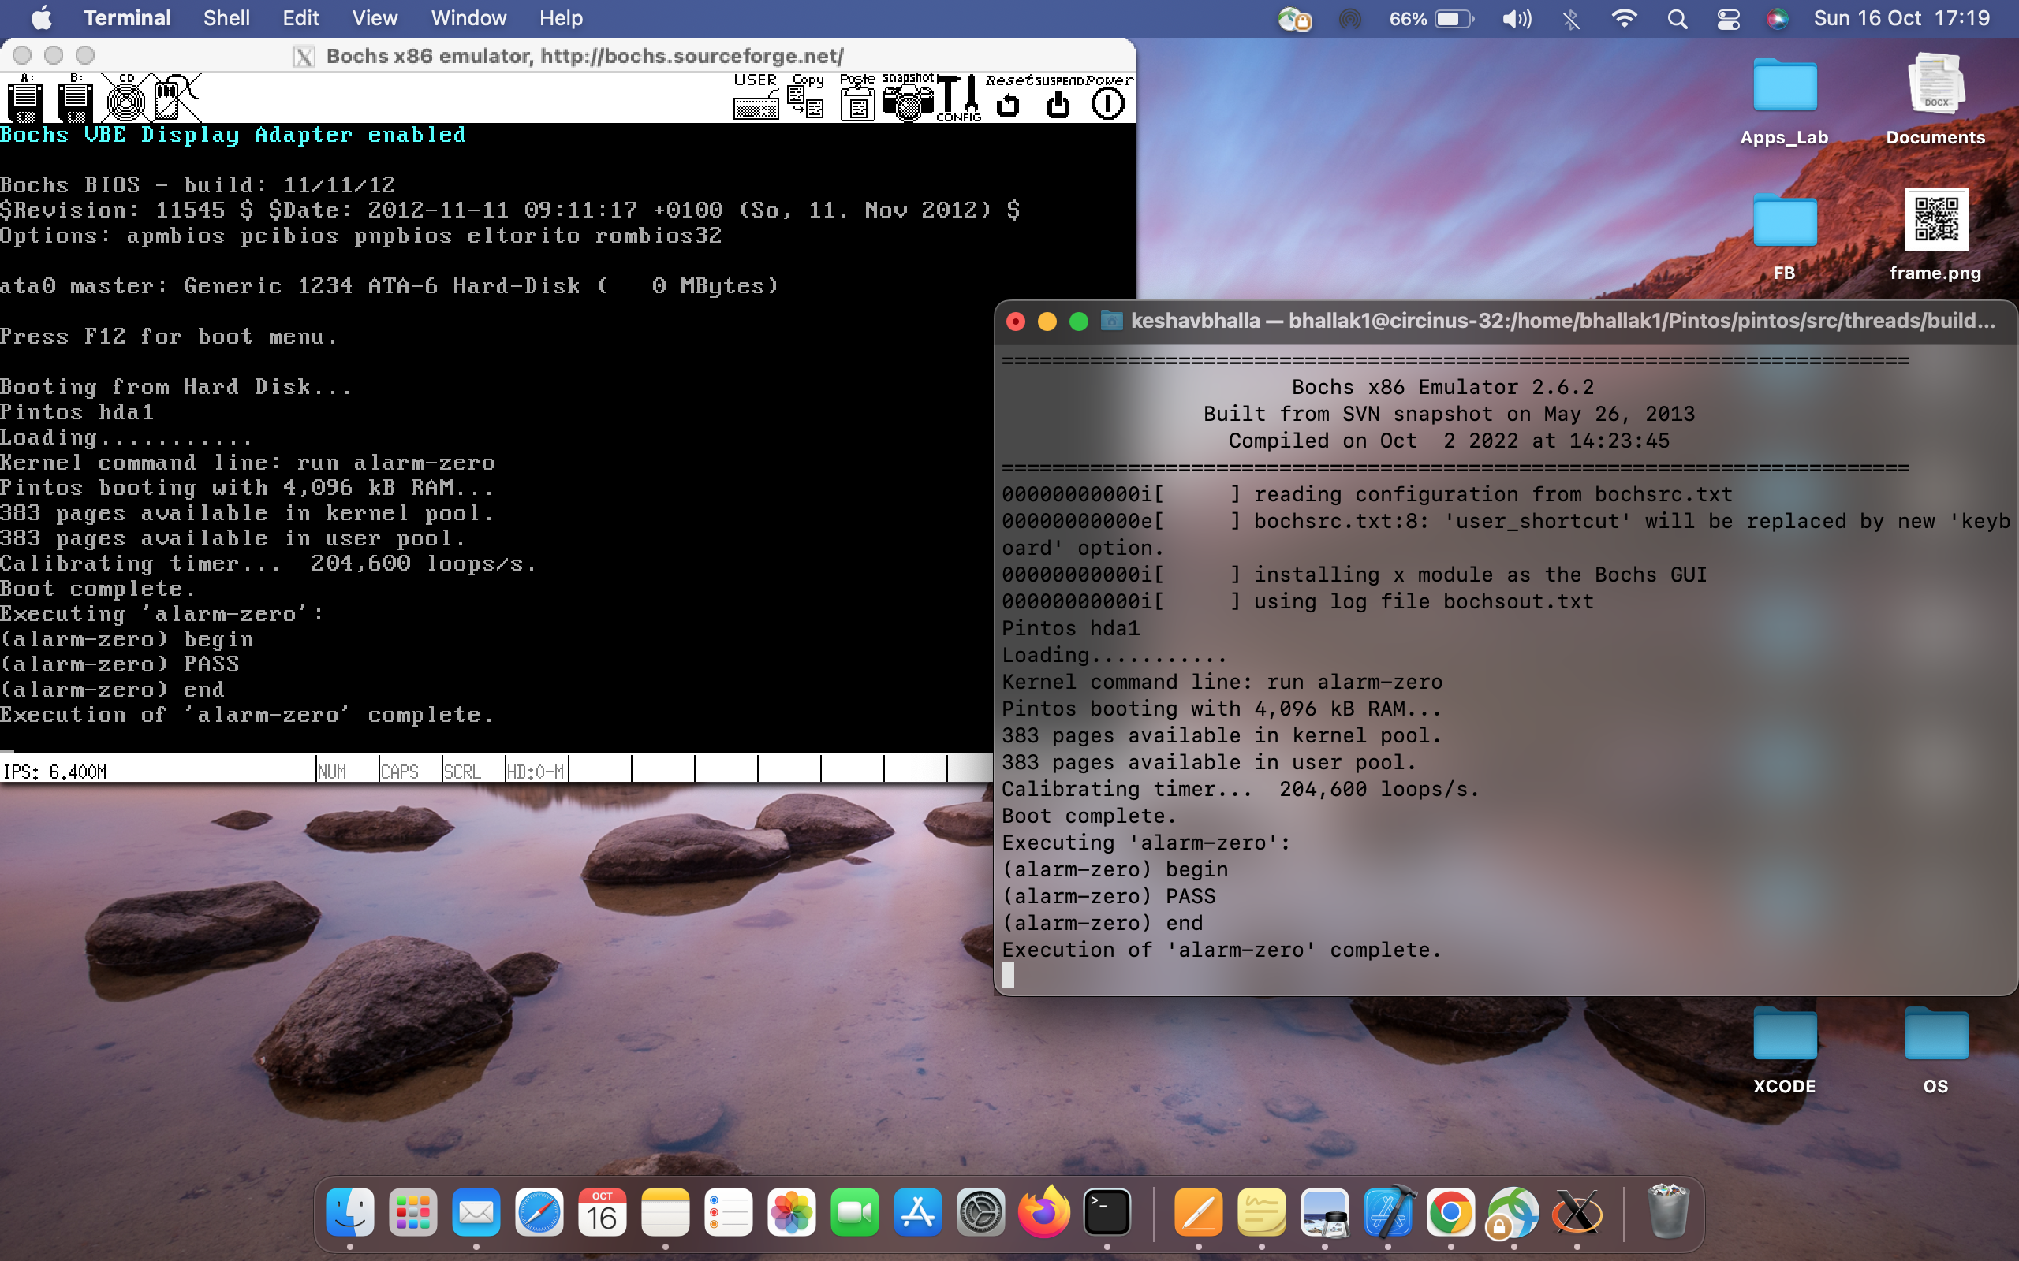

==============

==============

---- **DATA STRUCTURES** ----

No global or static variable is used.

Used a character array to store input string : char input_string[51]

Used a variable to store index of string : int index

---- **ALGORITHMS** ----

>> C2: Explain how you read and write to the console for the kernel monitor.

For every string :

Read every character in a string using input_getc() function

Check if that string is whoami :

print(Name)

print(CS143A>)

continue

Check if that string is exit:

break

Otherwise:

print(Invalid)

continue

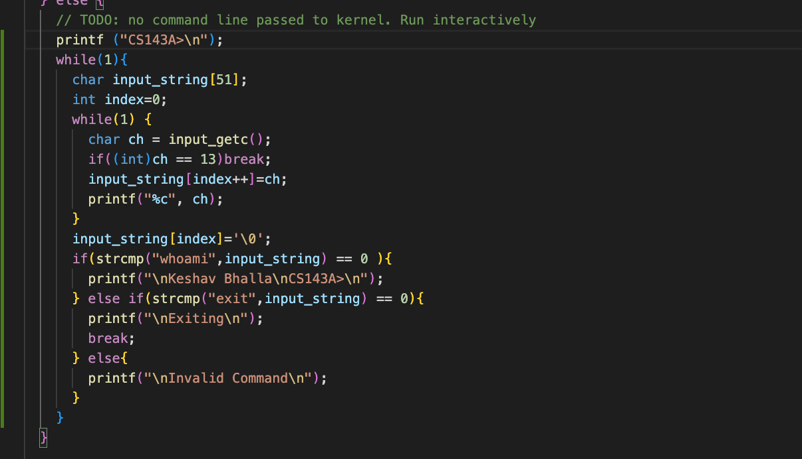

>> C3: Any additional enhancement you implement?