Analyzing Predictive Factors of Academic Success in University

A Linear Regression Analysis of High School Performance, SAT Scores, and Extracurricular Activities

Student Name:

Instructor’s Name:

Department Name:

Date of Submission:

# Introduction

The challenge of identifying students who will succeed in university settings has long been a critical concern for admission officers. While traditional metrics, such as high school grades and standardized test scores, have been the cornerstone of admission decisions, there is growing recognition that non-academic factors may also play a significant role in predicting academic success. The study looks at the relationship of university academic performance with three potential predictive factors: high school GPA, SAT scores, and extracurricular activity participation. In a sample of 100 fourth-year university students, we carry out linear regression analysis to test these variables in predicting university academic success measured by GPA through the first three years of university study.

# Literature Review

The prediction of academic success in higher education has been one of the key issues in educational research. Conventionally, high school GPA has been regarded as one of the most valid predictors of college success (McFarlane, Thorne J. McFarlane, and Bernard 2017). Studies consistently indicate that high school GPA maintains a strong correlation with college performance, possibly because it captures both cognitive abilities and non-cognitive factors such as motivation and study habits.

Standardized testing, notably the SAT, has also been a major factor in making admission decisions. Research carried out by the College Board (2019) highlights moderate to strong correlations between SAT scores and first-year college GPA. However, some research suggests that the predictive validity of the SAT scores could vary depending on different student populations and different institutional contexts (Beatty et al. 2011; Rigdon, Sackett, 2009; Kuncel, Sackett, and Borneman 2008).

Most recently, the focus has turned to the predictive power of extracurricular activities toward academic success. Research by authors (H. Marsh and Kleitman 2002) indicated that extracurricular activities were positively linked to academic achievement, thus perhaps improving time management skills, leadership potential, and social capital. However, the relationship between extracurricular involvement and academic performance is complex, with some research suggesting a curvilinear relationship where excessive involvement may detract from academic achievement (Eccles 2006).

The importance of the current study is that it contributes to the literature by simultaneously estimating these three factors: high school GPA, SAT scores, and extracurricular activities, relative to one another as predictors of university academic success. The results will also be particularly useful for admission officers looking to construct more comprehensive and evidence-based admission criteria.

# Results

## Exploratory Data Analysis

### Descriptive Statistics

The sample included 100 fourth-year university students. The university GPA for the first three years was, on average, 7.28 (SD = 2.37) on a 12-point scale. Students in the sample had entered university with a mean high school GPA of 7.98 (SD = 2.05), also on a 12-point scale. The average SAT score was 1,083 (SD = 144) out of a possible 1,600 points. Regarding extracurricular involvement, students reported that they spent an average of 4.8 hrs/wk (SD = 3.3) in organized activities during their last year of high school.

Table 1 presents the descriptive statistics for all variables included in the analysis.

**Table 1**

| **Characteristic** | **N = 100**1 |
| --- | --- |
| Univ_GPA | 7.28 (2.37) |
| HS_GPA | 7.98 (2.05) |
| SAT | 1,083 (144) |
| Activities | 4.8 (3.3) |
| 1Mean (SD) | |

*Note.* GPA = Grade Point Average; SAT = Scholastic Assessment Test. GPA is measured on a 12-point scale. SAT scores range from 400 to 1,600. Extracurricular activities represent average hours per week spent in organized activities during the final year of high school.

### Correlation Analysis

Some notable patterns were observed in the analysis of the relationships between variables. High school GPA was moderately positively related to university GPA, r =.53, p <.05, indicating that students who did well at high school tended to continue doing well at university. Extracurricular activities were weakly positively related to university GPA, r =.12, and high school GPA, r =.13; neither of these relationships was significant. Even more intriguingly, SAT scores almost do not correlate with university GPA, r =.02 and a low negative in high school, r = -.10. The result showed that SAT also correlates poorly and a low negative to the extent of extracurricular activities, r = -.17.

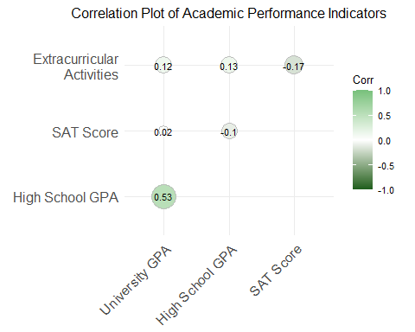

*Note.* N = 100. GPA = Grade Point Average; SAT = Scholastic Assessment Test.

## Regression Analysis

Multiple regression was conducted to predict university GPA based on high school GPA, SAT scores, and extracurricular activities. Overall, the model was significant, F(3, 76) = 11.45, p <.001, accounting for 17% of the variance in university GPA (R² =.17). High school GPA was the sole significant predictor of university GPA, β = 1.27, SE = 0.23, p <.001. The SAT scores were not a significant predictor, β = 0.16, SE = 0.23, p =.48, neither were the extracurricular activities, β = 0.30, SE = 0.23, p =.20. This model can be represented as:

$$University GPA = 7.50 + 1.27(HS_GPA) + 0.16(SAT) + 0.30(Activities)$$

|  |  |  |  |  |
| --- | --- | --- | --- | --- |
| term | estimate | std.error | statistic | p.value |
| (Intercept) | 7.50 | 0.23 | 33.28 | 0.00 |
| HS_GPA | 1.27 | 0.23 | 5.56 | 0.00 |
| SAT | 0.16 | 0.23 | 0.71 | 0.48 |
| Activities | 0.30 | 0.23 | 1.29 | 0.20 |

The model’s performance in making predictions was checked against a test set; this yielded an RMSE of 2.15 and an MAE of 1.84. Given these error metrics and considering the actual versus predicted value visualization shown in Figure 1, moderate predictive capability with some deviation from perfect prediction was depicted.

**Figure 1**  
*Scatter Plot of Actual versus Predicted University GPA*

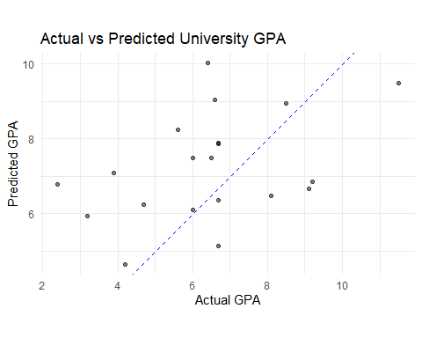

*Note:* Figure shows a scatter plot with actual GPA on the x-axis and predicted GPA on the y-axis, with points showing moderate dispersion around the diagonal line of perfect prediction

Model diagnostics-AIC = 344.99 and BIC = 356.90-and the scatter plot of predicted versus actual values indicate that although the model captures some meaningful relationships, there might be other factors that influence university academic performance not taken into consideration in this model.

These findings indicate that high school GPA is still a valid predictor of success at the university level, but SAT scores and extracurricular activities may be less valid predictors than traditionally believed. Admission officers may want to place more weight on applicants’ high school GPAs while de-emphasizing the applicant’s SAT scores and extracurricular activities as predictors of academic success.

# Conclusion

This study investigated the predictive relationships between traditional and non-traditional admission criteria and academic success at the university level. The findings yield several important implications for university admission policies and practices. The results of the analysis revealed that high school GPA is the best predictor of university academic performance, with a significant positive relationship with university GPA. Therefore, our finding is in consonance with earlier studies that academic achievements in high school serve to this day as the gold standard predictor of future success at university.

However, academic achievement or success in higher education obviously became an intricate phenomenon that our proposed model could explain no more than 17% of its variation using the variables considered here.

Surprisingly, SAT scores did not show any significant relationship with university GPA, challenging the traditional emphasis placed on standardized testing in admission decisions. This finding adds to the ongoing debate about the value of standardized testing in predicting academic success and supports the growing trend among universities to adopt test-optional policies.

Similarly, the hours spent in extracurricular activities, while showing a positive trend, did not emerge as a statistically significant predictor of university performance. This suggests that while extracurricular involvement may contribute to student development in other important ways, its direct impact on academic performance may be limited or more complex than initially hypothesized.

# References

Beatty, Adam, Paul R. Sackett, Nathan R. Kuncel, Thomas Kiger, Winny Shen, and Jana Rigdon. 2011. “Estimating the Reliability of College Grades.” American Psychological Association (APA). <https://doi.org/10.1037/e518362013-262>.

Eccles, Ronald, and Khawla Sadiq Jawad Eccles. 2006. “Placebo Effect.” *Encyclopedia of Life Sciences*, January. <https://doi.org/10.1038/npg.els.0004114>.

Kuncel, Nathan, Paul Sackett, and Matthew Borneman. 2008. “Aggregating up to Dimension Scores in Assessment Centers.” American Psychological Association (APA). <https://doi.org/10.1037/e518442013-675>.

Marsh, Herbert W., and Sabina Kleitman. 2003. “School Athletic Participation: Mostly Gain with Little Pain.” *Journal of Sport and Exercise Psychology* 25 (2): 205–28. <https://doi.org/10.1123/jsep.25.2.205>.

Marsh, Herbert, and Sabina Kleitman. 2002. “Extracurricular School Activities: The Good, the Bad, and the Nonlinear.” *Harvard Educational Review* 72 (4): 464–515. <https://doi.org/10.17763/haer.72.4.051388703v7v7736>.

McFarlane, Jameson, Thorne J. McFarlane, and Leon Bernard. 2017. “Academic Influence Of Social Network Sites On The Collegiate Performance Of Technical College Students.” *Zenodo*, April. <https://doi.org/10.5281/ZENODO.1130917>.

Rigdon, Jana, Paul R. Sackett, and Nathan R. Kuncel. 2009. “Current Look at Gender and Math Performance in Standardized Testing.” American Psychological Association (APA). <https://doi.org/10.1037/e518422013-548>.