Critique NPR

For my data, I choose all the flight track data in December from 2004-2014.

**Don’t only blame Weather in Christmas**

The first story is based on my own curious about the weather influence may affect the flight performance. As we all know, Miami is always considered as a sunny city and provides better weather condition for departure especially in December. To use control variable method, I choose Miami to control the departure weather condition. And try to find which flight route departure from Miami to the destination may be affected by weather most; I sort 2004-2014 December data by WEATHER_DELAY. The first 20 results show the flight route and delay details. They are mainly LGA, JFK,BOS EWR, which destination city is New York, Boston, Newark, Philadelphia and etc. which states or cities suffered with extreme weather.

Then I also sort the first 20 results of ARR_DELAY, which is difference in minutes between scheduled and actual arrival time. Early arrivals show negative numbers. But after sorting ARR_DELAY, on top of the list are not the north cities in snow weather, but the warm island in San Juan, Puerto Rico, which always considered a nice vacation place in Caribbean Sea. The reason cause it delay twice in 7 days (2004 Dec 21 and 28) was caused by Carrier delay. American Airlines was the carrier for those two late flights.

After control the departure city’s weather, though the destination maybe suffered the extreme weather, the reason of flight delay maybe not only about weather.

So don’t always blame weather to the delay flight, there is always many reason cause the late flight. Passengers suffered from the bad weather while they sitting in the aircraft, they should know that people in warm southern cities maybe not even see their aircraft.

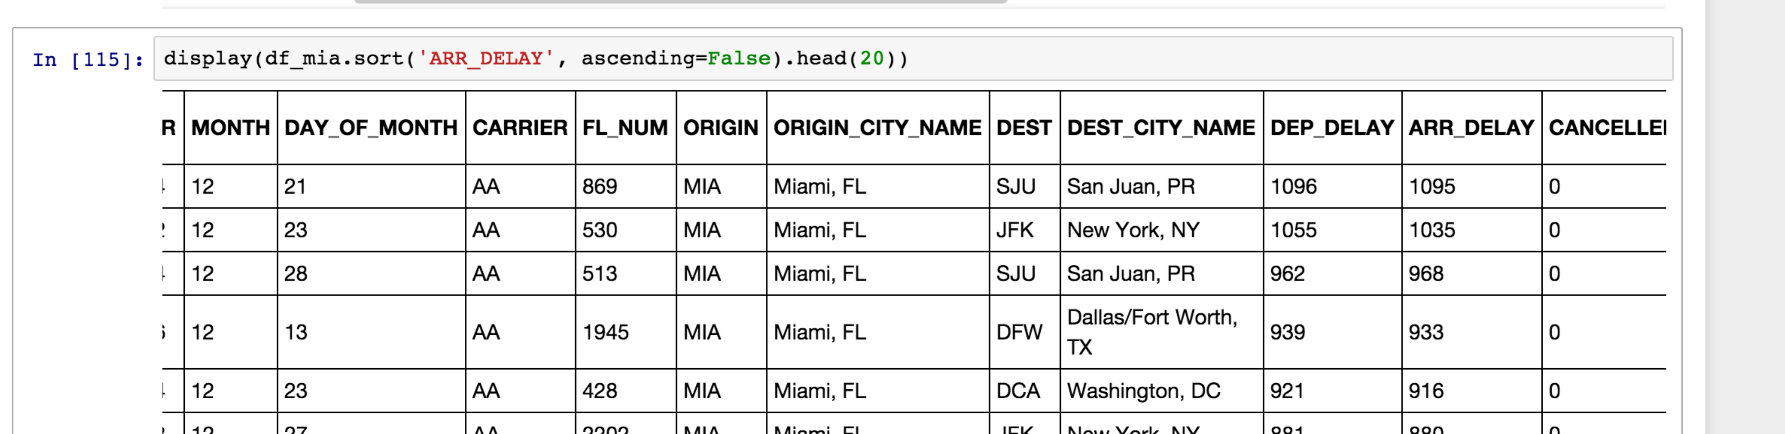

**Go All the Way North from Miami in December except New York**

For the second story, I am so curious whether the weather caused by different latitude may affect flight performance. After made 10 years ARR_DELAY (Difference in minutes between scheduled and actual arrival time. Early arrivals show negative numbers) data and reviewing every dates in Dec, the range of the delay minutes vary from destinations, and shows the latitude as the main cause.

After make the boxplots for several east cost cities, the airports in New York City were considered as the worst airports performed in last 10 years during Christmas. People departure from Miami International Airport and the range of them delay in EWR, JFK, LGA were large, and the outliers had large difference. The flight route performed unstable in the Christmas.

