Final Prototype Evaluation Report: ABE Hotel Website System

1. Admin Dashboard (Overview)
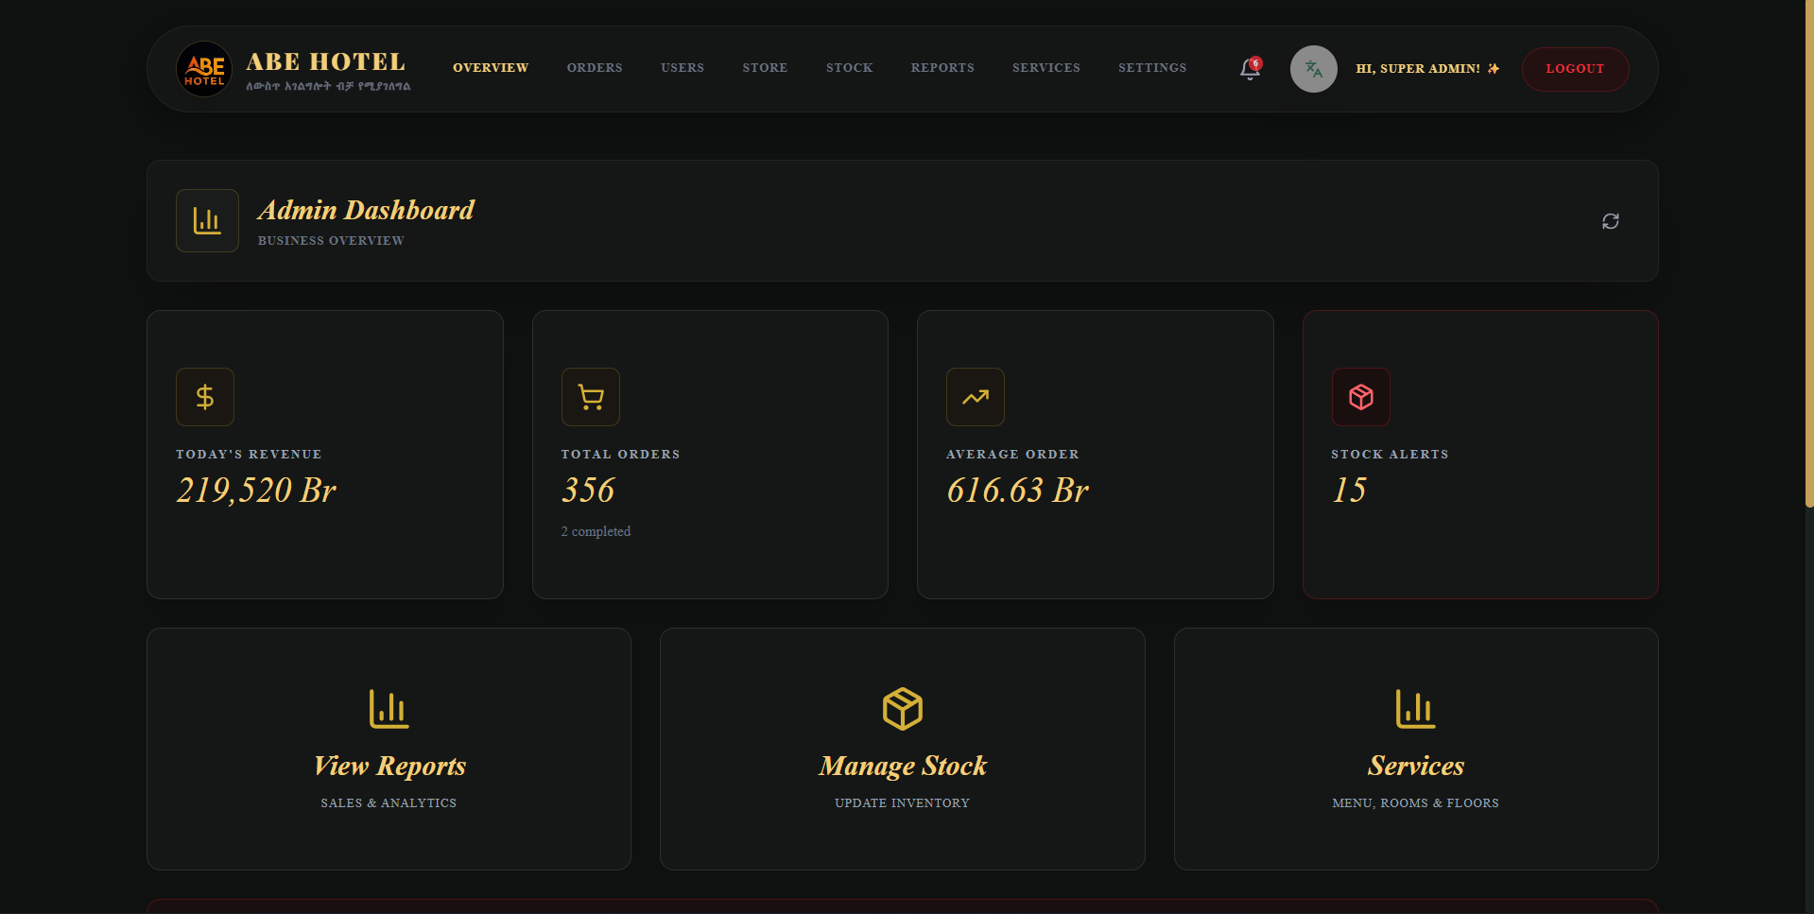
Evaluation Focus: System Command and Control
- Holistic Monitoring: The dashboard provides a high-level summary of vital business metrics, including Today's Revenue, Total Orders, and Average Order Value, allowing for immediate financial health assessment.
- Proactive Maintenance: A dedicated 'Stock Alerts' tile ensures that inventory shortages are identified before they impact operations, demonstrating the system's ability to support uninterrupted service.
- Streamlined Navigation: Direct links to Reports, Stock Management, and Services emphasize a user-centric design that minimizes clicks for core administrative tasks.

2. Order Management
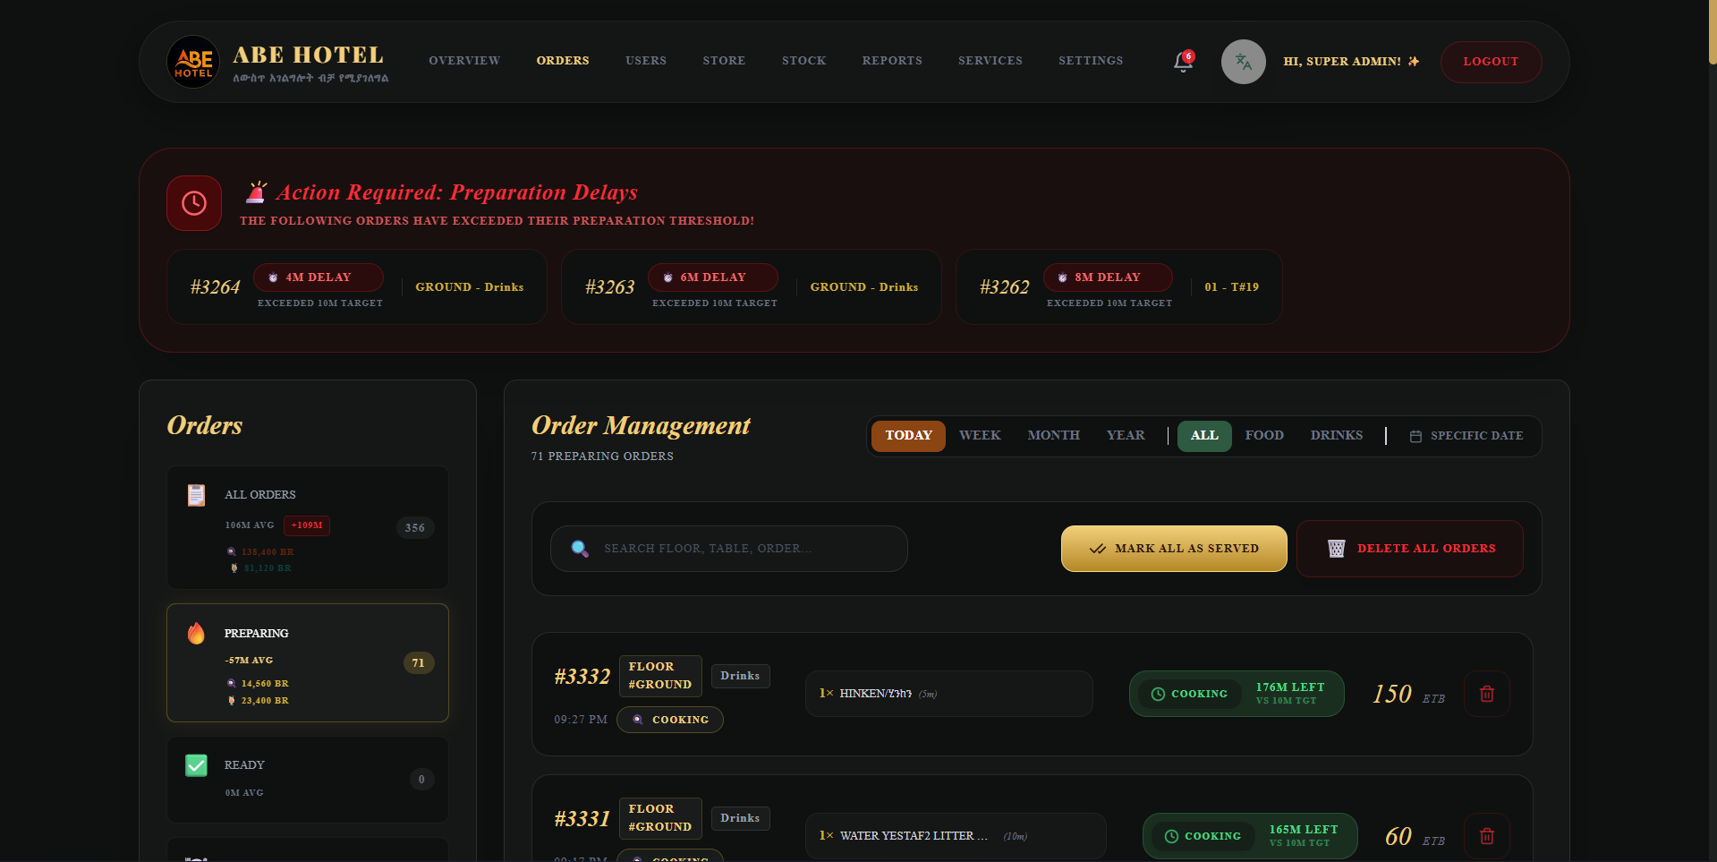
Evaluation Focus: Workflow Transparency and Efficiency
- Critical Alert System: The 'Action Required: Preparation Delays' section highlights the system's real-time monitoring capability, flagging orders that exceed time thresholds to maintain service standards.
- Granular Tracking: Each order is tracked by floor, order number, and category, providing deep visibility into the status of active transactions.
- Data-Driven Operations: Integration of average preparation times helps management identify bottlenecks in the kitchen or bar.

3. Staff & User Administration
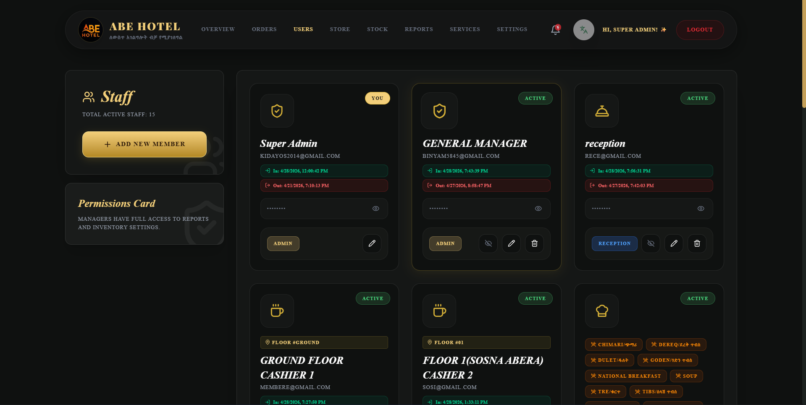
Evaluation Focus: Security and Accountability
- Role-Based Access: Clear segregation of duties between Super Admins, General Managers, Receptionists, and Cashiers, which is fundamental for internal control.
- Activity Monitoring: Real-time 'In' and 'Out' timestamps for staff members provide a clear audit trail of who is managing the system at any given time.
- Credential Integrity: Secure password masking and status indicators reinforce the prototype's readiness for secure production environments.

4. Store & Fixed Asset Management
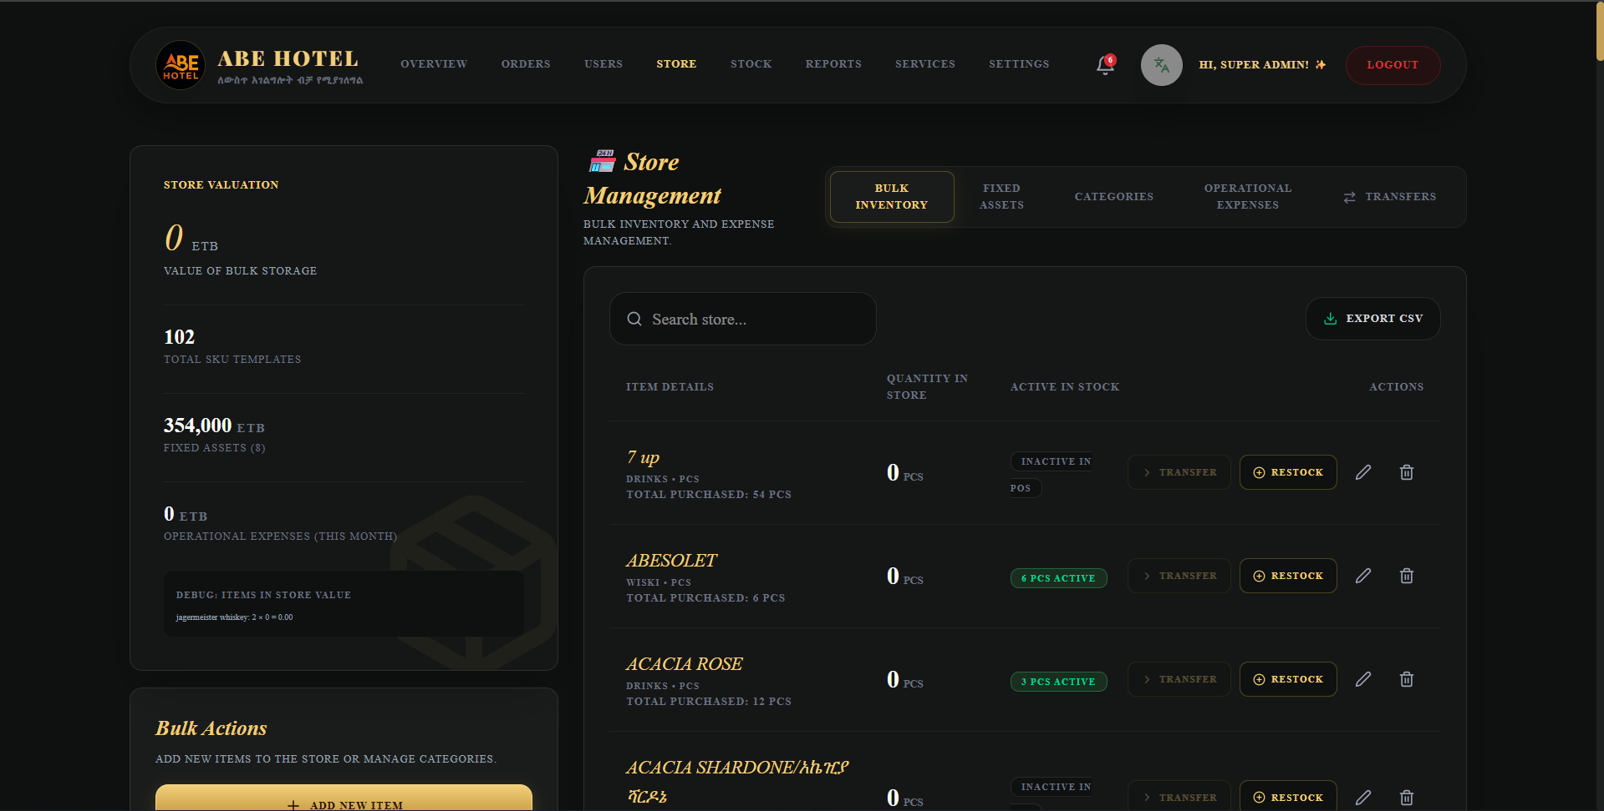
Evaluation Focus: Resource Optimization
- Integrated Asset Tracking: By combining Bulk Inventory with Fixed Asset Management, the system provides a comprehensive view of the hotel's physical capital and operational materials.
- Valuation Accuracy: Real-time store valuation supports accurate financial reporting and insurance assessments.
- Seamless Restocking: The 'Restock' and 'Transfer' functions demonstrate a smooth transition between bulk storage and active POS inventory.

5. Stock Management
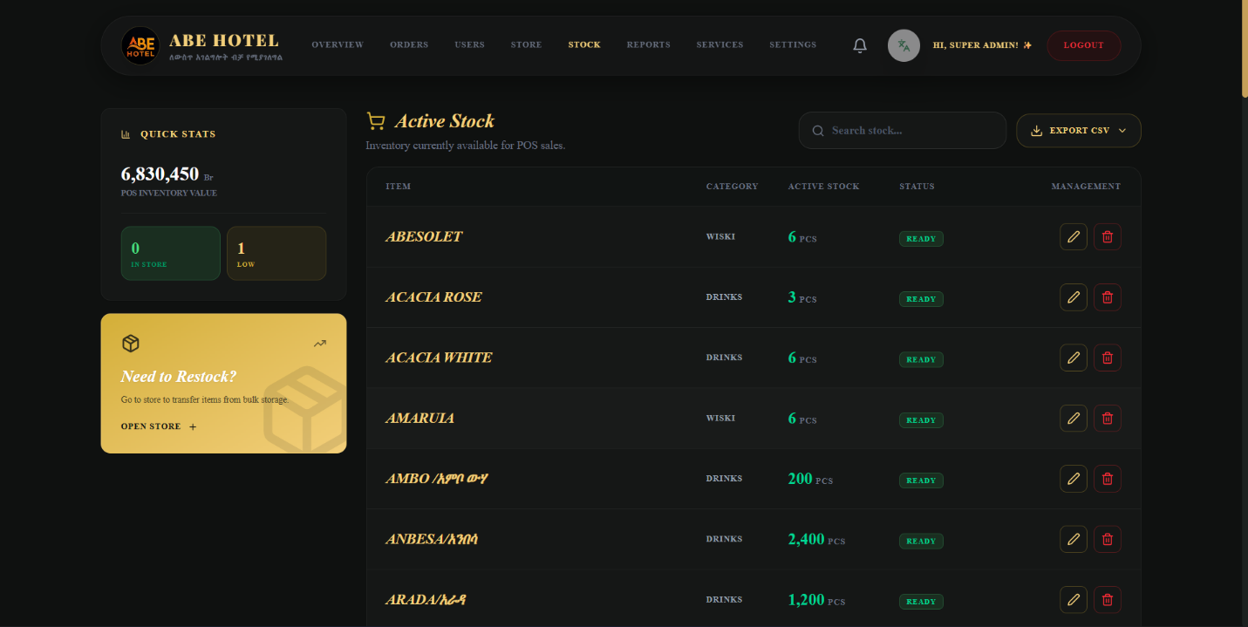
Evaluation Focus: Inventory Precision
- Real-Time Visibility: The stock list shows the exact quantity in POS, ensuring that sales staff only offer what is physically available.
- Categorical Organization: Items are grouped by type, making it easy to manage large inventories and verify physical counts against system records.

6. Financial Reporting
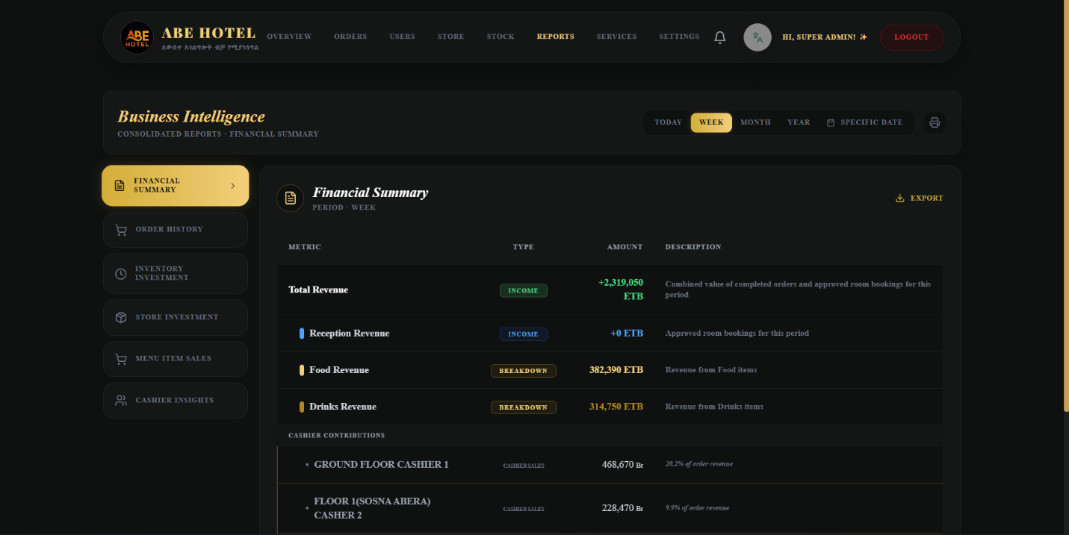
Evaluation Focus: Strategic Decision Support
- Revenue Segregation: Detailed breakdowns allow management to identify the most profitable segments of the business.
- Performance Benchmarking: The 'Cashier Contributions' report enables objective performance reviews and target setting for frontline staff.
- Flexible Reporting Periods: The ability to toggle between Today, Week, Month, and Year ensures that both tactical and strategic trends are captured.

7. Service Management
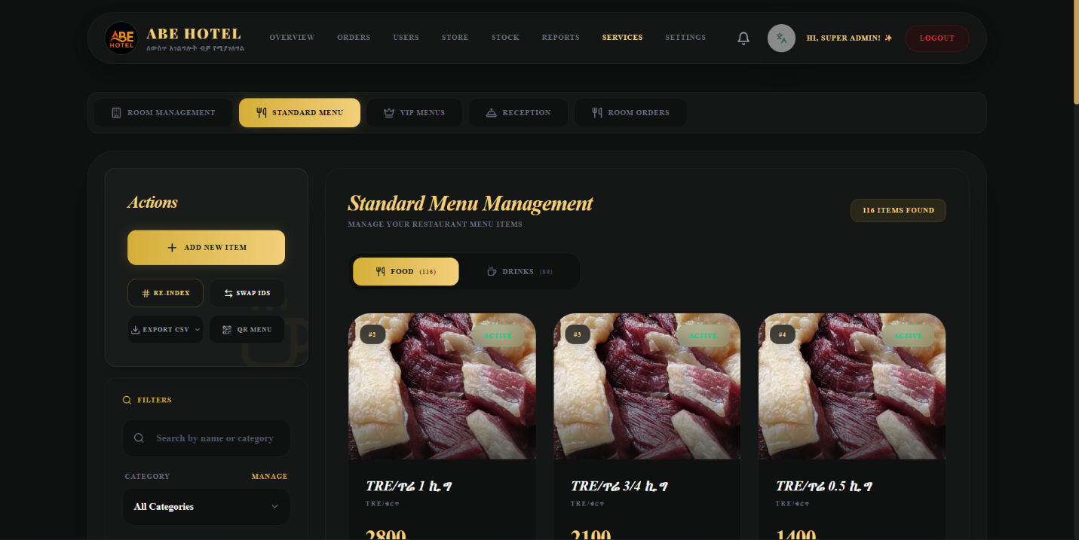
Evaluation Focus: Service Standardization
- Configurable Offerings: Demonstrates the flexibility to define and update the services provided by the hotel/restaurant, ensuring the system remains current with changing menus or room types.

8. Chef Kitchen Operations
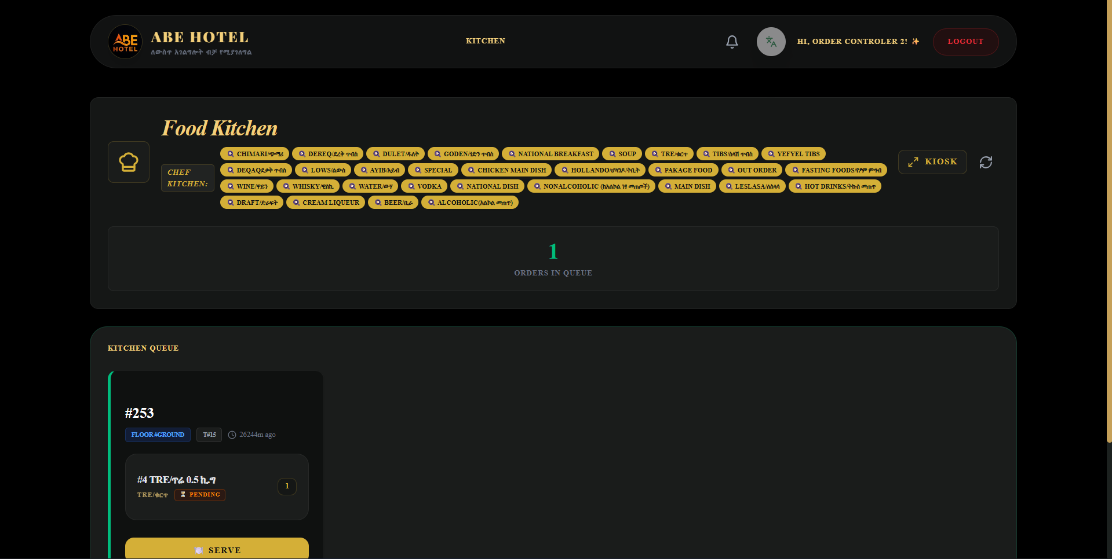
Evaluation Focus: Culinary Execution Control
- Simplified Workflow: A dedicated kitchen queue ensures chefs focus on the next priority order, reducing confusion and prep-time errors.
- Preparation Syncing: Visual status indicators keep the kitchen in perfect synchronization with the front desk.

9. Cashier POS
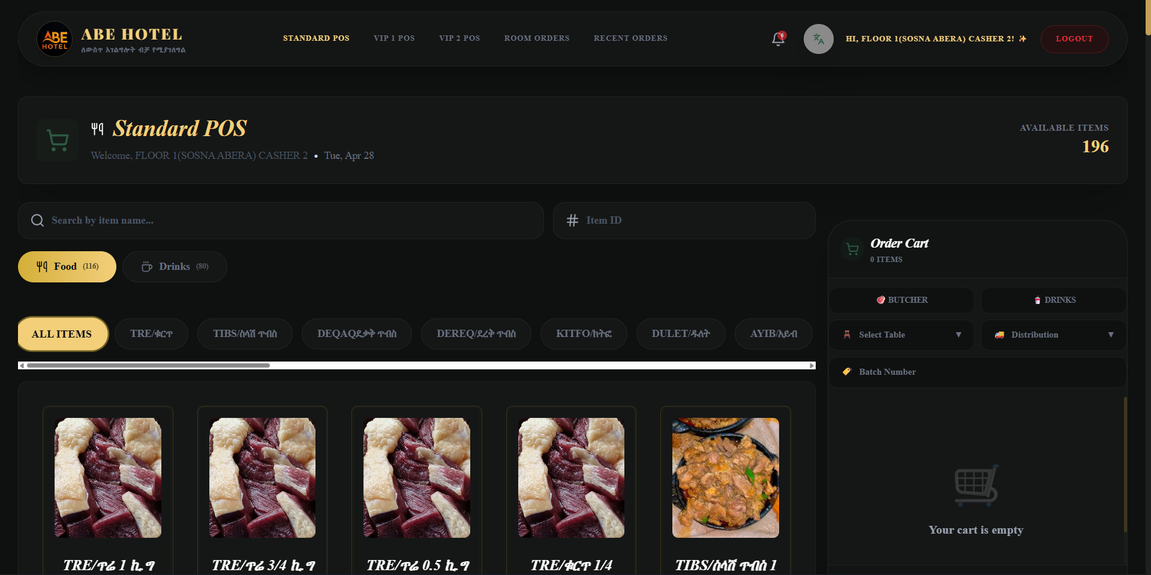
Evaluation Focus: Transactional Speed and Accuracy
- Visual POS Interface: Large, clear item cards with images and titles minimize entry errors and speed up the checkout process.
- Cart Management: A logical 'Order Cart' workflow allows cashiers to efficiently manage multi-item orders, assign tables, and handle diverse distribution needs.

