# Welcome to Tigray Martyrs' Memorial Monument Center E-DMS System

# User Manual

Prepared By: Tigray Martyrs' Memorial Monument Center

Introduction  
E-DMS system is a web-based platform that automates the storage, management and access of digital documents. Which makes searching, finding, accessing, sharing and maintaining of documents easy and efficient.

Purpose of the E-DMS Guide  
This manual should be used as a guide by all users, when using the system, uploading, maintaining, sharing and approving documents.

# Sign In

Enter <ip-address>:<port>/EDMS

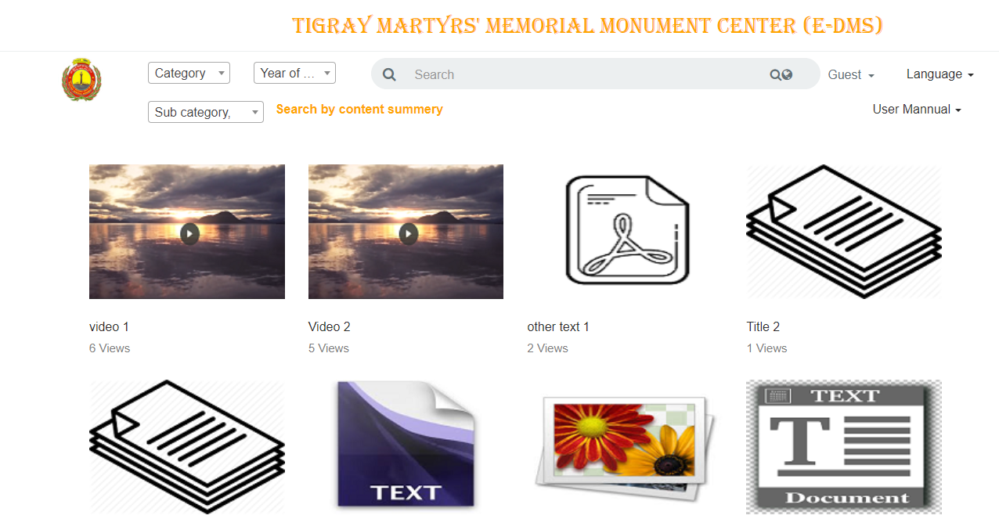

* Click Guest > Sign In link

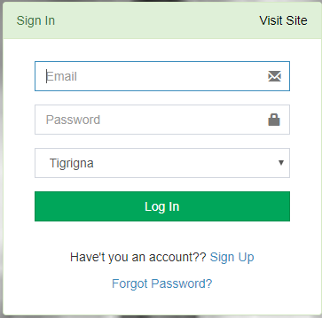

* Enter your Email or Username and Password
* Select Language
* Click “Log In” Button

# Admin Dashboard

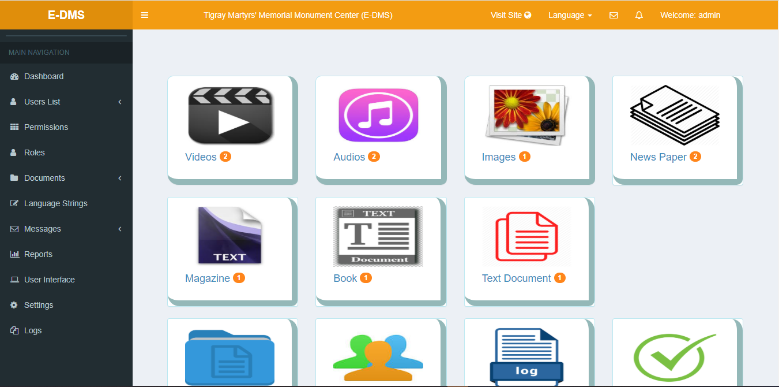

Roles  
Roles page where you can add, edit and delete roles.

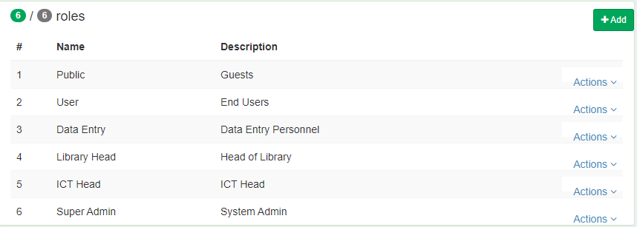

Permissions  
Permissions page allows you to assign and edit permissions to roles.

* Click Permissions Link from the Main Navigation

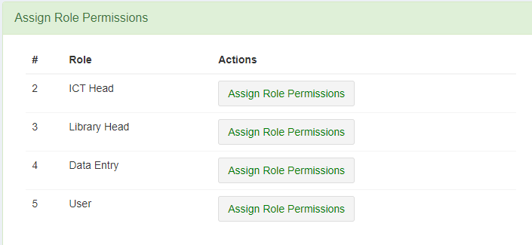

Select a Role and click on “Assign Permissions” Button

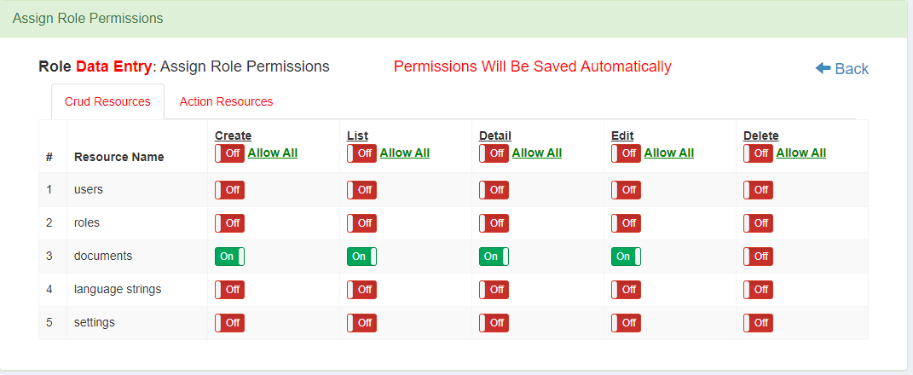

User Types(Roles):  
There are 6 kind of user type (roles) on this system listed below.  
Super Admin  
The administrator of this system who has the overall access of the system.  
Library Head  
The user of this system who is responsible for approval of document permissions. Additional actions could also granted by administrator.

# Data Entry

The user of this system who is responsible for uploading documents. Additional actions could also granted by administrator.

ICT Head  
The user of this system who is responsible for setting up the system. Additional actions could also granted by administrator.

User  
The user of this system who has signed up by its own and allowed to sign in after approved by administrator.

Public User  
Anyone who access public documents of the system with no identity.

Users  
Users page where you can add, edit, deactivate and delete users.

1. Add User

* Fill the form fields
* System generated password is pre populated
* To see or change the password click on “Show Password” Button and see/change it.
* Click “Save” button.
* Email message will be sent automatically to the provided user email.
* The user must go to his email and get his password.

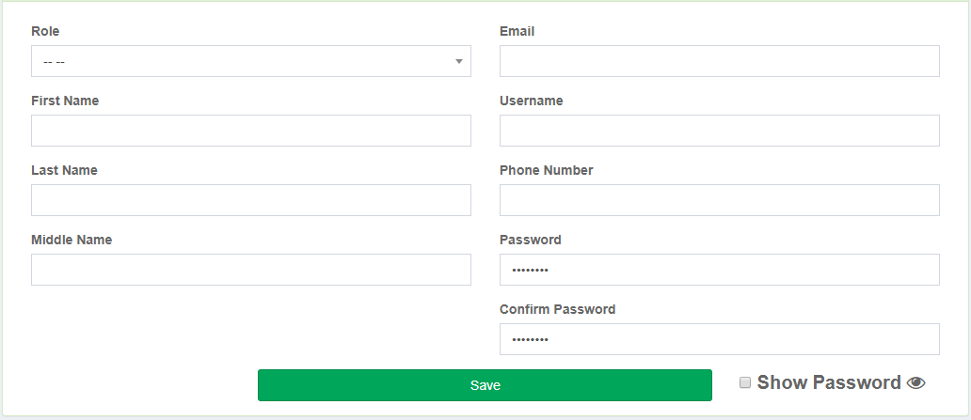

B. View, Edit, Delete and Deactivate Users

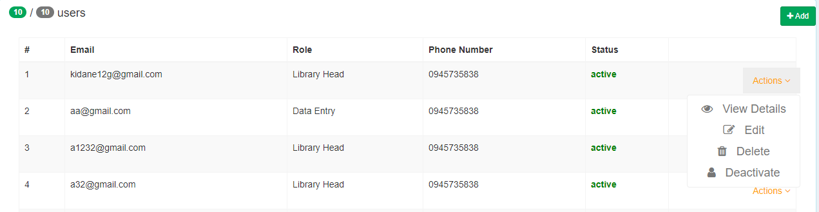

1. Approve/Reject new Users   
   Every new users should be approved by administrator before they are allowed to sign in to the system.

To Approve/Reject new users Click Users > New Users Link from the Main Navigation

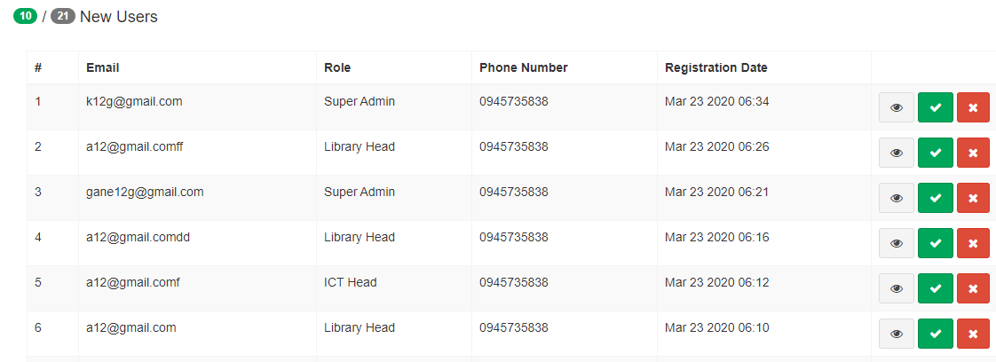

To Approve Click



To Reject Click



Document Categories:  
There are 7 document categories on this system listed below.

Video, Audio, Image, News Paper, Magazine, Book, Other Text Document

Document Sub Categories:  
There are 5 document sub categories on this system listed below.  
Entertainment, Economic, Sport, War and Other

Documents  
Documents page where you can upload, search, view, share, and delete documents.

* Click Documents link from the Main Navigation

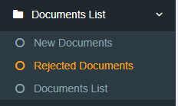

1. Documents List

* You can filter documents by title, author, publisher and year of publishment



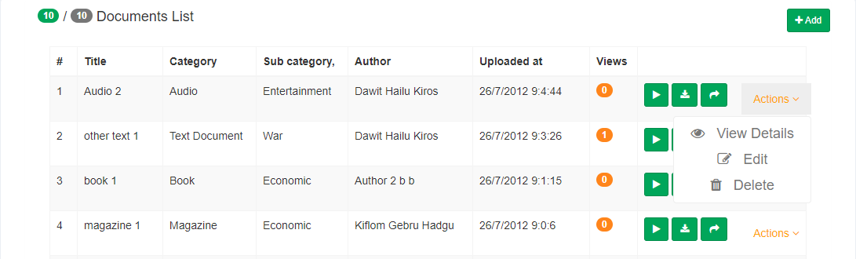

1. Upload New Document

* Click on “Add” Button and document upload form will be displayed

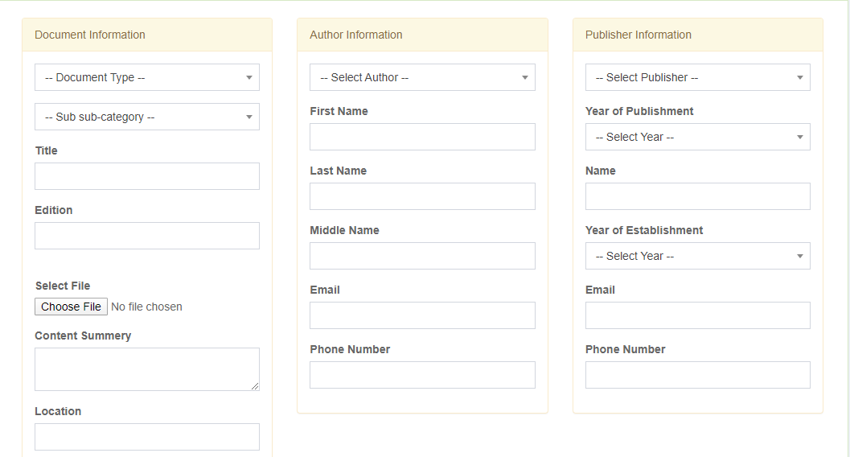

1. Approve/Reject New Uploaded Document

* Click on New Documents Link from the Main Navigation

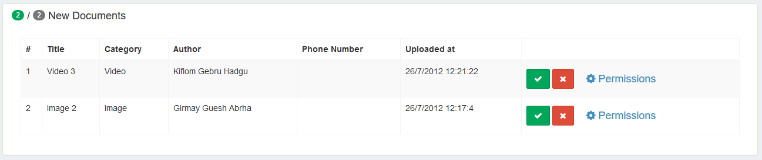

N.B before approving/rejecting of any document. Approval of its permissions is required. To do so.

* Click on “Permissions” Link from the Main Navigation 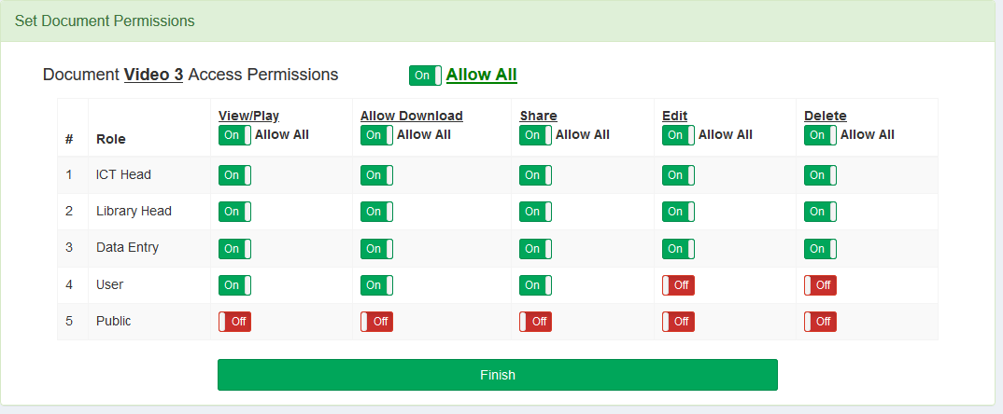

After setting the appropriate document permissions to each role, click “Finish” Button. Now you can Approve/Reject the document.

* To See document details click



* To Approve click



* To Reject click



1. View Details

Click on Actions > View Details button

1. Edit

Click on Actions > Edit

1. Delete

Click on Actions > Delete

1. Play



1. Download



1. Share



# Language Strings

Page that allows you to change phrases and their translation in Tigrigna, Amharic and English

* Click Language Strings Link from the Main Navigation

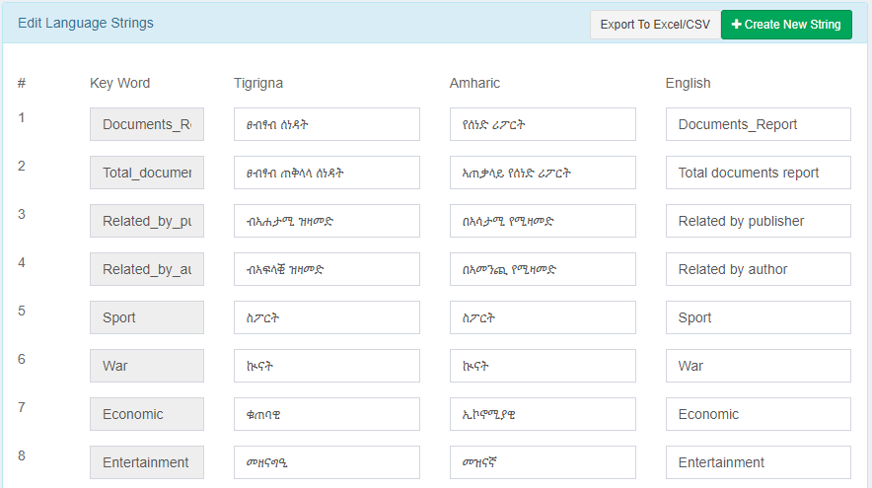

# Messages

Allows inter messaging of users with each other within the system, It enables them to send and receive messages. Shows notifications for unread messages



* Click Messages Link from the Main Navigation

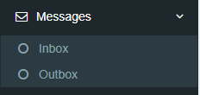

* To see inbox messages click on Inbox
* To see outbox messages click on Outbox

# Reports

Allows to generate report and print as PDF or download Excel.

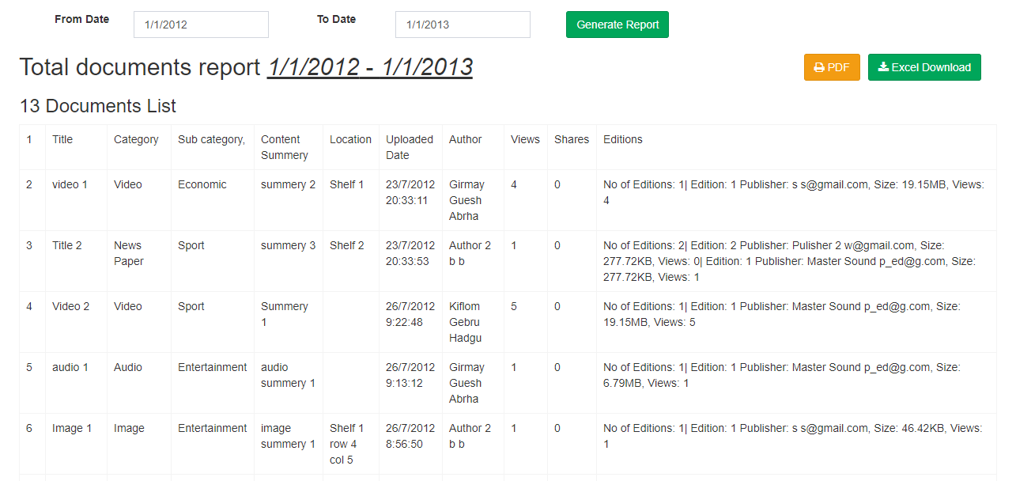

# User Interface

To update User Interface of the system i.e. App Name, Logo, Background Image

* Click User Interface from the Main Navigation

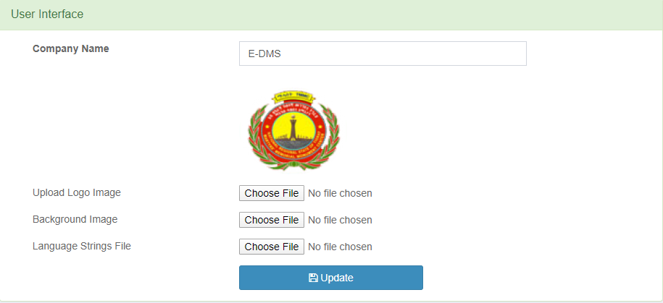

# System Settings

Allows to update system settings

* Click Settings Link from the Main Navigation

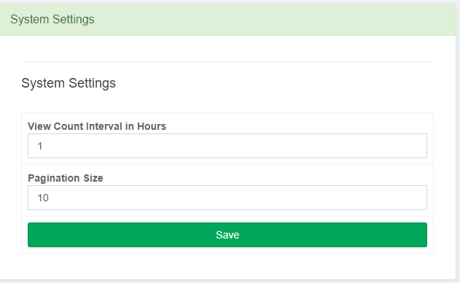

# Logs

Allows to track activities performed within the System.

* Click Logs Link from the Main Navigation

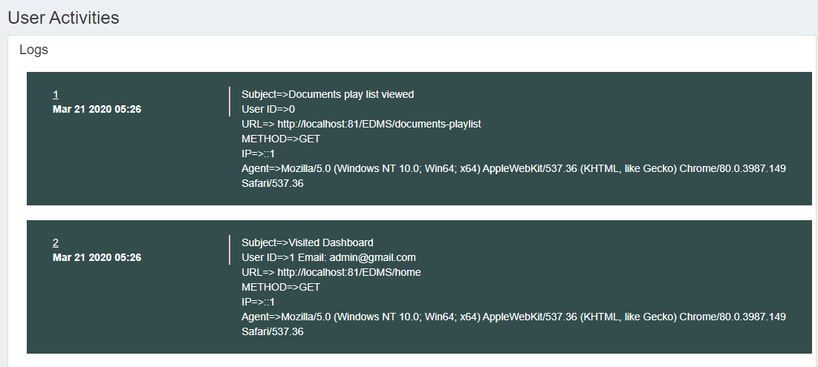

# Visit Site

To visit the public pages of the system and play/view their document contents

* Click on “Visit Site” Link from the Top Navigation.



All permitted documents will be available on the document gallery and you can play, download, and share according the document permissions.

# Change Current Language

To change the current language

* Click on “Language” link and choose the one you are interested in.

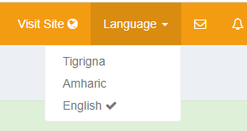

# Change Account Profile

To change your account profile

* Click on the link showing your name and click on “Profile Settings” link.

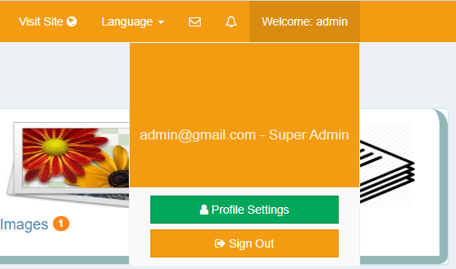

Here you can change your Username, Full Name, and Password

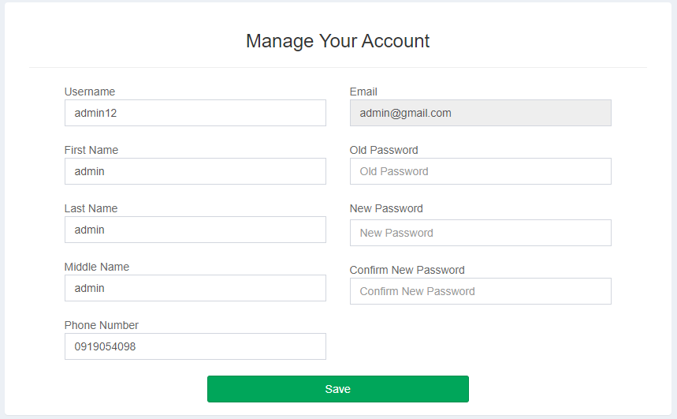

# Sign Out from the system

After finished your tasks you need to sign out from the system.

* Click on the “Sign Out” Button.



# For Public Users

Everyone who has access the system url can access public documents. And can play/view, download and share them when permitted. You can find specific document by filtering by Title, Author, Publisher, Year of publishment, Category, Sub Category and Content Summery.

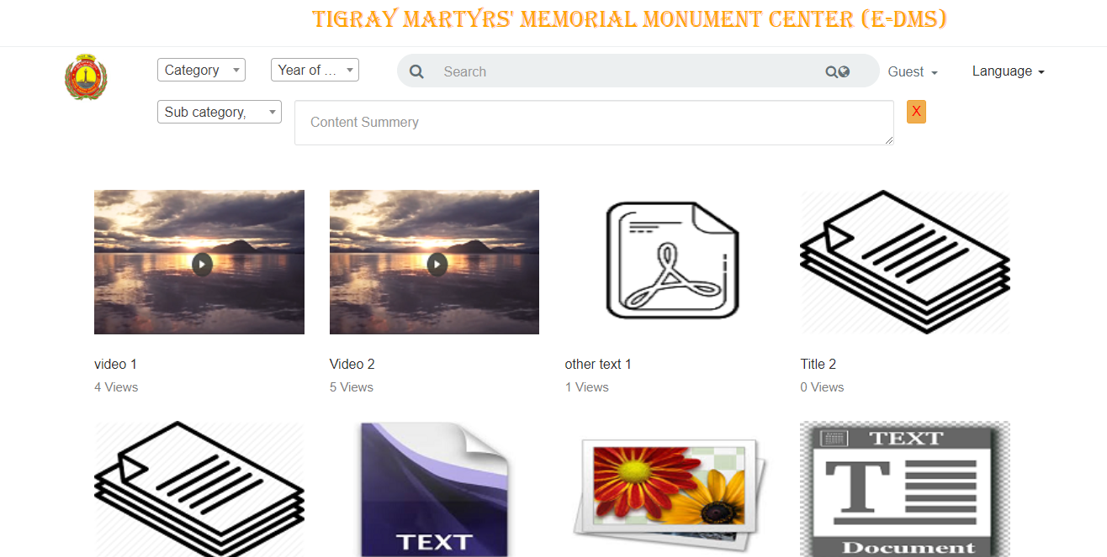

# Sign Up

Public users can also have identity by registering themselves using the sign up option. And after approved by administrator their account will be activated and allowed to Sign In.

To sign up

* Click on Guest > Sign Up link

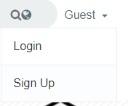

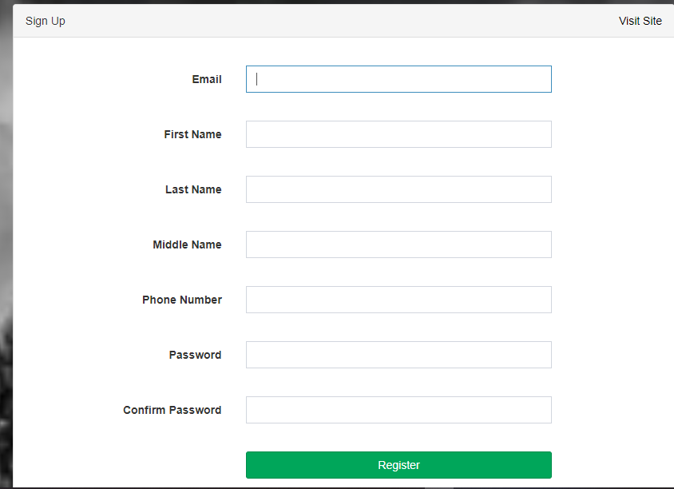

* Enter your details and click “Register” button.
* Now if you don’t get any errors, you are successfully registered and wait for your account to be approved by administrator
* Sign In with your credentials, if your account is approved by administrator you will be Signed In and it allows you to set your Username.
* But if your account is not approved yet, you will get “account not activated” message.