Product description:

App name: Quizzy

Background:

This project was part of my study at Seattle central college for Android development class. The aim of the project is to create an application to test users on the subject matter in this case Android programming.

Issue: Preparing electronic quiz for the students

App description: The app I created named “Quizzy”. It will run on Android mobile phones. The user will select either true or false for the given question that is displayed, If the user answers the question correctly it will display a message saying the answer they have picked is correct, if the answer is incorrect it will display a message saying it was incorrect. The user can forward to the next question or go back to the previous question using the "back "and "forward" buttons. The questions can be anything but for this particular project, the user will be tested about computer programming. I will use the Android Studio to create it.

Process

Interface: The interface is very simple. It contains image textboxes and buttons. For this particular project we use arrays to have the questions but in the future it can be upgradable and can have features like connecting to databases to retrieve the questions, registering score of the user etc.

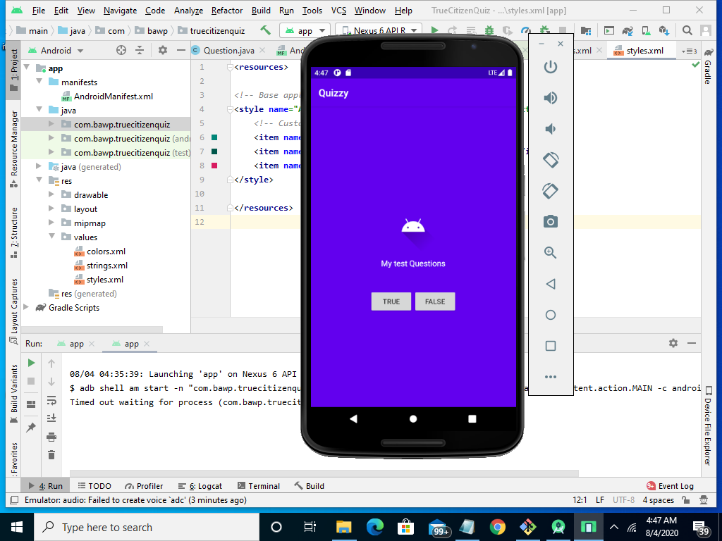

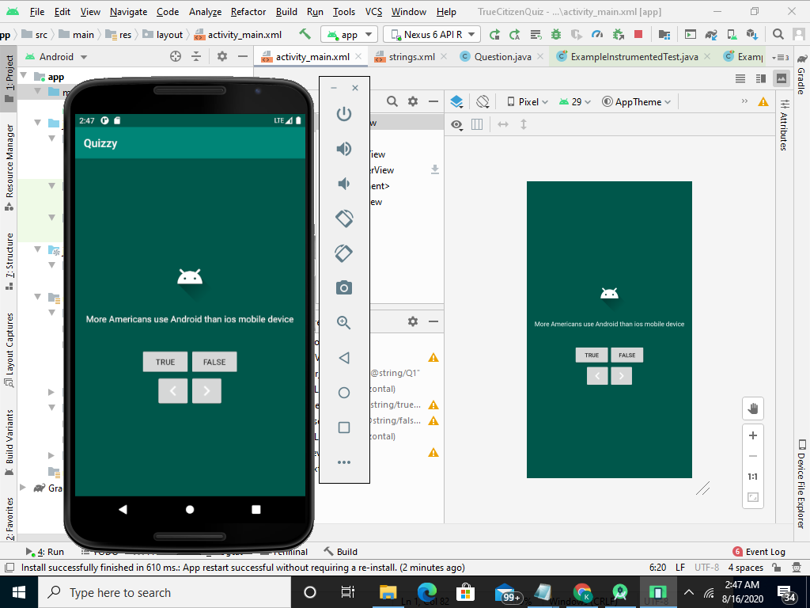

Result

