Project: There’s an App for That!

Project Plan Document



**Shade Leaf**

**Engineering & Consulting**

Project: There’s an App for That!

Joshua Kidder, Team Lead

Syed Asghar

Mack Najorka

DeVry University

Author Note

This paper was prepared for CEIS390

taught by Professor D. McCann

Project Week #: 8

DEC 19, 2020

**Table Of Contents**

1. Executive Summary ……………………………………………………………………………………………………….…………………………………………3

2. Project Charter ……………………………………………………………………………………………………………………………………………………...9

3. Project Scope Statement ………………………………………………………………………………………………………………………………………..24

4. Work Breakdown Structure/Project Schedule ………………………………………………………………………………………………………63

5. Risk Management Plan …………………………………………………………………………………………………………………………………………….67

6. Project Budget and Resource Management Report …………………………………………………………………………………………………71

7. Communications Management Plan …………………………………………………………………………………………………………………………78

8. Project Update Summary …………………………………………………………………………………………………………………………………………95

9. Individual team member lessons learn (one page per team member) ………………………………………………………………………..96

10. Journal Log Table …………………………………………………………………………………………………………………………………………………97

REFERENCES ……………………………………………………………………………………………………………………………………………………………………104

# Executive Summary

Founded in 1603, Green Man’s Pantry brings only authentic vegan goods, with a touch of ayurveda practices. From his own flurry of leaves,

the company regularly introduces innovative plant-based alternatives, offering an assortment of products from all countries of the world, to

their customers, that include various kinds of plants, plant milk and creams, seeds, mayonnaise, dressings, mock meat, fish substitutes, breads,

pastries, vegan cheeses, chocolate, sweets, coffee, toiletries, cosmetics and food for domesticated animals—ranging from protein products,

breakfast items, chilled goods and frozen food. All products are strictly plant-based as well as being certified organic.

Green Man’s Pantry has partnered with Shade Leaf Engineering & Consulting, an ambitious and innovative start-up organization, providing

competitive cutting-edge technologies and aiming to streamline EDI applications and processes for cliental in need of customizing their order

management, billing management, inventory management, logistical management, and customer, personnel management. Our vision is a

unified, effective web application presence, with modern visual designs and information architecture that encourages positive and rewarding

interactions. The software product will be designed and created by Joshua Kidder, Simple Software Engineer; Syed Asghar, Software Engineer;

Jim Brank, Software Engineer; and Mack Najorka, Software Engineer—Students at DeVry University, BA of Software Programming—to

meet the client’s need of this segment. Shade Leaf Engineering & Consulting was formed as an Ohio L.L.C by founder and owner Joshua

Kidder, Simple Software Engineer; Students at DeVry University, BA of Software Programming and is based in Xenia.

**1.1 The Project**

The project, There’s an App for That!, seeks to improve Green Man’s Pantry order management and inventory management processes, in

addition to customer and personnel management processes, by implementing an automated mobile web application presence for the purpose

of receiving customer orders, scheduling and routing shipments, proof of delivery (process a signed receipt), creating invoices for orders and

shipments, registering invoices in accounts receivable system and post payment of receipt, by analyzing the current state of Green Man’s

Pantry manual processes and daily routines—identifying and implementing critical improvements that encourages positive user interactions,

and establishing policy and standards for application platform management, design, content, presentation and development—developing a

modern, compelling user-friendly interface design and set of design templates.

**1.2 Milestones**

Several milestones have been established and will act as a set of goals and a tracking mechanism for achieving the goals. While

the milestones are initially static; they can be dynamic if needed. The accompanying table lists important project milestones,

with estimated dates of completion. The milestone schedule indicates out emphasis on planning for implementation.

|  |  |  |
| --- | --- | --- |
| Milestones | Start | Finish |
| Green Man's Pantry Portal | 11/2/2020 | 11/30/2021 |
| Scope | 11/2/2020 | 12/18/2020 |
| Analysis/Software Requirements (Phase 1) | 12/21/2020 | 1/8/2021 |
| Purchasing (Phase 1) | 1/11/2021 | 1/15/2021 |
| System Design (Phase 2) | 1/18/2021 | 3/31/2021 |
| Physical Design (Phase 3) | 4/1/2021 | 4/16/2021 |
| Mobile Application Coding (Phase 4) | 4/19/2021 | 6/30/2021 |
| System Testing (Phase 5) | 7/1/2021 | 7/30/2021 |
| User Training (Phase 6) | 8/2/2021 | 8/13/2021 |
| User Documentation (Phase 6) | 8/16/2021 | 8/27/2021 |
| System Installation (Phase 7) | 8/30/2021 | 9/15/2021 |
| Pilot (Phase 8) | 9/16/2021 | 10/15/2021 |
| System Deployment (Phase 9) | 10/18/2021 | 11/19/2021 |
| Post Implementation Review | 11/22/2021 | 11/30/2021 |
| Software development template complete | 11/30/2021 | 11/30/2021 |

**1.3 Business Need**

Green Man's Pantry, and its Stakeholders, have chosen to replace its ERP system, and move into a modern EDI approach of

handling their procurement platform, with use of mobile application technology, providing planning and project management,

sourcing and contract management, supplier management, order management, invoicing management, shipping management,

audit logs, and custom reports, optimizing the business processes of Green Man's Pantry by primarily integrating mobility,

cloud services, and database technologies into business processes through the production of web-based applications that will

be targeted for tablet and mobile use, as well as a web-based portal—partnering with Shade Leaf Engineering & Consulting, to

streamline the process to reduce financial overhead, and so that supplier issues can be tracked more efficiently through a single,

easy to use interfaced, web portal—with Tablets & Smartphones being the critical platforms.

This project will reduce operational overhead and help eliminate redundant and inefficient workforce, while also speeding up

order processing response times, improve invoicing and shipment tracking, generate custom reports, sync sourcing opportunities,

and manage supplier information, projecting a substantial increase in revenue, while also increasing Shade Leaf Engineering &

Consulting's presence within the industry. The mobile application will allow real-time updates of customer information, shipment

delivery, and order tracking so real-time changes may be performed. Making these changes on the fly, the customer will get

correct orders on time and reduce the cost of shipping, return merchandise, or losing it to spoilage or other product damages, while

eliminating the process of verifying carbon copies.

**1.4 Budget Analysis**

The project budget analysis includes complete provisions for plan-vs-actual estimates for the implementation of a new mobile

application electronic data interchange platform service—the project executive will hold monthly, and quarterly follow-up

meetings to discuss variances and course corrections. The project initially projected planned development costs of designing

new databases, software architecture for web application development, and the promotion of start-up technologies at around

$1,600,000.00—the initial budgeting management process was projected through a top-down approach where the product owner,

consultant, stakeholders, and managers planned the years project portfolio, estimating the number of resources required for

developing a rough project timeline and cost estimate, giving the project's lifecycle a kick-start with funding resources.

As the initial budgeting management process was projected through a top-down approach, the project was also moved into a

bottom-up approach, where the budgeting was refined, identifying operating system conflicts and developing detailed project

budgets, schedules and monthly forecasts, based on direct input from the not only the core team, but also the development

team--estimating actual projected costs at around $2,100,000.00. With the bottom-up approach guiding the steering committee,

the project executive will begin sending up approval requests, for funds, that have not been fully depleted on specific expense

types first, to be directed towards other expenses that may arise, such as, expenses towards project delays—the bottom-up

approach will continue over the course of the project life cycle unless a mandatory funding limit is enforced.

The accompanying table has been provided outlining the actual budgeted costs of the project, which includes refined work

packages/chunks, with accurate estimates at a detailed level. Included in the projected actual costs is a budget contingency that

is currently recognized as a separate project cost estimate type, equaling fifteen percent of the total estimated cost of the

projected software development budget that has been estimated to be accurate estimates. The idea of the budget contingency is

that if the project runs into delays, that incur additional expenses, these additional expenses can be taken from the contingency

plan, with a memo request for extension/approval, accounting for the purchase, the funds spent, and account drawn from. Any

left-over budgeting funds will start the allocation of extra funds to cover uncertainties and improve the chances that the project

can be completed within the time frame originally specified. Sometime during the system testing phase, management will

determine if additional contractor/support will be needed for architectural design of the software mobile application, for

successful project completion. If the contingency budget funds are not used throughout the software development lifecycle of

this project, then the funds will be re-allocated, into the next development phase of the web development application services,

after the completion of the mobile application development phase.

Actual Cost Projections

**1.5 Project Team Management**

In the event that conflicts arise during the development of the mobile application between personnel, the project executive will

be the first source of resolution, using tactics such as mediating conflicts employing diffusion or confrontation solutions—

arbitrating conflicts by imposing judgement on warring parties using company policies for solutions—accepting conflicts in

knowing that some personalities of project team members simply don't jive, or by eliminating the conflict by critically evaluating

the nature and severity of the conflict and either transferring the team member or removing the team member from the project

all together. The project executive understands the project has scarce resources, which may lead to differentiation among other

department leads, and uncertainty with lines of authority with the progress of development of the project. The project executive

will address all conflicts through mediation, arbitration, control, acceptance or elimination, unless the conflict cannot be resolved

and needs to be handled through an alternative functional department.

**1.6 Organizational Structure**

A strong matrix structure has been selected for this software development project. This structure is the most functional for Shade

Leaf Engineering & Consulting as Green Man’s Pantry has given full autonomy of the software development life cycle to the

independent consulting company. The lead project executive has been granted full authority over the course of the project and the

budget, so that in, not only is their mediations between executives and the software engineers, but so that the software engineers

also fall into a hierarchy management structure for reporting purposes. This will allow the project executive to control most of the

projects activities and functions, including the assignment and control of project resources, and key decision-making authority.

Though some functional managers will have some input into the assignment of personnel from their departments. This matrix

structure also allows for open communication and knowledge sharing within the work group, while also allowing employees to

communicate across the boundaries, creating a pleasant, cooperative, work environment that helps in integrating the organization.

# Project Charter

|  |  |  |  |
| --- | --- | --- | --- |
| **Project Name** | There’s an App for That! | **Project Number** | SET_96055.2 |
| **Project Team # and Name** | Team 1, Shade Leaf Engineering & Consulting | **Prioritization** | High |
| **Owner(s)** | Green Man’s Pantry.  Shade Leaf Engineering & Consulting. | **Start Date** | OCT 2020 |
| **Scheduled Completion Date** | NOV 2021 |

|  |  |  |  |  |  |  |
| --- | --- | --- | --- | --- | --- | --- |
| Mission/ Purpose | | | | Green Man's Pantry is an international vegan food distributor, specializing in both vegan and raw vegan goods with a touch of ayurveda practices, that has been using an outdated ERP system of integrated software applications across finance, human resources, procurement, distribution, and other departments. At the time, this internal process was state of the art, however over time and with increasing advances in technology, the system is becoming ever increasingly slow, is full of data processing bugs, and is unappealing, creating delays with purchase orders, shipment tracking, and invoicing of product between the company and its business partners. Green Man's Pantry, and its Stakeholders, have chosen to replace its ERP system, and move into a modern EDI approach of handling their procurement platform, with use of mobile application technology, providing planning and project management, sourcing and contract management, supplier management, order management, invoicing management, shipping management, audit logs and custom reports, partnering with Shade Leaf Engineering & Consulting, to streamline the process so that supplier issues can be tracked more efficiently through a single, easy to use interfaced, web portal--with Tablets & Smartphones being the critical platforms. The name of the project is called There's an App for That!, and the application will be called Green Man Pantry’s Portal. This new application will speed up order processing response times, improve invoicing and shipment tracking, generate custom reports, sync sourcing opportunities, and manage supplier information, projecting a substantial increase in revenue, while also increasing Shade Leaf Engineering & Consulting presence within the industry. | | |
|  | | | | | | |
| **Project Description and Project Product** | | | | Shade Leaf Engineering & Consulting’s project, There’s an App for That!, will see the creation of a software application for the client, Green Man’s Pantry, which will be called Green Man’s Pantry Portal. This application will optimize the business processes of Green Man’s Pantry by primarily integrating mobility and cloud & database technologies into the business processes of Green Man’s Pantry. The project will see the production of a web-based application that will be optimized for Tablet and Mobile use, along with a website, as part of future product design. It will have an appealing graphical user interface on all mediums, from the mobile device to the computer. The application will also be connected to database servers and will utilize cloud technologies to produce faster processing times. These faster processing times are what will produce the faster response times and streamlined processes such as invoicing and shipment tracking, and information management such as supplier information. The mobility that comes from having a system that utilizes mobile and tablet features allows for employees to access information from the database quickly and from any location. | | |
|  | | | | | | |
| Objectives | | | | This project aims to provide the client, Green Man Pantry, with an application, optimized for mobile and tablet use, with an accompanying website, that will optimize the business processes of the company. The objective will be met by achieving the following goals:   * Designing a mobile application with an appealing User Interface and User Experience   + This will include consulting with Green Man Pantry for design features to be included and potentially designing multiple templates to meet the specifications of the client. * Extending the mobile application and its interface by developing the software to also be used on a tablet * Connecting the designed application to a database server that will store company information that will include but is not limited to:   + Customer Information   + Supplier Information   + Shipment Information   + Invoice Information * Configuring cloud technologies such as Google Cloud, Amazon Web Services, or Microsoft Azure to speed up various data processing throughout the application. * Adding location services for efficient shipment and invoice tracking. * Building out a website to accompany the mobile and tablet applications for computer use. | | |
|  | | | | | | |
| **Business Need** | | | | It is the goal of this goal to reduce the financial overhead of this company and utilize modern technological practices to increase productivity in the workplace. By monitoring in the field in real time, operational deficiencies can be corrected before they cause negative impact events. By controlling all aspects of the app from the ground up, the customer will be free of expensive licensing agreements that may cause an undue burden on the liquidity of cash flow.    This project will reduce operational overhead and help eliminate redundant and inefficient workforce. The app will also allow real-time updates of customer information so real-time changes may be performed. By making these changes on the fly, the customer will get their correct orders on time and reduce the cost of shipping return merchandise or losing it to spoilage or other effects. In the field warehouse operations will ensure the proper merchandise reaches the proper truck and minimize overall costs of logistical support. No longer will paper copies have to be verified and re-verified, be prone to error or get lost for various reasons. By having a virtual copy, it will be possible to have every at the same place in every stage of product delivery.    With this app, as soon as the product is delivered, records are updated, and invoices shipped to the customer. No longer will the customer’s invoice be at the mercy of the United States Postal Service or other carrier. By utilizing a digital invoicing system, the company will save on postage and/or shipping to let the customer know when payment is expected. | | |
| **Milestones** | The project, There's an App for That!, will be submitted in accordance with the milestone schedule below. Upon approval of the project charter, resources will be assigned to the project and work will commence within three business days. The Project Executive must approve any schedule changes which may impact  the milestones. A detailed schedule will be included in the project charter. The high-level milestone schedule is:   1. Customer Specifications (10/26/20 – 10/30/20) 2. Hardware requirements (11/2/20 – 11/13/20) 3. Internal requirements (11/16/20 – 12/04/20) 4. Allocating resources (12/07/20 – 01/29/21) 5. Development (02/01/21 – 04/30/21) 6. Alpha Testing (05/03/21 – 07/02/21) 7. Beta Testing (07/05/21 – 07/30/21) 8. Customer Demo (08/02/21 – 08/06/21) 9. Final Testing (09/07/21 -10/29/21) 10. Release Date (11/1/21)   . | | | | | |
| **Budget** | The order of magnitude for this project, There’s an App for That!, including personnel charges, is $1,200,000.00, as outlined in the below chart, which are expected to be charged to Green Man’s Pantry Human Resources Department in separate monthly installments by the Project Executive to Shade Leaf Engineering & Consulting. Additional budget money will be available upon request by the Project Executive and approved.   |  |  | | --- | --- | | **Software Development Budget** | **Total Costs** | | **Development costs** |  | | Development labor | $100,000 | | Software licenses | $200,000 | | Server software | $100,000 | | 15 servers @ $12,000 | $200,000 | |  |  | | Printer | $25,000 | | Other equipment | $250,000 | | Testing | $100,000 | | Training | $25,000 | | Supplies | $50,000 | | **Total development costs** | $1,050,000 | | **Operational costs** |  | |  |  | | Hardware | $50,000 | | Software | $75,000 | | Operational labor | $25,000 | | **Total operational costs** | $150,000 | | **Total Estimated Costs** | $1,200,000 | | | | | | |
|  | | | | | | |
| **User Acceptance Criteria** | | | Green Man's Pantry has partnered with Shade Leaf Engineering & Consulting to develop a customized mobile web presence for its distribution company and trading partners. This project will be monitored and measured not only through web meetings, conference calls, and onsite meetings, but also through a waterfall/agile approach consisting of the following phases: analysis, design, code, test, display, and maintain--where not only the core team, development team, and project managers, but also the stakeholders will submit any work done towards the project through an agile framework called SPRINTS. This project will be successful when the following conditions are met:   * Analysis and Planning is completed with all personal, including stakeholders, project executive, business and product owner, subject matter experts, development team, and external consultants, to create the project plan and software requirements needed for the development of the procurement platform web portal--with requirements being fully documented. * System Design is completed, including Specialized Login Module Design, Admin Module Design, New Partner Sign-up Module Design, Template Module Design, Purchasing Module Design, Shipment Tracking Module Design, Billing Module Design, Accounts Receivable Management Module Design, Sourcing Management Module Design, Customer & Personnel Management Module Design and Reports Module Design. * Code Phase is completed, including Login Module Design, Admin Module Design, New Partner Sign-up Module Design, Template Module Design, Purchasing Module Design, Shipment Tracking Module Design, Billing Module Design, Accounts Receivable Management Module Design, Sourcing Management Module Design, Customer & Personnel Management Module Design and Reports Module Design. * System Testing is completed, including Unit Testing, Integration Testing, System Integration Testing, Functional Testing and Go Live Testing, all functionality meets client's business requirements, partners business requirements and ANSI X12 Standards for transaction sets--and all partnerships have been established between the client and its entire list of trading partners. * User can access a functioning mobile application, with account login, logout and password reset features. The web portal page should also contain informational information and the distribution company, its partners, and onboarding instructions. Name of Mobile App Widget: Green Man’s Pantry * Distributor can login to the web portal page, view partners; track partner visits; sync list of potential prospects; schedule and route shipments; track shipments, receipt of shipments, orders, receipt of orders, order delays, invoicing, receipt of invoicing, invoicing delays; manage accounts receivable, post receipt of payments; manage inventory. * Distributor can login to the web portal page, manage company personnel system privileges; verify, create, edit and delete system templates, and announcements; and view and print documents for all processes. * Partner can access the account signup page, entering user information, i.e., username/password/email; company profile information, i.e., company name, address; billing information, i.e., credit card information or invoice billing; and select document types that will be processed to the distributor, i.e., 850, 875, 810, 880, 856, 997, etc. * Partner receives a system response, auto-generated email, that informs them of the account signup being completed and that additional training documents will be received shortly. * Partner can login to the web portal page, manage company personnel system privileges; verify, create, edit and delete system templates, and announcements; begin sending purchase orders, track shipments, receive invoices and view and print documents for all processes. * User documentation and training standards for navigation, accessibility, and compliance, containing policies, business partner requirements, ansi standard requirements and governance regulations are developed, along with side sets of documentation with recommended priorities of future development works. | | | |
| |  |  |  | | --- | --- | --- | | **High-Level Project Assumptions** | | The following project assumptions are to be considered for the project There’s an App for That! and its associated application, Green Man Pantry’s Portal:   1. The company will have sufficient funding. 2. The company will have necessary resources when needed. 3. Individuals will have access to resources without delay so that tasks may be completed on time. 4. Costs will not change during the project cycle. 5. Equipment will not break during the project cycle. 6. There will be enough customers who want the product. 7. Laws and regulations will remain the same through the project cycle and will not cause the scope to change. | | **High-Level Project Constraints** | The mobile application platform program is expected to expedite processes and provide synergies just in time for the holiday season and must be functioning and online by NOV 2021. The platform will move through several phases of development: analysis, design, code, test, display and maintain. Design and development of the mobile application platforms user interface, credentials, template module design, purchasing module design, shipment tracking design, invoicing module design, accounts receivable management design, sourcing management design, trading partner and personnel management module design, reports management module design, and all partnerships must be established through valid ISA & GS IDs between the client, before formal approval of user  documentation and training initiatives. High-level constraints are listed below:   1. Project Timeline – In time for the next holiday season, i.e., NOV 2021 2. Project Budget 3. Labeling Laws – Many states have passed laws regarding the labeling of plant-based foods. These include Alabama, Arkansas, Kentucky, Louisiana, Mississippi, Montana, North Dakota, Oklahoma, South Carolina, South Dakota, and Wyoming have all passed labeling laws restricting the use of the term meat. In many cases, violations could lead to criminal prosecution. User interfaces would need to restrict the use of meat-based names in the product name and keeping this current and up to date is critical under the Federal Food, Drug, & Cosmetic Act (FDCA). 4. Certified BeVeg - The client, Green Man's Pantry, is vegan certified. The client will need to produce up-to-date certification documents and submit them as part of the project. Certified BeVeg will need to be promoted, as well as implementing validation restrictions into the client's mobile application program as needed regarding regulations and laws, while also only using approved graphics by BeVeg. Informational at beveg.com 5. Certified Vegan - The client, Green Man's Pantry, is vegan certified. The client will need to produce up-to-date certification documents and submit them as part of the project. Certified Vegan will need to be promoted, as well as implementing validation restrictions into the client's mobile application program as needed regarding regulations and laws, while also only using approved graphics by Vegan Action. Information on vegan certification be found on Vegan.org and does have costs as shown below:  |  |  |  | | --- | --- | --- | | Fee Band | Annual Revenue | Annual Fee | | A | Up to $15000 | $150 | | B | Up to $100,000 | $250 | | C | Up to $250,000 | $400 | | D | Up to $500,000 | $600 | | E | Up to $999,000 | $1000 | | F | Over $1 Million | $2000 | | G | Up to $10 Million | $3000 |  1. Certified Vegan Society Trademark - The client, Green Man's Pantry, is vegan society trademark certified. The client will need to produce up-to-date certification documents and submit them as part of the project. Certified Vegan Society Trademark will need to be promoted, as well as implementing validation restrictions into the client's mobile application program as needed regarding regulations and laws, while also only using approved graphics by Vegan Society Trademark. Informational at vegansociety.com 2. Certified Organic - The client, Green Man's Pantry, is organic certified. The client will need to produce up-to-date certification documents and submit them as part of the project. Certified Organic awareness will need to be promoted, as well as implementing validation restrictions into the client's mobile application program as needed regarding regulations and laws, while also only using approved graphics by USDA. Informational at usda.gov 3. Certified Ayurvedic Chefs/Culinary Artists - The client, Green Man's Pantry, has incorporated certified ayurvedic chefs/culinary artists into its production processes, to use the healing power of food to bring health and wholeness to everybody. The client will need to produce up-to-date certification documents and submit them as part of the project. Certified Ayurvedic Chefs/Culinary Artists will need to be promoted, along with regulations and laws, while also only using approved graphics associated with the practice of Certified Ayurvedic Food Handling. 4. Quality Control  * Screen size, sensors and interactions - Mobile devices have small screen sizes, though tablets are moving to more laptop size screens. There are limited canvas spaces with some mobile devices, meaning the use of typing could be viewed as an inconvenience, with limited space and touch interactions of different elements. Other formatting variations to display content will need to be considered and planned for. * Network issues - The mobile product will have to contend with network latencies and failure points. To contend with these types of issues and increase a positive user experience will need to avoid blocking spinners and ensure the platform and design permits loading partial elements and cached data to keep the user occupied while waiting. The design platform will also need to optimize for walking in and out of Wi-Fi zones as this affects not just the software on the phone, but also the backend that supports the application. * Application updates - Making updates are incredibly hard for mobile applications, even the tiniest of changes. It's known that shipping even the smallest change takes on average of seven days to be approved by Apple. Also, the data sits client side, meaning users must go in and download the updates manually. If changes don’t perform as expected (driving wrong user behaviors, introducing bugs, etc.), fixing the issue immediately can be extremely difficult, in addition to waiting for additional review processes and slow user adoption.  1. Customer Satisfaction 2. Slow deliveries of product could impact timelines 3. Prices on resources could shift due to a volatile market 4. EDI transactions with the United States must conform to X12 EDI standards and require compliant, quality software for translation. These standards allow companies to communicate and transfer documents from business-to-business without incompatible software or unsecure connections that leave proprietary data vulnerable to outsiders. The five functional transaction sets and subsets include: communications & control, finance, transportation, supply chain and insurance--with subsets defined as HIPAA - Health Insurance Portability and Accountability Act, UCS - Uniform Communication Standard, VICS - Voluntary Interindustry Commerce Standards, AIAG - Automotive Industry Action Group, CIDX - Chemical Industry Data Exchange, EIDX - Electronics Industry Data Exchange Group (CompTIA) and PIDX - American Petroleum Institute. The client, Green Man's Pantry, at this time is assumed to fall under the grocery industry subset UCS - Uniform Communication Standard, however further analysis will need to be completed. | | | **Exclusions and Boundaries** | | The following exclusions are to be considered for the project There’s an App for That! and its associated application, Green Man Pantry’s Portal:   * Green Man Pantry’s Portal will not be a communication application. The only exchange between suppliers and customers is through invoice information and tracking information. Further communication must be made through other means. * Green Man Pantry’s Portal’s Initial builds will not include high-level business analytics. The portal is being designed primarily for business tracking and mobile access. Future builds could see analytics implemented but initial builds will not see that feature. * Green Man Pantry’s Portal’s Initial builds will not address internal company workings for departments such as Human Resources. Its primary focus will be incoming and outgoing business processes. Future builds may add in multi-department features; however, initial builds will not do so. * Green Man Pantry’s Portal’s Initial builds will not include Auto-AI features such as automatic order replenishment. Future builds could see implementing certain AI features in steps, but initial builds will not include this feature. * Green Man Pantry’s Portal will not serve as a shopping marketplace. The application is being designed as a business tool to serve the distributor. For all end customer and retail front needs, a separate site should be available, not provided through the project portal. * Green Man Pantry’s Portal’s Initial builds will not include any marketing features, including the use of any social media, or entertainment features. * Green Man Pantry’s Portal’s Initial builds will not include offline viewing and download abilities. In order to keep data displaying with real-time accuracy, the system must be connected online to be able to access the databases accordingly. Future builds may see the addition of this feature; however, initial builds will not include it. * Green Man Pantry’s Portal’s visibility for third party services, such as brokers or third-party logistics, will be limited by the level of integration of these third-party service-providers. | | | | | | | |
| **Major Risks** | | | The following major risks are to be considered for the project There’s an App for That! and its associated application, Green Man Pantry’s Portal:   1. Catastrophic Risk – i.e., Hurricane, Flash Flood, Forest Fire, Tornado, etc. destroys the facility, delays shipments, delays processing of orders/invoices 2. Loss of Interest in Vegan Products, not enough resources for plant-based foods due to waste of edible plant products of field yielders 3. Choosing the wrong methodology and failing to see certain limitations 4. Possibility of state shutdown, COVID, etc. 5. Product could become contaminated 6. State could issue recalls on product 7. Limited supplies | | | |
|  | | | | | | |
| KEY STAKEHOLDERS | | | | | | |
| **Project Executive Authority Level** | | The **Project Executive** has ultimate authority over the project. The project executive leads the team in planning and implementing the project from initiation to closure. The responsibilities include providing resources, scope and change management, keeping the project plan current (deliverables, schedule, and resources), issue and risk management, maintaining project documents, reporting project status, facilitating conflict resolutions within the project and between cross-functional teams, help resolve escalated issues, approve scope changes, approve major deliverables, and provide high-level direction.    **Name: Joshua Kidder – Project Executive** | | | | |
| **Project Core Team** | | **Core Team Members** are accountable for ensuring successful contribution for defined area of responsibility, representing their functional area for project activities and are the functional representatives responsible for project decisions, ensuring cross-functional representation and collaborative project execution. The responsibilities include making project-level decisions on behalf of their function or area of expertise, enlist the support of other resources and from extended teams, negotiate functional resource needs and assignments, provide leadership and direction to extended team members and maintain responsibility for functional area's performance and budget. | | | | |
| **Project**  **Development Team** | | **Core Dev Members** are accountable for designing and building software products required by the product holder and stakeholders, as well as providing functional and subject matter expertise as needed, executing project tasks in accordance with the project plan, rendering professional opinions outside the core competencies of the core team, working closely with colleagues, sharing best practices, and working together to resolve issues. These responsibilities include planning, testing, analysis, programming, throughout the course of the project, up-to including multiple aspects of the software development process.  **Name: Joshua Kidder - Architecture Owner; Joshua Kidder - Agile Team Leader; Joshua Kidder, Syed Asghar, Jim Brank, Mack Najorka - Development Team Members; Joshua Kidder, Syed Asghar, Jim Brank, Mack Najorka - Specialists** | | | | |
| **Subject Matter Experts (SMEs)** *(What resources will you need with special expertise?)* | | **Subject Matter Experts** are accountable for providing the knowledge and expertise in a specific subject, business area, or technical area for the project, ensuring the facts and details are correct so the project's deliverables will meet the needs of stakeholders, legislation, policies and standards; as well as executing project tasks in accordance with the project plan, rendering professional opinions outside the core competencies of the core team and development team, working closely with colleagues at all levels as needed, sharing best practices, and working together to resolve issues. These responsibilities include supporting the definition of processes and policies, supply business rules and procedures, and communicate the contexts in which the rules, processes and policies are applied; accurately represent business units' needs to the project team; validate requirements and deliverables that describe the product or service(s) that the project will produce; bring information about the project back to the customer community; provide input into and create/execute user documentation and training material; test the product or service(s) towards the end of the project (go live testing), using and evaluating for accuracy and usability, providing feedback to the project team; guide professionals on the project to ensure the content is accurate; resolve issues relevant to the project deliverables and obtain or provide approval for changes to rules, processes and policies.  **Business analytics, Cybersecurity, Regulatory compliance, Database administrators, Build masters, Information security professionals, User experience experts, and Quality analysis specialists** | | | | |
| **Stakeholders** | | **Stakeholders** set and communicate the requirements of the product, including which features and capabilities are needed, which security and privacy settings are essential, and ease of use factors, acting as the voice of the customer. Their responsibilities include scheduling and approving priorities, updates, and issues that emerge during the development process, provide timely responses to queries, providing team members with access to expert stakeholders, communicating project statuses, represent work of the agile team collaboratively amongst stakeholders, demonstrate software programs collaboratively amongst stakeholders and collaboratively educate amongst stakeholders about the development process.  **Those funding the project, Product owner, Senior managers, Portfolio managers, Supervisors, Operations staff, Direct end users, Indirect users & DeVry faculty members** | | | | |
| **APPROVALS** | | | | | | |
| Type Name | | | | | Signature | Date |
| **Project Executive Approval** | | | | |  |  |
| **Product Owner Approval** | | | | |  |  |

# Project Scope Statement

|  |  |  |  |  |
| --- | --- | --- | --- | --- |
| **Project Name** | There’s an App for That! | | **Project Number** | SET_96055.2 |
| **Project Team # and Name** | Team 1, Shade Leaf Engineering & Consulting | | **Prioritization** | High |
| **Project Executive** | Joshua Kidder | | **Start Date** | OCT 2020 |
| **Scheduled Completion Date** | NOV 2021 |
| Statement of Work—Project Description and **Project Product** | | | Statement of Work  GENERAL DESCRIPTION  As negotiated between Shade Leaf Engineering & Consulting and Green Man's Pantry goals of enterprise, mobile solution, and service-based approaches to information technology: services will include selection of new systems, servers, mainframes, cloud services, processor types and architecture, consolidate and integrate systems, software architecture, database architecture, develop interfaces with other systems/services, expand the existing systems to support other program areas, and to support data and requirements from other servicers, in accordance with applicable guidance by Green Man's Pantry.  Shade Leaf Engineering & Consulting shall perform the development work required by this negotiation on a Labor Hour and Fixed Price basis. The work order shall be performed in accordance with all sections of this work order and client Green Man's Pantry. Shade Leaf Engineering & Consulting must propose labor categories and hourly rates that are contained within Green Man's Pantry negotiation--along with this work order, the labor rates shall not exceed the rates unless Shade Leaf Engineering & Consulting proposes a specialized work category not defined by the work order category description. If a specialized labor category is proposed, Shade Leaf Engineering & Consulting must provide the appropriate justification.  SERVICES AND PRICES/COSTS  Shade Leaf Engineering & Consulting agrees to perform up to the point at which the total amount payable by Green Man's Pantry, including reimbursement in the event of termination of services by Green Man's Pantry, equals the Total Amount allotted by Green Man's Pantry. Green Man's Pantry will be obligated to allocate additional funding in any event specialized labor categories exceed the Total Amount allocated for the work order. As expressed, the Total Amount payable by Green Man's Pantry in the event of termination of applicable negotiations of services includes costs, profit, and estimated termination settlement costs for development services.  Shade Leaf Engineering & Consulting will notify Green Man's Pantry in writing at least sixty days prior to the date when, or of Shade Leaf Engineering & Consulting's best judgement, the work order will approach ninety percent of the Total Amount. The notification will state: (a) the approximate date of Total Amount depletion, (b) an estimate of additional funding, if any, needed to continue development of mobile application platform, and (c) a defined specialized work category of development services performing.  The Total Amount Represents The Maximum Amount Allotted By Green Man's Pantry.   * Shade Leaf Engineering & Consulting Services Applicable To Base Year Only.   All Other Work Order Proposals Shall Price Services Separately From The Total Amount Of The Base Year.  Travel Expenses Will Be Allocated At Actual Cost In Accordance With Scheduled Travel Arrangements.    Shade Leaf Engineering & Consulting may apply indirect costs to travel in accordance with usual accounting practices consistent with Green Man's Pantry.  Green Man's Pantry has allotted funds to this work order in accordance with the following table:   |  |  |  |  |  | | --- | --- | --- | --- | --- | | Deliverable | Obligated Funding Date | Total Estimated Work Order Cost | Obligated Funding Amount | Total Estimated Funding Price | | WBS & Milestones | Nov 6, 2020 | $1,200,000.00 | $1,600,000.00 | $1,600,000.00 | |  |  |  |  |  | | Total |  | **$1,200,000.00** | **$1,600,000.00** | **$1,600,000.00** |   WORK ORDER ACCESS FEE  The Work Order Access Fee is 1/2 of a percent (i.e., 0.0050) that will be applied to the total amount/cost for Shade Leaf Engineering & Consulting services and billed to Green Man's Pantry.    The formula is: Total WOAF = Total Amount * WOAF Percentage.    On all Work Orders, regardless of Work Order type, Shade Leaf Engineering & Consulting must estimate WOAF in their proposals and Green Man's Pantry may fund WOAF as a separate billing service.    Green Man's Pantry remits the WOAF to Shade Leaf Engineering & Consulting in accordance as defined in this Work Order.  PURPOSE  Green Man's Pantry, and its Stakeholders, have partnered with Shade Leaf Engineering & Consulting, negotiating a work order to render services related to the Operations, Development, Modernization and Enhancement, of Green Man's Pantry procurement platform and other related information technology systems--replacing its outdated Enterprise Resource Planning (ERP) systems, to move into a modernized Electronic Data Interchange (EDI) approach, with use of mobile application technology to handle their business activities such as accounting, procurement, planning and project management, risk management and compliance, sourcing and contract management, and supply chain operations: order management, invoice management, shipping management, audit logs and custom reports.  These systems primarily support finance, human resources, procurement, and distribution departments. This new application platform will streamline the process, speeding up order processing response times, improve invoice and shipment tracking, generate custom reports, sync sourcing opportunities, and manage supplier information, through a single, easy to use interfaced, web portal--with Tablets & Smartphones being the critical platforms, projecting a substantial increase in revenue, while also promoting Shade Leaf Engineering & Consulting presence within the industry.  Shade Leaf Engineering & Consulting’s vision for Green Man's Pantry is to:   * Automate and increase efficiency of Green Man's Pantry procurement platform and administrative processes * Retire manual and/or paper-based processes * Increase use of single-sign-on, with fewer-points of entry * Increase integration among Green Man's Pantry systems * Streamline database design to increase performance and reliability * Centralize data and share resources * Reduce overall data footprint * Increase accuracy and standardization of data * Better use of existing data for improved analysis, reporting and decision-making * Improve system design, interface, usability, and user-friendliness * Improve quality of system releases to minimize need for corrective maintenance * Improve systems with stronger financial controls for accountability * Utilize innovative web technologies for integrated and cost-effective solutions * Reduce overall costs to operate/maintain Green Man's Pantry systems   PROJECT PRODUCT  Shade Leaf Engineering & Consulting’s project, There’s an App for That!, will see the development of a software application for the client, Green Man’s Pantry, to be called Green Man’s Pantry Portal. This application will optimize the business processes of Green Man’s Pantry by primarily integrating mobility, cloud & database technologies, and electronic data interchange solutions for the development, redesign, modernization and enhancement of eBusiness processes managed by Green Man’s Pantry, including Financials, Order processing, Logistics, Manufacturing, Quality, Supply Chain Planning, Procurement, Project management, Budgeting and forecasting, Digital Commerce, Fulfillment, Sourcing, Human Resources and Payroll, Catalogue Management and Custom Reports—allowing new business opportunities in every direction from Marketplaces and Storefronts, to EDI Trading Partners & Networks and Collaborative Replenishment/VMI.  The project will see the production of a mobile application that will be optimized for Tablet & Mobile use--using Direct EDI/Point-to-Point, EDI AS2, EDI FTP/VPN/SFTP/FTPS, Web EDI, Mobile EDI and EDI VAN technologies; along with the development of a web-based application platform, as part of future product design. The application platform will have an appealing graphical user interface on all mediums, from the mobile device to the computer. The application will also be connected to database servers and will utilize cloud technologies to produce faster processing times. These faster processing times are what will produce faster response times and streamlined processes such as invoicing and shipment tracking, and information management such as supplier information. The mobility that comes from having a system that utilizes mobile and tablet features allows for employees to access information from the database quickly and from any location.    Highlight of features and enhancements for the Mobile EDI based application:     * Specialized Log-in - allowing for administrator, security officer, and application service user * Development, redesign, modernization and enhancement of eBusiness processes, including Financials, Order processing, Logistics, Manufacturing, Quality, Supply Chain Planning, Procurement, Project management, Budgeting and forecasting, Sourcing, Human Resources and Payroll, Audit Logs and Custom Reports. * Direct Exchange (DEX) * Web EDI solution - Companies are not required to install any EDI Software or manage a complex EDI environment. Enables small- and medium-sized businesses to create, receive, turn around and manage electronic documents using a browser. * Direct EDI/Point-to-point EDI - you and your trading partners can connect directly via the internet using the same communication method or protocol, through the purchase of a software package that enables the use of all agreed upon protocols such as AS2, SFTP, FTPS. * EDIFact support – you can now create and translate EDIFact files. * XML/CSV/HDT mapping – completely enhanced to include XML to XML and cXML support. Schema support includes .dtd and .xsd file types. * Event Driven scheduler – Jobs and processes can now be executed based the existence of data in a directory, using specialized tools. * EDI FTP/VPN, SFTP, FTPS - Communications with your trading partners can now be imbedded with your regular job stream, with an ease of mind, of security layers, secure internet protocols, and that transfer protocol services provide message management features delivering an ACK, a confirmation to the sender that documents have been successfully received * EDI AS2/AS3/AS4 features - Communications with your trading partners can now be imbedded with your regular job stream. Exchange of AS2/AS3/AS4 set-up information is handled, AS2/AS3/AS4 testing for the client and trading partners is handled, documents are exchanged in real time, unique GLN-Global Location Number identifying your company and trading partners, end-to-end data encryption, SSL encryption and hashing, large file transfer, electronic acknowledgement confirmation MDN-Message Disposition notification, benefits of shared infrastructure, skills and security. * ebMS/ebXML Messaging Service Protocol – specialized enhancement using messaging layer framework, that specifies how messages are send and received over the internet, including security, digital signature, and reliability. * AMQP Advanced Message Queuing Protocol – specialized enhancement using an open standard protocol working at the application layer allowing message orientation, queuing, and routing, while providing reliability and security for sending and receiving messages. * EDI VAN - Communications with your trading partners can be handled through our secure, private network services, where EDI documents can be sent and received between trading partners. In addition to secure communications, EDI VAN delivers: Full mailbox service, Inspection and authentication of all EDI messages, Full audit trail, Message notification, Ancillary services - data backup and recovery, document mapping and compliance, etc. * File Retention Manager and Document Tracking - Now have one location to manage all EDI, EDIFact, Flat File and XML file retention based on Trading Partner and Document type. Once the service requested is triggered tracking the archived physical files are automatically removed from the system. Tracking also includes expanded document key values like PO Number or Invoice Number to easily locate your documents in archives.   CURRENT ENVIRONMENT  The technical environment for the existing information technology systems is defined below:   * Green Man's Pantry currently uses the following desktop business applications: Microsoft Windows 10, Linux, Office 365, and regularly upgrades the environment. * SAP/R3 an enterprise resource planning software designed to coordinate business processes such as order fulfillment, billing, human resource management, and production planning.   All deliverables will be in a format compatible with standards listed.    SCOPE  The milestones and deliverables in the following requirements will be implemented and discussed with Green Man's Pantry Product Owner & Project Executive. This work order will be performed for a one-year period with one base period, and the possibility of extension.    Shade Leaf Engineering & Consulting shall support the following functions:   * Systems Development, Modernization and Enhancement of Information Technology services for Green Man's Pantry systems and subsystems as budgets permit. * Requirements analysis, design, development, testing, and deployment of changes and enhancements to existing/and or new systems in the rendering of new functionality in response to mobile application platform services requested. * Green Man's Pantry may also include development of future systems, consolidation of systems, integration of systems for improved data sharing, and/or the expansion of the existing systems to support other department areas. * Services will include coordination from the client, core team, development team, support resources, and effective project management following the project planning management process and work breakdown schedule. * Information Technology Corrective Maintenance services, including application bug fixes, fixes to reports that are inaccurate, correcting business rules that contain bad logic, and completion of scheduled enterprise architecture and infrastructure, and software upgrades as identified by   THE PROJECT PLANNING AND MANAGEMENT PROCESS  All projects shall be initiated through the work breakdown schedule with a work order request and will follow the project planning and management process.    The project phases defined are included in the Project Plan:   * Planning & Requirements * Project Proposal, Project Charter, Scope Statement, Work Breakdown Schedule, Risk Management Plan, Project Schedule/Budget and Resource Management Plan, Communication Plan, Package Report * System Design * Interface Design, Specialized Login, New Partner Sign-up Module, Administrative Module, Template & Reports Module, Procurement Module, Purchase Order Module, Shipment Tracking Module, Invoice Module, Accounts Receivable Management Module, Sourcing Management Module, Trading Partner Management Module * System Coding * Interface Design, Specialized Login, New Partner Sign-up Module, Administrative Module, Template & Reports Module, Procurement Module, Purchase Order Module, Shipment Tracking Module, Invoice Module, Accounts Receivable Management Module, Sourcing Management Module, Trading Partner Management Module * System Testing * Unit Testing, Integration Testing, System Integration Testing, Functional Testing User Documentation & Training Requirements Definition Document, Solution Architecture Document, Technical Design Document, Interface Control Document, Test Plan, Release Plan, Communication Plan, Data Conversion Plan, Test Report, Operations and Maintenance Document, Project Completion Document * Display/Installation * Incomplete Product Display, Validation Testing Of Product Development To Date, Release To Production * Pilot Testing * Deployment Of Final Product To Limited Group/Subset Of Users, Successful--Data Conversion Plan Continues As Schedule * Initiate Maintenance/New Feature Requests * Post Implementation Review * There's an App for That! Software Development Complete   As part of the concept, requirements, or design phases, and based upon the scope and complexity of work, the project plan may also include either or both of the following services as required by Shade Leaf Engineering & Consulting:   * Business Analysis * Business Process Reengineering   The project planning management process requires monthly reviews, as well as SCRUM reviews as projects progress through the phases. Shade Leaf Engineering & Consulting shall participate in monthly reviews and technical project reviews as requested by Green Man's Pantry.  PROJECT MANAGEMENT  Project Management shall be required for the development of Green Man's Pantry mobile application platform to ensure software developers and other technical staff follow project plans established in the work breakdown schedule for each work order request. Green Man's Pantry, along with Shade Leaf Engineering & Consulting, will closely monitor the cost and schedule of the work order requests to minimize cost and/or schedule variance.  Project Management encourages the client, core team, development team, and support resources, to follow the work breakdown schedule, methodology, procedures, deliverables and best practices that conform to the standards of the Project Management Life Cycle, Software Development Life Cycle and Agile Methodology as set forth by the Project Management Body.    QUALITY ASSURANCE PLAN  Shade Leaf Engineering & Consulting shall provide a Quality Assurance Plan outlining the minimum standards identified by the Quality Assurance resources. Shade Leaf Engineering & Consulting is identified as a team, and shall also identify other team resources, that are dedicated to Quality Assurance ensuring only high-quality products and services are delivered to Green Man's Pantry.  Shade Leaf Engineering & Consulting shall create a Lessons Learned Document, updating each release, and as required throughout the Software Development Life Cycle. Shade Leaf Engineering & Consulting shall publish lessons learned to the team after each release and make recommendations as appropriate to Green Man's Pantry to increase the quality of future deliverables and improve reliability and efficiency of systems.    RISK MANAGEMENT  Shade Leaf Engineering & Consulting emphasizes the importance of identifying, monitoring, managing, and mitigating risks for new product development. Shade Leaf Engineering & Consulting will, with input from Green Man's Pantry, develop a Risk Management Plan for each new product development project. Monthly updates, in the form of a Risk Management Review, will be identified as tasks in the Work Breakdown Schedule. When Shade Leaf Engineering & Consulting determines a technical project risk is on path to be finalized in the future, or already has been finalized, Shade Leaf Engineering & Consulting must notify Green Man's Pantry.   * Change Management: Identifies steps for initiating software changes that may alter the current system or current requirements. Shade Leaf Engineering & Consulting will maintain an Audit Log for each system to log and track all change requests and requests to implement new requirements. * Release Management: Consists of specific processes managing the risks associated with each release. These processes address responsibilities of all functional areas affected by a release. * Problem Tracking: Issues will be thoroughly tracked through Jira and will be submitted to Green Man's Pantry for evaluation and approval of the proposed resolution.   TRACEABILITY REQUIREMENTS LOG  A Traceability Requirements Log shall be created and updated as required as part of the Software Requirements Phase of all new project development projects. The Traceability Requirements Log is a direct input to the Software Requirements Document. The Traceability Requirements Log links new and/or changed requirements to where and how they have been implemented in the system, providing backwards and forward traceability, meaning the log documents each requirement from its source--through the Software Development Life Cycle: planning and requirements, analysis, design, programming, testing, and deployment.    TESTING  Shade Leaf Engineering & Consulting will conduct functional, unit, system/integration, regression, smoke, load/performance, and stability testing as needed, as outlined in the quality assurance plan for each system release. Each test will be identified as a milestone in the Work Breakdown Schedule. Use of industry-standard automated testing software may be used during the testing process. If automated testing software is used, the software must be flexible to handle changes and requirements of any complexity, along with the ability to maintain ongoing test data, ensure the requirements are met, and that regression testing will fully test all previous functionality.    USER ACCEPTANCE TESTING  Green Man's Pantry will perform acceptance testing of the new product development platform systems' code, database changes/additions after each successful completion of testing by Shade Leaf Engineering & Consulting. Shade Leaf Engineering & Consulting shall prepare and update User Acceptance Test plans for users to follow during the initial testing phase, then users are encouraged to conduct their own AD HOC testing. Shade Leaf Engineering & Consulting will assist Green Man's Pantry with the preparation and execution of the acceptance test by establishing test data and maintaining the test environment. Shade Leaf Engineering & Consulting will provide draft versions of all documentation, including the Traceability Requirements Log, which will be delivered with the final product at the time of user acceptance testing. The Traceability Requirements Log will link all new and/or changed requirements to where and how they have been implemented in the system, providing backwards and forward traceability, to assist users during testing. Shade Leaf Engineering & Consulting will correct any errors uncovered by the User Acceptance Test team and document the results in a Test Report.  Green Man's Pantry will examine the test results and determine the functionality of the new systems code, and database changes/additions to be released into production environment. This planned release will be certified under one of the following:   * Error free and should be released into production * Errors still exist that should be addressed, however, a decision could be made that * the release can proceed, and the errors can be corrected through a later release * the release can proceed but defective components will be removed, and errors will be corrected in a later release. * There are critical system issues and should not be released into production. Should be returned for further development and retesting.   PRODUCTION RELEASE  After Green Man's Pantry has performed User Acceptance Testing and final performance load and stress testing are completed, the product will be submitted as an Application System Production Release, following a work order request, and associated documentation required for production release. This will include the preparation of the system release, as well as the release of ISA Test IDs, ISA Production IDs, Login IDs, and Passwords, and necessary software code. Shade Leaf Engineering & Consulting will prepare and manage Release Documentation to document the fixes/changes/enhancements included in each system release and support the release process using quality assurance best practices.  Shade Leaf Engineering & Consulting will determine if the release is categorized as a "low", "medium", "high" or "emergency" release. Green Man's Pantry current guideline identifies 30 business days (or more) for "low" releases, 30 business days for "medium" releases, 14 business days for "high" releases, and 3 business days for "emergency" releases. Shade Leaf Engineering & Consulting will coordinate release testing, including copying all relevant files into the test environment used to simulate each release. Shade Leaf Engineering & Consulting will maintain the test environments infrastructure during the installation and configuration of software upgrades and application system releases as required. Shade Leaf Engineering & Consulting will follow-up to provide verification and validation of the intended results after the release into production has been completed, to verify the port to production was completed correctly.    CONCEPT OF SOFTWARE ARCHITECTURE  The Concept of Software Architecture will be based upon the templates and checklists outline in the Agile Methodology. This document is referred to as ConArch. This document is not necessary for routine work on existing systems. The ConArch will be required, though, for deployment of new systems, major re-engineering or modernization of existing systems, or development of new system modules to meet new business requirements. Shade Leaf Engineering & Consulting will develop a ConArch or update an existing ConArch for the Requirements and Design phases. The ConArch will be delivered first, before the Software Requirements Document, and then refined before the Technical Design document.    BUSINESS PROCESS MODELS  Business process models may include any of the following:   * Pseudo Code * Flow Charts * Use Cases & Diagrams * Use Case Specifications * UML Charts * Class Charts * Sequence Diagrams * State Machine Diagrams * Risk Assessment * Work Process Simulations * Project Management Life Cycle Diagrams * Software Development Life Cycle Diagrams * Agile Methodology Diagrams   DISPLAY  Green Man's Pantry, and its Stakeholders can initiate a call for Display, to Shade Leaf Engineering & Consulting. The Display is an incomplete product prototype that is tested to validate the functionality of the developed product to date. The Display completely demonstrates unit functions upon validating system functionality. If Green Man's Pantry initiates a request calling for a Display, the Display shall be deployed using the development language of the final product delivery, as well as the database of the final product delivery. The Display will be tested to verify the efficiency of the code as well as the performance of the database. The Traceability Requirements Log will also be included with a call Display, the Traceability Requirements Log will include verification tasks for each requirement for testing purposes.    PILOT  Shade Leaf Engineering & Consulting will conduct and initiate Pilot testing. During Pilot testing, deployment of the final product will be released to a limited group or subset of users. The Pilot test is intended to reduce overall risk of the project, placing a limited number of users at risk of product failure in the Deployment phase, If the Pilot successfully passes testing, then the Final Production Release and Data Conversion will continue as scheduled. Shade Leaf Engineering & Consulting will develop data recovery plans prior to pilot testing in case the pilot is not successful, outlining corrective action plans.    OPERATIONAL MAINTENANCE  Shade Leaf Engineering & Consulting will be supporting the ongoing operational maintenance, performing modifications that correct application problems caused by design, logic, or coding errors. This type of maintenance will be initiated through a service desk ticket and often involves errors that must be addressed immediately. Examples of these types of issues include the following:     * Invoice calculations that generate incorrect promotions, allowances, line-item totals and total amounts * Data fields that omit a required field * Data fields that store entries in improper database locations * Improper logic in business rules, or specifications * Error messages * Interfaces not functioning as intended * Application configuration issues * Reports not displaying information correctly   COMPLIANCE  All information technology database and platform systems developed through this work order will comply with Federal and State regulations, of information technology and vegan food handling/distribution practices, unless an exception to this requirement exists. Any exceptions to this work order will be listed here.  Applicable Standards, which apply to this negotiation   * Federal Food, Drug, & Cosmetic Act (FDCA) states the labeling of plant-based foods restricts the use of the term meat, or meat-based names in the product name. * BeVeg Certified. Green Man's Pantry will provide certification documentation as part of the Project Scope. Green Man's Pantry will also provide official BeVeg logos/graphics to be promoted on the mobile application portal. Informational at beveg.com * Vegan Certified. Green Man's Pantry will provide certification documentation as part of the Project Scope. Green Man's Pantry will also provide official Vegan logos/graphics to be promoted on the mobile application portal. Informational at vegan.org * Vegan Society Trademark Certified. Green Man's Pantry will provide certification documentation as part of the Project Scope. Green Man's Pantry will also provide official Vegan Society Trademark logos/graphics to be promoted on the mobile application portal. Informational at vegansociety.com * Organic Certified. Green Man's Pantry will provide certification documentation as part of the Project Scope. Green Man's Pantry will also provide official Organic logos/graphics to be promoted on the mobile application portal. Informational at usda.gov * Certified Ayurvedic Chefs/Culinary Artists. Green Man's Pantry will provide certification documentation as part of the Project Scope. Ayurvedic Chefs/Culinary Artists will need to be promoted, along with regulations and laws based upon vegan practices/standards. Green Man's Pantry will also provide official logos/graphics associated with the practice of Certified Ayurvedic Food Handling. * EDI transactions within the United States must conform to X12 EDI standards and require compliant, quality software for translation. These standards allow companies to communicate and transfer documents from business-to-business without incompatible software or unsecure connections that leave proprietary data vulnerable to outsiders. EDI Development Licenses are required to be purchased to keep the project within EDI Standards. This includes Site Licenses, Developer Licenses, Desktop Licenses, and AS2 Support Packages.   SCOPE OF INSPECTION  Green Man's Pantry can inspect deliverables for content, completeness, accuracy, and conformance to work order requirements of the Project Management Life Cycle. Inspection includes validation of information and software through automated tools and testing of deliverables. The scope and nature of this testing must be requested to Shade Leaf Engineering & Consulting to ensure the completeness, quality, and performance of all deliverables.  PERIOD OF PERFORMANCE  This work order will be performed for a one-year period with one base period, and the possibility of extension.  WORK ORDER SCHEDULE AND MILESTONE DATES   |  |  | | --- | --- | | **Deliverable** | **Due Date** | | **Project Proposal Approval** | Nov 1, 2020 | | **Project Charter & Scope Statement Approval** | Nov 15, 2020 | | **Work Breakdown Schedule** | Nov 22, 2020 | | **Risk Management Plan** | Nov 29, 2020 | | **Project Schedule & Budget** | Dec 6, 2020 | | **Communication Plan** | Dec 13, 2020 | | **Project Package Report** | Dec 19, 2020 | | **Analysis & Planning** | Jan 8, 2021 | | **System Design** | Mar 31, 2021 | | **Interface Design** | Mar 31, 2021 | | **Specialized Login Design** | Jan 15, 2021 | | **New Partner Sign-up Module Design** | Jan 22, 2021 | | **Admin Module Design** | Jan 29, 2021 | | **Template & Reports Module Design** | Mar 31, 2021 | | **Procurement Module Design** | Feb 5, 2021 | | Procurement Notices (836) Module Design | Feb 5, 2021 | | **Purchasing Module Design** | Feb 19, 2021 | | Product Registration (140) Module Design | Feb 12, 2021 | | Purchase Order (850) Module Design | Feb 12, 2021 |  |  |  | | --- | --- | | Purchase Order (875) Module Design | Feb 12, 2021 | | Purchase Order Acknowledgment (855) Module Design | Feb 19, 2021 | | Price Information (879) Module Design | Feb 19, 2021 | | **Shipment Tracking Module Design** | Mar 5, 2021 | | Transportation Appointment Schedule Information   (163) Module Design | Feb 26, 2021 | | Motor Carrier Load Tender (204) Module Design | Feb 26, 2021 | | Motor Carrier Bill of Lading (211) Module Design | Feb 26, 2021 | | Motor Carrier Deliver Shipment Status Inquiry (213)   Module Design | Feb 26, 2021 | | Motor Carrier Pickup Manifest (215) Module Design | Mar 5, 2021 | | Advanced Ship Notice (856) Module Design | Mar 5, 2021 | | Routing and Carrier Instructions (853) Module Design | Mar 5, 2021 | | **Invoicing Module Design** | Mar 19, 2021 | | Motor Carrier Freight Details & Invoice (210) Module Design | Mar 12, 2021 | | Consolidators Freight Bill and Invoice (223) Module Design | Mar 12, 2021 | | Invoice (810) Module Design | Mar 12, 2021 | | Invoice (880) Module Design | Mar 19, 2021 | | Freight Invoice (859) Module Design | Mar 19, 2021 | | **Accounts Receivable Management Module Design** | Mar 31, 2021 | | **Sourcing Management Module Design** | Mar 31, 2021 | | **Trading Partner Management Module Design** | Mar 31, 2021 | | **System Coding** | June 30, 2021 | | **System Testing** | Jul 30, 2021 | | **User Documentation & Training** | Aug 27, 2021 | | **Display/Installation** | Sept 15, 2021 | | **Pilot Testing** | Sept 30, 2021 | | **Initiate Maintenance & New Feature Requests** | Nov 1, 2021 | | **Post Implementation Review Complete** | Nov 15, 2021 | | **There’s an App for That! Software Development Complete** | Nov 30, 2021 | |  |  |   INVOICE SUBMISSION  Shade Leaf Engineering & Consulting will provide invoice data, including labor charges, rates, and quantities of labor hours. Shade Leaf Engineering & Consulting will submit invoices as follows:  Shade Leaf Engineering & Consulting will utilize Green Man's Pantry electronic system to submit invoices.  Invoices will be sent to:   * www.greenmanpantry.com/billing   INVOICE REQUIREMENTS  Shade Leaf Engineering & Consulting will submit Requests for Payments with the format outlined in INVOICE REQUIREMENTS and considered proper payment procedure. The data elements indicated below will be included on each invoice:   * Work Order Number: * Invoice Number: * Project Number: * Project Title: * Accounting Control Transaction Number: * Period of Performance: * Client Name and Address:   Shade Leaf Engineering & Consulting will provide invoice data, including labor charges, rates, and quantities of labor hours.  INVOICING INSTRUCTIONS  Shade Leaf Engineering & Consulting will provide a proper invoice for each work order, to be submitted no later than seven working days after approval by Green Man's Pantry of the product, service, or critical occurrence. A separate invoice for each work order will be submitted on official company letterhead, as a MEMO, with detailed costs for each of the following:   * For fixed priced services, products delivered * For time priced services, labor adjusted for each skill level * Total labor charges * Travel and per diem charges * Total invoice amount * Prompt discount offered   For time priced services, the amount invoiced will include labor charges for actual hours worked and other expenses based upon the work order rates and conditions, not to exceed the limits of the work order. | | | |
|  | | | | | | |

|  |  |  |
| --- | --- | --- |
| **Project Deliverables** | Green Man's Pantry has partnered with Shade Leaf Engineering & Consulting, in There's An App for That!, to develop a enterprise, mobile solutions, and service-based approach to information technology, with the use of electronic data interchange solutions, with the redesign, modernization and enhancement of eBusiness processes, including Financials, Order processing, Logistics, Manufacturing, Quality, Supply Chain Planning, Procurement, Project management, Budgeting and forecasting, Digital Commerce, Fulfillment, Sourcing, Human Resources and Payroll, Catalogue Management and Custom Reports--allowing new business opportunities in every direction from Marketplaces and Storefronts, to EDI Trading Partners & Networks and Collaborative Replenishment/VMI.    * **Green Man's Pantry engages** in weekly/monthly meetings with Shade Leaf Engineering & Consulting to consult in the development/ design of a mobile solution for * **Planning & Analysis gathering** of the current state of Green Man's Pantry daily routines, identifying and implementing critical improvements to be implemented into the application, outlining the project proposal, project charter, scope statement, work breakdown schedule, risk management plan, project schedule/budget, resource management plan, communication plan, and final package report * **Requirements gathering** of trading partner migration and setup requirements, gathering hardware, software, and software licensing requirements, gathering edi installation and mapping requirements, gathering business partner requirements, gathering software development requirements, articulating how the mobile solution will be used in eBusiness processes in alignment with the Product Owner & Stakeholders goals and objectives, and implementing an online presence on mobile devices for Green Man's Pantry * **Framework account signups**—transferable to Green Man's Pantry, Install and configure associated platforms, Select the arch-types: iOS, Android and Web applications services as the arch-types the platform will interact with * **System Design including** interface design, specialized login, new partner signup module, administrative module, templates and report modules, procurement module, order purchasing module, shipment track module, invoice module, accounts receivable management module, sourcing management module, and trading partner management module--with design documents for the mobile solution application * **System Coding including** interface design, specialized login, new partner signup module, administrative module, templates and report modules, procurement module, order purchasing module, shipment track module, invoice module, accounts receivable management module, sourcing management module, and trading partner management module—with design documents for the mobile solution application, establishing a fluid mobile solution web-application architecture, encouraging positive user interactions * **System Testing including** unit testing, integration testing, system integration testing, smoke testing, functional testing, and user acceptance testing of system features and functionality, including front-end back-end testing, and ethical hacking practices—while also policy and standards creating User Documentation & Training Requirements Definition Document, Solution Architecture Document, Technical Design Document, Interface Control Document, Test Plan, Release Plan, Communication Plan, Data Conversion Plan, Test Report, Operations and Maintenance Document, Project Completion Document, and Lessons Learned, documentation documents * **Trading partner establishment** of all interconnects between Green Man's Pantry and their list of trading partners through all Mobile EDI, Direct Exchange, Direct EDI, EDIFact, XML/CSV/HDT, FTP-VPN/SFTP/FTPS, AS2/AS3/AS4, Web EDI, and EDI VAN connections * **Display/Installation upon** request for call of Display, deployment using the development language of the final product, and the database of the final product, will be executed as an incomplete product prototype that is tested to validate the functionality of the developed product to date—upon successful completion of validation testing, the release to production will be scheduled, including full release of developed product, completing and finalizing all trading partner establishments * **Pilot Testing deployment** of the final product to a limited group or subset of users, to reduce the overall risk of the project, placing a limited number of users at risk of product failure in the Deployment phase. Upon successfully passing pilot testing, the final production release and data conversion will continue as scheduled. Data recover plans will be created prior to pilot testing in the event pilot testing is not successful * **Maintenance/New Feature Requests** will kick-off operational maintenance and Shade Leaf Engineering & Consulting will begin working on modifications and/or bug fixes caused by design, logic, or coding errors. These are completed out of the current pool of known issues, or through service desk tickets submitted by the client and their trading partners--at this time the new feature requests will be opened, and the development of the web-based application platform will be initiated, using Web EDI solutions. * **Post Implementation Review** * **There's An App for That! Software Development Complete** | |
|  | | |
| **Project Objectives** | The objective of this project is to develop a comprehensive application solution for Green Man’s Pantry which helps unify their logistical and data heuristics into a singular function. It is the goal to complete this ambitious project to launch in time for the fall and winter holiday season in 2021. This unifying platform is expected to cut operational costs by 20% and a budget of $1.6 million. We are also expected to complete the following objectives:   * Create a singular platform to reduce user error * Install a backend backbone help ensure data remains secure * Project is estimated of having an operational lifespan of 15 years | |
| **Project Assumptions** | The following project assumptions are to be considered for the project There’s an App for That! and its associated application, Green Man Pantry’s Portal:   * The company will have sufficient funding at launch * The company will have necessary resources when needed. * Individuals will have access to resources without delay so that tasks may be completed on time. * Costs will not change during the project cycle. * Equipment will not break during the project cycle. * There will be enough customers who want the product. * Laws and regulations will remain the same through the project cycle and will not cause the scope to change * Veganism is trending and at an all-time high, safe to assume the business will have a plethora of customers * Assume the location of the company will have enough customers to support Vegan based products. * We will have sufficient stakeholders * All team members will have the required skills and not require additional outside training. * Scope will not change after stakeholders agree on the scope statement. * Vendors will not go out of business during project life span. * No major catastrophic event will befall the company, IE Earthquake, Tornado, Hurricane, Fire, etc. * We won’t have a high-end competitor push our company out. | |
| **Project Constraints** | The mobile application platform program is expected to expedite processes and provide synergies just in time for the holiday season and must be functioning and online by NOV 2021. The platform will move through several phases of development: analysis, design, code, test, display and maintain. Design and development of the mobile application platforms user interface, credentials, template module design, purchasing module design, shipment tracking design, invoicing module design, accounts receivable management design, sourcing management design, trading partner and personnel management module design, reports management module design, and all partnerships must be established through valid ISA & GS IDs between the client, before formal approval of user documentation and training initiatives. High-level constraints are listed below:   * Project Timeline – In time for the next holiday season, i.e., NOV 2021 * Project Budget * Labeling Laws – Many states have passed laws regarding the labeling of plant-based foods. These include Alabama, Arkansas, Kentucky, Louisiana, Mississippi, Montana, North Dakota, Oklahoma, South Carolina, South Dakota, and Wyoming have all passed labeling laws restricting the use of the term meat. In many cases, violations could lead to criminal prosecution. User interfaces would need to restrict the use of meat-based names in the product name and keeping this current and up to date is critical under the Federal Food, Drug, & Cosmetic Act (FDCA). * Certified BeVeg - The client, Green Man's Pantry, is vegan certified. The client will need to produce up-to-date certification documents and submit them as part of the project. Certified BeVeg will need to be promoted, as well as implementing validation restrictions into the client's mobile application program as needed regarding regulations and laws, while also only using approved graphics by BeVeg. Informational at beveg.com * Certified Vegan - The client, Green Man's Pantry, is vegan certified. The client will need to produce up-to-date certification documents and submit them as part of the project. Certified Vegan will need to be promoted, as well as implementing validation restrictions into the client's mobile application program as needed regarding regulations and laws, while also only using approved graphics by Vegan Action. Information on vegan certification be found on Vegan.org and does have costs as shown below:  |  |  |  | | --- | --- | --- | | Fee Band | Annual Revenue | Annual Fee | | A | Up to $15000 | $150 | | B | Up to $100,000 | $250 | | C | Up to $250,000 | $400 | | D | Up to $500,000 | $600 | | E | Up to $999,000 | $1000 | | F | Over $1 Million | $2000 | | G | Up to $10 Million | $3000 |  * Certified Vegan Society Trademark - The client, Green Man's Pantry, is vegan society trademark certified. The client will need to produce up-to-date certification documents and submit them as part of the project. Certified Vegan Society Trademark will need to be promoted, as well as implementing validation restrictions into the client's mobile application program as needed regarding regulations and laws, while also only using approved graphics by Vegan Society Trademark. Informational at vegansociety.com * Certified Organic - The client, Green Man's Pantry, is organic certified. The client will need to produce up-to-date certification documents and submit them as part of the project. Certified Organic awareness will need to be promoted, as well as implementing validation restrictions into the client's mobile application program as needed regarding regulations and laws, while also only using approved graphics by USDA. Informational at usda.gov * Certified Ayurvedic Chefs/Culinary Artists - The client, Green Man's Pantry, has incorporated certified ayurvedic chefs/culinary artists into its production processes, to use the healing power of food to bring health and wholeness to everybody. The client will need to produce up-to-date certification documents and submit them as part of the project. Certified Ayurvedic Chefs/Culinary Artists will need to be promoted, along with regulations and laws, while also only using approved graphics associated with the practice of Certified Ayurvedic Food Handling. * Quality Control   + Screen size, sensors and interactions - Mobile devices have small screen sizes, though tablets are moving to more laptop size screens. There are limited canvas spaces with some mobile devices, meaning the use of typing could be viewed as an inconvenience, with limited space and touch interactions of different elements. Other formatting variations to display content will need to be considered and planned for.   + Network issues - The mobile product will have to contend with network latencies and failure points. To contend with these types of issues and increase a positive user experience will need to avoid blocking spinners and ensure the platform and design permits loading partial elements and cached data to keep the user occupied while waiting. The design platform will also need to optimize for walking in and out of Wi-Fi zones as this affects not just the software on the phone, but also the backend that supports the application.   + Application updates - Making updates are incredibly hard for mobile applications, even the tiniest of changes. It's known that shipping even the smallest change takes on average of seven days to be approved by Apple. Also, the data sits client side, meaning users must go in and download the updates manually. If changes don’t perform as expected (driving wrong user behaviors, introducing bugs, etc.), fixing the issue immediately can be extremely difficult, in addition to waiting for additional review processes and slow user adoption. * Customer Satisfaction * Slow deliveries of product could impact timelines * Prices on resources could shift due to a volatile market * EDI transactions with the United States must conform to X12 EDI standards and require compliant, quality software for translation. These standards allow companies to communicate and transfer documents from business-to-business without incompatible software or unsecure connections that leave proprietary data vulnerable to outsiders. The five functional transaction sets and subsets include: communications & control, finance, transportation, supply chain and insurance--with subsets defined as HIPAA - Health Insurance Portability and Accountability Act, UCS - Uniform Communication Standard, VICS - Voluntary Interindustry Commerce Standards, AIAG - Automotive Industry Action Group, CIDX - Chemical Industry Data Exchange, EIDX - Electronics Industry Data Exchange Group (CompTIA) and PIDX - American Petroleum Institute. The client, Green Man's Pantry, at this time is assumed to fall under the grocery industry subset UCS - Uniform Communication Standard, however further analysis will need to be completed. * Location matters. Certain places such as Israel have a vegan population of 5% which makes it very friendly to vegan based companies. Other places such as Australia have only 1% of their population interested. | |
| **Exclusions** | The following exclusions are to be considered for the project There’s an App for That! and its associated application, Green Man Pantry’s Portal:   * It is assumed the network infrastructure already exists to accommodate the load during peak hours of implementation. * iOS and android support will not be greater than two iterative generations behind the current release. Furthermore, only Apple and Samsung devices will be supported in this application. * The customer is responsible for all Internet surcharges in relation to data caps that may be incurred through their preferred carrier. The customer assumes all the risk in this. * The data and its protection remain the sole responsibility of the client. It is their responsibility to ensure the 3-2-1 rule is always maintained. * We are not liable for any security breaches due to poor network protections on the client’s network. It is the assumption of this company proper protections protocols are already enacted. * Damage incurred by the client will be at their expense. The customer may ensure the equipment at their own expense if they desire. All damages must be paid within full. * IoT carries an inherent risk within protocol firmware. We will not update the security of the devices beyond the natural lifetime of the project. Updates beyond the lifecycle may be included with an extended contract on a per basis assessment. * We are not liable for any downturn in economic indicators. * It is the customer’s responsibility to ensure they comply with all state, federal, and international laws governing compliance in relation to data retention. * We will not support third party devices beyond the scope of this project. | |
| **Acceptance Criteria** | Green Man's Pantry has partnered with Shade Leaf Engineering & Consulting to develop a customized mobile web presence for its distribution company and trading partners. This project will be monitored and measured not only through web meetings, conference calls, and onsite meetings, but also through a waterfall/agile approach consisting of the following phases: analysis, design, code, test, display, and maintain--where not only the core team, development team, and project managers, but also the stakeholders will submit any work done towards the project through an agile framework called SPRINTS. This project will be successful when the following conditions are met:   * Analysis and Planning is completed with all personal, including stakeholders, project executive, business and product owner, subject matter experts, development team, and external consultants, to create the project plan and software requirements needed for the development of the procurement platform web portal--with requirements being fully documented. * System Design is completed, including Specialized Login Module Design, Admin Module Design, New Partner Sign-up Module Design, Template Module Design, Purchasing Module Design, Shipment Tracking Module Design, Billing Module Design, Accounts Receivable Management Module Design, Sourcing Management Module Design, Customer & Personnel Management Module Design and Reports Module Design. * Code Phase is completed, including Login Module Design, Admin Module Design, New Partner Sign-up Module Design, Template Module Design, Purchasing Module Design, Shipment Tracking Module Design, Billing Module Design, Accounts Receivable Management Module Design, Sourcing Management Module Design, Customer & Personnel Management Module Design and Reports Module Design. * System Testing is completed, including Unit Testing, Integration Testing, System Integration Testing, Functional Testing and Go Live Testing, all functionality meets client's business requirements, partners business requirements and ANSI X12 Standards for transaction sets--and all partnerships have been established between the client and its entire list of trading partners. * User can access a functioning mobile application, with account login, logout and password reset features. The web portal page should also contain informational information and the distribution company, its partners, and onboarding instructions. Name of Mobile App Widget: Green Man’s Pantry * Distributor can login to the web portal page, view partners; track partner visits; sync list of potential prospects; schedule and route shipments; track shipments, receipt of shipments, orders, receipt of orders, order delays, invoicing, receipt of invoicing, invoicing delays; manage accounts receivable, post receipt of payments; manage inventory. * Distributor can login to the web portal page, manage company personnel system privileges; verify, create, edit and delete system templates, and announcements; and view and print documents for all processes. * Partner can access the account signup page, entering user information, i.e., username/password/email; company profile information, i.e., company name, address; billing information, i.e., credit card information or invoice billing; and select document types that will be processed to the distributor, i.e., 850, 875, 810, 880, 856, 997, etc. * Partner receives a system response, auto-generated email, that informs them of the account signup being completed and that additional training documents will be received shortly. * Partner can login to the web portal page, manage company personnel system privileges; verify, create, edit and delete system templates, and announcements; begin sending purchase orders, track shipments, receive invoices and view and print documents for all processes. * User documentation and training standards for navigation, accessibility, and compliance, containing policies, business partner requirements, ANSI standard requirements and governance regulations are developed, along with side sets of documentation with recommended priorities of future development works. | |
| |  |  |  | | --- | --- | --- | | **Technical Requirements** | The following is needed to be able to successfully make Green Man’s Pantry’s  Portal functional:   * Smartphones will be required for application testing purposes. The Portal’s main interface will be across mobile devices, therefore when testing, the main interface must be used to make sure development is happening properly. * Tablets will be required for application testing purposes. The Portal’s main interface will be across mobile devices, therefore when testing, the main interface must be used to make sure development is happening properly.      * Desktop and Laptop computers will be required for actual application development. Windows-based computers will offer a wide variety of compatibility with older systems when it comes to implementing the application across the company. Therefore, windows-based hardware would be recommended. Trusted brands include Microsoft, HP, ASUS, and Lenovo. * Server hardware will be required for data storage and application operations. The project will utilize both cloud technology and local server technology as well. Recommended server hardware includes Dell PowerEdge series or Lenovo ThinkServer series. * Internet Modems will be required for data transmission and application operation. This is one of a few required hardware technologies to make internet access available. The modem is what is required to accept the feed from internet carriers and make it usable as internet access for the project. * Powerful Wireless Routers will be required for data transmission and application operation. This is one of a few required hardware technologies to make internet access available. The router is the device that takes the feed from the modem and translates it into Wi-Fi. One main advantage of the portal is be able to wirelessly access resources & databases and update information. Without WiFi this advantage becomes unavailable and therefore is a must to be able to successfully complete the project. * Ethernet cables will be required for data transmission and application operation. This is one of a few required hardware technologies to make internet access available. Ethernet cables have multiple uses and will be required at multiple steps of the project. They will be utilized for connecting WiFI technologies to configure and set up the internet access smoothly. They will also provide developers and project employees an option for hardwiring devices as needed during the development process. Also, they will be essential in connecting and setting up the local servers which will provide database & resource access as needed throughout the development and post-development of the project. * Power Strips and power management hardware, including power backup sources and backup batteries will be required to handle safe power delivery of computer and server technology. This will also be needed as a backup so if power is lost to servers, the backup batteries can keep the server running. * Development programs will be required for basic development of application. The application will need development software such as NetBeans or Sublime Text in order for programmers to build out the code of the application. These programs will require enterprise licenses for use across the project. * Cloud Services will be needed for fast and smooth operation and response of the application. By connecting to a cloud service such as Amazon Web Services, Google Cloud, or Microsoft Azure, there can be quick response time and some application features can be offloaded into the cloud service instead of a local server. This will allow for optimal application operation and efficient use of database & resource storage. * EDI Development Technology Software and Licenses will be required for new operation efficiency. One objective of the project is to switch to an EDI approach for certain business operations. In order to have the application meet those EDI standards, EDI development licenses are required to be purchased to keep the project within EDI standards. This includes Site licenses, Developer Licenses, Desktop Licenses, AS2 Support Packages, and anything else that comes with the EDI Development frameworks. * Cybersecurity Software is needed to protect all data and hardware. There is plenty of room for potential software breaches which need to be covered by thorough and strong security software. Databases will be filled with client information, and the application itself will be used by different people in different areas. There will also be team members working on the project at various points. These are all areas of potential breaches and must be properly covered by top of the line security software for smooth and successful operation of the project. * Database Licenses will be required to operate databases correctly. Though cloud services will also be used, in order to efficiently and properly utilize local servers and databases, respective licenses must be acquired. Licenses could include ones such as an Oracle Database license. * Website Domain will be needed for future project additions. When the website will be implemented, a domain will be required in order to host the site on the preferred domain name. * Printers will be needed for various required printing. As the project progresses, certain documentation may require printing for the project. For that printing, a respective printer will be required. A business-scale laser printer is recommended for quick printing with large volume. * Network Service will be required from a carrier in order to have internet access. This is another piece of Networking that would be required. Modems and Routers will translate the feed, however, there needs to be a feed coming in to begin with to the networking hardware. This service will essentially provide that feed. A partnership with Verizon may allow service to both computer hardware and to mobile devices & tablets. * Billing software may be required to meet certain features of the application. Mobile invoicing and billing may be programmed into the application, but integration of an existing software welded together with the application may also be found efficient. In the case of integration, software licenses would be required for any software looking to be integrated. | | |  |  | | | |
|  | | |
| **APPROVALS** | | |
| Type Name | Signature | Date |
| **Project Executive Approval** |  |  |
| **Product Owner Approval** |  |  |

# Work Breakdown Structure/Project Schedule

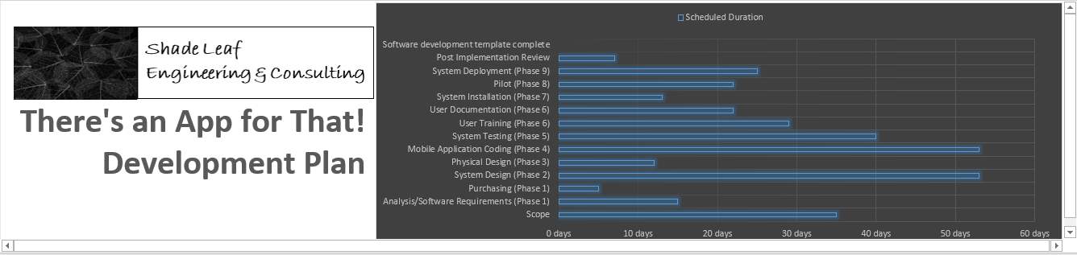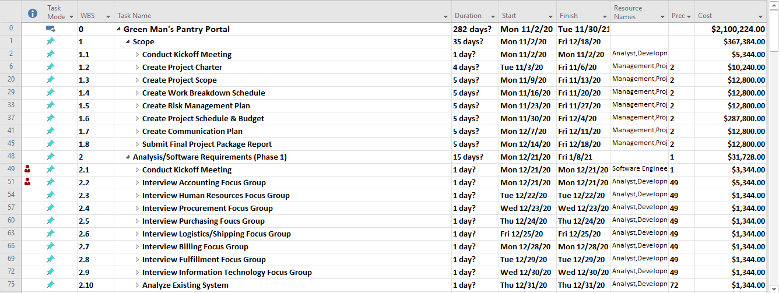

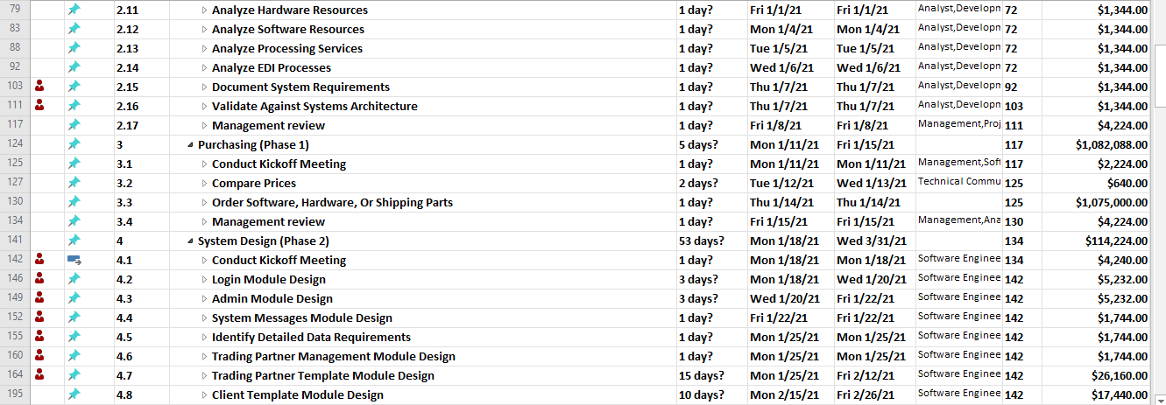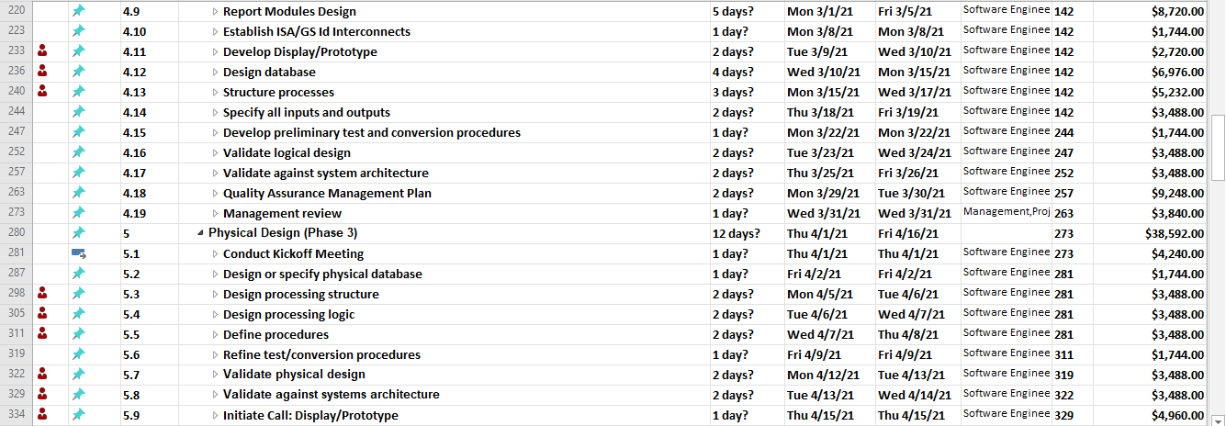

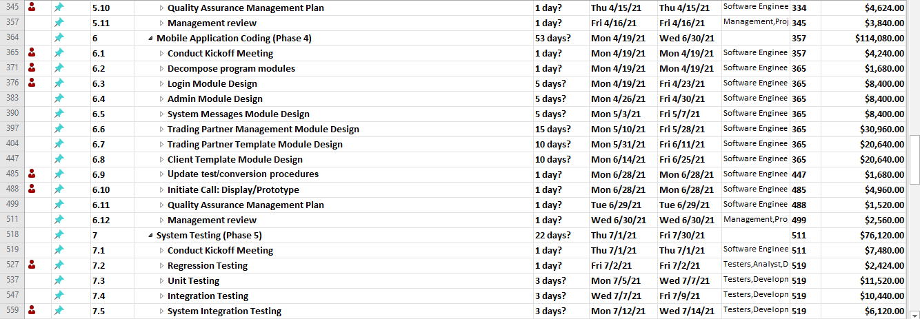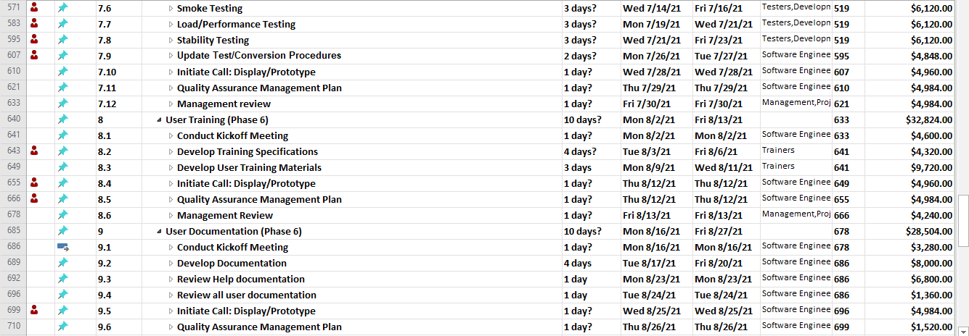

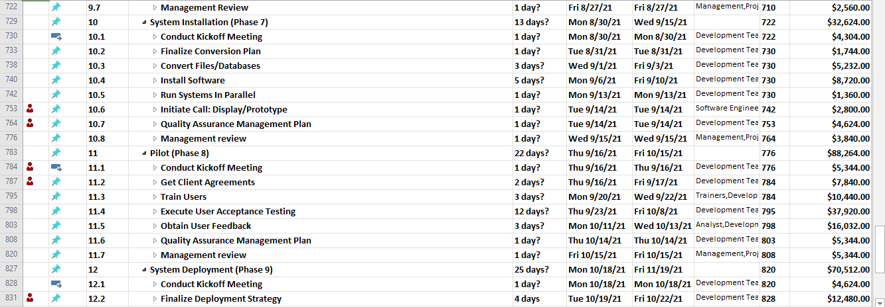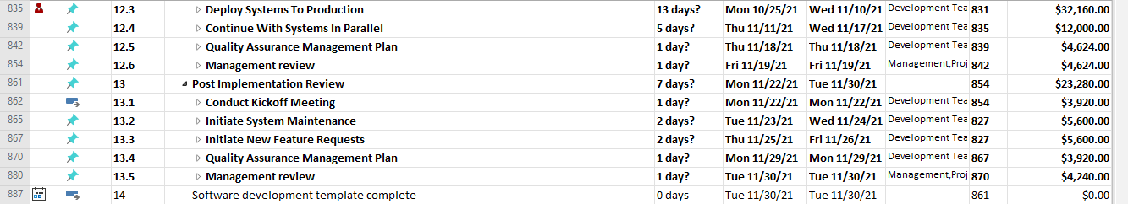

# Risk Management Plan

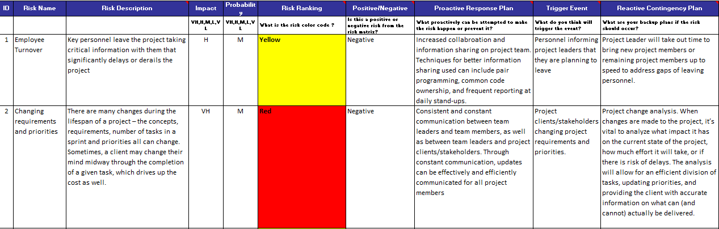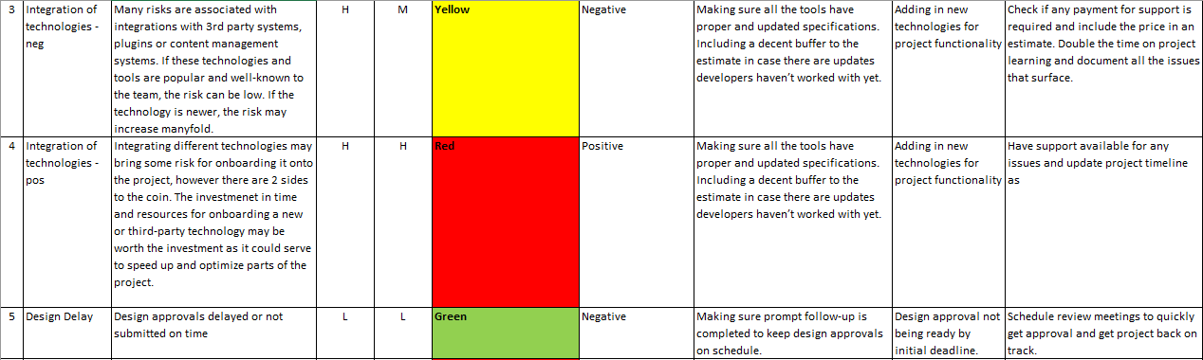

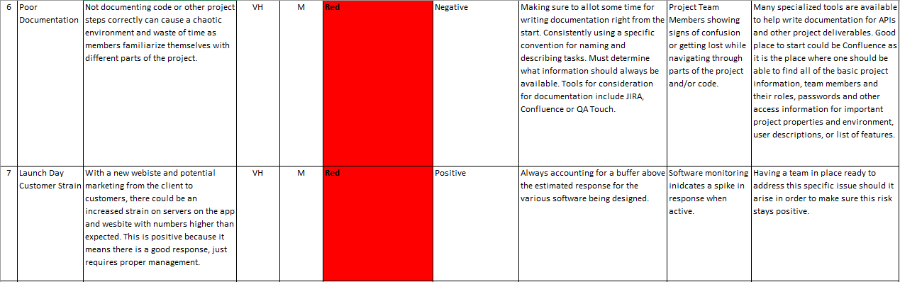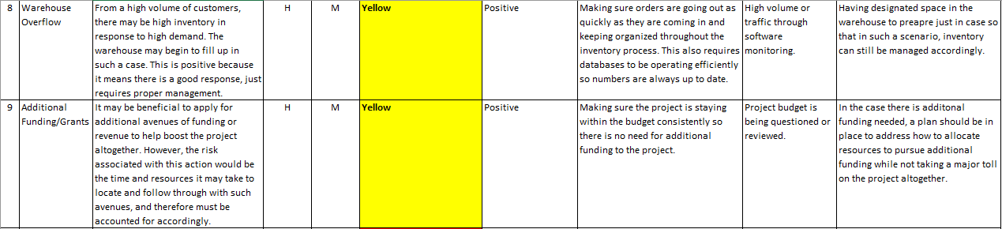

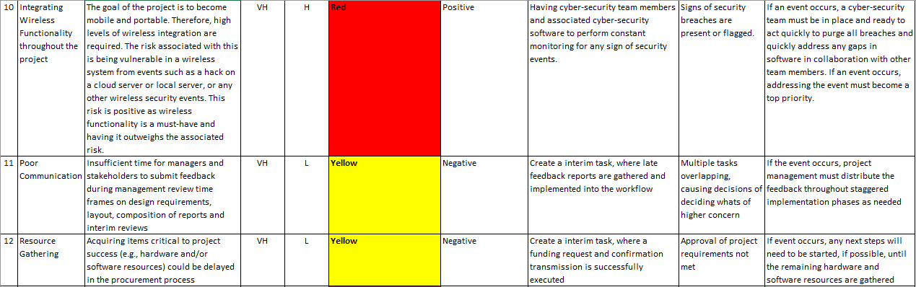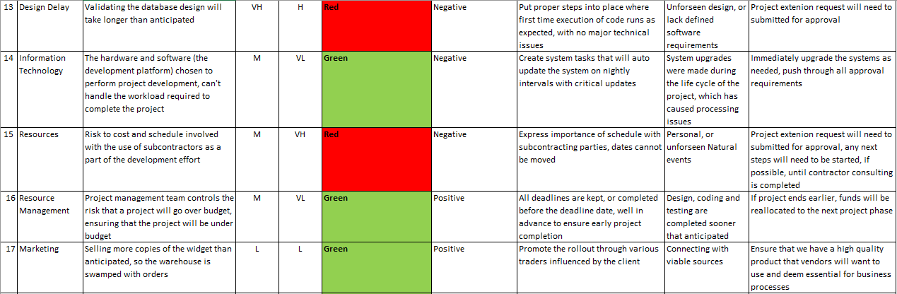

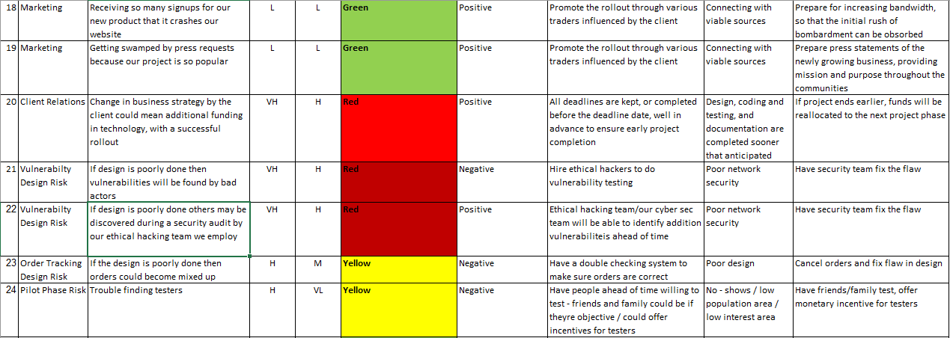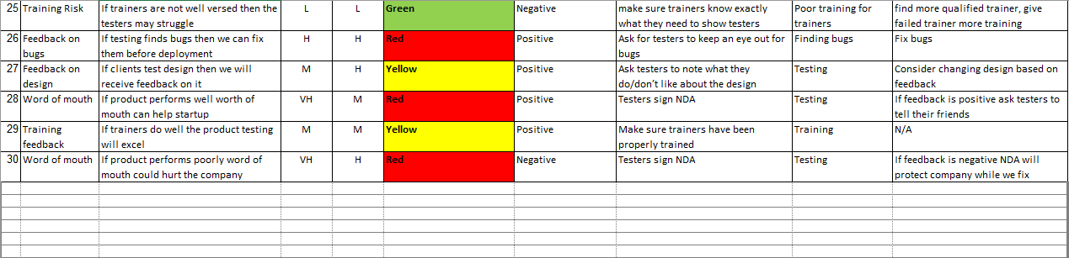

# Project Budget and Resource Management Report

# Part 1: Project Budget (Cost Management)

## Approach to estimating

Green Man's Pantry has chosen Shade Leaf Engineering & Consulting to implement a new mobile application electronic data

interchange platform service, and had together projected that the initial development costs of its desired mobile application

services with the purchases of designing a new databases and architecture for web application development was initially

estimated at $1,600,000.00—Shade Leaf Engineering & Consulting is a new start-up company with limited but effective

resources; Green Man's Pantry is investing its eBusiness strategies with Shade Leaf Engineering & Consulting to promote the

companies partnership in the reduction of carbon foot printing through the use of solar panel technology, and its diverse

approaches in eco-friendly energy production, such as the use of electric fish to power its headquarters building, allotting

initial funds upfront for development costs. The initial budgeting management process was projected through a top-down

approach where the product owner, consultant, stakeholders, and managers planned the years project portfolio, estimating the

number of resources required for developing a rough project timeline and cost estimate, giving the project a kick-start with

funding resources. As the initial budgeting management process was projected through a top-down approach, the project will

progressively move into a bottom-up approach, where the budgeting will be refined, identifying operating system conflicts and

developing detailed project budgets, schedules and monthly forecasts, based on direct input from the not only the core team, but

also the development team, who will be implementing the project.

## Budget Table (Original and Actual columns only)

## 

## Budget Table (Original and Actual; add third column for the Variance)

Two tables have been provided outlining the original estimated budgeted costs of the project versus the actual budgeted costs

of the project—original estimated table = original software development budget, and actual budgeted costs = projected software

development budget. The original estimated budget only includes unknown rough estimates from managers outlining a budget

plan by defining project tasks and work packages for consultant services for one year, while the actual budget costs table includes

refined work packages/chunks, with accurate estimates at a detailed level. Initially, the top-down approach was used in planning

the year's project portfolio, estimating the costs needed for developing a rough project timeline and cost estimate to be used as a

guideline but with estimates that aren't very precise. After the initiate estimate were submitted, detailed planning began and the

project moved into a bottom-up approach, where the project team defined tasks, making accurate estimates at a detailed level. In

the chart provided here, estimated vs. projected budgets are displayed, showing the vast differences with the detailed planning in

the cost variances.

## Budget Contingency

The budget contingency is currently recognized as a separate project cost estimate type, equaling fifteen percent of the total

estimated cost of the projected software development budget that has been estimated to be accurate estimates. The idea of the

budget contingency is that if the project runs into delays, that incur additional expenses, these additional expenses can be taken

from the contingency plan, with a memo request for extension/approval, accounting for the purchase, the funds spent, and

account drawn from. Any left-over budgeting funds will start the allocation of extra funds to cover uncertainties and improve the

chances that the project can be completed within the time frame originally specified. Sometime during the system testing phase,

management will determine if additional contractor/support will be needed for architectural design of the software mobile

application, for successful project completion. If the contingency budget funds are not used throughout the software development

lifecycle of this project, then the funds will be re-allocated, into the next development phase of the web development application

services, after the completion of the mobile application development phase.

# 

# Part 2: Resource Management

## Resource Assignments

Currently, Shade Leaf Engineering & Consulting has no other major software development projects in the works and the resources

assigned to the project are assigned solely to the functional aspects within their job scope, with no additional resources needed for

the development of the project. The project executive assigned to oversee the completion of the project, is primarily working on the

There's an App for That! project, with no other major projects assigned—though the project executive may be assigned other duties

as the project executive and the senior simple software engineer are one and the same person, such as system architecture design,

module coding, system testing, etc. The project executive, product owner, executives, stakeholders, development team,

management, and core team members all work eight-hour days, seven days a week; with overtime as needed.

Since overallocation of resources is signaled in red, then any overallocation of resources will be solved by the project executive

by linking involved task if related within a subdivision. If the work assigned exceeds the time available, then the work may be

moved to new dates to meet time availability within a given day. Green Man’s Pantry is aware that Shade Leaf Engineering &

Consulting consists of solely four Software Engineers, with the project moving to meet the scheduled milestones at the

engineers’ pace.

The project executive will report to the product owner, executives and stakeholders, directors, managers, development team,

and external analysts will report to the project executive, while staff personnel will report to the managers of their respective

departments. The project executive will submit updates to stakeholders periodically, while the development team will submit

reports to the project executive weekly as tasks and milestones are met. Director's and manager's will also be required to submit

feedback when called upon, with the information being submitted to the project executive which will also be shared with the

product owner and stakeholders. The project executive will create a clear sense of the mission, with widely shared and

understood goals to project better project performance, where all team members will understand the overall project objective and

how their specific performance will contribute to achieving the project objectives—the success of the project not only consists of a

functioning mobile application but also successful user acceptance testing and feedback from core team members.

## Project Team Management

In the event that conflicts arise during the development of the mobile application between personnel, the project executive will be

the first source of resolution, using tactics such as mediating conflicts employing diffusion or confrontation solutions—arbitrating

conflicts by imposing judgement on warring parties using company policies for solutions—accepting conflicts in knowing that

some personalities of project team members simply don't jive, or by eliminating the conflict by critically evaluating the nature

and severity of the conflict and either transferring the team member or removing the team member from the project all together.

The project executive understands the project has scarce resources, which may lead to differentiation among other department

leads, and uncertainty with lines of authority with the progress of development of the project. The project executive will address

all conflicts through mediation, arbitration, control, acceptance or elimination; unless the conflict cannot be resolved and needs

to be handled through an alternative functional department.

## Organizational Structure

A strong matrix structure has been selected for this software development project. This structure is the most functional for Shade

Leaf Engineering & Consulting as Green Man’s Pantry has given full autonomy of the software development life cycle to the

independent consulting company. The lead project executive has been granted full authority over the course of the project and the

budget, so that in, not only is their mediations between executives and the software engineers, but so that the software engineers

also fall into a hierarchy management structure for reporting purposes. This will allow the project executive to control most of the

projects activities and functions, including the assignment and control of project resources, and key decision-making authority.

though some functional managers will have some input into the assignment of personnel from their departments. This matrix

structure also allows for open communication and knowledge sharing within the work group, while also allowing employees to

communicate across the boundaries, creating a pleasant, cooperative, work environment that helps in integrating the organization. Employees are also able to enhance their skills and knowledge by taking part in different parts of the project.

# Communications Management Plan

# Part 1: Based on Project Scenario Resources Communication Plan

This part explains communication plans for team member resources needed to complete your project scenario:

Communication plan content is based on the resources in our MS project plan/ Work Breakdown Schedule. This demonstrates how communication *should occur* (a plan) based on our *project scenario* resources being managed in the MS project plan/ Work Breakdown Schedule.

|  |  |  |  |  |  |  |  |  |
| --- | --- | --- | --- | --- | --- | --- | --- | --- |
| **ID** | **Communication Vehicle** | **Target Audience** | **Description/Purpose** | **Frequency** | **Sender** | **Distribution Vehicle** | **Internal / External?** | **Comments** |
| 1 | Project Proposal Kickoff Meeting | Project Executive, Product Owner, Stakeholders, Development Team | Introduce the project team and the project. Review project objectives and management approach. | Once | Project Executive | Face to Face, WebEx, Email | Internal & External | Agenda, Meeting Minutes |
| 2 | Steering Committee Review | Project Executive, Product Owner, Stakeholders, Development Team | Update current status of project obstacles | Bi-Monthly | Project Executive | Face to Face, WebEx, Email | Internal & External |  |
| 3 | Project Team Meetings | Project Executive, Product Owner, Stakeholders, Development Team, Management | Review status of the project with the team | Weekly | Project Executive | Face to Face, WebEx, Email | Internal Only | Agenda, Meeting Minutes, Project Schedule |
| 4 | Technical Design Meetings | Project Executive, Product Owner, Stakeholders, Development Team | Discuss and develop technical design solutions for the project | As Needed | Development Team | Face to Face | Internal | Agenda, Meeting Minutes |
| 5 | Weekly Status Report / Sprints | Project Executive, Product Owner, Stakeholders, Development Team, Management | Status updates, current timeline, key accomplishments, planned work, etc. | Weekly | Project Executive, Development Team | Email | Internal & External |  |
| 6 | Bi-weekly Status Report | Project Executive, Product Owner, Stakeholders, Development Team, Management | Status updates, current timeline, key accomplishments, planned work, etc. | Bi-Weekly | Project Executive, Development Team | Email | Internal & External |  |
| 7 | Monthly Project Status Meetings | Project Executive, Product Owners, Stakeholders,  Development Team, Accounting Managers, Human  Resource Managers, Procurement Managers,  Purchasing Managers, Logistics Managers,  Billing Managers, Fulfillment Managers, Data Entry Managers, Operations Manager, Sales Manager, Shipping/ Receiving Manager, Training Manager, Personnel Staff, Analysts | Report on the status of the project to management | Monthly | Project Executive | Face to Face, WebEx, Email | Internal & External | Project Schedule |
| 8 | Quarterly Project Status Reports | Project Executive, Product Owners, Stakeholders,  Development Team, Accounting Managers, Human  Resource Managers, Procurement Managers,  Purchasing Managers, Logistics Managers,  Billing Managers, Fulfillment Managers, Data Entry Managers, Operations Manager, Sales Manager, Shipping/ Receiving Manager, Training Manager, Personnel Staff, Analysts | Report on the status of the project to management | Quarterly | Project Executive | Face to Face, WebEx, Email | Internal & External |  |
| 9 | Project Status Reports | Project Executive, Product Owner, Stakeholders, Development Team, Management | Report the status of the project including activities, progress, costs and issues | As Needed | Project Executive | Email | Internal & External | Project Status Report, Project Schedule |
| 10 | Project Milestone Status Reports | Project Executive, Product Owner, Stakeholders, Development Team, Management | Communicate statuses of completion of major milestones and next steps | As Needed | Project Executive | Face to Face, WebEx, Email | Internal & External |  |
| 11 | Scope & Project Plan Kickoff Meeting | Project Executive, Product Owner, Stakeholders, Development Team, Management | Communicate the initial schedule of the scope and project plan, and next steps | Once | Project Executive, Development Team | Face to Face, WebEx, Email | Internal & External |  |
| 12 | Scope & Project Plan Management Review | Project Executive, Product Owner, Stakeholders, Development Team, Management | Communicate approval statuses, budget, and next steps | Once | Project Executive, Development Team | Face to Face, WebEx, Email | Internal & External |  |
| 13 | Software Requirements Kickoff Meeting | Project Executive, Product Owner, Stakeholders, Development Team, Management | Communicate the initial project plan of gathering software requirements, gather software requirements from client | Once | Project Executive | Face to Face | Internal & External |  |
| 14 | Accounting Focus Group Meeting | Project Executive, Development Team, Accounting Managers & Selected Staff | Gather software requirements for the accounting platform module | Once | Project Executive | Face to Face | Internal & External |  |
| 15 | Human Resources Focus Group Meeting | Project Executive, Development Team, Human Resources Managers & Selected Staff | Gather software requirements for the human resources platform module | Once | Project Executive | Face to Face | Internal & External |  |
| 16 | Procurement Focus Group Meeting | Project Executive, Development Team, Procurement Managers & Selected Staff | Gather software requirements for the procurement platform module | Once | Project Executive | Face to Face | Internal & External |  |
| 17 | Purchasing Focus Group Meeting | Project Executive, Development Team, Purchasing Managers & Selected Staff | Gather software requirements for the purchasing platform module | Once | Project Executive | Face to Face | Internal & External |  |
| 18 | Logistics/ Shipping Focus Group Meeting | Project Executive, Development Team, Logistics/ Receiving/ Shipping Managers & Selected Staff | Gather software requirements for the receiving/ shipping platform module | Once | Project Executive | Face to Face | Internal & External |  |
| 19 | Billing Focus Group Meeting | Project Executive, Development Team, Billing Managers & Selected Staff | Gather software requirements for the billing platform module | Once | Project Executive | Face to Face | Internal & External |  |
| 20 | Fulfillment Focus Group Meeting | Project Executive, Development Team, Fulfillment Managers & Selected Staff | Gather software requirements for the fulfillment platform module | Once | Project Executive | Face to Face | Internal & External |  |
| 21 | Information Technology Focus Group Meeting | Project Executive, Development Team, Information Technology Managers & Selected Staff | Gather software requirements for the information technology systems | Once | Project Executive | Face to Face | Internal & External |  |
| 22 | Hardware Resources Approval Meeting | Project Executive, Product Owner, Stakeholders, Development Team | Obtain approval for the purchase of hardware resources | Once | Project Executive | Face to Face | Internal & External |  |
| 23 | Software & Licensing Resources Approval Meeting | Project Executive, Product Owner, Stakeholders, Development Team | Obtain approval for the purchase of software and licensing resources | Once | Project Executive | Face to Face | Internal & External |  |
| 24 | Processing Services Resources Approval Meeting | Project Executive, Product Owner, Stakeholders, Development Team | Obtain approval for the purchase of processing services resources | Once | Project Executive | Face to Face | Internal & External |  |
| 25 | Software Requirements Management Review | Project Executive, Product Owner, Stakeholders, Development Team, Management | Communicate the completion of requirements analysis, budget and next steps | Once | Project Executive | Face to Face | Internal & External |  |
| 26 | Purchasing Kickoff Meeting | Project Executive, Product Owner, Stakeholders, Development Team, Management | Communicate the initial project plan of purchasing the hardware and software resources | Once | Project Executive | Face to Face | Internal & External |  |
| 27 | Purchasing Management Review | Project Executive, Product Owner, Stakeholders, Development Team, Management | Communicate the completion of the purchasing of the hardware and software resources | Once | Project Executive | Face to Face | Internal & External |  |
| 28 | System Design Kickoff Meeting | Project Executive, Product Owner, Stakeholders, Development Team | Communicate the initial schedule of the system design phase and next steps | Once | Development Team | Face to Face | Internal Only |  |
| 29 | System Design Management Review | Project Executive, Product Owner, Stakeholders, Development Team | Communicate the completion of the system design phase and next steps | Once | Project Executive | Face to Face | Internal Only |  |
| 30 | Physical Design Kickoff Meeting | Project Executive, Product Owner, Stakeholders, Development Team | Communicate the initial schedule of the physical design phase and next steps | Once | Development Team | Face to Face | Internal Only |  |
| 31 | Initiate Call: Display/Prototype Meeting | Project Executive, Product Owner, Stakeholders, Development Team, Management | Display a demo of the requested product type | As Needed | Project Executive | WebEx | Internal & External | Initiate Call: Display/Prototype Meeting |
| 32 | Physical Design Management Review | Project Executive, Product Owner, Stakeholders, Development Team | Communicate the completion of the physical design phase and next steps | Once | Project Executive | Face to Face | Internal Only |  |
| 33 | Mobile Application Coding Kickoff Meeting | Project Executive, Product Owner, Stakeholders, Development Team | Communicate the initial schedule of the programming phase, and next steps | Once | Development Team | Face to Face | Internal Only |  |
| 34 | Initiate Call: Display/Prototype Meeting | Project Executive, Product Owner, Stakeholders, Development Team, Management | Display a demo of the requested product type | As Needed | Project Executive | WebEx | Internal & External | Initiate Call: Display/Prototype Meeting |
| 35 | Mobile Application Coding Management Review | Project Executive, Product Owner, Stakeholders, Development Team, Management | Communicate the completion of the programming phase, and next steps | Once | Project Executive | Face to Face | Internal Only |  |
| 36 | System Testing Kickoff Review | Project Executive, Product Owner, Stakeholders, Development Team, Management | Communicate the initial schedule of the system testing phase and next steps | Once | Development Team | Face to Face | Internal Only |  |
| 37 | Regression Testing Status Review | Project Executive, Product Owner, Stakeholders, Development Team, Management | Communicate the status of the regression testing and procedures phase, and any issues | Once | Development Team | Face to Face | Internal Only |  |
| 38 | Unit Testing Status Review | Project Executive, Product Owner, Stakeholders, Development Team, Management | Communicate the status of the unit testing phase, and any issues | Once | Development Team | Face to Face | Internal Only |  |
| 39 | System Integration Testing Status Review | Project Executive, Product Owner, Stakeholders, Development Team, Management | Communicate the status of the system integration testing phase, and any issues | Once | Development Team | Face to Face | Internal Only |  |
| 40 | Smoke Testing Status Review | Project Executive, Product Owner, Stakeholders, Development Team, Management | Communicate the status of the smoke testing phase, and any issues | Once | Development Team | Face to Face | Internal Only |  |
| 41 | Load/ Performance Testing Status Review | Project Executive, Product Owner, Stakeholders, Development Team, Management | Communicate the status of the load/ performance testing phase, and any issues | Once | Development Team | Face to Face | Internal Only |  |
| 42 | Stability Testing Status Review | Project Executive, Product Owner, Stakeholders, Development Team, Management | Communicate the status of the stability testing phase, and any issues | Once | Development Team | Face to Face | Internal Only |  |
| 43 | Initiate Call: Display/Prototype Meeting | Project Executive, Product Owner, Stakeholders, Development Team, Management | Display a demo of the requested product type | As Needed | Project Executive | WebEx | Internal & External |  |
| 44 | System Testing Management Review | Project Executive, Product Owner, Stakeholders, Development Team, Management | Communicate the completion of the system testing phase, and next steps | Once | Project Executive | Face to Face | Internal Only |  |
| 45 | User Training Kickoff Meeting | Project Executive, Product Owners, Stakeholders, Development Team, Accounting, Human Resource Managers, Procurement Managers,  Purchasing Managers, Logistics Managers, Billing Managers,  Fulfillment Managers, Data Entry Managers | Communicate the initial schedule of the user training phase and next steps | Once | Development Team | Face to Face | Internal & External |  |
| 46 | Initiate Call: Display/Prototype Meeting | Project Executive, Product Owner, Stakeholders, Development Team, Management | Display a demo of the requested product type | As Needed | Project Executive | WebEx Meeting | Internal & External |  |
| 47 | User Training Management Review | Project Executive, Product Owner, Stakeholders, Development Team, Management | Communicate the completion of the user training phase, and next steps | Once | Project Executive | Face to Face, WebEx Meeting | Internal & External |  |
| 48 | Documentation Kickoff Meeting | Project Executive, Product Owner, Stakeholders, Development Team, Management | Communicate the initial schedule of the documentation phase and next steps | Once | Development Team | Face to Face | Internal & External |  |
| 49 | Help Documentation Review Meeting | Project Executive, Product Owner, Stakeholders, Development Team, Management | Incorporate help documentation feedback | Once | Development Team | Face to Face | Internal & External |  |
| 50 | Documentation Review Meeting | Project Executive, Product Owner, Stakeholders, Development Team, Management | Incorporate help documentation feedback | Once | Development Team | Face to Face | Internal & External |  |
| 51 | Initiate Call: Display/Prototype Meeting | Project Executive, Product Owner, Stakeholders, Development Team, Management | Display a demo of the requested product type | As Needed | Project Executive | WebEx | Internal & External |  |
| 52 | Documentation Management Review | Project Executive, Product Owner, Stakeholders, Development Team, Management | Communicate the completion of the documentation phase, and next steps | Once | Project Executive | Face to Face | Internal Only |  |
| 53 | System Installation Kickoff Meeting | Project Executive, Product Owner, Development Team, CTO, Director of Information Management, Stakeholders, Development Team, Management | Communicate the initial schedule of the installation phase and next steps | Once | Development Team | Face to Face, WebEx | Internal & External |  |
| 54 | Smoke Test Kickoff Meeting | Project Executive, Product Owner, Development Team, CTO, Director of Information Management, Stakeholders, Development Team, Management, Staff Team | Communicate the initial schedule of the smoke test and next steps | Once | Development Team | Face to Face, WebEx | Internal & External | One individual will be selected by Client & Shade Leaf Consultant from the listed personnel that meets the objective for each department. |
| 55 | Smoke Test Review | Project Executive, Product Owner, Development Team, Stakeholders, Development Team, Management, Staff Team | Obtain feedback from smoke test users and system analysis reports | Once | Development Team | Face to Face, WebEx | Internal & External |  |
| 56 | Smoke Test Regression Review | Project Executive, Product Owner, Development Team, Stakeholders, Development Team, Management | Communicate the status of regression testing, and any issues | As Needed | Development Team | Face to Face, WebEx | Internal & External |  |
| 57 | Initiate Call: Display/Prototype Meeting | Project Executive, Product Owner, Stakeholders, Development Team, Management | Display a demo of the requested product type | As Needed | Project Executive | WebEx | Internal & External |  |
| 58 | System Installation Management Review | Project Executive, Project Executive, Development Team, CTO, Director of Information Management, Stakeholders, Development Team, Management | Communicate the completion of the installation phase, and next steps | Once | Project Executive | Face to Face, WebEx | Internal & External |  |
| 59 | Pilot Kickoff Meeting | Project Executive, Product Owner, Development Team, CTO, Director of Information Management, Stakeholders, Development Team, Management, Staff Team | Communicate the initial schedule of the pilot phase and next steps | Once | Project Executive | Face to Face, WebEx | Internal & External |  |
| 60 | Client Agreements Meeting | Project Executive, Product Owner, Stakeholders, | Identify test groups, and gather agreement consensus | Once | Project Executive | WebEx, Email | Internal & External |  |
| 61 | User Acceptance Testing Kickoff Meeting | Project Executive, Product Owner, Stakeholders, Development Team, Accounting Managers, Human Resource Managers, Procurement Managers, Purchasing Managers, Logistics Managers, Billing Managers, Fulfillment Managers, Data Entry Managers, Operations Manager, Sales Manager, Shipping/ Receiving Manager, Training Manager, Personnel Staff | Communicate the initial schedule of the user acceptance testing phase and next steps | Once | Project Executive | Face to Face, WebEx | Internal & External |  |
| 62 | User Acceptance Testing Review | Project Executive, Product Owner, Stakeholders, Development Team, Accounting Managers, Human Resource Managers, Procurement Managers, Purchasing Managers, Logistics Managers, Billing Managers, Fulfillment Managers, Data Entry Managers, Operations Manager, Sales Manager, Shipping/ Receiving Manager, Training Manager, Personnel Staff | Obtain feedback from user acceptance testing and system analysis reports | Once | Development Team | Face to Face, WebEx | Internal & External |  |
| 63 | User Acceptance Testing Regression Review | Project Executive, Product Owner, Development Team, Stakeholders, Development Team, Management | Communicate the status of regression testing, and any issues | As Needed | Development Team | Face to Face, WebEx | Internal & External |  |
| 64 | Pilot Management Review | Project Executive, Product Owner, Development Team, Stakeholders, Development Team, Management | Communicate the completion of the pilot phase, and next steps | Once | Project Executive | Face to Face, WebEx | Internal & External |  |
| 65 | System Deployment Kickoff Meeting | Project Executive, Product Owner, Development Team, Stakeholders, Development Team, Management | Communicate the initial schedule of the deployment phase and next steps | Once | Project Executive | Face to Face, WebEx | Internal & External |  |
| 66 | System Deployment Management Review | Project Executive, Product Owner, Development Team, Stakeholders, Development Team, Management | Communicate the completion of the deployment phase, and next steps | Once | Project Executive | Face to Face, WebEx | Internal & External |  |
| 67 | Post Implementation Review Meeting | Project Executive, Product Owner, Development Team, Stakeholders, Development Team, Management | Communicate software maintenance plan and finalize contractor implementation, initiate closure/completion of software development project | Once | Project Executive | Face to Face, WebEx | Internal & External |  |
| 68 | Completion of Software Implementation Meeting | Project Executive, Product Owner, Development Team, Stakeholders, Development Team, Management | Finalize completion of software implementation, close project | Once | Project Executive | Face to Face, WebEx | Internal & External |  |

# 

# Part 2: Based on Actual Team Members Communication Plan

This part explains how the actual team communicated to get our **weekly project assignment deliverables** completed:

Communication Plan content is based on the resources in your project team, meaning actual team members, and how each of us actually communicated within the team to get the weekly project assignment deliverables completed on time in the course.

|  |  |  |  |  |  |  |  |  |  |
| --- | --- | --- | --- | --- | --- | --- | --- | --- | --- |
| **ID** | **Meeting/ Communication Type** | **Frequency** | **Location** | **Delivery Method** | **Owner** | **Sender** | **Receiver** | **Attendees** | **Comments** |
|  |
| 1 | Microsoft Team Kick Off Discussion | Weekly | Microsoft Teams | System Platform | Joshua | Joshua | Team | Joshua, Syed, Mack | Includes overview of weekly segments, templates and team discussions towards project |  |
| 2 | Microsoft Team Discussion | As Needed | Microsoft Teams | System Platform | Joshua, Syed, Mack | Individual | Team | Joshua, Syed, Mack |  |  |
| 3 | Microsoft Team Meeting | Weekly | Microsoft Teams | System Email | Joshua | Joshua | Team | Joshua, Syed, Mack | To discuss the weekly segment, what needs done, who’s doing what, Recorded Meetings |  |
| 4 | CANVAS Kick Off Discussion | Weekly | CANVAS | Student Center, System Email | Joshua | Joshua | Team | Joshua, Syed, Mack |  |  |
| 5 | CANVAS Discussion | As Needed | CANVAS | System Email | Joshua, Syed, Mack | Individual | Team | Joshua, Syed, Mack |  |  |
| 6 | Statement of Participation (SOP) | Weekly | Microsoft Teams | Microsoft Word | Joshua | Joshua | Team | Joshua, Syed, Mack | Assigned segments to individuals within the SOP for each week |  |
| 7 | Journal Work Log | Weekly | Microsoft Teams | SOP | Joshua | Joshua | Team | Joshua, Syed, Mack | Each team member recorded their work log summary, time spent, etc. |  |
| 8 | Email | As Needed |  | Personal Email | Team | Individual | Individual, Team | Individual, Team |  |  |
| 9 | Text | As Needed |  | Personal Text | Team | Individual | Individual, Team | Individual, Team |  |  |
|  |  |  |  |  |  |  |  |  |  |  |
|  |  |  |  |  |  |  |  |  |  |  |

## 

## Actual Team Communication Lessons Learned

Describe any lessons learned in your *actual team* communication process and what you would do differently.

|  |  |  |  |  |  |
| --- | --- | --- | --- | --- | --- |
| **ID** | **Category** | **Issue Name** | **Problem/Success** | **Impact** | **Recommendation** |
|  |
| 1 | Week 1: Statement of Participation | Contact Requirements | Success: All team members provided there contact information for this segment of the project as required | Contributed to successful completion of this week’s segment |  |  |
| 2 | Week 1: Statement of Participation | Statement of Commitment | Success: All team members provided there statement of commitment for this segment of the project as required | Contributed to successful completion of this week’s segment |  |  |
| 3 | Week 1: Statement of Participation | Task Assignments | Success: Team members contributed to the creation of task assignments for this segment of the project as required | Contributed to successful completion of this week’s segment |  |  |
| 4 | Week 1: Project Proposal | Template | Success: Team members were able to access the weekly template and work within the template with no major issues | Contributed to successful completion of this week’s segment |  |  |
| 5 | Week 1: Microsoft Teams | Join Channel | Success: All team members joined the created group within Microsoft Teams | Contributed to successful completion of this week’s segment |  |  |
| 6 | Week 1: Microsoft Teams | Team Meeting | Success: Team members joined the Team Meeting for this week’s segment to complete the assignment | Contributed to successful completion of this week’s segment |  |  |
| 7 | Week 1: CANVAS Discussion | Communication | Problem: All team members did not post within the CANVAS discussion group, due to participation in Microsoft Teams | Professor is not able to actually see any conversations being held towards the scope of the project |  |  |
| 8 | Week 2: Statement of Participation | Assignments | Success: Team members contributed to the completion of task assignments and updating the work log for this segment of the project as required | Contributed to successful completion of this week’s segment |  |  |
| 9 | Week 2: Project Charter | Template | Success: Team members were able to access the weekly template and work within the template with no major issues | Contributed to successful completion of this week’s segment |  |  |
| 10 | Week 2: Microsoft Teams | Communication | Success: All team members were able to retrieve the weekly template, work within the weekly template, and contribute to the discussion channel as needed, for this week’s segment of the project | Contributed to successful completion of this week’s segment |  |  |
| 11 | Week 2: Microsoft Teams | Team Meeting | Success: Team members joined the Team Meeting for this week’s segment to complete the assignment | Contributed to successful completion of this week’s segment |  |  |
| 12 | Week 2: CANVAS Discussion | Communication | Problem: All team members did not post within the CANVAS discussion group, due to participation in Microsoft Teams | Professor is not able to actually see any conversations being held towards the scope of the project |  |  |
| 13 | Week 3: Statement of Participation | Assignments | Success: Team members contributed to the completion of task assignments and updating the work log for this segment of the project as required | Contributed to successful completion of this week’s segment |  |  |
| 14 | Week 3: Scope Statement | Template | Success: Team members were able to access the weekly template and work within the template with no major issues | Contributed to successful completion of this week’s segment |  |  |
| 15 | Week 3: Microsoft Teams | Communication | Success: All team members were able to retrieve the weekly template, work within the weekly template, and contribute to the discussion channel as needed, for this week’s segment of the project | Contributed to successful completion of this week’s segment |  |  |
| 16 | Week 3: Microsoft Teams | Team Meeting | Problem: Team members did not attend the Monday meeting, or the Saturday meeting | Lack of participation within the group, lowers confidence that work will be completed |  |  |
| 17 | Week 3: CANVAS Discussion | Communication | Problem: All team members did not post within the CANVAS discussion group, due to participation in Microsoft Teams | Professor is not able to actually see any conversations being held towards the scope of the project |  |  |
| 18 | Week 4: Statement of Participation | Assignments | Problem: All team members did not contribute to the completion of task assignments, or update the work log properly for this segment of the project as required | Caused other team members to pick up the slack of unfinished work |  |  |
| 19 | Week 4: Work Breakdown Schedule | Template | Problem: All team members did not contribute to the completion of task assignments for this segment of the project as required | Caused other team members to pick up the slack of unfinished work |  |  |
| 20 | Week 4: Microsoft Teams | Communication | Success: All team members were able to retrieve the weekly template, work within the weekly template, and contribute to the discussion channel as needed, for this week’s segment of the project | Contributed to successful completion of this week’s segment |  |  |
| 21 | Week 4: Microsoft Teams | Team Meeting | Problem: Team members did not attend the Monday meeting, or the Saturday meeting | Lack of participation within the group, lowers confidence that work will be completed |  |  |
| 22 | Week 4: Microsoft Project | Software | Problem: Not all team members had the required software needed for the class, nor was there instructions within CANVAS on where to go to get the software |  |  |  |
| 23 | Week 4: CANVAS Discussion | Communication | Problem: All team members did not post within the CANVAS discussion group, due to participation in Microsoft Teams | Professor is not able to actually see any conversations being held towards the scope of the project |  |  |
| 24 | Week 5: Statement of Participation | Assignments | Problem: All team members did not contribute to the completion of task assignments, or update the work log properly for this segment of the project as required | Caused other team members to pick up the slack of unfinished work |  |  |
| 25 | Week 5: Risk Register | Template | Problem: All team members did not contribute to the completion of task assignments for this segment of the project as required | Caused other team members to pick up the slack of unfinished work |  |  |
| 26 | Week 5: Microsoft Teams | Communication | Success: All team members were able to retrieve the weekly template, work within the weekly template for this week’s segment of the project | Contributed to successful completion of this week’s segment |  |  |
| 27 | Week 5: Microsoft Teams | Team Meeting | Problem: Team members did not attend the Monday meeting, or the Saturday meeting | Lack of participation within the group, lowers confidence that work will be completed |  |  |
| 28 | Week 5: CANVAS Discussion | Communication | Problem: All team members did not post within the CANVAS discussion group, due to participation in Microsoft Teams | Professor is not able to actually see any conversations being held towards the scope of the project |  |  |
| 29 | Week 6: Statement of Participation | Assignments | Success: All team members contributed to the completion of task assignments, or update the work log properly for this segment of the project as required | Caused other team members to pick up the slack of unfinished work |  |  |
| 30 | Week 6: Project Schedule | Template | Success: All team members contributed to the completion of task assignments for this segment of the project as required | Caused other team members to pick up the slack of unfinished work |  |  |
| 31 | Week 6: Microsoft Teams | Communication | Success: All team members were able to retrieve the weekly template, work within the weekly template for this week’s segment of the project | Contributed to successful completion of this week’s segment |  |  |
| 32 | Week 6: Microsoft Teams | Team Meeting | Problem: The Monday meeting was canceled due to personal reasons; the Saturday meeting was conducted as scheduled | Lack of participation within the group, lowers confidence that work will be completed |  |  |
| 33 | Week 6: CANVAS Discussion | Communication | Problem: All team members did not post within the CANVAS discussion group, due to participation in Microsoft Teams | Professor is not able to actually see any conversations being held towards the scope of the project |  |  |
| 34 | Week 7: Statement of Participation | Assignments | Problem: All team members did not contribute to the completion of task assignments, or update the work log properly for this segment of the project as required | Caused other team members to pick up the slack of unfinished work |  |  |
| 35 | Week 7: Communication Plan | Template | Success: All team members contributed to the completion of task assignments for this segment of the project as required | Caused other team members to pick up the slack of unfinished work |  |  |
| 36 | Week 7: Microsoft Teams | Communication | Success: All team members were able to retrieve the weekly template, work within the weekly template for this week’s segment of the project | Contributed to successful completion of this week’s segment |  |  |
| 37 | Week 7: Microsoft Teams | Team Meeting | Problem: Team members attend the Thursday meeting | Contributed to successful completion of this week’s segment |  |  |
| 38 | Week 7: CANVAS Discussion | Communication | Problem: All team members did not post within the CANVAS discussion group, due to participation in Microsoft Teams | Professor is not able to actually see any conversations being held towards the scope of the project |  |  |

# Project Update Summary

Provide an overall summary of the current state of the project, including any outstanding issues or problems that will be addressed in the project. Any recommendations for changes or requests requiring approval should also be included. In addition, the conclusion should include next steps for the project and provide the next scheduled status update and how it will be communicated. This should be approximately one page.

# Individual Team Member Lessons Learned (one page per team member)

Mack Najorka

I started this course with absolutely no knowledge of project management. What goes on behind the scenes when it comes to

developing a project. The process of thinking through everything that is going to happen from start to finish. I’ve never had to

put real thought into a project outside of writing out pseudocode or a drawing a design for a program ahead of time. Learning

about agile was the first step. This was interesting to me because I liked the iterative process of it. This is how I’d prefer to

work on projects so seeing that it’s an actual process people take was cool. There’s been a lot of things I’ve never experienced

before that were introduced during this course, things such as a work breakdown structure I had never worked with. I’ve

never had a job that required something like this to be done. I’ve never had to work in Microsoft teams either, but it actually

has been quite useful, especially once I caved and downloaded the desktop app rather than just using a link through the browser.

The risk assessment portion of this project was actually cool because of the level of threats. It was cool and actually something I

wanted to take into other projects. Assessing risks like this was cool because it allowed for an easy visual representation of what

risks are worth taking, which ones are worth taking with some extra steps to mitigate potential risks and which risks were just

overall, at a glance, absolutely not worth taking. These are just a few of the stuff from this course that I found to be cool and

useful. The biggest takeaway was the overall planning process, the iterative process, and the risk assessments. These are things

that will be translating through not just this course, but other aspects of life and other projects that I will be working on.

Syed Asghar

Our project management CEIS390 course has been quite an interesting learning experience. A major advantage for this

course was getting some hands-on experience in trying to plan a project. It provided significant insight into techniques and

work operations that can be applied in a number of different settings including being able to pursue project management in

a professional setting.

The first week provided an introduction and overview into what the project management would look like for the

8-Week journey. It seemed like a daunting task at first but once we were set with our teams, it was a matter of breaking down

the tasks that lie ahead. This was the first time I also used Microsoft teams. Collaboration on Microsoft teams made working

together and sharing documents very smooth. It also allowed for an easy place to keep communication going and for holding

live meetings. In terms of the scope, I didn’t realize how much detail goes into the scope of a project. It showed me that you

really have to have a lot of details in consideration when trying to initially plan a project. The biggest takeaway from this

course in my opinion came from the exposure we received to a Work-Breakdown Structure and setting one up in Microsoft

Project. This course was also the first time I used Microsoft Project. I wasn’t aware that there was such a thorough

program available for planning tasks. Even though we barely touched the surface, I am now able to take away how to set up

tasks, schedule tasks, and assign resources within Project. I’m also able to play around with elements such as cost and

depicting a Gantt chart within Project as well. In addition to Microsoft Project, I was also able to learn new ways on displaying

risk management for a project. I’ve outlined risks for projects before, however, the technique specifically learned in this

class keeps the risk management much more organized and easier to see with the color coding and the risk details that all fill

the risk chart. Lastly, the communication table was also a new way to outline correspondence for a project and showed how

organized a team can get when trying to plan different aspects of the project.

Ultimately, we successfully planned a team project, and the experience was a great tool to keep under out belts.

On a personal note, this was my first exposure to project management and now I hope to find a future career role that is

more involved with project management, if not in project management altogether. I look forward to being able to apply whatever

I have learned for future careers.

Joshua Kidder

**Lessons Learned (Team Lead)**

* lack of team support during team meetings, team members were generally not available during the times given for team

meetings to be held based upon individual time zone conflicts.

* lack of team motivation, team members generally did not put full effort into the success of the project, some team

members left the team altogether

* team members complained about tasks assigned, or not having enough time to complete tasks due to personal life

conflicts, or other various reasons

* team members praised the agile approach that the project was geared towards, and further learning about this

methodology throughout the course

* team members praised the communication vehicle that was used for the course of the project, and liked the experience

of working within Microsoft Teams as a group

* team members praised knowledge sharing in multiple avenues: extraction and installation of microsoft project;

explanations on how to complete various tasks throughout the course project, such as work breakdown schedule

# Team 1 Journal Log Table

**Week 1: Statement of Participation and One-page Project Idea Documents**

|  |  |  |  |
| --- | --- | --- | --- |
| **Name** | **Date** | **Hours** | **Description of Contribution** |
| Joshua Kidder | 10/30 | 1.5 | One Page Project Idea, completed all sections/writings of the document |
| Joshua Kidder | 10/31 | 1.5 | Statement of Participation, completed sections in team meeting |
| Joshua Kidder | 10/31 | 1 | Email/Discussion participation with team members |
| Syed Asghar | 10/31 | 1 | Email/Discussion participation with team members |
| Jim Brank | 10/31 | 1 | Statement of Participation, bid on work tasks in team meeting |
| Jim Brank | 10/31 | 1 | Email/Discussion participation with team members |
| Mack Najorka | 10/31 | 1.5 | Statement of Participation, bid on work tasks in team meeting |
| Mack Najorka | 10/31 | 1 | Email/Discussion participation with team members |
|  |  |  |  |
|  |  |  |  |

**Week 2: Project Charter**

|  |  |  |  |  |  |  |
| --- | --- | --- | --- | --- | --- | --- |
| **Name** | | **Date** | | **Hours** | | **Description of Contribution** |
| Joshua Kidder | | 11/01 | | 1 | | Created team channels, posting Week 2 Milestone; uploaded Project Charter template and other related documents to FILES; scheduled team meeting for Monday 8:00PM EST |
| Joshua Kidder | | 11/02 | | 1 | | Conducted team meeting |
| Joshua Kidder | | 11/02 | | 2.5 | | Created Mission/Purpose section statement |
| Joshua Kidder | | 11/03 | | 3.5 | | Created User Acceptance Criteria section statements |
| Joshua Kidder | | 11/04 | | .45 | | Mid-week checkup post, scheduled meeting |
| Joshua Kidder | | 11/04 | | 2.5 | | Created Key Stakeholder section definitions/statements |
| Joshua Kidder | | 11/07 | | .15 | | Reviewed submitted sections x3 |
| Joshua Kidder | | 11/07 | | 3.5 | | Made updates to Assumptions, Constraints and Major Risks |
| Joshua Kidder | | 11/07 | | 1 | | Conducted team meeting |
| Joshua Kidder | | 11/08 | | .15 | | Uploaded final documents to the Canvas Discussion Area, submitted assignment |
| Syed Asghar | | 11/05 | | 3 | | Updated Project Charter according to assigned tasks |
| Syed Asghar | | 11/07 | | .5 | | Attended Team Meeting |
| Mack Najorka | 11/5/20 | | 2 | | Did my assigned portion for the week. | | |

**Week 3: Scope Statement**

|  |  |  |  |
| --- | --- | --- | --- |
| **Name** | **Date** | **Hours** | **Description of Contribution** |
| Joshua Kidder | 11/08 | 1 | Created team channels, posted Week 3 Milestones/Objectives; uploaded Project Scope template and other related documents to FILES; scheduled team meeting for Monday 8:00PM EST |
| Joshua Kidder | 11/09 | .45 | Conducted team meeting |
| Joshua Kidder | 11/09 | .15 | Created team meeting for Saturday 11/14 |
| Joshua Kidder | 11/12 | .30 | Researched Statement of Work requirements |
| Joshua Kidder | 11/12 | 2.5 | Created section General Description |
| Joshua Kidder | 11/13 | 2 | Created sections Services, Prices/Costs and Work Order Access Fees |
| Joshua Kidder | 11/13 | 8 | Created remaining sections within Statement of Work |
| Joshua Kidder | 11/14 | 4.0 | Completed section Project Deliverables |
| Joshua Kidder | 11/14 | 1 | Conducted team meeting |
|  |  |  |  |
| Syed Asghar | 11/12 | 1.25 | Updated Acceptance Criteria & began Research for Technical Requirements |
| Syed Asghar | 11/13 | 2.5 | Continued research on Technical Requirements and edited & updated Technical Requirements accordingly |
| Mack Najorka | 11/14 | 1 | Filled in Product assumptions and constraints. |
|  |  |  |  |

**Week 4: WBS/Project Schedule**

|  |  |  |  |
| --- | --- | --- | --- |
| **Name** | **Date** | **Hours** | **Description of Contribution** |
| Joshua Kidder | 11/15 | 2 | Created team channels, posted Week 4 Milestones/Objectives; uploaded Work Breakdown Schedule template and other related documents to FILES; scheduled team meeting for Monday 8:00PM EST |
| Joshua Kidder | 11/16 | 1 | Conducted team meeting |
| Joshua Kidder | 11/18 | 0 | No team meeting scheduled Saturday 11/21 |
| Joshua Kidder | 11/18 | 3 | Created WBS sections |
| Joshua Kidder | 11/19 | 6 | Updated WBS sections |
| Joshua Kidder | 11/20 | 3 | Updated WBS sections |
| Joshua Kidder | 11/21 | 3 | Updated WBS sections/ system crash |
| Joshua Kidder | 11/22 | 6 | Recreated WBS sections |
| Joshua Kidder | 11/22 | .5 | Updated WBS based upon Syed’s input |
| Syed Asghar | 11/20 | 3 | Generated WBS points and inputted into MP for assigned parts of WBS |
|  |  |  |  |
|  |  |  |  |

**Week 5: Risk Management Plan**

|  |  |  |  |
| --- | --- | --- | --- |
| **Name** | **Date** | **Hours** | **Description of Contribution** |
| Joshua Kidder | 11/22 | 2 | Created team channels, posted Week 5 Risk Register; uploaded Risk Register template and other related documents to FILES; scheduled team meeting for Monday 8:00PM EST |
| Joshua Kidder | 11/23 | 1 | Conducted team meeting |
| Joshua Kidder | 11/25 | 0 | No team meeting scheduled Saturday 11/28 |
| Joshua Kidder | 11/27 | 2 | Worked on negative Risks |
| Joshua Kidder | 11/28 | 2.5 | Worked on positive Risks |
| Joshua Kidder | 11/29 | 2.5 | Week 4, WBS, created dates and predecessors |
| Mack Najorka | 11/28 | 2 | Had issues with project working, had to go through tech support to fix |
| Mack Najorka | 11/28 | 1 | Worked on Week 4 Submission WBS |
| Mack Najorka | 11/28 | 2 | Worked on Risks |
| Syed Asghar | 11/27 | 3.25 | Worked on 5 negative and 5 positive Risks for Register |
|  |  |  |  |
|  |  |  |  |

**Week 6: Resource Management Plan**

|  |  |  |  |
| --- | --- | --- | --- |
| **Name** | **Date** | **Hours** | **Description of Contribution** |
| Joshua Kidder | 11/29 | 2 | Created team channels, posted Week 6 Project Schedule/Budget Resources overview; uploaded Project Schedule/Budget Resources template and other related documents to FILES; scheduled team meeting for Monday 8:00PM EST |
| Joshua Kidder | 11/30 | .1 | Monday team meeting canceled/ unable to attend |
| Joshua Kidder | 12/3 | 1.5 | Created Approach to estimation section |
| Joshua Kidder | 12/3 | 2.5 | Researched budgeting expenses for personnel salaries, software licenses, software, hardware, analyst, travel, contingency, etc.; updated the software development budget to reflect actual/detailed projected budgeting expenses. |
| Joshua Kidder | 12/4 | 5 | Created budgeting variance table and budget contingency plan |
| Joshua Kidder | 12/5 | 1 | Created Saturday team meeting/ helping syed with updating the work breakdown schedule with resource and cost assignments |
| Syed Asghar | 12/5 | 5 | Learned how to use resourcing for MPP, updated resources and assigned accordingly in WBS, priced out budget in WBS accordingly |
| Mack Najorka | 12/6 | .5 | Worked on resources section. Left the first portion for Jim did parts 2/3 |
| Joshua Kidder | 12/6 | 3.5 | Updated the budget table, and the resource management section, included parts on Jim’s portion. |
|  |  |  |  |

W**eek 7: Communications Plan**

|  |  |  |  |
| --- | --- | --- | --- |
| **Name** | **Date** | **Hours** | **Description of Contribution** |
| Joshua Kidder | 11/29 | 1.5 | Created team channels, posted Week 7 Communication Plan overview; uploaded Communication Plan template and other related documents to FILES |
| Joshua Kidder | 12/09 | .15 | Scheduled team meeting for Thursday 4:00PM EST |
| Joshua Kidder | 12/10 | 1 | Conducted team meeting for Thursday 4:00PM EST |
| Joshua Kidder | 12/10 | 2.5 | Created communication plan design, added sections for User Training, User Documentation, System Installation; Updated the layout of the Communication Plan document |
| Joshua Kidder | 12/11 | 1.5 | Updated communication plan design, added sections for Pilot, System Deployment, Post Implementation Review |
| Syed Asghar | 12/11 | 2 | Worked on item 1-17 of the Communication Plan |
| Joshua Kidder | 12/12 | 1 | Created Part 2: Actual Team Members Communication Plan |
| Joshua Kidder | 12/12 | 2 | Created Team Members Lessons Learned Section |
| Mack Najorka | 12/12 | 1 | Worked on software portion of the project. Items 18-28~ |
|  |  |  |  |
|  |  |  |  |

**Week 8: Final Project Package (.doc) and PowerPoint Presentation (.ppt) in Week 8 class**

|  |  |  |  |
| --- | --- | --- | --- |
| **Name** | **Date** | **Hours** | **Description of Contribution** |
| Joshua Kidder | 12/13 | 1 | Created team channels, posted Week 8 Project Package overview; uploaded Project Package template and other related documents to FILES |
| Joshua Kidder | 12/13 | .15 | Scheduled team meeting for Monday 8:00PM EST |
| Joshua Kidder | 12/15 | 2 | Created Executive Summary section of Project Package |
| Joshua Kidder | 12/16 | 2 | Copied over Project Charter, Scope sections to Project Package |
| Joshua Kidder | 12/17 | 6 | Copied over WBS, Risk Management, Project Budget & Resource Management Report, Communications Management Plan and Journal Log Table to the Project Package |
| Joshua Kidder | 12/18 | 5 | Created PowerPoint Presentation, copied over Team Members Lessons Learned to Project Package |
| Mack Najorka | 12/18 | 2 | Reading through Project package correcting errors/Trying to reduce powerpoint size |
| Mack Najorka | 12/18/20 | 6 | Reading through Project package correcting errors/Trying to reduce PowerPoint size.. Added Lessons learned slides and presentation log at the end. Proofing PowerPoint is taking considerable time as there is an incredible amount of grammatical errors. |
| Mack Najorka | 12/18/20 | 1 | Size reduced from 61 slides to 48, with 1-19 being useful and voiced over and 20-48 being graphs/WBS information logs. |
| Syed Asghar | 12/18/20 | 2 | Added in slide narrations and updated lessons learned section for both report and presentation. |
| Joshua Kidder | 12/19 | 2 | Updated PP with final team contributions, added narrations to slides, fixed slide designs |
|  |  |  |  |

# 

# REFERENCES