Abstract --- A feeling of being sleepy and lethargic, combined with driving is a dangerous mixture. Drowsy driving usually happens due to lack of sleep, untreated sleep disorders, drinking alcohol, medications, or shift work. There is no exact time or moment the sleep can take over the conscious. The danger, risk and tragedy involved in drowsy driving is alarming. The drowsiness detection system will be made using python, CNN and OpenCV. Using Inception V3 we can increase the accuracy and make the system more precise. Artificial intelligence and machine learning has made it possible to detect and prevent accidents caused by drowsiness. This development is based on artificial neural network which is a branch of artificial intelligence. This paper aims to understand the optimal and correct way of creating an effective system to detect drowsiness.
Keywords --- Artificial Intelligence; CNN; Drowsiness Detection; Drivers; Machine Learning; OpenCV
I. INTRODUCTION
Drowsiness has been a cause of death in multiple places around the globe. Using machine learning to help reduce these accidents can make a huge relief. An effective system and accurate model can be the most beneficial and will help a ton. If this system is integrated with other hardware, it can be life changing. Drowsiness makes a person pay less attention on the road, affects ability to make decisions and slows reaction time. More than 2 people out of 20, around the age of 18 and above have fallen asleep while driving. In 2017, 91k crashes, 50k injuries and approximately 850 deaths were estimated by National Highway Traffic Safety Administration.
A. Research Objectives
Anyone who doesn’t get enough sleep, takes medications which makes them drowsy are likely to doze off while driving. The signs of drowsy driving include, yawning, blinking frequently missing exits, drifting from lanes etc. Drowsy driving can cause death or life changing, paralyzing injuries resulting bed ridden situation or amputation of limbs etc. Drowsy driving can be avoided by sleeping for at least 7 hours, developing good habits related to sleeping, avoid taking alcohol or medications that cause sleepiness.
B. Target group
The risk of drowsy driving surrounds anyone who drives with less than recommended sleep, drives late night or is driving on a straight road without any distractions or interruptions like rumbles or bumpers. The target group for this drowsiness detector includes Ola, Uber drivers, bus, and truck drivers, i.e., commercial drivers and honestly anyone who drives daily or at night.
C. The proposed solution
The model proposed will be made using OpenCV and CNN or Euclidian distance calculation which will detect the face and then focus on the eyes, foresee if the eyes of the driver are open or closed. The model will wait for a certain time before tooting and waking the driver.
D. Novelty of the project
Using a huge dataset that will result in increased accuracy of prediction of drowsiness can be a huge asset and a plus point of the proposed project. This detection system can run in the offline mode, without internet or network as it has no requirement related to the same. The system can also include a voice assistant feature, whose sole purpose is to ask the driver if he/she wants to pick the call or drop it. It can also alert the driver if the charging is too low. This system can run the background, which ensures that you can use your google maps along with this system. The only requirement will be the continuous usage of the camera. By using grey scaled images, the system isn’t necessarily depending on the lighting levels on the face of the driver.
E. Why will this solution work?
Drowsiness detector is made using CNN i.e., Convolutional Neural networks, a special type of deep neural network specialized in image classification purposes. The CNN architecture of the model consists of 4 layers of which 3 are convolutional layers of 32 and 64 nodes and kernel size 3 and a fully connected layer made of 128 nodes. These layers in basic terminology are input, output, and hidden layers. It performs the convolutional operations on 2-dimensional matrix multiplication. Using the CNN model we can increase the accuracy, which we might not get from using Euclidian distance. Python being a very high-level language supports our cause of using a machine learning model to classify the eyes of the driver as open or closed. It also provides a huge scale of libraries that the system requires like Video Stream, dlib, playsound, imutils, NumPy and SciPy. OpenCV will provide the system with the video and frames it needs to run the algorithm and detect the drowsiness state of the driver. The training of the classification model will be done using a huge dataset and grey scaled images which will ensure independence from light levels on the face of the driver. The system will be using 2 types of drowsiness detections, i.e., using CNN classifier and using Euclidian distance between the region of interest, eyes. The CNN model will provide us with the binary format of the eyes being closed or open in a sequence of 0s and 1s. By setting a limit of several 0s or 1s, we can raise an alarm before the person starts to drowse. The Euclidian distance will give us the eye aspect ratio and using experiment, the system will be fed a threshold after which it will start counting the number of frames the eyes of the driver were closed for. After the number of consecutive frames crosses the threshold of the frame, the system will raise an alarm to wake the driver up. Both these detection systems will provide a good detection system for the proposed system.
II. RELATED WORK
The system made by Data Flair uses haar cascade which takes input from camera, detects face and ROI using cascade classifier and detection using detect multi scale which returns array with x, y coordinates, height, and width of the boundary box [1]. Using detect multiscale the system detects the left and right eye and the classifier feeds the image to the model which calculates the score depending on how long the eyes were closed. One way of implementing this system is by using raspberry pie like in [2] and instead of using CNN we can use the Euclidian distance formula to find out if the user’s eyes are open or closed. The Eye Aspect Ratio EAR, is computed as distance between upper eye lid and lower eye lids’ summation divided by 2 times the horizontal distance between the eyes. The value returned will approximately be constant when the eye is open and will rapidly decrease towards zero during a blink. If the eyes are closed, the EAR will again be a constant, but it will be much smaller when compared to when the eyes are open. [3] is the continuation of the above method by finding the EAR in a video as a qualitative measure. The blog also touches on the downfalls of using this during fast changing angles which can produce a false-positive detection, detecting a blink when in real the person did not. Soukupová and Čech suggest computing EAR for the nth frame along with EAR for N – 6 and N + 6 frames and forming a 13D feature vector and training a support vector machine on those feature vectors.
CSIR-CEERI, Chennai center proposed a system which can monitor fatigue and drowsiness levels [4] using ECG sensors attached to various locations to monitor physical parameters continuously and non-intrusively. This system heavily relies on hardware and if combined with machine learning, can help with detecting drowsiness easily and efficiently. Grant Zhong [5] used the similar method to create his own drowsiness detector which can not only detect heavy sleepiness but also detect softer signals. He used a dataset of 30 hours of footage of 60 participants and was able to obtain enough data for alert and drowsy level. He also used MAR which is mouth aspect ratio which calculates the ratio of the length of the mouth to the wideness of the mouth. MAR will be higher based on the state of driver. As a drowsy, sleepy person will tend to yawn and this will give us an early indication of drowsiness. PUC focuses more on pupil rather than the entire eye. He also calculated MOE, i.e., mouth over eye ratio. Using all these features yielded him a poor accuracy of 50-60%. One way of classification can be done [6] by using a large temporal window of a frame as an input. For 30fps videos it was experimentally found that ±6 frames have a significant impact on blinking detection for a frame where the eyes are most closed while one blinks. To counter this a thirteen-dimensional feature is gathered by concatenating the Eyes Aspect Ratios or EARs of its adjacent ±6 frames. The implementation of this work was done by using a linear Support Vector Machine (SVM) classifier AKA EAR-SVM which is trained from manually annotated sequences. A 13-dimensional feature is computed and classified by EAR-SVM for each frame except the beginning and end of a video sequence. An interesting way of finding the ROI is by using facial proportions in which the face Is divided into 3 parts. 1st part contains the forehead and eyebrows, 2nd contains the eyes and nose, and the 3rd contains the mouth and chin area. This however won’t always be accurate as different races lead to different proportions across the globe. The other method is applying Anthropometric measurement which is the science behind analysis of different parts of the human body. We’ll need to measure 3 distances based on the anthropometric landmarks. The 4 landmarks are as follows, TR for hairline (trichion), N for nasion, SN for subnasale and GN for gnathion, i.e., the lowest part of the chin.
III. THE PROPOSED SYSTEM
The core focus of the proposed system is the driver’s eyes which is the Region of Interest (ROI). The system first must detect the driver’s face, locate the ROI, compare it with the pre-set thresholds (based on the experimental values) and if the score is more than the threshold, it will be programmed to raise an alarm. The different resources the system requires are as follows:
- SciPy: to compare distance between eyes (facial landmarks) in eye aspect ratio(ear) calculation.
- Imutils: to make computer vision and image preprocessing functions work easily with OpenCV
- Dlib: to detect and localize facial landmarks.
- OpenCV: to take facial detection as an input for the system.
- CNN: to classify whether the eyes are open or close.

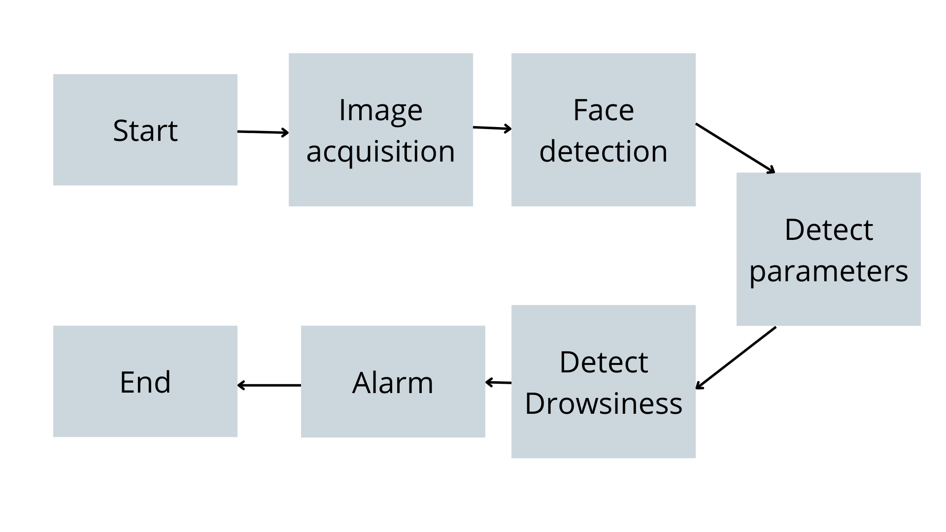
Figure 1 Procedure of the system
A. Facial Landmark detection
Facial landmark detection can be done using OpenCV and a library known as dlib. As soon as the system is initiated, the camera sensors will trigger the webcam to start. Using dlib, the system initiates a detector and a predictor to detect frontal face and shape. Then using the correct array slicer indexes, the system obtains the ROI, i.e., the left and right eye of the driver. After image preprocessing using grey scaling for intensity extraction, the system uses Video Stream to declare a variable for frames of images taken from webcam. The dlib's detector to locate the facial landmarks.
B. Detection of ROI
The system uses dlib’s predictor to get the facial landmarks and convert the result into a NumPy array. The next step is to extract the coordinates of left and right eye. After finding the eye corner and eye-centers, it is essential to find the distance between eye’s center and eyebrow region. Consider the face region, an array of 68 points as shown below in the image. After close examination we can see that the eyes can be assessed by using right eye’s points [36,42] and left eye’s points [42,48]. A main task in this step is to visualize each of these facial landmarks overlay the results on input layers. To extract the facial regions, we simply need to compute a box bounded by the x, y coordinates and use NumPy array slicing to extract it. This can be achieved by training a set of labeled facial landmarks on an image. These images should be manually labeled by specifying the x and y coordinates. After the training is completed, an ensemble of regression trees is trained to estimate and find the ROI.
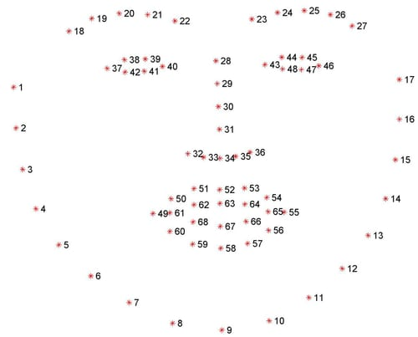
Figure 2 Facial Landmarks of face.

C. Classification of eyes using CNN
CNN is very popular for computer vision task which takes input from images and extract features from an image and make learnable parameters to efficiently classify, detect etc. We use something called filters to extract various features from images. We convolute our image using filters using convolutional operations. Our model will be classifying in binary, i.e., 0 and 1. It predicts each eye, lpred[0] = 1 states that the eyes are open and lpred[0] = 0 states that the eyes are closed.
D. Score calculation algorithm
To determine how long the eyes of the driver were closed for, we calculate the score. If both the eyes are closed, we steadily increase the score and when eyes are closed, we decrease the score. We show the score on the screen which will show the real time status of the person. By defining the threshold of 15, we can determine that the eyes of the driver are closed for too long. This is when our system will play the alarm.
IV. EXPERIMENTAL SETUP
A. Dataset Description
To create the dataset, a script had been written to capture eyes from a camera and store it in the local disk. The images were separated into their respective labels ‘Open’ or ‘Closed’. The unnecessary data was cleaned manually, removing all unwanted data for the model. The dataset contains over 84000 images of people’s eyes under different lighting conditions so gets easy for detection under low light conditions [7]. There were also several images in which the person is yawning with eyes closed. After training the model on the dataset, the final weights had been attached in the model architecture file. Thus, we can use this dataset to see if the person’s eyes are open or closed. Width of the boundary box of the object, after iterating over the faces to draw boundary boxes for each face.
Table 1 Data splitting
 | Closed | Open
Training | 37946 | 38952
Testing | 4000 | 4000

B. Pre-processing
For the detection of face in the image, first convert the image into grayscale as the OpenCV algorithm for object detection takes gray images in the input. However, the color information to detect the objects in not needed. Thus, haar cascade classifier will be used to detect faces. We use this line to set our classifier [face= cv2.CascadeClassifier(path to the haar cascade xml file)] Then detection using detectMultiScale(gray) is performed which returns an array of detections with x, y coordinated, and height, the width of the boundary of the box of the object. Finally, iteration over the faces is done and a boundary box is drawn for each face.
C. Feature Extraction
The same method is used to to detect faces and eyes. By setting the cascade classifier for eyes in leye and reye respectively then detect the eyes using detect Multiscale(gray). The data from the eyes image is only extracted from the full image. This is done achieved by extracting the boundary box of the eye and therefore can retrieve the eye image from the frame with this code. l_eye = frame [y : y+h, x : x+w] l_eye only contains the image data of the eye. This will be fed into the CNN classifier which will predict if eyes are open or closed. Likewise, the extraction can be done for the r_eye().

V. FLOW/ BLOCK DIAGRAMS
The diagram is the flow chart of the scoring system. It explains the basic algorithm behind the counter and alarm. Here, Eye Aspect Ratio will continuously detect if the eyes are closed or open. The system will be provided with a minimum Eye Aspect Ratio (EAR), i.e., the threshold after which the system will commence counting the number of frames the driver is detected drowsy (based on how long his eyes are closed).
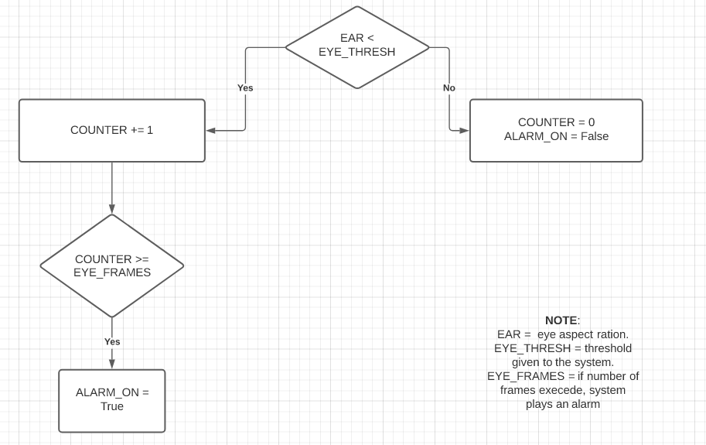
Figure 3 Scoring system
This image shows the proposed system implemented in a real-life mobile application that continuously checks the eyes states, head movement and yawning. This is the future scope of the said project. Using real-time image acquisition and alerting the driver, we can reduce the accidents caused by driving.
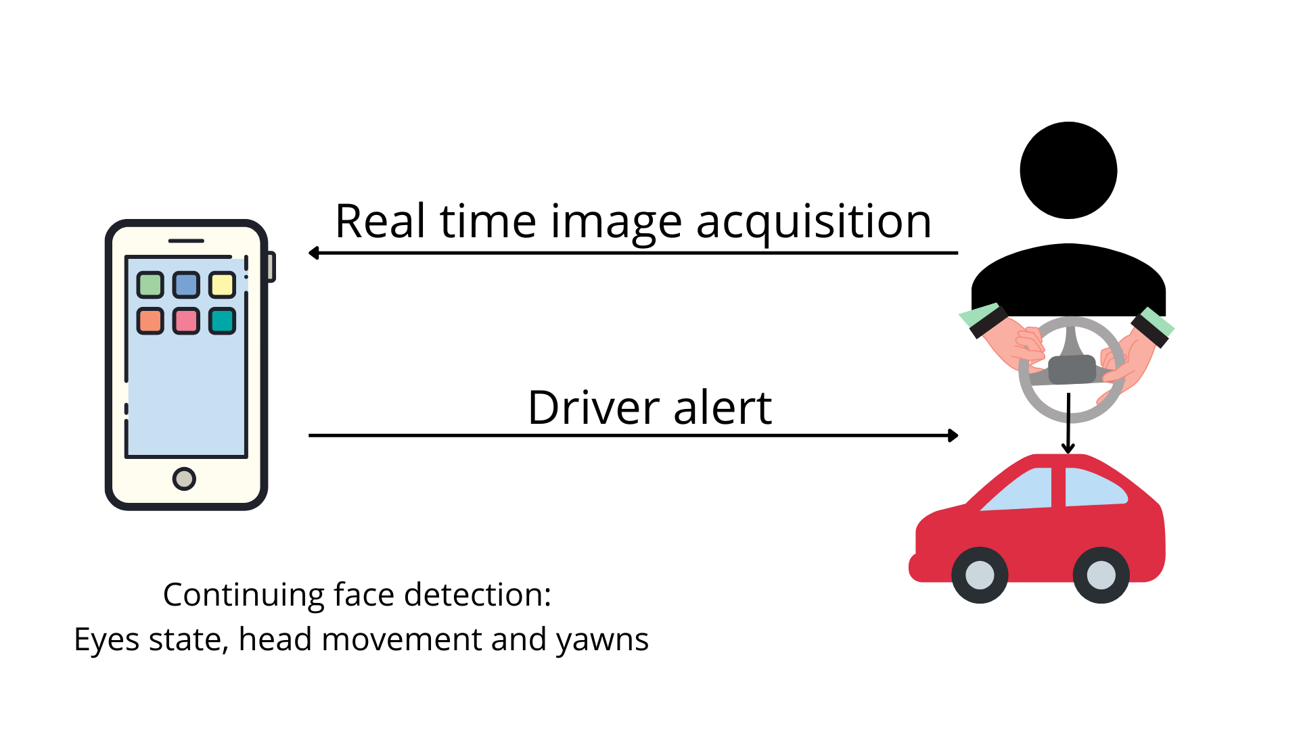
Figure 4 Pictorial depiction
The diagram below explains the flow of the proposed system. The system will first take input from the webcam/ camera, detect the face, and create a box for region of interest, i.e., eyes. The ROI will be fed to the classifier and the CNN model will classify whether the driver’s eyes are open or closed. The system calculates a score based on the threshold and number of frames. This score determines if the driver is drowsy or not. If the score exceeds the limit, it will ring an alarm to wake the driver.
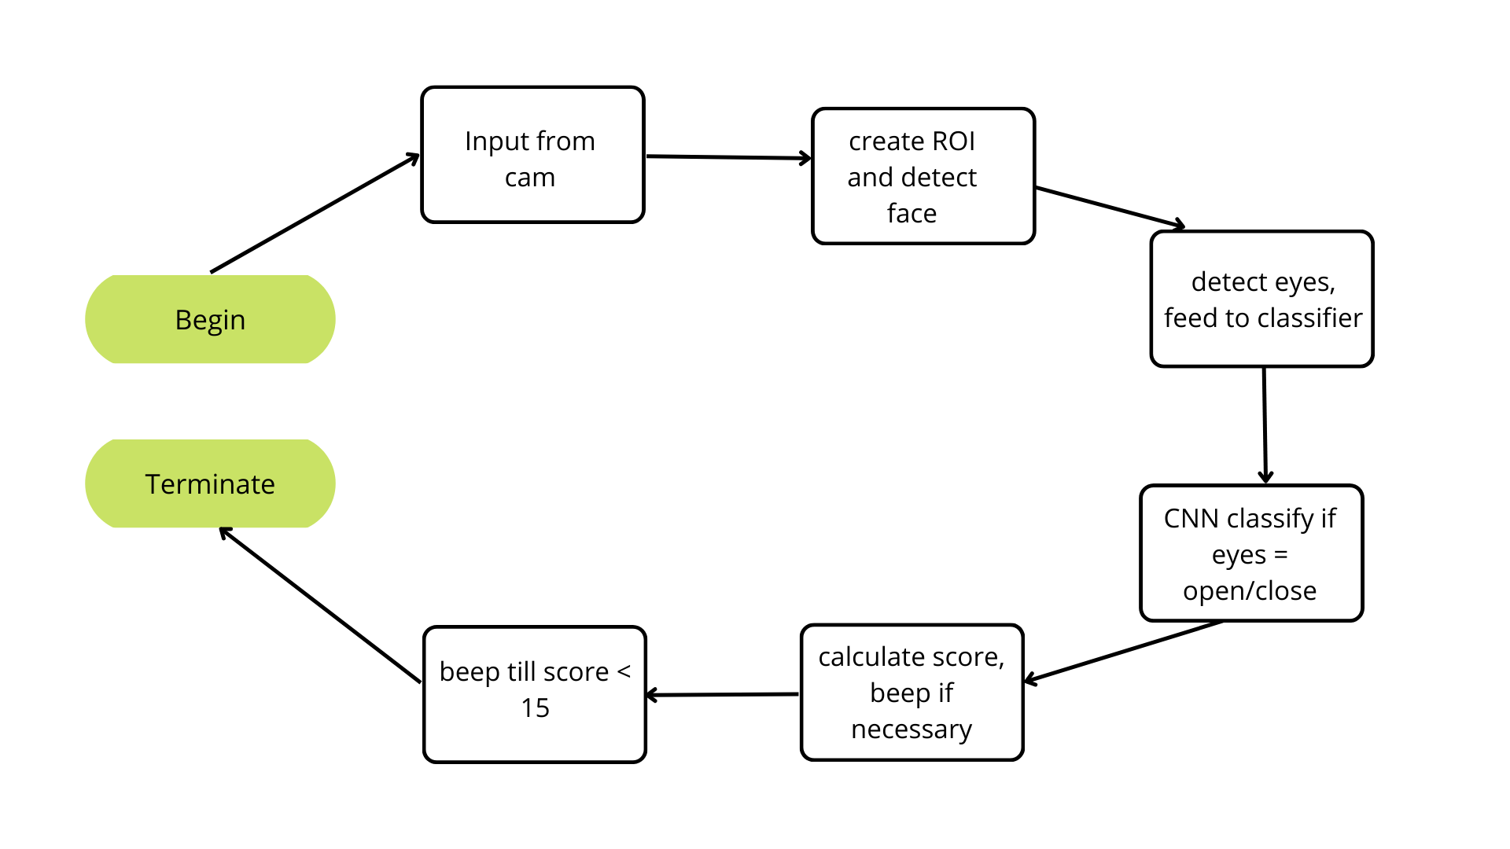
Figure 5 Flow diagram

VI. RESULT
This system is still under process and will be able to detect drowsiness very efficiently after gaining and including so many types of models and techniques. The pre-processing successfully obtains results with respect to facial recognition. The haar cascade classifier can detect the face and returning an array of detections with x, y coordinated, and height, the width of the boundary of the box of the object. Post iteration over the faces is done and a boundary box is drawn for each face. It should be able to detect region of interest, i.e., eyes and take the video as an input and detect if the driver is drowsy or not. In Lenovo ThinkPad T470, i7 processor, 16GB RAM it approximately took 85 minutes to run 5 epochs. The model is giving an accuracy of 93.94% after final epoch of 5/5.
Table 2 Accuracy and loss of model for InceptionV3
Total Epochs | Accuracy | Val. Loss
Epoch 1 | 92.34% | 21.67%
Epoch 2 | 93.01% | 19.15%
Epoch 3 | 93.48% | 19.37%
Epoch 4 | 93.70% | 19.12%
Epoch 5 | 93.94% | 18.11%

Average of accuracy for all the epochs, i.e., the accuracy of the model is 93.294% and the final loss of the model came out to be 18.11%.

Table 3 Accuracy and loss of model for ResNet50
Total Epochs | Accuracy | Val. Loss
Epoch 1 | 50.35% | 69.32%
Epoch 2 | 50.38% | 69.31%
Epoch 3 | 50.61% | 69.31%
Epoch 4 | 50.45% | 69.31%
Epoch 5 | 50.63% | 69.31%

The average accuracy and loss after using another pre-made, ResNet50 neural network architecture was 50.484% and 69.312% respectively.
The layers which were added by us did not help with the accuracy. The better model is InceptionV3 with 93.3% accuracy.
The layers used in these models included mixed sequences of Dropout, Input, Flatten, Dense and MaxPooling2D. The activation functions utilized include Relu and Softmax.

VII. CONCLUSION
The proposed system really has the potential to change the number of accidents happening due to drowsiness and sleepiness while driving. The system takes no guarantee that the driver will not fall asleep on the wheel as that requires proper 7-8 hours’ sleep, not using medications that make you drowsy before driving etc.
VIII. FUTURE SCOPE
The system can be made more beneficial if we integrate it into phones and connect it with google maps and trigger the detection system if the driver opened maps in a moving vehicle. It can help predict the drowsiness of the driver continuously without depending on the person to start the app. We can also add multiple other features for detection like yawning, slowness in blinking etc. Making multiple models and combining all of them using transfer learning can help us get more diversity and increase accuracy. Integrating this system with car itself can change the evolution of this industry. The combination of IoT and hardware system, this prediction model can be made more accurate and precise.
REFERENCES
[1] Data Flair. Driver Drowsiness Detection using OpenCV and Keras. (2019)
[2]Adrian R. Drowsiness Detection with OpenCV. (2017)
[3]Adrian R. Eye blinking detection with OpenCV, Python and dlib. (2017)
[4] CSIR-CEERI, Chennai Centre. AI-Powered Driver Fatigue and Drowsiness Detection System
[5] Grant Z.; Rui Y.; He W.; Aurangzaib S.; Gaurav C. Drowsiness Detection with Machine Learning. (2019)
[6] Priya S.; Debotosh B.; Barin K.; Mita N. An Approach to Detect the Region of Interest of Expressive Face-Images. (2014)
[7]Media Research Lab (MRL).Dataset.

