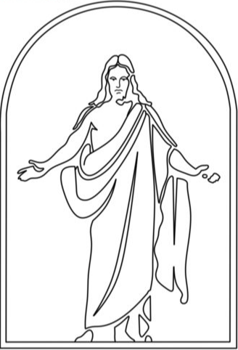

**Pasay Philippine Stake  
Pasay 3rd Ward  
Sacrament Program**

**Date:** October 19, 2025

**Presiding:** Sherwin Tan

**Conducting:** (2nd Co) Bro. Joenice Gaco

**Acknowledgement:** (1st Co) Bro. John Moroni Mendoza,Bro. Adrian Matro (wrd Clrk), Johanne Perlas (Asst. Clrk. rec). Bro. Norman Oliva (Asst. Clrk. fin), (wrd exc. Secr.) John Russelle Domingo, (wrd exc. Asst. Secr.) Genesis Ferareza, To all Visitors and Stake Leaders (Welcome).

**Announcements:**

1. Acknowledgement for attending ward home evening

2. cleaning chapel.

**Chorister:** Sis. Kyle Domingo | **Pianist:** Bro. Oscar Driz

**Opening Hymn:** #1001 “Come, Thou Fount of Every Blessing”

**Invocation:** :

**Stake Business:** Kindly approach the stake high councilors

**Sacrament Hymn:**  #181 “Jesus of Nazareth, Savior and King”

*Thank you for your reverence during the sacrament, and thank you to the priesthood brethren who bless and passed the bread and water. You may now Join your family.*

**Speakers:**

1st speaker: Sis. Lyka Villanueva

2nd speaker: Sis. Myrna Driz

3rd speaker: Sis. Lindsey Tan

**Closing Hymn:**  #270 “I'll Go Where You Want Me to Go”

**Benediction:** :

**Sacrament Attendance:________**