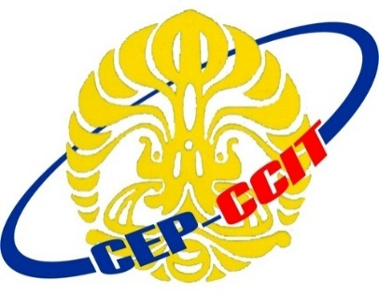

Continuning Education Program

Center for Computing and Information Technology

Faculty of Engineering

University of Indonesia

**ISAS ( Information Search and Analysis Skill)**

**“Framework Code Igniter Version 3”**

Name :

♦ Muhammad Hudya Ramadhana

Class : 3SC1 (PNJ)

Faculty : Bayu Citra Nur Aulia S.T, M.T