

**Continuing**

**Education**

**Program**

**Center for Computing and Information Technology**

**Faculty of Technic University of Indonesia**

**PROJECT ON**

**“Rent House”**

**Group : 9**

**Muhammad Hudya Ramadhana**

**Mutia Ayu Dianita**

**­­**

**Faculty : Bayu Citra Nur Aulia S.T, M.TI**

**Class :3 SC 1**

Faculty of Engineering University of Indonesia

Depok 16424

2016

**PROJECT ON**

*Rent House*

Developed By

*Name : Muhammad Hudya Ramadhana*

*Mutia Ayu Dianita*

NIIT

**RENT HOUSE**

Batch Code : 3 SC 1

Start Date : September 30, 2016

End Date : October 20, 2016

Name Of The Coordinator : Bayu Citra Nur Aulia S.T,M.TI

Name Of Developer : Muhammad Hudya Ramadhana

Mutia Ayu Dianita

Date Of Submission : October 21, 2016

NIIT

**CERTIFICATE**

This is to certify that this report, titled Jobfield Recruitment embodies the original work done by ***Muhammad Hudya Ramadhana and Mutia Ayu Dianita*** in partial fulfillment of their course requirement at NIIT.

Coordinator:

*Bayu Citra Nur Aulia S.T,M.TI*

**ACKNOWLEDGEMENT**

We have benefited a lot from the feedback and suggestions given to us by Mrs. Bayu Citra Nur Aulia S.T, M.TI and other faculty members. The Project presentation opportunity we have with CCIT-FTUI is a greatchance for learning and professional development. Therefore, we consider ourselves very lucky as we are provided with an opportunity to be a part of it. We are also grateful for having a change to meet so many wonderful people and professionals who led us through this project period.

Bearing in mind, we would like to express our deepest gratitude and special thanks to Bayu Citra Nur Aulia S.T, M.TIof CCIT-FTUI faculty who is spite of being extraordinarily busy with her duties, took time out to hear, guide and keep us on the correct path and allowing us to carry out our project until completion.

Our Project assignment won’t be as good as it is now without any help, feedback and suggestion that were given to us by our friends within the campus. So, we would also like to say thank you to all of them. We will strive to use gained skills and knowledge in the best possible way, and we will continue to work on the improvements, in order to attain desired career objective.

**SYSTEM ANALYSIS**

**System Summary:**

Rent House Application is an application that allows admin to add customer, room, laundry, rent, and monthly paid data to rent house’s database. This application also displays the data and admin can update and delete the data. And admin can see the report of monthly paid of customer

**RENT HOUSE INTERFACE**

*Login Form*

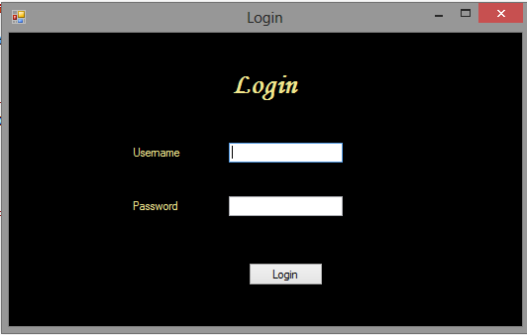

*Home Form*

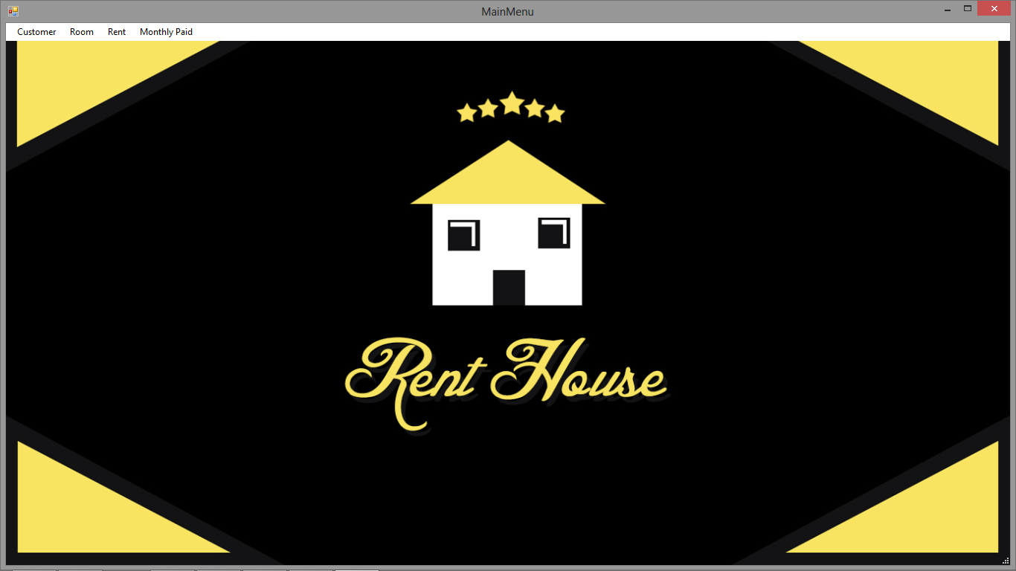

**RENT HOUSE INTERFACE**

*Add Customer*

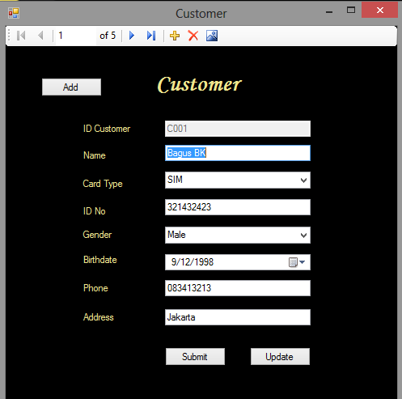

*Display Customer*

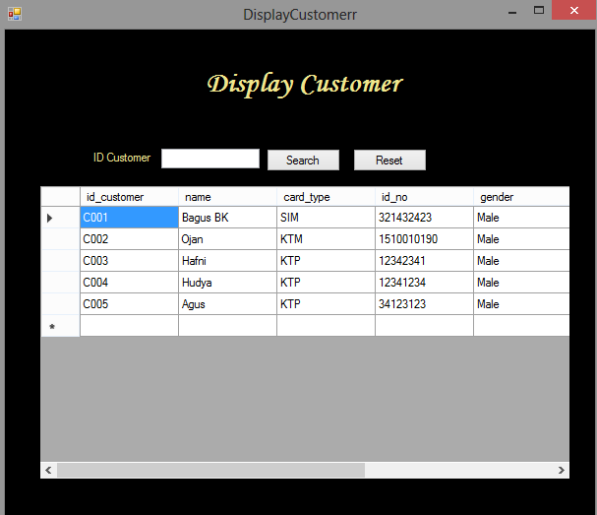

**RENT HOUSE INTERFACE**

*Add Room*

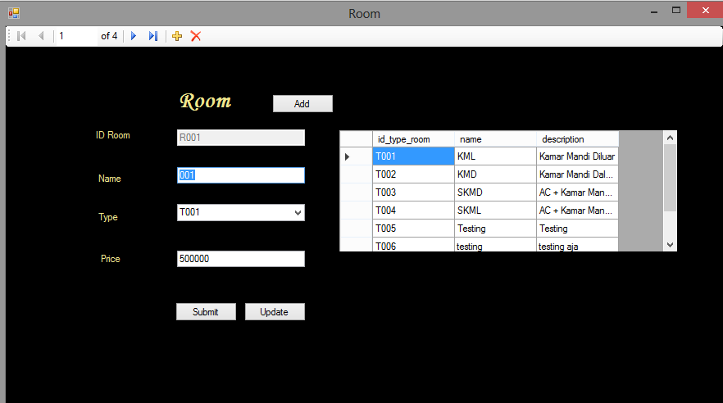

*Display Room Form*

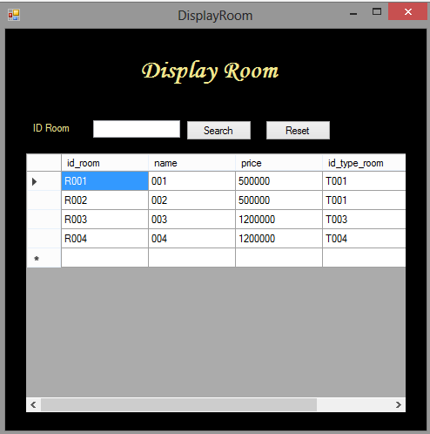

**RENT HOUSE INTERFACE**

*Rent In Form*

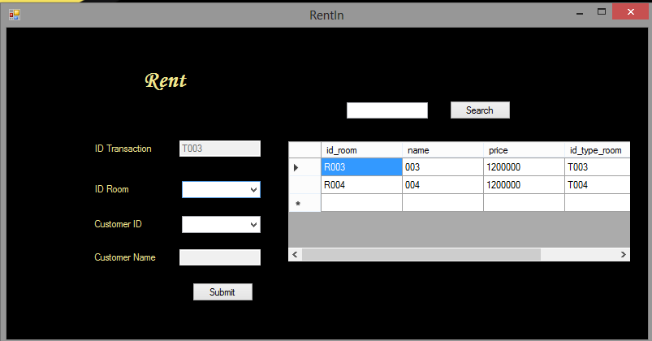

*Rent Out Form*

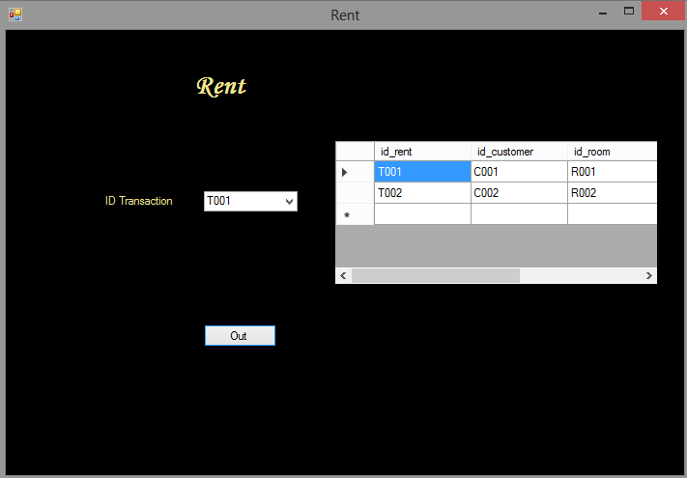

**RENT HOUSE INTERFACE**

*Display Rent Form*

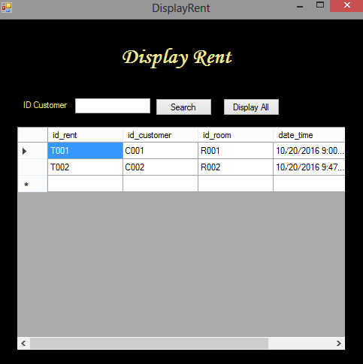

*Display Monthly Paid*

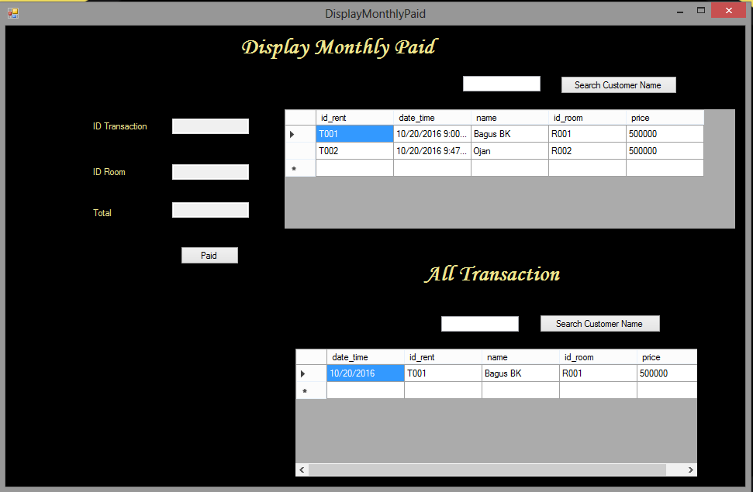

**RENT HOUSE INTERFACE**

*Report Form*

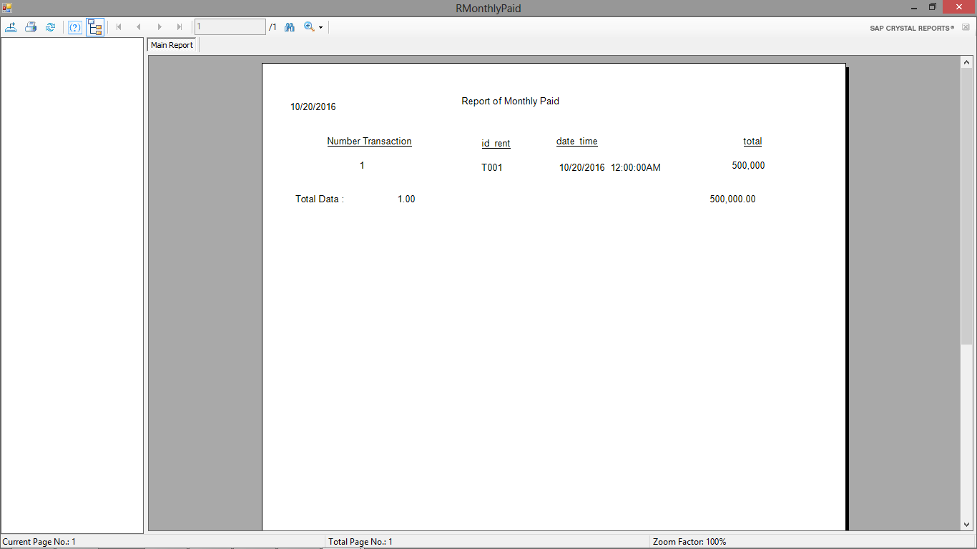

**CONFIGURATION**

**Hardware: Asus Expert 50, Intel(R) Core(TM) i3** **8.00 GB (RAM)**

**Operating System: Microsoft Windows 8.1 Pro, 64-bit Operating System**

**Software: SQL Server 2008**

**Visual Studio 2010**

**INDIVIDUAL PROJECT SCHEDULE**

|  |  |  |  |  |  |
| --- | --- | --- | --- | --- | --- |
| **S. No** | **Activity Description** | **Planned Date of Completion** | **Actual Date** | **Responsibility** | **Remarks** |
| 1 | Creating the windows logon form | 14th Oct 2016 | 14th Oct 2016 | Hudya |  |
| 2 | Creating the main menu windows form | 16th Oct 2016 | 16th Oct 2016 | Mutia |  |
| 3 | Creating customer windows form | 16th Oct 2016 | 16th Oct 2016 | Hudya/  Mutia |  |
| 4 | Creating display customer windows form | 16th Oct 2016 | 16th Oct 2016 | Hudya/  Mutia |  |
| 5 | Creating room windows form | 16th Oct 2016 | 16th Oct 2016 | Hudya/  Mutia |  |
| 6 | Creating display room windows form | 16th Oct 2016 | 16th Oct 2016 | Hudya/  Mutia |  |
| 7 | Creating type room windows form | 16th Oct 2016 | 16th Oct 2016 | Hudya/  Mutia |  |
| 8 | Creating rent windows form | 16th Oct 2016 | 16th Oct 2016 | Hudya/  Mutia |  |
| 9 | Creating rent in windows form | 16th Oct 2016 | 16th Oct 2016 | Hudya |  |
| 10 | Creating display rent windows form | 16th Oct 2016 | 16th Oct 2016 | Hudya/  Mutia |  |
| 11 | Creating display monthly paid | 17th Oct 2016 | 17th Oct 2016 | Hudya/  Mutia |  |
| 12 | Creating connection with SQL Server | 17th Oct 2016 | 17th Oct 2016 | Hudya |  |
| 13 | Creating reports | 19th Oct 2016 | 19th Oct 2016 | Mutia |  |
| 14 | Creating documentation | 20th Oct 2016 | 20th Oct 2016 | Mutia |  |

**DATABASE DESIGN**

**Database Name:** rent_house

**Number of tables:** 6

**Table Names:**

1. Admin
2. Customer
3. Room
4. Type Room
5. Rent
6. Monthly Paid

**TABLE DESIGN**

**Database Name:** rent_house

**Admin:**

|  |  |  |  |
| --- | --- | --- | --- |
| **Field Name** | **Data Type** | **Width** | **Description** |
| id_admin | varchar | 4 | Admin ID |
| username | varchar | 50 | Username of the Admin |
| password | varchar | 50 | Password of the Admin |
| name | varchar | 50 | Name of the Admin |
| gender | varchar | 10 | Gender of the Admin |
| Roles | varchar | 50 | Role of the Admin |

**Customer:**

|  |  |  |  |
| --- | --- | --- | --- |
| **Field Name** | **Data Type** | **Width** | **Description** |
| id_customer | varchar | 4 | Customer ID |
| name | varchar | 100 | Name of the Customer |
| card_type | varchar | 10 | Type Card of ID of the Customer |
| id_no | varchar | 25 | Number of ID card of the Customer |
| gender | varchar | 10 | Gender of the Customer |
| birthdate | date |  | Birthdate of the Customer |
| phone | varchar | 13 | Phone number of the Customer |
| address | text |  | Address of the customer |

**Monthly Paid:**

|  |  |  |  |
| --- | --- | --- | --- |
| **Field Name** | **Data Type** | **Width** | **Description** |
| id_monthly_paid | Int |  | Monthly Paid ID |
| id_rent | varchar | 4 | Rent ID |
| date_time | Datetime |  | Date and Time of Monthly Paid |
| total | int |  | Total of Monthly Paid |

**Rent:**

|  |  |  |  |
| --- | --- | --- | --- |
| **Field Name** | **Data Type** | **Width** | **Description** |
| id_rent | varchar | 4 | Rent ID |
| id_customer | varchar | 4 | Customer ID |
| id_room | varchar | 4 | Room ID |
| date_time | datetime |  | Current Date of Rent |
| date_out | datetime |  | Date Out of Rent |

**Room:**

|  |  |  |  |
| --- | --- | --- | --- |
| **Field Name** | **Data Type** | **Width** | **Description** |
| id_room | varchar | 4 | Room ID |
| name | varchar | 50 | Name of the Room |
| price | int |  | Price of the Room |
| id_type_room | varchar | 4 | Type Room ID |
| status | varchar | 20 | Status of the Room |

**Type Room:**

|  |  |  |  |
| --- | --- | --- | --- |
| **Field Name** | **Data Type** | **Width** | **Description** |
| id_type_room | varchar | 4 | Type Room ID |
| name | varchar | 50 | Name of Type Room |
| description | text |  | Description of the Type Room |

**VALIDATION PERFORMED**

**Admin:**

|  |  |
| --- | --- |
| **Validation Required** | **Method Used For Validation** |
| Id must be unique | Primary key constraint |

**Customer:**

|  |  |
| --- | --- |
| **Validation Required** | **Method Used For Validation** |
| Id must be unique | Primary key constraint |
| birthdate | Age must be above 17 |

**Monthly Paid:**

|  |  |
| --- | --- |
| **Validation Required** | **Method Used For Validation** |
| Id must be unique | Primary key constraint |
| id_rent | Foreign key from rent table |

**Rent:**

|  |  |
| --- | --- |
| **Validation Required** | **Method Used For Validation** |
| Id must be unique | Primary key constraint |
| id_customer | Foreign key from customer table |
| id_room | Foreign key from room table |

**Room:**

|  |  |
| --- | --- |
| **Validation Required** | **Method Used For Validation** |
| Id must be unique | Primary key constraint |
| id_type_room | Foreign key from type_room table |

**Type Room:**

|  |  |
| --- | --- |
| **Validation Required** | **Method Used For Validation** |
| Id must be unique | Primary key constraint |

**Rent  
In.cs**

**Display  
Rent.cs**

**Display  
Monthly  
Paid.cs**

**Room.cs**

**TypeRoom.cs**

**Rent.cs**

**Display  
Room.cs**

**Display  
Customer.cs**

**Display  
Room.cs**

**Customer.cs**

**MainMenu.cs**

**Login.cs**

**RentHouse.sln**

**LOGICAL FLOW DIAGRAM**

**Logical Flow Diagram representing the control flow of Rent House Management Application**