

**Continuing**

**Education**

**Program**

**Center for Computing and Information Technology**

**Faculty of Technic University of Indonesia**

**PROJECT ON**

**“Rent House”**

**Group : 9**

**Muhammad Hudya Ramadhana**

**Mutia Ayu Dianita**

**­­**

**Faculty : Indah Ayu Yuliani S.T, M.M**

**Class :3 SC 1**

Faculty of Engineering University of Indonesia

Depok 16424

2016

**PROJECT ON**

*Rent House*

Developed By

*Name : Muhammad Hudya Ramadhana*

*Mutia Ayu Dianita*

NIIT

**RENT HOUSE**

Batch Code : 3 SC 1

Start Date : November 24, 2016

End Date : December 7, 2016

Name Of The Coordinator : Indah Ayu Yuliani S.T,M.M

Name Of Developer : Muhammad Hudya Ramadhana

Mutia Ayu Dianita

Date Of Submission : November 23, 2016

NIIT

**CERTIFICATE**

This is to certify that this report, titled Jobfield Recruitment embodies the original work done by ***Muhammad Hudya Ramadhana and Mutia Ayu Dianita*** in partial fulfillment of their course requirement at NIIT.

Coordinator:

*Indah Ayu Yuliani S.T, M.M*

**ACKNOWLEDGEMENT**

We have benefited a lot from the feedback and suggestions given to us by Mrs. Indah Ayu Yuliani S.T, M.M and other faculty members. The Project presentation opportunity we have with CCIT-FTUI is a greatchance for learning and professional development. Therefore, we consider ourselves very lucky as we are provided with an opportunity to be a part of it. We are also grateful for having a change to meet so many wonderful people and professionals who led us through this project period.

Bearing in mind, we would like to express our deepest gratitude and special thanks to Indah Ayu Yuliani S.T, M.Mof CCIT-FTUI faculty who is spite of being extraordinarily busy with her duties, took time out to hear, guide and keep us on the correct path and allowing us to carry out our project until completion.

Our Project assignment won’t be as good as it is now without any help, feedback and suggestion that were given to us by our friends within the campus. So, we would also like to say thank you to all of them. We will strive to use gained skills and knowledge in the best possible way, and we will continue to work on the improvements, in order to attain desired career objective.

**SYSTEM ANALYSIS**

**System Summary:**

The proposed software system for Rent House will be used by two different types of user :

1. Owner of Rent House.
2. Operator.

The proposed software system needs to provide the following functionalities to the

Owner of Rent House :

1. Allow Owner to Add and Modify Room Types Data.
2. Allow Owner to Add and Modify Room Data.
3. Allow Owner to Add and Modify Operator Data.

The proposed software system also provide the following functionalities to the Operator of Rent House :

1. Allow Operator to Add and Modify Customer
2. Allow Operator to Add Transacton (Rent In or Rent Out)
3. Allow Operator to Add Monthly Paid of Customer

The proposed software system also allow the Owner to view the report :

1. Report of Monhtly Paid Transaction

**HARDWARE AND SOFTWARE REQUIREMENTS**

**Hardware: Asus Expert 50, Intel(R) Core(TM) i3** **8.00 GB (RAM)**

**Operating System: Microsoft Windows 8.1 Pro, 64-bit Operating System**

**Software: Astah Jude Professional**

**INDIVIDUAL PROJECT SCHEDULE**

|  |  |  |  |  |  |
| --- | --- | --- | --- | --- | --- |
| **S. No** | **Activity Description** | **Planned Date of Completion** | **Actual Date** | **Responsibility** | **Remarks** |
| 1 | Creating the use case | 27th Nov 2016 | 27th Nov 2016 | Mutia |  |
| 2 | Creating the sequence diagram | 27th Nov 2016 | 29th Nov 2016 | Hudya |  |
| 3 | Creating communication diagram | 1st Dec 2016 | 1st Dec 2016 | Hudya |  |
| 4 | Creating class diagram | 27th Nov 2016 | 27th Nov 2016 | Mutia |  |
| 5 | Creating Deployment diagram | 3rd Dec 2016 | 3rd Dec 2016 | Mutia |  |
| 6 | Creating statemachine diagram | 1st Dec 2016 | 1st Dec 2016 | Hudya |  |
| 7 | Creating activity diagram | 1st Dec 2016 | 1st Dec 2016 | Hudya |  |
| 8 | Creating object diagram | 4th Dec 2016 | 4th Dec 2016 | Mutia |  |

**USE CASE DIAGRAM FOR RENT HOUSE**

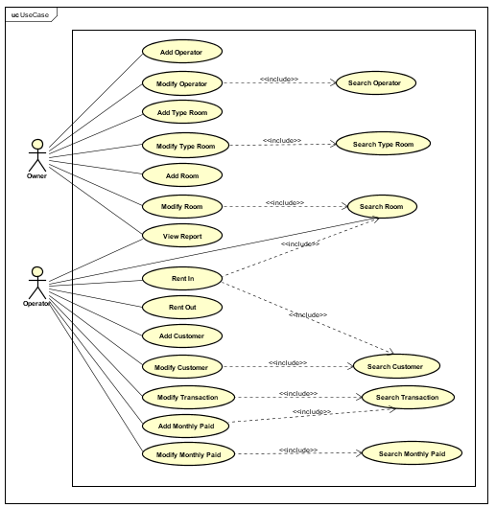

**CLASS DIAGRAM FOR RENT HOUSE**

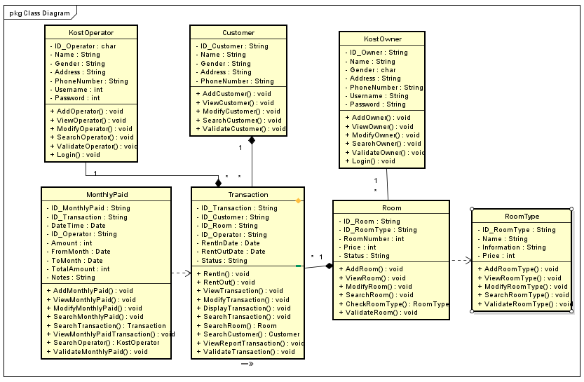

**SEQUENCE DIAGRAM FOR RENT HOUSE**

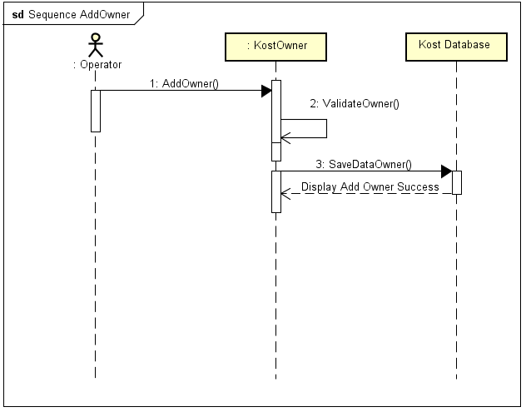

*Sequence Add Owner*

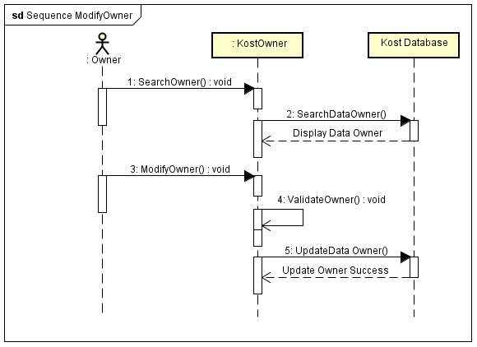

*Sequence Modify Owner*

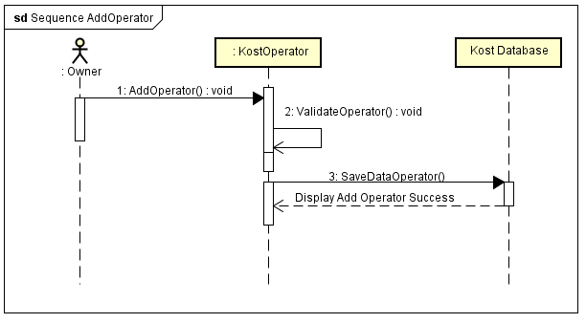

*Sequence Add Operator*

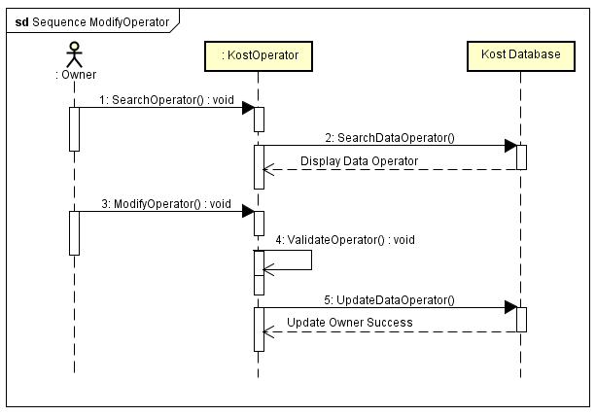

*Sequence Modify Operator*

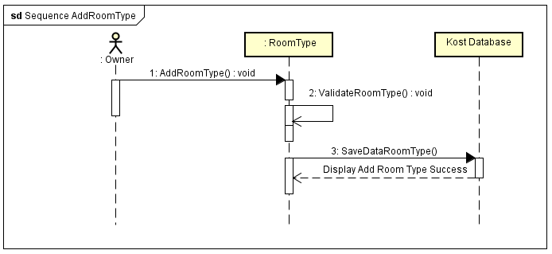

*Sequence Add Room*

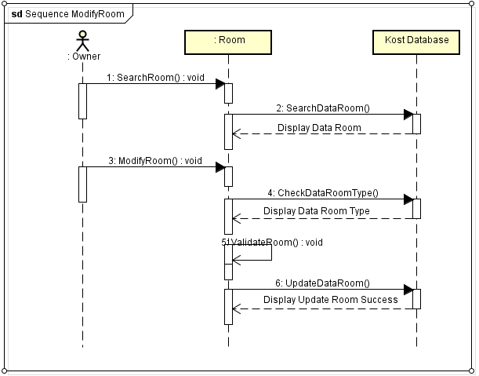

*Sequence Modify Room*

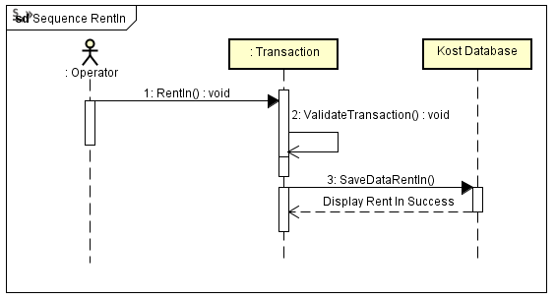

*Sequence Rent In*

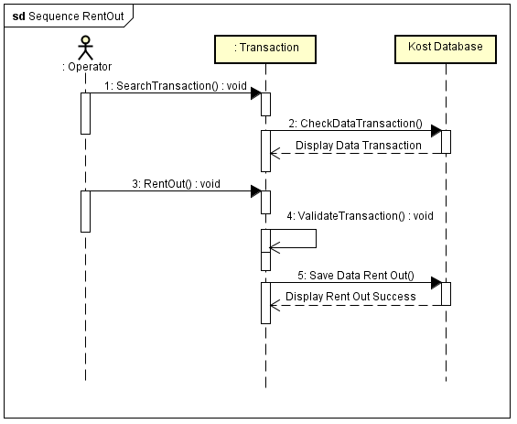

*Sequence Rent Out*

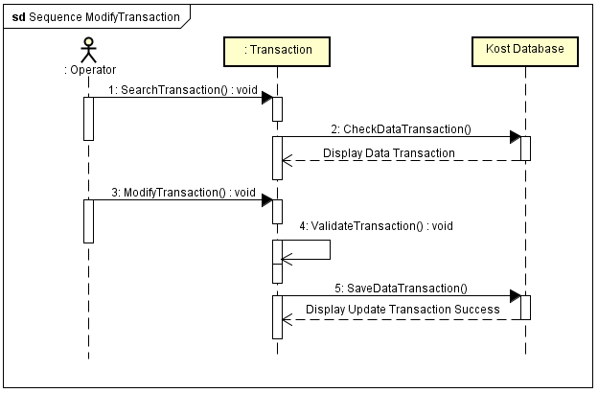

*Sequence Modify Transaction*

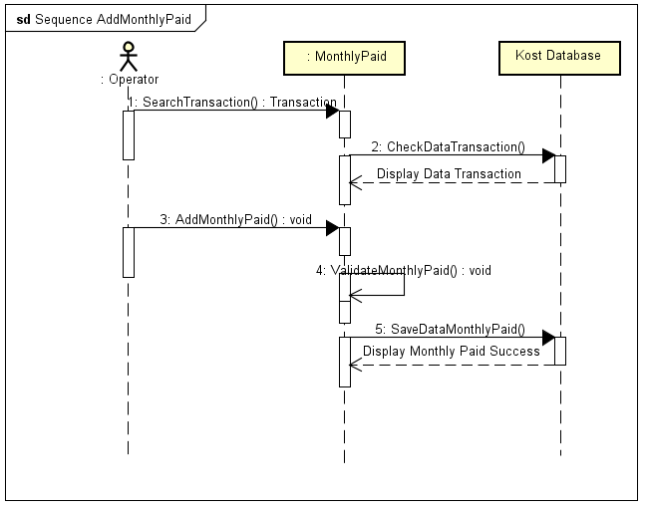

*Sequence Add Monthly Paid*

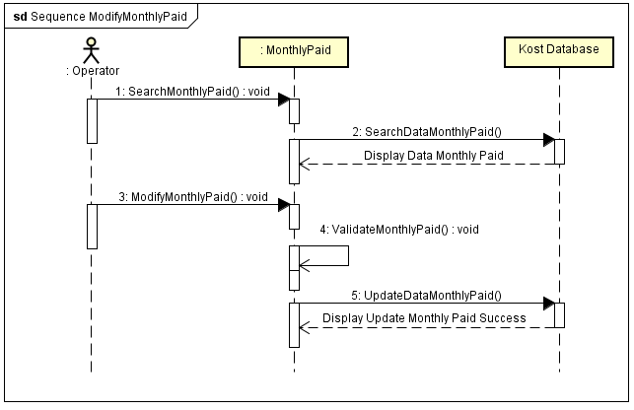

*Sequence Modify Monthly Paid*

*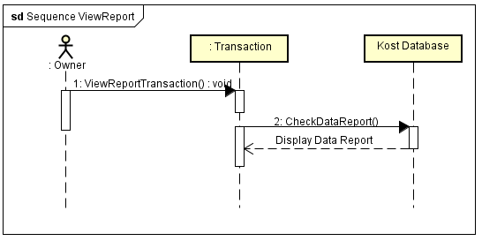Sequence View Report*

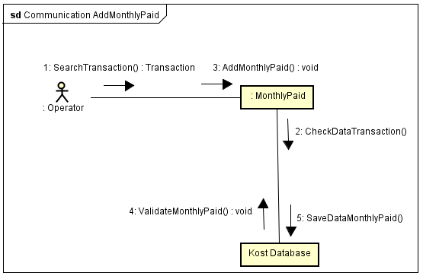

*Communication Add Monthly Paid*

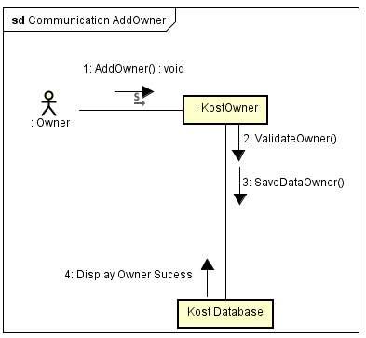

*Communication Add Owner*

**COMMUNICATION DIAGRAM FOR RENT HOUSE**

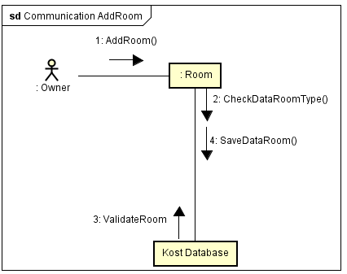

*Communication Add Room*

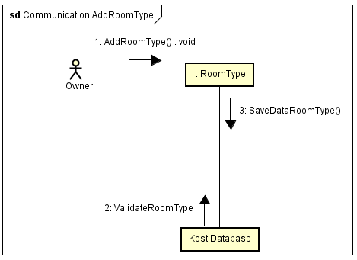

*Communication Add Room Type*

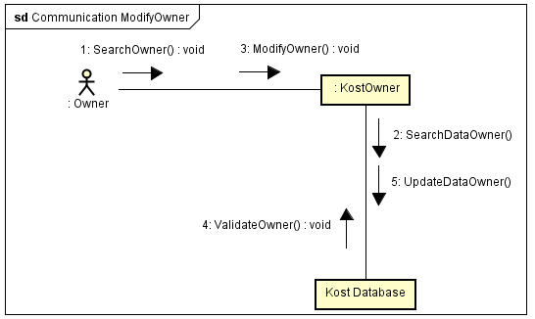

*Communication Modify Owner*

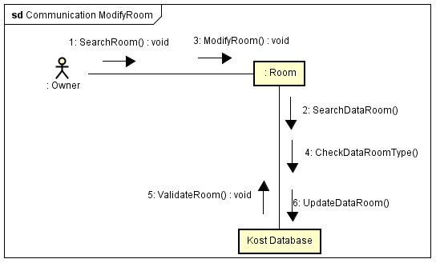

*Communication Modify Room*

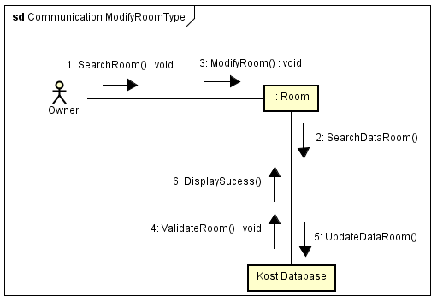

*Communication Modify Room Type*

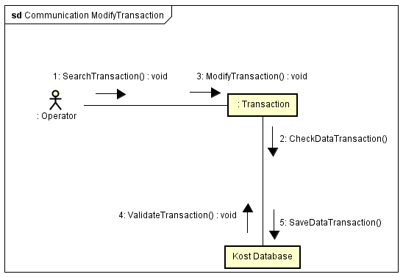

*Communication Modify Transaction*

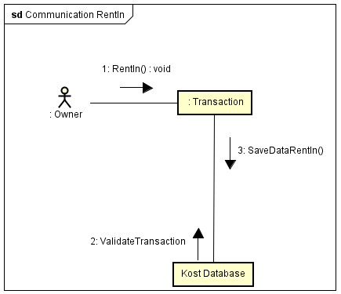

*Communication Rent In*

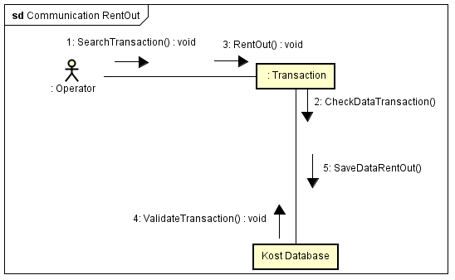

*Communication Rent Out*

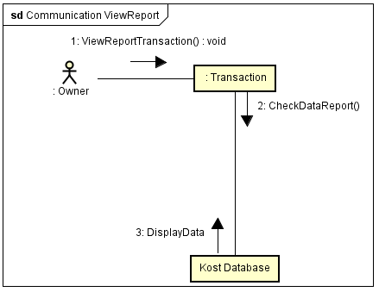

*Communication View Report*

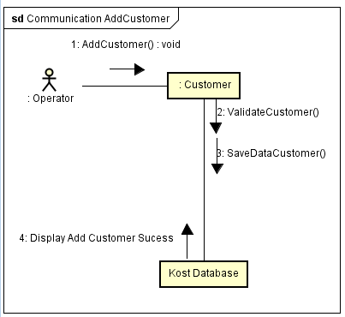

*Communication Add Customer*

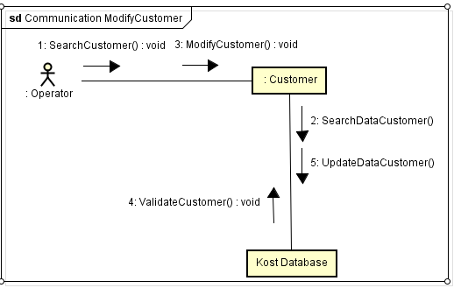

*Communication Modify Customer*

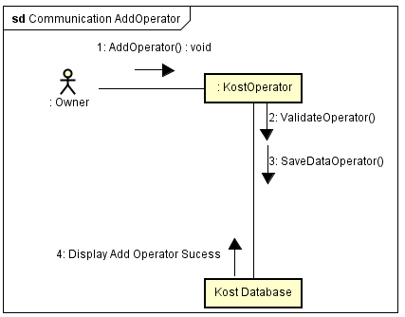

*Communication Add Operator*

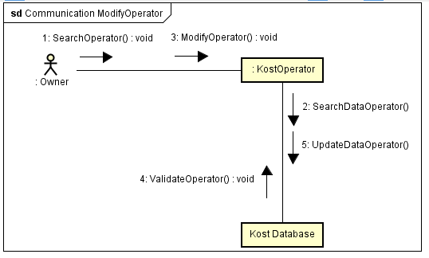

*Communication Modify Operator*

**ACTIVITY DIAGRAM FOR RENT HOUSE**

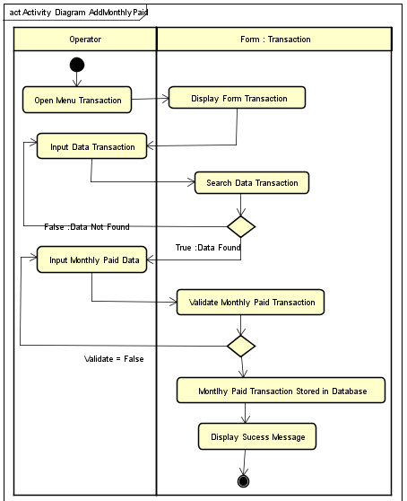

*Activty Diagram Add Monthly Paid*

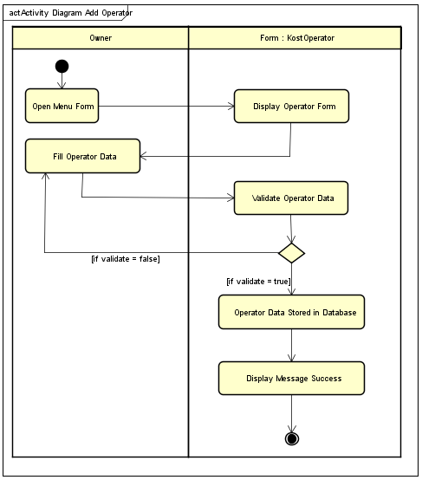

*Activty Diagram Add Operator*

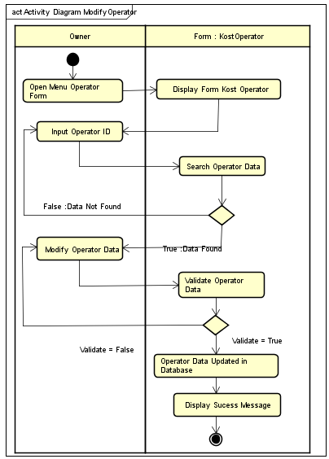

*Activty Diagram Modify Operator*

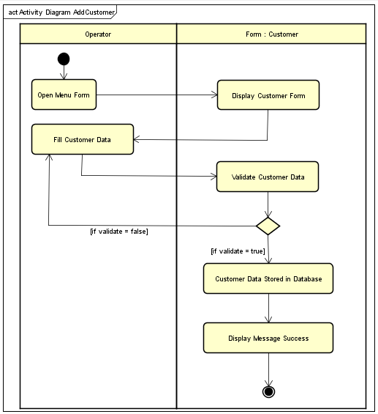

*Activty Diagram Add Monthly Paid*

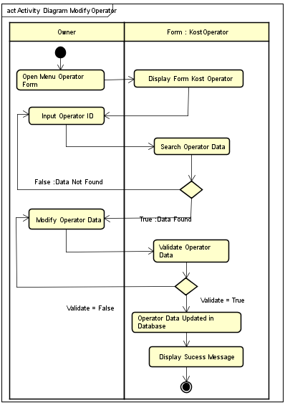

*Activity Diagram Modify Operator*



*Activty Diagram Add Monthly Paid*

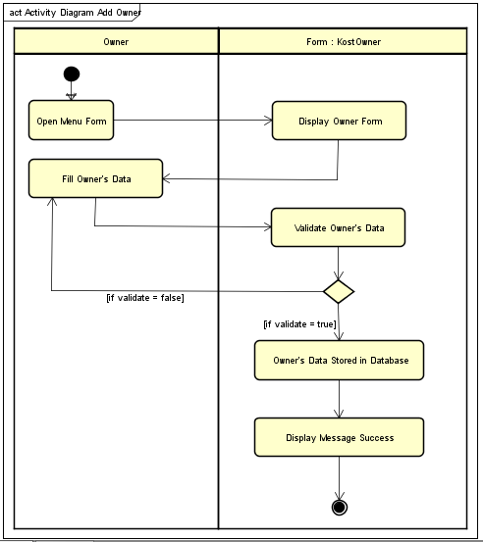

*Activty Diagram Add Owner*

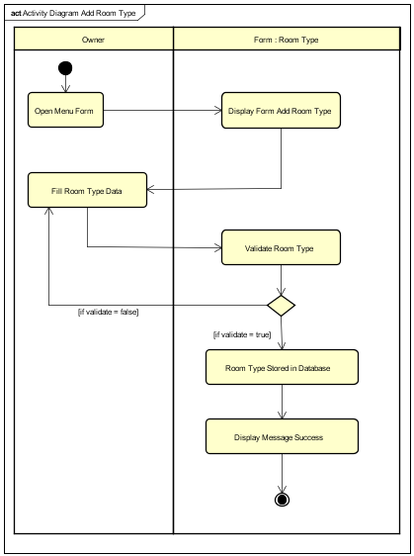

*Activty Diagram Add Room Type*

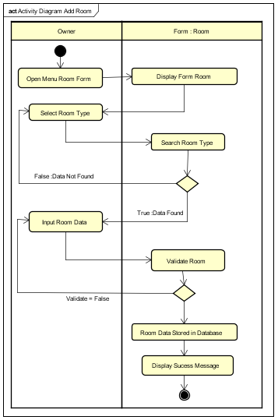

*Activity Diagram Add Room*

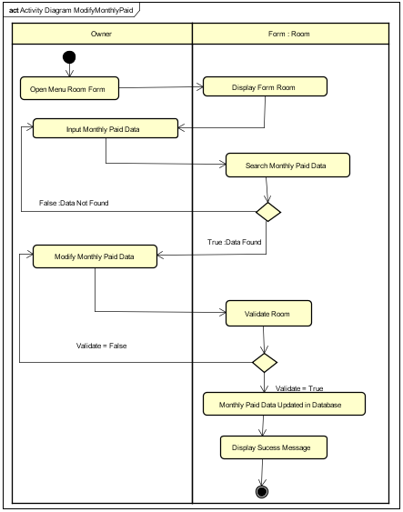

*Activty Diagram Modify Monthly Paid*

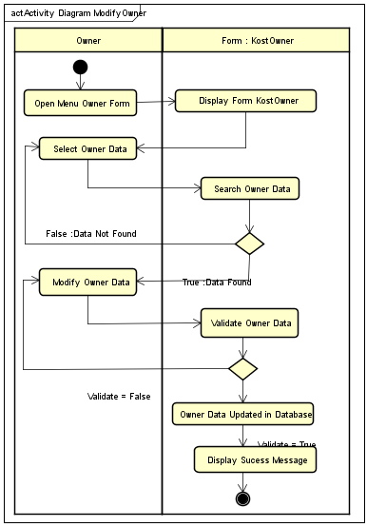

*Activity Diagram Modify Owner*

**

*Activty Diagram Modify Monthly Paid*

**

*Activity Diagram Modify Owner*

**COMPONENT DIAGRAM FOR RENT HOUSE**

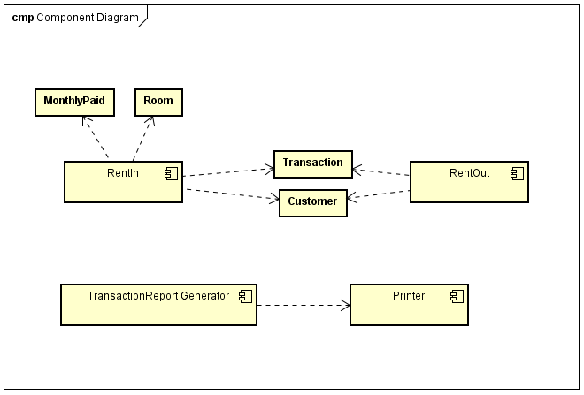

*Component Diagram Rent House*

**DEPLOYMENT DIAGRAM FOR RENT HOUSE**

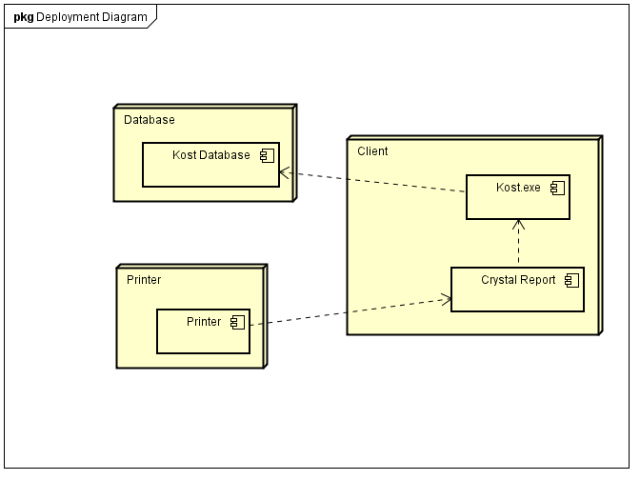

*Deployment Diagram Rent House*

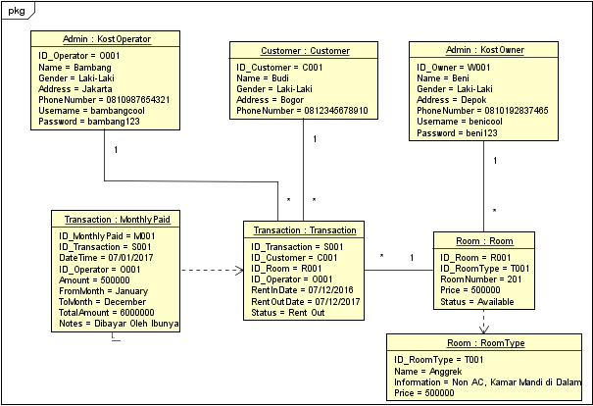

*Object Diagram Rent House*

**OBJECT DIAGRAM FOR RENT HOUSE**

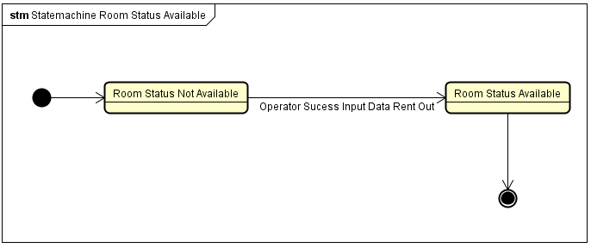

*Statemachine Diagram Room Status Available*

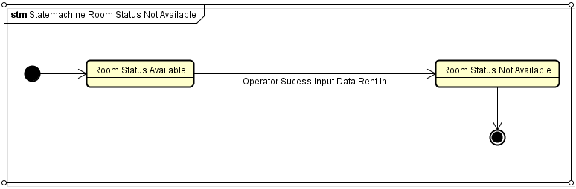

*Statemachine Diagram Room Status Not Available*

**STATEMACHINE DIAGRAM FOR RENT HOUSE**