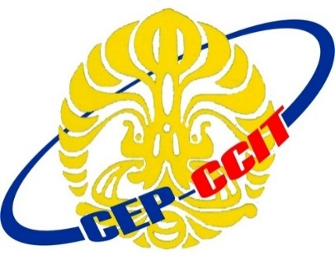

Continuing Education Program

Center for Computing and Information Technology

Faculty of Engineering

University of Indonesia

**ISAS ( Information Search and Analysis Skill)**

**“Face Recognition as Authentication Security”**

Group 1

Muhamad Hudya Ramadhana

Mutia Ayu Dianita

Faculty :

Dudy Fathan Ali, S.Kom

Class : 4SC1 (PNJ)

Faculty of Engineering University of Indonesia

Depok 16424