**Aim:** To manage the road traffic using the data of number of vehicles.

**Objective**: Familiar with C++

**S/W Requirement**: Operating System, Turbo C++

**H/W Requirement**: Keyboard, Mouse, CPU, Motherboard, RAM, Hard disk, printers.

**Description:** In the following code I have prompt the user to tell the number of heavy, light, emergency vehicles on each of the four roads. After that, using different loops we have found the maximum number of emergency vehicles. So there will be a green signal for that road which has maximum number of emergency vehicles. If in case, there is no emergency vehicle then we will calculate the total number of vehicles on each road i.e. heavy vehicles plus light vehicles. So there will be a green signal on the road which has maximum number of total vehicles.

**Code:**

/*ROAD TRAFFIC MANAGEMENT SYSTEM*/

#include<iostream>

using namespace std;

class traffic

{

int hv[4];//heavyvehicle

int lv[4];//lightvehicle

int ev[1];//emergencyvehicle

public:

int x,y;

void getdata(){

cout<<”ROAD TRAFFIC MANAGEMENT SYSTEM”;

cout<<"ENTER THE NUMBER OF VEHICLES ON EACH OF THE FOUR ROADS\n";

for(int i=0;i<4;i++){

cout<<"FOR ROAD "<<i+1<<" ENTER VEHICLES\n";

cout<<"HEAVY VEHICLES LIKE TRUCK,BUSES\n";

cin>>hv[i];

cout<<"LIGHT VEHICLES LIKE TWO WHEELERS\n";

cin>>lv[i];

cout<<"EMERGENCY VEHICLES LIKE AMUBLANCE\n";

cin>>ev[i];

}

}

void change()

{

int temp=ev[0];

for(int i=0;i<4;i++)

{

if(ev[i]>temp){

temp=ev[i];

x=i;

}}

if(temp==0)

{

int sum[4];

for(int i=0;i<4;i++)

{

sum[i]=hv[i]+lv[i];

}

int temp2=sum[0];

for(int i=0;i<4;i++)

{

if(sum[i]>temp2){

temp2=sum[i];

x=i;

}

}

}}

void display()

{

for(int i=0;i<4;i++)

{

if(i==x)

cout<<"GREEN SIGNAL.TRAFFIC ON THE ROAD"<<i+1<<"IS ALLOWED TO GO."<<endl;

else cout<<"RED SIGNAL.TRAFFIC ON THE ROAD"<<i+1<<" IS REQUESTED TO WAIT."<<endl;

}

}

};

int main()

{

traffic c;

c.getdata();

c.change();

c.display();

}

**Scope:**

This program helps us to manage the road traffic. As we all know road accidents are major cause of deaths these days so it is very necessary to manage road traffic. With this we can reduce the burden on traffic police as we will be using automated systems. Traffic management also helps in time saving. From the given code we can move the traffic fast in case of emergency as it will check the emergency vehicles.

**Output:**

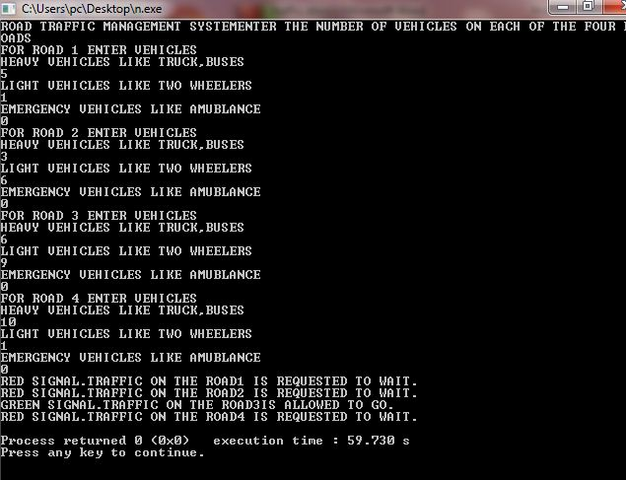

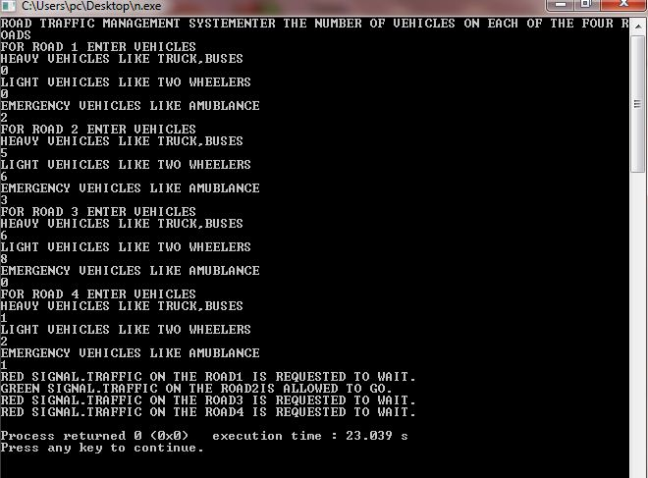

**Result**

This program can be very helpful in managing the rush in metropolitian cities.